A Microfluidic System for Particle Enrichment by Integrating an Acoustic Field with Oscillatory Flow
Jing-Tong Na^{1, 2}, Yan-Ran Wang³, Jia-Ming Zhao³, Shan-Shan Li⁴, Yong-Jiang Li², Jun Yu², Kai-Rong Qin²,
Shu-Xin Liu^{1, 2*}, Chun-Dong Xue^{1, 2}*

1. Department of Nephrology, Central Hospital of Dalian University of Technology, Dalian 116033, China.
2. Faculty of Medicine, Dalian University of Technology, Dalian 116024, China.
3. School of Optoelectronic Engineering and Instrumentation Science, Dalian University of Technology,
Dalian 116024, China.
4. School of Locomotive and Rolling Stock Engineering, Dalian Jiaotong University, Dalian 116028, China.
*Corresponding author’s email address：root8848@sina.com; xuechundong@dlut.edu.cn.

Supplementary information
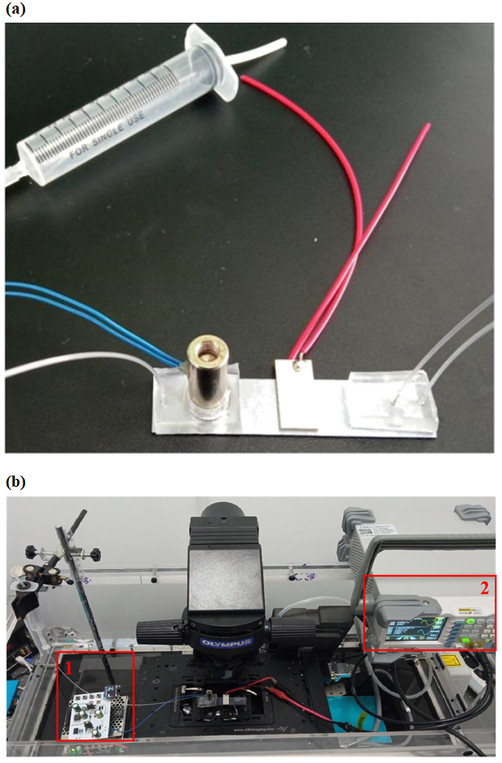
Fig. S1. Particle enrichment microfluidic system. (a) and (b) The real shot of the microfluidic chip, and the particle enrichment microfluidic system.

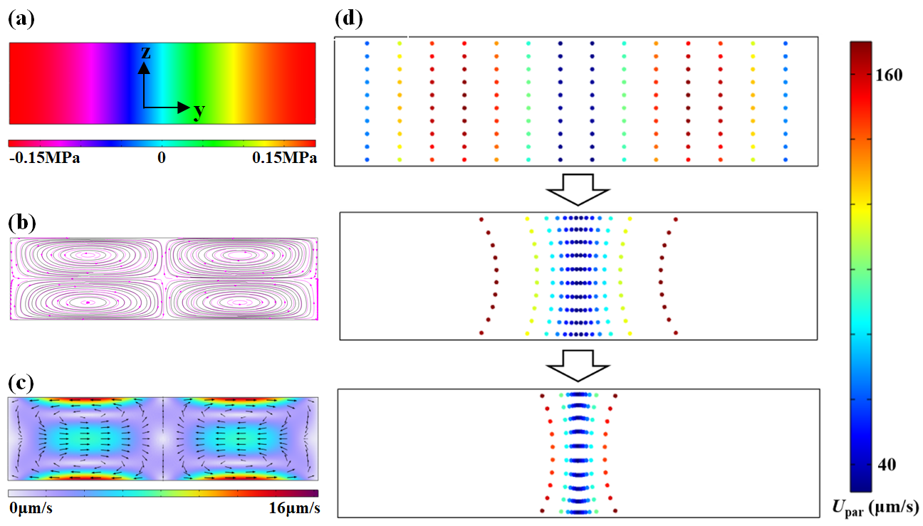
Fig. S2. Simulation analysis of the particle motion under the acoustic field effect. (a) Acoustic pressure distribution under acoustic standing waves. (b) and (c) the spatial distributions of both velocity magnitude and vectors under acoustic streaming effect. (d) Particles enrichment toward the central line of the channel cross-section under the acoustic field.

