Supplementary Information
First-Principles Study of Hydrogen-Related Defects at the a-SiO2/Si(100) Interface
Hong Luo ª, Di Qi ª, Zizhao Ma ª, Xin Guo ª, Hang Zhou ^{b, c}, Yang Liu ^{b, c,} , Xu Zuo ^{a, d, e,}
ª College of Electronic Information and Optical Engineering, Nankai University, Tianjin 300350, China
^{b} Institute of Electronic Engineering, China Academy of Engineering Physics, Mianyang 621999, People’s Republic of China
^{c} Microsystem and Terahertz Research Center, China Academy of Engineering Physics, Chengdu 610200, People’s Republic of China
^{d} Key Laboratory of Photoelectronic Thin Film Devices and Technology of Tianjin, Nankai University, Tianjin 300350, China
^{e} Engineering Research Center of Thin Film Optoelectronics Technology, Ministry of Education, Nankai University, Tianjin 300350, China
S1. Permittivity profile
To construct the classical electrostatic model, it is necessary to extract a reliable dielectric constant profile from the atomistic structure. When determining the dielectric constant of the system, it can be obtained from the atomic polarizability, in which the dielectric constant is decomposed into contributions from the effective electronic polarizability of individual atoms and the ionic polarizability[1–3]. Accordingly, the electronic ($ε_{∞}$) and static ($ε_{0}$) dielectric constants of the system can be written as follows，
$ε_{∞}=1+\frac{4π}{Ω}\sum_{n}{α_{elec}^{(n)}}$ (1)
$ε_{0}−ε_{∞}=\frac{4π}{Ω}\sum_{I}{α_{ion}^{(I)}}$ (2)
where $Ω$ denotes the volume of the supercell, $α_{elec}^{(n)}$ represents the effective electronic polarizability, and $α_{ion}^{(I)}$ corresponds to the effective ionic polarizability. Accordingly, based on the above expressions, the static dielectric constant of the system can be written as follows,
$ε=1+\frac{4π}{Ω}\sum{(α_{elec}+α_{ion})}$ (3)
By multiplying the normalized Gaussian function with the effective polarizability of each atom, a smooth spatial distribution of the dielectric constant can be obtained. Accordingly, the polarizability can be defined as a function of the z coordinate, which is expressed as follows:
$α\left(z\right)=\frac{4πα_{i}}{σ{\left(2π\right)}^{1/2}}e^{{−\left(z−z_{i}\right)}^{2}/(2σ^{2})}$ (4)
Here, $α_{i}$ denotes the total effective polarizability of the $i^{th}$ silicon atom, defined as the sum of its ionic and electronic polarizabilities. $z_{i}$ represents the atomic z coordinate of the$i^{th}$ silicon atom. The parameter $σ$ corresponds to the distance between two adjacent silicon atomic planes along the [001] direction$(σ=1.2Å)$. The ionic and electronic polarizabilities of silicon atoms with different oxidation states are taken from the values listed in Table S1.
Table S1. Effective electronic and ionic polarizabilities of Si atoms in different oxidation states[1].
 | Si⁰ | Si¹⁺ | Si²⁺ | Si³⁺ | Si⁴⁺
$$α_{eIec}(Å^{3})$$ | 18.65 | 11.40 | 8.73 | 6.81 | 4.44
$$α_{ion}(Å^{3})$$ | 0 | 5.40 | 9.24 | 9.06 | 7.14
The coordinates of all silicon atoms and their corresponding equivalent Gaussian distributions are assembled in a matrix form and processed numerically using MATLAB. The resulting dielectric constant profile of the a-SiO₂/Si interface along the z direction is shown in Fig. S1. Along the z axis, the profile successively traverses the vacuum/Si, a-SiO₂/Si, and a-SiO₂/vacuum interfaces. The dielectric constant of the vacuum region is set to 1, while that of the silicon region is taken as 12.8.
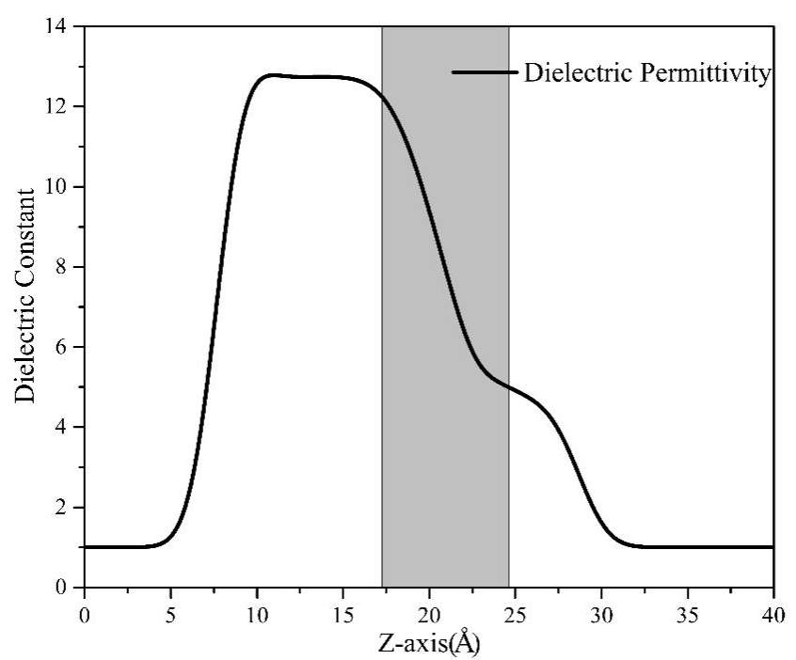
Figure S1. Dielectric constant profile along the z direction across the a-SiO₂/Si interface. The shaded region denotes the interfacial suboxide layer.
S2. Defect Charge Distribution
When solving the electrostatic potential of the model, it is necessary to consider its spatial charge distribution, and here a Gaussian charge distribution is adopted. In addition, solving the Poisson equation under periodic boundary conditions (PBC) also requires a charge background with opposite signs, so that the net charge in the supercell is zero. The calculation formula for the charge distribution is as follows[2–4],
$ρ_{periodic}\left(r\right)=\frac{qQ_{0}}{σ^{3}{\left(2π\right)}^{3/2}}e^{−r^{2}/(2σ^{2})}−\frac{qQ_{0}}{abc}$ (5)
Where $q$ represents the charge state of the defect, the charge $Q_{0}=1.6×{10}^{−19}C$, $σ$ is the standard deviation of the Gaussian distribution obtained from the defect charge density distribution, and $abc$ is the volume of the supercell.
Without adding a uniform background charge, the electrostatic energy of the model under isolated conditions can also be obtained by proportionally enlarging the supercell using grounded boundary conditions. The formula for its spatial charge density distribution is,
$ρ_{periodic}\left(r\right)=\frac{qQ_{0}}{σ^{3}{\left(2π\right)}^{3/2}}e^{−r^{2}/(2σ^{2})}$ (6)
S3. Structure Parameters
S3.1 In the Positively Charged State
Under positive charge conditions, all ten defect sites evolve into hydrogen-bridge configurations after full structural relaxation, which can be further classified into symmetric and asymmetric positive hydrogen bridges. Among them, seven configurations form stable positive hydrogen bridges Si-H-Si(HB⁺). For these seven cases, the corresponding bond-length and bond-angle distributions were analyzed, and the detailed numerical values are summarized in Table S2.
Table S2. Bond lengths and angles for the Si-H-Si(HB⁺) configuration
Sites | Si(1)-H($Å$) | Si(2)-H($Å$) | Average bond length($Å$) | $∠$Si(1)-H-Si(2) ($°$)
5 | 1.648 | 1.710 | 1.678 | 136.092
11 | 1.640 | 1.627 | 1.634 | 155.286
19 | 1.662 | 1.726 | 1.694 | 176.774
24 | 1.661 | 1.610 | 1.636 | 150.404
31 | 1.593 | 1.614 | 1.602 | 145.87
44 | 1.662 | 1.634 | 1.648 | 135.753
62 | 1.585 | 1.637 | 1.611 | 137.119
For the remaining three asymmetric positive hydrogen-bridge configurations, the corresponding bond lengths and bond angles were calculated and analyzed. In addition, the average bond angles of the three-coordinated silicon atoms, together with the tetrahedral structural parameters, are reported to characterize the local coordination environment. The detailed values are summarized in Table S3. The tetrahedral parameter ($t$) can be calculated using the following formula,
$t=\frac{360−\sum_{i=1}^{i=3}{α_{i}}}{31.5}$ (7)
Where $α_{i}$ represents the three bond angles formed with the three-coordinated silicon atom Si(1). For ideal ${sp}^{3}$ hybridization, the value of t is equal to 1. For ideal ${sp}^{2}$ hybridization, the value of $t$ is equal to 0.
Table S3. Structural parameters of a-HB⁺ at different defect sites, including the Si(1)-H distance, average bond angle of the threefold-coordinated Si atom, Si(2)-H bond length, and the tetrahedral distortion parameter $t$.
Sites | Si(1)--H($Å$) | Si(2)-$H$($Å$) | Average bond angle of Si(2) ($°$) | $$t$$
22 | 1.800 | 1.619 | 116.030 | 0.38
32 | 1.810 | 1.656 | 105.398 | 1.39
68 | 1.812 | 1.584 | 116.250 | 0.36
S3.2 In the neutral State
In the neutral state, eight out of the ten defect configurations relax into the Si–H···Si structure, while the remaining two form the Si–H–Si configuration. For the Si–H–Si(HB⁰) structures, the corresponding bond lengths and bond angles were calculated and analyzed, with the detailed values summarized in Table S4.
Table S4. Bond lengths of Si(1)-H and Si(2)-H, average bond length, and the size of the bond angle ∠Si(1)-H-Si(2) for the silicon-hydrogen bonds formed with the hydrogen atom.
Sites | Si(1)-H($Å$) | Si(2)-H($Å$) | Average bond length($Å$) | $∠$Si(1)-H-Si(2) ($°$)
11 | 1.641 | 1.621 | 1.631 | 154.553
31 | 1.600 | 1.610 | 1.605 | 145.629
For the eight Si–H···Si defect configurations, the Si–H bond lengths were calculated. In addition, the average bond angles of the dangling-bond silicon atoms and the tetrahedral distortion parameter t were evaluated. The corresponding numerical values are listed in Table S5.
Table S5. Bond lengths of Si(1)-H, distances between the three-coordinated silicon atom Si(2) and the hydrogen atom, average bond angles on the three-coordinated silicon atom, and tetrahedral parameters (t) for different defect sites.
Sites | Si(1)-H($Å$) | Si(2)$···H$($Å$) | Average bond angle of Si(2) ($°$) |  | t
5 | 1.492 | 2.745 | 107.451 | 1.2
19 | 1.616 | 1.849 | 116.247 | 0.36
22 | 1.477 | 3.30 | 112.769 | 0.69
24 | 1.526 | 2.162 | 110.711 | 0.88
32 | 1.536 | 2.186 | 107.692 | 1.17
44 | 1.48 | 2.59 | 107.565 | 1.18
62 | 1.488 | 2.325 | 107.273 | 1.21
68 | 1.494 | 2.184 | 112.323 | 0.73
S3.3 In the Negatively Charged State
In the negatively charged systems, the relaxed structures of the ten defect sites can be classified into three distinct configurations: Si–H–Si, Si–H···Si, and fivefold-coordinated silicon defect structures. Among them, two cases relax into the Si–H–Si configuration, and the corresponding structural parameters are summarized in Table S6.
Table S6. Bond lengths and angles for the Si-H-Si configuration in the negatively charged state.
Sites | Si(1)-H($Å$) | Si(2)-H($Å$) | Average bond length($Å$) | $∠$Si(1)-H-Si(2) ($°$)
11 | 1.622 | 1.636 | 1.629 | 152.281
31 | 1.556 | 1.756 | 1.656 | 149.580
Five cases form the Si–H···Si configuration, with their structural parameters listed in Table S7.
Table S7. Bond lengths of Si(1)-H, distances between the three-coordinated silicon atom Si(2) and the hydrogen atom, average bond angles on the three-coordinated silicon atom, and tetrahedral parameters (t) for different defect sites.
Sites | Si(1)-H($Å$) | Si(2) ···$H$($Å$) | Average bond angle of Si(2) ($°$) | t
19 | 1.609 | 1.873 | 116.616 | 0.32
32 | 1.495 | 2.731 | 107.9 | 1.15
35 | 1.476 | 2.641 | 118.108 | 0.18
44 | 1.479 | 2.577 | 101.808 | 1.73
68 | 1.492 | 2.208 | 112.416 | 0.72
The remaining three cases evolve into fivefold-coordinated silicon defect structures. For these configurations, the bond lengths between the hydrogen atom and the bonded silicon atom, as well as the Si-Si bond lengths between the two silicon atoms at the defect center, were calculated in Table S8.
Table S8. Bond lengths of Si(1)-Si(2) and Si-H for the five-coordinated silicon atom defect configuration.
Sites | Si(1)-Si(2) ($Å$) | Si-H($Å$)
5 | 2.429 | 1.497
24 | 2.399 | 1.63
62 | 2.455 | 1.507
References
1. F. Giustino, Phys. Rev. B 71, (2005).
2. P. Li, Z. Chen, P. Yao, F. Zhang, J. Wang, Y. Song, and X. Zuo, Appl. Surf. Sci. 483, 231 (2019).
3. P. Yao, Y. Song, and X. Zuo, J. Phys. Chem. C 125, 15044 (2021).
4. H.-P. Komsa and A. Pasquarello, Phys. Rev. Lett. 110, 095505 (2013).

E-mail: yangliuphy@gmail.com (corresponding author)
E-mail: xzuo@nankai.edu.cn (corresponding author)

