Supplementary Table 1 STROBE Statement—Checklist of items that should be included in reports of cohort studies

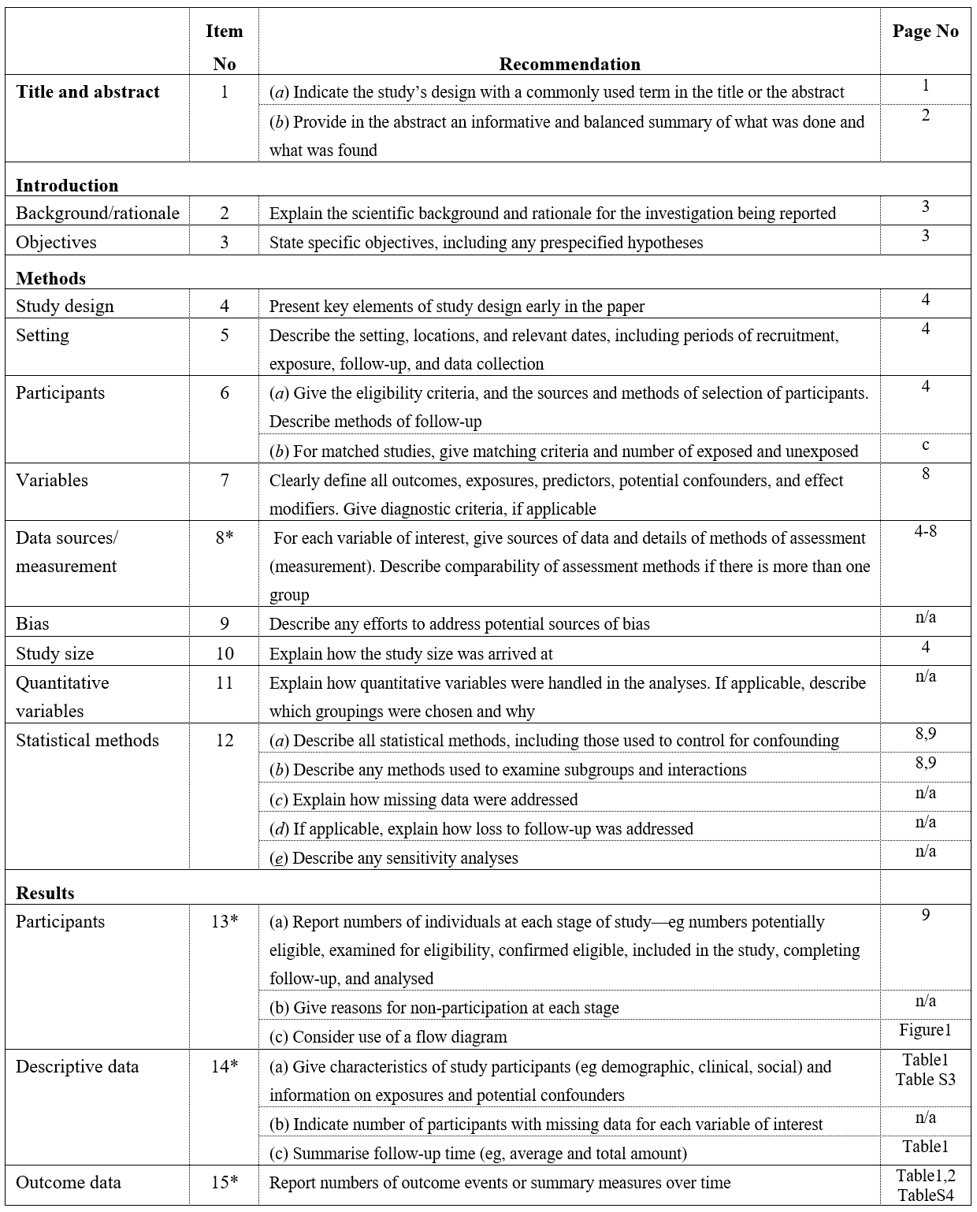

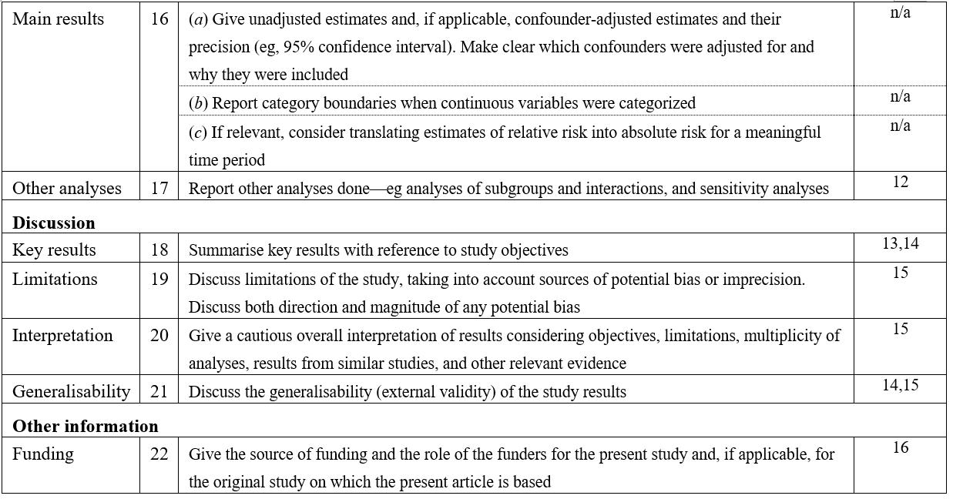

*Give information separately for exposed and unexposed groups.

Note: An Explanation and Elaboration article discusses each checklist item and gives methodological background and published examples of transparent reporting. The STROBE checklist is best used in conjunction with this article (freely available on the Web sites of PLoS Medicine at http://www.plosmedicine.org/, Annals of Internal Medicine at http://www.annals.org/, and Epidemiology at http://www.epidem.com/). Information on the STROBE Initiative is available at http://www.strobe-statement.org.

Supplementary Table 2 Primer sequences used in the studies
miRNA | Primer Sequence  Forward (5` - Oligo Seq - 3`)  Reverse (5` - Oligo Seq - 3`)
has-miR-192-5p | CAGCTGACCTATGAATTGACA
 | CCAGTTTTTTTTTTTTTTTGGCTGT
has-miR-155-5p | CGCAGTTAATGCTAATCGTGATAG
 | GGTCCAGTTTTTTTTTTTTTTTAACC
has-miR-93-5p | GCAAAGTGCTGTTCGTG
 | GTCCAGTTTTTTTTTTTTTTTCTACCT
has-miR-221-5p | GCAGACCTGGCATACAATG
 | GGTCCAGTTTTTTTTTTTTTTTAAATCTAC
has-miR-222-5p | GCTCAGTAGCCAGTGTAGA
 | GTCCAGTTTTTTTTTTTTTTTAGGATCT
has-miR-184 | CAGTGGACGGAGAACTGA
 | GTCCAGTTTTTTTTTTTTTTTACCCT
has-miR-148b-3p | AGTCAGTGCATCACAGAAC
 | GGTCCAGTTTTTTTTTTTTTTTACAAAG
has-miR-193b-3p | GAACTGGCCCTCAAAGTC
 | GGTCCAGTTTTTTTTTTTTTTTAGC
has-miR-195-5p | CGCAGTAGCAGCACAGA
 | TCCAGTTTTTTTTTTTTTTTGCCA
has-miR-206 | GCAGTGGAATGTAAGGAAGTGT
 | TCCAGTTTTTTTTTTTTTTTCCACA
has-miR-766-3p | ACTCCAGCCCCACAG
 | TCCAGTTTTTTTTTTTTTTTGCTGA
has-miR-224-5p | AAGTCACTAGTGGTTCCGT
 | GTCCAGTTTTTTTTTTTTTTTCTAAACG
has-miR-1247-3p | CGGGAACGTCGAGACT
 | GGTCCAGTTTTTTTTTTTTTTTGCT
has-miR-199 | CTGAGTCCCAGTGTTCAGACT
 | GTGCAGGGGTCCGAGGT
has-miR-222-3p | CAGAGCTACATCTGGCTACT
 | CCAGTTTTTTTTTTTTTTTACCCAGT
hsa-miR-199a-5p | CCCAGTGTTCAGACTACCTG
 | GTCCAGTTTTTTTTTTTTTTTGAACAG
hsa-miR-199a-3p | CAGACAGTAGTCTGCACATTG
 | GTCCAGTTTTTTTTTTTTTTTAACCAA
has-miR-122-3p | GCAGAACGCCATTATCACAC
 | CAGGTCCAGTTTTTTTTTTTTTTTATTTAG
has-miR-122-5p | GCAGTGGAGTGTGACAATG
 | CCAGTTTTTTTTTTTTTTTCAAACACC
U6 | GCTTCGGCAGCACATATACTAAAAT
 | CGCTTCACGAATTTGCGTGTCAT

Supplementary Table 3 Baseline of living liver donors
Variables | Value
Sex, female : male | 3 (30.0) : 7 (70.0)
Age, year | 38.0 (21.0-53.0)
Underlying liver disease | None
BMI (kg/m²) | 22.4 (19.0-25.7)
Platelet count (×10³/µL) | 239.0 (184.0-332.0)
Prothrombin time (%) | 99.6 (80.9-119.0)
Creatinine (mg/dL) | 0.8 (0.7-1.1)
Total bilirubin (mg/dL) | 0.5 (0.2-1.4)
Aspartate aminotransferase (U/L) | 17.0 (14.0-24.0)
Alanine aminotransferase (U/L) | 13.5 (7.0-28.0)
Data presented as number (percent) or median (range)

Supplementary Table 4. Comparison of circulating cell-free and exosomal microRNA expression between hepatocellular carcinoma patients and living liver donors
Timepoint | miRNA | Circulating cell free miRNA |  |  |  | Circulating exosomal miRNA
 |  | Relative expression |  | Relative Ratio | P | Relative expression |  | Relative Ratio | P
 |  | HCC | Donor | Relative Ratio |  | HCC | Donor | Relative Ratio
POD7 | mir122-3p | 0.258 | 0.150 | 1.717 | 0.36 | 0.389 | 0.053 | 7.272 | 0.19
 | mir122-5p | 0.289 | 0.343 | 0.844 | 0.13 | 0.536 | 0.096 | 5.563 | >0.99
 | mir1247-3p | 0.463 | 0.261 | 1.775 | 0.73 | - | - | - | -
 | mir148b | 0.701 | 0.277 | 2.527 | 0.55 | 0.207 | 0.365 | 0.567 | 0.02
 | mir155 | 0.447 | 0.282 | 1.589 | 0.32 | 0.201 | - | - | -
 | mir184 | 4.086 | 0.035 | 118.608 | <0.01 | 0.249 | 0.107 | 2.328 | 0.04
 | mir192 | 0.491 | 0.275 | 1.785 | 0.33 | 1.000 | 0.214 | 4.666 | <0.01
 | mir193b | 0.457 | 0.361 | 1.266 | 0.74 | 0.214 | 0.131 | 1.629 | 0.17
 | mir195 | 0.395 | 0.075 | 5.258 | 0.72 | 0.159 | 0.090 | 1.763 | 0.16
 | mir199a-3p | 1.140 | 0.262 | 4.355 | 0.54 | 0.201 | 0.107 | 1.883 | 0.90
 | mir199a-5p | 1.779 | 0.120 | 14.842 | 0.56 | 0.278 | 0.071 | 3.922 | 0.49
 | mir206 | 3.217 | 0.107 | 30.069 | 0.50 | 0.262 | 0.043 | 6.108 | 0.01
 | mir21-3p | 0.764 | 0.031 | 25.091 | 0.02 | 0.198 | 0.558 | 0.354 | 0.25
 | mir21-5p | 0.536 | 0.262 | 2.043 | 0.55 | 0.230 | 0.324 | 0.712 | 0.02
 | mir221 | 0.749 | 0.158 | 4.729 | 0.87 | 0.105 | - | - | -
 | mir222-3p | 0.706 | 0.168 | 4.195 | 0.56 | 0.191 | 0.179 | 1.065 | 0.08
 | mir223 | 0.883 | 0.163 | 5.407 | 0.96 | 0.306 | 0.228 | 1.341 | 0.99
 | mir224 | 1.040 | 0.010 | 105.751 | <0.01 | 0.917 | 0.087 | 10.512 | 0.02
 | mir766 | 2.072 | 0.081 | 25.736 | 0.01 | 0.566 | 0.225 | 2.513 | 0.20
 | mir93 | 0.501 | 0.313 | 1.600 | 0.33 | 0.165 | 0.334 | 0.494 | 0.03
Relative expression was calculated based on preoperative day values and is presented as mean values. Relative ratio was calculated as HCC patients/Donors. P-values were obtained using the Mann–Whitney U test.
HCC, hepatocellular carcinoma; POD, postoperative day.

Supplementary Table 5 Pathway enrichment analysis of the sixteen hub genes in the most significant module
Category | GO ID | Term | P | Count
BP | GO:0000082 | G1/S transition of mitotic cell cycle | 3.84E-07 | 5
BP | GO:0045944 | Positive regulation of transcription by RNA polymerase II | 1.41E-05 | 8
BP | GO:0008284 | Positive regulation of cell population proliferation | 2.97E-05 | 6
BP | GO:0000122 | Negative regulation of transcription by RNA polymerase II | 5.66E-04 | 6
BP | GO:0006338 | Chromatin remodeling | 1.53E-03 | 5
BP | GO:0007165 | Signal transduction | 2.30E-03 | 6
CC | GO:0000785 | Chromatin | 8.44E-05 | 7
CC | GO:0005654 | Nucleoplasm | 1.01E-04 | 11
CC | GO:0005829 | Cytosol | 1.76E-03 | 11
CC | GO:0005737 | Cytoplasm | 2.66E-03 | 11
CC | GO:0005634 | Nucleus | 0.015 | 10
CC | GO:0005730 | Nucleolus | 0.016 | 5
MF | GO:0042802 | Identical protein binding | 1.84E-05 | 9
MF | GO:0005515 | protein binding | 5.99E-03 | 16
MF | GO:0003677 | DNA binding | 0.025 | 5
MF | GO:0005524 | ATP binding | 0.028 | 5
KEGG | hsa01522 | Endocrine resistance | 7.33E-11 | 8
KEGG | hsa05200 | Pathways in cancer | 6.64E-10 | 11
KEGG | hsa04151 | PI3K-Akt signaling pathway | 6.69E-10 | 10
KEGG | hsa05224 | Breast cancer | 1.27E-09 | 8
KEGG | hsa05225 | Hepatocellular carcinoma | 3.36E-09 | 8
KEGG | hsa05218 | Melanoma | 7.52E-08 | 6
KEGG | hsa05206 | MicroRNAs in cancer | 2.25E-07 | 8
KEGG | hsa05205 | Proteoglycans in cancer | 4.44E-07 | 7
KEGG | hsa05207 | Chemical carcinogenesis - receptor activation | 6.05E-07 | 7
KEGG | hsa04919 | Thyroid hormone signaling pathway | 9.93E-07 | 6
KEGG | hsa05226 | Gastric cancer | 2.77E-06 | 6
KEGG | hsa04218 | Cellular senescence | 3.46E-06 | 6
GO, gene ontology; BP, biological process; CC, cellular component; MF, molecular function; KEGG, Kyoto Encyclopedia of Genes and Genome.

Supplementary Figure 1. Heatmap of differential expression of circulating cell-free miRNA (A) and exosomal miRNAs (B) between hepatocellular carcinoma patients and living liver donor. Fold change indicates the postoperative-to-preoperative expression ratio within each group. Relative ratio compares expression levels between HCC patients and donors at each timepoint, while Δ relative ratio reflects how this difference changes from preoperative to postoperative states.
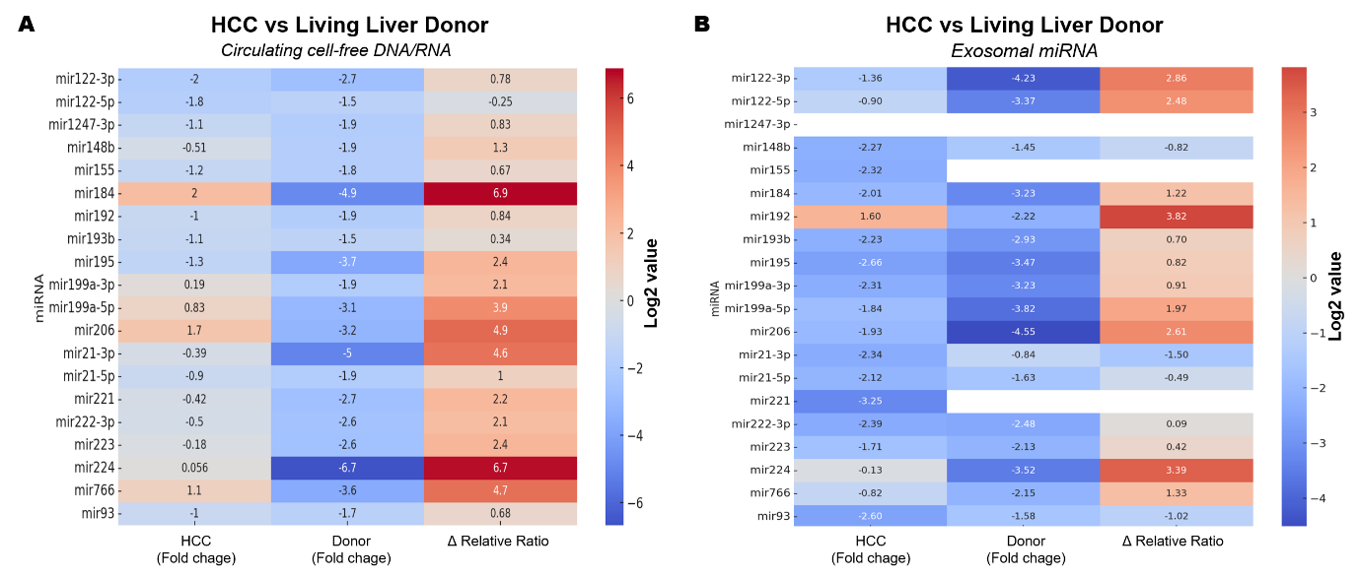

Supplementary Figure 2. Full-length original membrane of ALIX (96 kDa) detected in human plasma-derived exosomes.
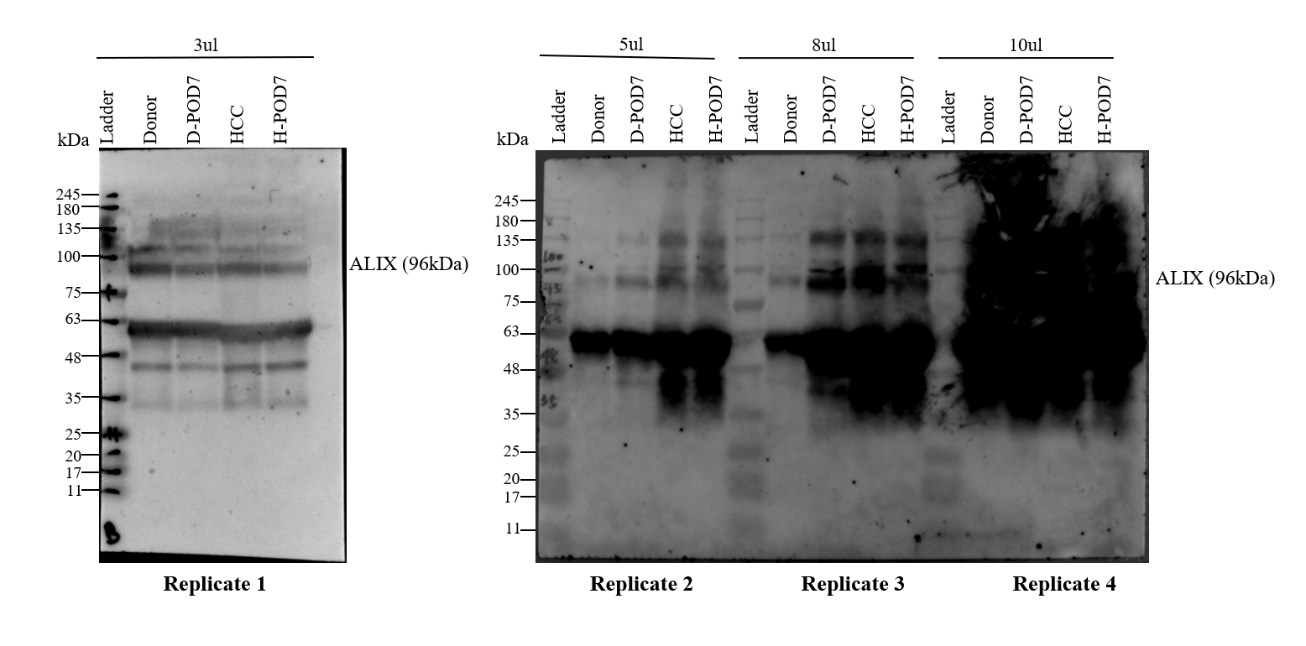

Supplementary Figure 3 Kaplan-Meier analysis of recurrence-free survival relative to the expression of the 16 hub genes based on the TCGA database. (A–N) CCND1, CCND2, KLF4, NOTCH3, BDNF, MET, CDK4, BCL2, AKT2, IGF1R, MYC, HDAC4, ESR1, KRAS, SMARCB1, and AGO2, respectively.
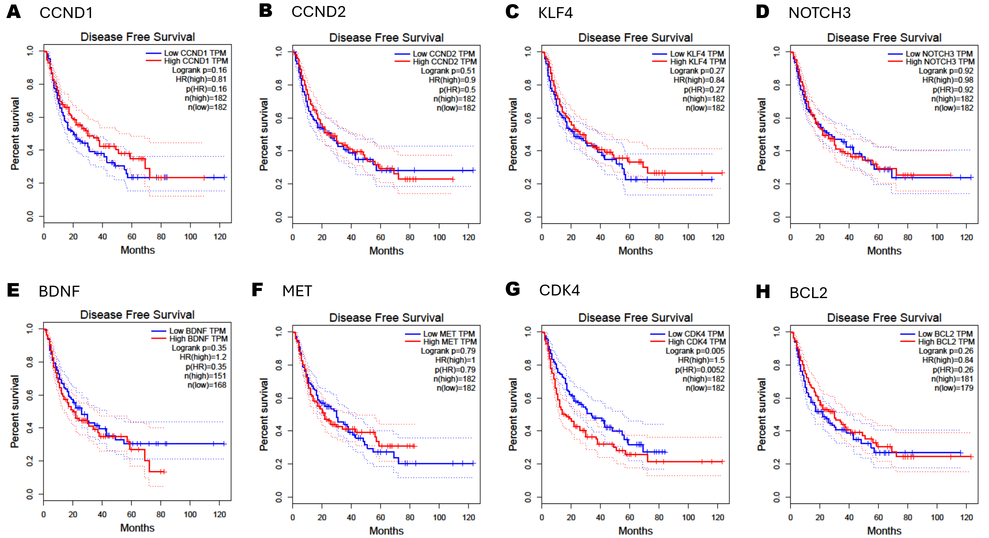
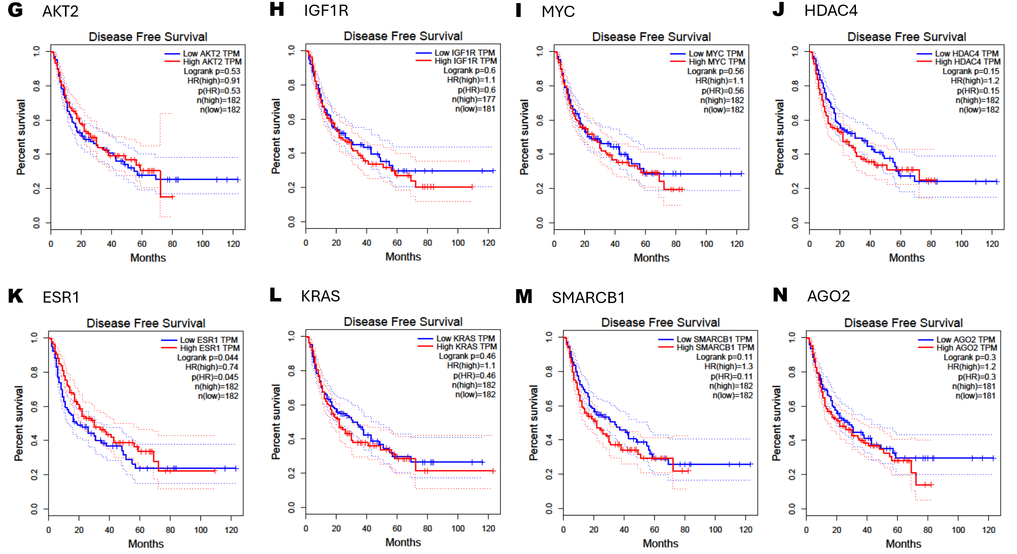

Supplementary Figure 4 Kaplan-Meier analysis of overall survival relative to the expression of the 16 hub genes based on the TCGA database. (A–N) CCND1, CCND2, KLF4, NOTCH3, BDNF, MET, CDK4, BCL2, AKT2, IGF1R, MYC, HDAC4, ESR1, KRAS, SMARCB1, and AGO2, respectively.
