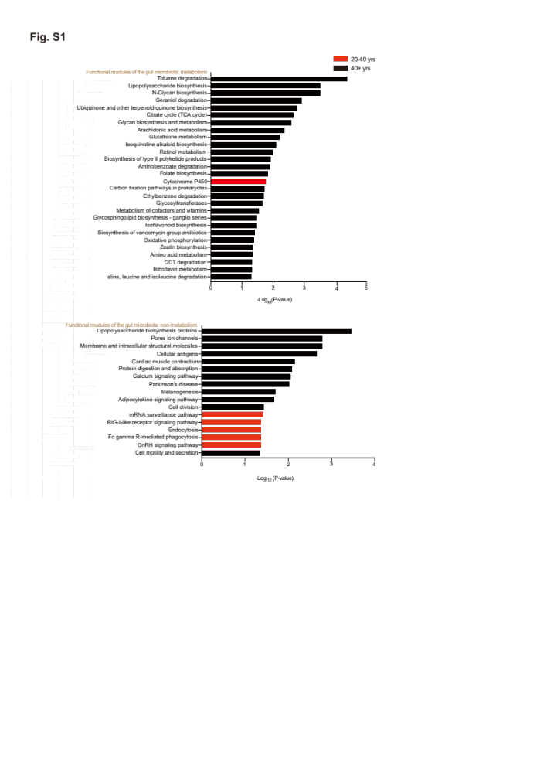
Supplementary Fig. 1 Pathways predicted active in different age groups according to KEGG pathway analysis. Red columns represented pathways active in 20-40 yrs group, black columns represented pathways more active in more than 40 yrs group. KEGG, Kyoto Encyclopedia of Genes and Genome. 20-40 yrs, n=50; more than 40 yrs, n=116.

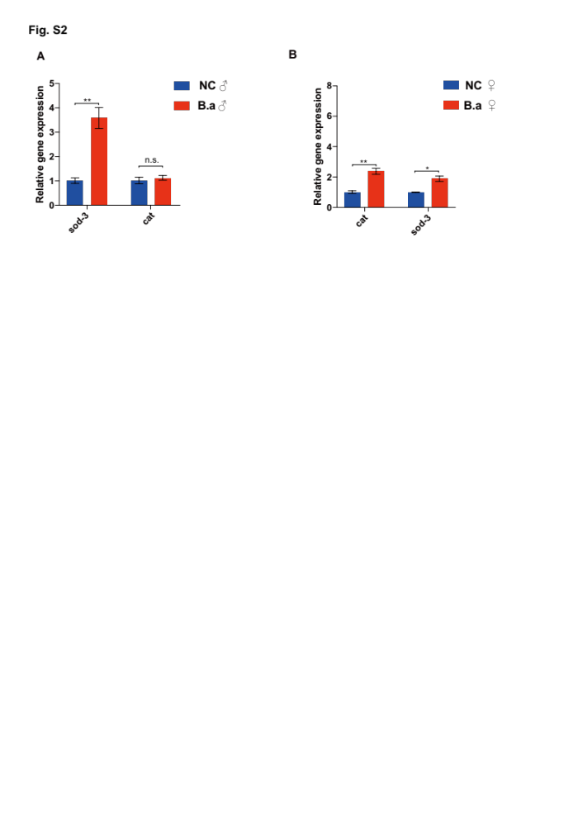
Supplementary Fig. 2 Relative mRNA expression of C. elegans corresponding homologous genes in Drosophila strain w¹¹¹⁸. (A and B) Relative mRNA expression of sod-3 and cat in male (A) and female (B) Drosophila supplemented with B. adolescentis (B.a) or 2.5% sucrose solution (NC) on day 40. Data were shown as mean$±$SEM and Student’s t-test was performed. *p<0.05; **p<0.01; n.s., not significant.

Supplementary Fig. 3 B. adolescentis supplement upregulated CAT expression in muscle tissues and downregulated p53 expression in brain tissues. (A) Relative expression of CAT in the muscle tissue of 7-month-old mice among three groups by quantitative real-time PCR. n=10, 6, 9, respectively. (B) Representative images of immunohistochemistry staining of p53 in the hippocampal DG region among three groups, scale bar, 200μm. The black boxes indicate the area magnified in the down panels, scale bar, 50μm. WT + PBS, wild-type C57BL/6 mice gavaged with PBS; G3 + PBS, Terc⁻/⁻ G3 mice gavaged with PBS; G3 + B.a, Terc⁻/⁻ G3 mice gavaged with B. adolescentis. Data were shown as mean$±$SEM and Student’s t-test was performed. *p<0.05; ***p<0.001.

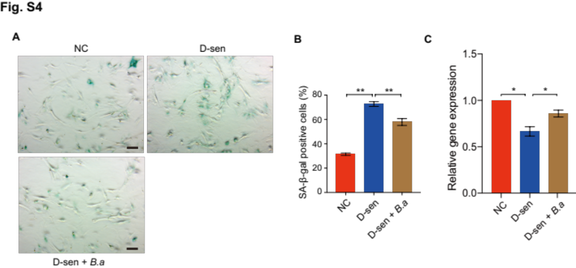
Supplementary Fig. 4 B. adolescentis supplement inhibited cellular senescence in DOX-induced senescent MEFs by regulating CAT. (A and B) Representative images of SA-β-gal staining of wild-type MEFs supplemented with PBS (NC), DOX-induced senescent MEFs supplemented with PBS (D-sen) or B. adolescentis (D-sen+B.a) (A) and corresponding percentage evaluation of SA-β-gal-positive cells (B). Scale bar, 100μm. (C) Quantitative real-time PCR of CAT expression in DOX-induced senescent MEFs supplemented with PBS (D-sen) or B. adolescentis (D-sen+B.a). Data were shown as mean$±$SEM and Student’s t-test was performed. *p<0.05; **p<0.01; DOX, doxorubicin.

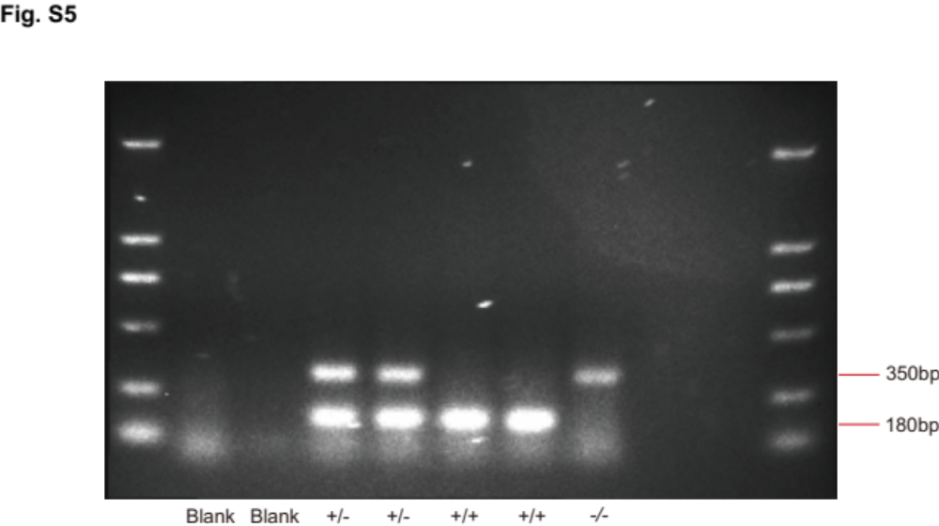

Supplementary Fig. 5 Mice genotype identification by agarose gel electrophoresis.

