Supplementary Information for:

Iceberg-Induced Collapse of Access Connectivity and a Dramatic Reduction in Chick Survival at the Coulman Island Emperor Penguin Colony
Jinku Park¹, Jong-U Kim², Youmin Kim^{2,3}, Yongsik Jeong¹, Younggen Oh^{2,4}, Jungyuem Kim², Jeong-Hoon Kim^{2*}
Corresponding Authors: Jeong-Hoon Kim (jhkim94@kopri.re.kr)

List of contentts for supplementary materials
- Supplementary Fig. S1 | Annual life-cycle stages of emperor penguins and timing of the 2025 iceberg grounding event.
- Supplementary Fig. S2 | Evidence of chick mortality at the Coulman Island emperor penguin colony.
- Supplementary Fig. S3 | Field photographs showing persistent obstruction at the grounded iceberg and evidence of prolonged stalling behaviour.
- Supplementary Fig. S4 | Schematic of Iceberg-Induced Obstruction and Altered Access Pathways at Coulman Island Emperor Penguin Colony.
- Supplementary Fig S5 | A satellite true-color image covering the region from the Nansen Ice Shelf to Coulman Island.
- Supplementary Fig. S6 | Helicopter-based mapping of Coulman Island emperor penguin sub-colonies (December 2025).
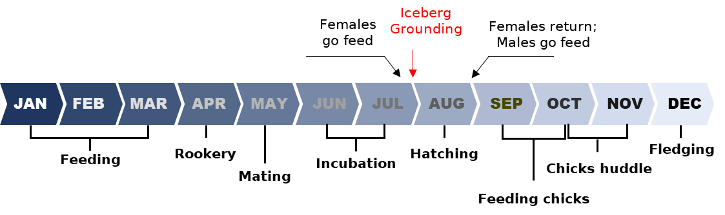
Supplementary Fig. S1 | Annual life-cycle stages of emperor penguins and timing of the 2025 iceberg grounding event. Schematic representation of the typical annual cycle of emperor penguins, courtship, incubation, chick-rearing, and moult, adapted from Trathan et al. (2020). The grounding of the iceberg along the Coulman Island access corridor occurred in late July 2025 (red arrow), coinciding with the early chick-rearing period when regular adult return for feeding is critical for chick survival.

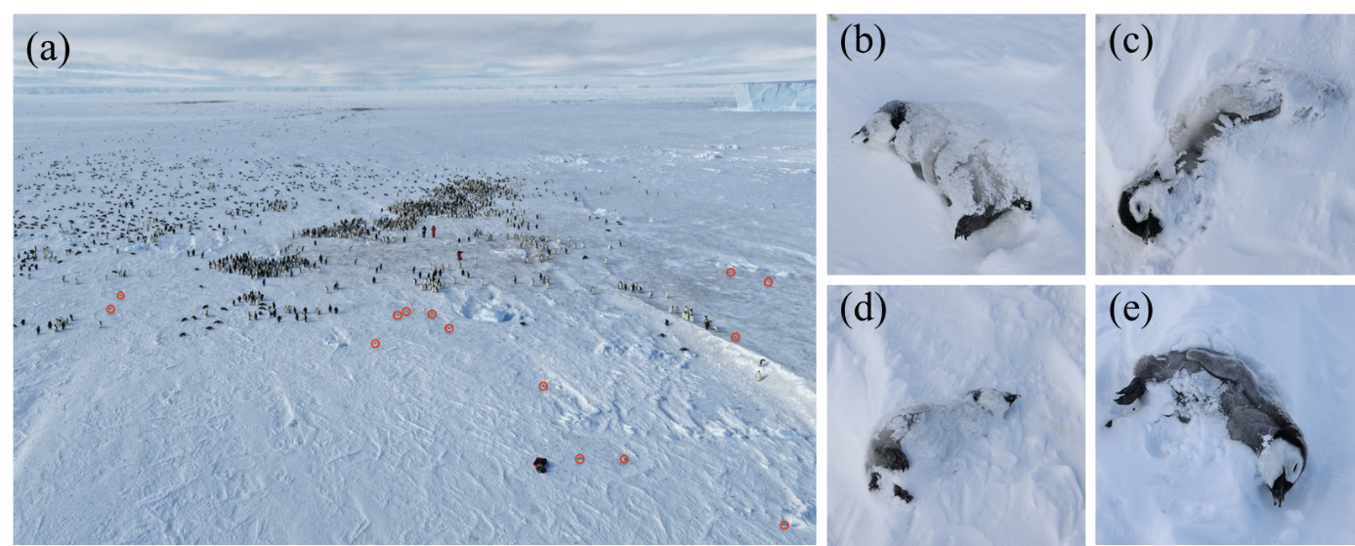
Supplementary Fig. S2 | Evidence of chick mortality at the Coulman Island emperor penguin colony. a Drone-based still image acquired on 13 November 2025 showing the breeding area; red circles indicate locations where chick carcasses were visually identified from the aerial perspective. b-e Close-up photographs of emperor penguin chick carcasses taken on the same date. Extensive snowfall had already buried many carcasses, allowing only a subset to be detected at the surface.

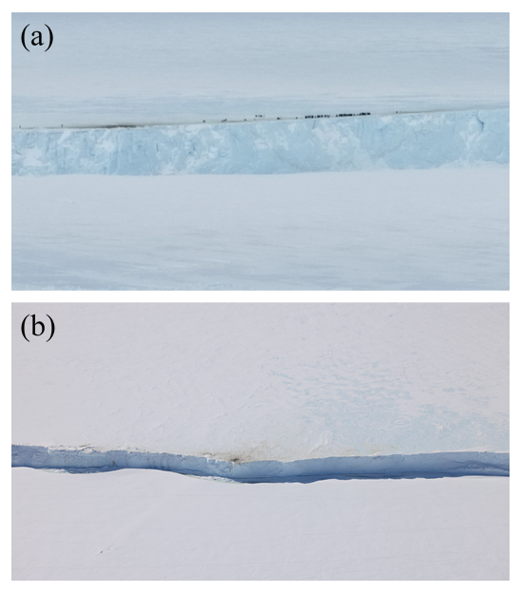
Supplementary Fig. S3 | Field photographs showing persistent obstruction at the grounded iceberg and evidence of prolonged stalling behaviour. a Aerial image from 13 November 2025 documenting adult emperor penguins halted along the southern cliff margin of the grounded iceberg. Individuals remained clustered at the edge without advancing toward the breeding site, indicating a behavioural standstill induced by the physical barrier. b Aerial image from 5 December 2025 showing the same boundary zone after the penguins had departed. The darkened surface layer along the ice margin represents accumulated guano deposited while adults remained stalled in this location for an extended period, reflecting prolonged immobility at the obstruction point.

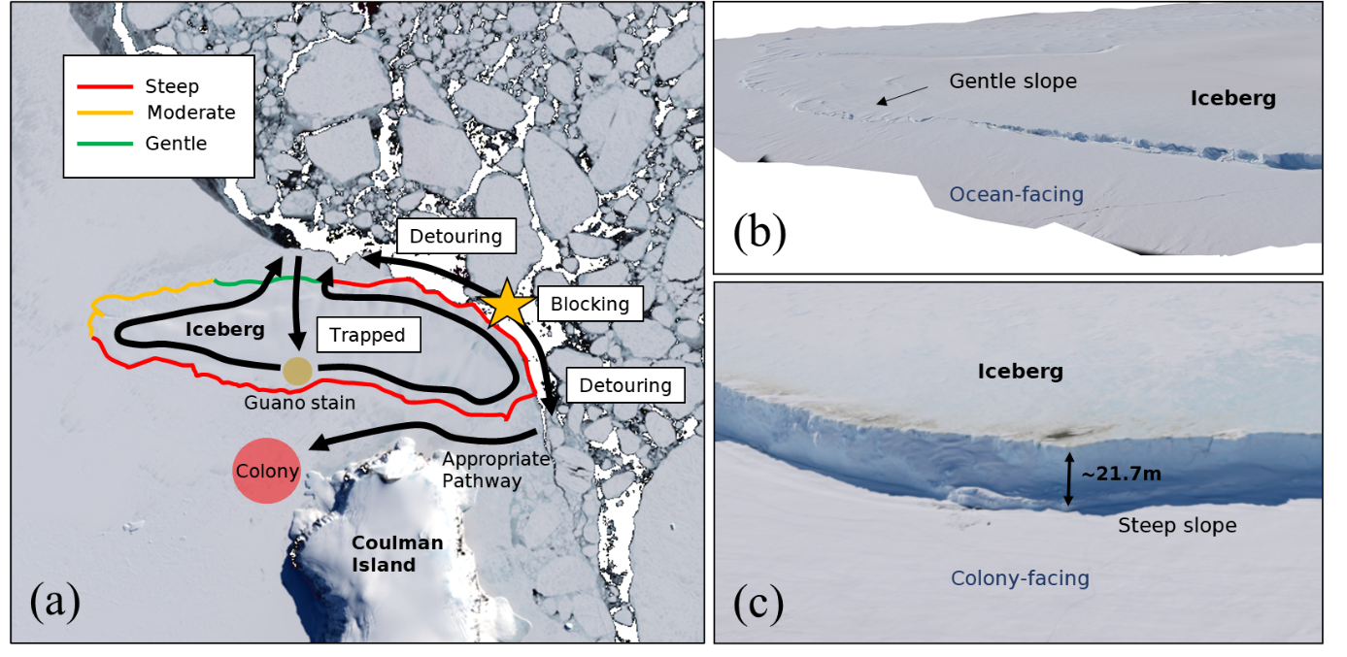
Supplementary Fig. S4 | Schematic of Iceberg-Induced Obstruction and Altered Access Pathways at Coulman Island Emperor Penguin Colony. a Conceptual illustration of how a grounded iceberg modified terrestrial access routes between the Coulman Island emperor penguin colony and adjacent sea-ice foraging areas. The iceberg’s perimeter is classified by slope category (steep, moderate, gentle), indicating variable traversability along its margins. A steep eastern flank (blocking zone) likely restricted direct access, forcing adults to detour around the iceberg along longer and potentially energetically costly routes. b Oblique view of the ocean-facing flank of the iceberg, characterised by a relatively gentle surface gradient. c Aerial photography of the colony-facing flank, showing a pronounced iceberg front (~21.7 m vertical relief), consistent with a steep barrier likely to impede direct passaged.

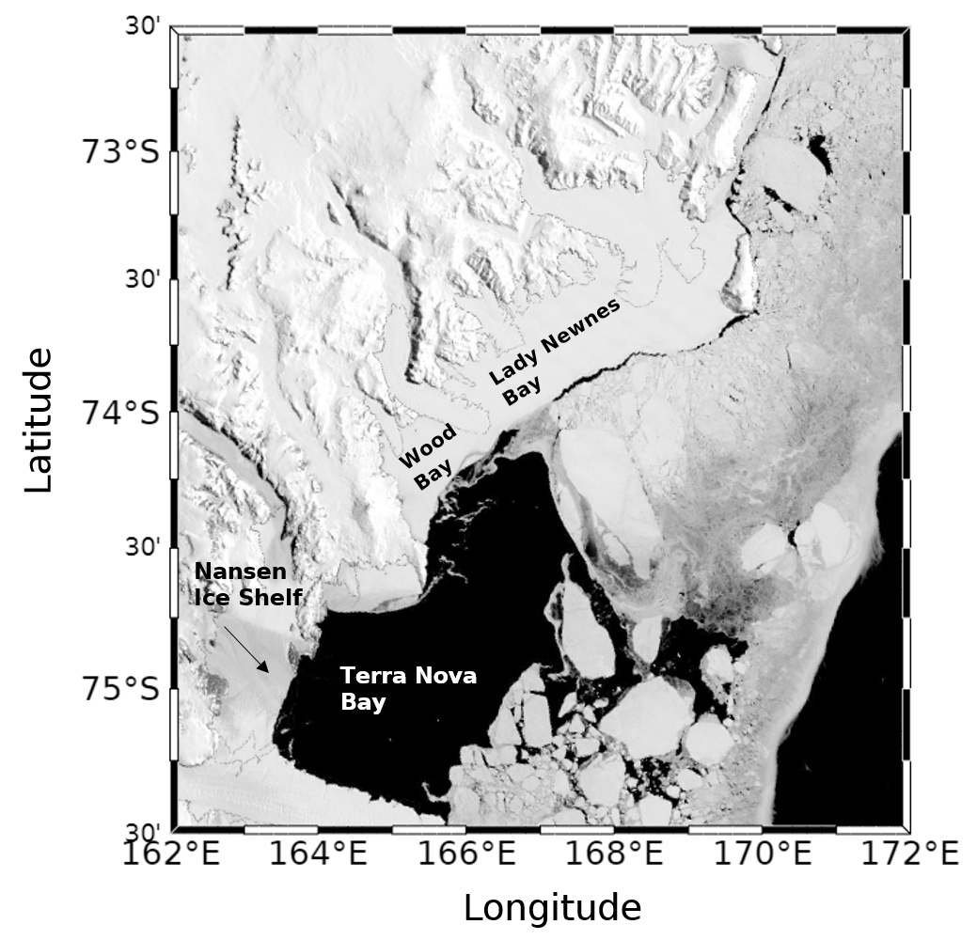
Supplementary Fig S5 | A satellite true-color image covering the region from the Nansen Ice Shelf to Coulman Island. MODIS Terra True Color image acquired on 4 December 2024, highlighting the well-defined fast-ice edge along the Victoria Land coast. This configuration likely constrained the 2025 iceberg drift by steering it along the consolidated fast-ice boundary and ultimately directing the berg northward toward Coulman Island.

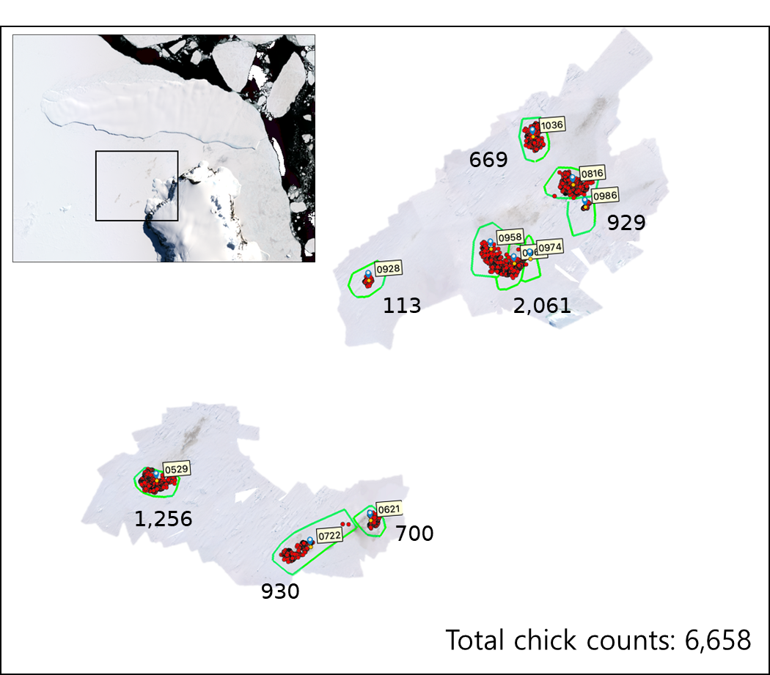
Supplementary Fig. S6 | Helicopter-based mapping of Coulman Island emperor penguin sub-colonies (December 2025). Landsat-8 OLI imagery acquired on 6 December 2025 provides spatial context for the breeding area and the adjacent grounded iceberg (inset). The outlined box indicates the area surveyed using helicopter-based aerial photography. Orthorectified helicopter-derived mosaics acquired on 4 December 2025 delineate discrete breeding sub-colonies (green polygons). Red dots represent individually counted chicks derived from high-resolution photographic interpretation, and numbers indicate chick counts within each sub-colony. The total number of chicks recorded across all mapped sub-colonies was 6,658.

