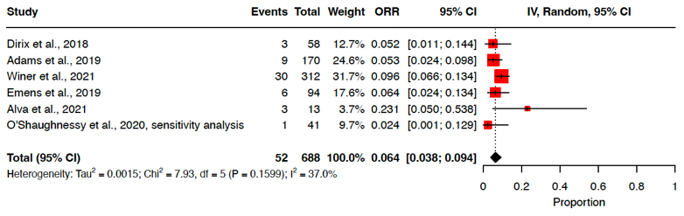
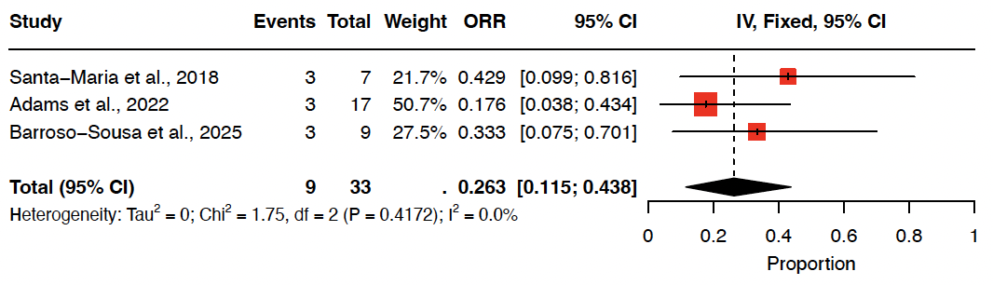
Sensitivity Analysis
A
B
ORR, Single ICI
ORR, Dual ICI

Figure S1. Forest plots of ORR of (A) single and (B) dual ICI studies, sensitivity analysis. Among single ICI studies, ORR was 6.4%, whereas ORR among dual ICI studies was 26.3%. The sensitivity analysis excluded single-agent or dual ICI studies that used HDAC inhibitors.

6-month PFS, Dual ICI
6-month PFS, Single ICI
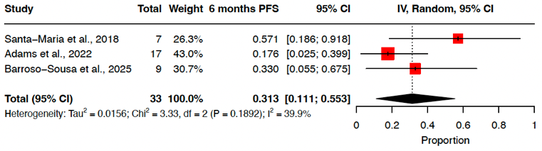
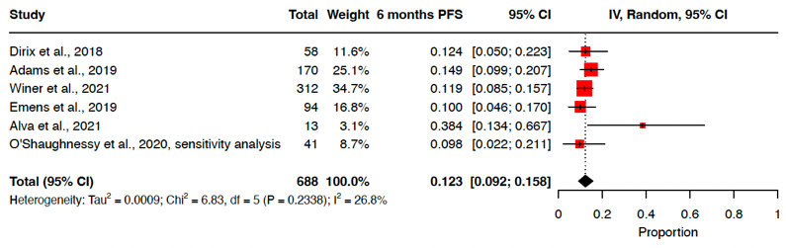
B
A

12-month PFS, Dual ICI
12-month PFS, Single ICI
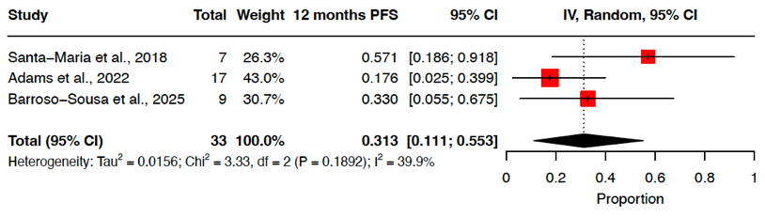
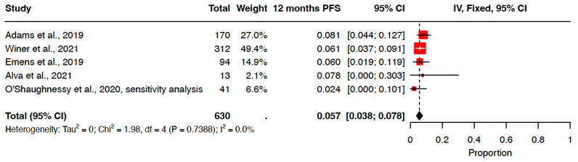
D
C

Figure S2. Forest plot of 6-month PFS of (A) single and (B) combination ICI studies and 12-month PFS of (C) single and (D) dual ICI studies, sensitivity analysis. Estimated PFS rate at 6 months was 12.3% and 31.3% for single and dual ICI studies, respectively. Estimated PFS rate at 12 months was 5.7% and 31.3%, for single and dual ICI studies, respectively. The sensitivity analysis excluded single-agent or dual ICI studies that used HDAC inhibitors.

