Meta-analysis Algorithm

Model Selection
Model | Assumption | When to use
Fixed-Effect | Single true effect, all variation due to chance | Homogeneous studies, low heterogeneity (measured by I², typically less than 25%)
Random-Effects | True effect varies between studies, some variation due to real differences between studies | Diverse studies, moderate/high heterogeneity

Pooled Analysis
Forest plots were used to visualize effect size of individual results of studies and overall pooled estimates.

Sensitivity Analysis
Including studies that did not use Entinostat in their treatment plan.

Publication Bias
We used funnel plots to assess the possibility of publication bias. Our results show that no publication bias influences the results of the meta-analysis. Details are as follows.

- Single ICI, pooled analysis
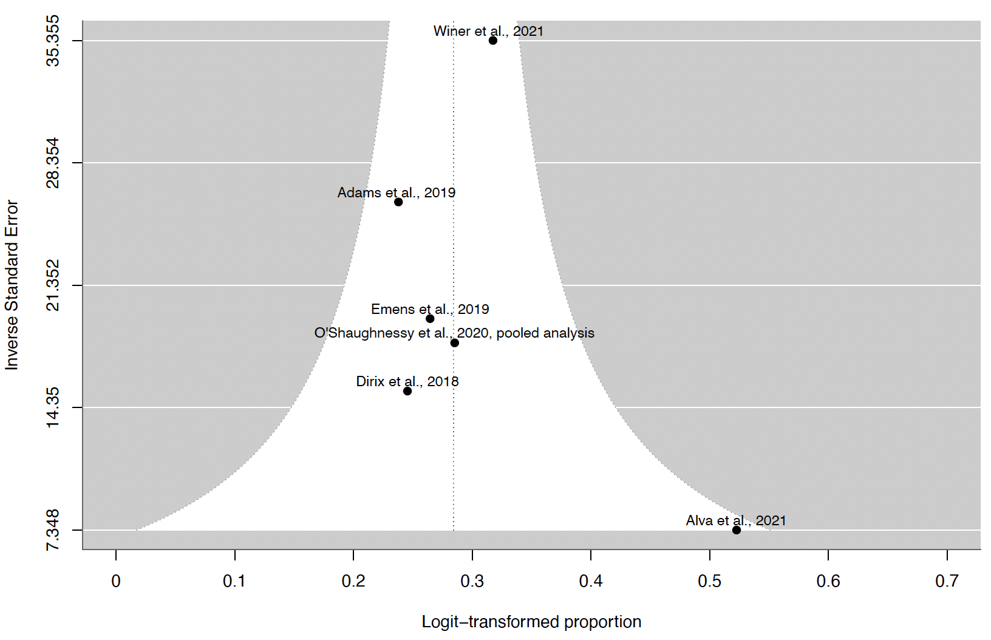

- Single ICI, sensitivity analysis
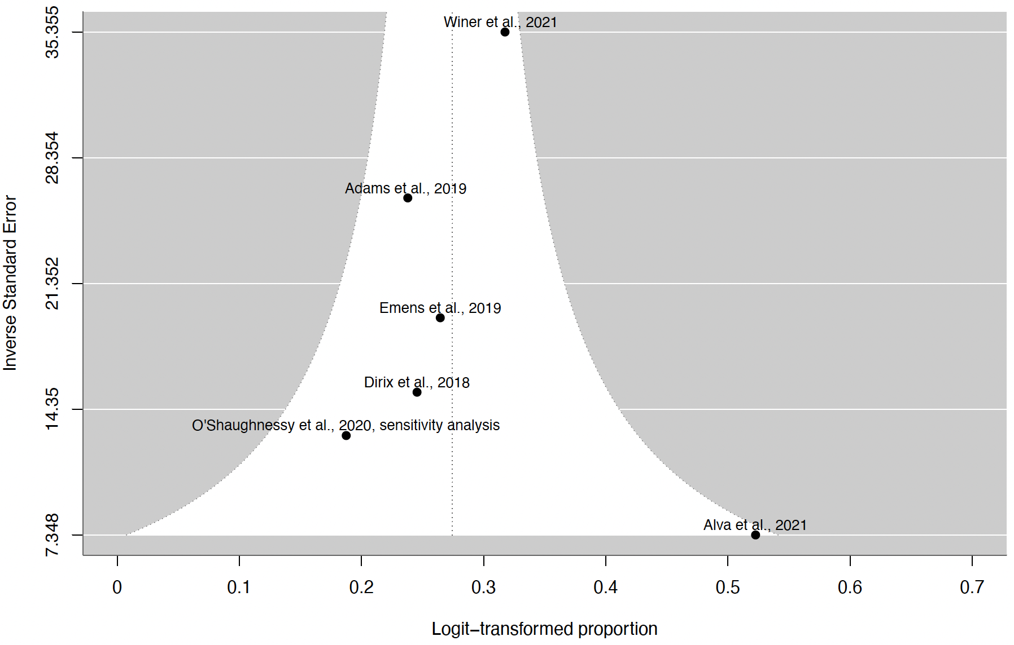

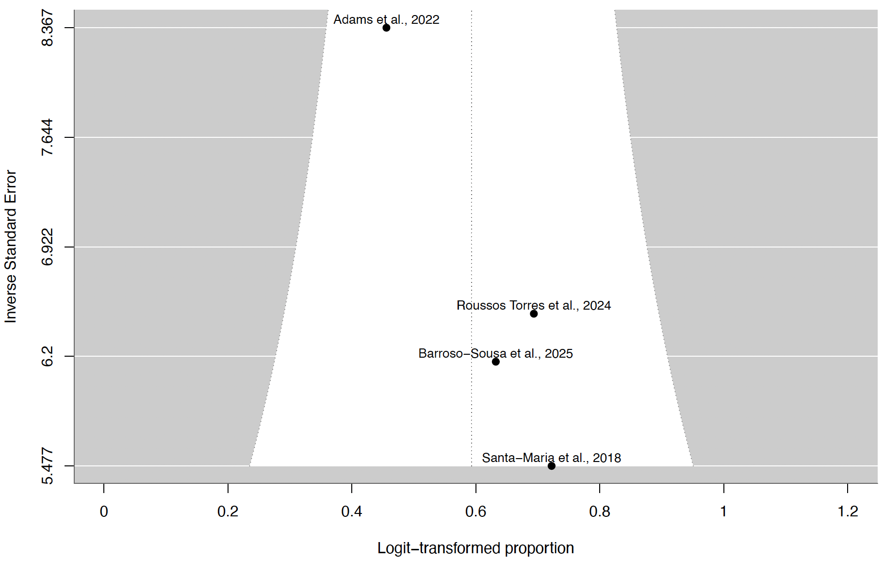
- Dual ICI, pooled analysis

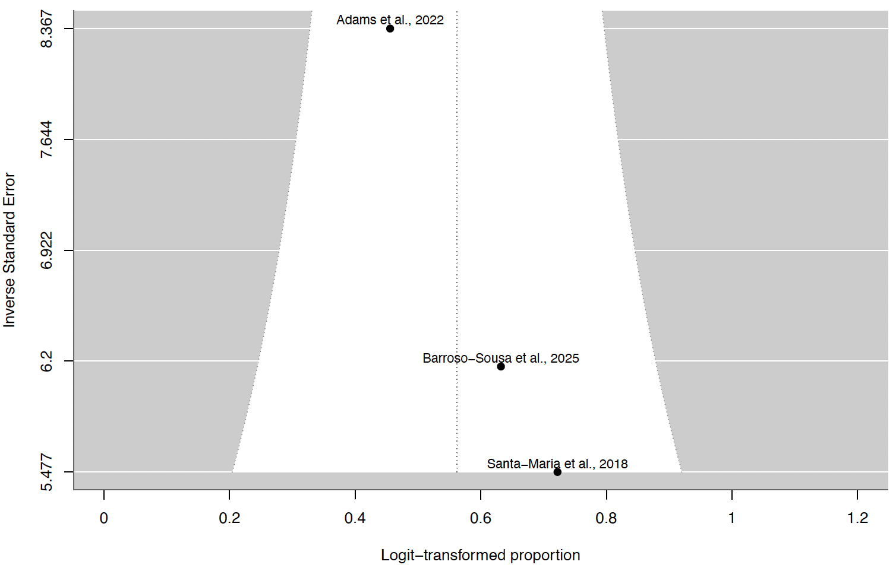
- Dual ICI, sensitivity analysis

Discussion
1. A network meta-analysis was not possible due to 8/10 included studies being single-arm trials and not linked through a common comparator.
2. For the two randomized controlled trials included, no additional meta-analysis was performed for effect size between intervention group and control group, as the two studies used different intervention agents.
3. For PFS and OS, standard error of median month is estimated using the following formula:
