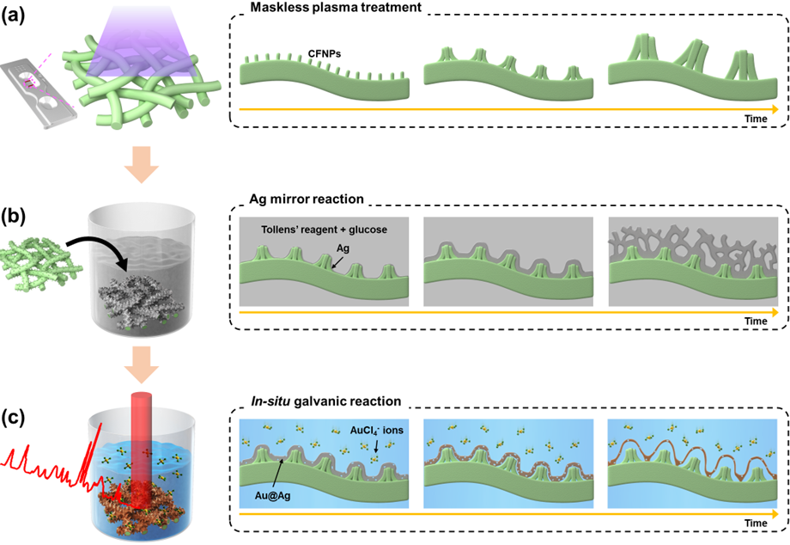
Scheme 1. Schematic of the procedure followed to fabricate Au@Ag/CFNPs through maskless plasma treatment and chemical syntheses.

