Au@Ag alloy containing interior hotspots galvanically prepared on an in-vitro diagnostic material for ultrasensitive and rapid detection of plasticizers

Soo Hyun Leeª, ChaeWon Mun^{b}, Jun-Yeong Yang^{b}, Seunghun Lee^{b}, and Sung-Gyu Park^{a,b,*}

ªDivision of Genetic Analysis Materials Research, Korea Institute of Materials Science (KIMS), Changwon 51508, Republic of Korea
^{b}Advanced Bio and Healthcare Materials Research Division, Korea Institute of Materials Science (KIMS), Changwon 51508, Republic of Korea

*E-mail: sgpark@kims.re.kr

Keywords
Surface-enhanced Raman spectroscopy, Galvanic reaction, Interior hotspots, Plasticizers, Lateral flow assay

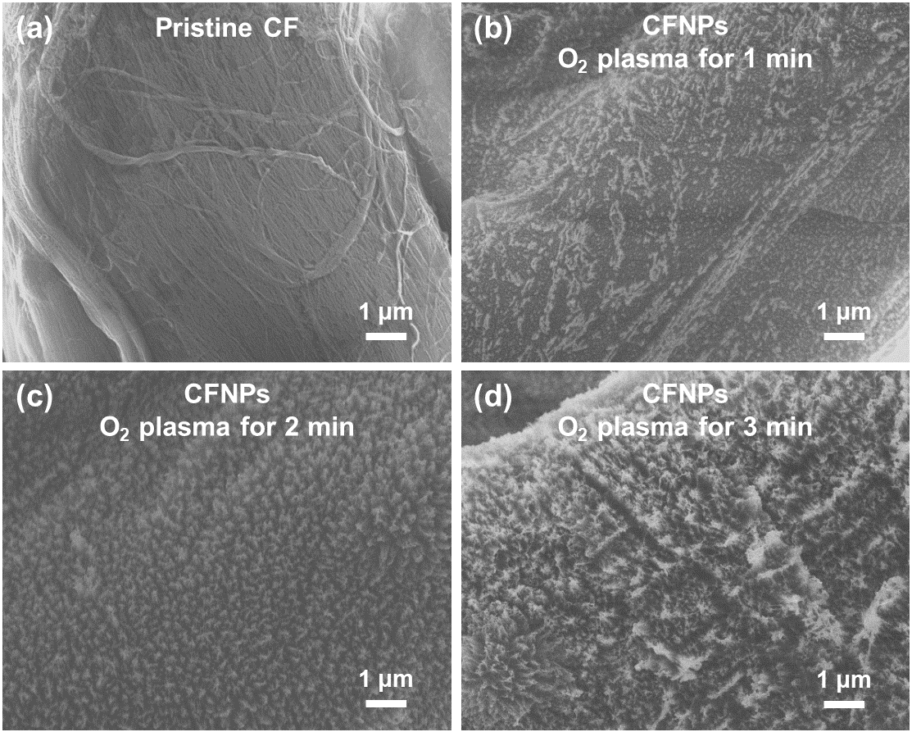
Fig. S1. Influence of plasma treatment time on CFNP morphology. SEM images of CFNPs subjected to O₂ plasma treatment for (a) 0, (b) 1, (c) 2, and (d) 3 min.

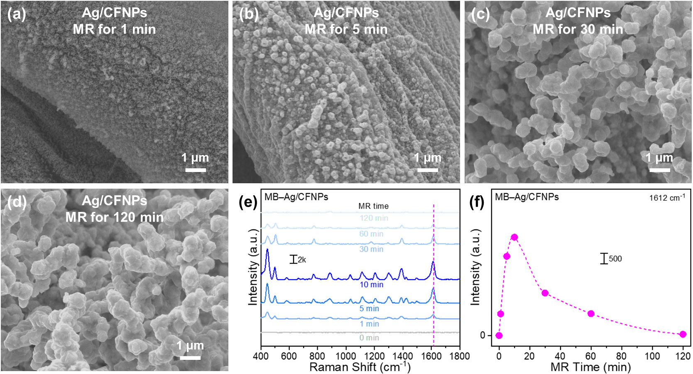
Fig. S2. Influence of Ag MR time on SERS activity. SEM images of Ag/CFNPs after MR for (a) 1, (b) 5, (c) 30, and (d) 120 min. (e) SERS spectra of MB−Ag/CFNPs for different MR times, and (f) the corresponding intensity profile at 1612 cm⁻¹.

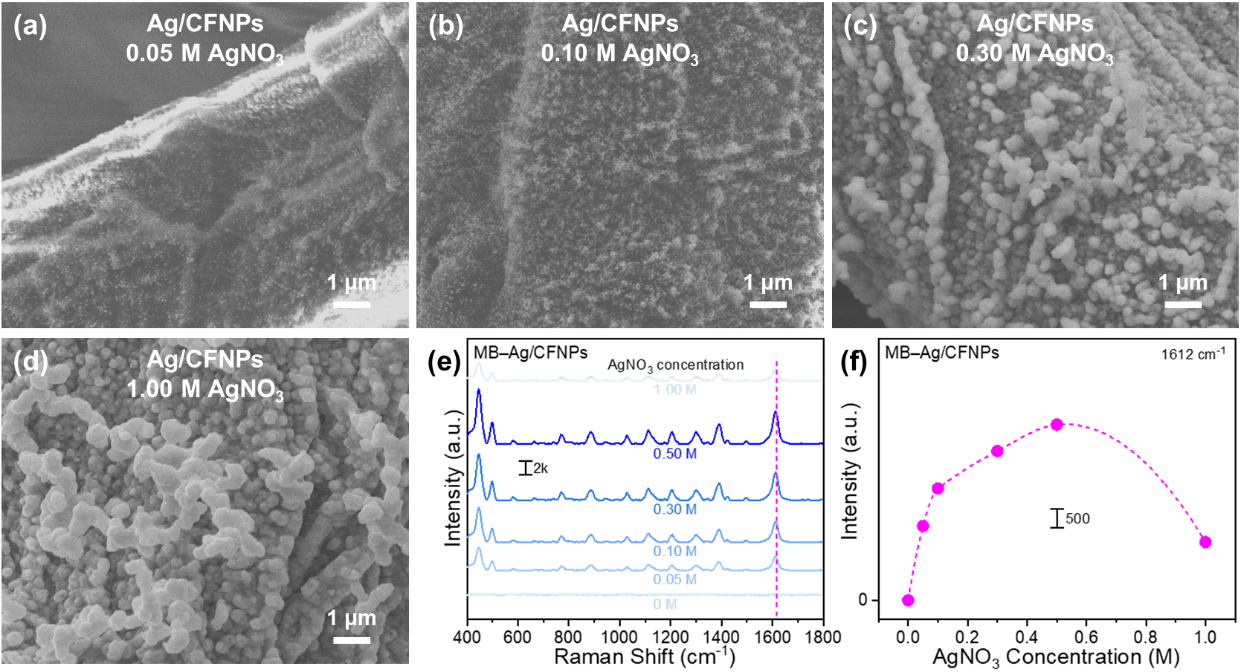
Fig. S3. Influence of AgNO₃ concentration on SERS activity. SEM images of Ag/CFNPs with AgNO₃ concentrations of (a) 0.05, (b) 0.1, (c) 0.3, and (d) 1.0 M. (e) SERS spectra of MB−Ag/CFNPs at different AgNO₃ concentrations, and (f) the corresponding intensity profile at 1612 cm⁻¹.

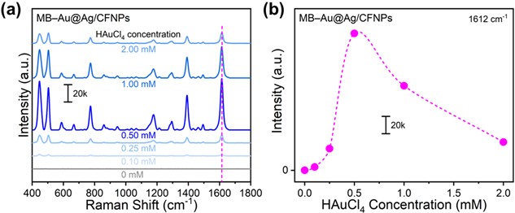
Fig. S4. Influence of HAuCl₄ concentration on SERS activity. (a) SERS spectra of MB−Au@Ag/CFNPs for HAuCl₄ concentrations of 0, 0.1, 0.25, 0.5, 1.0, and 2.0 mM, and (b) the corresponding intensity profile at 1612 cm⁻¹.

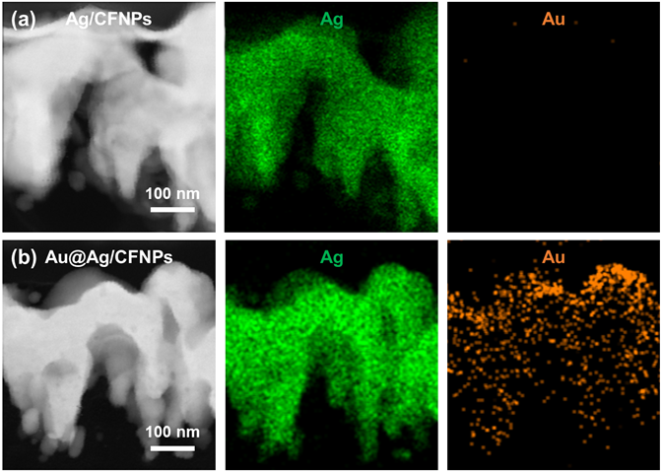
Fig. S5. Analysis of interior hotspots. STEM and elemental mapping images of (a) Ag/CFNPs and (b) Au@Ag/CFNPs.

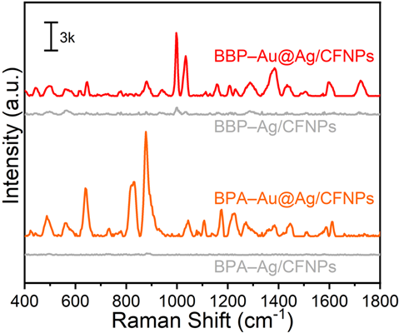
Fig. S6. Function of interior hotspots for signal enhancement. SERS spectra of plasticizer−Ag/CFNPs compared with in situ plasticizer−Au@Ag/CFNPs.

Table S1. SERS peak assignments of MB used in the present study.
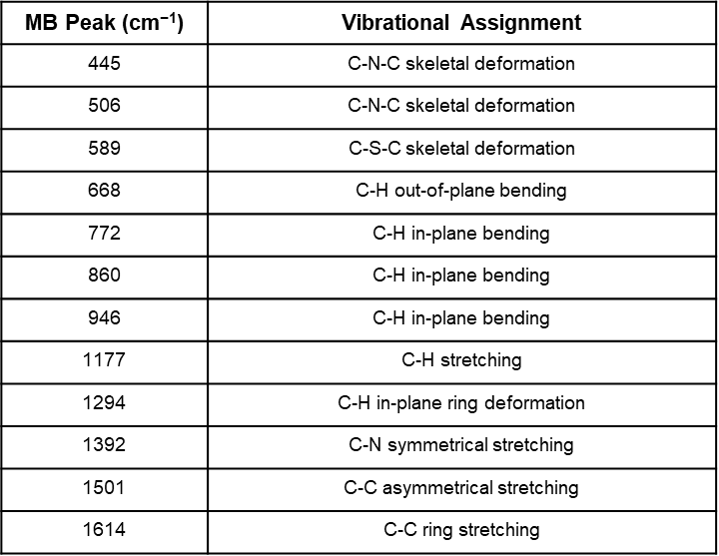

Table S2. SERS peak assignments of BBP used in the present study.
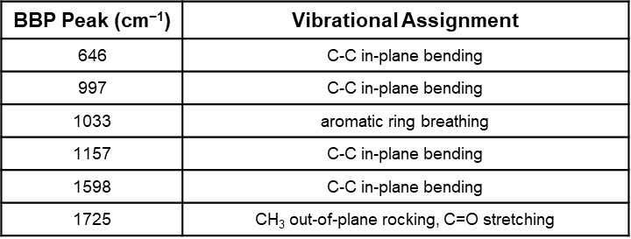

Table S3. SERS peak assignments of BPA used in the present study.
