Supplementary Information

Non-trivial and potentially dominant impact of land use/cover change on global gross primary productivity (2000-2100)

Hou et al.

Supplementary Figures

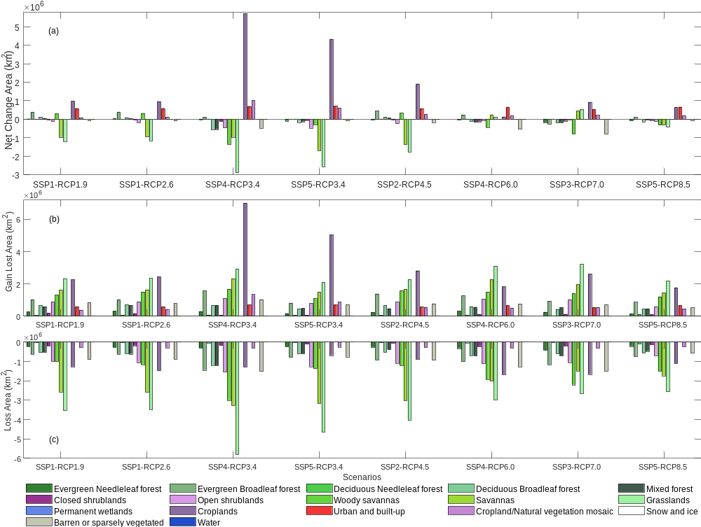
Supplementary Figure 1. Global changes of 17 LULC types from 2015 to 2100 under eight coupled SSP-RCP scenarios. (a) Net change of the LULC types; (b) Gain area of the LULC types; and (c) Loss area of the LULC types.
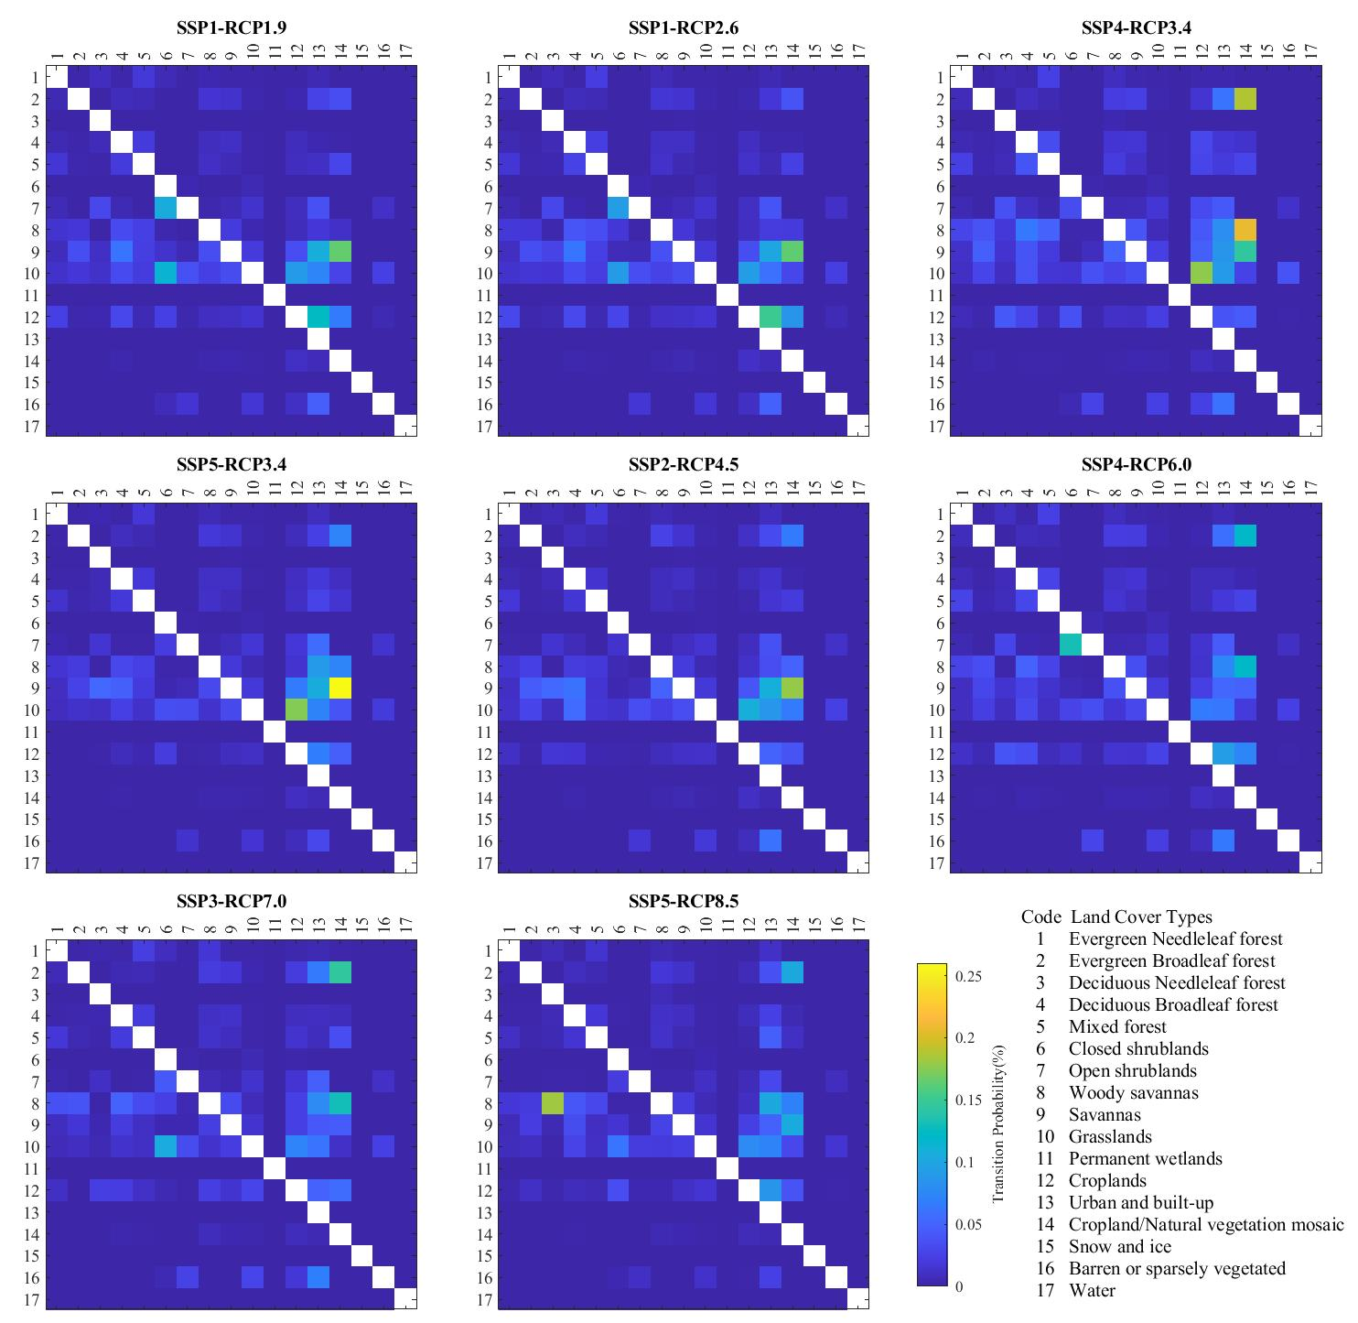
Supplementary Figure 2. Transition probability between LULC pairs during 2015-2100 under the eight scenarios.

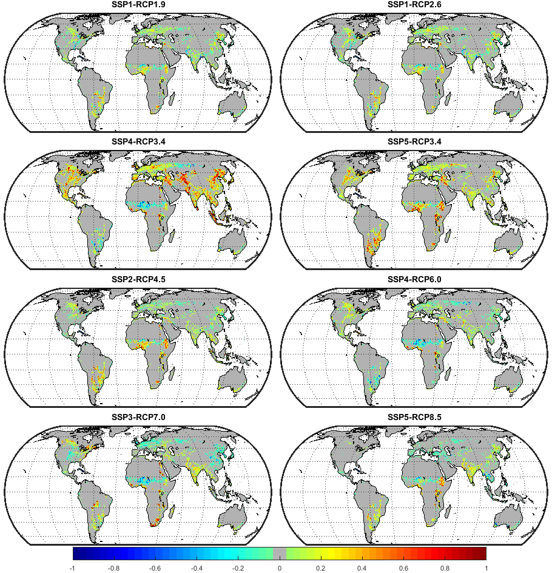
Supplementary Figure 3. Spatial patterns of the percentage change of farmland from 2015 to 2100 for the eight scenarios at 0.5° grid scale.

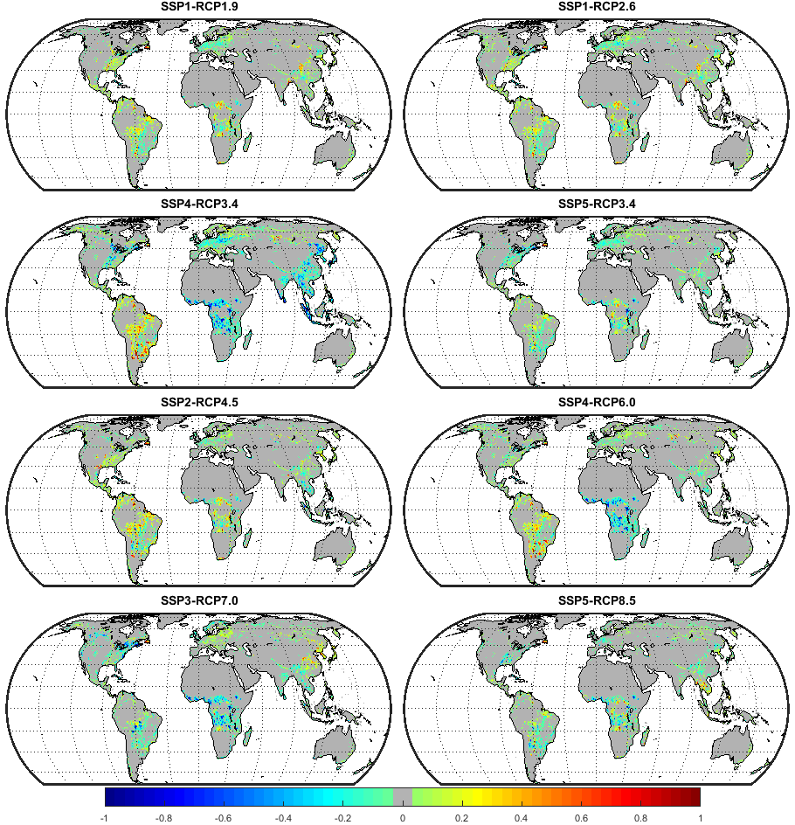
Supplementary Figure 4. Spatial patterns of the percentage change of forest land from 2015 to 2100 for the eight scenarios at 0.5° grid scale.
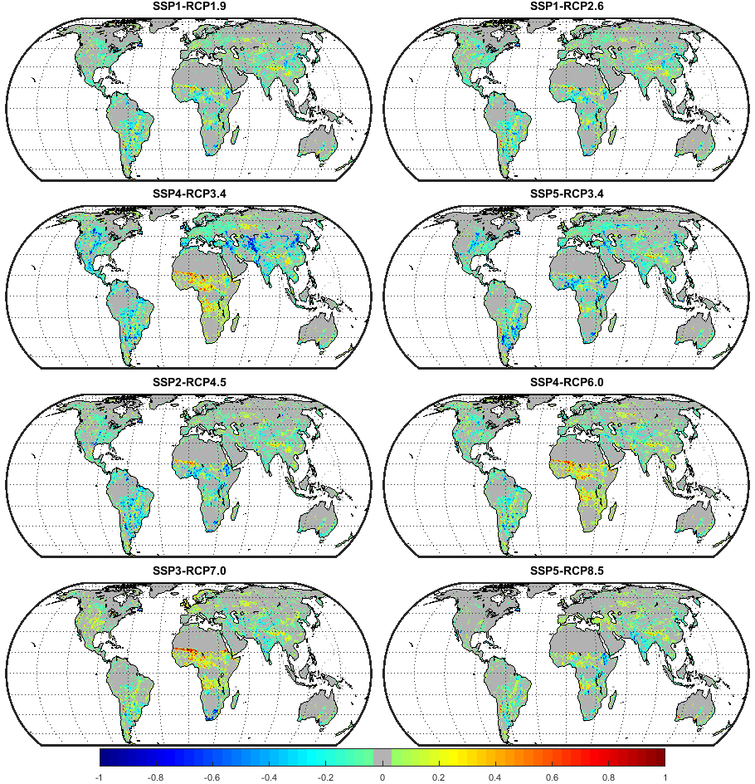
Supplementary Figure 5. Spatial patterns of the percentage change of grassland from 2015 to 2100 for the eight scenarios at 0.5° grid scale.
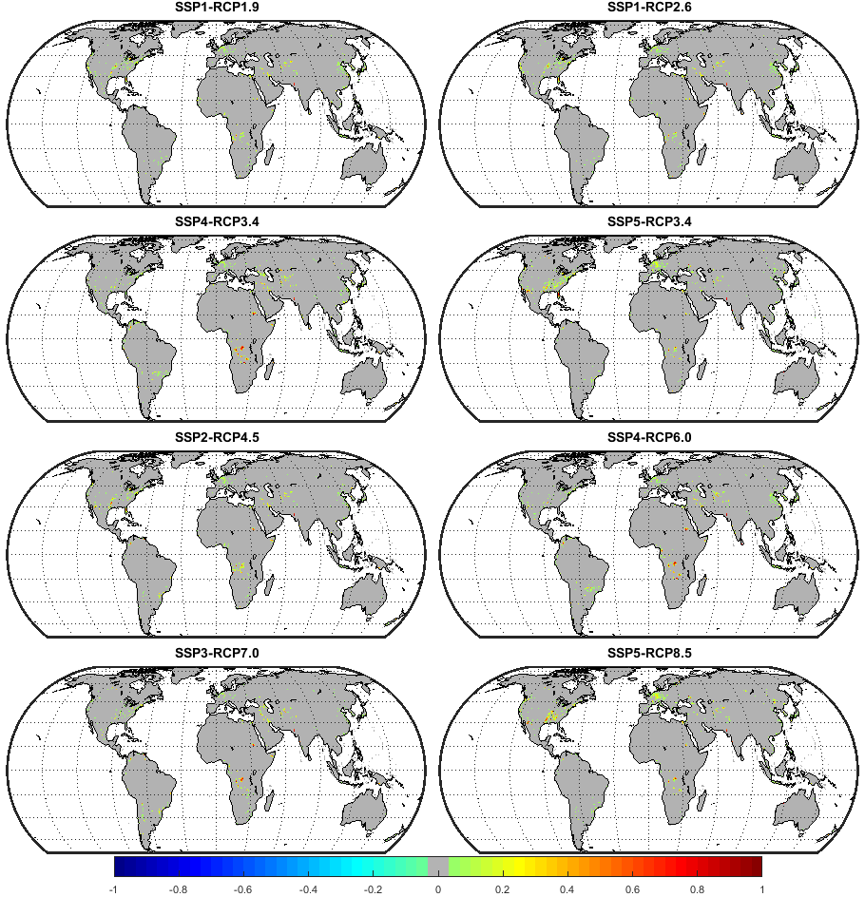
Supplementary Figure 6. Spatial patterns of the percentage change of urban land from 2015 to 2100 for the eight scenarios at 0.5° grid scale.

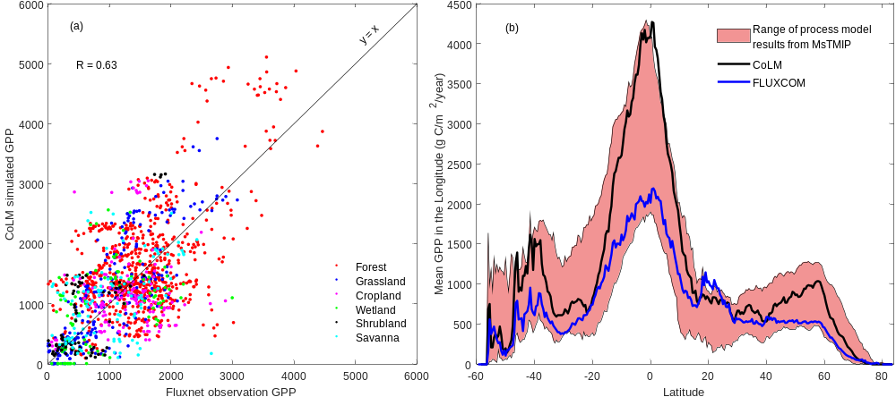
Supplementary Figure 7. (a) Comparison of our estimated GPP simulated by CoLM with in-situ GPP observations at FLUXNET tower sites; and (b) 14 Terrestrail Biosphere Models (TBM) results derived from the Multi-scale Synthesis and Terrestrial Model Intercomparison Project (MsTMIP) and FLUXCOM¹ in latitudinal distribution. The result demonstrates CoLM’s good performance in simulating GPP for different kinds of land use/cover (LULC) types, with an overall correlation coefficient of 0.63 (p < 0.001). While the correlation values are 0.56, 0.82, 0.11, 0.48, 0.71, and 0.41 for forest, grassland, cropland, wetland, shrubland, and savanna, respectively. The GPP from CoLM is generally higher than that of FLUXCOM and most TBMs in the latitudinal direction, especially in the tropics and near 40°S. This may be due to the overestimation of downward radiation of the CRUNCEP forcing dataset in tropical regions (e.g., Amazon²) and the parameterization scheme for tropical fractional coverage of forest³.

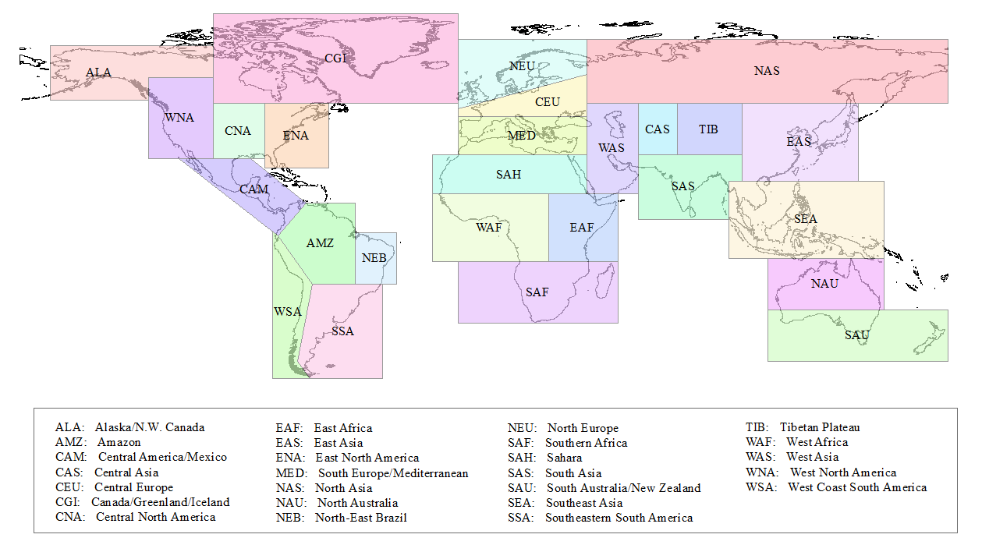
Supplementary Figure 8. Spatial boundaries of the 26 geographical regions defined in the SREX of IPCC AR5.

Supplementary Tables

Supplementary Table 1. Simulation experiments design with LULC change only (climate unchanged), climate change only (LULC unchanged), and both of them (both LULC and climate change) for comparison of the effects of LULC change and climate change on GPP dynamics.
Description | Name of experiments | Land use | Climate forcing
Climate unchanged | LULC119 | SSP1-RCP1.9 | 28-year average of CURNCEP
Climate unchanged | LULC126 | SSP1-RCP2.6 | 28-year average of CURNCEP
Climate unchanged | LULC434 | SSP4-RCP3.4 | 28-year average of CURNCEP
Climate unchanged | LULC534 | SSP5-RCP3.4 | 28-year average of CURNCEP
Climate unchanged | LULC245 | SSP2-RCP4.5 | 28-year average of CURNCEP
Climate unchanged | LULC460 | SSP4-RCP6.0 | 28-year average of CURNCEP
Climate unchanged | LULC370 | SSP3-RCP7.0 | 28-year average of CURNCEP
Climate unchanged | LULC585 | SSP5-RCP8.5 | 28-year average of CURNCEP
Land use unchanged | Clim45 | Constant of 2001 | RCP4.5 from CESM4
Land use unchanged | Clim60 | Constant of 2001 | RCP6.0 from CESM4
Land use unchanged | Clim85 | Constant of 2001 | RCP8.5 from CESM4
Both land use and climate changed | Clim45-LULC245 | SSP2-RCP4.5 | RCP4.5 from CESM4
Both land use and climate changed | Clim60-LULC460 | SSP4-RCP6.0 | RCP6.0 from CESM4
Both land use and climate changed | Clim85-LULC585 | SSP5-RCP8.5 | RCP8.5 from CESM4

Supplementary Table 2. Reclassification from the LUH2 scheme to the IGBP scheme
IGBP Code | IGBP Class | LUH2 Class | Broad Category
1 | Evergreen needle-leaf forest | forested primary land  potentially forested secondary land  (include added tree cover) | Forest
2 | Evergreen broad-leaf forest |  | Forest
3 | Deciduous needle-leaf forest |  | Forest
4 | Deciduous broad-leaf forest |  | Forest
5 | Mixed forests |  | Forest
8 | Woody savannas |  | Forest
6 | Closed shrub lands | managed pasture rangeland  non-forested primary land  (carbon > 0.5 kg /m^2)  non-forested secondary land  (carbon > 0.5 kg /m^2) | Grassland
7 | Open shrub lands |  | Grassland
9 | Savannas |  | Grassland
10 | Grasslands |  | Grassland
12 | Cropland | C3 annual crops  C3 perennial crops  C3 nitrogen-fixing crops  C4 annual crops  C4 perennial crops | Agriculture
14 | Cropland/natural vegetation mosaic |  | Agriculture
13 | Urban and built-up | urban land | Urban land
16 | Barren or sparsely vegetated land | non-forested primary land  (carbon < 0.5 kg /m^2)  non-forested secondary land  (carbon < 0.5 kg /m^2) | Barren land
11 | Permanent wetlands | ice and water | Ice and Water
15 | Snow and ice | ice and water | Ice and Water
17 | Water | ice and water | Ice and Water

Supplementary Table 3. Driving factors for estimating the occurrence probability of each LULC type in FLUS model
LULCC Drivers | Year | Resolution | Data Source
Distance to Roads |  | 1 km | ESRI World Roads (http://www.arcgis.com)
Distance to Cities |  | 1 km | Nature Earth Populated Places (http://www.naturalearthdata.com)
Distance to Rivers |  | 1 km
Population | 2015 | 1 km | NASA Gridded Population of the World (Center for International Earth Science Information Network - CIESIN - Columbia University)
GDP | 2015 | 1 km | Dryad Digital Repository⁴
Soil Quality | 2008 | 1 km | World Harmonization Soil Quality (http://www.fao.org/)
Mean Precipitation | 1970-2000 | 1 km | World Climate Data⁵
Mean Temperature | 1970-2000 | 1 km | World Climate Data⁵
DEM | 2010 | 1 km | GMTED2010⁶
Slope | 2010 | 1 km | GMTED2010⁶
Note: GDP is the abbreviation of gross domestic product; DEM is the abbreviation of digital elevation model.

Supplementary Table 4. Figure of Merit (%; recommended by Li et al.⁷) of the 26 regions for LULC simulations during 2010- 2015. The test results of the 26 regions range from 5 to 12%, with a mean value of 8.73%.
ALA | AMZ | CAM | CAS | CEU | CGI | CNA | EAF | EAS
11 | 6 | 10 | 7 | 5 | 9 | 8 | 11 | 7
ENA | MED | NAS | NAU | NEB | NEU | SAF | SAH | SAS
6 | 8 | 11 | 12 | 12 | 8 | 12 | 8 | 7
SAU | SEA | SSA | TIB | WAF | WAS | WNA | WSA
9 | 8 | 10 | 8 | 10 | 9 | 6 | 9

Reference
1. Jung M, et al. The FLUXCOM ensemble of global land-atmosphere energy fluxes. Sci Data 6, 74 (2019).
2. Wang AH, Zeng XB, Guo DL. Estimates of Global Surface Hydrology and Heat Fluxes from the Community Land Model (CLM4.5) with Four Atmospheric Forcing Datasets. J Hydrometeorol 17, 2493-2510 (2016).
3. Zhu JW, Zeng XD, Li F, Song X. Preliminary Assessment of the Common Land Model Coupled with the IAP Dynamic Global Vegetation Model. Atmospheric and Oceanic Science Letters 7, 505-509 (2014).
4. Kummu M, Taka M, Guillaume JHA. Data Descriptor: Gridded global datasets for Gross Domestic Product and Human Development Index over 1990-2015. Sci Data 5 (2018).
5. Fick SE, Hijmans RJ. WorldClim 2: new 1-km spatial resolution climate surfaces for global land areas. Int J Climatol 37, 4302-4315 (2017).
6. Danielson JJ, Gesch DB. Global multi-resolution terrain elevation data 2010 (GMTED2010). (2011).
7. Li X, et al. A New Global Land-Use and Land-Cover Change Product at a 1-km Resolution for 2010 to 2100 Based on Human–Environment Interactions. Annals of the American Association of Geographers 107, 1040-1059 (2017).

