Supplementary Information for Global strategic deployment of Direct Air Capture technologies
Kenneth Okosun^{1,2*}, Henrik Wenzel^{1,2}, Freia Harzendorf¹, Thomas Schöb¹, Mak Đukan¹, Jochen Linßen¹, Detlef Stolten², Jann M. Weinand¹
¹ Forschungszentrum Jülich GmbH, Institute of Climate and Energy Systems – Jülich Systems Analysis (ICE-2), 52425 Jülich, Germany
² RWTH Aachen University, Chair for Fuel Cells, Faculty of Mechanical Engineering, 52062 Aachen, Germany
* Corresponding author’s e-mail address: k.okosun@fz-juelich.de

Keywords: Direct Air Capture, site assessment, weather impact, geospatial analysis, levelized cost, negative emission technology, carbon dioxide removal, renewable energy potential

- Weather-dependence of DAC
Relative humidity was calculated from the global hourly dewpoint temperature and air temperature data of ERA5 using the Sonntag formula [1,2]:
$$RH =\frac{e_{wd}}{e_{w}}*100$$ | [1]
$$\ln{e_{w}(T)}=-6096.9385 T^{-1}- 2.711193*{10}^{-2}*T+ 1.673952*{10}^{-5}*T^{2}+ 2.433502*\ln{T}+21.2409642$$ | [2]
$$\ln{e_{wd}(T_{d})}=-6096.9385 T_{d}^{-1} - 2.711193*{10}^{-2}*T_{d}+1.673952*{10}^{-5}*T_{d}^{2}+ 2.433502*\ln{T_{d}}+21.2409642$$ | [3]
where T is the temperature, T_{d} is the dewpoint temperature, and RH (%) is the relative humidity, which is a ratio of the amount of water vapor, e_{wd}, in the air to the amount of water vapor, e_{w}, that would be in the air if saturated at the same temperature and pressure.
The literature-based weather-dependent performance graphs in Figure S1 for the liquid solvent DAC and the solid sorbent DAC show the impact of air temperature and relative humidity on the DAC processes considered. For L-DAC (Figure S1A), relative productivity increases with temperature due to higher CO₂ absorption rates and shows only modest sensitivity to humidity. The specific water requirement rises substantially at high temperatures and low humidity due to evaporative losses in the air contactor. In contrast, the specific electrical requirement remains essentially constant across varying weather conditions, as it is dominated by the high-temperature calcination step, which takes place in a controlled environment and is less sensitive to ambient conditions. Overall, the weather-dependent maps in Figure 2A reflect the aggregated behavior captured in the published performance relationships used in this study [3].Relative productivity decreases with increasing temperature and improves under moderate humidity for S-DAC (Figure S1B). The beneficial effect of humidity persists to high relative humidity levels, while the reduction in CO₂ uptake at very high humidity results from increased water loading. The rise in thermal energy requirements with humidity reflects the higher latent heat needed to desorb co-adsorbed water. The specific electrical requirement shows only moderate sensitivity to weather conditions, mainly due to changes in CO₂ loading that affect airflow and vacuum/compression work. The weather sensitivities shown in Figure 2B, therefore, represent the net effects already captured in the performance data applied in this analysis [4].
A structural difference exists between the available process models for L-DAC and S-DAC. In the liquid-solvent model, ambient temperature and humidity influence CO₂ capture rates via the air contactor model, and downstream energy demands scale accordingly. However, auxiliary electrical loads such as fans, pumps and mixers, are not explicitly recalculated as functions of ambient conditions [3]. In contrast, the solid-sorbent model allows fan and vacuum pump electricity demand to vary directly with temperature and humidity [4], thereby capturing weather-driven variability in auxiliary energy demand more explicitly. This asymmetry reflects the current state of published process models rather than a modelling choice specific to this study. Importantly, existing literature indicates that for L-DAC, environmental impacts on electricity consumption are mainly driven by air density effects on fan power, while most other electrical loads remain relatively insensitive to ambient conditions [5]. Reported weather-driven variability in fan electricity typically ranges on the order of 0.055 – 0.085 MWh/tCO₂ in coastal regions [6], suggesting that any understatement of weather sensitivity in L-DAC is bounded and unlikely to qualitatively alter the comparative regional cost patterns identified in this analysis.

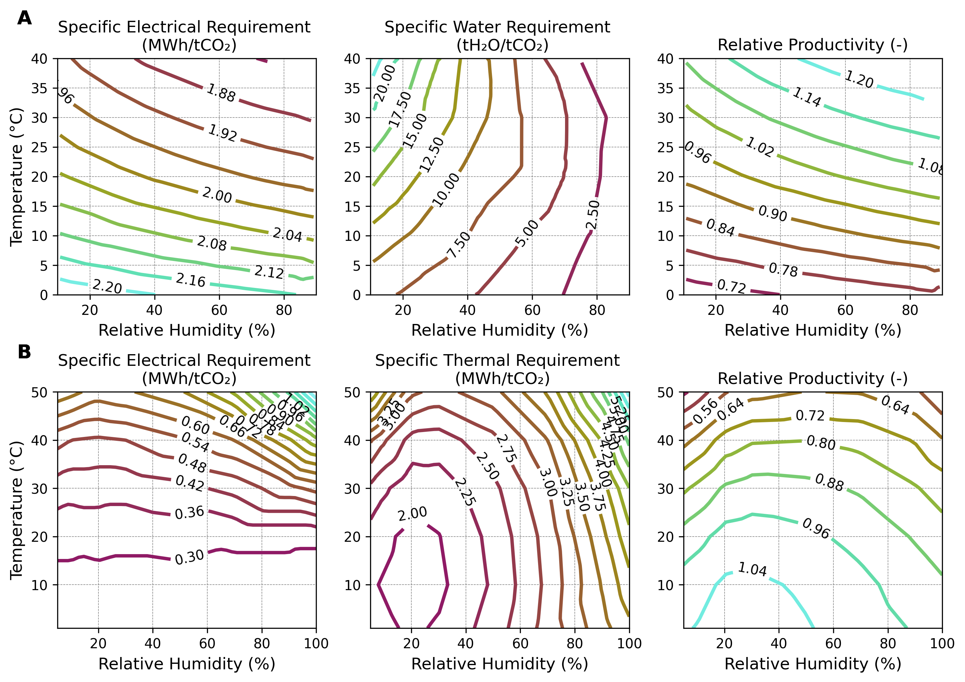
Figure S1. Weather-dependent performance maps for A. L-DAC and B. S-DAC. Relative productivity provides a baseline for comparing the capture efficiency of each technology at a global average temperature and relative humidity. The performance maps are adapted from the literature [3,4].
DAC operation in different climate classes
Significant hourly performance variation of DAC necessitates proper planning of energy and water resources to ensure near-steady operation over the year. We analyzed three locations with distinct Köppen-Geiger climate classes to assess the seasonal and temporal variability of the relative productivity and electricity consumption of L-DAC and S-DAC. The Köppen-Geiger system categorizes climate into five primary classes, directly capturing temperature and moisture conditions relevant to DAC performance [7]. The selected locations are Darwin (Australia), Rotterdam (Netherlands), and Jubail (Saudi Arabia), which correspond to the tropical, arid, and temperate climate classes of the Köppen-Gieger system, respectively (Figure S2). The cold and polar climate classes are excluded from this analysis due to limited performance data and operational restrictions in these regions. Another criterion considered in selecting locations was their proximity to geologic storage. All three locations currently develop carbon storage; hence, co-locating them with a DAC plant reduces the cost of transporting CO₂ over long distances [8–10].
Across the three analyzed climate zones – temperate (Rotterdam), arid (Jubail), and tropical (Darwin) – the local weather conditions significantly impact the relative productivity, electricity consumption, and water demand of both L-DAC and S-DAC technologies. The Port of Rotterdam in the Netherlands has a temperate climate, marked by warm summers and cool winters. Average summer temperatures exceed 15°C, and winter temperatures average above 4°C, with an average humidity level of 81%. Arid climates range from hot deserts to cold regions. Jubail in Saudi Arabia exemplifies a hot, arid climate, with maximum temperatures reaching 48°C and an average humidity of 49%, experiencing extremes in mid-year. Darwin, a tropical city in Australia, has high temperatures and humidity, typically above 27°C and over 70% humidity. Mild seasonal variation occurs mid-year, with decreased temperatures early in the day and lower humidity late in the day.
The variability of electricity and water consumption for DAC throughout the year is significant. Even for a single day, the electricity consumption for S-DAC can fluctuate by up to 67%, and water consumption for L-DAC can vary by over 1000% in Darwin. Additionally, the hot and humid weather in tropical climates generally provides an optimal operating condition for L-DAC. In the arid and temperate climate classes, operations could be constrained by high evaporation rates driven by low humidity or winter freezing temperatures. In contrast, S-DAC, though with lower productivity, is more suited for arid regions as the dry conditions reduce energy consumption, while co-capturing a small amount of water from the air could be beneficial in other processes, such as sustainable fuel production. Enhanced sorbent functionalization may enable improved CO₂ capture performance at elevated temperatures.

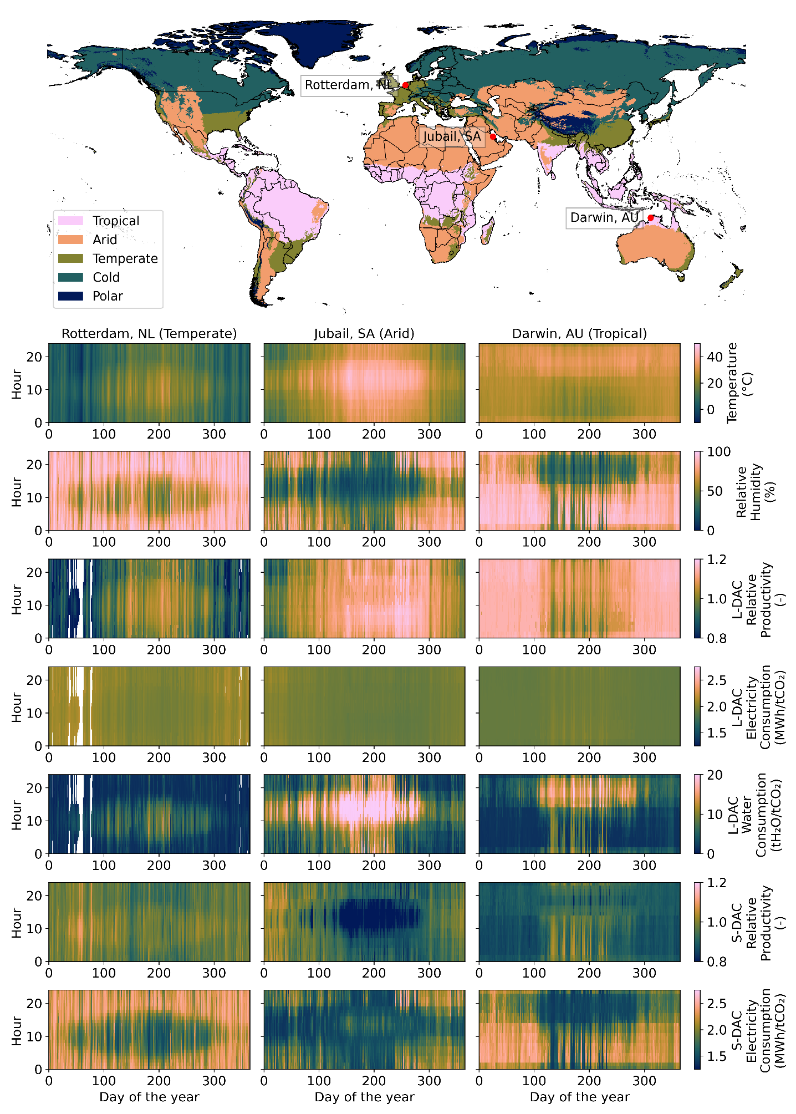
Figure S2: Hourly DAC performance and weather conditions. The world map shows the spatial distribution of the five main Köppen-Geiger climate classes determined for 1991 – 2020 at 0.1° resolution [7]. Three locations corresponding to the tropical, arid, and temperate classes are selected to assess the hourly performance of DAC using the weather year 2018. The nearest values of the location coordinate for Darwin (-12.46, 130.84), Jubail (26.96, 49.57), and Rotterdam (51.92, 4.48) are used to derive hourly timeseries performance data for the two DAC technologies, along with their corresponding temperature and humidity values. The cold and polar classes are excluded from the analysis due to limited DAC performance data within their regions. Hourly production, electricity consumption, and water consumption are assumed to be steady, equivalent to that of a large-scale plant. White spaces in the timeseries plot of L-DAC correspond to hours with temperatures below 0°C.

- Thermal Energy Partitioning Between Concentrated Solar Power and Electric Calcination for L-DAC
In order to quantify the relative contributions of concentrated solar power (CSP) and an electrically heated calciner to the thermal energy demand of the liquid solvent DAC plant, we divided the temperature profile for calcium carbonate (CaCO₃) heating into two ranges:
- Low- to intermediate-temperature heating (ambient to 380 °C), assumed to be supplied by CSP.
- High-temperature heating (370–900 °C), supplied by the electric calciner.
To allow for HTF piping and heat-exchanger losses and to avoid control cycling due to short-term CSP temperature fluctuations, the calciner electric assist is initiated at 370 °C, i.e., slightly below the CSP design outlet (380 °C). The required sensible heat was estimated using average heat capacities ($C_{p}$​) of CaCO₃ reported in the literature[11], with $C_{p}$​ = 1.01 J g⁻¹K⁻¹ between ambient and 380 °C, and $C_{p}$ = 1.27 J g⁻¹K⁻¹ between 370 °C and 900 °C. For a given CaCO₃ mass, the heat contributions are expressed as:
$$Q_{CSP}=m∙C_{p,20-380}∙(T_{380}-T_{amb})$$
$$Q_{calciner}=m∙C_{p,370-900}∙(T_{900}-T_{370})$$
where $T_{amb}$​ is the ambient air temperature used to capture site-specific conditions. The total sensible heat requirement is therefore:
$$Q_{total}=Q_{CSP}+Q_{calciner}$$
The fractional energy contributions of each source were calculated as the ratio of $Q_{CSP}$​ and $Q_{calciner}$​ to $Q_{total}$​. For reference, assuming $T_{amb}$ = 25, CSP supplies approximately 35% of the total heating demand, while the electric calciner supplies the remaining 65%.

- Techno-economic assumptions
Table S1. Techno-economic assumptions for DAC in the year 2050.
 |  | Unit | Value | Source/notes
Liquid solvent DAC
 | CAPEX | €/tCO₂/a | 1368 – Upper quartile | [12–19]  Upper and lower quartiles are used for the pessimistic and optimistic cases, respectively
 | CAPEX | €/tCO₂/a | 677 – Median
 | CAPEX | €/tCO₂/a | 290 – Lower quartile
 | OPEX_fix | % of CAPEX | 4 - 9 | Upper bound is used for the pessimistic case [12–19]
 | OPEX_var (non-energy related) | €/tCO₂ | 1.4 - 3 | Upper bound is used for the pessimistic case [12,19]
 | WACC | % | 10 | [15,19]
 | Lifetime | Year | 25 | [14,17,19]
 | Relative productivity/capacity factor | - | Hourly weather-dependent productivity | [3]
 | Specific energy demand | MWh/tCO₂ | Hourly weather-dependent demand derived from literature [3,20] | Within the range of 1 GtCO₂/yr scale plant [19], NOAK Liquid DACCS [12], 1 MtCO₂/yr scale plant [21]
 | Specific water demand | tH₂O/tCO₂ | Hourly weather-dependent demand | [3]
 | Utilization factor | % | 90 | [12,21]
Solid sorbent DAC
 | CAPEX | €/tCO₂/a | 1137 – Upper quartile | [12–19]  Upper and lower quartiles are used for the pessimistic and optimistic cases, respectively
 | CAPEX | €/tCO₂/a | 705 – Median
 | CAPEX | €/tCO₂/a | 272 – Lower quartile
 | OPEX_fix | % of CAPEX | 4 - 6 | Upper bound is used for the pessimistic case [12–19]
 | OPEX_var (non-energy related) | €/tCO₂ | 39 - 74 | Upper bound is used for the pessimistic case [12,19]
 | WACC | % | 10 | [15,19]
 | Lifetime | Year | 25 | [12,14,17,19]
 | Relative productivity/capacity factor | - | Hourly weather-dependent productivity | [4]
 | Specific energy demand | MWh/tCO₂ | Hourly weather-dependent demand derived from literature [4]. | In the optimistic case, the thermal demand is reduced by 45% to match projected efficiency in [12,19]
 | Utilization factor | % | 90 | [12,19]

Table S2. Cost assumptions for energy sources, conversion, and storage in the year 2050.
 |  | Unit | Value | Source/notes
Ofpv_singleaxis
 | CAPEX | €/kW | 327 | [22,23]
 | OPEX_fix | % | 1.7 | [22,23]
 | Lifetime | year | 30 | [22,23]
Wind onshore
 | CAPEX | €/kW | 1174 | [22,23]
 | OPEX_fix | % | 2.5 | [22,23]
 | Lifetime | year | 30 | [22,23]
CSP_he
 | CAPEX | €/kW | 309 | [24]
 | OPEX_fix | % | 2 | [24]
 | Lifetime | year | 30 | [24]
CSP_ss
 | CAPEX | €/kW | 266 | [24]
 | OPEX_fix | % | 2 | [24]
 | Lifetime | year | 30 | [24]
Geothermal EGS/heat
 | CAPEX | €/kW | * | Region-specific [25]
 | OPEX_fix | % | 2 | [25]
 | Lifetime | year | 30 | [25]
Heat pump
 | CAPEX | €/kW | 665 | [26]
 | OPEX_fix | % | 0.2 | [26]
 | Lifetime | year | 25 | [26]
 | 2nd law efficiency | % | 50 | Modeled by calculating the coefficient of performance based on the prevailing hourly temperature in each region, 110°C sink temperature [4,27]
Electric heater
 | CAPEX | €/kW | 145 | [26]
 | OPEX_fix | % | 0.4 | [26]
 | Lifetime | year | 20 | [26]
 | Conversion efficiency | % | 99 | [26]
CSP_he powerplant
 | CAPEX | €/kW | 976 | [24]
 | OPEX_fix | % | 2 | [24]
 | Lifetime | year | 30 | [24]
 | Conversion efficiency | % | 39 | [24]
CSP_ss powerplant
 | CAPEX | €/kW | 976 | [24]
 | OPEX_fix | % | 2 | [24]
 | Lifetime | year | 30 | [24]
 | Conversion efficiency | % | 43 | [24]
Battery_LIIon
 | CAPEX | €/kW | 176 | [28]
 | OPEX_fix | % | 2.5 | [23]
 | Lifetime | year | 15 | [23]
 | Discharge efficiency | % | 0.96 | [23]
 | Self-discharge | %/d | 0.1
Heat storage
 | CAPEX | €/kW | 1 | [23]
 | OPEX_fix | % | 2 | [23]
 | Lifetime | year | 20 | [23]
 | Discharge efficiency | % | 1 | [23]
 | Self-discharge | %/d | 0.24 | [23]
Csp_he storage
 | CAPEX | €/kW | 38 | [24]
 | OPEX_fix | % | 2 | [24]
 | Lifetime | year | 30 | [24]
 | Discharge efficiency | % | 99 | [24]
 | Self-discharge | %/d | 1 | [24]
Csp_ss storage
 | CAPEX | €/kW | 26 | [24]
 | OPEX_fix | % | 2 | [24]
 | Lifetime | year | 30 | [24]
 | Discharge efficiency | % | 99 | [24]
 | Self-discharge | %/d | 1 | [24]
Water
 | Commodity cost | €/m³ | 0 – 3.5 | [29]

- World Region Grouping
Table S3. Merit Order World Regions.
Region | Countries
Western South America | Aruba, Bolivia, Bonaire, Sint Eustatius and Saba, Colombia, Curaçao, Ecuador, Peru, Venezuela
Southern South America | Argentina, Chile, Falkland Islands, Paraguay, South Georgia and the South Sandwich Islands, Uruguay
North Eastern South America | French Guiana, Guyana, Suriname
Rest of the World | Afghanistan, American Samoa, Anguilla, Antigua and Barbuda  Bahamas, Barbados, Bermuda, British Virgin Islands  Cayman Islands, Cook Islands, Clipperton Island, Cuba, Dominica, Dominican Republic, Fiji, French Polynesia, French Southern Territories  Greenland, Grenada, Guadeloupe, Guam, Haiti, Heard Island and McDonald Islands, Jamaica, Kiribati, Marshall Islands, Martinique, Micronesia, Montserrat, Nauru, New Caledonia, Niue, Norfolk Island, Northern Mariana Islands  Pakistan, Palau, Papua New Guinea, Pitcairn Islands, Puerto Rico, Saint Kitts and Nevis, Saint Lucia, Saint Vincent and the Grenadines, Saint-Barthélemy, Saint-Martin, Samoa, Sint Maarten, Solomon Islands, Tokelau, Tonga, Trinidad and Tobago, Turks and Caicos Islands, Tuvalu, Vanuatu, Virgin Islands, U.S., Wallis and Futuna
Sub-Sahara Africa | Angola, Benin, Botswana, Bouvet Island, Burkina Faso  Burundi, Cameroon, Cape Verde, Central African Republic  Chad, Comoros, Côte d'Ivoire, Democratic Republic of the Congo, Djibouti, Equatorial Guinea, Eritrea, Ethiopia, Gabon, Gambia, Ghana, Guinea, Guinea-Bissau, Kenya, Lesotho, Liberia, Madagascar, Malawi, Mali, Mauritius, Mayotte, Mozambique, Namibia, Niger, Nigeria, Republic of Congo, Reunion, Rwanda, Saint Helena, Senegal, Seychelles, Sierra Leone, Somalia, South Africa, South Sudan, Sudan, Swaziland, São Tomé and Príncipe, Tanzania, Togo, Uganda, Zambia, Zimbabwe
Europe | Akrotiri and Dhekelia, Albania, Andorra, Austria, Belgium, Bosnia and Herzegovina, Bulgaria, Croatia, Cyprus, Czech Republic, Denmark, Estonia, Faroe Islands, Finland, France, Germany, Gibraltar, Greece, Guernsey, Hungary, Ireland, Isle of Man, Italy, Jersey, Kosovo, Latvia, Liechtenstein, Lithuania, Luxembourg, Macedonia, Malta, Moldova, Monaco, Montenegro, Netherlands, Northern Cyprus, Norway, Poland, Portugal, Romania, San Marino, Serbia, Slovakia, Slovenia, Spain, Svalbard and Jan Mayen, Sweden, Switzerland, Turkey, Ukraine, United Kingdom, Vatican City, Ãland
MENA | Algeria, Armenia, Bahrain, Egypt, Iran, Iraq, Israel, Jordan, Kuwait, Lebanon, Libya, Mauritania, Morocco, Oman, Palestina, Qatar, Saudi Arabia, Syria, Tunisia, Turkmenistan, United Arab Emirates, Western Sahara, Yemen
Northern Asia | Azerbaijan, Belarus, Georgia, Kazakhstan, Kyrgyzstan, Mongolia, Russia, Tajikistan, Uzbekistan
Southern Main Asia | Bangladesh, Bhutan, British Indian Ocean Territory, India, Maldives, Nepal, Sri Lanka
South East Asia | Brunei, Cambodia, Christmas Island, Cocos Islands, Indonesia, Laos, Malaysia, Myanmar, Paracel Islands, Philippines, Singapore, Spratly Islands, Thailand, Timor-Leste, Vietnam
Central America | Belize, Costa Rica, El Salvador, Guatemala, Honduras, Nicaragua, Panama
North America | Canada, Saint Pierre and Miquelon, United States, United States Minor Outlying Islands
Brazil | Brazil
Iceland | Iceland
Mexico | Mexico
East Asia | China, Hong Kong, Macao, North Korea, Japan, South Korea, Taiwan
Australia New Zealand | Australia, New Zealand

- Energy System Model Inputs
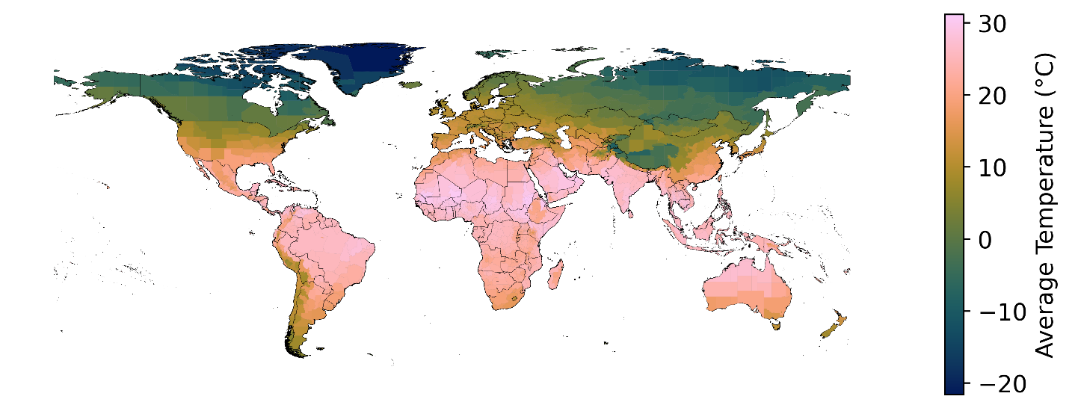
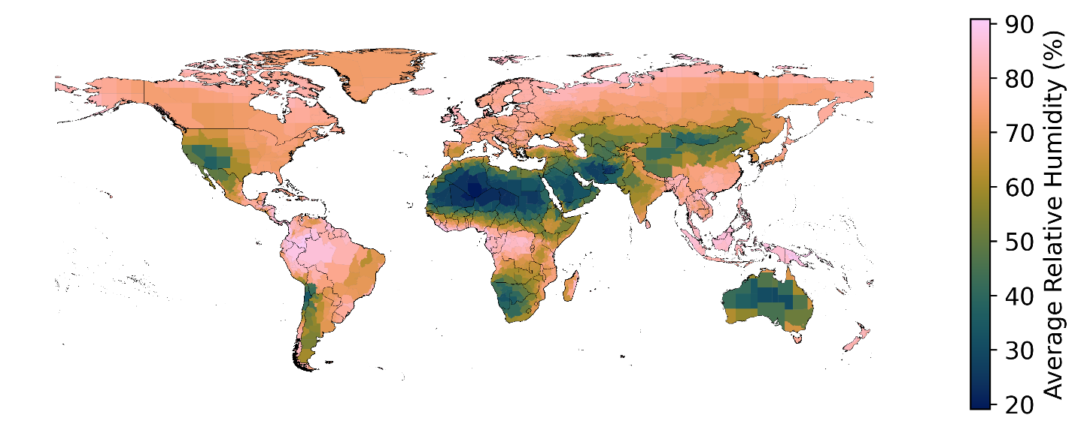
Figure S3. Average temperature and relative humidity values for 2018

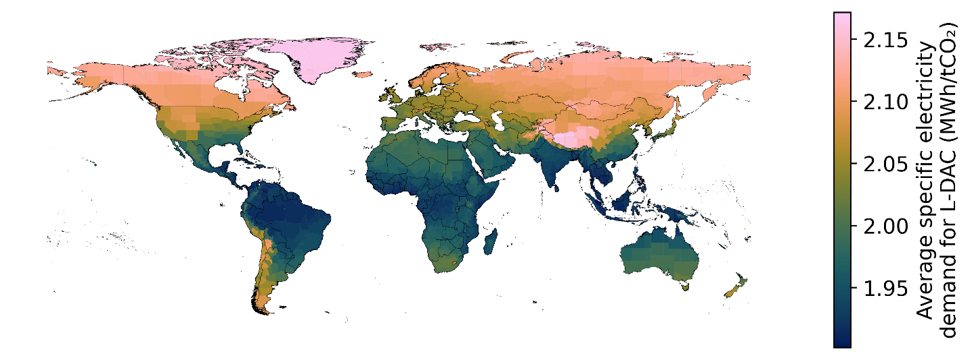
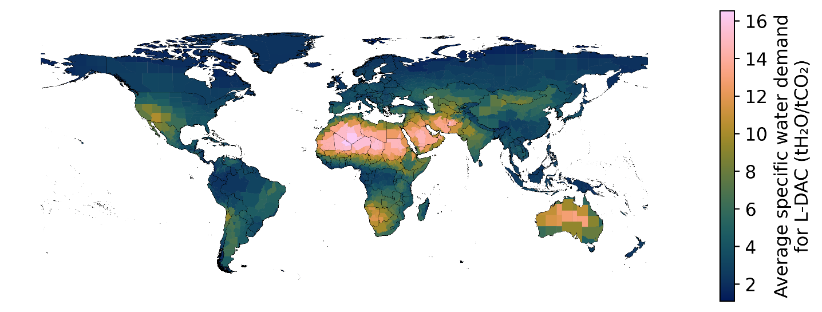
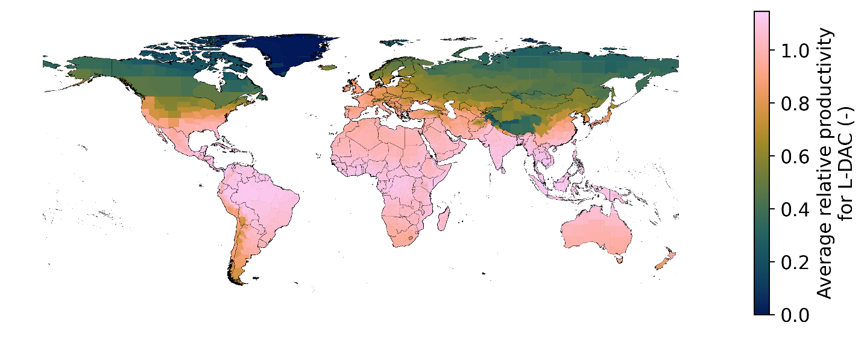
Figure S4. Global specific energy consumption, water consumption, and relative productivity of L-DAC. The average amount of water consumed globally can range from 1 to 18 tH₂O/tCO₂. This significant variation in global water consumption for liquid solvent DAC stems from the relative rates of water generation and evaporation in the air contactor. The consistently high humidity in the tropical regions of Middle Africa, Southeastern Asia, and the northern part of South America makes them the region with the least water consumption.
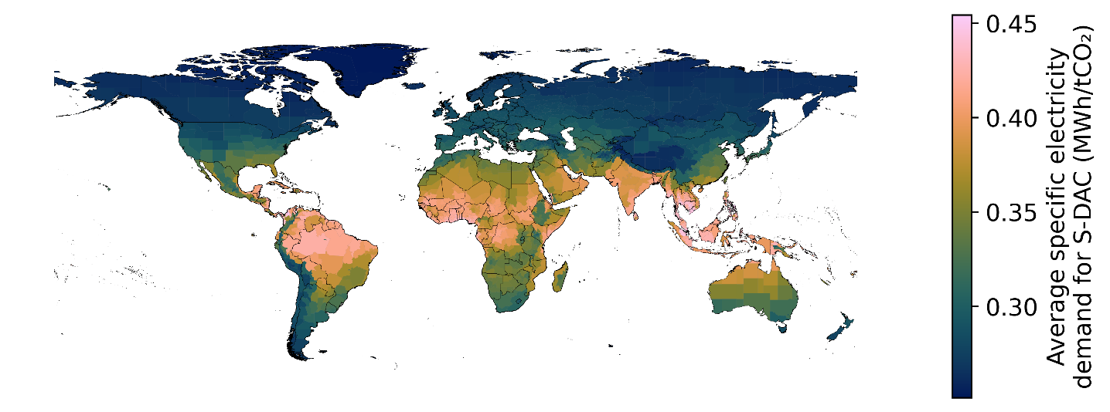
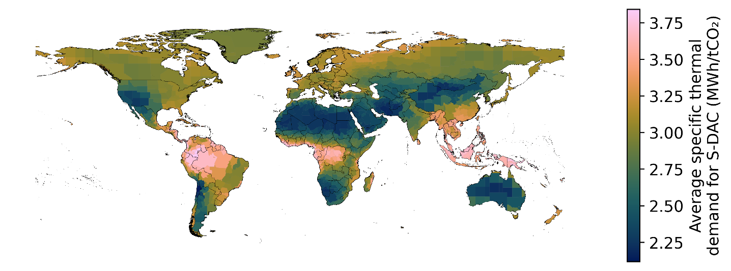
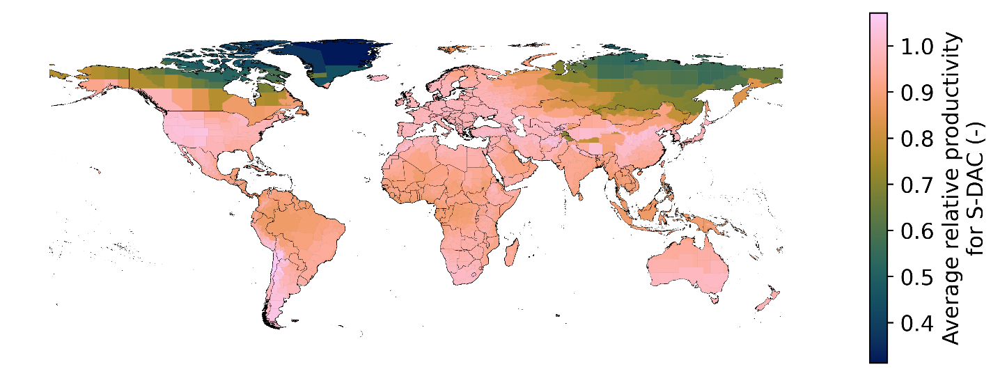
Figure S5. Global specific electricity consumption, thermal consumption, and relative productivity of S-DAC. The specific energy consumption of S-DAC is more sensitive to local temperature and relative humidity than L-DAC. The specific thermal consumption of S-DAC accounts for the heat required for desorption, while the specific electricity consumption covers the electrical requirement of the DAC plant.

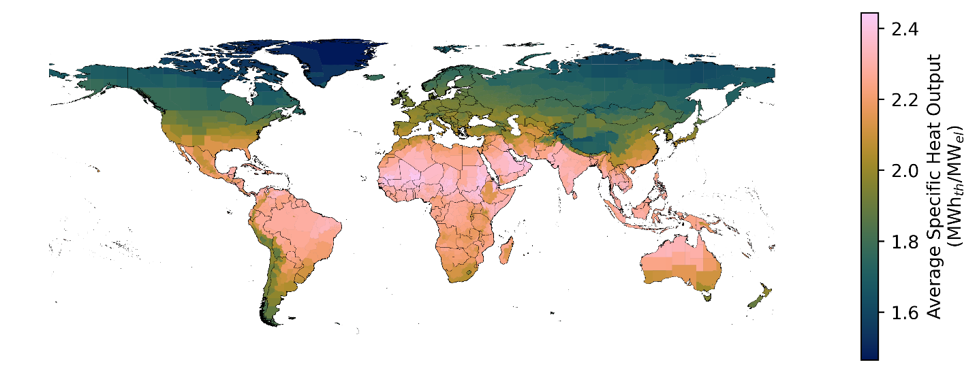
Figure S6. Average specific heat pump conversion factor

- Energy System Model Results
  - Electric Scenario
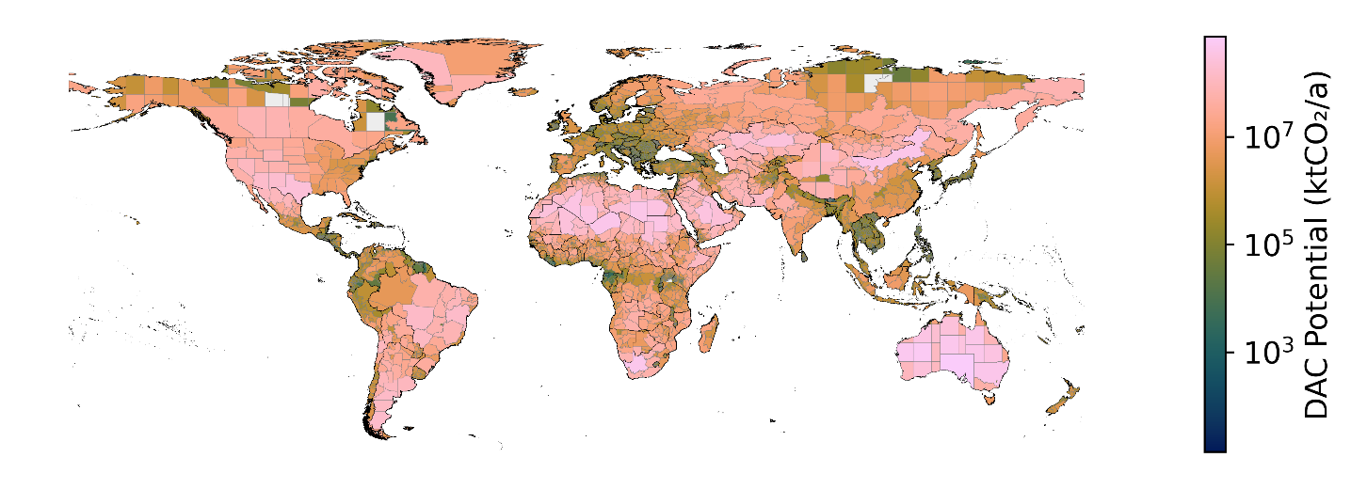
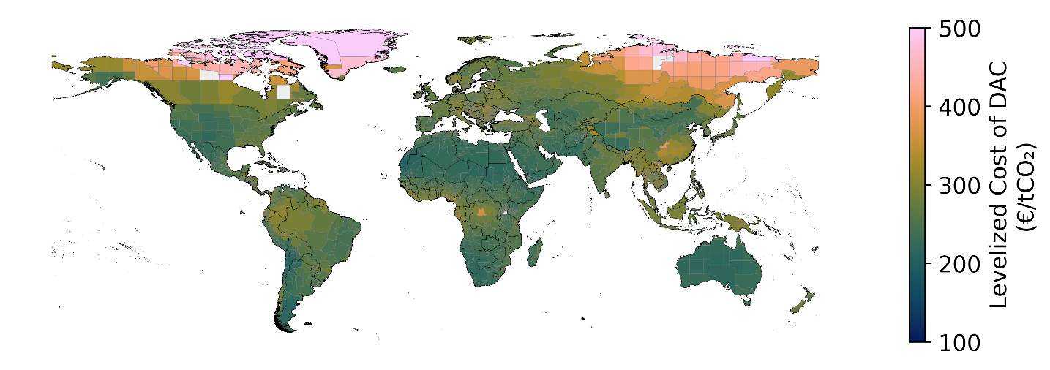
Figure S7. Global potential and levelized cost of S-DAC

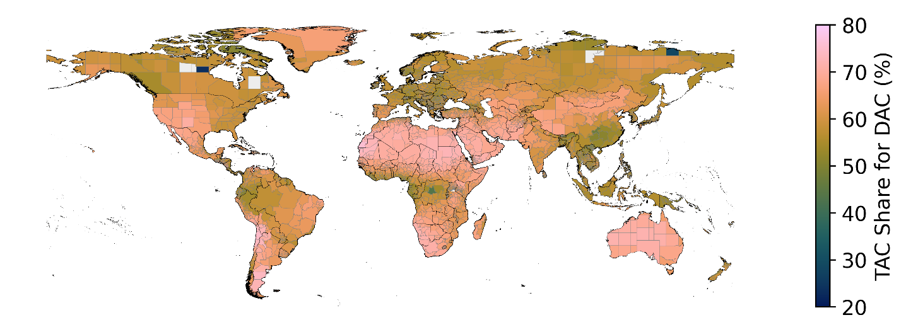
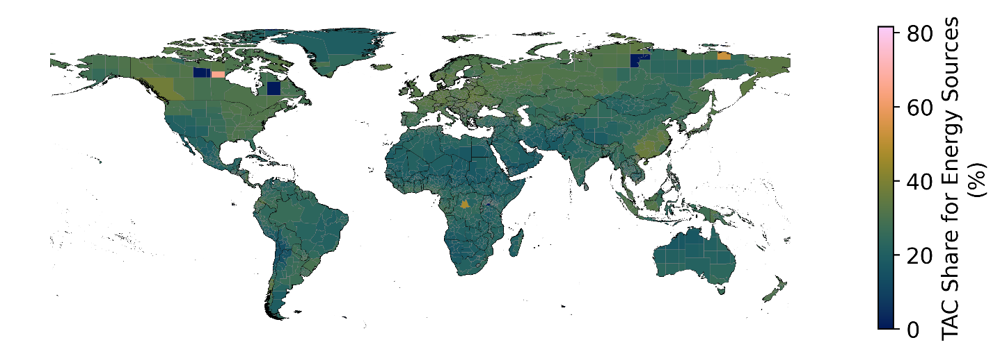
Figure S8. Total annualized cost share for S-DAC and energy sources

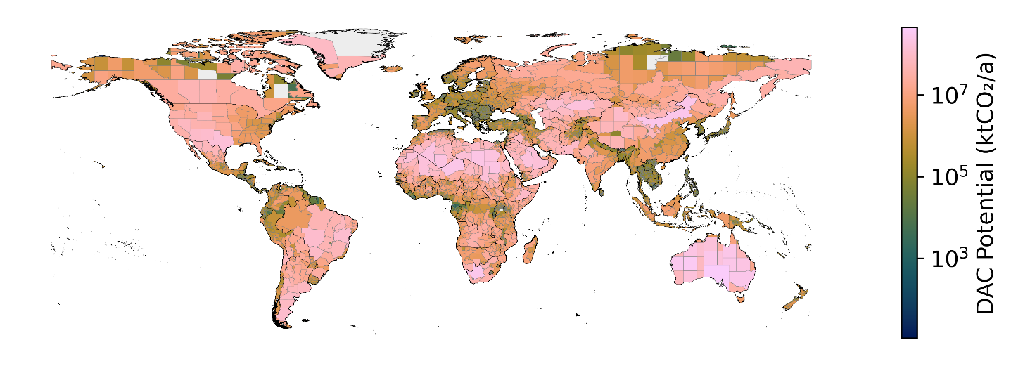
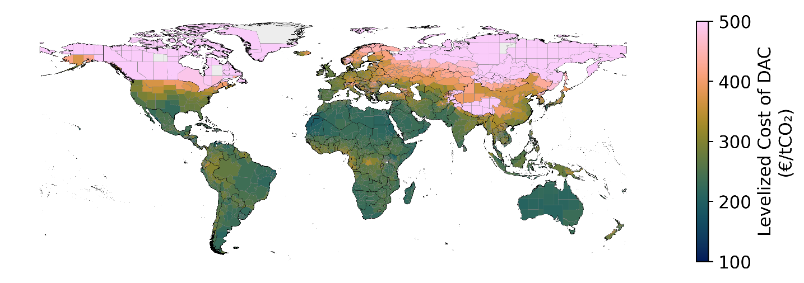
Figure S9. Global potential and levelized cost of L-DAC

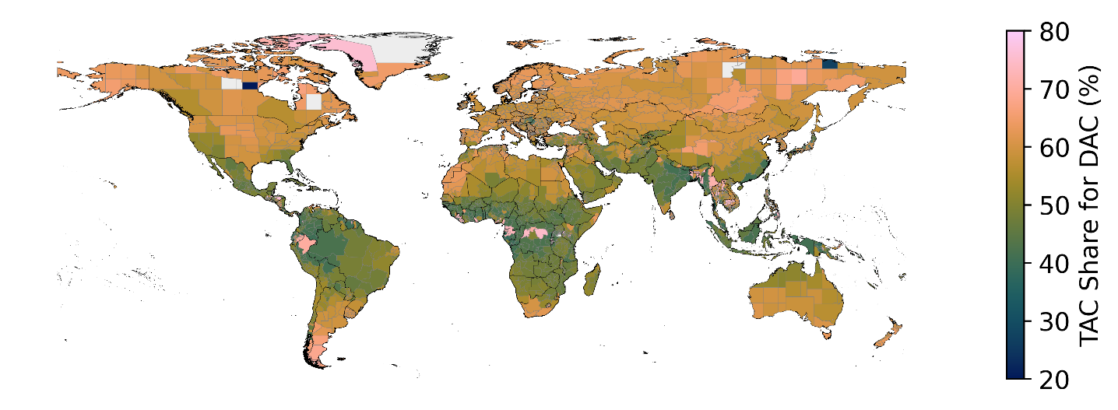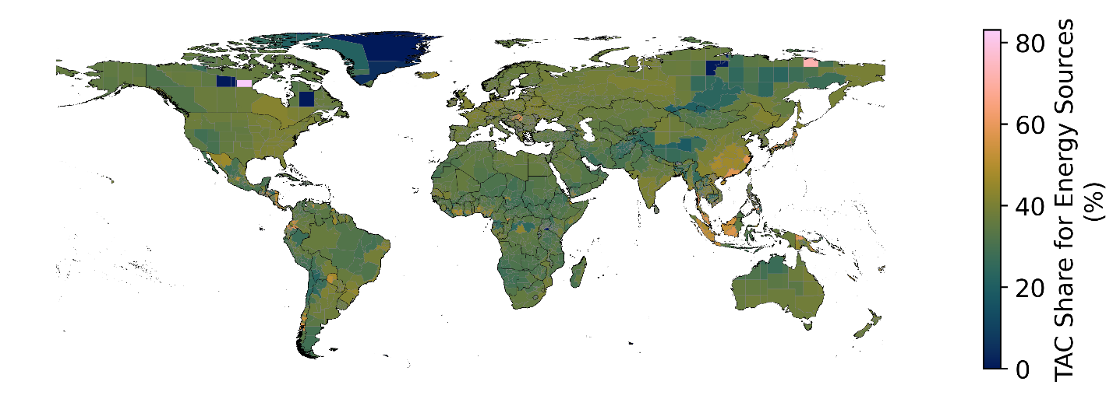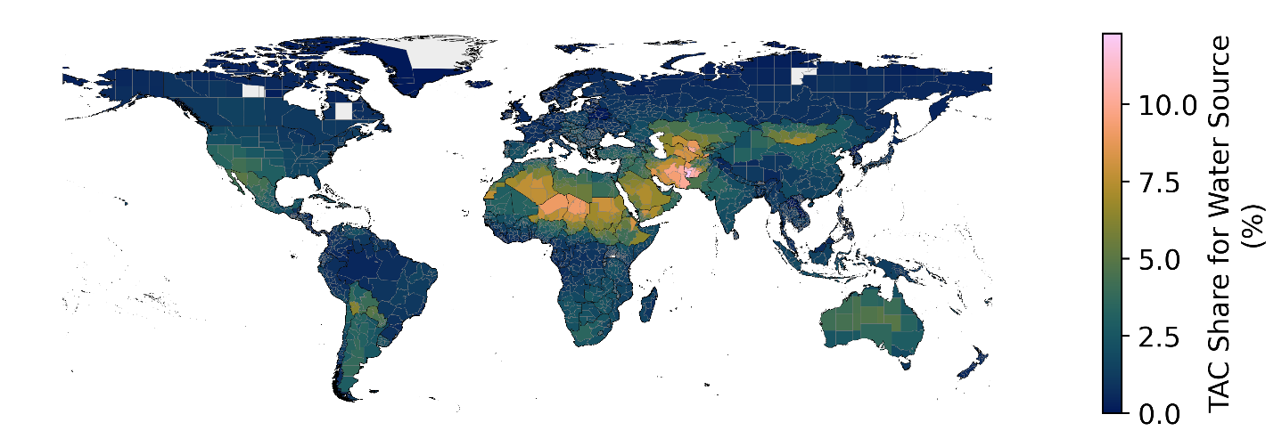
Figure S10. Total annualized cost share for L-DAC, energy and water sources

  - Hybrid Scenario
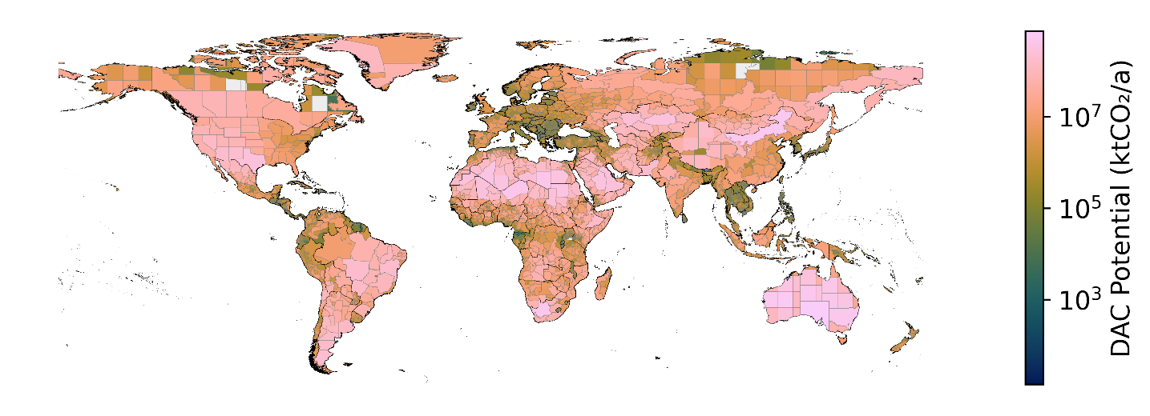
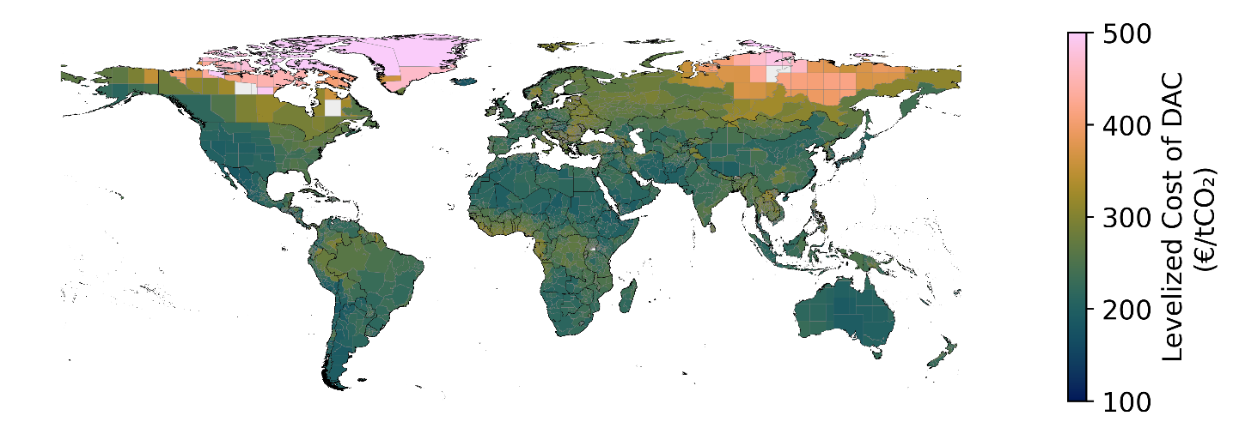
Figure S11. Global potential and levelized cost of S-DAC

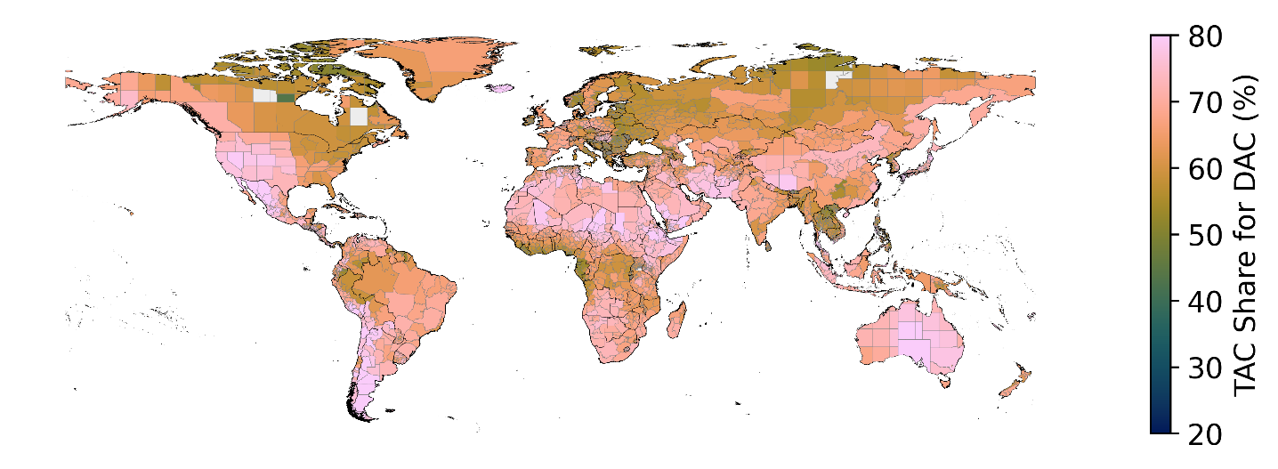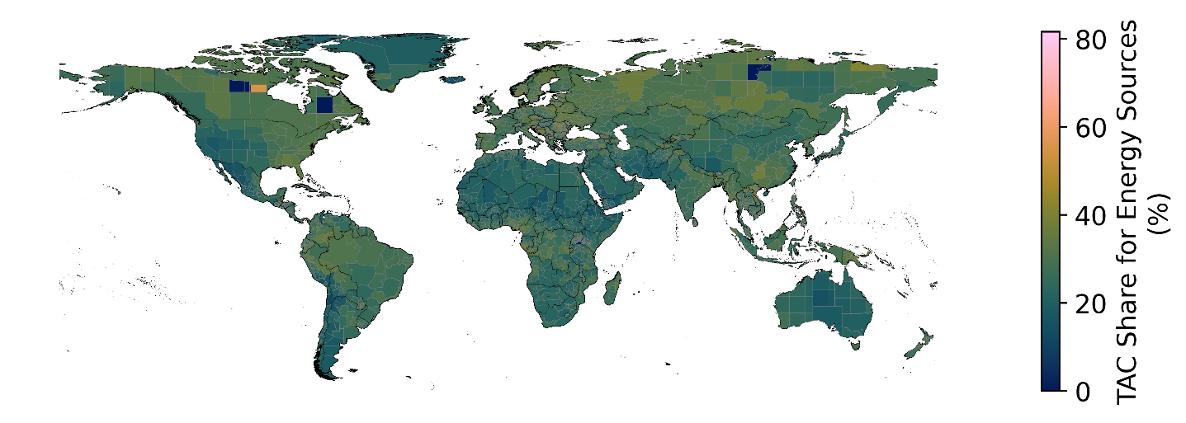
Figure S12. Total annualized cost share for S-DAC and energy sources

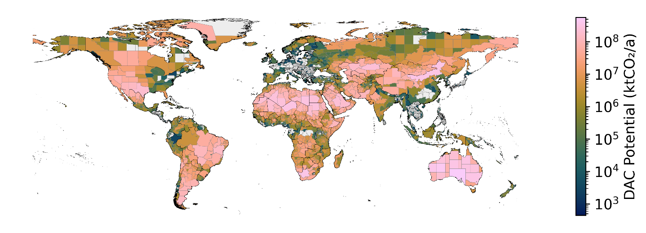
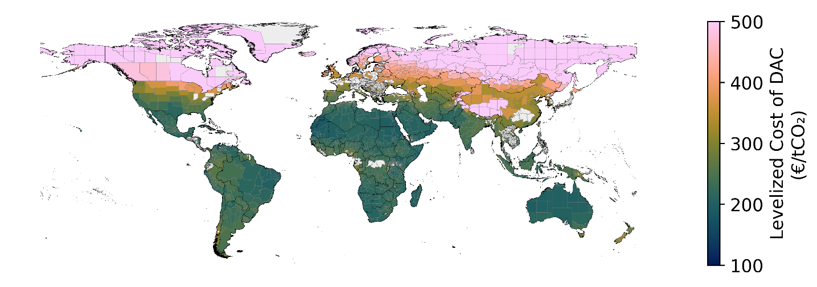
Figure S13. Global potential and levelized cost of L-DAC. White spots within the map represent regions with no CSP potential

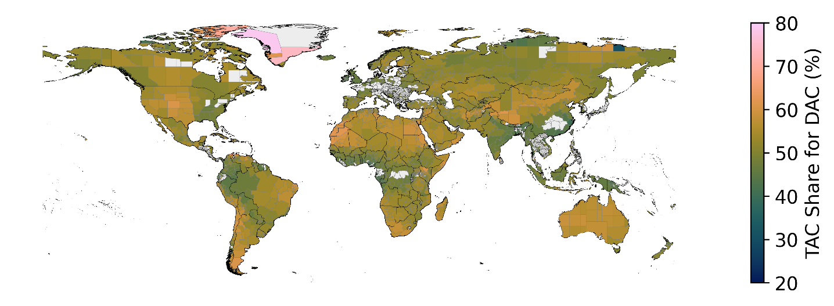
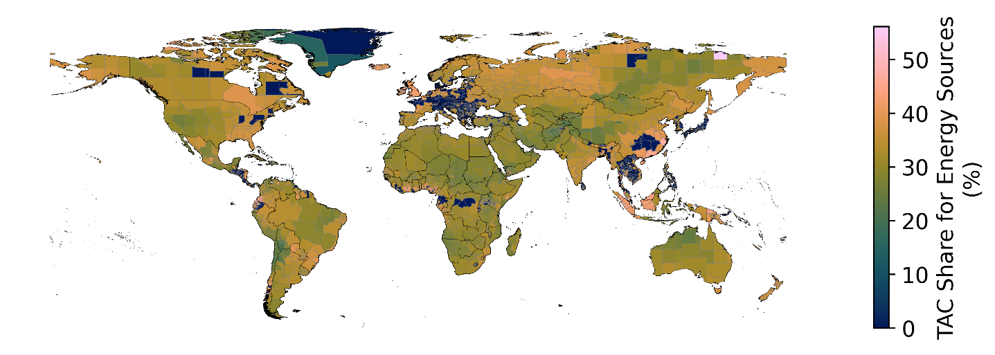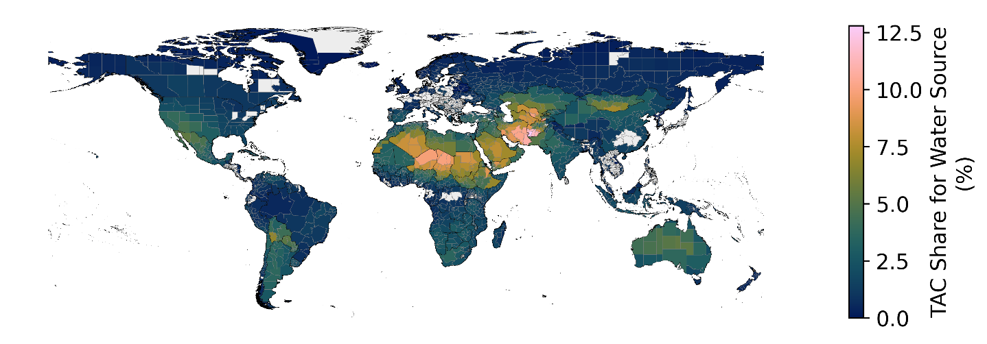
Figure S14. Total annualized cost share for L-DAC, energy and water sources

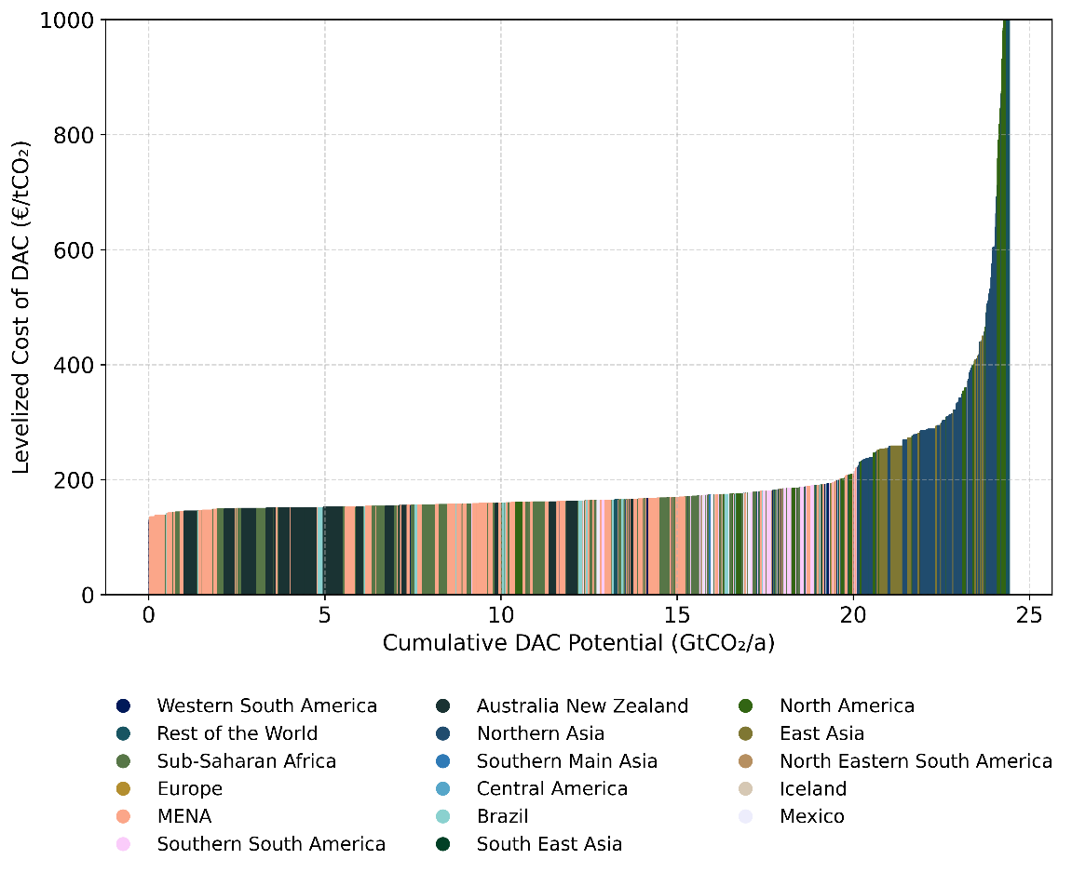
Figure S15. Global merit order for L-DAC in 2050 for the optimistic case
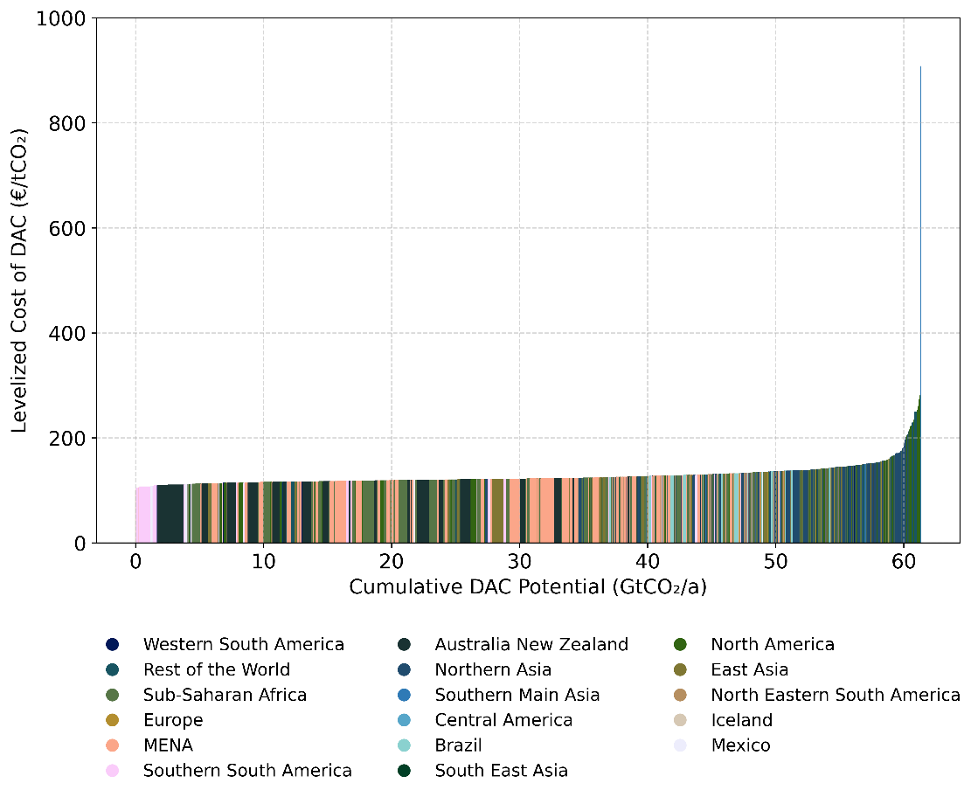
Figure S16. Global merit order for S-DAC in 2050 for the optimistic case
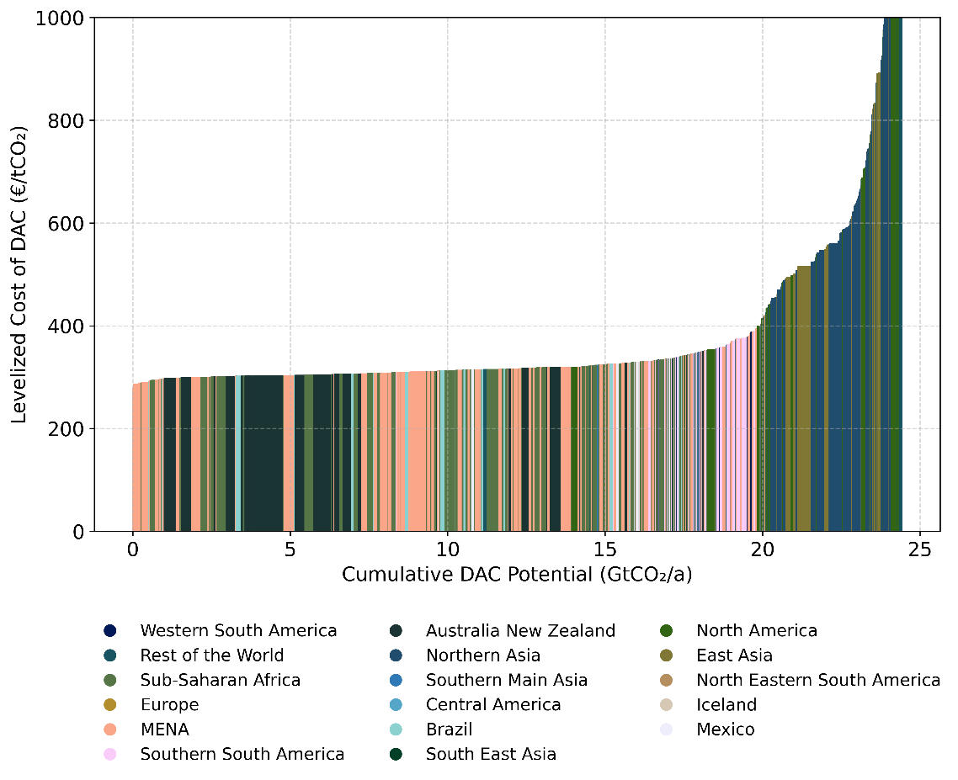
Figure S17. Global merit order for L-DAC in 2050 for the pessimistic case
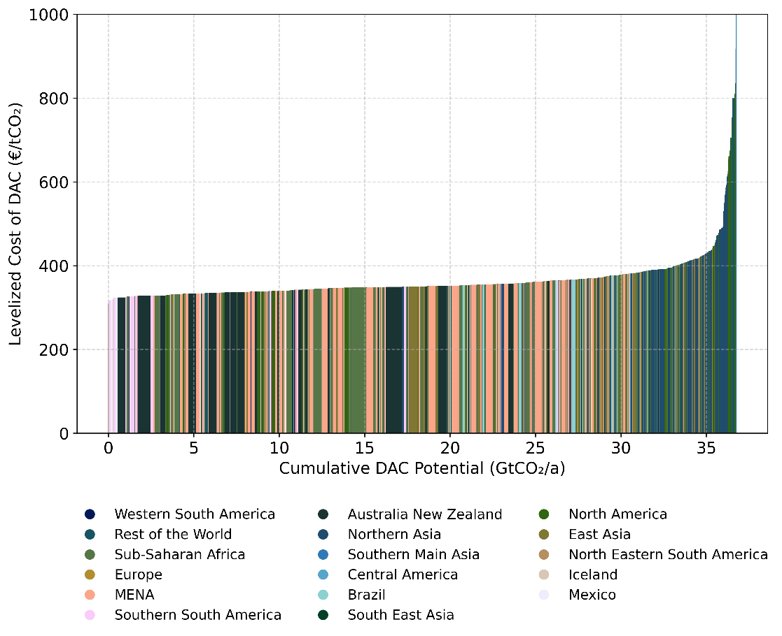
Figure S18. Global merit order for S-DAC in 2050 for the pessimistic case
  - Sensitivity Analysis
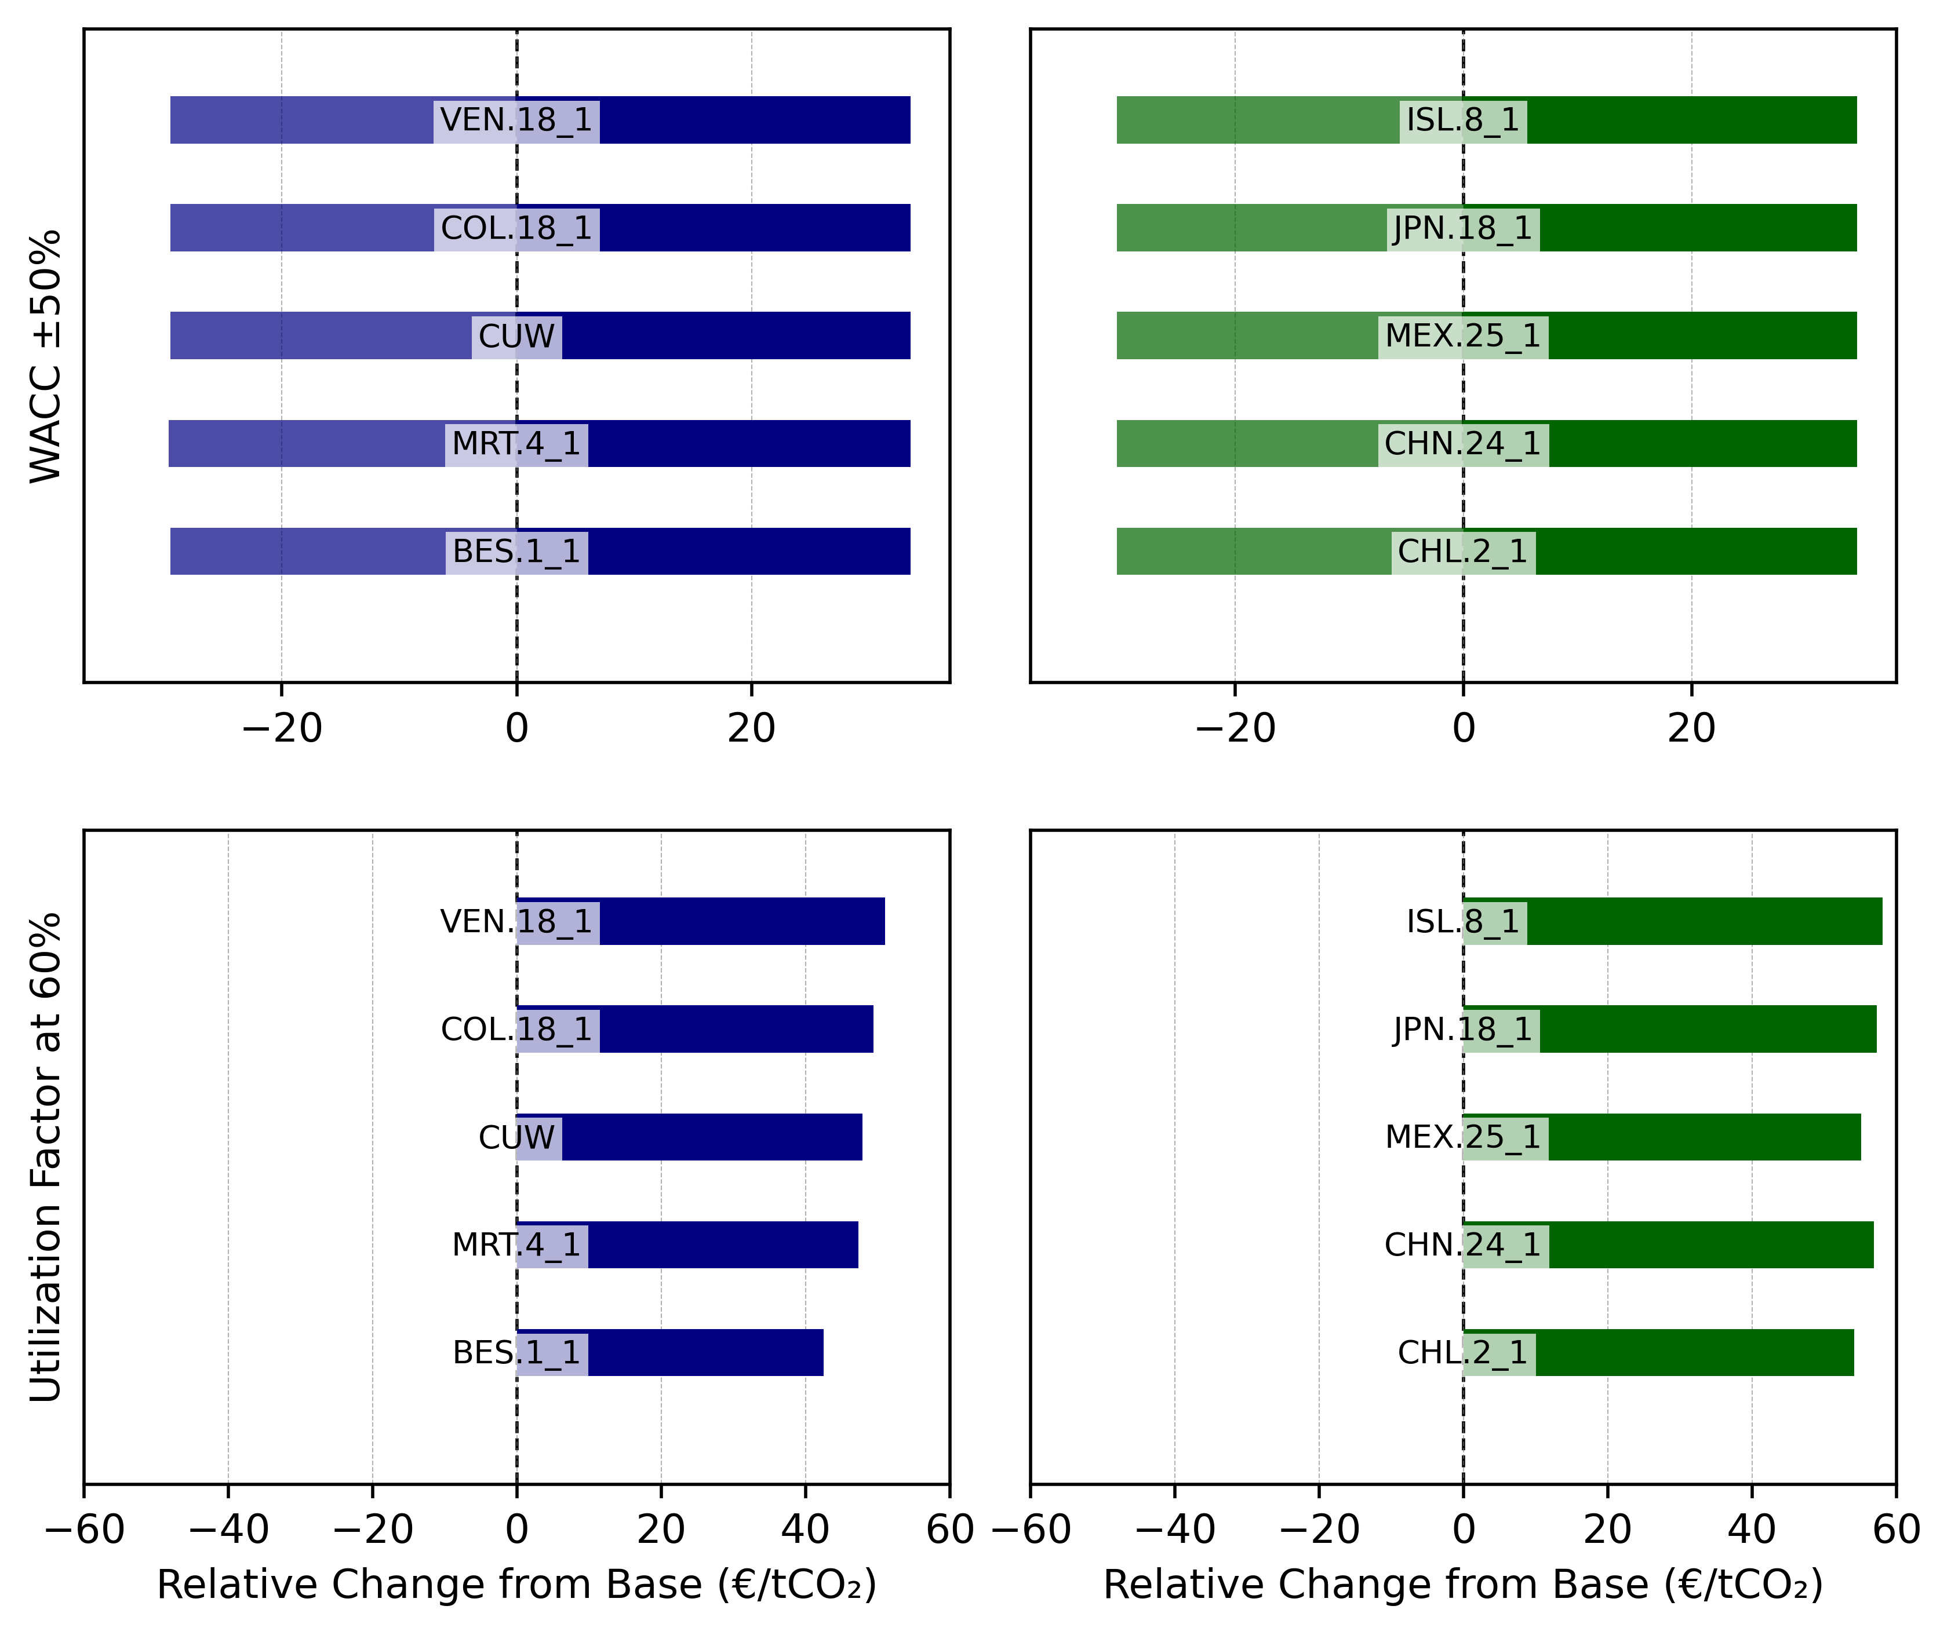
Figure S19. Sensitivity analysis of the levelized cost of DAC for low-cost regions in Figure 2 of the main paper. The blue color represents L-DAC, while the green color represents S-DAC. A-B. WACC costs were varied by ±50% from the base 10% to evaluate their influence on the levelized costs of S-DAC and L-DAC. C-D. The effect of a lower utilization factor of 60% (5256 FLH) from the base 90%.

References
1. Sonntag D. Important new values of the physical constants of 1986, vapour pressure formulations based on the ITS-90, and psychrometer formulae [Internet]. 1990. Available from: https://api.semanticscholar.org/CorpusID:99374562
2. Wexler A. Vapor Pressure Formulation for Water in Range 0 to 100 °C. A Revision. J Res Natl Bur Stand. 1976;80A.
3. An K, Farooqui A, McCoy ST. The impact of climate on solvent-based direct air capture systems. Appl Energy. 2022 Nov;325:119895. doi:10.1016/j.apenergy.2022.119895
4. Sendi M, Bui M, Mac Dowell N, Fennell P. Geospatial analysis of regional climate impacts to accelerate cost-efficient direct air capture deployment. One Earth. 2022 Oct;5(10):1153–64. doi:10.1016/j.oneear.2022.09.003
5. Shorey P, Abdulla A. Liquid solvent direct air capture’s cost and carbon dioxide removal vary with ambient environmental conditions. Commun Earth Environ. 2024 Oct 19;5(1):607. doi:10.1038/s43247-024-01773-1
6. Prats-Salvado E, Jagtap N, Monnerie N, Sattler C. Solar-Powered Direct Air Capture: Techno-Economic and Environmental Assessment. Environ Sci Technol. 2024 Feb 6;58(5):2282–92. doi:10.1021/acs.est.3c08269
7. Beck HE, McVicar TR, Vergopolan N, Berg A, Lutsko NJ, Dufour A, et al. High-resolution (1 km) Köppen-Geiger maps for 1901–2099 based on constrained CMIP6 projections. Sci Data. 2023 Oct 23;10(1):724. doi:10.1038/s41597-023-02549-6
8. Global CCS Institute. The Global Status of CCS [Internet]. Australia; 2023. Report No. Available from: https://www.globalccsinstitute.com/wp-content/uploads/2024/01/Global-Status-of-CCS-Report-1.pdf
9. Porthos. CO2 reduction through storage under the North Sea [Internet]. 2023. Available from: https://www.porthosco2.nl/en/
10. The CCUS Hub. Aramco Jubail [Internet]. 2022. Available from: https://ccushub.ogci.com/focus_hubs/aramco-jubail-ccs-hub/
11. Jacobs GK, Kerrick DM, Krupka KM. The high-temperature heat capacity of natural calcite (CaCO3). Phys Chem Miner. 1981 Mar;7(2):55–9. doi:10.1007/BF00309451
12. IEAGHG. Global Assessment of Direct Air Capture Costs [Internet]. 2021. Report No. Available from: https://publications.ieaghg.org/technicalreports/2021-05%20Global%20Assessment%20of%20Direct%20Air%20Capture%20Costs.pdf
13. Fasihi M, Efimova O, Breyer C. Techno-economic assessment of CO2 direct air capture plants. J Clean Prod. 2019 Jul;224:957–80. doi:10.1016/j.jclepro.2019.03.086
14. Sievert K, Schmidt TS, Steffen B. Considering technology characteristics to project future costs of direct air capture. Joule. 2024 Mar;S2542435124000606. doi:10.1016/j.joule.2024.02.005
15. Realmonte G, Drouet L, Gambhir A, Glynn J, Hawkes A, Köberle AC, et al. An inter-model assessment of the role of direct air capture in deep mitigation pathways. Nat Commun. 2019 Jul 22;10(1):3277. doi:10.1038/s41467-019-10842-5
16. Pett-Ridge J, Kuebbing S, Mayer A, Hovorka S, Pilorgé H, Ammar HZ, et al. Roads to removal: options for carbon dioxide removal in the United States [Internet]. 2023 Dec. Report No. Available from: https://roads2removal.org/wp-content/uploads/07_RtR_Direct-Air-Capture.pdf
17. Hanna R, Abdulla A, Xu Y, Victor DG. Emergency deployment of direct air capture as a response to the climate crisis. Nat Commun. 2021;12(1). Located at: Scopus. doi:10.1038/s41467-020-20437-0
18. Fuhrman J, Clarens A, Calvin K, Doney SC, Edmonds JA, O’Rourke P, et al. The role of direct air capture and negative emissions technologies in the shared socioeconomic pathways towards +1.5 °C and +2 °C futures. Environ Res Lett. 2021 Nov 1;16(11):114012. doi:10.1088/1748-9326/ac2db0
19. Young J, McQueen N, Charalambous C, Foteinis S, Hawrot O, Ojeda M, et al. The cost of direct air capture and storage can be reduced via strategic deployment but is unlikely to fall below stated cost targets. One Earth. 2023 Jul;6(7):899–917. doi:10.1016/j.oneear.2023.06.004
20. McQueen N, Desmond MJ, Socolow RH, Psarras P, Wilcox J. Natural Gas vs. Electricity for Solvent-Based Direct Air Capture. Front Clim. 2021 Jan 27;2:618644. doi:10.3389/fclim.2020.618644
21. Keith DW, Holmes G, St. Angelo D, Heidel K. A Process for Capturing CO2 from the Atmosphere. Joule. 2018 Aug;2(8):1573–94. doi:10.1016/j.joule.2018.05.006
22. IEA. Global Energy and Climate Model key input data [Internet]. [cited 2025 Oct 17]. Available from: https://www.iea.org/data-and-statistics/data-product/global-energy-and-climate-model-key-input-data
23. Neue Ziele auf alten Wegen? Strategien für eine treibhausgasneutrale Energieversorgung bis zum Jahr 2045. Jülich: Forschungszentrum Jülich GmbH, Zentralbibliothek, Verlag; 2022.
24. Okosun K, Wenzel H, Harzendorf F, Schöb T, Đukan M, Linßen J, et al. Global strategic deployment of Direct Air Capture technologies (Unpublished). 2026.
25. Franzmann D, Heinrichs H, Stolten D. Global geothermal electricity potentials: A technical, economic, and thermal renewability assessment. Renew Energy. 2025 Sep;250:123199. doi:10.1016/j.renene.2025.123199
26. European Commission. Joint Research Centre., ILF Consulting Engineers Austria GmbH., AIT Austrian Institute of Technology GmbH. Long term (2050) projections of techno-economic performance of large-scale heating and cooling in the EU. [Internet]. LU: Publications Office; 2017 [cited 2025 Aug 13]. Available from: https://data.europa.eu/doi/10.2760/24422
27. Wenzel H, Harzendorf F, Okosun K, Schöb T, Weinand JM, Stolten D. Weather conditions severely impact optimal direct air capture siting. Adv Appl Energy. 2025 Sep;19:100229. doi:10.1016/j.adapen.2025.100229
28. Hatton L, Johnson N, Dixon L, Mosongo B, De Kock S, Marquard A, et al. The global and national energy systems techno-economic (GNESTE) database: Cost and performance data for electricity generation and storage technologies. Data Brief. 2024 Aug;55:110669. doi:10.1016/j.dib.2024.110669
29. Caldera U, Breyer C. Strengthening the global water supply through a decarbonised global desalination sector and improved irrigation systems. Energy. 2020 Jun;200:117507. doi:10.1016/j.energy.2020.117507

