Supplementary Information

Nanoengineered Dual-Functional Protein Coatings Conferring Antithrombotic and Antimicrobial Protection to Vascular Stents

Xiang Wu^{1, 2, 3#}, Doudou Tang^{4#}, Peiru Zhang^{3#}, Junjie Deng^{5#}, Mengjie Li⁴, Jian Zhuo⁶, Hanjie Shao¹, Jun Li⁷, Jingyun Ma¹, Huigang Li^{2, 3}, Xinhua Zhou¹, Yanhua Wan⁸, Haili Li⁹, Wei Jian^{10*}, Yongchun Liu^{4*}, Xiao Xu^{2, 3*}, Di Lu^{2, 3, 9*} & Hong Li^{1*}

¹ Ningbo Medical Center Li Huili Hospital; Health Science Center, Ningbo University, Ningbo 315000, P. R. China
² Hepatobiliary Center, The First Affiliated Hospital of Nanjing Medical University, Nanjing, 210000, P. R. China
³ Zhejiang University School of Medicine, 310000, P. R. China
⁴ Key Laboratory of Applied Surface and Colloid Chemistry, Ministry of Education, Xi'an Key Laboratory of Organometallic Material Chemistry, Xi'an Key Laboratory of Polymeric Soft Matter, School of Chemistry and Chemical Engineering, Shaanxi Normal University, Xi'an 710119, P. R. China.
⁵ Centre for Translational Medicine Research & Development, Shenzhen Institutes of Advanced Technology, Chinese Academy of Sciences, Shenzhen 518055, P. R. China
⁶ Health Science Center, Ningbo University, Ningbo 315000, P. R. China
⁷ School of Basic Medical Sciences and Forensic Medicine, Hangzhou Medical College, Hangzhou, Zhejiang, 310000, P. R. China
⁸ Third Department of General Surgery, Jiujiang First People's Hospital, Jiujiang, 332000, P. R. China
⁹ Ningbo Clinical Pathology Diagnosis Center, Ningbo, 315211, PR China
¹⁰ School of Mechanics and Engineering Science, Ningbo University, Ningbo, 315211, PR China

# X. W, DD. T, PR. Z and JJ.D contributed equally to this work.
* Corresponding authors: Wei Jian: jianwei@nbu.edu.cn; Yongchun Liu: surfbioliu@snnu.edu.cn; Di Lu: zjuludi@zju.edu.cn; Xiao Xu: zjxu@zju.edu.cn and Hong Li: lihong196311@163.com

This file includes:
Supplementary Discussion
Supplementary Figures 1 to 9
Materials
Methods
References

Table of Contents
Supplementary Discussion 5
1. Morphology of the hemoglobin-derived coating 5
2. XPS survey scan of the PTH coating 5
3. Conformational transitions via tryptophan fluorescence 5
4. Analysis of pH-dependent roughness variation 6
5. Molecular insights into the hydration layer via RDF analysis 6
6. Colony formation assay 7
6. Assessment of in vivo platelet adhesion 8
7. Analysis of the spleen transcriptome to assess systemic immune homeostasis 8
8. Risk assessment and functional monitoring 10
Supplementary Figures 15
Supplementary Figure 1 15
Supplementary Figure 2 15
Supplementary Figure 3 16
Supplementary Figure 4 16
Supplementary Figure 5 17
Supplementary Figure 6: 17
Supplementary Figure 7: 17
Supplementary Figure 8: 18
Supplementary Figure 9: 19
Materials 20
Methods 20
Regulation of coating thickness by pH, protein concentration, TCEP concentration and coating cycles 20
Morphological and structural characterization of PTH coatings 21
Optical transmittance 22
UV-vis fluorescence and ThT/ANS binding assays 22
Thioflavin T (ThT) binding 22
ANS binding 23
Circular dichroism (CD) spectroscopy(chirascan) 23
FTIR(Vertex70) 23
Dynamic light scattering (DLS) 24
Adhesion, wettability and shear resistance of PTH coatings 24
X-ray photoelectron spectroscopy (XPS Escalab Xi+) 24
Water contact angle and wettability stability 24
Contact angle and surface morphology under fluid shear 25
Friction coefficient 25
Anti-Platelet adhesion 25
Quartz Crystal Microbalance (QCM) 25
Anti-bacterial adhesion 26
HUVEC culture 27
Cell viability (CCK-8 assay) 27
Live/dead staining 27
Hemolysis assay 27
Scratch wound-healing assay 28
Western blot analysis of signaling proteins in cells 28
Western blot of vascular tissues and platelet adhesion on stents 28
Ex vivo tissue and blood analysis 29
Histology and immunohistochemistry (IHC) 29
Transcriptome sequencing and bioinformatic analysis 29
References 29

Supplementary Discussion

1. Morphology of the hemoglobin-derived coating
The morphology of self-assembled heme-depleted hemoglobin coatings on silicon wafers under optimized conditions is shown in Figure S1. The coating formed a uniform, dense layer with a smooth surface, devoid of any detectable large-area cracking or delamination (Figure S1a). High-magnification imaging of localized regions revealed fine nanoscale textures (Figure S1b), indicative of a relatively uniform nanostructure at the microscale. Optimized conditions—hemoglobin concentration: 2 mg/mL; TCEP concentration: 50 mM; volume ratio: 1:1; temperature: 30 °C—enabled formation of a continuous, stable, and uniform PTH coating on silicon wafers within 2 hours. These parameters establish a reproducible fabrication protocol for PTH coatings on vascular graft materials such as ePTFE and Dacron. Moreover, morphological analysis confirms the favorable interfacial assembly of heme-depleted hemoglobin¹.

2. XPS survey scan of the PTH coating
The XPS survey scan spectrum shown in Figure S2 reveals that the elemental ratios of C, N, and O in the PTH coating are similar to those in pure bovine hemoglobin powder, with no characteristic peaks for other elements such as TCEP, indicating that no additional impurities were introduced during the coating preparation². The spectrum also shows significantly enhanced signals for C, N, and O on the PTH-coated surface, while the characteristic peaks of the substrate material (e.g., F, Si) are attenuated or partially suppressed, suggesting that the substrate is covered by a protein-rich coating. The comparison with the uncoated substrate further confirms that heme-depleted hemoglobin has successfully formed a continuous and sufficiently thick overlayer, effectively attenuating the elemental signals from the underlying substrate.

3. Conformational transitions via tryptophan fluorescence
Figure S3 shows the temporal fluorescence profiles of tryptophan residues in hemoglobin during TCEP-induced self-assembly. Upon transition from the native α-helical conformation to a β-sheet-enriched amyloid-like state, an increase in fluorescence intensity around 340 nm is observed, reflecting the exposure of hydrophobic regions upon protein unfolding and aggregation³. The progression of unfolding and β-sheet-rich aggregate formation is depicted by the differently colored trajectories. These spectral shifts are consistent with a TCEP-driven conformational rearrangement of hemoglobin, leading to the formation of amyloid-like aggregates that underpin PTH coating self-assembly. Such structural transitions are essential for generating a stable and functional protein coating suitable for vascular surface modification.

4. Analysis of pH-dependent roughness variation
Figure S4 shows the quantitative variation in surface roughness of PTH coatings prepared under different reaction pH. Overall, surface roughness exhibits a significant increasing trend with elevated pH of the reaction solution: under acidic conditions (e.g., pH 5–5.5), the PTH coating surfaces are relatively smooth with low roughness values, whereas under near-neutral or alkaline conditions (e.g., pH 6–6.5), surface roughness increases markedly, indicating that the protein forms richer micro/nano-scale topographical features during interfacial self-assembly. Surface roughness is a critical parameter influencing blood-contacting interfacial behaviors, including protein adsorption, platelet adhesion, and cell adhesion. Figure S4 demonstrates that the surface roughness of PTH coatings can be precisely tuned by simply adjusting the pH of the reaction solution, thereby providing a process basis for "tailoring" interfacial topology according to specific application requirements (e.g., anticoagulation, endothelialization). For this study, PTH coatings were prepared under pH that balance coating integrity with appropriate roughness, facilitating simultaneous optimization of hemocompatibility and cytocompatibility⁴.

Molecular insights into the hydration layer via RDF analysis
Figure S5 presents the Radial Distribution Function (RDF) analysis of water molecules (O_{w}) relative to the PTH coating surface, providing atomistic insights into its superior anti-biofouling properties. Overall, the g (r) curve exhibits a sharp and prominent primary peak located at approximately r ≈ 0.28 nm, indicating the formation of a highly ordered and dense first hydration shell at the coating interface. This strong surface hydration is primarily driven by robust hydrogen bonding and electrostatic interactions between water molecules and the hydrophilic residues within the phase-transitioned protein network. The presence of such a well-defined hydration layer is a critical parameter influencing blood-contacting interfacial behaviors, as it creates a formidable physical and energetic barrier (as depicted in the MD simulation in Figure 4k) that prevents non-specific protein adsorption and subsequent cell adhesion. Figure S5 demonstrates that the PTH coating can effectively “lock” water molecules to form a stable, continuous “water film”, which shields the underlying substrate from hydrophobic interactions and van der Waals forces. This molecular-level hydration mechanism serves as the fundamental basis for the exceptional hemocompatibility and anti-biofouling performance observed in experimental assays, ensuring that the PTH surface remains resistant to platelet and bacterial attachment under physiological conditions.

6. Colony formation assay
Representative images (Figure S6a) show that the uncoated control group formed relatively fewer and smaller colonies, with sparse distribution, whereas the PTH-coated group displayed a markedly higher number of colonies, with a denser distribution, indicating enhanced cell proliferation. Quantitative analysis (Figure S6b) confirmed that the PTH coating significantly increased the number of colonies per unit area compared with the uncoated control. The colony formation assay directly reflects the proliferative capacity of endothelial cells under conditions with or without the PTH coating. Figure S6 demonstrates that the PTH coating not only does not inhibit endothelial cell proliferation but rather significantly promotes cell proliferation, as evidenced by the increased colony formation. This is consistent with the enhanced wound healing observed in the PTH-coated group in the scratch wound healing assay, indicating that the PTH coating provides a favorable microenvironment for endothelial cell proliferation and regeneration of the vascular surface. For vascular graft materials, this pro-proliferative behavior facilitates early postoperative endothelialization, thereby reducing the risk of thrombosis and intimal hyperplasia.

6. Assessment of in vivo platelet adhesion
In the uncoated control group (Figure S7a), substantial platelet adhesion was observed on the graft lumen, with some regions showing highly aggregated and spread platelets exhibiting extended pseudopodia, indicative of platelet activation or even hyperactivation, and forming the morphological basis for early thrombus-like deposition. In the PTH-coated group (Figure S7b), the number of platelets on the luminal surface at the same timepoint was markedly reduced, with residual platelets mostly distributed in isolation, showing significantly diminished spreading and almost no extensive platelet aggregation or mesh-like structures. The in vivo SEM findings are highly consistent with in vitro platelet adhesion and coagulation assays: the PTH coating significantly attenuates platelet adhesion and activation on the graft luminal surface, mitigating the morphological substrate for early thrombosis. The preservation of this anti-platelet adhesion characteristic under genuine hemodynamic shear conditions and complex plasma protein milieu demonstrates that the PTH coating maintains stable anticoagulant interfacial function in vivo. Combined with subsequent systemic parameters including platelet counts, and other coagulation indices, these results suggest that the PTH coating achieves an optimal balance between “local anti-platelet adhesion” and “absence of systemic hypercoagulability”, thereby contributing to enhanced early patency rates of vascular grafts.

7. Analysis of the spleen transcriptome to assess systemic immune homeostasis
Figure S8a presents a transcriptomic clustering heatmap of spleen tissues across treatment groups. Overall, samples from the PTH-coated and uncoated groups did not separate into two distinct clusters, instead maintaining relatively close expression profiles, with divergence confined to specific gene sets. This suggests that the PTH coating exerts a limited and targeted influence on splenic gene expression, rather than inducing broad transcriptional reprogramming. For an implantable material, a strong systemic immune reaction—often reflected as clear sample segregation and widespread gene expression changes in the spleen—was not observed. The similarity in global expression patterns between groups, with differences emerging only in pathway‑related genes, indicates that the PTH coating preserves splenic immune homeostasis while eliciting only mild, localized immunomodulation without triggering systemic hyperactivation.
Figure S8b identifies differentially expressed genes (DEGs) between the PTH-coated and uncoated groups using thresholds of |logFC| > 0.5 and p < 0.05. The number of significantly up- or down-regulated genes was modest, with most logFC values indicating moderate rather than large-fold changes. This limited scale and magnitude of differential expression suggest that the PTH coating induces “fine‑tuning” rather than “remodeling” of the splenic transcriptome. On one hand, this reflects the material’s bioactive, immunomodulatory properties; on the other, it demonstrates that such modulation does not disrupt overall immune homeostasis. Thus, the PTH coating elicits a clinically favorable systemic response—gently reshaping the local immune microenvironment without provoking systemic imbalance.
Figures S8c–d show the results of GO and GSEA–KEGG enrichment analyses performed on the identified DEGs. The significantly enriched terms were primarily related to immune regulation, inflammatory balance, cell migration/recruitment, and tissue homeostasis maintenance, rather than broad upregulation of typical high‑intensity pro‑inflammatory or acute immune‑activation pathways. Notably, pathways strongly linked to intense inflammatory responses—such as NF‑κB hyperactivation or cytokine storm‑associated signaling—showed no significant enrichment or upward trend. This functional enrichment profile, which favors immunomodulation and homeostasis over global pro‑inflammatory signaling, is of considerable relevance. It indicates that, at the splenic level, the PTH coating acts mainly by fine‑tuning the immune microenvironment—supporting local vascular repair through moderate regulation of immune‑cell migration and activation—while avoiding sustained amplification of strong pro‑inflammatory signals that could provoke systemic inflammatory injury. This pattern aligns with the “inflammation‑downregulating, repair‑upregulating” tendency observed in the liver transcriptome and at the level of the PI3K–AKT–mTOR pathway described in the main text.

8. Risk assessment and functional monitoring
Figure S9a displays peripheral platelet counts at various time points. Platelet counts in both groups remained within physiological ranges throughout, without severe thrombocytopenia or extreme elevation. The PTH-coated group did not show sustained higher platelet counts than the uncoated group, indicating that the coating does not induce additional hypercoagulable states. Platelets are a critical hub linking inflammation and thrombosis, and their sustained elevation or abnormal activation significantly increases thrombotic risk. Previous in vitro experiments have confirmed that PTH coating markedly reduces platelet adhesion on material surfaces and prolongs PT/APTT, demonstrating excellent anticoagulant properties. Building on this, Figure S9g shows that platelet counts in systemic circulation were not driven toward hypercoagulability, indicating that PTH coating achieves a favorable balance between "local reduction of platelet adhesion" and "absence of systemic hypercoagulation," which is expected to reduce graft-associated thrombotic complications.
Figure S9b shows the temporal profile of calcitonin (or procalcitonin) levels. Throughout the follow-up period, this parameter showed no sustained abnormal elevation in either group, with levels in the PTH-coated group remaining comparable to those in the control group and no extreme values indicative of severe bacterial infection or sepsis. Calcitonin, particularly procalcitonin, is an important clinical biomarker for evaluating severe bacterial infection and sepsis. If an implanted material causes severe infection or sepsis, its levels typically show significant and sustained elevation. The stable calcitonin levels in the PTH-coated group, which were not higher than the control group, demonstrate that the PTH coating does not increase the risk of severe infection or sepsis-related complications during in vivo application, consistent with its in vitro ability to inhibit bacterial adhesion and biofilm formation.
Figures S9c–e depicts serum levels of IL-1β, IL-6, and TNF-α, three canonical pro-inflammatory cytokines. In the early postoperative period, both groups exhibited variable elevations of these inflammatory markers, followed by a subsequent decline. Compared with the uncoated group, the PTH-coated group displayed lower IL-6 and TNF-α levels at most time points, with statistically significant differences observed at several key time points; IL-1β in the PTH-coated group likewise did not exhibit sustained upregulation relative to the control group. IL-1β, IL-6, and TNF-α are key upstream mediators that amplify the inflammatory cascade, and their sustained overexpression is closely associated with tissue injury, thrombosis, and organ dysfunction⁵. As previously demonstrated through liver transcriptome and Western blotting analyses, PTH coating attenuates activation of the PI3K–AKT–mTOR pathway, consequently suppressing the expression of inflammatory factors such as TNF-α and IL-6. These findings of reduced systemic cytokine levels corroborate this molecular mechanism: they demonstrate that while PTH coating attenuates local inflammatory signaling, its effects extend systemically, and provide systemic-level evidence supporting the mitigating effect of PTH coating on postoperative inflammatory peaks, which is beneficial for reducing secondary damage to the vasculature and liver.
Figure S9f illustrates the temporal profile of C-reactive protein (CRP). In both group, CRP levels showed modest elevations in the early postoperative period, followed by a decline, exhibiting a typical pattern of postoperative inflammatory stress. Compared with the uncoated group, the PTH-coated group exhibited no sustained abnormal elevation in overall CRP levels and was marginally lower than the control group at certain time points. As a canonical acute-phase protein, CRP is clinically utilized to evaluate systemic inflammatory response and infection severity; implantation materials that induce significant systemic inflammation or infection usually exhibit sustained CRP elevation. In this study, the PTH-coated group displayed only transient fluctuations attributable to surgical trauma, with overall levels not exceeding those of the control group, indicating that the PTH coating did not provoke significant systemic inflammatory exacerbation while performing its local functions. These findings align well with its anti-inflammatory and antibacterial properties demonstrated in vitro.
Figure S9g shows changes in peripheral total leukocyte counts. In the early postoperative period, leukocyte counts in both groups transiently increased, then decreased and stabilized. The PTH-coated group did not exhibit persistently and significantly higher leukocyte counts than the control group; at some time-points, the PTH coating group even displayed slightly lower counts, indicating that its systemic inflammatory burden was not greater than that of conventional uncoated stents. Total leukocyte count serves as a comprehensive indicator of the body's overall response to surgical trauma, foreign bodies, and infection. The overlapping or slightly lower WBC curve in the PTH-coated group suggests that the coating did not induce additional bone marrow mobilization or massive recruitment of inflammatory cells, consistent with the histological finding of reduced immune cell infiltration in the vascular wall (decreased CD68 staining).
Figure S9h further presents the dynamic profile of neutrophil counts. Both groups showed elevated neutrophil proportions or absolute numbers in the early postoperative period, which declined over time. The PTH-coated group did not demonstrate prolonged or higher-magnitude neutrophil elevation compared with the control group; in fact, it exhibited a faster decline at certain time points. Neutrophils are central effector cells in acute inflammatory and infectious responses, and their sustained elevation typically indicates significant acute inflammatory or infectious burden. The absence of a prolonged or exacerbated neutrophil pattern in the PTH-coated group suggests that, while not impairing necessary defensive responses, the coating does not drive long-term high-level neutrophil activation, thereby reducing the risk of secondary tissue damage from material-associated inflammation.
Figure S9i presents the dynamic changes in serum alanine aminotransferase (ALT) levels in rats at different postoperative time points. Both groups showed mild ALT elevation in the early postoperative period, consistent with transient hepatocellular stress caused by surgical trauma and anesthetic stress, followed by a gradual decline over time. Overall, the PTH-coated group exhibited no sustained abnormal elevation in ALT levels at any time point, with changes comparable in magnitude to the uncoated group. ALT, primarily derived from hepatocyte cytoplasm, is a sensitive indicator of hepatocellular injury. Systemic hepatotoxicity of an implanted material typically manifests as sustained and marked ALT elevation. In this study, ALT in the PTH-coated group only showed transient fluctuations consistent with surgical stress, gradually recovered thereafter, and overall levels did not exceed those of the control group, suggesting that under the current dosage and implantation conditions, the PTH coating did not induce additional hepatocellular necrosis or liver function impairment. From the perspective of hepatic safety, these results provide the first layer of biochemical evidence for the long-term in vivo application of the PTH coating.
Figure S9j illustrates the temporal changes in serum aspartate aminotransferase (AST) levels in rats. Similar to ALT, AST levels in both groups increased to some extent in the early postoperative period and then gradually decreased and stabilized. Throughout the observation period, the PTH-coated group showed no sustained and significantly higher AST levels compared with the uncoated group, indicating that the PTH coating does not aggravate surgery-related liver injury. AST reflects both hepatocellular injury and can be affected by damage to other tissues; marked systemic toxicity or severe circulatory burden typically results in sustained AST elevation. In this study, neither ALT nor AST showed unfavorable changes in the PTH-coated group, and their temporal trends were highly consistent with those of the control group, demonstrating that the PTH coating does not introduce additional hepatic or myocardial toxicity at the systemic level, which is favorable for the long-term safe implantation of stents.
Collectively, based on the spleen transcriptomic analysis (Figure S8), and dynamic monitoring results of multi-dimensional systemic inflammation and thrombosis/infection-related indicators (Figure S9), it can be concluded that the PTH-coated vascular grafts did not induce additional hepatotoxicity, aberrant systemic immune activation, or hypercoagulability/severe infection risk under long-term implantation conditions in vivo. Combined with the pro-endothelial repair and anti-inflammatory effects observed at the local vascular and hepatic tissue levels in previous sections, these systemic-level results collectively constitute a relatively complete chain of safety evidence, providing robust support for the translational application of PTH coating in high-risk vascular reconstruction, liver transplantation, and other clinical scenarios.

Supplementary Figures

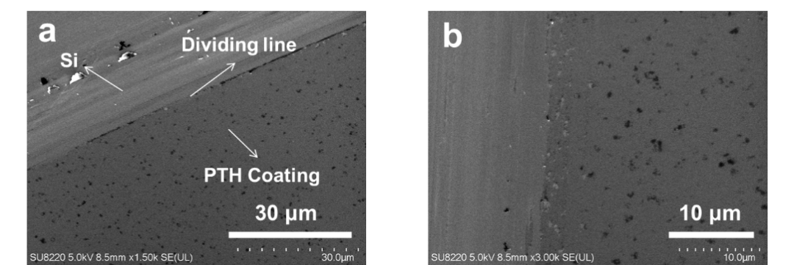
Supplementary Figure 1: SEM image of PTH coating formed by mixing hemoglobin (2 mg/ml) with TCEP (50 mM) in a 1:1 ratio, followed by 2 hours of inverted coating deposition at 30°C on a silicon wafer. (a) Longitudinal section at the interface between the PTH coating and the silicon wafer. (b) Microstructure of PTH coating in longitudinal section.

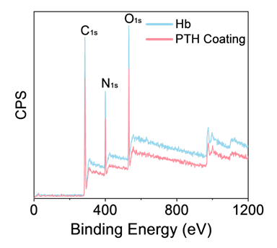
Supplementary Figure 2: XPS spectrum of PTH coating.

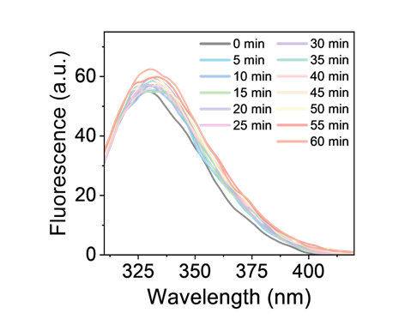
Supplementary Figure 3: Fluorescence change curve of tryptophan in hemoglobin.

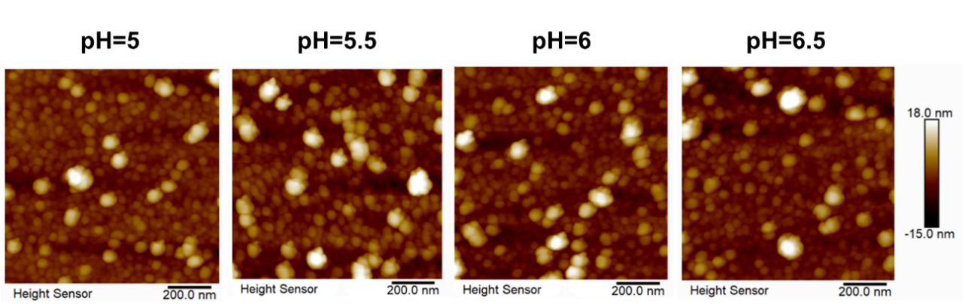
Supplementary Figure 4: Surface roughness of PTH coating prepared under different pH.

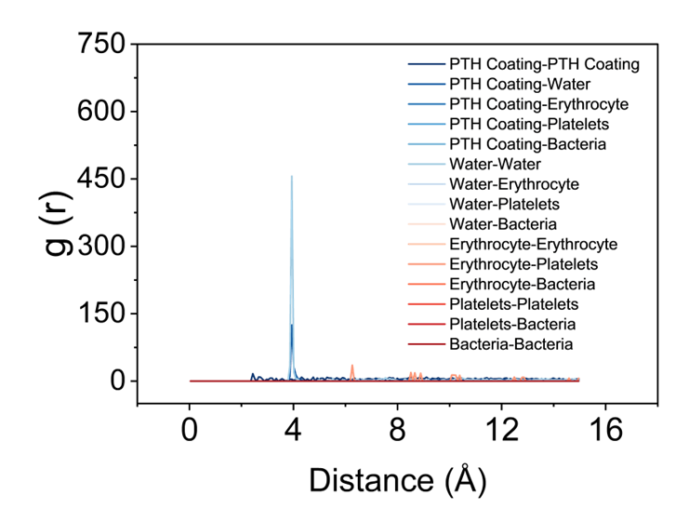
Supplementary Figure 5: Radial Distribution Function (RDF) Analysis

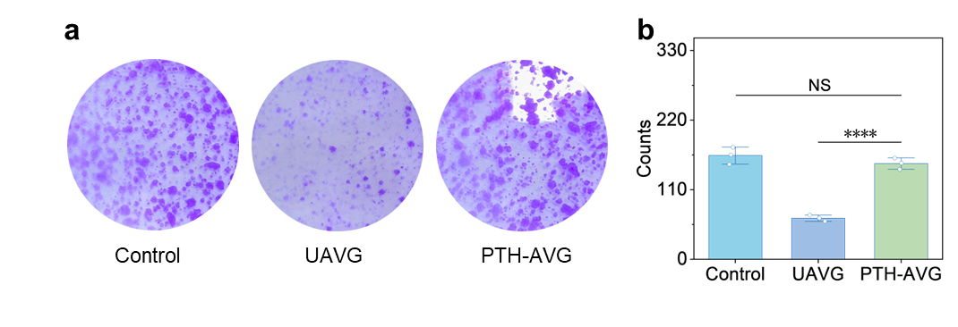
Supplementary Figure 6: Colony formation assay in HUVECs coculture with PTH-AVG. a, Representative images and b, Data of migration in HUVECs coculture with PTH-AVG.

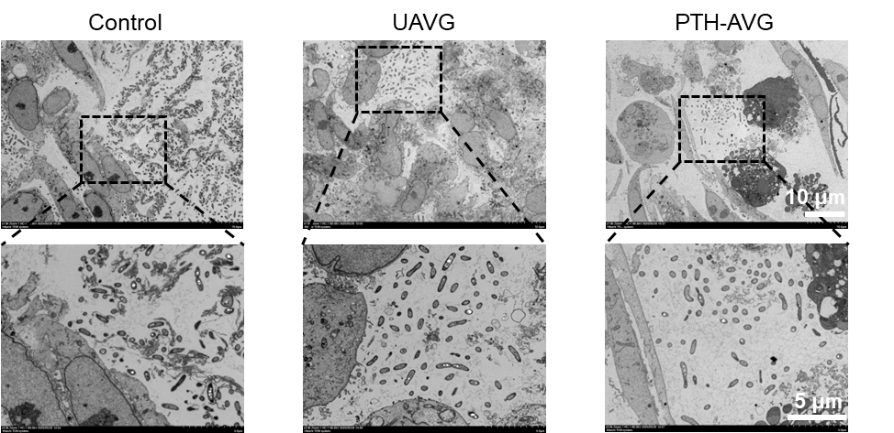
Supplementary Figure 7: TEM images of rat portal vein antiplatelet adhesion experiments.

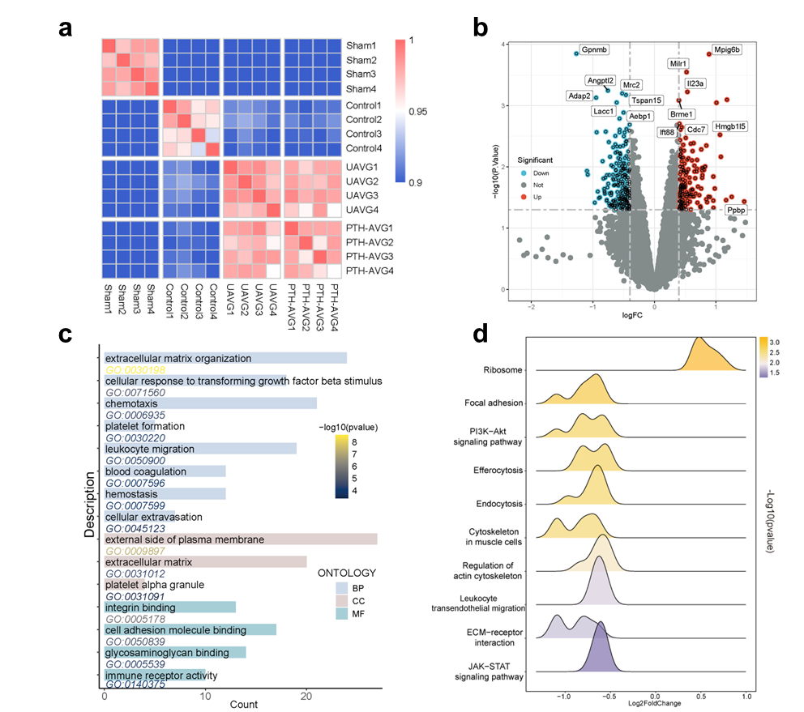
Supplementary Figure 8: The biological effects of PTH coating on Rat spleens. a, Heatmap of spleen tissue sample sequencing. b, Differentially expressed genes between coated and uncoated group identified using logFC > 0.5 and p < 0.05 criteria; c, d, GO, GSEA and KEGG enrichment analyses of coated versus uncoated group in spleen tissue.

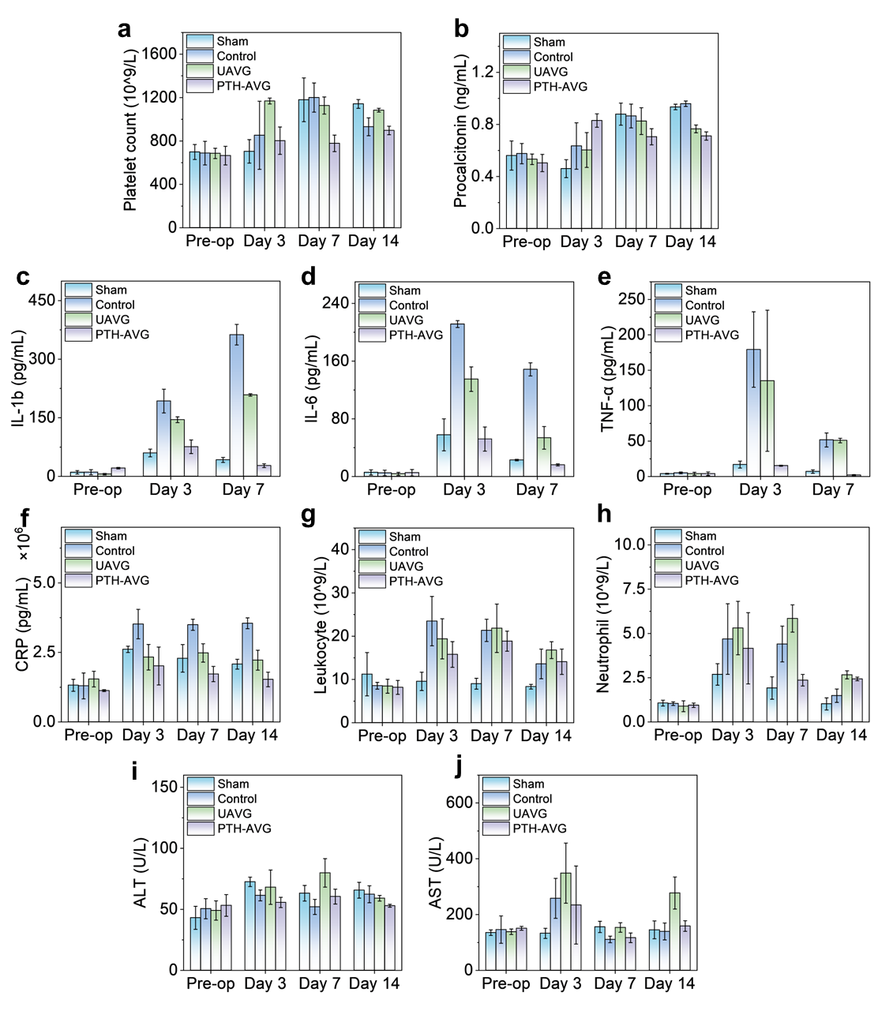
Supplementary Figure 9: Monitoring of physiological indices in rats during in vivo experiments of PTH coating. a, b, Expression levels of (a) platelets and (b) procalcitonin. c, e, Expression levels of inflammation-related factors: (c) IL-1β, (d) IL-6, and (e) TNF-α. f, h, Levels of (f) C-reactive protein (CRP), (g) leukocytes, and (h) neutrophils. i, j, Biochemical indicators of liver function in rats: (i) alanine aminotransferase (ALT) and (j) aspartate aminotransferase (AST) (n=3).

Materials
Bovine hemoglobin (Hb) stock solutions were prepared at concentrations ranging from 0.1 to 20 mg mL⁻¹ as required for each experiment. Tris(2-carboxyethyl)phosphine hydrochloride (TCEP) was used at working concentrations of 5-100 mM, and the pH of TCEP solutions was adjusted to the desired value (pH 4.0-11.0) using HCl or NaOH. Buffer systems included phosphate-buffered saline (PBS), simulated body fluid (SBF), bovine serum albumin (BSA) solutions, trypsin solutions and 0.9% (w/v) sodium chloride injection. Substrates used for coating included glass coverslips (18 mm × 18 mm), quartz slides, single-crystal silicon wafers, mica sheets, and polymeric materials such as poly(vinyl chloride) (PVC) and polytetrafluoroethylene (PTFE).
Human umbilical vein endothelial cells (HUVECs) were obtained from the Cell Bank of the Chinese Academy of Sciences. Cells were cultured in Dulbecco’s modified Eagle’s medium (DMEM) supplemented with 10% fetal bovine serum (FBS) and 1% penicillin/streptomycin in a humidified incubator at 37 °C with 5% CO2. Male specific-pathogen-free (SPF) Sprague-Dawley (SD) rats (7 weeks old, 200–250 g) were supplied by the Laboratory Animal Center of Hangzhou Medical College. All animal procedures were approved by the institutional Animal Ethics Committee (HMC-2024-0512) and performed in accordance with relevant guidelines and regulations.

Methods

Regulation of coating thickness by pH, protein concentration, TCEP concentration and coating cycles
pH gradient. Hb solution (10 mg mL⁻¹) was mixed 1:1 (v/v) with 50 mM TCEP solutions adjusted to pH 4, 5, 6, 7, 8, 9, 10 or 11, and incubated at 30 °C for 3 h. Silicon wafers were then inverted onto the reaction surfaces to collect the interfacial coating, yielding PTH coatings formed under different pH conditions for subsequent thickness measurements.
TCEP concentration gradient. TCEP solutions of different concentrations (10, 30, 50, 70 and 100 mM, pH 5.0) were prepared and mixed 1:1 with 10 mg mL⁻¹ Hb. After incubation at 30 °C for 5 h, PTH coating were collected at the air-liquid interface using silicon wafers to obtain coatings formed at varying reductant concentrations.
Hb concentration gradient. Hb solutions at 2, 5, 10, 15 and 20 mg mL⁻¹ were each mixed 1:1 with 50 mM TCEP (pH 5.0) and incubated at 30 °C for 5 h. PTH coating formed at the air–liquid interface was collected with silicon wafers to generate coatings prepared at different protein concentrations.
Repeated coating cycles. Hb (10 mg mL⁻¹) and 50 mM TCEP (pH 5.0) were mixed 1:1 and incubated at 30 °C, with each coating cycle lasting 1 h. The interfacial coating was collected repeatedly by silicon wafers for 1, 3, 6, 10 or 12 cycles to obtain PTH multilayer coating with different numbers of stacked layers.

Morphological and structural characterization of PTH coatings
Surface and cross-section morphology. PTH coatings were first prepared under the standard conditions described in Method A with a static incubation of 7 h. Silicon wafers were then used to peel the protein coating at the air-liquid interface in such a way that one half of the wafer was covered by the coating while the other half remained uncoated, providing a clear boundary between the coating and the bare substrate. Samples were freeze-dried and sputter-coated with gold using an ion sputter coater to improve conductivity. Surface morphology and cross-sectional thickness were observed using a high-resolution field-emission scanning electron microscopy (SEM, ZEISS, SU8220).
Self-supporting coating and negatively stained samples. Hb (10 mg mL⁻¹) and 50 mM TCEP (pH 5.0) were mixed 1:1, and carbon-coated copper grids were inverted onto the reaction surface for 2 h to allow coating formation on the grids. After gentle rinsing with ultrapure water and freeze-drying, the interface between the PTH coating and the carbon support was examined using a field-emission Transmission electron microscopy (TEM, Tecnai G2 F20).
Negative staining. PTH coatings were first formed on glass slides. Copper grids were then used to lift the coating from the air–liquid interface with half of the grid area coated. The grids were stained with 2% (w/v) phosphotungstic acid aqueous solution (pH adjusted to 7.0 with NaOH) for approximately 5 min, gently rinsed with ultrapure water, freeze-dried, and imaged at scale bars of 200 nm and 50 nm.
Coating thickness was determined using a spectroscopic imaging ellipsometer (Nanofilm_EP4SE). PTH coating prepared under the different conditions were uniformly deposited on silicon wafers. Representative regions were selected for imaging, and coating thickness values were obtained by fitting the ellipsometric data using a predefined refractive index model.
Effect of pH on surface roughness. Hb (10 mg mL⁻¹) was mixed 1:1 with 50 mM TCEP adjusted to pH 4.5, 5.0, 5.5, 6.0 or 6.5, and incubated at 30 °C for 2 h. Mica sheets were inverted onto the air–liquid interface to collect PTH coating for each pH condition. Atomic force microscopy (Oxford Cypher VRS) imaging was performed in tapping mode, and the RMS roughness was calculated using NanoScope Analysis software.
Roughness changes before and after fluid flushing. PTH coating were formed on mica substrates and then subjected to water flow at 0.25 L s⁻¹ for 0, 12 or 24 h. AFM images were collected at each time point, and RMS roughness values were extracted using NanoScope Analysis to evaluate the morphological stability of the coating under simulated blood-flow conditions.

Optical transmittance
Hb (10 mg mL⁻¹) and 50 mM TCEP (pH 5.0, 5.8, 6.2 or 7.4) were mixed 1:1. Quartz slides pretreated with 2% SDS were immersed in each reaction solution at 30 °C for 2 h, then rinsed with ultrapure water and dried. Blank quartz slides were used to establish the baseline. Transmittance spectra of PTH-coated slides were recorded from 190 to 900 nm with a path length of 1 cm and an integration time of 10 s.

UV-vis fluorescence and ThT/ANS binding assays
Intrinsic tryptophan fluorescence. Hb (2 mg mL⁻¹) and 50 mM TCEP (pH 5.0) were mixed 1:1. The first fluorescence measurement was performed immediately after mixing, followed by measurements every 5 min up to 60 min. The excitation wavelength was set to 285 nm, and emission was monitored at 340 nm, with 3 nm slit widths for both excitation and emission, to track dynamic changes in Trp fluorescence during the phase transition.

Thioflavin T (ThT) binding
PTH coating were prepared on glass slides (10 mg mL⁻¹ Hb + 50 mM TCEP, pH 5.0, 30 °C, 24 h), collected, dried, and ground into a powder. The powder was resuspended in ultrapure water and mixed 1:1 with a 10 μg mL⁻¹ ThT solution. Fluorescence emission between 465 and 535 nm was recorded and compared with pure ThT and pure Hb solutions to evaluate amyloid-like structure formation.

ANS binding
A similar procedure was used for ANS binding assays. PTH powder was mixed with ANS probe solution, and the fluorescence intensity was monitored as a function of time to assess exposure of hydrophobic regions.

Circular dichroism (CD) spectroscopy(chirascan)
To meet the concentration requirements for far-UV CD, Hb (0.1 mg mL⁻¹) was mixed 1:1 with 5 mM TCEP (pH 5.0) and incubated for 50 min. A 200 μL aliquot was then transferred to a 1 mm CD cuvette, and spectra were recorded from 190 to 260 nm to analyze changes in α-helical and β-sheet content.

FTIR(Vertex70)
Hb and TCEP (10 mg mL⁻¹ Hb + 50 mM TCEP, pH 5.0) were mixed and dispensed onto multiple glass slides. After incubation at 30 °C for 24 h, large-area PTH coating were collected, dried and ground into powder. PTH and native Hb powders were each mixed with KBr, pressed into thin sheets, and analyzed by Fourier-transform infrared spectroscopy (FTIR). The amide I region (1600-1700 cm⁻¹) was subjected to peak deconvolution to quantify changes in secondary structure.

Zeta Potential Analysis
To investigate the influence of pH on surface charge characteristics, PTH-coated silicon wafers and bare silicon wafers (control group) were prepared. A series of phosphate buffer solutions with pH ranging from 3.0 to 10.0 was prepared to cover the target gradient. Each wafer was immersed in the corresponding buffer solution and allowed to reach equilibrium. The surface zeta potential was measured using a Zeta Potential Analyzer at a constant temperature of 25°C. Each pH point was measured in triplicate to ensure data reproducibility. The resulting surface charge profiles were recorded and analyzed to determine the isoelectric point (pI) and the protonation/deprotonation behavior of the PTH coating across the different pH environments.

Dynamic light scattering (DLS)
Hb (2 mg mL⁻¹) and 50 mM TCEP (pH 5.0) were mixed 1:1 and immediately loaded into a cuvette. DLS measurements were carried out at 0, 30 and 60 min to monitor the evolution of particle size distribution of protein aggregates during the phase transition.

Adhesion, wettability and shear resistance of PTH coatings
Pull-off adhesion test
PTH coatings were prepared in accordance with Method A and incubated at 30 °C for 9 h. PTFE sheets were used to retrieve the coating at the air-liquid interface. The PTH-coated PTFE sheets were fixed to the test substrate, and the PTH coating surface was adhered to the probe of a pull-off adhesion tester using AB glue, ensuring tight contact. The maximum tensile force at detachment was recorded, and it was determined to be 270 ± 30 kPa. This force was further compared with that of conventional biological coatings commonly used in laboratories (i.e., gelatin, collagen, sodium alginate, and chitosan) deposited on PTFE substrates. The pull-off strength was calculated as a measure of coating–substrate adhesion. Each condition was tested in quintuplicate.

X-ray photoelectron spectroscopy (XPS Escalab Xi+)
After preparation, PTH coating were directly analyzed by XPS to obtain survey spectra and high-resolution C 1s and N 1s spectra. Peak fitting and deconvolution were performed using PeakFit 4 software to determine surface chemical composition and bonding states.

Water contact angle and wettability stability
PTH coatings were prepared on glass (10 mg mL⁻¹ Hb + 50 mM TCEP, pH 5.0, 30 °C, 9 h) and transferred to different substrates (glass, silicon, PVC, PTFE, copper). Static water contact angles were measured using an optical contact angle goniometer and compared with those of the corresponding bare substrates. To assess stability in complex physiological environments, PTH-coated samples were immersed in PBS, SBF, BSA solution, trypsin solution and physiological saline for 12 h. Samples were then removed and immediately subjected to contact angle measurements to evaluate changes in wettability.

Contact angle and surface morphology under fluid shear
PTH coating were prepared on glass or mica and exposed to water flow at 0.25 L s⁻¹ for 0, 5, 8, 12 or 24 h. Water contact angles were recorded at each time point. For mica-based samples, AFM imaging was performed to monitor changes in surface roughness and morphology under simulated blood-flow shear.

Friction coefficient
The friction coefficient of PTH coatings was determined at room temperature using a digital pull-off/adhesion tester (BGD 500) operated according to the manufacturer’s recommended load and sliding speed. The dynamic and static friction coefficients of PTH-coated surfaces and their corresponding bare substrates were measured separately under steady sliding conditions, both before erosion and after 24 hours of erosion.

Anti-Platelet adhesion
PTH coatings were prepared on silicon wafers using the inverted interfacial transfer method. Coated wafers were fully immersed in pre-activated platelet suspensions and incubated for 2 h. After incubation, wafers were rinsed with 1× PBS to remove non-adherent platelets and fixed overnight in 1% glutaraldehyde at 4 °C. Fixed samples were dehydrated through a graded ethanol series (10 min in each concentration, from low to high), dried, and examined by SEM to evaluate platelet adhesion and morphological changes on the PTH surface.

Quartz Crystal Microbalance (QCM)
To evaluate surface interactions, bare QCM sensors, native Hb-loaded sensors, and PTH film-loaded sensors were placed into the flow modules. Initially, Simulated Body Fluid (SBF) was introduced to establish a stable baseline. Once stabilized, platelet-SBF (1mg/mL) and erythrocyte-SBF (1mg/mL) suspensions were sequentially injected, with changes in frequency (Δf) and energy dissipation (ΔD) recorded. Subsequently, ultrapure water was introduced to re-stabilize the signal, followed by the injection of aqueous solutions of fibrinogen (1mg/mL) and human serum albumin (HSA) (1mg/mL) to monitor further frequency and dissipation shifts. All experiments were conducted at a constant flow rate of 200 μL/min and a controlled temperature of 25°C. The fundamental frequency of the sensors was 5 MHz, and the 3rd, 5th, 7th, 9th, 11th, and 13th overtones were recorded. The adsorbed mass of the various samples on the different surfaces was calculated using the Smartfit mode of the DFind software.

Molecular Dynamics Simulation Methods
To investigate the long-term interfacial stability and the biological response of the PTH nanocoating, molecular dynamics (MD) simulations were performed using the LAMMPS package. The simulation domain was established as a 400 × 100 × 230 A°³ box with periodic boundary conditions in the X and Y directions. The interfacial architecture was designed as a dual-barrier system: an ultra-dense PTH basal layer (Z = 0 to 30 A°) and a biomimetic hydration shield (Z = 30 to 55 A°), which served as the primary defense against non-specific adsorption. Six particle types were defined to represent the coating, the hydration layer, platelets (Type 3), red blood cells (Type 5), bacteria (Type 6), and endothelial cells (ECs, Type 4).A hybrid potential model was employed to govern the interfacial interactions: the Lennard-Jones (LJ) potential was used to simulate the robust short-range repulsive forces of the hydration layer against biological fouling, while the Morse potential was utilized to model the specific biochemical affinity and infiltration behavior of ECs towards the PTH coating. Simulations were executed in the NVT ensemble at a physiological temperature of 310.15 K. Hemodynamic challenges were simulated by assigning a downward velocity (V_{z} = -18.0) to blood components and pathogens. Simultaneously, a constant driving force (F_{x} = 18.0, F_{z} = -10.0) was applied to the ECs to promote their lateral crawling and integration into the coating interface. The system was evolved for 250,000 steps to ensure the observation of long-term cellular growth trends and barrier integrity.

Anti-bacterial adhesion
PTH coatings were prepared on silicon wafers using the inverted interfacial transfer method, and the coated wafers were retrieved thereafter. For the anti-bacterial adhesion assay, the retrieved PTH coating-coated wafers were fully immersed in pre-activated Staphylococcus aureus suspensions (with a concentration of approximately 1×10⁸ CFU/mL) and incubated for 12–24 h. After incubation, the wafers were rinsed with 1× PBS to remove non-adherent bacteria, followed by overnight fixation in 1% glutaraldehyde. Subsequently, the fixed samples were dehydrated through a graded ethanol series (including 50%, 60%, 70%, 80% and 90% v/v; 10 minutes per concentration, in ascending order of concentration). After drying, the surfaces of PTH coatings on the wafers were examined by SEM to check for residual bacteria; the absence of residual bacteria indicated that the coatings possessed anti-bacterial adhesion properties.

HUVEC culture
HUVECs were routinely maintained in DMEM containing 10% FBS and 1% penicillin/streptomycin in a humidified incubator (37 °C, 5% CO₂). For experiments, cells were seeded onto culture plates pre-coated with PTH coating or onto uncoated substrates and allowed to adhere and stabilize before functional assays.

Cell viability (CCK-8 assay)
HUVECs were seeded at 2 × 10³ cells per well in 96-well plates and cultured on substrates with or without PTH coatings. At designated time points, culture medium was removed and replaced with 90 μL fresh DMEM and 10 μL CCK-8 reagent per well. After incubation at 37 °C for 2 h, optical density (OD) at 450 nm was measured using a microplate reader to assess cell proliferation and viability under different conditions.

Live/dead staining
HUVECs were cultured on PTH-coated or uncoated substrates to predetermined time points and rinsed gently with PBS. Live/dead staining working solution was prepared according to the manufacturer’s instructions and added to the cells, which were then incubated for 10–20 min at room temperature in the dark. After PBS washing, green/red fluorescence images were acquired using a fluorescence microscope for qualitative evaluation of cell survival.

Hemolysis assay
To assess the hemocompatibility of the PTH coating, a hemolysis assay was performed using fresh anticoagulated whole blood. The blood was diluted with PBS and subsequently incubated with the PTH-modified substrates at 37 °C. PBS and 1% Triton X-100 were used as negative and positive controls, respectively. After a predetermined incubation period, the samples were centrifuged at 3,000 rpm for 5 min. The absorbance of the resulting supernatant was determined at 545 nm. The hemolysis percentage was calculated according to the standard formula, where a lower hemolysis rate indicates superior blood compatibility of the engineered coating.
$\text{HR}\text{(\%)=}\frac{{\text{A}}_{\text{s}}\text{-}{\text{A}}_{\text{n}}}{{\text{A}}_{\text{p}}\text{-}{\text{A}}_{\text{n}}}\text{×100\%}$ (1)
where A_{s}, A_{n} and A_{p} represent the absorbance of the sample, the negative control, and the positive control, respectively. A material is considered to have good blood compatibility if the HR is less than 5%.

Scratch wound-healing assay
HUVECs were seeded at 1 × 10⁵ cells per well in six-well plates. When confluence reached ~90%, a straight scratch was generated across the cell monolayer using a sterile 200 μL pipette tip along a pre-marked line. Detached cells were removed by washing with PBS three times, and serum-free medium was added. Images of the scratch area were captured at 0, 24 and 48 h under the same field of view. Wound areas were quantified using ImageJ software, and wound closure rates were calculated.

Western blot analysis of signaling proteins in cells
At predetermined time points, HUVECs were lysed in RIPA buffer containing protease inhibitors. Protein concentrations were determined by the BCA method, and equal amounts of protein were separated by SDS–PAGE and transferred to PVDF membranes. Membranes were incubated with primary antibodies against β-actin, PI3K, phospho-PI3K, AKT, phospho-AKT, mTOR and phospho-mTOR, followed by HRP-conjugated secondary antibodies. Signals were visualized by enhanced chemiluminescence (ECL), and expression of proteins in the PI3K/AKT/mTOR pathway was analyzed.

Western blot of vascular tissues and platelet adhesion on stents
Excised vascular segments were rinsed in ice-cold PBS, finely minced and lysed in RIPA buffer. Western blotting was then carried out as described for cellular signaling analysis to examine the expression of PI3K/AKT/mTOR pathway proteins and thereby evaluate the regulatory effects of the PTH coating on this pathway in vivo. Platelet adhesion on the implanted stent surfaces was assessed after fixation and graded dehydration, followed by SEM imaging. The in vivo adhesion patterns were subsequently compared with the in vitro platelet adhesion data for cross-validation.

Ex vivo tissue and blood analysis
Peripheral blood was collected at each time point. One portion was placed in serum tubes, centrifuged at 3,000 rpm for 15 min at 2-8 °C, and serum biochemical indices such as ALT and AST were measured using an automated biochemical analyzer (Chemray 240/420/800). The remaining blood was collected into anticoagulant tubes and analyzed on a veterinary automatic hematology analyzer (BC5000vet) to determine WBC count, neutrophil count, platelet count and other hematological parameters.

Histology and immunohistochemistry (IHC)
At predetermined postoperative time points, liver and vascular tissues were collected and fixed in 4% paraformaldehyde. The specimens were subsequently processed for paraffin embedding and sectioning by Servicebio, followed by H&E staining to evaluate tissue morphology. Immunohistochemical staining for angiogenesis-related markers as well as mTOR and phospho-mTOR was then performed to assess the effects of the PTH coating on vascular regeneration and local tissue responses.

Transcriptome sequencing and bioinformatic analysis
Total RNA was extracted from liver and spleen tissues following standard procedures. Libraries were constructed and sequenced on a high-throughput platform. Differentially expressed genes (DEGs) between coated and uncoated samples were identified using thresholds of logFC > 0.5 and p < 0.05. GO enrichment and GSEA-KEGG pathway analyses were performed to evaluate the systemic impact of the PTH coating on hepatic and immune-related signaling pathways. Results were visualized as heatmaps and enrichment analysis by bubble plots.

References
1. Zhang, Y. et al. α-helix-mediated protein adhesion. J. Am. Chem. Soc. 145, 17125–17135 (2023).
2. Major, G. H. et al. Perspective on improving the quality of surface and material data analysis in the scientific literature with a focus on x-ray photoelectron spectroscopy (XPS). J. Vac. Sci. Technol. A 41, (2023).
3. Stachurska, K. & Antosiewicz, J. M. Contribution of each tryptophan to the total fluorescence emitted by a protein with multiple tryptophan residues depends on the energy of the excitation radiation quantum. ACS Omega 9, 43998–44004 (2024).
4. Zhu, J. et al. Multimodal nanoimmunotherapy engages neutrophils to eliminate staphylococcus aureus infections. Nat. Nanotechnol. 19, 1032–1043 (2024).
5. Ridker, P. M. & Lüscher, T. F. Anti-inflammatory therapies for cardiovascular disease. Eur. Heart J. 35, 1782–1791 (2014).

