Supplementary Material for
Why does Re anti-segregate from the grain boundaries in Ni?
Changle Li¹, Sourabh Bhagwan Kadambi², Boopathy Kombaiah³, Nutth Tuchinda⁴,
Christopher A. Schuh^{1*}
¹Department of Materials Science and Engineering, Northwestern University, 2145 Sheridan Road, Evanston, IL 60208, USA
²Computational Mechanics and Materials Department, Idaho National Laboratory, Idaho, ID 83415, USA
³Materials and Fuel Complex, Idaho National Laboratory, Idaho, ID 83415, USA
⁴Otto H. York Department of Chemical and Materials Engineering, New Jersey Institute of Technology, 138 Warren St, Newark, NJ 07103, USA
* Correspondence to: *schuh@northwestern.edu

- Experimental details

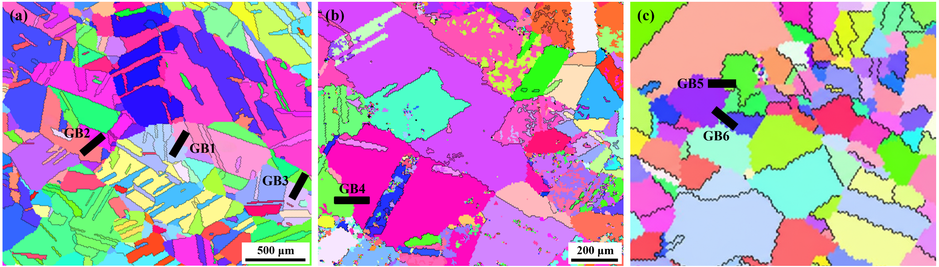
Fig. S1 EBSD inverse pole figures of the Ni-3Re alloy. Six GB orientations are marked by black bars.
Table S1 Chemical composition of Ni-Re alloy used in this study measured from analytical techniques.
Ni | Re | C | N | O | S | B | P
wt.% | wt.% | wt.ppm | wt.ppm | wt.ppm | wt.ppm | wt.ppm | wt.ppm
91.1 | 8.85 | 29 | <5 | 100 | <5 | <0.005 | 0.08
at.% | at.% | at.ppm | at.ppm | at.ppm | at.ppm | at.ppm | at.ppm
97.0 | 2.97 | 151 | <22 | 390 | <10 | <0.03 | 0.2

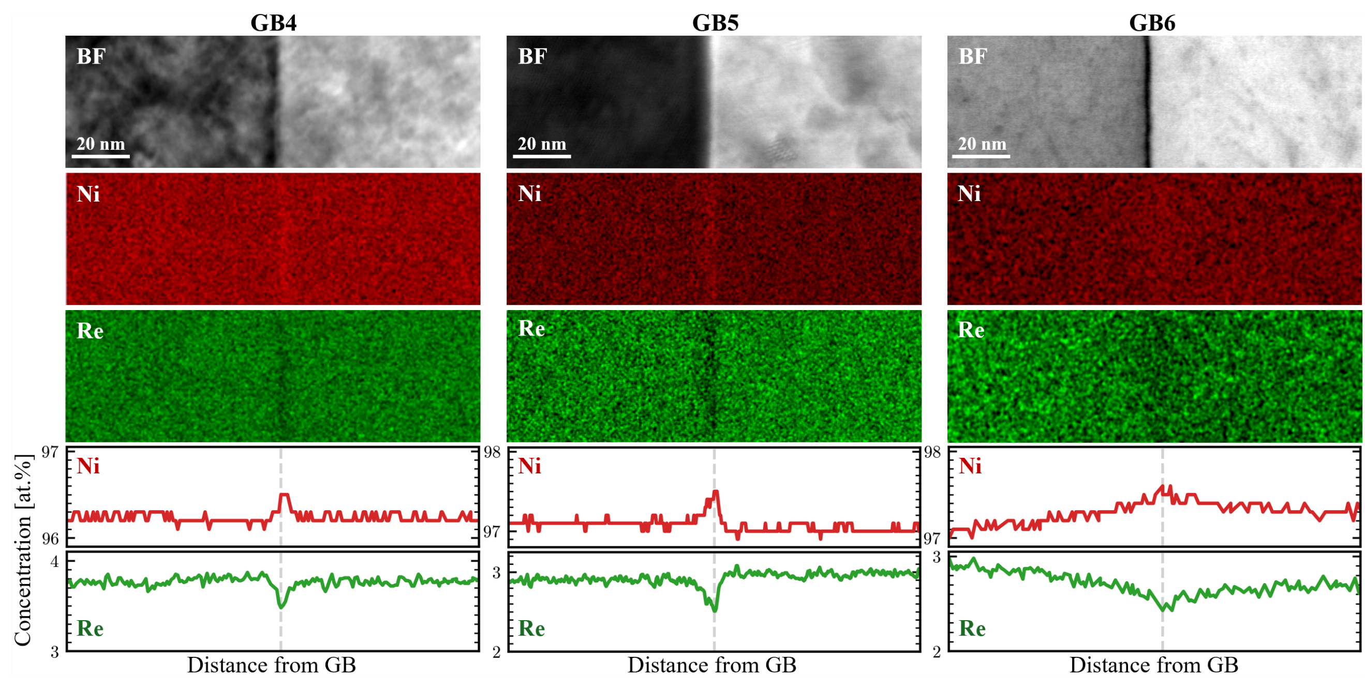
Fig. S2 Scanning transmission electron microscopy high-angle annular dark-field images, energy-dispersive x-ray spectroscopy maps, and compositional maps for GB4, GB5, and GB6 in Ni-3Re system.

Table S2 Comparison of segregation strength β_{GB} between experimental measurements and theoretical predictions. The predicted X_{GB} are obtained using the experimental X_{C} at 1250 °C. All concentrations are in unit of at.%.
GB | Experiment |  |  |  | Predicted
GB | X_{C} | X_{GB} | β_{GB} | Γ | X_{GB}(FM) | X_{GB}(NM) | β_{GB}(FM) | β_{GB}(NM)
 | at.% | at.% |  | atoms/nm² | at.% | at.%
GB1 | 3.21 ± 0.04 | 2.71 | 0.844 | -0.343 | 12.79 | 2.99 | 3.983 | 0.930
GB2 | 3.30 ± 0.13 | 2.29 | 0.694 | -0.692 | 13.08 | 3.07 | 3.964 | 0.930
GB3 | 2.87 ± 0.06 | 2.49 | 0.868 | -0.260 | 11.64 | 2.68 | 4.057 | 0.932
GB4 | 3.77 ± 0.04 | 3.48 | 0.923 | -0.199 | 14.62 | 3.50 | 3.868 | 0.926
GB5 | 2.94 ± 0.05 | 2.52 | 0.857 | -0.288 | 11.88 | 2.74 | 4.041 | 0.932
GB6 | 2.75 ± 0.09 | 2.43 | 0.884 | -0.219 | 11.23 | 2.57 | 4.084 | 0.933

- Benchmarking magnetic approximations
For the symmetric tilt Σ5(210) GB, a 40-layer slab is constructed using the GB-code package [1]. To evaluate the influence of magnetic states on Re segregation at high temperatures, we employ four magnetic schemes: ferromagnetic (FM), non-magnetic (NM), double-layered antiferromagnetic (AFMD), and non-collinear magnetic (NCM) states. All computational parameters are identical to those described in the Methods section, except for the k-point mesh of 8×4×1 adopted here to accommodate the Σ5 GB supercell geometry. The central site equidistant from the two GB planes is used as the bulk reference, so the segregation energy at the i-th site ΔEi seg is defined as ${∆E}_{\text{seg}}^{i}=E_{\text{GB}}^{i}-E_{\text{bulk}}$, where Ei GB and $E_{\text{bulk}}$ are the total energies with a solute occupying the GB and bulk sites, respectively. Fig. S3 compares our calculated minimum segregation energies under the FM state with values reported in the literature [3]–[9], showing good agreement with most prior DFT studies and validating our computational approach.
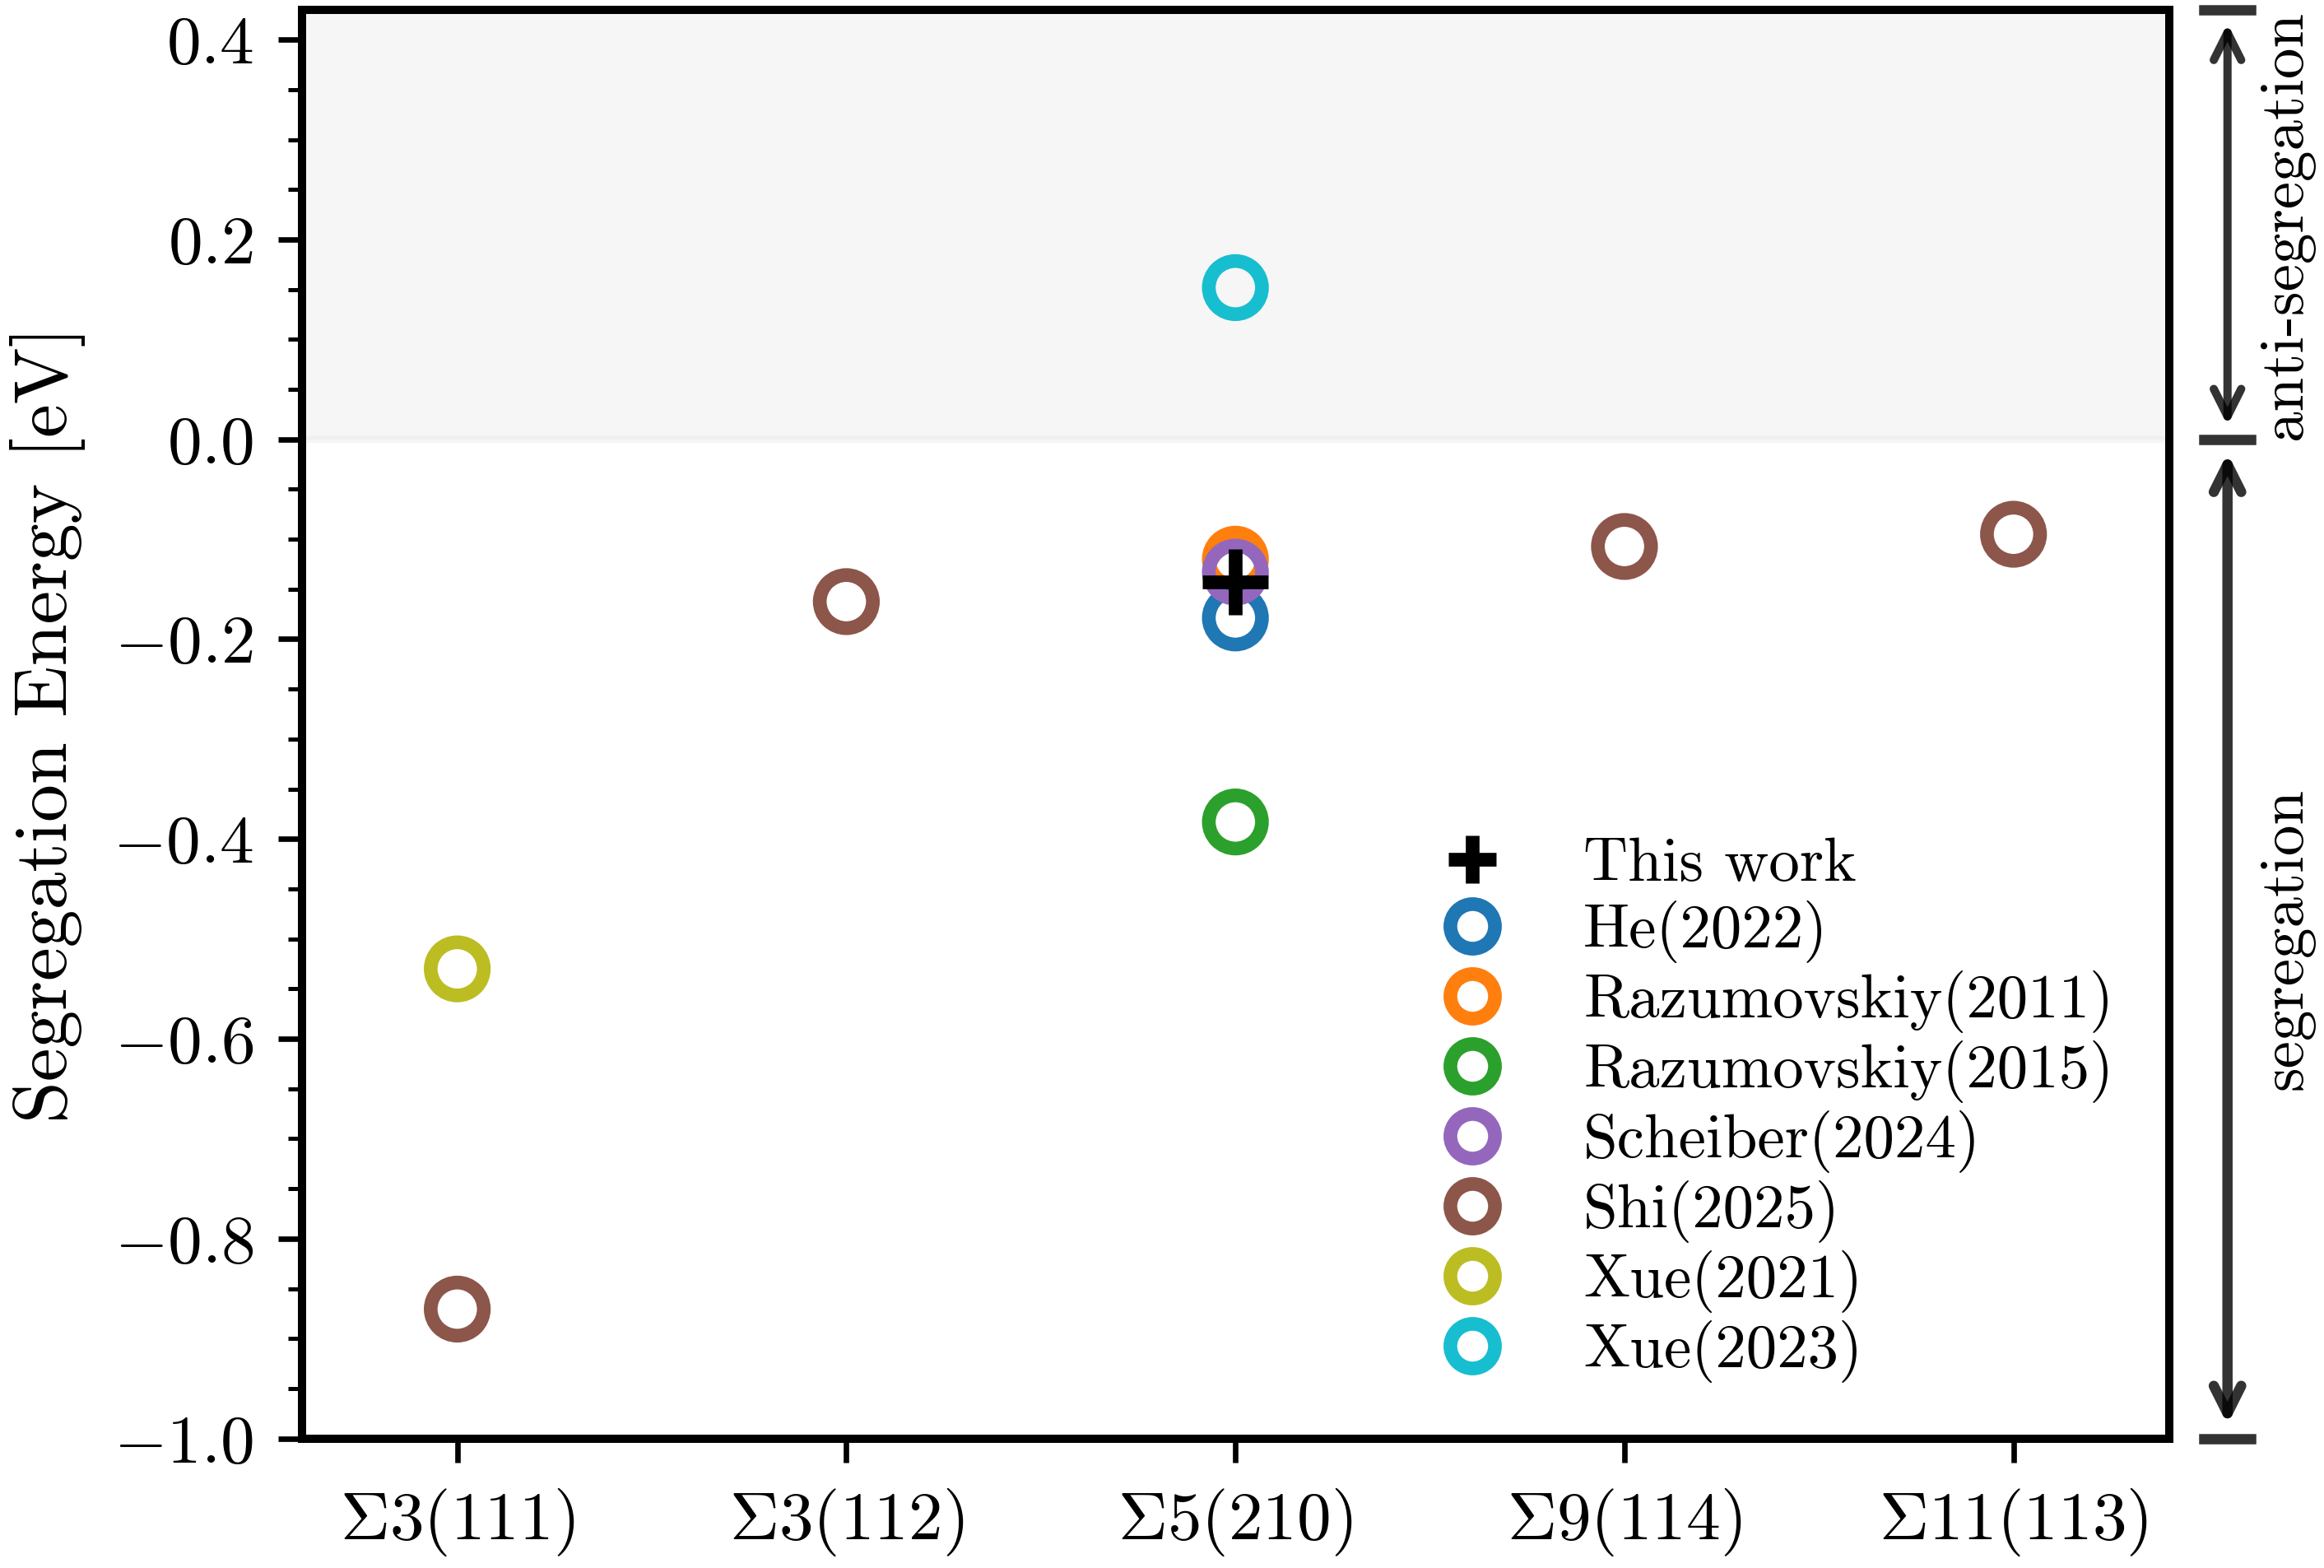
Fig. S3 Comparison of calculated Re segregation energies in Ni Σ5(210) CSL GB between this work and prior literature values [3]–[9], together with other CSL GBs results. All energies correspond to the minimum GB site under the FM state and all values are in unit of eV/atom.

In the AFMD configuration, each pair of atomic layers perpendicular to the GB plane is assigned opposite spin orientations, ensuring zero net magnetization while maintaining finite local moments. To better capture the high-temperature paramagnetic state, in which magnetic moments are randomly oriented in three-dimensions, we also perform non-collinear magnetic calculations. Because small local moments are prone to flipping during structural relaxation under non-collinear constraints, achieving self-consistent field convergence is technically challenging. We therefore adopt a static calculation strategy. Taking the AFMD lattice volume as representative of the paramagnetic volume, we use the electronic charge density from the relaxed AFMD structure as a starting point and perform single-point energy evaluations with the non-collinear magnetic configuration. As shown in Fig. S4a, the FM state exhibits uniform magnetic moments of 0.6-0.7 μ_{B} across all atoms, while both AFMD and NCM states show fluctuations in the range of −0.2-0.2 μ_{B} at each atomic site. The NCM configuration explicitly samples random spin orientations, as evidenced by the spatial components (m_{x}, m_{y}, m_{z}) in Fig. S4b, which fluctuate randomly while maintaining zero vector sum. The small local moments in both AFMD and NCM states further support the NM approximation as a reasonable choice for high-temperature calculations.

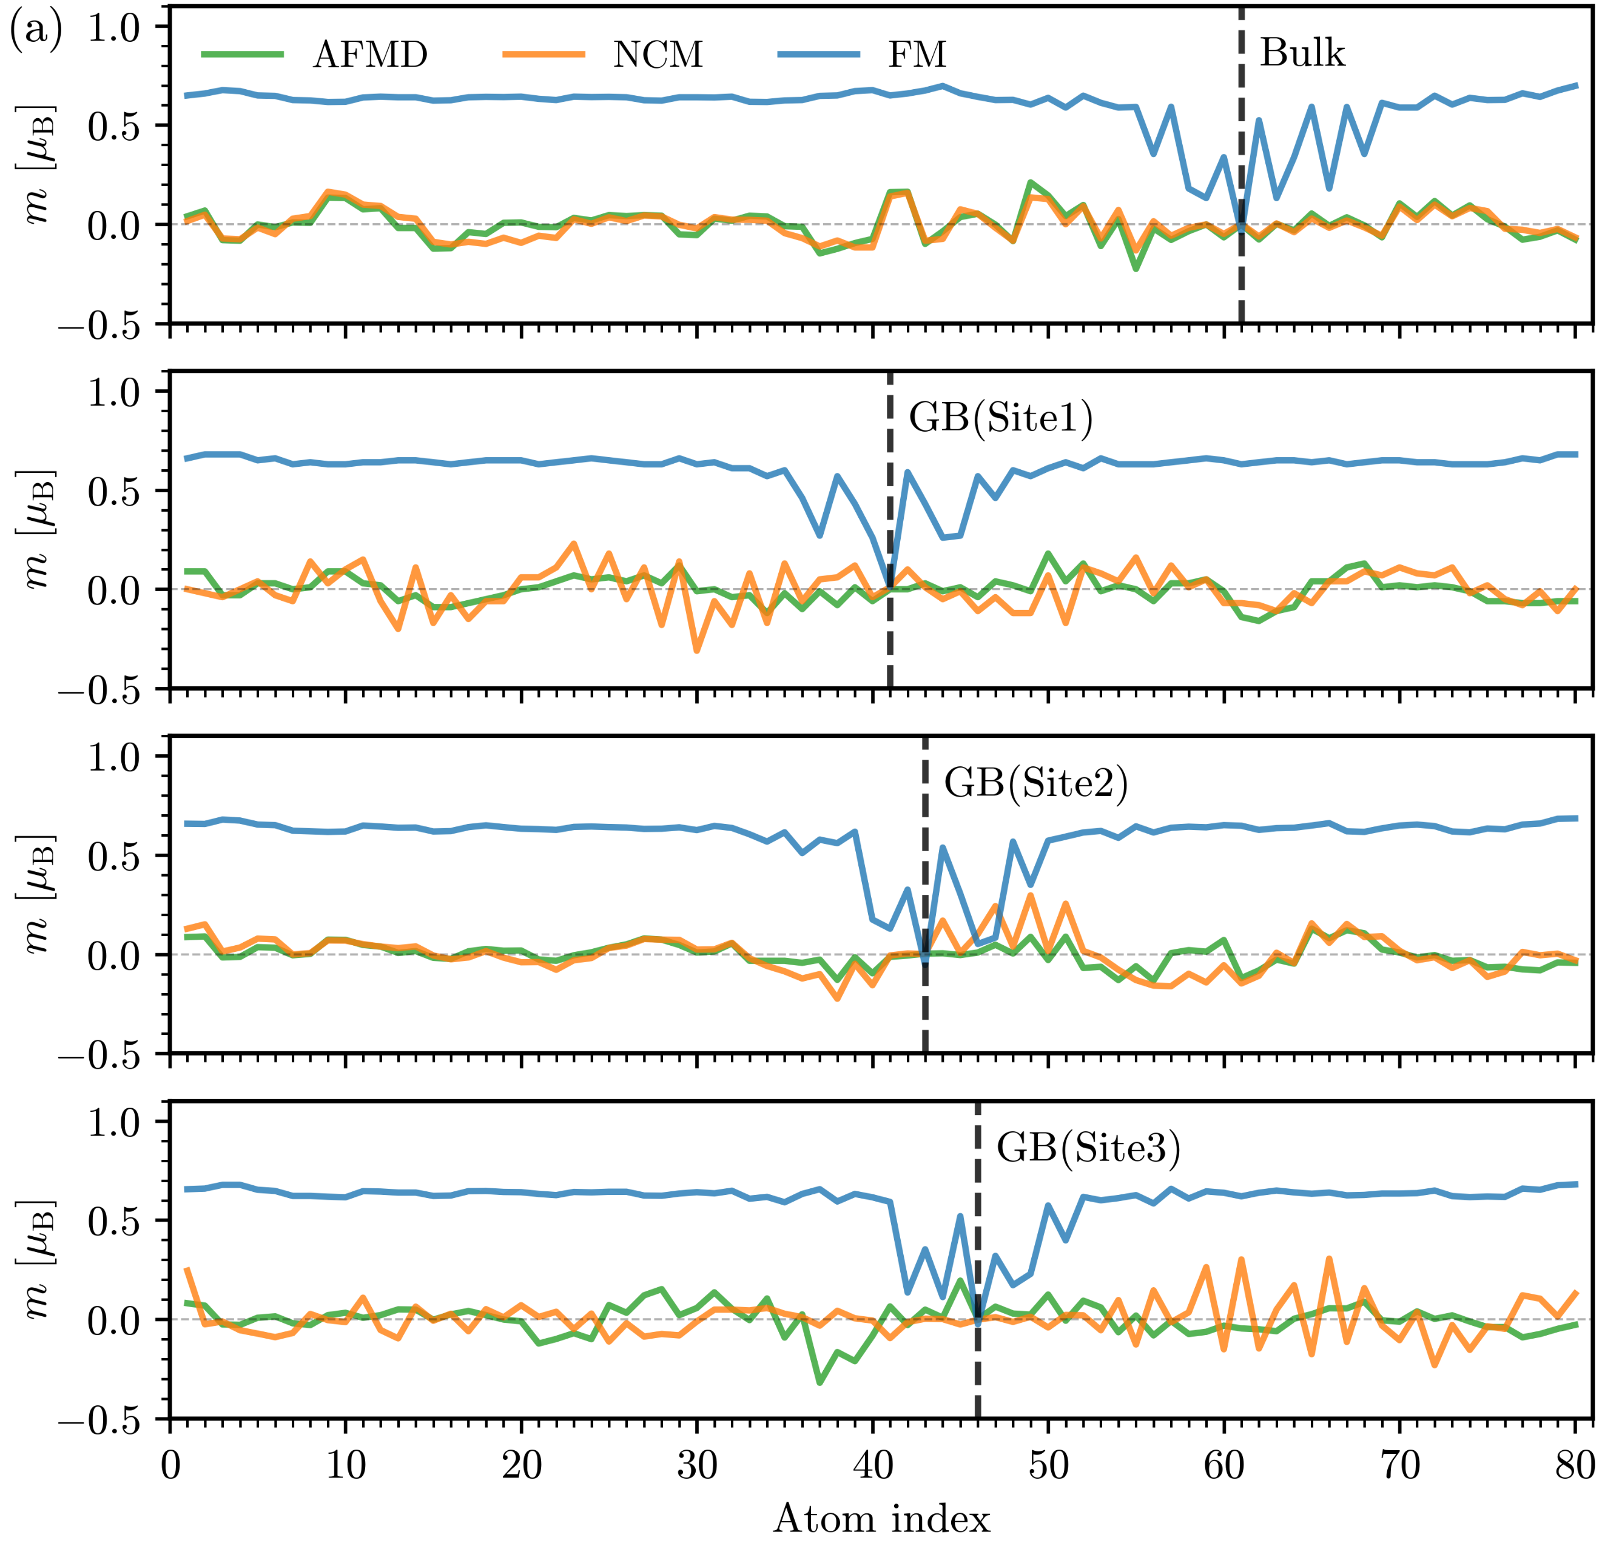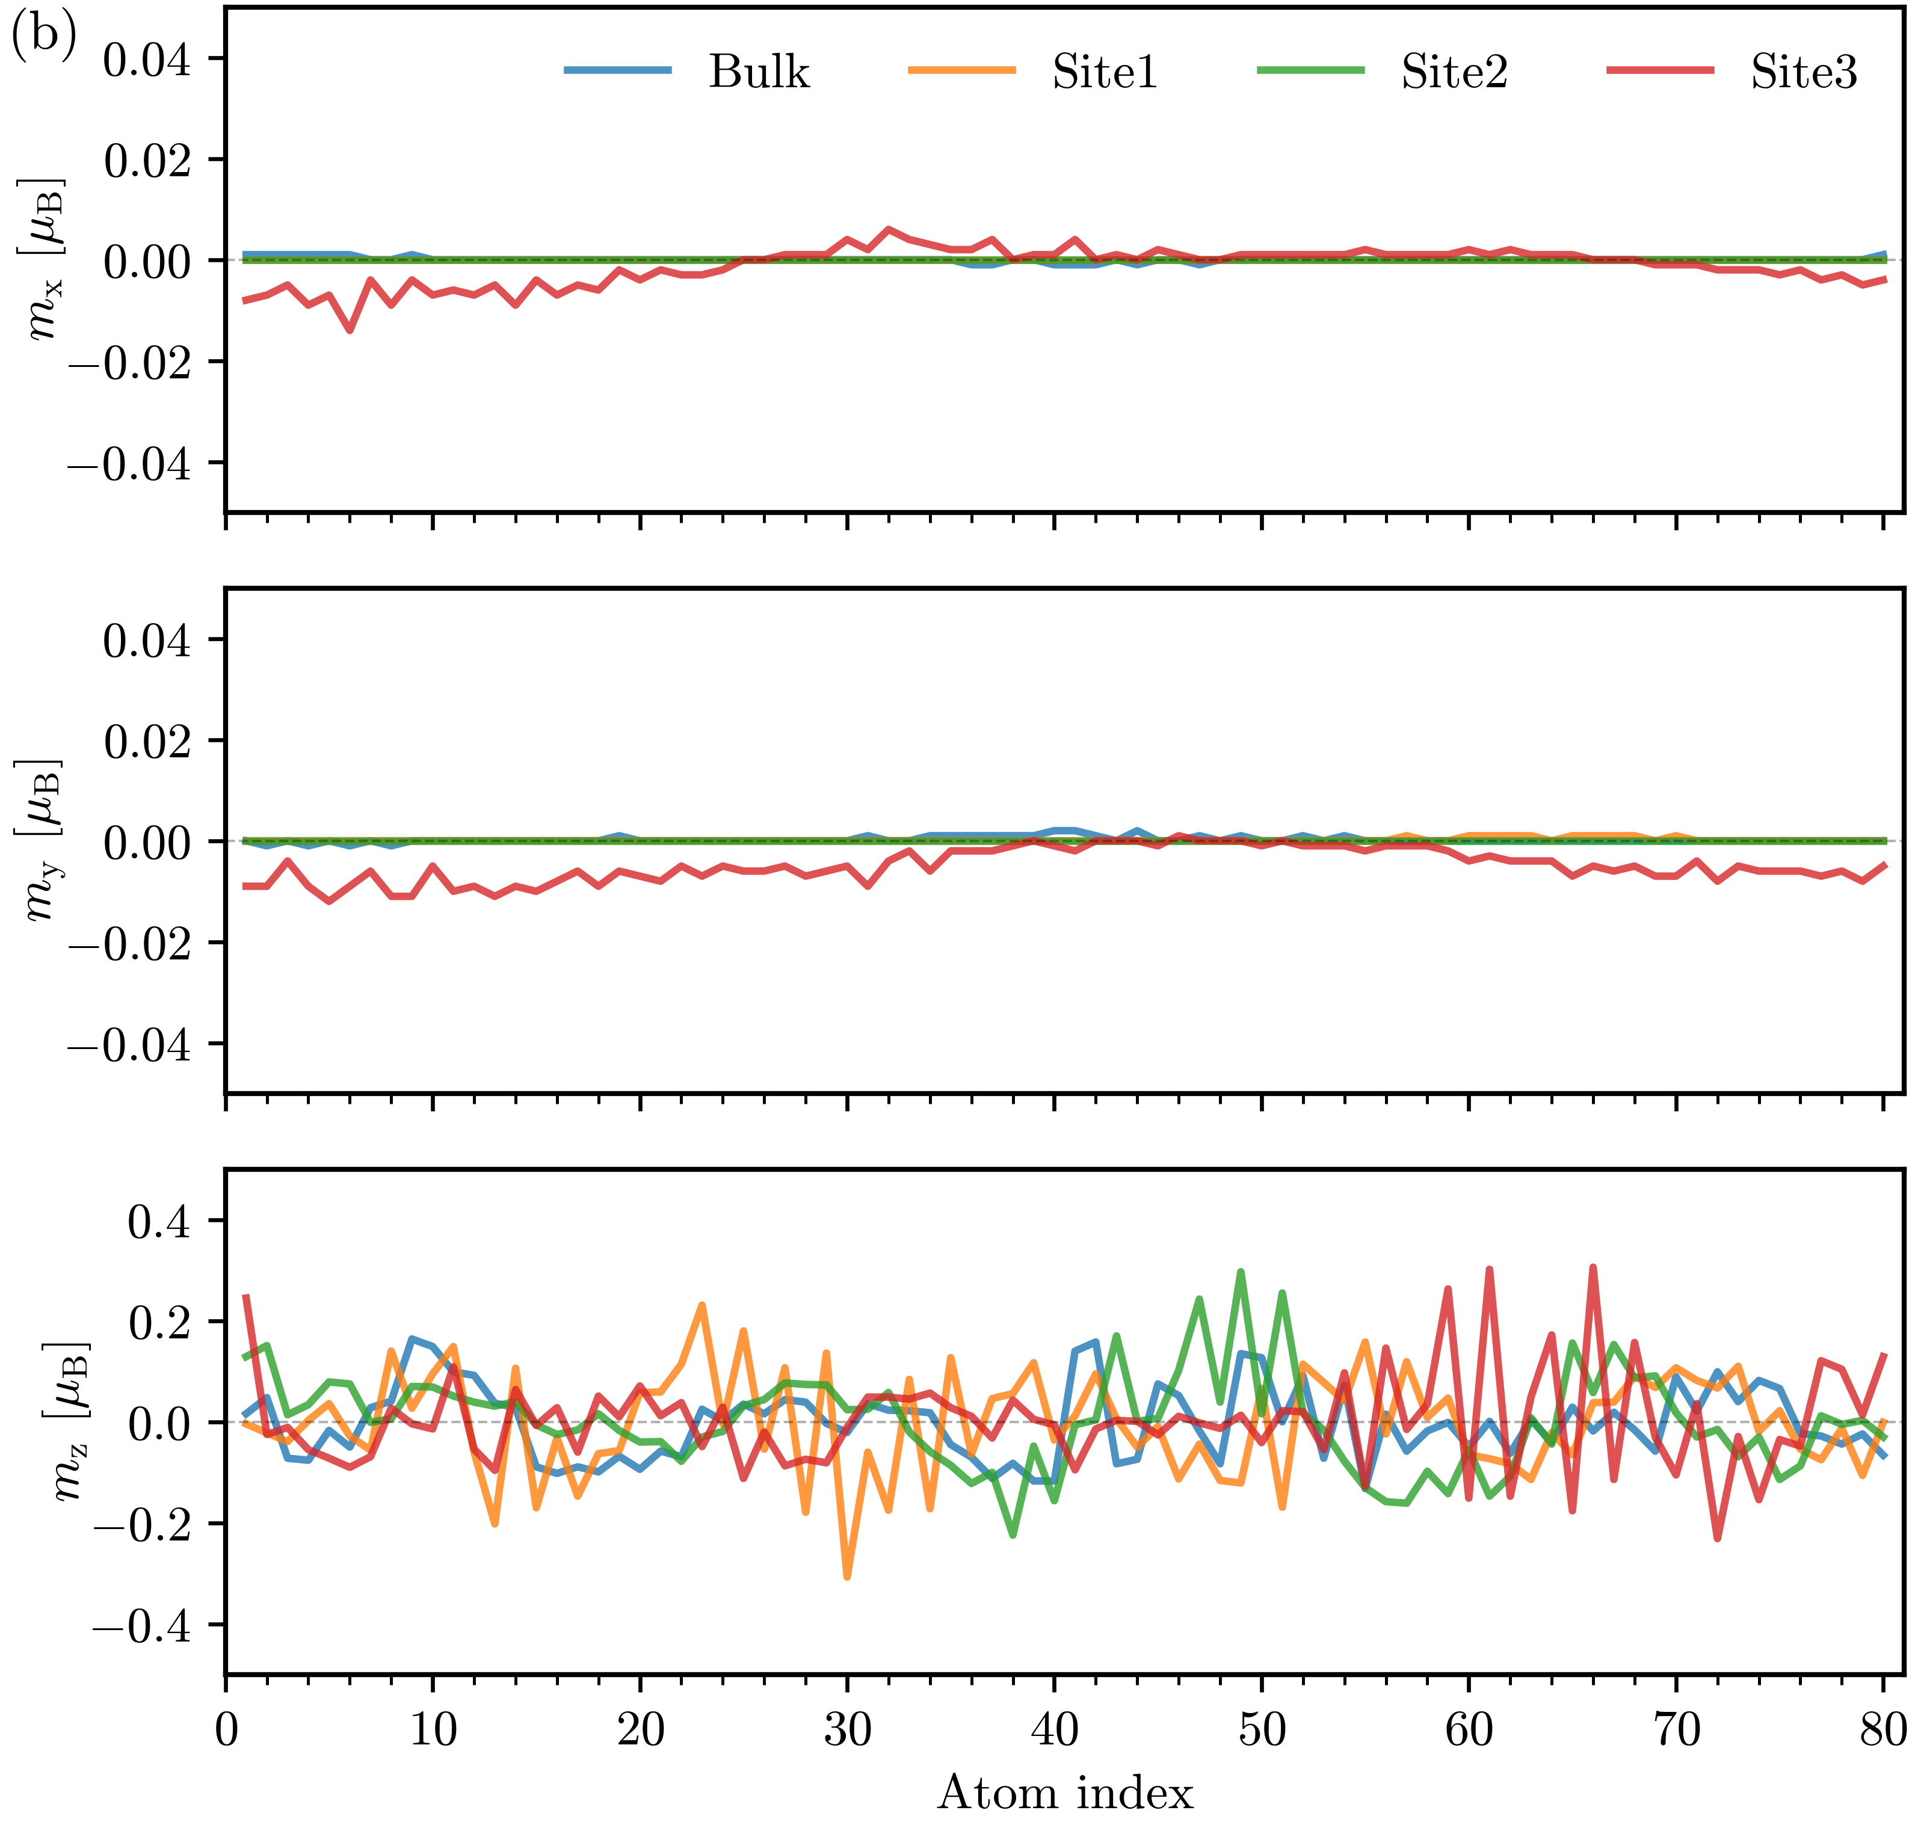
Fig. S4 Magnetic moment distributions under different magnetic states for the Σ5(210) GB. (a) Local magnetic moment (m) as a function of atom index for FM, AFMD, and NCM states. The dashed lines indicate the solute at the bulk region and GB regions (Sites 1-3). (b) Spatial components (m_{x}, m_{y}, m_{z}) of magnetic moments under the NCM state, showing random three orientations.

- Decomposition of magnetic contribution
The Stoner model [10]–[12] describes the total energy change per atom upon forming a ferromagnetic state with moment m as ΔE_{mag}(m) = ΔE_{kin}(m) + ΔE_{ex}(m), where ΔE_{kin}(m) represents the kinetic energy cost of spin splitting and the magnetic exchange contribution ΔE_{ex}(m). The net magnetic contribution is generally estimated by ΔE_{mag}(m) = −1/4Im² [11], [12], with I being the Stoner exchange parameter and m is the local magnetic moment. The total magnetic moment of a supercell is defined as M = Σm_{i}².
The segregation energy in the FM state is expressed as:
$∆E_{seg}^{FM}=\left(E_{GB}^{Re,FM}-E_{GB}^{Ni,FM}\right)-\left(E_{bk}^{Re,FM}-E_{bk}^{Ni,FM}\right)$ (1)
Decomposing each FM total energy into its non-magnetic (NM) and magnetic contributions
$$∆E_{seg}^{FM}≈\left[\left(E_{GB}^{Re,NM}+{∆E}_{GB,Ni+Re}^{mag}\right)-\left(E_{GB}^{Ni,NM}+{∆E}_{GB,Ni}^{mag}\right)\right]-\left[\left(E_{bk}^{Re,NM}+{∆E}_{bk,Ni+Re}^{mag}\right)-\left(E_{bk}^{Ni,NM}+{∆E}_{bk,Ni}^{mag}\right)\right]$$
$$=\left[\left(E_{GB}^{Re,NM}-E_{GB}^{Ni,NM}\right)-\left(E_{bk}^{Re,NM}-E_{bk}^{Ni,NM}\right)\right]+\left[\left({∆E}_{GB,Ni+Re}^{mag}-{∆E}_{GB,Ni}^{mag}\right)-\left({∆E}_{bk,Ni+Re}^{mag}-{∆E}_{bk,Ni}^{mag}\right)\right]$$
$=∆E_{seg}^{NM}-\frac{1}{4}I\left[\left(M_{GB}^{Ni+Re}-M_{GB}^{Ni}\right)-\left(M_{bk}^{Ni+Re}-M_{bk}^{Ni}\right)\right]$ (2)
$∆E_{seg}^{FM}≈∆E_{seg}^{NM}+{∆E}_{mag}$ (3)
Thus, the expected shift of the segregation energy between ferro- and non-magnetic states is captured by the second term, which we can evaluate by introducing the following assumptions. Solute segregation to a GB reduces the local magnetic moment of the first-nearest neighbor (1NN) Ni atoms. In fcc Ni, a bulk site has 12 1NN atoms, while segregation to a GB reduces this coordination [13] on average to about 10 1NN atoms. We denote ${\overline{m}}_{Ni}$ as the average magnetic moment of unperturbed Ni atoms, and ${\overline{m}}_{Ni}^{*}$ as the average magnetic moment of the 1NN Ni atoms perturbed by the Re solute. The total magnetic moments of the supercells can be written as:
$M_{GB}^{Ni+Re}=\left(N_{GB}-10\right){\overline{m}}_{Ni}^{2}+10{\overline{m}}_{Ni}^{*2}=N_{GB}{\overline{m}}_{Ni}^{2}-10\left({\overline{m}}_{Ni}^{2}-{\overline{m}}_{Ni}^{*2}\right)$ (4)
$M_{GB}^{Ni}=N_{GB}{\overline{m}}_{Ni}^{2}$ (5)
$M_{bk}^{Ni+Re}=\left(N_{bk}-12\right){\overline{m}}_{Ni}+12{\overline{m}}_{Ni}^{*}=N_{bk}{\overline{m}}_{Ni}^{2}-12\left({\overline{m}}_{Ni}^{2}-{\overline{m}}_{Ni}^{*2}\right)$ (6)
$M_{bk}^{Ni}=N_{bk}{\overline{m}}_{Ni}^{2}$ (7)
Substituting into the magnetic correction term:
${∆E}_{mag}=-\frac{1}{4}I\left[12\left({\overline{m}}_{Ni}^{2}-{\overline{m}}_{Ni}^{*2}\right)-10\left({\overline{m}}_{Ni}^{2}-{\overline{m}}_{Ni}^{*2}\right)\right]=-\frac{1}{2}I\left({\overline{m}}_{Ni}^{2}-{\overline{m}}_{Ni}^{*2}\right)$ (8)
The magnetic contribution to the segregation energy is thus governed by the difference in squared magnetic moments between unperturbed and Re-perturbed 1NN Ni atoms, weighted by the Stoner exchange parameter I. We adopt I = 1.04 eV from previous first-principles calculations for fcc Ni [14], [15]. The average magnetic moments ${\overline{m}}_{Ni}$and ${\overline{m}}_{Ni}^{*}$ for Σ5 GB sites under three magnetic states are summarized in Table S3, together with the corresponding magnetic correction energies from the Stoner model. The proxy states for the paramagnetic condition both show very little effect of magnetism on segregation, however, the FM state has a substantial effect of order 16 kJ/mol.
Table S3 Average magnetic moments of unperturbed Ni atoms and Re-perturbed 1NN Ni atoms, and the corresponding magnetic correction energies from the Stoner model.
Site | FM |  |  | AFMD |  |  | NCM
Site | $${\overline{m}}_{Ni}$$ | $${\overline{m}}_{Ni}^{*}$$ | $${∆E}_{mag}$$ | $${\overline{m}}_{Ni}$$ | $${\overline{m}}_{Ni}^{*}$$ | $${∆E}_{mag}$$ | $${\overline{m}}_{Ni}$$ | $${\overline{m}}_{Ni}^{*}$$ | $${∆E}_{mag}$$
Site | μ_{B} | μ_{B} | kJ/mol | μ_{B} | μ_{B} | kJ/mol | μ_{B} | μ_{B} | kJ/mol
1 | 0.637 | 0.303 | -15.83 | 0.052 | 0.034 | -0.08 | 0.087 | 0.048 | -0.27
2 | 0.631 | 0.245 | -16.94 | 0.046 | 0.034 | -0.05 | 0.064 | 0.023 | -0.18
3 | 0.633 | 0.280 | -16.16 | 0.058 | 0.051 | -0.04 | 0.078 | 0.013 | -0.29

- Buffer radius tests

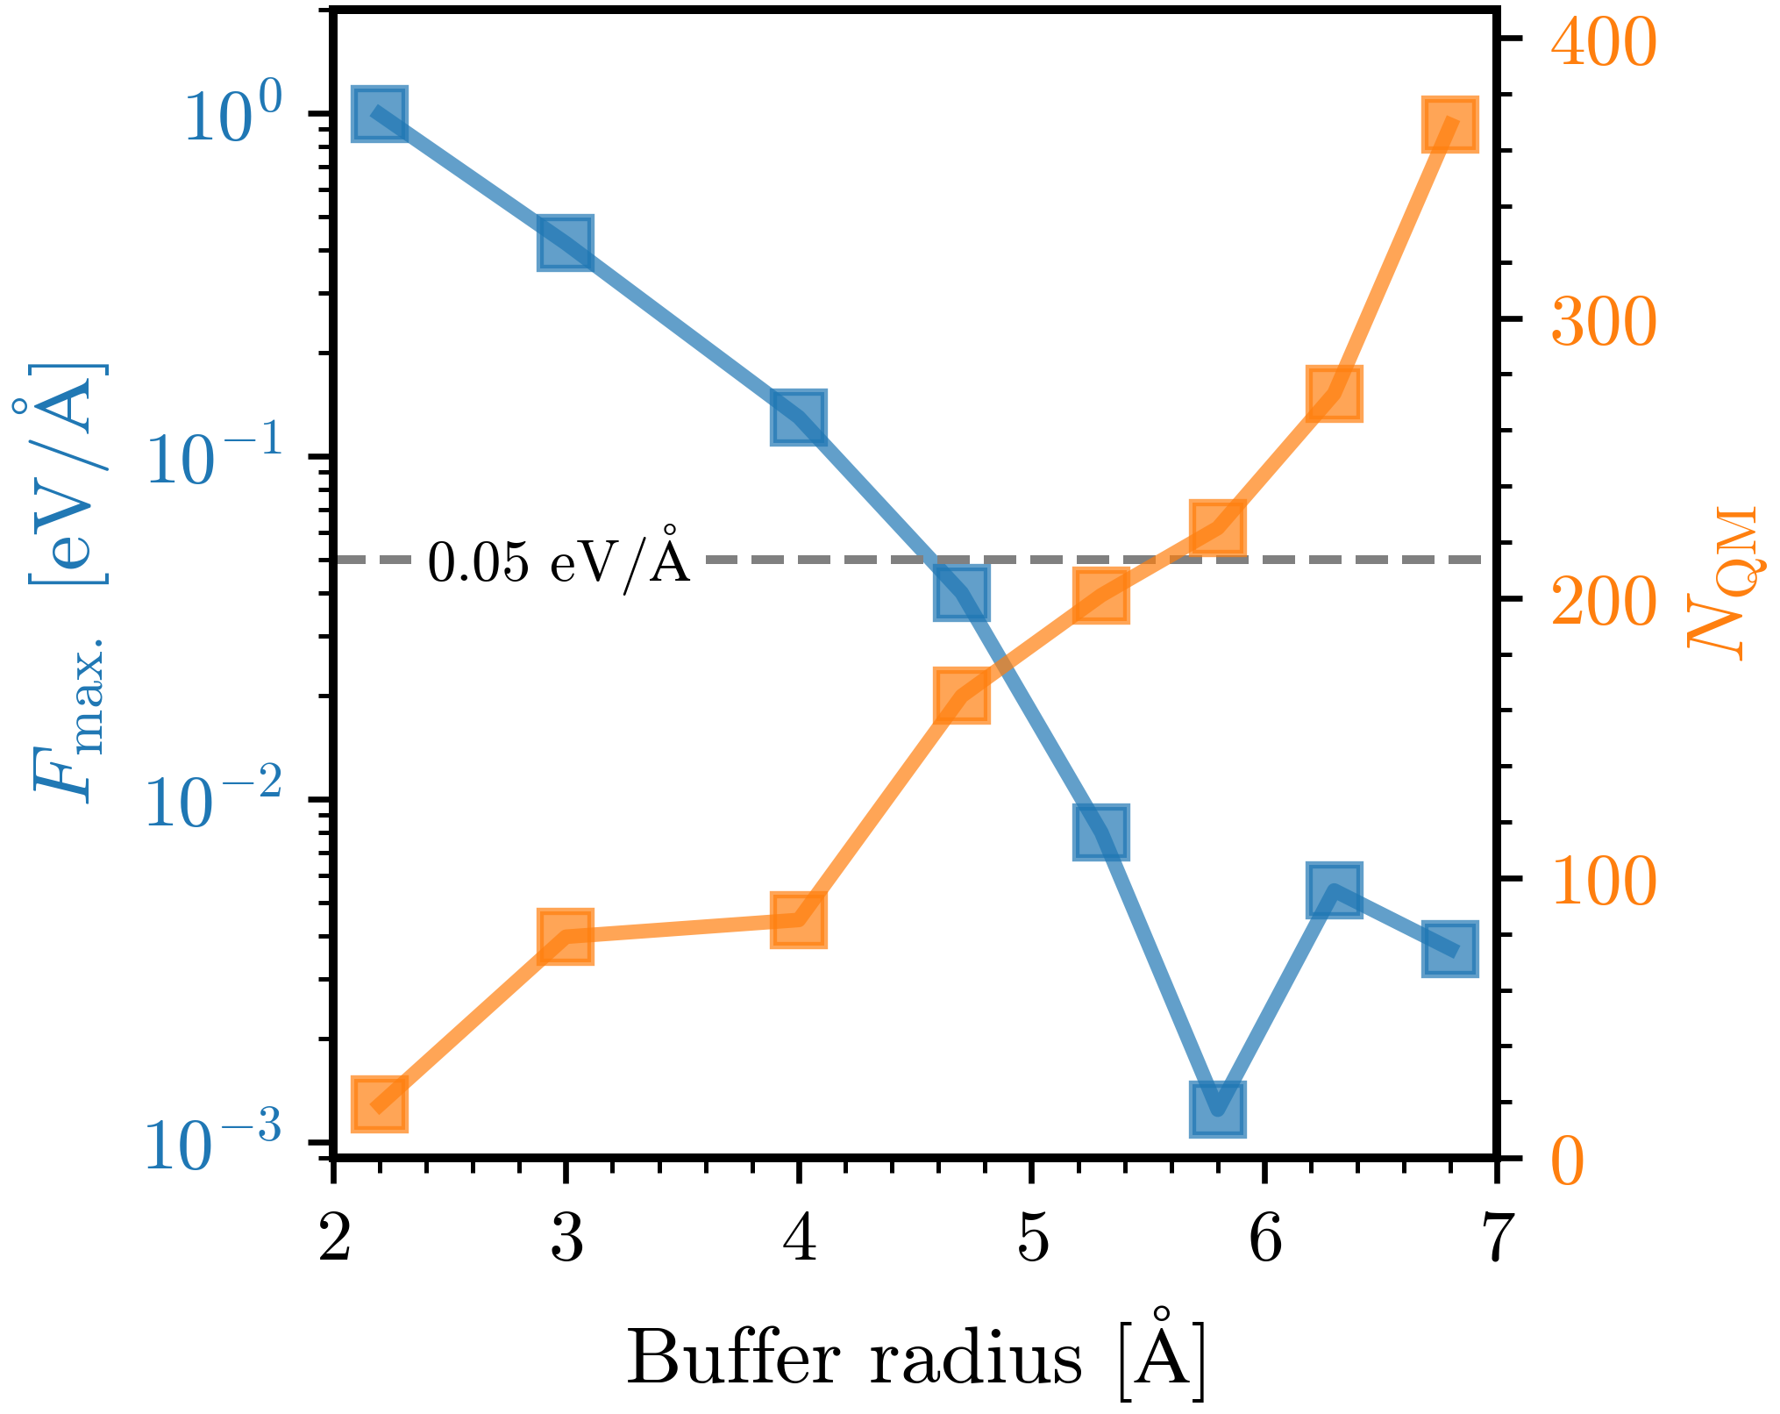
Fig. S5 Maximum atomic force (F_{max.}) on atoms and the total number of atoms of the QM cell as a function of buffer radius.

- Comparison of segregation spectra
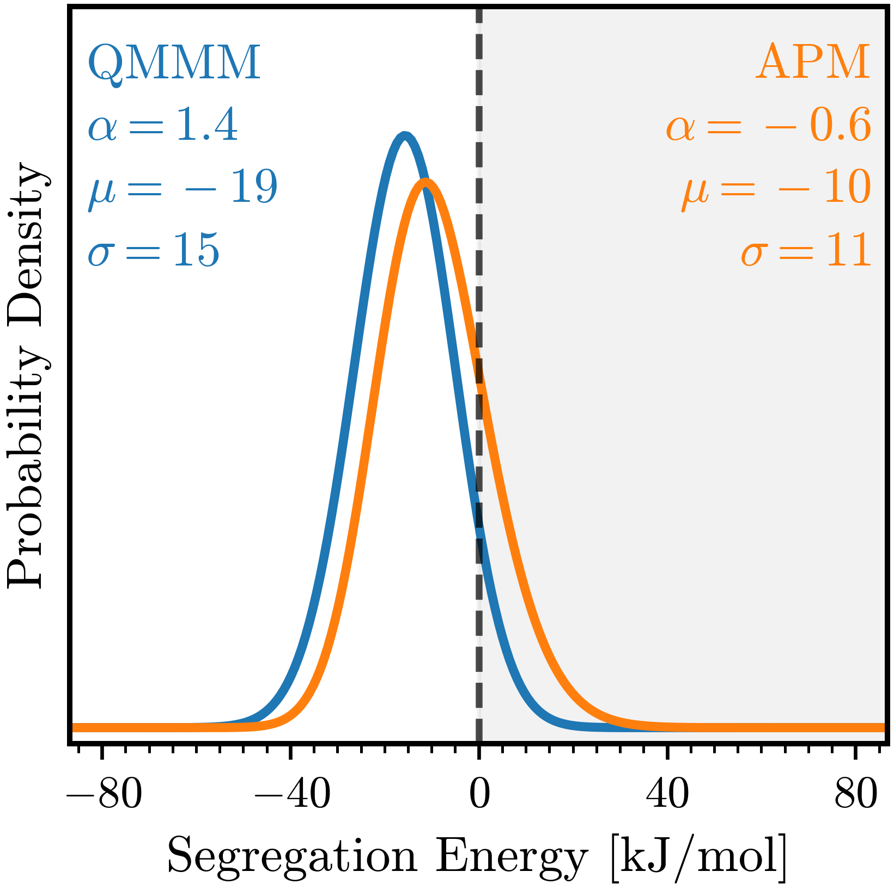
Fig. S6 Comparison of the Re segregation energy spectra in ferromagnetic Ni polycrystals obtained from QM/MM calculations (blue) and the machine-learning potential-based APM method (orange) [16]. The shaded region indicates positive (anti-segregation) energies.

- Estimation of entropy parameters
The isotherm predictions in the main text (Eq. 4) account for excess site entropies with entropic parameters of χ and ΔS_{seg}⁰. No direct measurements or calculations of these entropic parameters exist for the Ni-Re system. Prior computational work [17] has shown that solutes with similar electronic structures exhibit consistent entropic parameters. Specifically, for late transition metals (Ag, Au, Pd, Pt) in Ni, both the magnitude and sign of their parameters are remarkably similar, particularly for those in the same column, as summarized in Table S4. Given that Re, Mo, and W are neighboring 5d/4d transition metal elements with similar electronic structures, we adopt the reported entropic parameters for Ni-Mo and Ni-W systems [17] as reasonable approximations for Ni-Re. We use the average of these two systems as our estimation, with the range between them defining uncertainty bounds (shown as dashed lines with shading in Fig. 4).
Table S4 Entropic parameters for solute segregation in Ni-based alloys.
Solute | χ (×10⁻⁴)  K⁻¹ | ΔS_{seg}⁰ (×10⁻³)  kJ·mol⁻¹·K⁻¹ | Refs.
Ag | 2.24 | 7.51 | [17]
Au | 2.27 | 7.74 | [17]
Pd | 2.74 | 4.46 | [17]
Pt | 2.55 | 4.68 | [17]
Mo | 3.50 | -0.49 | [17]
W | 2.77 | -0.68 | [17]
Re | 3.14 ± 0.37 | -0.59 ± 0.10 | This work

References
[1] R. Hadian, B. Grabowski, and J. Neugebauer, “GB code: A grain boundary generation code,” J. Open Source Softw., vol. 3, no. 29, p. 900, 2018, doi: 10.21105/joss.00900.
[2] J. P. Perdew, K. Burke, and M. Ernzerhof, “Generalized gradient approximation made simple,” Phys. Rev. Lett., vol. 77, no. 18, pp. 3865–3868, 1996, doi: 10.1103/PhysRevLett.77.3865.
[3] S. He, W. Ecker, O. E. Peil, R. Pippan, and V. I. Razumovskiy, “The effect of solute atoms on the bulk and grain boundary cohesion in Ni: Implications for hydrogen embrittlement,” Materialia, vol. 21, p. 101293, 2022, doi: 10.1016/j.mtla.2021.101293.
[4] V. I. Razumovskiy, A. Y. Lozovoi, I. M. Razumovskii, and A. V Ruban, “Analysis of the alloying system in Ni-base superalloys based on ab initio study of impurity segregation to Ni grain boundary .,” Adv. Mater. Res., vol. 278, pp. 192–197, 2011, doi: 10.4028/www.scientific.net/AMR.278.192.
[5] V. I. Razumovskiy, A. Y. Lozovoi, and I. M. Razumovskii, “First-principles-aided design of a new Ni-base superalloy : Influence of transition metal alloying elements on grain boundary and bulk cohesion,” Acta Mater., vol. 82, pp. 369–377, 2015, doi: 10.1016/j.actamat.2014.08.047.
[6] D. Scheiber, V. Razumovskiy, O. Peil, and L. Romaner, “High-Throughput First-Principles Calculations and Machine Learning of Grain Boundary Segregation in Metals,” Adv. Eng. Mater., vol. 26, p. 2400269, 2024, doi: 10.1002/adem.202400269.
[7] Y. Shi, H. Xue, F. Tang, R. Dang, F. Si, and Y. Hu, “Weighted average study of transition metal segregation at Ni grain boundaries and its effect on grain boundary cohesion,” J. Mater. Res. Technol., vol. 36, pp. 292–299, 2025, doi: 10.1016/j.jmrt.2025.03.099.
[8] H. Xue, Y. Luo, F. Tang, X. Yu, X. Lu, and J. Ren, “Solute segregation induced stabilizing and strengthening effects on Ni Σ3 [110](111) symmetrical tilt grain boundary in nickel-based superalloys,” J. Mater. Res. Technol., vol. 11, pp. 1281–1289, 2021, doi: 10.1016/j.jmrt.2021.01.066.
[9] H. Xue, R. Dang, F. Tang, X. Lu, J. Ren, and J. Li, “Nonmetallic trace elements induced rhenium co-segregation in nickel Σ5 [001](210) symmetrical tilt grain boundary,” J. Mater. Res. Technol., vol. 25, pp. 2913–2924, 2023, doi: 10.1016/j.jmrt.2023.06.183.
[10] E. C. Stoner, “Collective electron ferromagnetism II . Energy and specific heat,” Proc. R. Soc. London. Ser. A. Math. Phys. Sci., vol. 169, no. 938, pp. 339–371, 1939, doi: 10.1098/rspa.1939.0003.
[11] P. M. Marcus and V. L. Moruzzi, “Stoner model of ferromagnetism and total-energy band theory,” Phys. Rev. B, vol. 38, no. 10, pp. 6949–6953, 1988, doi: 10.1103/PhysRevB.38.6949.
[12] G. L. Krasko and G. B. Olson, “Energetics of bcc-fcc lattice deformation in iron,” Phys. Rev. B, vol. 40, no. 17, pp. 536–545, 1989, doi: 10.1103/PhysRevB.40.11536.
[13] H. A. Murdoch and C. A. Schuh, “Estimation of grain boundary segregation enthalpy and its role in stable nanocrystalline alloy design,” J. Mater. Res., vol. 28, no. 16, pp. 2154–2163, 2013, doi: 10.1557/jmr.2013.211.
[14] E. Şaşıoğlu, C. Friedrich, and S. Blügel, “Effective Coulomb interaction in transition metals from constrained random-phase approximation,” Phys. Rev. B, vol. 83, p. 121101(R), 2011, doi: 10.1103/PhysRevB.83.121101.
[15] G. Stollhoff, A. M. Oleś, and V. Heine, “Stoner exchange interaction in transition metals,” Phys. Rev. B, vol. 41, no. 10, pp. 7028–7041, 1990, doi: 10.1103/PhysRevB.41.7028.
[16] N. Tuchinda, C. Li, and C. A. Schuh, “The augmented potential method: Multiscale modeling toward a spectral defect genome,” Scr. Mater., vol. 271, p. 116969, 2026, doi: 10.1016/j.scriptamat.2025.116969.
[17] N. Tuchinda and C. A. Schuh, “Grain boundary segregation spectra from a generalized machine-learning potential,” Scr. Mater., vol. 264, p. 116682, 2025, doi: 10.1016/j.scriptamat.2025.116682.

