Supplementary Materials for

Temporally-resolved deep learning reveals autism symptom-specific neural signatures during naturalistic social experiences

Lei Li et al.

Corresponding authors: Lei Li, Ph.D. & Vinod Menon, Ph.D.
Email: hpleili@stanford.edu; menon@stanford.edu

This file includes:

Supplementary Methods
Supplementary Results
Supplementary Figures S1 to S8
Supplementary Tables S1 to S8
References

I. Supplementary Methods

Diagnostic process and inclusion criteria

All clinical diagnoses in this study were drawn from the Diagnosis_ClinicianConsensus file of the Child Mind Institute Healthy Brain Network (CMI-HBN), which reflects evaluations conducted by licensed clinicians using a structured consensus protocol (1). Each participant could receive up to 10 diagnoses, with determinations based on integrated evidence—including structured interviews, symptom profiles, and developmental/clinical history—rather than any single instrument. The CMI-HBN documentation explicitly notes that these procedures do not constitute comprehensive ASD evaluations; accordingly, only a subset of participants received an ASD diagnosis, while others with possible but unconfirmed ASD presentations were flagged for specialized follow-up.

To support diagnostic reliability and stratify confidence, each diagnosis was annotated with a standardized certainty label, including:
- Confirmed (diagnostic criteria fully met under HBN protocols),
- Presumptive (likely meets criteria; additional confirmation recommended),
- Requires Confirmation (evidence present but insufficient for a confident diagnosis),
- Rule-out (symptoms present but better explained by other conditions or too limited for diagnosis),
- By History (prior diagnosis reported but not confirmed during the HBN evaluation),
- Past (symptoms previously present but not currently active),
- No Diagnosis Given: Incomplete Evaluation (assessment not completed).
- No Diagnosis Given

For the present analysis, we included participants with Confirmed or Presumptive ASD and excluded cases labeled Rule-out, By History, or Requires Confirmation to maximize diagnostic specificity. Typically developing control (TDC) participants were defined as those with no reported psychiatric diagnosis (i.e., No Diagnosis Given, or No Diagnosis Given: Incomplete Evaluation).

fMRI Preprocessing

Functional MRI (fMRI) data preprocessing was performed in SPM12 using custom MATLAB scripts. Initial quality assurance (QA) procedures excluded participants with excessive head motion (mean framewise displacement (FD) > 0.5 mm or > 10% of volumes requiring repair). Functional images were then preprocessed using standard steps, including head motion correction (realignment to the mean functional image) and slice-time correction. Subsequently, functional images were normalized to the Montreal Neurological Institute (MNI152) template (2 mm isotropic resolution) and spatial smoothed with a 6 mm Gaussian kernel. Time series were band-pass filtered (0.008—0.09 Hz) to reduce scanner drift and physiological noise. Finally, nuisance regression was performed to remove physiological and motion-related artifacts by regressing out mean time series from white matter and cerebrospinal fluid masks, along with six head motion parameters.

Data input to the deep learning model

Regional fMRI time series were extracted using the Brainnetome Atlas, comprising 246 regions of interest (ROIs). For each participant, the data were organized as an N_{C} × N_{T} matrix, where N_{C} denotes the number of regions (246) and N_{T} denotes the number of time points, and were standardized by z-scoring (2). Participant metadata (sex, age, site) were encoded as categorical and numerical covariates and were provided as additional model inputs. Specifically, metadata comprised two dummy-coded sex indicators, one continuous age variable, and three dummy-coded site indicators, resulting in six features in total. When necessary, temporal interpolation was applied to harmonize the number of time points across participants and acquisition sites.

DNN architecture and prior applications

Our lab previously developed a spatiotemporal deep neural network (stDNN) built on a 1D convolutional backbone to capture both spatial and temporal dynamics in fMRI time series. This backbone has been widely used in our lab’s prior work, including classification of multiple neurological and psychiatric conditions (3, 4) and demographic attribute inference such as sex classification (5). Here, we adopted this backbone to exploit the sequential organization of ROI‐level fMRI signals acquired during naturalistic movie viewing, which are naturally represented as region-wise time series. In contrast to 2D convolutions designed for images, 1D convolutions operate along the temporal axis while treating ROIs as channels, thereby preserving region‐wise resolution while implicitly modeling inter-regional correlations. This design enables the model to learn spatio-temporal relationships in the data without compromising spatial specificity (5). The architecture takes preprocessed ROI × time inputs, optionally augmented with subject‐level metadata, and passes them through stacked convolutional, normalization, and non‐linear activation layers to generate feature embeddings suitable for both classification and regression tasks.

Rationale for developing the DualPathNet architecture

Naturalistic movie‐viewing paradigms elicit neural responses that encompass both global, time-aggregated patterns and time-varying, event-locked fluctuations, each carrying complementary information relevant to ASD classification. In contrast, most prior ASD neuroimaging studies have focused on resting‐state fMRI, which captures static intrinsic connectivity patterns in the absence of structured stimuli and may be less sensitive to transient, stimulus‐locked neural responses. As a result, conventional models developed primarily for resting‐state data often emphasize a single dimension of brain function, limiting their capacity to capture the full spatiotemporal complexity of movie‐evoked brain activity.

To address this gap, we developed a DualPath spatiotemporal DNN (DualPath stDNN), comprising two computational streams that share an initial 1D convolutional encoding stage. The DualPath architecture is designed to support two complementary objectives in fMRI modeling: (1) learning global temporal summaries that support classification, and (2) localizing temporally specific, event-level signals for interpretability. The Global Temporal-Pooling path computes temporally averaged feature representations and captures global, distributed neural signatures that contribute to overall classification performance. However, temporal pooling alone cannot localize the specific time points that drive prediction (6).

To address this limitation, we introduced a second pathway using an attention-based multiple instance learning (MIL) mechanism that assigns adaptive weights to individual time points according to their predictive relevance (7). This attention-based MIL path enables the model to isolate temporally sparse but functionally salient fMRI patterns associated with ASD.

In addition to the fMRI time series input, we incorporated subject-level metadata—age (continuous), sex (binary), and site (categorical)—into the classification framework. Categorical variables (sex, site) were one-hot encoded, whereas age was used as a continuous covariate (3). Metadata features were concatenated with the learned temporal feature embeddings from both the Global Temporal-Pooling and attention-based MIL paths prior to fusion, enabling the model to account for demographic and acquisition-related variance alongside neurodynamic signals. Specifically, in Global Temporal-Pooling path, the temporally averaged feature vector $z_{mean}∈R^{512}$was concatenated with the metadata vector $z_{meta}∈R^{d}$ to produce ${\tilde{z}}_{mean}∈ R^{512+d}$, which was then passed to a linear classifier. In the attention-based MIL path, the shared convolutional encoder produced timepoint-wise feature vectors $h_{t}∈R^{512}$. Each $h_{t}$was concatenated with $z_{meta}$ to form ${\tilde{h}}_{t}∈ R^{512+d}$. These vectors were passed through a fully connected layer followed by a temporal softmax to compute attention weights. The resulting attention-pooled representation $z_{attn}$captures temporally localized but highly informative neural patterns.

The final representation was obtained by a learned weighted fusion of the two branches:
$$z= α×{\tilde{z}}_{mean}+(1-α)× z_{attn}$$
Conceptually, the Global Temporal-Pooling branch extracts a global, time-aggregated summary of spatiotemporal brain activity across the viewing period, resulting in a temporally compressed representation that reflects stable, subject-level characteristics, such as global functional connectivity patterns or enduring neural traits associated with ASD. In contrast, the attention-based MIL branch is optimized to capture state-level fluctuations, such as transient yet behaviorally salient neural responses to specific audiovisual events, by upweighting time points that are most predictive. By computing timepoint-wise attention scores across the full time series, this path emphasizes transient, event-locked neural responses that may correspond to socially, emotionally, or cognitively salient moments in the movie stimuli. Together, the DualPath architecture integrates global and temporally localized neural information, improving classification performance while supporting event-level interpretability through attention and attribution. A learnable fusion parameter combines the temporally pooled and attention-weighted embeddings, ensuring that both sustained and moment-specific neural signals contribute meaningfully to the final decision boundary.

Model implementation details

The DualPathNet takes ROI-wise fMRI time series as an input tensor $X∈R^{B×C×T }$, where B is batch size, C = 246 is the number of ROIs, and T is the number of time points. The model applies a shared 1D convolutional encoder along the temporal dimension to learn time-resolved feature embeddings.

Shared temporal encoder (1D CNN)

The input is passed through three 1D convolutional blocks, each followed by batch normalization and ReLU activation:
- Conv1: kernel size = 7, output channels = 256 → Output shape: B×256×T
- Conv2: kernel size = 7, output channels = 256 → Output shape: B×256×T
- Conv3: kernel size = 5, output channels = 512 → Output shape: B×512×T
Dropout (rate = 0.5) is applied after the final convolutional block.

After the shared convolutional encoder, the representation is processed by two branches.

Global Temporal-Pooling branch

This branch performs global average pooling across the temporal dimension, yielding an output of shape: B×512, which is concatenated with participant metadata (6 dimensions: sex dummy codes, age, and site dummy codes) to form a B×518 representation. This fused vector is passed through a fully connected layer for classification.

Attention-based MIL branch

For the MIL branch, the same 6-dimensional metadata vector is broadcast across all time points and concatenated with each 512-dimensional timepoint feature vector. Each concatenated vector (518 dimensions) is then passed through a timepoint-wise fully connected layer to produce a scalar attention logit $u_{t}∈R$ . Attention weights are obtained by applying a softmax over time:
$$α_{t}= \frac{exp⁡(u_{t})}{\sum_{j}{exp⁡(u_{j})}}$$

Attention-weighted pooling is performed over time:
$z_{attn}= \sum_{t}{α_{t}×} {\tilde{h}}_{t}$,
where ${\tilde{h}}_{t}$ denotes the metadata-augmented timepoint features.

The two branches are combined via weight fusion:
$z= α×{\tilde{z}}_{mean}+(1-α)× z_{attn}$,
where $α$ is a tunable fusion weight.

The final prediction is produced by a sigmoid classifier:
$\hat{y}=σ(Wz+b)$,
where σ(⋅) denotes the sigmoid activation function, $z∈ R$is the fused representation from the DualPath architecture, and $W$ and $b$ are learnable parameters of the classifier.

Model training minimizes the binary cross-entropy loss:
$$Loss\left(y,\hat{y}\right)= - \sum_{i}{{[y}_{i}log⁡({{\hat{y}}_{i})}}+\left(1-y_{i}\right)log⁡(1-{{\hat{y}}_{i})]}$$

Hyperparameter search and training strategy

To optimize DualPathNet, we employed a nested cross-validation framework implemented in PyTorch Lightning, with Weights & Biases (W&B) used for experiment tracking and monitoring. Model generalization performance was evaluated using stratified fivefold outer cross-validation. To ensure subject-level independence, fold assignments were generated using stratified group-based splitting, preventing data from the same subject appearing in both training and test folds.

Within each outer training fold, hyperparameter optimization was conducted using an inner cross-validation loop. Hyperparameters—including learning rate, batch size, dropout rate, fusion weight ($α$), weight decay, and early stopping patience, were sampled from predefined ranges using random search. For each candidate configuration, performance was assessed as the mean validation accuracy across inner folds. The fusion weight α controls the relative contributions of the Global Temporal-Pooling and attention-based MIL branches:

$$z= α×{\tilde{z}}_{mean}+(1-α)× z_{attn}$$

After selecting the optimal hyperparameter configuration, the model was retrained on the full outer training fold. A small internal validation subset within the outer training fold was used exclusively for early stopping. Final performance was then evaluated on the corresponding outer test fold, which remained completely independent of model selection.

Training was performed using the Adam optimizer with cross-entropy loss. Early stopping was based on validation accuracy. Final performance metrics, including accuracy, precision, recall, and macro-F1, were computed as the mean and standard deviation across outer folds.

Model stability and control analyses

To assess the reliability and generalizability of DualPathNet, we performed a series of stability and sensitivity analyses examining training stability, robustness to sampling variation, and potential confounds related to participant metadata or acquisition site.

Repeated cross-validation evaluation

To evaluate the stability and robustness of classification performance across different data partitions, we fixed the optimal hyperparameters identified through nested cross-validation and performed 100 repetitions of stratified fivefold cross-validation using different random splits. The resulting distribution of classification accuracies was summarized using a box plot, where the box denotes the interquartile range (IQR), the whiskers indicate the spread of accuracy scores, and any outliers are shown individually. The mean and standard deviation were annotated to provide a compact summary of reproducibility and reliability across sampling configurations.

Metadata contribution test via orthogonal projection removal

To assess whether classification performance depended disproportionately on non-neural metadata (age, sex, site), we performed an orthogonal projection removal analysis to remove feature subspace associated with metadata embeddings using singular value decomposition (SVD) and matrix projection. Let $X ∈ R^{n×d}$ denote the fMRI feature matrix and Z$∈ R^{n×k}$ the metadata matrix. We computed the SVD of $Z$,

$Z=UΣV^{T}$,

And formed the orthogonal projection onto the column space of$Z$,

$$P=UU^{T}$$

We then residualized the fMRI features by removing the metadata-aligned component:

$$X_{clean}=X-PX$$

Models retrained on $X_{clean}$retained substantial predictive performance, suggesting that classification was not driven primarily by metadata-related variance but instead driven by neural signals.

Site effect control via ComBat harmonization

To further evaluate the influence of acquisition site heterogeneity, we applied ComBat harmonization to the fMRI data prior to model training. ComBat removes site-related batch effects while preserving variance attributable to biological and covariate effects (8). We compared three configurations: (a) original data with full metadata, (b) ComBat-harmonized data with full metadata, and (c) ComBat-harmonized data with metadata excluding site. Performance was comparable across all variants, indicating that classification was not driven by site effects and that the DualPath model generalizes across acquisition centers.

Alternative classification models

To benchmark the classification performance of our DualPath stDNN model, we conducted control analyses using a range of conventional machine learning algorithms and baseline deep learning architectures previously developed by our team. Conventional classifiers included both linear and nonlinear models: K-Nearest Neighbor (KNN), Decision Tree, Linear Support Vector Machine (SVM), Logistic Regression, Ridge Classifier, LASSO, and Random Forest.

We also evaluated several baseline deep learning models derived from our prior stDNN framework (3, 5). These architectures have been independently validated in prior work and demonstrated strong performance across multiple fMRI classification tasks (e.g., ASD diagnosis and sex classification). For the present benchmarks, we used simplified variants that relied only on a global, time-averaged representation of brain activity (an “average path” baseline), without attention, multi-instance learning, or event/segment-level temporal modeling. Specifically, these models applied temporal convolution followed by global average pooling across time, yielding a static subject-level embedding for final classification.

All control models were trained and evaluated using the stratified fivefold cross-validation protocol without nested hyperparameter optimization, as these models required minimal tuning, and assessed using accuracy and macro-F1 score averaged across folds.

Identification of informative ROIs and time points using integrated gradients

To interpret the DualPathNet model and identify the spatial and temporal components most influential for ASD vs. TDC classification, we applied Integrated Gradients (IG) to compute feature-level attributions. IG is a path-based attribution algorithm that quantifies the contribution of each input feature to the model’s prediction relative to a reference baseline (9-12).

Functional network characterization using a developmentally appropriate parcellation
To ensure that functional network assignments were appropriate for our developmental cohort, we mapped the 246 Brainnetome ROIs to the Dev-Atlas (13), a pediatric functional parcellation derived from a large-scale developmental dataset (n > 4,000). Unlike standard adult-based atlases (e.g., Yeo-7), which may not fully reflect developmental functional organization, the Dev-Atlas provides a fine-grained 24-network architecture specifically optimized for youth. Using a developmentally grounded template minimizes potential biases from adult-centric network definitions and enhances the sensitivity to detect subtle, age-dependent functional differences relevant to ASD.
Mapping procedure. Dev-Atlas templates were spatially resampled to the Brainnetome Atlas geometry (2 mm isotropic, MNI space) using nearest-neighbor interpolation to preserve discrete network labels. For each Brainnetome ROI, we quantified voxel-wise overlap with all 24 Dev-Atlas networks and assigned the ROI to the network with the greatest volumetric coverage (i.e., the maximum-overlap label).
Anatomical validation. To reduce potential ambiguities arising from spatial boundary uncertainty in temporolimbic regions, we conducted a targeted anatomical review of network assignments. Specifically, the network assignment for the right inferior temporal gyrus (TI_R) was harmonized with its contralateral homolog to reduce potential bias from dropout, and the right posterior insula (dIg_R) was assigned to the Sensorimotor Network (SMN) to resolve spatial ambiguity and align with established functional anatomy. Finally, for system-level interpretation, the 24 Dev-Atlas networks were organized into six canonical functional systems: Default Mode, Sensorimotor, Visual, Control, Dorsal Attention, and Ventral Attention.

ROI-level attribution in DualPathNet (Global Temporal-Pooling and attention-based MIL paths)

For the Global Temporal-Pooling path, which aggregates temporal features across the entire fMRI sequence, IG was used to compute attribution scores for each region of interest (ROI). Specifically, for an input $x∈ R^{C × T}$ and model output $F (x)$, the IG attribution for feature $x_{i}$ is defined as:
$${IG}_{i}=\left(x_{i} - x_{i}^{'}\right) ∙ \int_{α=0}^{1}{\frac{∂F\left(x^{'}+ α\left(x-x^{'}\right)\right)}{∂x_{i}}} dα$$
where$x_{i}^{'}$ is a zero-valued baseline input with the same shape as $x$, $and F\left(⋅\right)$ denotes the model output (logit) for the true class. IG was computed using Captum’s IntegratedGradients module in PyTorch.

For the attention-based MIL path, which emphasizes temporally localized yet salient neural signals, we also used IG to quantify the contribution of each brain region at each time point. The input $x∈ R^{C × T}$was first passed through the shared temporal convolutional encoder to produce time-resolved embeddings. Subject-specific metadata were then concatenated to the embeddings to yield ${\tilde{h}}_{t}∈ R^{512+d}$ (d = 6) at each time point $t$. The MIL path assigns attention weights $α_{t}$​ to each timepoint and computes the attention-pooled representation:
$$z_{attn}= \sum_{t=1}^{T}{α_{t} ∙ {\tilde{h}}_{t}}$$

To assess the contribution of each input element (i.e., ROI activation at time $t$), we applied IG to the attention-based MIL path output for the class of interest, yielding an attribution map in $R^{C × T}$ that captures which regions and moments most strongly influenced the attention-weighted representation and downstream prediction.

To identify the most discriminative brain regions, we first averaged IG scores within each ROI across participants within each cross-validation fold and then took the median across folds to form a group-level attribution map. IG values were then flattened, and a top 5% threshold was applied across all elements to identify high-attribution ROI-timepoint features. We then computed how frequently each ROIs appeared among these top-ranking elements and retained the most consistently selected regions. This procedure resulted in 12 ROIs (out of 246) as the most discriminative regions for each group (ASD or TDC) for each prediction path. These ROIs were subsequently visualized on cortical surfaces to facilitate interpretation.

Timepoint-level attribution (attention-based MIL path)

To interpret the temporally resolved decision process of DualPathNet, we leveraged the attention-based multiple instance learning (MIL) branch combined with Integrated Gradients (IG). Unlike global temporal pooling, the MIL branch explicitly retains temporal resolution by assigning adaptive attention weights to each time point, reflecting its relative importance to the classification decision.

Defining discrete events from attention weights. Instead of applying arbitrary thresholds to select time points, we defined discrete narrative "events" based on statistical group differences in model-derived attention. Specifically, we extracted attention weights for all ASD and TDC participants and performed timepoint-by-timepoint two-sample t-tests to identify frames with significant between-group differences in attention (p < 0.05, uncorrected). Consecutive significant time points were then clustered to define discrete events (e.g., E1–E4 in movieDM Segment 2). This approach localizes moments of maximal diagnostic divergence in attention, rather than relying on transient fluctuations.

Spatiotemporal feature attribution using IG. While attention identifies when discriminative signals arise, it does not specify where in the brain that signal is expressed. To localize spatial contributors, we computed IG attributions for the MIL branch to obtain ROI x timepoint attribution maps. To characterize the neural signature of each identified event, we (i) computed the time-resolved IG maps for all participants; (ii) averaged absolute IG values across the time points within each event window; and (iii) defined event-specific "discriminative drivers" as ROIs in the top 5% of mean IG for that event.

Physiological validation. To verify that attention weights indexed physiologically meaningful neural saliency rather than noise, we calculated the temporal concordance between attention scores and time-resolved IG magnitude (summed across regions) by computing their correlation across time within each participant.

Video annotation alignment

To aid interpretation on fMRI responses during naturalistic movie viewing, we implemented a multi-level annotation pipeline to extract and temporally align semantic, emotional, and descriptive features from video stimuli with the fMRI time course.

Semantic segmentation of video events

We first segmented each movie clip into discrete visual scenes using PySceneDetect (https://github.com/Breakthrough/PySceneDetect), an automated scene-boundary detection tool that identifies transitions based on frame-to-frame visual change (e.g., histogram/content shifts). These scene boundaries provided a coarse structural parse of the stimulus, serving as anchors for downstream annotation and alignment.

To derive higher-level semantic descriptions, we used CLIP (Contrastive Language–Image Pretraining) model from OpenAI (https://github.com/openai/CLIP) to embed video frames into a joint vision-language feature space. Frames were encoded with a pre-trained ViT-B/32 vision backbone and then grouped into semantically similar clusters using unsupervised K-means or agglomerative clustering to yield candidate event groups, such as “the boy unwraps a gift” or “the dog runs across the room.” Cluster-level semantic labels were manually verified to ensure interpretability and alignment with the narrative context. Finally, segment timestamps from stimulus presentation logs were used to map each labeled video segment to the corresponding fMRI time points (e.g., TRs), allowing direct alignment of semantic features with neural activation.

Emotion annotation

To annotate affective content, we adopted a zero-shot classification strategy leveraging CLIP’s ability to quantify semantic similarity between image and text. We curated a set of 30 text prompts based on the GoEmotions taxonomy (https://github.com/google-research/google-research/tree/master/goemotions), a validated emotional labeling framework (14). Our prompt set included 28 original GoEmotions emotion descriptors (e.g., “joyful,” “angry,” “disappointed”), supplemented by two additional neutral prompts— “a calm and quiet scene” and “a transition with little emotion”—to better capture affectively neutral or transitional periods in naturalistic stimuli. The final prompt set comprised 12 positive, 7 neutral, and 11 negative labels.

For each video segment (defined by a PySceneDetect boundaries and/or semantic cluster), we selected a representative keyframe (typically the segment midpoint). The keyframe was encoded using CLIP ViT-B/32, and cosine similarity was calculated between the visual embedding and each prompt embedding. The softmax-normalized highest-scoring emotion label was assigned as the emotion class for that segment. The CLIP model was run in a local environment using fixed model weights and dependencies to ensure reproducibility and allow for batch inference across all segments. Emotion labels were then aligned to fMRI time points for downstream interpretation of group differences.

Natural language description

To generate human-readable descriptions for each video segment, we employed BLIP-2 (Bootstrapped Language–Image Pretraining) framework (https://github.com/salesforce/LAVIS) for image-to-text generation with a Flan-T5-XL decoder (https://huggingface.co/google/flan-t5-xl). BLIP-2 decouples visual feature extraction from language generation by converting image features into query tokens via a vision-language transformer (Q-Former). In our setup, we used the pre-trained BLIP-2 + Flan-T5-XL checkpoint for image captioning and instruction following, downloaded via Hugging Face and deployed on GPU. For each segment, the representative keyframe was input to BLIP-2 to generate natural language descriptions such as “A boy looks curiously at a box” or “A dog limps forward but keeps playing.” These descriptions complemented the emotion and semantic labels and provided narrative grounding for interpreting attention weights and IG-derived importance maps.

Alignment with fMRI time series

All annotations—including scene boundaries, semantic clusters, emotional labels, and natural language captions—were aligned to the fMRI time series using the original stimulus timing files. To account for the hemodynamic delay of fMRI BOLD response, we applied an ~4s temporal shift when aligning video events to fMRI timepoints. This ensured that neural activations were matched to the underlying cognitive and perceptual events with greater fidelity. This alignment enabled a one-to-one mapping of video-driven events to fMRI data points, making it possible to directly examine how brain responses at specific time points correspond to meaningful visual, emotional, or narrative events in the stimulus. Finally, we cross-referenced the aligned annotations with neural saliency maps (IG) and attention weights extracted from the attention-based MIL path of DualPathNet. Together, this multimodal, temporally aligned annotation pipeline enabled semantically grounded interpretation of when and how ASD and TDC groups diverged during naturalistic social-emotional processing.
II. Supplementary Results

Classification robustness across random sampling splits

To assess the robustness of DualPathNet’ classification performance under different data partitions, we conducted 100 repetitions of stratified fivefold cross-validation for each task condition: movieTP, movieDM, and resting-state. For each repetition, we varied the random seeds to generate distinct fold assignments and recorded accuracy on the held-out fold.

As illustrated in Supplementary Figure S1, the distribution of accuracies across the 100 repetitions were stable across all three conditions. For movieTP, the model achieved a mean accuracy of 72.15% with a standard deviation of 1.96%, indicating tight clustering and minimal variability across resampling iterations. The movieDM condition showed slightly lower mean accuracy (64.68%) with moderately increased variance, while the resting-state condition exhibited both lower mean accuracy (63.44%) and greater dispersion, suggesting reduced robustness in the absence of externally structured stimuli.

These results confirm that DualPathNet achieves reproducible classification across random resampling splits, with the strongest stability under movieTP. The tighter distribution and higher central tendency for movieTP further support its prioritization for interpretability and brain-behavioral analyses.

Contribution of metadata assessed via orthogonal projection removal

To examine whether model performance was disproportionately driven by non-neural metadata (i.e., age, sex, and site), we applied an orthogonal projection removal procedure prior to classification. This method removed the component of the fMRI feature space that is linearly aligned with participant metadata using singular value decomposition (SVD) projection, yielding residualized features that preserve neural variability independent of these covariates.

After projection removal, DualPathNet was retrained and evaluated using the same fivefold cross-validation procedure under the movieTP condition. The resulting mean classification accuracy was 70.02%, showing only a modest drop compared to the original model. This result suggests that classification accuracy was not primarily driven by demographic or acquisition covariates, and that the dominant predictive signal originates from neural dynamics captured during movie viewing.

Controlling site variability using ComBat harmonization

To further evaluate potential confounding by acquisition site, we applied ComBat harmonization to ROI-wise fMRI time series prior to model training. ComBat removes site-specific batch effects while preserving biologically meaningful variation and is widely adopted for multisite neuroimaging studies.

DualPathNet trained and evaluated on ComBat-adjusted movieTP data achieved a mean accuracy of 72.03% under fivefold cross-validation, nearly identical to the original, unharmonized model. This result confirms that site-related variability did not substantially influence classification performance, supporting the robustness and generalizability of the approach.

Benchmarking against conventional machine learning models

To benchmark DualPathNet, we compared it against a range of baseline models, including conventional machine learning classifiers, alternative deep-learning architectures, and ablated versions of our own network. Conventional baselines included commonly used linear and non-linear classifiers, while deep learning benchmarks included LSTM-based models and previously published stDNN variants from our group that rely on simple temporal pooling strategies (3, 5, 15). We also tested single-path ablations of DualPathNet using only the Global Temporal-Pooling or only the attention-based MIL branch (Table S2).

Across these comparisons, DualPathNet consistently outperformed all alternatives. While several baselines achieved moderate accuracy, none matched the full dual-path architecture, highlighting the benefit of jointly modeling global, time-aggregated information and temporally localized, event-level dynamics in naturalistic paradigms for ASD classification.

Spatial attribution summary from IG-based feature analysis

To characterize spatial contributors to ASD classification under the MovieTP and MovieDM (Segment 2) conditions, we computed IG attribution scores separately for the Global Temporal-Pooling and attention-based MIL paths. For each path, we identified the top 5% contributing ROIs across participants. Crucially, to functionally characterize these regions within a developmentally appropriate framework, all 246 Brainnetome ROIs were mapped to the Dev-Atlas 24-network parcellation (13), rather than adult-based templates. Supplementary Tables S3–S7 summarize the highest-attribution ROIs for each path, detailing their anatomical labels, Dev-Atlas network affiliations (e.g., DMN_4 vs. DMN_1), and mean attribution weights.

This network mapping revealed that discriminative signals were not randomly distributed but clustered within specific functional subsystems relevant to adolescent brain organization. Furthermore, to identify neural signatures that persisted across changing narrative contexts, we constructed Core Presence Matrices (Tables S5 and S8) that quantify ROI recurrence across discrete attention-defined narrative events. These analyses highlighted cross-event stability within specific Default Mode (e.g., DMN_2, DMN_4) and Sensorimotor (e.g., SMN_4) subnetworks as consistent contributors to ASD classification.

III. Supplementary Figures

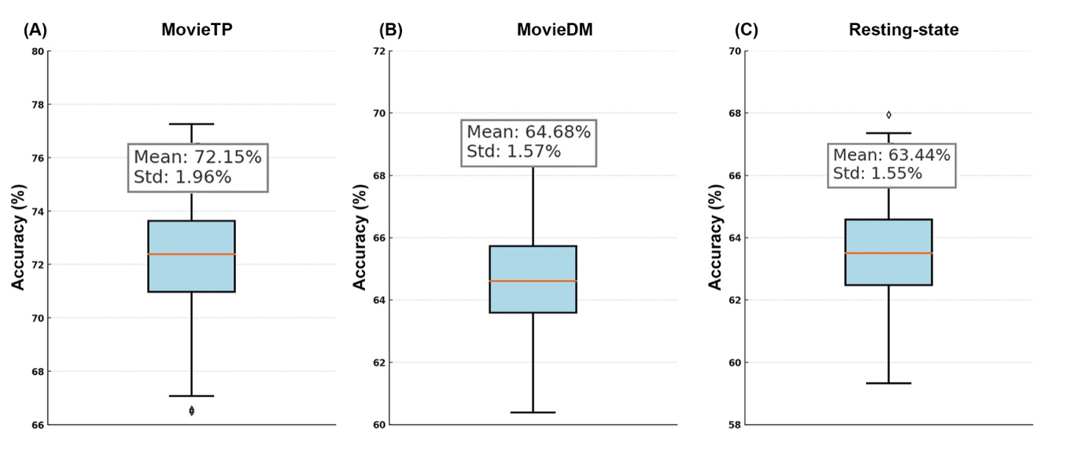

Figure S1. Classification robustness of DualPathNet across random sampling splits. Boxplots show the distribution of classification accuracies from 100 repetitions of stratified fivefold cross-validation for three conditions: (A) MovieTP, (B) MovieDM, and (C) Resting-state.

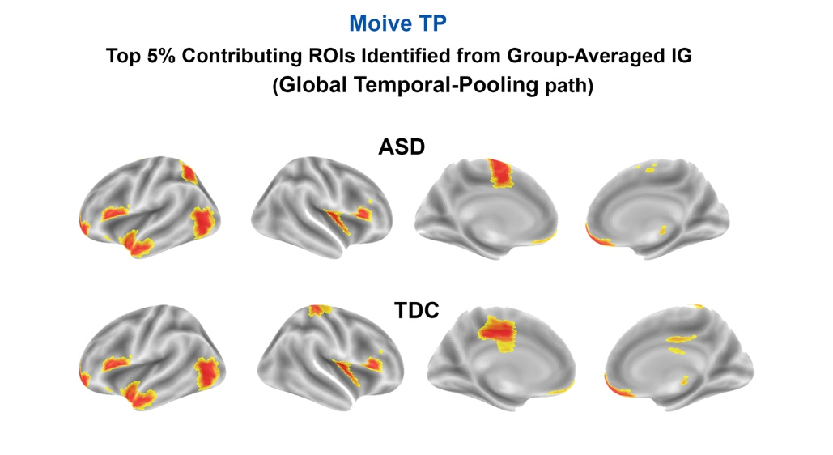
Figure S2. Stable spatial signatures identified by the Global Temporal-Pooling path during The Present (movieTP). Surface renderings illustrate the top 5% contributing brain regions derived from group-averaged Integrated Gradients (IG) for the ASD (top row) and TDC (bottom row) groups.
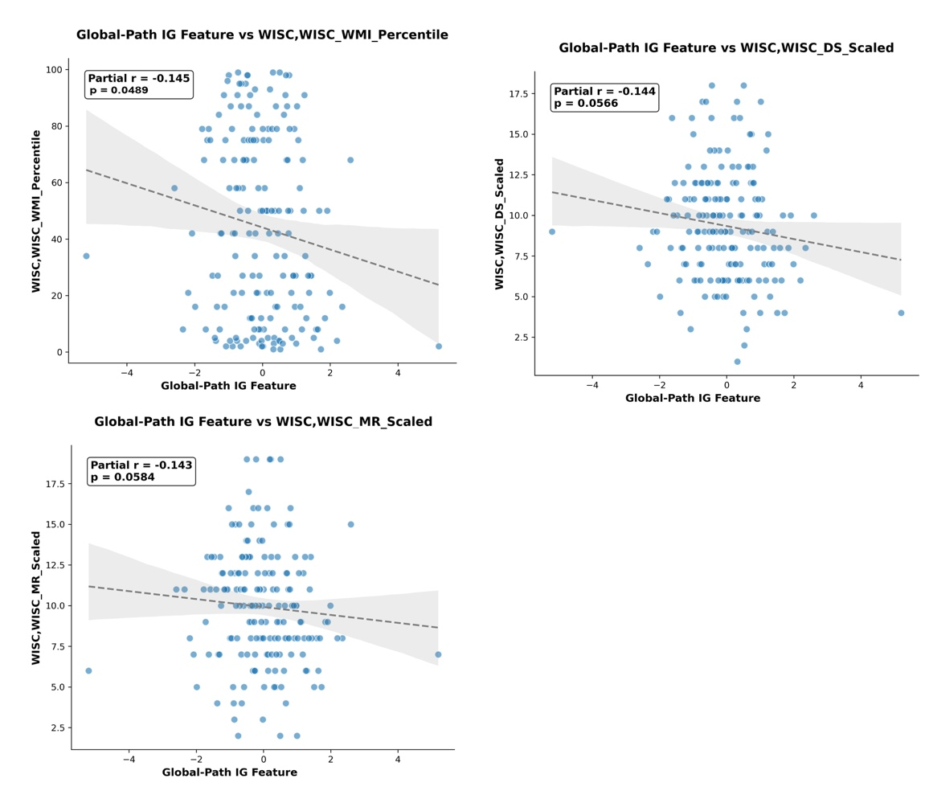
Figure S3. Associations between Global-Path IG features in movieTP and behavioral measures. Scatter plots illustrate partial correlations between the Global-Path Integrated Gradients (IG) features in movieTP and subscales of the Wechsler Intelligence Scale for Children (WISC), including the WISC Working Memory Index (WMI) percentile, Digit Span (DS) scaled score, and Matrix Reasoning (MR) scaled score. Grey dashed lines represent fitted linear trends, and shaded bands indicate 95% confidence intervals.

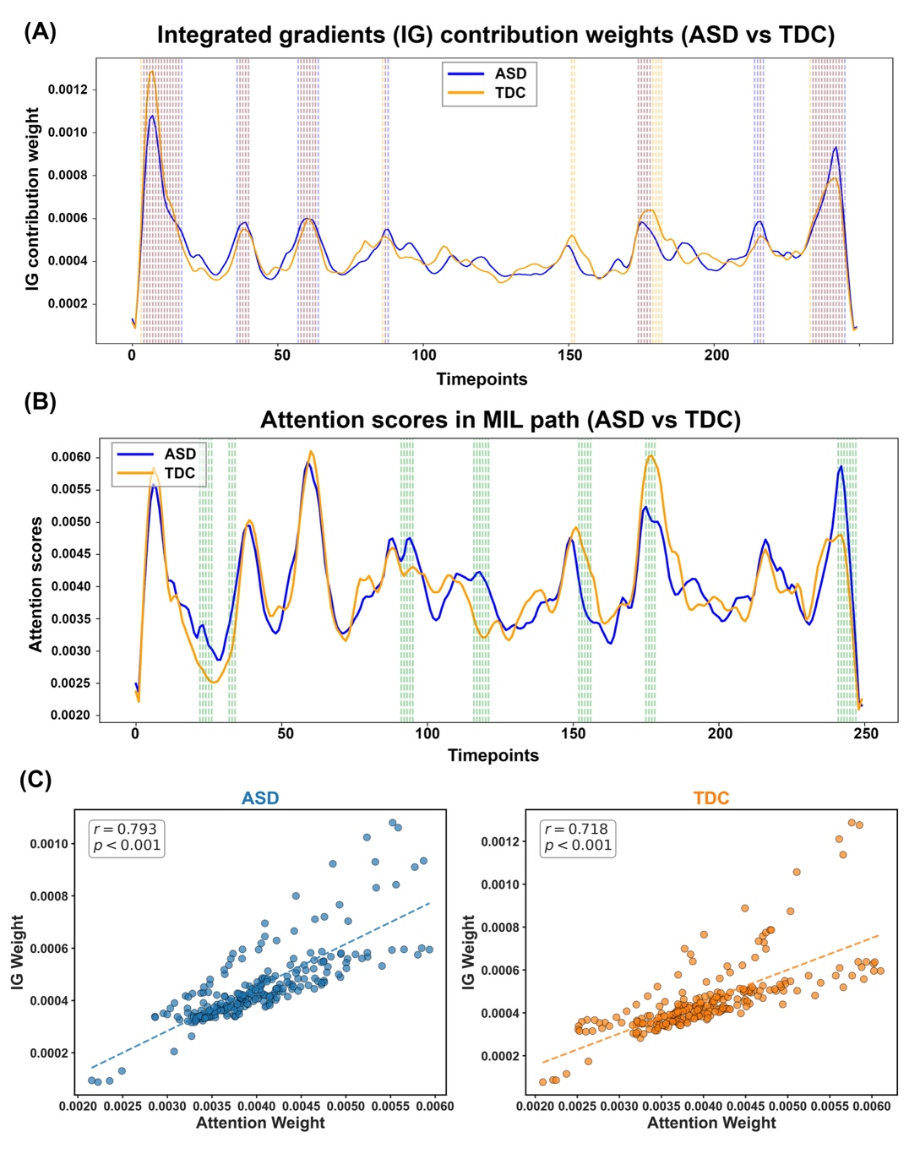
Figure S4. Temporal dynamics and physiological validation of the attention mechanism in The Present (movieTP). (A) Group-averaged IG magnitude across the movie time course (ASD in blue, TDC in orange). (B) Time-resolved attention scores from the MIL path. The close correspondence between ASD and TDC curves suggests broadly shared temporal saliency structure in this cohesive narrative. (C) Physiological validation: Pearson correlations between frame-level attention weights (x-axis) and subject-specific global IG magnitude (y-axis). Strong positive correlations in both ASD (r = 0.793, p < 0.001) and TDC (r = 0.718, p <0.001) groups confirm that MIL attention weights is physiologically grounded, tracking moments of high neural saliency rather than noise.
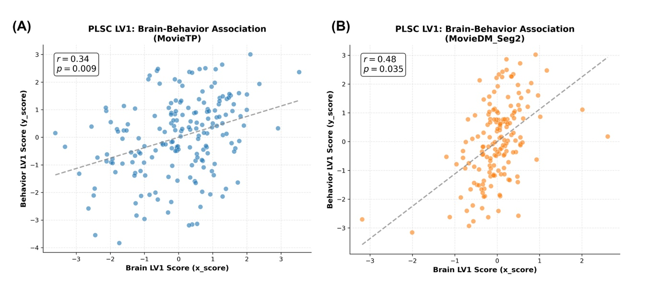
Figure S5. Brain-behavior associations identified using PLSC analysis. Scatter plots depict significant correlations between Brain LV1 scores (x-axis) and Behavior LV1 scores (y-axis) for the first latent variable (LV1). (A) Brain-behavior association in the MovieDM_Seg2 condition (r = 0.48, p = 0.035). (B) Brain-behavior association in the MovieTP condition (r = 0.34, p = 0.009). Each dot represents one participant; grey dashed lines indicate the fitted linear relationship. The statistical significance (p-values) of the latent variables was determined using permutation testing (5,000 permutations), which assessed the probability of observing a singular value at least as large as the empirical value under the null.

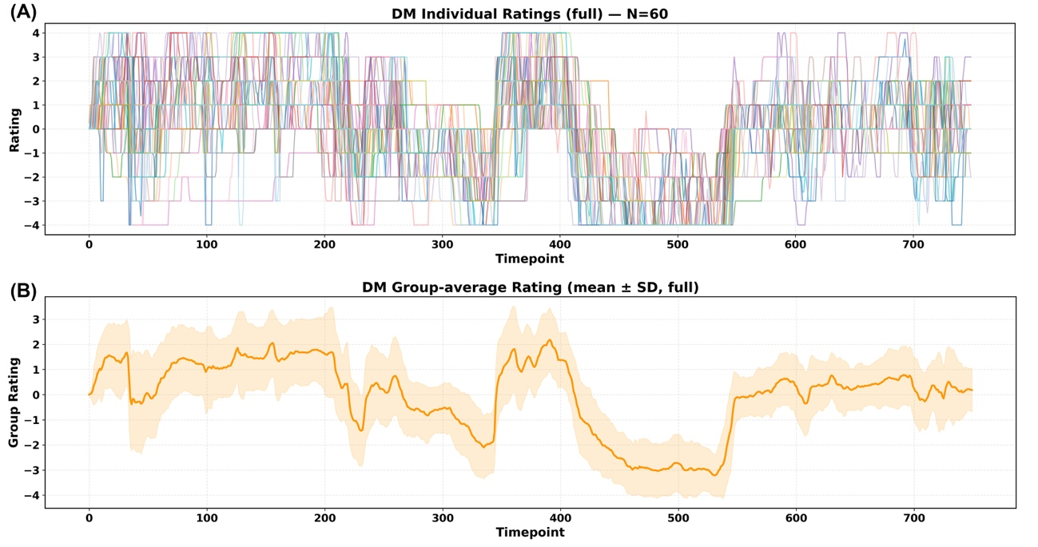
Figure S6. Manual emotional valence ratings for the MovieDM stimulus. (A) Continuous emotional valence ratings (z-scored within rater) from 20 independent adult raters, each completing three viewings (total N = 60 rating series). Positive values indicate more positive affect, and negative values indicate more negative affect. (B) Group-average valence trajectory (mean ± SD) across all raters.

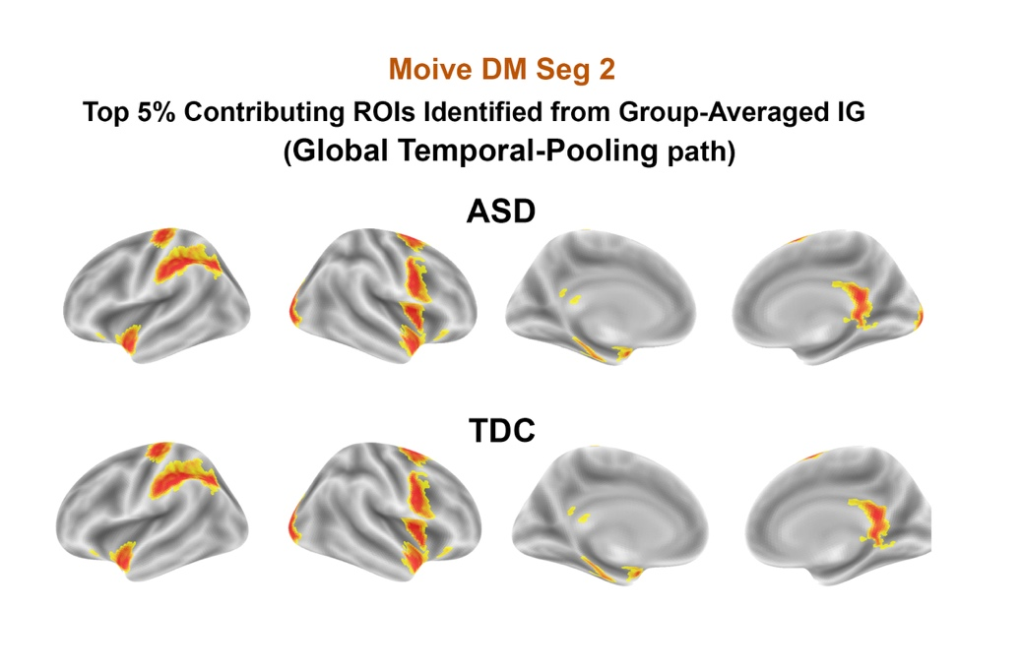
Figure S7. Stable spatial signatures identified by the Global Temporal-Pooling path during Despicable Me (movieDM, Segment 2). Surface renderings show the top 5% contributing brain regions identified by the Global Temporal-Pooling path for the ASD (top row) and TDC (bottom row) groups during the emotional transition segment.

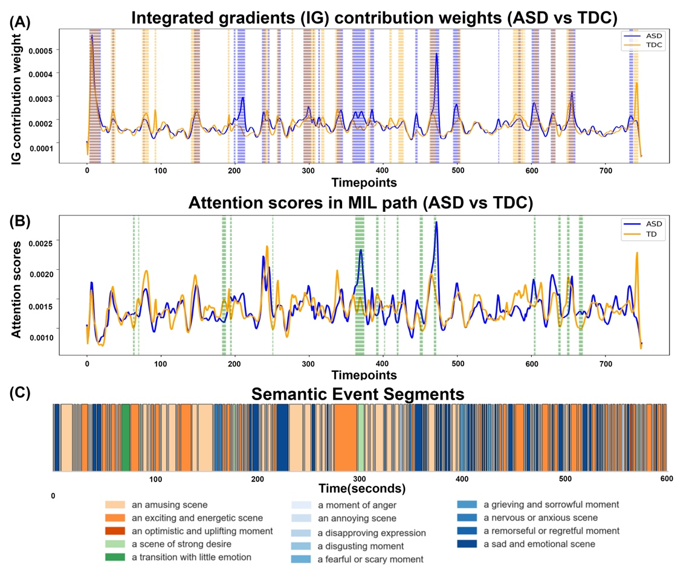
Figure S8. Temporal dynamics and automated semantic characterization of the Despicable Me (movieDM) stimulus. (A) Group-averaged Integrated Gradients (IG) magnitude across the entire time course for ASD (blue) and TDC (orange) groups. Peaks indicate moments when neural features contributed most strongly to classification. Shaded vertical bands denote attention-defined discriminative events. (B) Time-resolved attention scores from the MIL path, reflecting the model’s dynamic prioritization of specific temporal windows. (C) AI-generated semantic timeline of the movie stimulus. The color-coded bar visualizes the segment-level "semantic landscape," illustrating frequent transitions between contrasting emotional contexts (e.g., oscillations between "optimistic/uplifting" and "disapproving/sad").

IV. Supplementary Tables

Table S1. Demographic and head-motion characteristics by tasks.
Summary statistics for sample size (N), sex distribution (M/F), mean age, and mean framewise displacement (FD) for participants with autism spectrum disorder (ASD) and typically developing controls (TDC) across three fMRI conditions: MovieDM, MovieTP, and resting state.
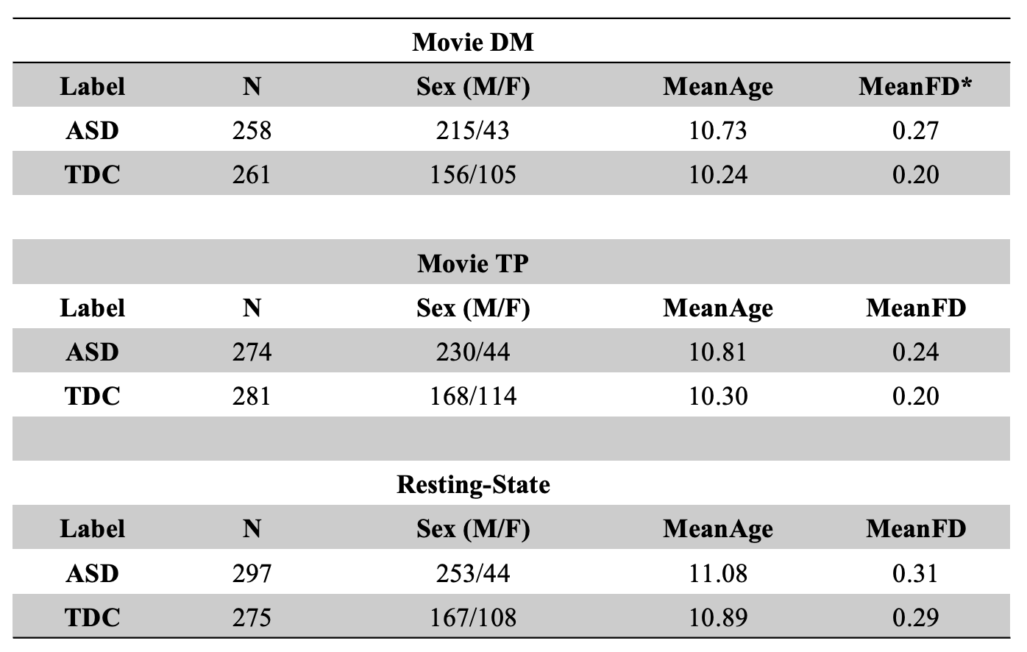
Note: Group differences in age and mean FD were assessed using two-sample t-tests, and differences in sex distribution were assessed using chi-square tests. Asterisks (*) indicate significant group differences (p < 0.05).

Table S2. Benchmark classification performance across baseline models and ablated variants.
Datasets | Classifier Model | Accuracy | F1-Score
MovieTP | K-Nearest Neighbor (KNN) | 54.54% | 0.6446
 | Decision Tree | 57.83% | 0.5274
 | Linear Support Vector Machine (SVM) | 52.10% | 0.5458
 | Logistic Regression | 55.19% | 0.5879
 | Ridge Classifier | 50.11% | 0.5190
 | Random Forest | 53.86% | 0.6021
 | stDNN model with Average pool | 68.99% | 0.6713
 | stDNN model with MIL pool | 67.69% | 0.6692
 | stDNN model with LSTM | 64.67% | 0.5398
 | DualPathNet | 73.14% | 0.7218
MovieDM | K-Nearest Neighbor (KNN) | 56.02% | 0.6622
 | Decision Tree | 54.69% | 0.5046
 | Linear Support Vector Machine (SVM) | 52.84% | 0.5227
 | Logistic Regression | 54.43% | 0.5320
 | Ridge Classifier | 51.24% | 0.5322
 | Random Forest | 56.48% | 0.5455
 | stDNN model with Average pool | 66.07% | 0.5948
 | stDNN model with MIL pool | 63.70% | 0.5788
 | stDNN model with LSTM | 63.10% | 0.6296
 | DualPathNet | 63.58% | 0.6704
Resting-state | K-Nearest Neighbor (KNN) | 56.02% | 0.6622
 | Decision Tree | 54.69% | 0.5046
 | Linear Support Vector Machine (SVM) | 52.84% | 0.5227
 | Logistic Regression | 54.43% | 0.5322
 | Ridge Classifier | 51.24% | 0.5067
 | Random Forest | 53.53% | 0.5277
 | stDNN model Average pool | 66.29% | 0.5960
 | stDNN model with MIL pool | 60.84% | 0.5492
 | stDNN model with LSTM | 63.33% | 0.5999
 | DualPathNet | 63.32% | 0.6876

Table S3. Top contributing brain regions for ASD participants from the Global Temporal-Pooling path (MovieTP condition).

Brain region | Brainnetome Label | DevAtlas  Network_ID | DevAtlas  Network Index | Network Name | Average IG weight
Tha_L_8_3 | Stha_L | 19 | SMN_4 | Sensorimotor | 0.00047
IFG_R_6_5 | A44op_R | 13 | VAN_3 | VentralAttention | 0.000448
OrG_L_6_4 | A11m_L | 1 | DMN_1 | DefaultMode | 0.000439
IFG_L_6_3 | A45c_L | 21 | DMN_4 | DefaultMode | 0.000436
MFG_R_7_6 | A6vl_R | 8 | CON_3 | Control | 0.000428
MTG_R_4_1 | A21c_R | 8 | CON_3 | Control | 0.000427
LOcC_R_4_1 | mOccG_R | 10 | VIS_1 | Visual | 0.000417
SFG_R_7_4 | A6dl_R | 5 | VAN_2 | VentralAttention | 0.000412
STG_R_6_4 | A22c_R | 3 | SMN_1 | Sensorimotor | 0.000411
INS_L_6_5 | dIg_L | 22 | SMN_5 | Sensorimotor | 0.000404
SPL_R_5_4 | A7pc_R | 15 | DAN_3 | DorsalAttention | 0.000402
IFG_R_6_2 | IFS_R | 6 | CON_1 | Control | 0.000398
Note: Network assignments follow the Dev-Atlas 24-network parcellation (13).

Table S4. Top contributing brain regions for TDC participants from the Global Temporal-Pooling path (MovieTP condition).

Brain region | Brainnetome Label | DevAtlas  Network_ID | DevAtlas  Network Index | Network Name | Average IG weight
Tha_L_8_3 | Stha_L | 19 | SMN_4 | Sensorimotor | 0.000434
IFG_L_6_3 | A45c_L | 21 | DMN_4 | DefaultMode | 0.000425
IFG_R_6_5 | A44op_R | 13 | VAN_3 | VentralAttention | 0.000421
MFG_R_7_6 | A6vl_R | 8 | CON_3 | Control | 0.000414
OrG_L_6_4 | A11m_L | 1 | DMN_1 | DefaultMode | 0.000411
LOcC_R_4_1 | mOccG_R | 10 | VIS_1 | Visual | 0.000399
PoG_L_4_4 | A1/2/3tru_L | 16 | SMN_2 | Sensorimotor | 0.000398
IFG_R_6_2 | IFS_R | 6 | CON_1 | Control | 0.000396
INS_L_6_5 | dIg_L | 22 | SMN_5 | Sensorimotor | 0.000396
STG_R_6_4 | A22c_R | 3 | SMN_1 | Sensorimotor | 0.000393
CG_R_7_5 | A24cd_R | 4 | VAN_1 | VentralAttention | 0.000393
MTG_R_4_1 | A21c_R | 8 | CON_3 | Control | 0.000385
Note: Network assignments follow the Dev-Atlas 24-network parcellation (13).

Table S5. Core Presence Matrix for ASD participants: Top Contributing Brain Regions across MovieTP Events.

Brain Region | Brainnetome Label | DevAtlas  Network | E1 | E2 | E3 | E4 | E5 | E6 | Total Events
IFG_L_6_3 | A45c_L | DMN_4 |  | ● | ● | ● | ● | ● | 5
OrG_L_6_4 | A11m_L | DMN_1 |  | ● | ● | ● |  | ● | 4
BG_L_6_3 | NAC_L | DMN_3 |  | ● | ● | ● |  | ● | 4
Tha_L_8_3 | Stha_L | SMN_4 | ● | ● |  | ● |  | ● | 4
IFG_R_6_2 | IFS_R | CON_1 |  | ● |  | ● | ● |  | 3
MFG_L_7_3 | A46_L | CON_2 |  | ● | ● |  |  | ● | 3
SFG_L_7_4 | A6dl_L | DAN_3 | ● | ● | ● |  |  |  | 3
SPL_R_5_4 | A7pc_R | DAN_3 |  |  |  | ● | ● | ● | 3
MFG_R_7_6 | A6vl_R | CON_3 | ● | ● |  |  |  |  | 2
MTG_R_4_3 | A37dl_R | CON_1 |  |  |  |  | ● | ● | 2
PhG_L_6_3 | TL_L | DMN_2 |  |  | ● | ● |  |  | 2
STG_R_6_4 | A22c_R | SMN_1 | ● |  |  |  | ● |  | 2
IPL_R_6_6 | A40rv_R | VAN_1 |  |  |  | ● | ● |  | 2
Tha_L_8_2 | mPMtha_L | VAN_1 | ● |  |  |  |  | ● | 2
ITG_L_7_5 | A37vl_L | CON_1 |  |  |  |  | ● |  | 1
PhG_R_6_5 | TI_R | CON_1 |  |  | ● |  |  |  | 1
ITG_L_7_6 | A20cl_L | CON_2 |  | ● |  |  |  |  | 1
ITG_L_7_4 | A20il_L | CON_2 | ● |  |  |  |  |  | 1
MTG_R_4_1 | A21c_R | CON_3 |  |  |  | ● |  |  | 1
PhG_R_6_1 | A35/36r_R | DMN_2 |  |  | ● |  |  |  | 1
IPL_R_6_5 | A39rv_R | DMN_2 |  |  |  |  | ● |  | 1
PhG_L_6_6 | TH_L | DMN_2 |  |  | ● |  |  |  | 1
ITG_R_7_3 | A20r_R | DMN_4 |  | ● |  |  |  |  | 1
MTG_L_4_2 | A21r_L | DMN_4 |  |  |  |  |  | ● | 1
STG_L_6_5 | A38l_L | DMN_4 |  |  |  | ● |  |  | 1
MTG_L_4_4 | aSTS_L | DMN_4 |  |  |  |  | ● |  | 1
SPL_R_5_3 | A5l_R | DAN_4 |  |  |  |  | ● |  | 1
STG_L_6_2 | A41/42_L | SMN_1 |  |  | ● |  |  |  | 1
STG_R_6_3 | TE1.0/TE1.2_R | SMN_1 |  | ● |  |  |  |  | 1
PoG_L_4_4 | A1/2/3tru_L | SMN_2 | ● |  |  |  |  |  | 1
PrG_R_6_3 | A4ul_R | SMN_3 |  |  |  |  | ● |  | 1
PrG_R_6_2 | A6cdl_R | SMN_3 |  |  |  |  | ● |  | 1
PoG_L_4_2 | A1/2/3tonIa_L | SMN_5 |  |  | ● |  |  |  | 1
INS_L_6_5 | dIg_L | SMN_5 |  |  |  |  |  | ● | 1
CG_R_7_5 | A24cd_R | VAN_1 |  | ● |  |  |  |  | 1
INS_L_6_1 | G_L | VAN_1 |  |  | ● |  |  |  | 1
INS_L_6_6 | dId_L | VAN_1 | ● |  |  |  |  |  | 1
BG_L_6_2 | GP_L | VAN_2 | ● |  |  |  |  |  | 1
IFG_L_6_5 | A44op_L | VAN_3 | ● |  |  |  |  |  | 1
IFG_R_6_5 | A44op_R | VAN_3 |  |  |  |  |  | ● | 1
SFG_L_7_6 | A9m_L | VAN_3 | ● |  |  |  |  |  | 1
Tha_R_8_1 | mPFtha_R | VAN_3 | ● |  |  |  |  |  | 1
ITG_R_7_2 | A37elv_R | VIS_1 |  |  |  |  |  | ● | 1
FuG_L_3_2 | A37mv_L | VIS_1 |  |  |  | ● |  |  | 1
FuG_R_3_2 | A37mv_R | VIS_1 |  |  |  | ● |  |  | 1

Note: Regions are ranked by their recurrence frequency (Total Events). Network labels refer to the Dev-Atlas 24Networks(13). Abbreviations: DMN = Default Mode Network; SMN = Sensorimotor Network; CON = Control Network; VAN = Ventral Attention Network; DAN = Dorsal Attention Network; VIS = Visual Network.
Table S6. Top contributing brain regions for ASD participants from the Global Temporal-Pooling path (MovieDM Seg2 condition).

Brain region | Brainnetome Label | DevAtlas  Network_ID | DevAtlas  Network Index | Network Name | Average IG weight
PhG_R_6_1 | A35/36r_R | 2 | DMN_2 | DefaultMode | 0.0015459
SFG_L_7_4 | A6dl_L | 15 | DAN_3 | DorsalAttention | 0.0015355
IPL_R_6_1 | A39c_R | 2 | DMN_2 | DefaultMode | 0.0014765
INS_L_6_6 | dId_L | 4 | VAN_1 | VentralAttention | 0.0012092
PrG_L_6_6 | A6cvl_L | 18 | DAN_4 | DorsalAttention | 0.0012064
CG_L_7_4 | A23v_L | 2 | DMN_2 | DefaultMode | 0.0011670
STG_R_6_4 | A22c_R | 3 | SMN_1 | Sensorimotor | 0.0011473
PrG_R_6_2 | A6cdl_R | 17 | SMN_3 | Sensorimotor | 0.0010976
IPL_R_6_2 | A39rd_R | 8 | CON_3 | Control | 0.0010389
Amyg_R_2_1 | mAmyg_R | 9 | DMN_3 | DefaultMode | 0.0010172
STG_L_6_5 | A38l_L | 21 | DMN_4 | DefaultMode | 0.001012
LOcC_L_4_3 | OPC_L | 23 | VIS_3 | Visual | 0.000997

Note: Network assignments follow the Dev-Atlas 24-network parcellation (13).
Table S7. Top contributing brain regions for TDC participants from the Global Temporal-Pooling path (MovieDM Seg2 condition).

Brain region | Brainnetome Label | DevAtlas  Network_ID | DevAtlas  Network Index | Network Name | Average IG weight
SFG_L_7_4 | A6dl_L | 15 | DAN_3 | DorsalAttention | 0.001643
PhG_R_6_1 | A35/36r_R | 2 | DMN_2 | DefaultMode | 0.00151
IPL_R_6_1 | A39c_R | 2 | DMN_2 | DefaultMode | 0.0014
PrG_L_6_6 | A6cvl_L | 18 | DAN_4 | DorsalAttention | 0.001219
STG_R_6_4 | A22c_R | 3 | SMN_1 | Sensorimotor | 0.001216
INS_L_6_6 | dId_L | 4 | VAN_1 | VentralAttention | 0.00117
PrG_R_6_2 | A6cdl_R | 17 | SMN_3 | Sensorimotor | 0.001111
CG_L_7_4 | A23v_L | 2 | DMN_2 | DefaultMode | 0.001103
IPL_R_6_2 | A39rd_R | 8 | CON_3 | Control | 0.001
STG_L_6_5 | A38l_L | 21 | DMN_4 | DefaultMode | 0.00099
Amyg_R_2_1 | mAmyg_R | 9 | DMN_3 | DefaultMode | 0.000976
LOcC_L_4_3 | OPC_L | 23 | VIS_3 | Visual | 0.000972

Note: Network assignments follow the Dev-Atlas 24-network parcellation (13).

Table S8. Core Presence Matrix for ASD participants: Top Contributing Brain Regions across MovieDM Seg2 Events.

Brain Region | Brainnetome Label | DevAtlas  Network | E1 | E2 | E3 | E4 | Total Events
CG_L_7_4 | A23v_L | DMN_2 | ● | ● | ● | ● | 4
PhG_R_6_1 | A35/36r_R | DMN_2 | ● | ● | ● | ● | 4
IPL_R_6_1 | A39c_R | DMN_2 | ● | ● | ● | ● | 4
SFG_L_7_4 | A6dl_L | DAN_3 | ● | ● | ● | ● | 4
PrG_R_6_2 | A6cdl_R | SMN_3 | ● | ● | ● | ● | 4
STG_R_6_4 | A22c_R | SMN_1 |  | ● | ● | ● | 3
PhG_R_6_5 | TI_R | CON_1 |  | ● | ● |  | 2
OrG_R_6_3 | A11l_R | CON_3 |  | ● | ● |  | 2
BG_R_6_3 | NAC_R | DMN_3 | ● |  |  | ● | 2
PrG_L_6_6 | A6cvl_L | DAN_4 | ● |  |  | ● | 2
Tha_L_8_3 | Stha_L | SMN_4 | ● | ● |  |  | 2
INS_R_6_5 | dIg_R | SMN_5 |  | ● | ● |  | 2
INS_L_6_6 | dId_L | VAN_1 | ● | ● |  |  | 2
ITG_L_7_6 | A20cl_L | CON_2 | ● |  |  |  | 1
IPL_R_6_2 | A39rd_R | CON_3 |  |  |  | ● | 1
OrG_L_6_4 | A11m_L | DMN_1 |  |  | ● |  | 1
PhG_L_6_2 | A35/36c_L | DMN_2 | ● |  |  |  | 1
Amyg_R_2_1 | mAmyg_R | DMN_3 |  |  |  | ● | 1
STG_L_6_5 | A38l_L | DMN_4 |  |  | ● |  | 1
STG_L_6_1 | A38m_L | DMN_4 |  |  | ● |  | 1
IFG_L_6_3 | A45c_L | DMN_4 |  |  |  | ● | 1
Amyg_L_2_2 | lAmyg_L | SMN_5 |  |  |  | ● | 1
CG_L_7_3 | A32p_L | VAN_3 |  | ● |  |  | 1
LOcC_L_2_1 | msOccG_L | VIS_2 | ● |  |  |  | 1
Note: Regions are ranked by their recurrence frequency (Total Events). Network labels refer to the Dev-Atlas 24Networks (13). Abbreviations: DMN = Default Mode Network; SMN = Sensorimotor Network; CON = Control Network; VAN = Ventral Attention Network; DAN = Dorsal Attention Network; VIS = Visual Network.

V. Reference

1. L. M. Alexander et al., An open resource for transdiagnostic research in pediatric mental health and learning disorders. Scientific data 4, 1-26 (2017).
2. L. Fan et al., The human brainnetome atlas: a new brain atlas based on connectional architecture. Cerebral cortex 26, 3508-3526 (2016).
3. K. Supekar et al., Robust, generalizable, and interpretable artificial intelligence–derived brain fingerprints of autism and social communication symptom severity. Biological Psychiatry 92, 643-653 (2022).
4. K. Supekar et al., Identification of robust and interpretable brain signatures of autism and clinical symptom severity using a dynamic time-series deep neural network. European Psychiatry 64, S145-S145 (2021).
5. S. Ryali, Y. Zhang, C. de Los Angeles, K. Supekar, V. Menon, Deep learning models reveal replicable, generalizable, and behaviorally relevant sex differences in human functional brain organization. Proceedings of the National Academy of Sciences 121, e2310012121 (2024).
6. C. Davatzikos. (Elsevier, 2019), vol. 197, pp. 652-656.
7. M. Ilse, J. Tomczak, M. Welling, in International conference on machine learning. (PMLR, 2018), pp. 2127-2136.
8. J.-P. Fortin et al., Harmonization of multi-site diffusion tensor imaging data. Neuroimage 161, 149-170 (2017).
9. K. Simonyan, A. Vedaldi, A. Zisserman, Deep inside convolutional networks: Visualising image classification models and saliency maps. arXiv preprint arXiv:1312.6034, (2013).
10. J. T. Springenberg, A. Dosovitskiy, T. Brox, M. Riedmiller, Striving for simplicity: The all convolutional net. arXiv preprint arXiv:1412.6806, (2014).
11. S. M. Lundberg, S.-I. Lee, A unified approach to interpreting model predictions. Advances in neural information processing systems 30, (2017).
12. R. R. Selvaraju et al., in Proceedings of the IEEE international conference on computer vision. (2017), pp. 618-626.
13. G. E. Doucet et al., Dev-Atlas: A reference atlas of functional brain networks for typically developing adolescents. Developmental Cognitive Neuroscience 72, 101523 (2025).
14. D. Demszky et al., GoEmotions: A dataset of fine-grained emotions. arXiv preprint arXiv:2005.00547, (2020).
15. W. Feng, G. Liu, K. Zeng, M. Zeng, Y. Liu, A review of methods for classification and recognition of ASD using fMRI data. Journal of neuroscience methods 368, 109456 (2022).

