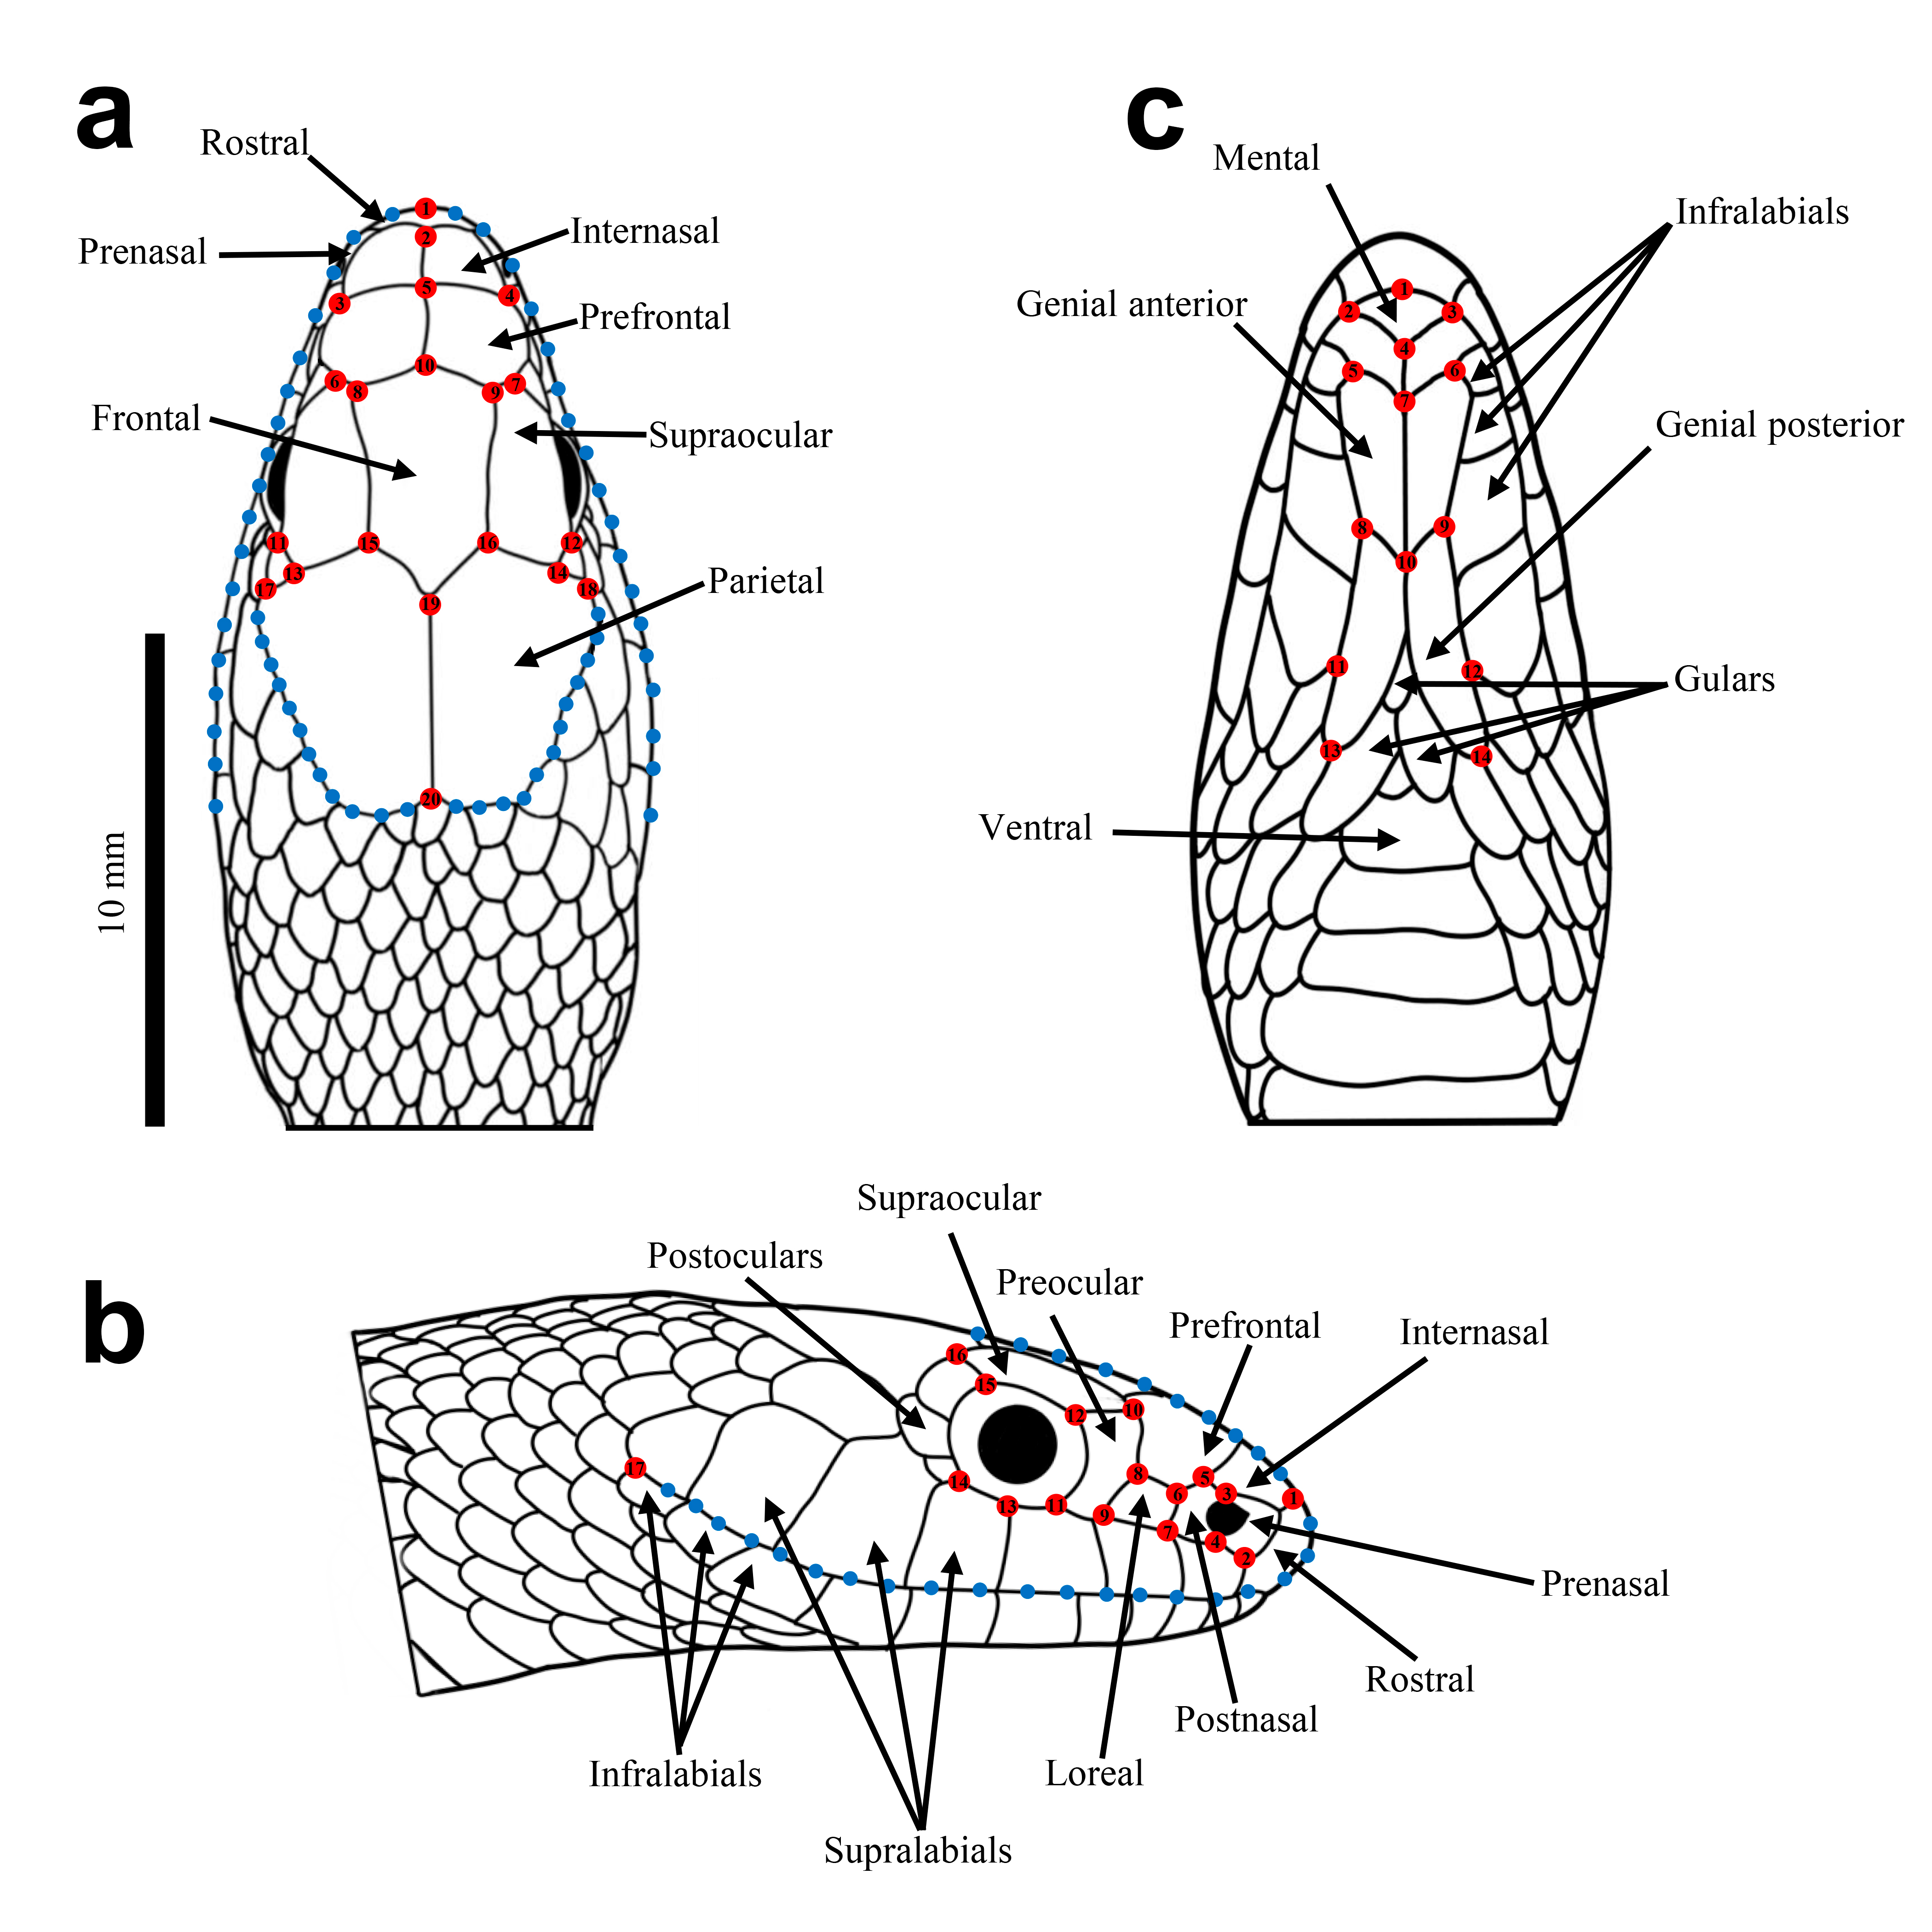

Figure S2. System of landmarks (red) and semilandmarks (blue) used to quantify variation in head shape among species of the Mexican Highland Clade, shown in dorsal (a), lateral (b), and ventral (c) views.

