Supplemental Material for
Treatment of multiple sclerosis with CD19-targeting CAR-T-cells
Antje Giede-Jeppe, MD^{1,2,}*, Malte Roerden, MD^{3,}*, Anna MP Stanger, PhD³, Luca Hensen, PhD³, Christoph Faul, MD³, Benjamin Bender, MD⁴, Lucca M Kimmich³, Julia Hummel, MD¹, Markus C Kowarik, MD^{1,2}, Ulf Ziemann, MD^{1,2}, Wolfgang Bethge, MD^{3,}*, Claudia Lengerke, MD^{3,5,}*,#

Methods
Three patients with MS refractory to available therapies received UKT-CART19.1 based on the recommendation by the interdisciplinary cell-therapy board at the University Hospital Tübingen. Treatment was performed after extensive patient counseling and informed consent on the basis of a hospital exemption and physician-specific production approval for advanced therapy medicinal products treatment. UKT-CART19.1 were manufactured in the academic GMP-facility at the University Hospital Tübingen as previously described¹. Briefly, autologous T-lymphocytes were collected by leukapheresis, transduced with a CD19-targeting second-generation CAR lentiviral vector containing a costimulatory 4-1BB and a CD3-zeta signaling domain(provided by Miltenyi Biotec), expanded 12 days in a CliniMacs Prodigy system and infused without prior cryopreservation on day 0(1x10⁶ cells/kg bodyweight), after standard lymphodepleting therapy with fludarabine(25 mg/m², d-5 to d-3) and cyclophosphamide(1000mg/m², d-3). Expanded-Disability-Status-Scale(EDSS)-scores², patient-reported-outcome-measures(PROMs)^{3, 4}, quantification of lymphocyte subsets and immunoglobulins in peripheral blood and/or CNS were performed at baseline and during follow-up after CAR-T-cell therapy. MRI neuroimaging including estimation of percent brain volume change(PBVC) was performed during follow-up using FSL/SIENA⁵, with HD-BET⁶ applied for robust brain extraction. UKT-CART19.1 subset composition prior to infusion(FigureS1), and methods regarding flow cytomety-based analysis of CAR-T-cells and B-cells are available in the supplemental material section.

Lymphodepletion regimen and supportive care
Prior to CAR-T-cell infusion, all patients receved lymphodepleting chemotherapy with fludarabine (25mg/m2; day -5 to -3) and cyclophosphamide (1000 mg/m2, day -3). Granisetrone was used as antiemetic therapy. Prophylactic 2-Mercaptoethanol sulfonate Natrium (MESNA) was administered before and after cyclophsohamide. Following lymphodepleting therapy, all patients received anti-viral prophylaxis with aciclovir (400 mg, twice daily) and trimethoprim/sulfamethoxazole (800/160 mg, three times per week) for at least three months and until stable recovery of CD4⁺ T cells in the peripheral blood >200/µl.
Flow cytometric analysis of B cells
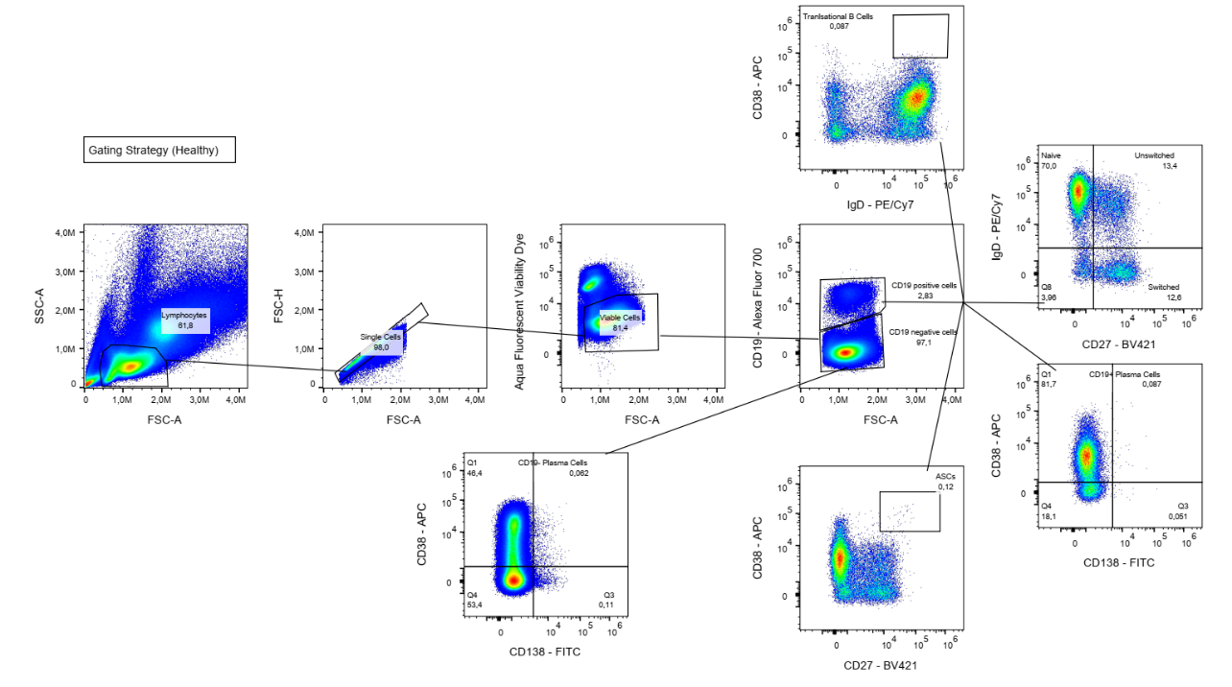
Peripheral blood mononuclear cells (PBMCs) were isolated from whole blood using Ficoll density gradient centrifugation and cryopreserved for later analysis. For flow cytometric analysis, cells were thawed and stained with flourophore-conjugated antibodies (Aqua viability dye; CD19-AF700; CD38-APC; CD138-FITC; CD27-BV421; IgD-PE-Cy7). Samples were acquired on a Cytek Aurora spectral cytometer. The gating strategy is shown below.

Flow cytometric analysis of CAR-T-cells
Clinical routine flow cytometry of CAR-T-cells was performed using peripheral blood (EDTA). For flow cytometric analysis, whole blood was stained with flourophore-conjugated antibodies (CD45-FITC; CD3-APC; CD19-BV711; CAR reagent-PE; CD8-BV786; CD4-BV605; CD27-BV510; CD45RA-PE-Cy7; CD38-PerCP-Cy5.5; HLA-DR-APC-H7; CD127-APC-R700; CD25-BV421). Samples were acquired on a FACS Lyrics spectral cytometer.
CSF antibody analysis
 | Patient #1 |  | Patient #2 |  | Patient #3
 | Baseline | after CAR-T | Baseline | after CAR-T | Baseline | after CAR-T
Liquor
Erythrocytes (Tsd/µl) | <1 | <1 | <1 | <1 | <1 | <1
Leukocytes (/µl) | 1 | 1 | 5 | 5 | >1 | 2
Polynuclear cells (%) | 0 | 0 | 0 | 0 | 0 | 0
Mononuclear cells (%) | 100 | 100 | 100 | 100 | 100 | 100
Lactate (mmol/l) | 1,5 | 1,6 | 2,1 | 2,4 | 1.8 | 1.7
Glucose (mg/dL) | 58 | 66 | 67 | 68 | 55 | 55
Protein (g/L) | 0.68 | 0.67 | 1.32 | 1.37 | 0.30 | 0.27
Albumin (g/L) | 0.465 | 0.401 | 0.958 | 1.030 | 0.146 | 0.122
Albumin i.S. (g/L) | 48.2 | 42.7 | 48.4 | 49.7 | 44.9 | 44.8
Albumin L/S-Q (x 10E-3) | 9.6 | 9.4 | 19.8 | 20.7 | 3.3 | 2.7
IgG (g/L) | 0.0462 | 0.0318 | 0.0149 | 0.0963 | 0.0101 | 0.0152
IgG i.S. (g/L) | 10,9 | 7,6 | 11.9 | 8.9 | 4.2 | 8.9
IgG L/S-Q (x10E-3) | 4,2 | 4,2 | 12.5 | 10.8 | 3.5 | 1.7
Ologoclonal bands (pattern) | 4 | 4 | 4 | 4 | 3 | Neg.

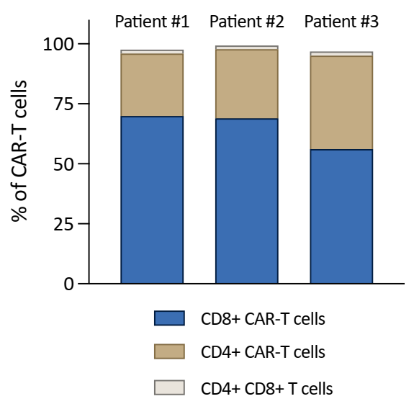
Figure S1. CAR-T-cell subsets in manufactured UKT-CART19.1

Table S1. Flow cytometric analysis of CAR-T-cell subsets in the finally formulated UKT-CART19.1 cell therapy product.
Table S1. Expanded disability status scale (EDSS) (sub-)scores
 | Patient #1 |  | Patient #2 |  | Patient #3
 | Baseline | after CAR-T | Baseline | after CAR-T | Baseline | after CAR-T
Expanded Disability Status Scale (EDSS) | 8.0 | 8.0 | 5.0 | 4.0 | 2.5 | 2.0
EDSS subscores
pyramidal | 4 | 4 | 3 | 3 | 2 | 2
cerebellar | 3 | 3 | 3 | 3 | 0 | 0
brainstem | 1 | 1 | 3 | 3 | 2 | 1
sensory | 2 | 2 | 2 | 1 | 1 | 1
bowel and bladder function | 2 | 2 | 1 | 1 | 1 | 1
visual function | 0 | 0 | 1 | 1 | 0 | 0
cerebral functions | 0 | 0 | 3 | 3 | 1 | 1
Walking | Chairbound | Chairbound | 200-300m | >500m | >500m | >500m

Table S2. T25W test, nine-hole-peg test, symbol-digit-modalities test
Patient #1 |  | Patient #2 |  | Patient #3
Baseline | after CAR-T | Baseline | after CAR-T | Baseline | after CAR-T
Timed 25ft-walk test (T25FW)
Chairbound | Chairbound | 7.5+9.4sec.  assistive device: walking stick | 6.9+8.8sec. assistive device: walking stick | 5.0+5.0sec. | 4.5+4.4 sec.
Nine-hole peg test (9HPT)
R (dominant): 440 sec.  L: - | R (dominant): 432 sec.  L: - | R (dominant): 26.8+27.5sec.  L: 50.4+68.6sec. | R (dominant): 26.8+26.0 sec.  L:46.6+58.7sec. | R (dominant):  19.0 +16.0sec.  L: 19.0+18.0 sec. | R (dominant):  14.3 + 15.1sec  L: 17.9+ 19.5sec.
Symbol digit modalities test (SDMT)
46/110 points | 45/110 points | 40/110 points | 38/110 points | 65/110 points | 71/110 points
R= Right; L=Left.
Score | Significant change as reported in the literature
T25FW | ≥ 20% worsening⁷⁻⁹
9HPT | ≥20% worsening^{7, 9, 10}
SDMT | ≥4-point change in SDMT score¹¹

Table S3. Quantification of cranial MRI lesion volume
Patient | Percent brain volume change (PBVC)* | Lesion volume** | Side ventricle**
#1 | -0.39% | -0.3ml | +0.8ml
#2 | +0.37% | +0.1ml | +0.2ml
#3 | -0.86% | -0.2ml | -1.3ml
*= calculated by SIENA, ** = calculated by AIRAscore v3.0.0.

References:
1. Phely L, Hensen L, Faul C, Ruff CA, Schneider D, Bethge WA, et al. Allogeneic CD19/CD22 CAR T-Cell Therapy for B-Cell Acute Lymphoblastic Leukemia. JAMA Oncology 2024; 10(6): 821–824.

2. Kurtzke JF. Rating neurologic impairment in multiple sclerosis: an expanded disability status scale (EDSS). Neurology 1983 Nov; 33(11): 1444–1452.

3. Walker LA, Cheng A, Berard J, Berrigan LI, Rees LM, Freedman MS. Tests of information processing speed: what do people with multiple sclerosis think about them? Int J MS Care 2012 Summer; 14(2): 92–99.

4. Fischer JS, Rudick RA, Cutter GR, Reingold SC. The Multiple Sclerosis Functional Composite Measure (MSFC): an integrated approach to MS clinical outcome assessment. National MS Society Clinical Outcomes Assessment Task Force. Mult Scler 1999 Aug; 5(4): 244–250.

5. Smith SM, Zhang Y, Jenkinson M, Chen J, Matthews PM, Federico A, et al. Accurate, robust, and automated longitudinal and cross-sectional brain change analysis. Neuroimage 2002 Sep; 17(1): 479–489.

6. Isensee F, Schell M, Pflueger I, Brugnara G, Bonekamp D, Neuberger U, et al. Automated brain extraction of multisequence MRI using artificial neural networks. Hum Brain Mapp 2019 Dec 1; 40(17): 4952–4964.

7. Bosma LV, Kragt JJ, Brieva L, Khaleeli Z, Montalban X, Polman CH, et al. Progression on the Multiple Sclerosis Functional Composite in multiple sclerosis: what is the optimal cut-off for the three components? Mult Scler 2010 Jul; 16(7): 862–867.

8. Hobart J, Blight AR, Goodman A, Lynn F, Putzki N. Timed 25-foot walk: direct evidence that improving 20% or greater is clinically meaningful in MS. Neurology 2013 Apr 16; 80(16): 1509–1517.

9. Collongues N, Kuhle J, Tsagkas C, Lamy J, Meyer N, Barro C, et al. Biomarkers of treatment response in patients with progressive multiple sclerosis treated with high-dose pharmaceutical-grade biotin (MD1003). Brain Behav 2021 Feb; 11(2): e01998.

10. Feys P, Lamers I, Francis G, Benedict R, Phillips G, LaRocca N, et al. The Nine-Hole Peg Test as a manual dexterity performance measure for multiple sclerosis. Mult Scler 2017 Apr; 23(5): 711–720.

11. Benedict RH, DeLuca J, Phillips G, LaRocca N, Hudson LD, Rudick R, et al. Validity of the Symbol Digit Modalities Test as a cognition performance outcome measure for multiple sclerosis. Mult Scler 2017 Apr; 23(5): 721–733.

Additional References of Main Text:
11. Absinta, M., et al. Association of Chronic Active Multiple Sclerosis Lesions With Disability In Vivo. JAMA Neurol 76, 1474–1483 (2019).
12. Lee, D.W., et al. ASTCT Consensus Grading for Cytokine Release Syndrome and Neurologic Toxicity Associated with Immune Effector Cells. Biology of Blood and Marrow Transplantation 25, 625–638 (2019).
13. Maglio, G., et al. Multiple Sclerosis: From the Application of Oligoclonal Bands to Novel Potential Biomarkers. Int J Mol Sci 25(2024).
14. Opfer, R., et al. Within-patient fluctuation of brain volume estimates from short-term repeated MRI measurements using SIENA/FSL. J Neurol 265, 1158–1165 (2018).
15. Rampotas, A., Richter, J., Isenberg, D. & Roddie, C. CAR-T cell therapy embarks on autoimmune disease. Bone Marrow Transplantation 60, 6–9 (2025).
16. KYSA-7: A Phase 2, Open-Label, Randomized, Multicenter Study of KYV-101, an Autologous Fully Human Anti-CD19 Chimeric Antigen Receptor T-Cell (CD19 CAR T) Therapy, in Subjects With Refractory Primary and Secondary Progressive Multiple Sclerosis. NCT06384976.
17. Fischbach, F., et al. CD19-targeted chimeric antigen receptor T cell therapy in two patients with multiple sclerosis. Med 5, 550–558.e552 (2024).
18. Junt, T., et al. Defining immune reset: achieving sustained remission in autoimmune diseases. Nature Reviews Immunology 25, 528–541 (2025).
19. La Mantia, L., et al. Cyclophosphamide for multiple sclerosis. Cochrane Database of Systematic Reviews 2009(1996).
20. Gehr, S., Kaiser, T., Kreutz, R., Ludwig, W.D. & Paul, F. Suggestions for improving the design of clinical trials in multiple sclerosis-results of a systematic analysis of completed phase III trials. EPMA J 10, 425–436 (2019).
21. van Munster, C.E. & Uitdehaag, B.M. Outcome Measures in Clinical Trials for Multiple Sclerosis. CNS Drugs 31, 217–236 (2017).
22. Haider, L., et al. Cranial Nerve Enhancement in Multiple Sclerosis Is Associated With Younger Age at Onset and More Severe Disease. Front Neurol 10, 1085 (2019).
23. van der Meijs, A.H., Tan, I.L. & Barkhof, F. Incidence of enhancement of the trigeminal nerve on MRI in patients with multiple sclerosis. Mult Scler 8, 64–67 (2002).
24. Qin, C., et al. Anti-BCMA CAR-T therapy in patients with progressive multiple sclerosis. Cell 188, 6414–6423.e6411 (2025).
25. Dunn, J., et al. A Phase 1, Open-label, Single Center Study of KYV-101, an Autologous Fully-human Anti-CD19 Chimeric Antigen Receptor T-Cell (CD19 CAR T) Therapy, in Subjects with Non-relapsing and Progressive Forms of Multiple Sclerosis (S3.001). Neurology 104, 5371 (2025).
26. Huihua Ding, W.L., Yiwen Shen, Chunyan Zhang, Yan Ye, Ran Wang, Shaoying Yang, Chunmei Wu, Dai Da, Chengxiao Zheng, Yuan Qian, Xiaobing Luo, Thule Trinh, Judy Zhu, Jiaqi Huang, Yong Hao, Xiaoying Yao, Zhenfen Ling, Yihong Yao and Nan Shen. Anti-CD20/BCMA Bispecific CAR-T Cell Therapy Promotes Immune Reset and Sustained Drug Free Remission in Refractory Autoimmune Diseases. in ACR Convergence 2025 (2025

