Supplementary Information
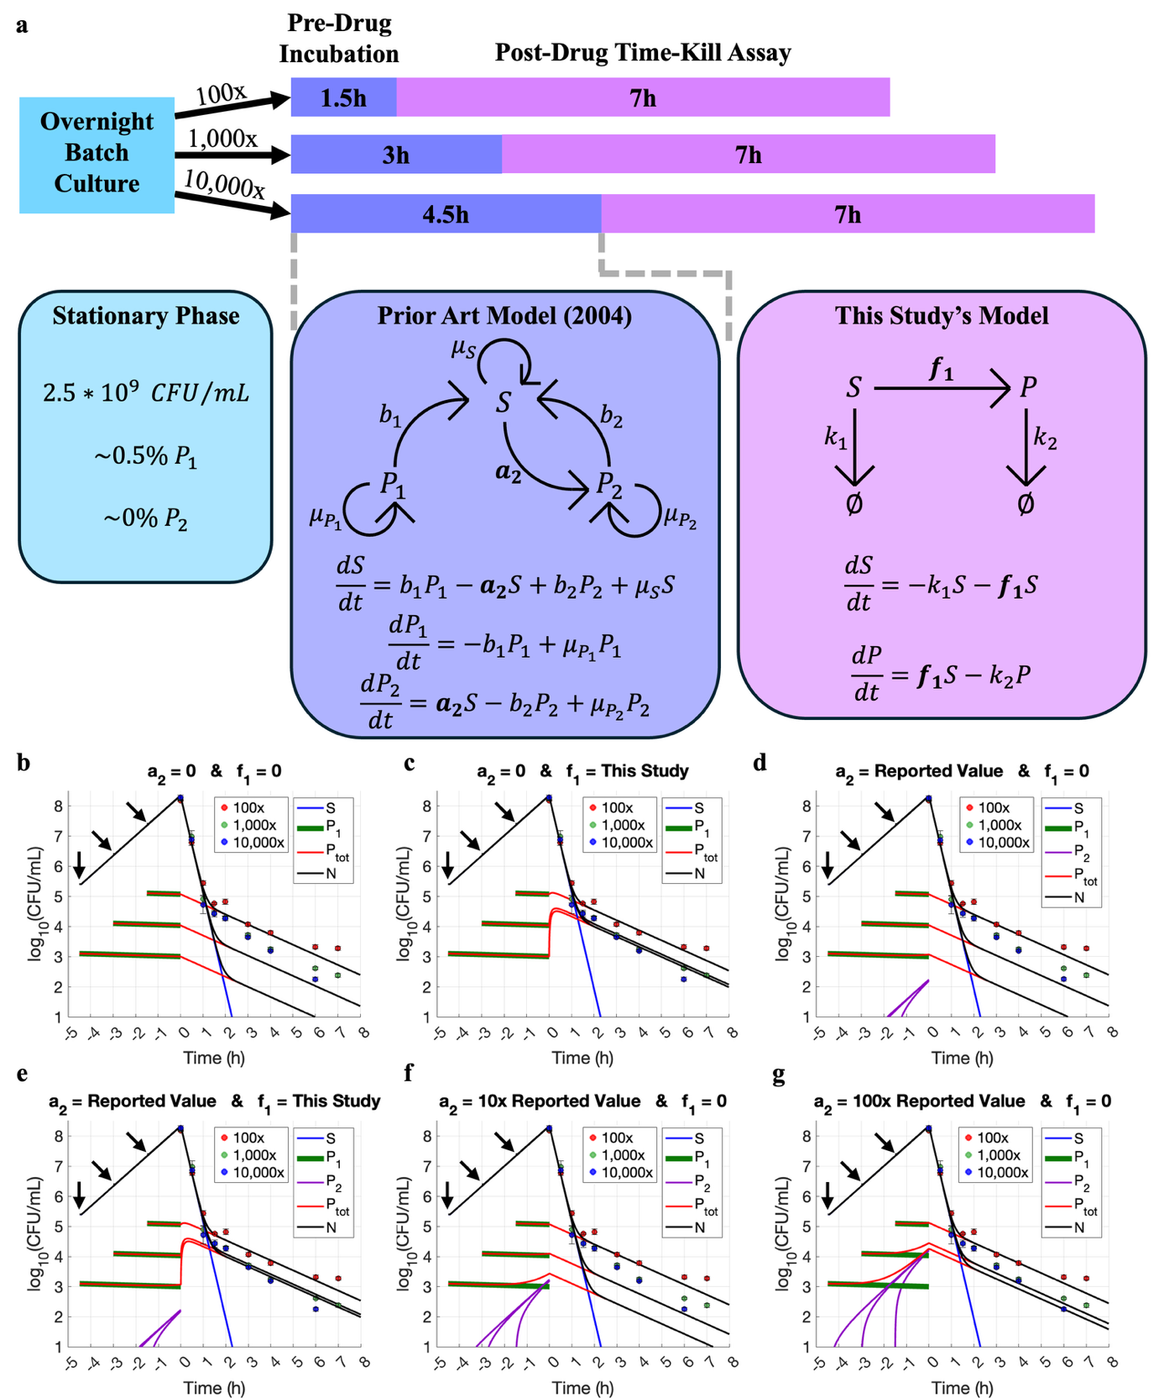
Supplementary Figure S1. Spontaneous persister formation does not explain the observed time-kill data from overnight batch cultures. (a) A schematic representation of the experimental setup and the associated kinetic modeling for each step. In the prior art model incorporating spontaneous persister formation (Balaban et al. 2004), P₁ represents pre-existing persisters from the stationary phase inoculum and P₂ represents spontaneous persisters that arise from susceptible cells at a rate a₂. In this figure, we used our experimental data and model fitting to compare the pre-existing persister model (b), our drug-induced persister model (c), the prior art spontaneous-persister-formation model (d) and the combined model of the latter two (e), modeling the persister dynamics from the beginning of inoculation until the end of the time-kill assay in each case. Results show that our model faithfully captures experimental data (c) while the prior art model does not (d). Incorporation of spontaneous persister formation is not necessary because the contribution of spontaneous persisters is negligible compared to the pre-existing and drug-induced persisters (e). To explore the possibility for the prior art model to fit our experimental data, we arbitrarily increased a₂ for the wild-type strain to biologically implausible values by 10-fold (f) or 100-fold (g). We found that the spontaneous persister formation rate must increase by at least 100-fold to achieve a reasonable fit (g). In other words, only when the spontaneous persister fraction becomes orders of magnitude larger, dominating the overall persister subpopulation, can the spontaneous-persister-formation model begin to fit the observed SDTK data. Under normal conditions, however, spontaneous persisters in the wild-type strain typically constitute only a small fraction of the total persister population because the spontaneous persister formation rate for the wild-type strain is expected to be extremely low, as reported by Balaban et al (2004). In panels (b-g), the curves for the 100-, 1,000-, and 10,000-fold diluted cultures are time-shifted to align the start of drug treatment at t=0. The inoculation times of these diluted pre-drug cultures are marked by arrows, with the 10,000-fold diluted culture starting at 4.5 hours before drug exposure (-4.5 h). The experimental data are from Fig. 2a, an ampicillin SDTK assay performed on batch-seeded wild-type E coli cultures.

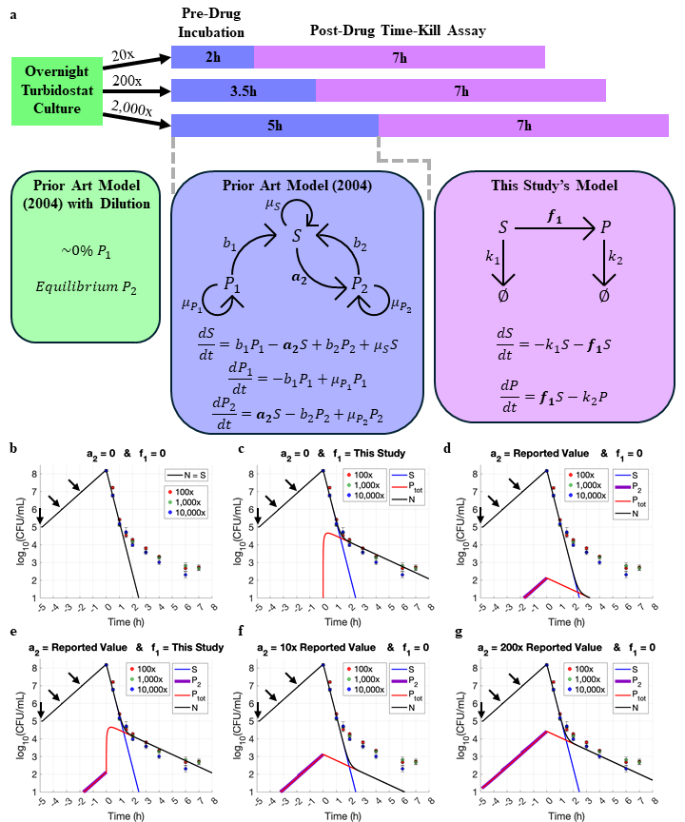
Supplementary Figure S2. Spontaneous persister formation does not explain the observed time-kill data from turbidostat experiments. This figure largely parallels Supplementary Figure S1 but with an overnight turbidostat culture instead of an overnight batch culture. (a) A schematic representation of the experimental procedure and the associated kinetic modeling for each step. The prior art model is the spontaneous-persister-formation model developed by Balaban et. al. (2004). The pre-existing persister model (b) cannot fit our experimental data because the continuous turbidostatic cultivation removes virtually all pre-existing persisters from the seed culture. Simulation results show that our drug-induced persister model faithfully captures all experimental data (c) while the prior spontaneous-persister-formation model does not (d). Incorporation of spontaneous persister formation is not necessary because the contribution of spontaneous persisters is negligible compared to the drug-induced persisters (e). To explore the possibility for the prior art model to fit our experimental data, we arbitrarily increased the spontaneous persister formation rate (a₂) for the wild-type strain to biologically implausible values by 10-fold (f) or 200-fold (g). We found that the spontaneous persister formation rate must increase by at least 200-fold to achieve a reasonable fit (g). In other words, only when the spontaneous persister formation rate becomes orders of magnitude larger than reported value can the spontaneous-persister-formation model begin to capture the observed experimental data. In panels b-g, the curves for the 20-, 200-, and 2000-fold diluted cultures are time-shifted to align the start of drug treatment at t = 0. The inoculation times of these diluted pre-drug cultures are marked by arrows, with the 2000-fold diluted culture starting at 5 hours before drug exposure (-5 h). The experimental data for fitting are from Fig. 2c, an ampicillin SDTK assay performed on turbidostat-seeded wild-type E coli cultures.

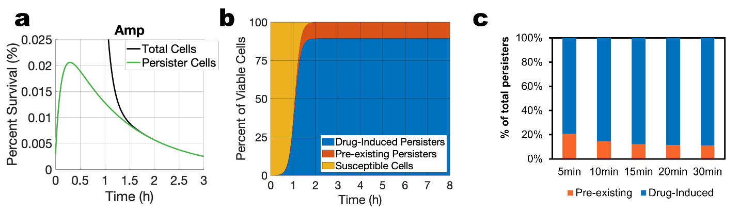
Supplementary Fig. S3. Model simulation of persister dynamics in cultures derived from 10,000-fold seed dilution. (a) Dynamics of persisters and total cells exposed to ampicillin. (b) Relative composition of surviving cells over 8 hours of treatment with ampicillin. (c) Relative fractions of pre-existing and drug-induced persisters in the first 30 min upon ampicillin exposure. The relative ratio reaches a steady state within 20 min of exposure.

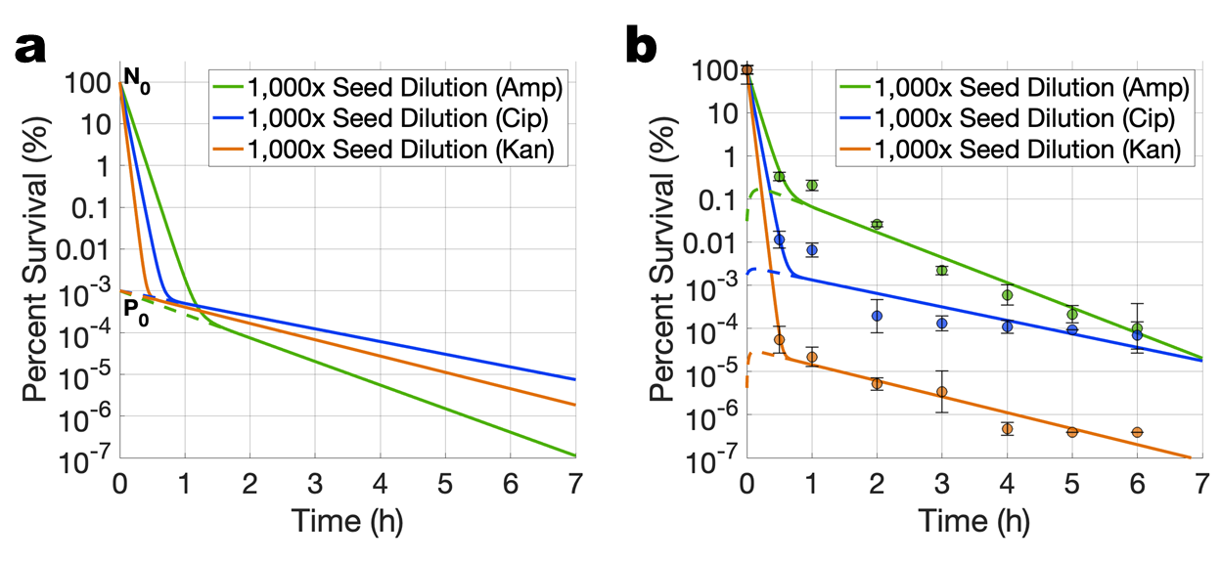
Supplementary Fig. S4. Same exponential-phase cultures were treated with different antibiotics. (a) Simulation of a static persister model assuming that the same pre-existing subpopulation is persistent to different antibiotics. (b) Experimental data showing the same cultures treated by ampicillin (Amp), ciprofloxacin (Cip), and kanamycin (Kan), each at 10x MICs. Antibiotics select and induce distinct subsets of persisters with substantial differences in fractions. The data support the drug-induced persister model and rule out the static model in which the same persister subpopulation is assumed to tolerate different antibiotics. Data points represent means ± SD from four replicates across two independent experiments.

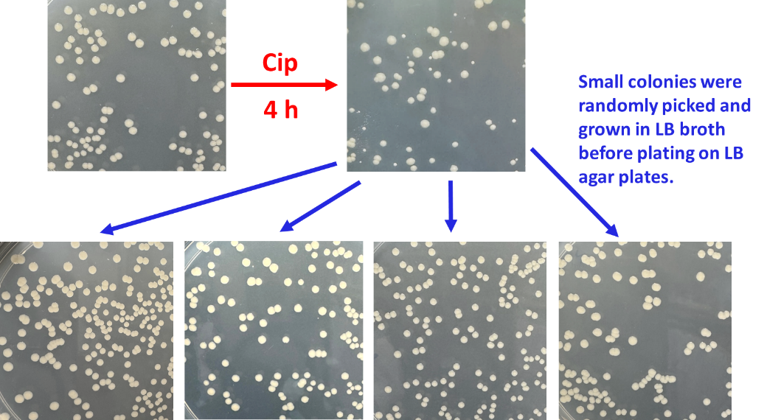
Supplementary Fig. S5. The small colonies observed after antibiotic treatment do not result from genetic mutations. When isolated and regrown, the small colonies emerging from ciprofloxacin treatment display colony size and morphology indistinguishable from the wild type prior to antibiotic exposure. Exponential-phase cultures were treated with ciprofloxacin (Cip) for 4 hours, after which persister cells were washed and plated on LB agar. Plates were incubated at 37 °C for 20 hours and then at room temperature for an additional 1-2 days to allow small colonies to emerge. These small colonies were randomly picked, grown in LB broth to exponential phase, and replated on LB agar to assess their colony sizes and morphology. In all cases, the regrown colonies matched wild-type characteristics, confirming that the initial small-colony phenotype was transient and not mutation-driven.

Fig. S6. Extended time-kill assays over a 24-hour period. (a) Time-kill kinetics of cultures treated with ampicillin, initiated from a 1,000-fold diluted inoculum. (b) Time-kill kinetics of cultures treated with ciprofloxacin, initiated from a 100-fold diluted inoculum. The killing dynamics exhibit at least three distinct phases. During the first 7~8 hours, two major phases are evident: rapid killing of susceptible cells, followed by slower killing of the persister subpopulation. From around 8 to 24 hours, a third phase becomes apparent, corresponding to the slowest elimination of an extremely small subpopulation of highly persistent cells. These “high-persistence” subsets were orders of magnitude smaller than the major persister fraction (~0.1%). Because this subset is negligible relative to the primary killing phases, our drug-induced kinetic model does not incorporate this ultra-rare persistence component. Data represent means ± SD from four replicates across two independent experiments.

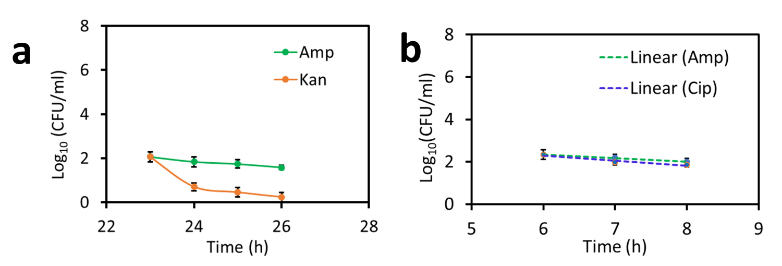
Fig. S7 Sequential drug treatments for cultures with extended exposure. (a) Bacteria were treated with ampicillin (Amp) for 23 h before exposed to kanamycin (Kan). (b) Bacteria were treated with Amp for 6 h before exposed to ciprofloxacin (Cip) or Amp. Data represent means ± SD from four replicates across two independent experiments.
Fig. S8 Sequential drug treatments for cultures derived from the 1,000-fold seed dilution. (a) Exponential-phase cultures were treated with ampicillin (Amp) for 2 h, followed by exposure to ciprofloxacin (Cip). (b) Exponential-phase cultures were treated with Cip for 2 h, followed by exposure to Amp. (c) Exponential-phase cultures were treated with Cip for 2 h before exposed to kanamycin (Kan). In cultures grown from the 1,000-fold seed dilution, drug-induced persisters accounted for approximately 50% of the total persister pool upon antibiotic treatment. Data represent means ± SD from four replicates across two independent experiments. Ampicillin persisters were rapidly killed by ciprofloxacin (Cip) or kanamycin (Kan), yielding biphasic killing curves consistent with the patterns observed in cultures grown from the 100-fold seed dilution.

Table S1: Relative contributions of spontaneous and drug-induced persister formation during SDTK assays in turbidostatic experiments.
$$P_{0}$$  (% of tot. cells) | $a_{2}$ (1/h) | $$a_{2}/a_{2}^{0}$$  * | Spontaneous  $P$ (% of $P_{tot}$) | $f_{1}$ (1/h) | $$f_{1}/f_{1}^{0}$$  ** | Drug-Induced  $P$ (% of $P_{tot}$)
0.052*** | 7.8 × 10⁻⁴ | 650 | 100 | 0 | 0 | 0
0.01 | 1.5 × 10⁻⁴ | 125 | 24.2 | 1.87 × 10⁻³ | 0.76 | 75.8
10⁻³ | 1.5 × 10⁻⁵ | 12.5 | 2.42 | 2.41 × 10⁻³ | 0.98 | 97.58
8 × 10⁻⁵ (Fig. 2c) | 1.2 × 10⁻⁶ | 1 | 0.19 | 2.46 × 10⁻³ | 1 | 99.81
10⁻⁵ | 1.5 × 10⁻⁷ | 0.125 | 0.02 | 2.47 × 10⁻³ | 1.004 | 99.98
0 | 0 | 0 | 0 | 2.47 × 10⁻³ | 1.004 | 100

* $a_{2}^{0}$ is the spontaneous persister formation rate constant value (a₂ = 1.2× 10⁻⁶ h⁻¹) previously measured for the wild-type E. coli strain exposed to ampicillin (Balaban et al. 2004).
** $f_{1}^{0}$ is our fitted value of persister formation rate constant (f₁ =2.46 × 10⁻³ h⁻¹) for bacteria exposed to ampicillin.
*** This P₀ value (the persister fraction before drug exposure) was determined by extrapolating the experimental data of the second killing phase, assuming f₁ = 0. Other P₀ values in column 1 are hypothetical scenarios except for the bolded row. The bolded text denotes that the simulation results were obtained using experimentally measured values of f₁ and a₂.

The sequence of models used for Table S1 is the same as shown in Fig S2a: the prior art spontaneous-persister-formation model in turbidostatic culture (pre-existing stationary-phase persisters get diluted out and spontaneous persisters form) and in pre-drug batch culture (spontaneous persister formation), and our drug-induced model during drug exposure (drug-induced persister formation). We assume that the turbidostatic culture removes all stationary-phase pre-existing persisters by continuous dilution. Therefore, all of the persisters observed in the time-kill assay are either spontaneously formed or drug-induced. In this special case, we can independently fit the spontaneous persister formation rate, a₂, and the drug-induced persister formation rate, f₁. As a result, given the value of any one parameter among a₂, f₁, and P₀ (the fraction of persisters immediately before drug exposure), the other two parameters/variables can be uniquely determined. Specifically, a₂ and P₀ are constrained by the prior spontaneous-persister-formation model of Balaban et. al. (2004), such that specifying one fixes the other. The value of f₁ is set by P₀, or vice versa, by fitting SDTK data with our kinetic model. The table shows hypothetical scenarios; a 650-fold increase in the reported a₂ value would be needed to explain the experimental data without f₁. In contrast, only a 1.004 multiplier on our fitted value of f₁ would be needed to explain the experimental data without a₂. Using the previously measured value for a₂, over 99.8% of all persisters are drug-induced after 1 hour of drug exposure. The experimental dataset fitted to generate this table is the same as shown in Fig. 2C and Supplementary Fig S2, a turbidostat-seeded ampicillin SDTK assay.

