Supplementary Information
For
Hybrid Longitudinal–Transverse Propagating Electric Fields in Photonic Crystal Waveguides
Yanrong Zhang¹, Hooman Barati Sedeh², Christopher S. Whittington³, Natalia M. Litchinitser², Shuren Hu^{1*}, Sharon M. Weiss^{1*}

¹ Department of Electrical and Computer Engineering, Vanderbilt University, Nashville, Tennessee 37203, United States
² Department of Electrical and Computer Engineering, Duke University, Durham, North Carolina 27708, United States
³ Interdisciplinary Materials Science Program, Vanderbilt University, Nashville, Tennessee 37235, United States
* Contact author e-mail addresses: shuren.hu@vanderbilt.edu; sharon.weiss@vanderbilt.edu

This file includes:
Supplementary Note 1 to 4
Supplementary Tables 1 to 3
Supplementary Figures 1 to 4

Supplementary Notes 1 to 4
Supplementary Note 1 | Origin of longitudinal electric (LE) field distribution using Gauss’s law
To study the phase relationship between $E_{x}$and $H_{z}$ ($x$ refers to the propagation direction along the waveguide, as shown in Supplementary Fig. S1), it is sufficient to examine the phase between $E_{x}$ and $E_{y}$, since net energy transport requires $E_{y}$ and $H_{z}$ to be in phase. Therefore, when $E_{x}$is found to be in phase with $E_{y}$, it can be concluded that$E_{x}$ is also in phase with $H_{z}$​, allowing it to contribute to the energy flow along the waveguide.
By knowing the transverse component of the electric field, $E,$($E_{y}, E_{z}$), we can express the longitudinal component $E_{x}$from Gauss’s law¹:
$$\begin{aligned}∇∙\left(εE\right)=0\#\left(S1\right)\end{aligned}$$
Eqn. S1 can be expanded to explicitly show the transverse and longitudinal components.
$$∇_{t}∙{(εE}_{t})+\frac{∂ε}{∂x}E_{x}+ε\frac{∂E_{x}}{∂x}=0 (S2)$$
In a homogeneous waveguide for which the permittivity is uniform in all directions, $ε\left(r\right)=ε\left(x,y,z\right)$ is a constant function such that $\frac{∂ε}{∂x}=\frac{∂ε}{∂y} =\frac{∂ε}{∂z} =0$. Assuming $E$ can be described as $E\left(x,y,z\right)=E_{t}e^{-iβx}$, Eqn. S2 can be simplified for a piecewise homogeneous waveguide to:
$$\begin{aligned}E_{x}=\frac{∇_{t}∙E_{t}}{iβ} \#\left(S3\right)\end{aligned}$$
where $β=\frac{2πn_{eff}}{λ_{0}}$ and $n_{eff}$ is the effective index of the waveguide and $λ_{0}$ is the free space wavelength of light². As indicated by the imaginary factor $i$ in Eqn. S3, $E_{x}$ is in quadrature phase (i.e., π/2 out of phase) with $E_{t}$, as well as with the magnetic field ($H_{z}$), and therefore contributes no net energy flow through the waveguide.
However, in a 1D photonic crystal waveguide³, the permittivity varies periodically along the propagation direction $x$. In this case, $\frac{∂ε}{∂x}≠0$. Therefore, the expression for $E_{x}$ from Eqn. S2 becomes:
$$\begin{aligned}E_{x}=A\left(\frac{∂ε}{∂x}\left(∇_{t}∙{(εE}_{t})\right)+ iεβ\left(∇_{t}∙{(εE}_{t})\right)\right)\#\left(S4\right)\end{aligned}$$
where
$$\begin{aligned}A=-\frac{1}{{\left(\frac{∂ε}{∂x}\right)}^{2}+{\left(εβ\right)}^{2}}\#\left(S5\right)\end{aligned}$$
Hence, in the case of waveguides with a permittivity that is not constant in the propagation direction, the longitudinal electric field $E_{x}$ has a real component (i.e., first term in Eqn. S4) and can therefore be partially in phase with $E_{t}$, as well as partially in-phase with the magnetic field, enabling it to contribute to net energy transport.
Supplementary Note 2 | Origin of longitudinal electric (LE) field distribution using Ampère’s law
Here, we derive a general formula for the longitudinal electric field component ($E_{x}$) of light directly from Ampère-Maxwell’s law:
$$\begin{aligned}∇×\vec{H}=\vec{J}+\frac{∂\vec{D}}{∂t}\#\left(S6\right)\end{aligned}$$
Assuming the current density $\vec{J}=0$ for dielectric waveguides, assuming harmonic time dependence $e^{iωt}$ for single frequency excitation, and rewriting the displacement field as $\vec{D}=ε\vec{E}$, we can express Eqn. S6 in the frequency domain:
$$\begin{aligned}∇×\vec{H}=iω\vec{D}=iωε\vec{E}\#\left(S7\right)\end{aligned}$$
Next, we expand the curl of $\vec{H}$ to show its components:
$$\begin{aligned}\left(\frac{∂H_{z} }{∂y}-\frac{∂H_{y}}{∂z}\right)\hat{x}+\left(\frac{∂H_{x}}{∂z}-\frac{∂H_{z}}{∂x}\right)\hat{y}+\left(\frac{∂H_{y}}{∂x}-\frac{∂H_{x}}{∂y}\right)\hat{z}=iωε\vec{E}\#\left(S8\right)\end{aligned}$$
If we assume $H_{z}$ polarized light where $H_{x}=H_{y}≈0$, which is considered to be a TE polarization state in traditional waveguide platforms, Eqn. S8 simplifies to:
$$\begin{aligned}\left(\frac{∂H_{z}}{∂y}\right)\hat{x}-\left(\frac{∂H_{z}}{∂x}\right)\hat{y}=iωε\vec{E}\#\left(S9\right)\end{aligned}$$
From Eqn. S9, we arrive at relationships that describe the well-known transverse $E_{y}$ component of light from the $H_{z}$ distribution, but also the longitudinal $E_{x}$ component of light from the $H_{z}$ distribution:
$$\begin{aligned}E_{y}=\left(-\frac{1}{iωε}\right)\left(\frac{∂H_{z}}{∂x}\right)\#\left(S10\right)\end{aligned}$$
$$\begin{aligned}E_{x}=\left(\frac{1}{iωε}\right)\left(\frac{∂H_{z}}{∂y}\right)\#\left(S11\right)\end{aligned}$$
Equation S11 implies that all electromagnetic waves that have a gradient of the $H_{z}$ magnetic field along the $y$ direction should have some $E_{x}$ contribution. Electromagnetic waves that are $H_{z}$ polarized but have no gradient along the $y$ direction, such as plane waves, do not have a longitudinal electric field component $E_{x}$. We note that in the phasor representation, all electromagnetic fields have a real and an imaginary component that together describe the amplitude and phase of the field. Therefore, the real and imaginary components of $H_{z}$ should always be considered when utilizing the equations given above.
Finally, we demonstrate the agreement of Eqn. S11 with FDTD simulation results from Ansys Lumerical in Fig. S1. Here, we consider antislot PhC waveguides with different antislot rotations angles. These results are obtained from unit cell simulations employing Bloch boundary conditions. Each unit cell is excited by an electric dipole oriented along the $y$ direction. Electric and magnetic field distributions in the $(x,y)$ plane are taken from the center of the silicon waveguide along the $z$ direction. The $H_{z}$ and $E_{x}$ field components are taken directly from simulation, while the $∂H_{z}/∂y$ distribution is calculated from the $H_{z}$ field distribution. The good agreement between the calculated $∂H_{z}/∂y$ and simulated $E_{x}$ distributions is consistent with Eqn. S11 and highlights that the $H_{z}$ magnetic field component is a dominant factor in determining the strength of the longitudinal electric field.
Supplementary Note 3 | Coupled mode theory describes band hybridization and anticrossing
Coupled mode theory provides a strong framework to describe the TE-LE hybridization quantitatively from a band structure perspective^{4,5}. Equation S12 shows the eigenvalue problem used to quantify the hybridization between the pure TE and pure LE photonic modes:
$$\begin{aligned}\left[\begin{matrix}f_{TE} & g_{TE-LE} \\ g_{TE-LE} & f_{LE}\end{matrix}\right]\left[\begin{matrix}α_{TE} \\ α_{LE}\end{matrix}\right]=f_{hybrid}\left[\begin{matrix}α_{TE} \\ α_{LE}\end{matrix}\right]\#\left(S12\right)\end{aligned}$$
Here, $f_{TE}$ and $f_{LE}$ represent the frequencies of the pure TE and pure LE bands, $f_{hybrid}$ represents the frequency of the hybrid band, $g_{TE-LE}$ (or $g$) represents the coupling strength between the pure TE and LE bands, and $α_{TE}$ and $α_{LE}$ are typically referred to as the mixing coefficients. By convention, ${\left|α_{TE}\right|}^{2}+{\left|α_{LE}\right|}^{2}=1$. Each variable is a function of $k_{x}$, the wave vector, and as such, the eigenvalue problem is solved numerically for each $k_{x}$. Finally, this eigenvalue problem will have two solutions, for $f_{hybrid}=f_{UH}$ and $f_{hybrid}=f_{LH}$, where $UH$ represents the upper hybrid band and $LH$ represents the lower hybrid band.
Unlike many systems, we are unable to decouple our system to obtain the pure TE and pure LE bands ($f_{TE}$ and $f_{LE}$) when the antislot is rotated away from its R0 and R90 positions. R0 and R90 are uncoupled systems, but their pure bands differ (i.e., $f_{TE(R0)}≠f_{TE\left(R90\right)}$ and $f_{LE\left(R0\right)}≠f_{TE\left(R90\right)}$). To address this issue, we approximate the pure TE and pure LE bands for intermediate angles by linearly interpolating fits to the R0 uncoupled bands and to the R90 uncoupled bands. We found that a fifth-order polynomial is adequate to model this behavior (Eqn. S13). This approach is empirically determined to be sufficient as the simulated crossings or degeneracy points are at the midpoint of the novel bandgap. The fits for the pure TE and LE bands are displayed in Table S1 and S2, respectively.
$$\begin{aligned}f_{pure}=p_{1}{\left(k_{x}\right)}^{5}+p_{2}{\left(k_{x}\right)}^{4}+p_{3}{\left(k_{x}\right)}^{3}+p_{4}{\left(k_{x}\right)}^{2}+p_{5}\left(k_{x}\right)+p_{6}\#\left(S13\right)\end{aligned}$$
Now that we have a suitable approximation for the pure TE and LE bands, we can begin solving the eigenvalue problem for $g$, the coupling strength coefficient. At each $k_{x}$, we can solve the determinant as follows:
$$\text{det}\left|A-λI\right|=0=\text{det}\left|\left[\begin{matrix}f_{TE} & g \\ g & f_{LE}\end{matrix}\right]-\left[\begin{matrix}f_{hybrid} & 0 \\ 0 & f_{hybrid}\end{matrix}\right]\right| \\ =\text{det}\left|\left[\begin{matrix}f_{TE}-f_{hybrid} & g \\ g & f_{LE}-f_{hybrid}\end{matrix}\right]\right| \\ 0=\left(f_{TE}-f_{hybrid}\right)\left(f_{LE}-f_{hybrid}\right)-g^{2} \\ g=\sqrt{\left(f_{TE}-f_{hybrid}\right)\left(f_{LE}-f_{hybrid}\right)} \\ \begin{aligned}g=\sqrt{f_{TE}f_{LE}-f_{TE}f_{hybrid}-f_{LE}f_{hybrid}+f_{hybrid}^{2}}\#\left(S14\right)\end{aligned}$$
Here, we can use the computed frequencies for the hybrid bands from our band structure simulations. Due to the approximations in determining the pure TE and pure LE bands for intermediate angles, the $g$ coefficient determined for the upper and lower hybrid bands differs slightly. We account for this by averaging $g_{UH}$ (upper hybrid band) with $g_{LH}$ (lower hybrid band) to obtain $g(k_{x})$ for a given rotation angle. Physically, $g$ represents the deviation from the fitted pure bands and therefore has units of frequency. $g$ is most intuitively understood at the anti-crossing point; there, $g$ is equal to half the bandgap size. Figure S2 shows the computed $g$ at the crossing or anti-crossing point for all antislot angles.
By solving this eigenvalue problem using software such as MATLAB, we also reproduce our eigenvalue – the frequency of the hybrid bands. Figure S3 plots the band structure simulation data, along with the assumed pure TE and pure LE bands, and the recalculated hybrid bands that utilize our computed $g$ coefficient. The close match between the hybrid band structure simulations with the recomputed hybrid band fit demonstrates both that the approximated pure TE and pure LE bands are adequate, but also that the $g$ coefficient alone is sufficient to describe the coupling behavior between the two modes.
In the same step, the eigenvectors $α_{TE}$ and $α_{LE}$ (mixing coefficients) were determined. This mixing coefficient represents the fraction of the pure TE or LE band one of the hybrid bands is at each point in $k_{x}$ space. Because only two modes are coupling with one another, these coefficients are reciprocal (i.e., if the upper hybrid band is 30% TE and 70% LE, the lower hybrid band will be 70% TE and 30% LE). Knowledge of the mixing fraction of the hybrid modes does not indicate more or less longitudinal electric field component – rather, it gives an indication of which mode profile (pure TE or pure LE) the hybrid mode will resemble more at a specific $k_{x}$ vector. In addition, the slope of the mixing coefficients indicates how the two modes are coupling – if it is a quick exchange of energy (low coupling) or if the coupled mode spends more time in$k_{x}$ space as a combination of the two modes (higher degree of coupling). The mixing coefficients for the upper hybrid band are shown in Figure S4 (the mixing coefficients are inverted for the lower hybrid band).
Supplementary Note 4 | Multipole Decomposition
The optical response of nonmagnetic meta-atoms is characterized by the electric current density $J_{in}$ and polarization $P_{in}$ induced by external electromagnetic fields. In the case of monochromatic fields, these values are connected by $J_{in}=-iωP_{in}$, wherein $ω$represents the angular frequency. Upon the interaction of light with the meta-atom, the induced polarization is related to the field distributions within the particle via $P_{in}=ϵ_{0}\left(ϵ_{p}-ϵ_{d}\right)E_{p}$, where $ϵ_{0}$, $ϵ_{p}$ and $ϵ_{d}$ are the free space, meta-atom, and surrounding medium dielectric constants, respectively, and $E_{p}$ is the total electric field inside the meta-atom^{6–8}. Therefore, the internal field distribution can directly change the induced polarization, which in turn alters the excited moments within the meta-atom. In the far-field region, the scattered field can be expressed as
$$E_{n}\left(r\right)=iωμ_{0}\frac{\exp\left(ik_{d}r\right)}{4πr} \left(\overset{̿}{I}-nn\right)\int_{V_{s}}{ J_{in}\left(r^{'}\right)\exp\left(-ik_{d}\left(n⋅r'\right)\right)dr'}$$ | (S15)
where $n=r/r$ is the unit vector directed from the particle’s center towards an observation point, $k_{d}$ is the wavenumber in the surrounding medium, and $\hat{\hat{I}}$ is a $3×3$ unitary matrix. The multipole decomposition of scattered waves can be obtained based on three approaches: (a) Taylor expansion of $\exp\left(-ik_{d}r\right)$ around a point with the radius vector $r_{0}$ located in the meta-atom volume; (b) writing the induced current density within the meta-atom in terms of a Kronecker delta function as $J_{in}\left(r'\right)=\int_{V_{s}}{J_{in}\left(r\right)δ\left(r^{'}-r\right)dr'}$, and then performing a Taylor expansion of the $δ\left(r^{'}-r\right)$ term in the vicinity of point $r_{0}$ and (c) spherical harmonic expansion of the $\exp\left(-ik_{d}r\right)$ term directly. As was shown in references 6-8, the first two methods ((a) and (b)) lead to the same results and provide multipoles in the long wavelength approximation (LWA) regime, while the third approach yields the multipole decomposition of the scattered field by finite-size scatterers with arbitrary dimensions, providing the exact multipole moments. To obtain the exact moments, the plane wave representation of $\exp\left(-ik_{d}\left(n⋅r'\right)\right)$ in the spherical harmonics leads to
$$\exp\left(-ik_{d}\left(n⋅r'\right)\right)=4π\sum_{l=0}^{∞}{\sum_{m=-l}^{l}{{\left(-i\right)}^{l}j_{l}\left(k_{d}r^{'}\right)Y_{lm}^{*}\left(θ,φ\right)Y_{lm}\left(θ,φ\right)}}$$ | (S16)
wherein $Y_{lm}\left(θ,φ\right)$ represents the spherical harmonics, $j_{l}\left(k_{d}r'\right)$ is the spherical Bessel function of order $l$, and the asterisk (*) denotes the complex conjugation. Substituting Eq. (S15) into Eq. (S16), the scattered electric field can be obtained as
$$E_{n}\left(r\right)=iωμ_{0}\frac{\exp\left(ik_{d}r\right)}{4πr} \left(\overset{̿}{I}-nn\right)\sum_{l=0}^{∞}{{\left(-i\right)}^{l}\left(2l+1\right)\int_{V_{s}}{ J_{in}\left(r^{'}\right)P_{l}\left(\cos\left(γ\right)\right)dr'}}$$ | (S17)
where $P_{l}\left(\cos\left(γ\right)\right)$ is the $l$-order Legendre polynomial, obtained from the application of the addition theorem for spherical harmonics. The induced multipole moments (up to electric quadrupole term) within the meta-atom can then be directly derived based on different combinations of $l$ as follows
$$D=\int{j_{0}\left(k_{0}r^{'}\right)Pdr^{'} }+\frac{k_{d}^{2}}{10}\int{\frac{15j_{2}\left(k_{d}r'\right)}{{\left(k_{d}r^{'}\right)}^{2}}}\left[\left(r^{'}⋅P\right)r^{'}-\frac{1}{3}r^{'2} P\right]dr',$$ | (S18)
$$m=-\frac{3}{2}iω\int{\frac{j_{1}\left(k_{d}r'\right)}{k_{d}r'}\left[r^{'}×P\right]}dr',$$ | (S18)
$$\hat{M}=-5iω\int{\frac{j_{2}\left(k_{d}r^{'}\right)}{{\left(k_{d}r^{'}\right)}^{2}}\left(\left[r^{'}×P\right]⊗r^{'}+r^{'}⊗\left[r^{'}×P\right]\right)dr'}$$ | (S18)
$$\hat{Q}=\int{\frac{3j_{1}\left(k_{d}r'\right)}{k_{d}r'}\left[3\left(r^{'}⊗P+P⊗r'\right)-2\left(r^{'}⋅P\right)\overset{̿}{I}\right]dr'}+6k_{d}^{2}\int{\frac{j_{3}\left(k_{d}r'\right)}{{\left(k_{d}r^{'}\right)}^{3}}\left[5 r^{'}⊗r^{'}\left(r^{'}⋅P\right)-r^{'2}\left(P⊗r^{'}+r^{'}⊗P\right)-\left(P⋅r^{'}\right)r^{'2}\overset{̿}{I}\right]dr'}$$ | (S18)
where D corresponds to the exact total electric dipole (TED), m is the exact magnetic dipole (MD) moment, and $\hat{Q}$, and $\hat{M}$ represent the electric quadrupole (EQ), and magnetic quadrupole tensors (MQ). The operators of $⋅$ , $×$, and $⊗$ represent the scalar, vector, and tensor products, respectively.

Supplementary Tables 1 to 3
Supplementary Table 1 | Fifth order polynomial fits for the pure TE band. Only R0 and R90 were decoupled and could be directly fitted ($R^{2}$ values shown for direct fits). Intermediate angle fits were determined by linearly interpolating the coefficients between the R0 and R90 fits.
Antislot PhC  Waveguide | $$p_{1}$$ | $$p_{2}$$ | $$p_{3}$$ | $$p_{4}$$ | $$p_{5}$$ | $$p_{6}$$ | $$R^{2}$$
R0 | -118.59 | 140.70 | -17.90 | -37.80 | 17.86 | -2.03 | 0.9966
R15 | 139.71 | -372.56 | 386.07 | -195.04 | 48.06 | -4.32 | --
R30 | 398.00 | -885.81 | 790.04 | -352.28 | 78.26 | -6.60 | --
R45 | 656.29 | -1399.07 | 1194.01 | -509.51 | 108.45 | -8.89 | --
R60 | 914.58 | -1912.32 | 1597.98 | -666.75 | 138.65 | -11.17 | --
R75 | 1172.87 | -2425.58 | 2001.95 | -823.99 | 168.85 | -13.46 | --
R90 | 1431.17 | -2938.83 | 2405.92 | -981.23 | 199.05 | -15.75 | 0.9977

Supplementary Table 2 | Fifth order polynomial fits for the pure LE band. Only R0 and R90 were decoupled and could be directly fitted ($R^{2}$ values shown for direct fits). Intermediate angle fits were determined by linearly interpolating the coefficients between the R0 and R90 fits.
Antislot PhC  Waveguide | $$p_{1}$$ | $$p_{2}$$ | $$p_{3}$$ | $$p_{4}$$ | $$p_{5}$$ | $$p_{6}$$ | $$R^{2}$$
R0 | 25.60 | -69.52 | 70.14 | -33.79 | 8.09 | -0.51 | 1.0000
R15 | 40.29 | -99.66 | 94.77 | -43.86 | 10.15 | -0.68 | --
R30 | 54.98 | -129.78 | 119.39 | -53.93 | 12.21 | -0.84 | --
R45 | 69.67 | -159.94 | 144.01 | -64.00 | 14.26 | -1.01 | --
R60 | 84.36 | -190.08 | 168.63 | -74.07 | 16.32 | -1.17 | --
R75 | 99.04 | -220.22 | 193.25 | -84.14 | 18.38 | -1.34 | --
R90 | 113.73 | -250.36 | 217.87 | -94.21 | 20.44 | -1.50 | 1.0000

Supplementary Table 3 | Comparison of properties related to longitudinal electric fields in different free space and guided-wave systems.
System Type |  | $$\frac{∂ε}{∂x}≠0$$ | Significant LE field component | Hybrid  LE-TE mode | References
Free space | Laser beam | No | No | - | -
Free space | Focused laser beam | Yes | Yes | - | e.g., [9]
Guided wave | Ridge waveguide | No | No | No | -
Guided wave | Nanowire waveguide | No | Yes | No | e.g., [2]
Guided wave | Traditional PhC waveguide | Yes | No | No | -
Guided wave | Rotated antislot PhC waveguide | Yes | Yes | Yes | This work
Note: $x$ represents propagation direction along the waveguide

Supplementary Figures 1 to 4
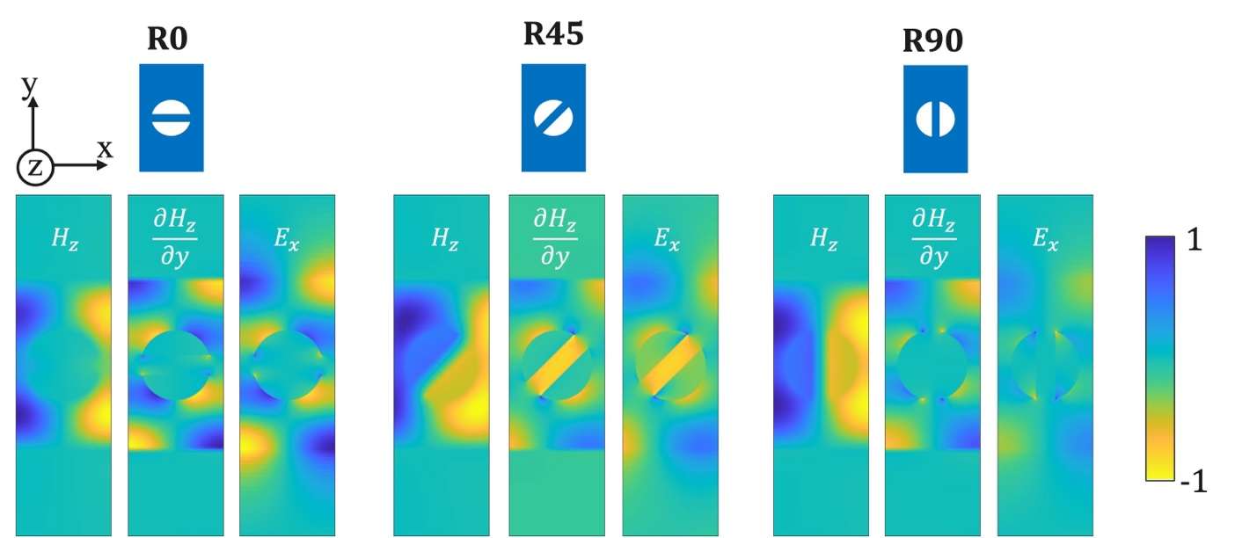
Supplementary Fig. S1 | Comparison of different antislot PhC waveguide unit cells with their simulated $H_{z}$ distribution, calculated $∂H_{z}/∂y$, and simulated $E_{x}$ distribution. The $H_{z}$ and $E_{x}$ distributions are direct simulation results. The $δH_{z}/δy$ distribution is computed using only the $H_{z}$ simulation data and is proportional to the $E_{x}$ simulation results, as seen by the matching spatial field distributions. This good agreement demonstrates that $H_{z}$ is a key contributing factor to the $E_{x}$ distribution.
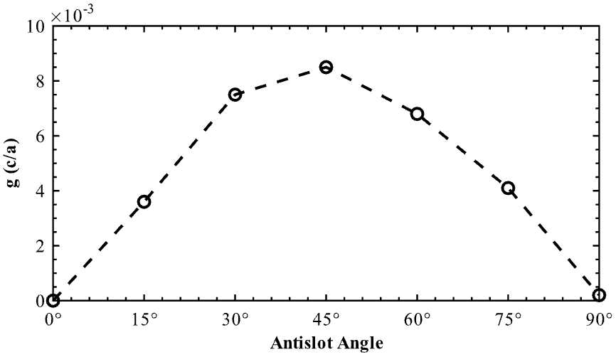
Supplementary Fig. S2 | Coupling strength coefficient as a function of antislot angle at each respective anti-crossing point ($g\left(k_{x}=\text{anti-crossing}\right)$). At the anti-crossing point, $g$ physically represents half the size of the bandgap.
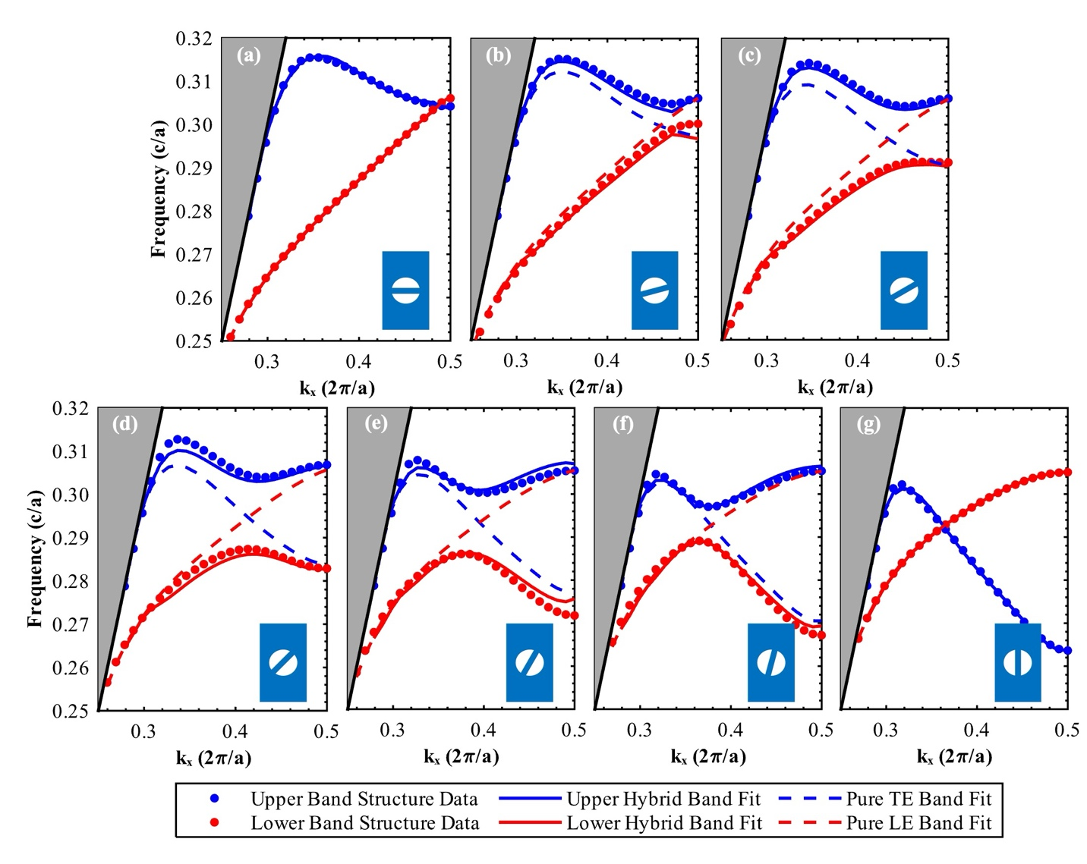
Supplementary Fig. S3 | Band structure data and fits for (a) R0, (b) R15, (c) R30, (d) R45, (e) R60, (f) R75, and (g) R90. The circle markers represent data that was determined via band structure simulations (i.e., MPB). The dashed lines represent the assumed uncoupled pure TE and pure LE bands that are approximated using the fits from Tables S1 and S2. The solid lines represent the coupled mode theory fit to describe the hybridization – this fit utilizes only the approximated pure TE and LE modes and the average fitted $g$ coefficient. Close matching between this fit and the simulated band structure data indicates that this model adequately describes the band hybridization.
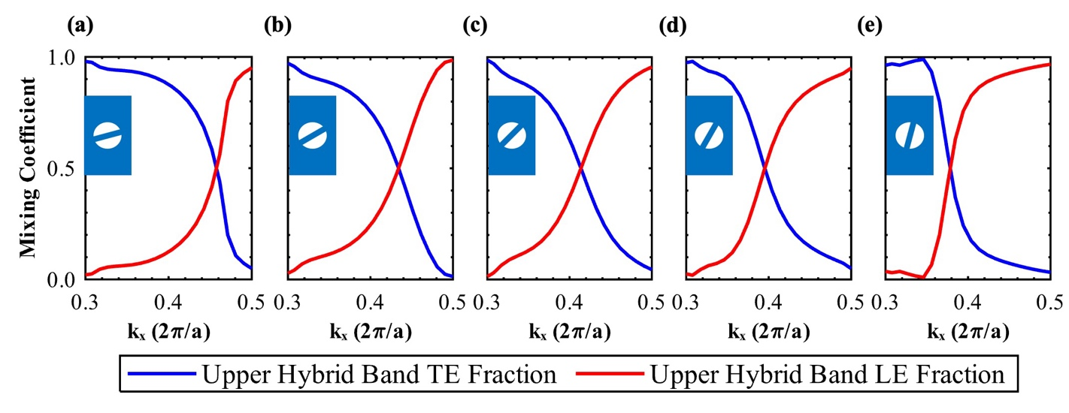
Supplementary Fig. S4 | Mixing coefficients for the upper hybrid band for (a) R15, (b) R30, (c) R45, (d) R60, and (e) R75. R0 and R90 are not shown because an upper hybrid band and lower hybrid band are not well-defined for an uncoupled system. The closer to R45, the longer in $k_{x}$ the hybrid mode stays significantly mixed.
Supplementary information references
1. Xu, C. L., Huang, W. P., Stern, M. S. & Chaudhuri, S. K. Full-vectorial mode calculations by finite difference method. IEE Proceedings - Optoelectronics 141, 281–286 (1994).
2. Driscoll, J. B. et al. Large longitudinal electric fields (Ez) in silicon nanowire waveguides. Opt. Express, OE 17, 2797–2804 (2009).
3. Joannopoulos, J. D., Johnson, S. G., Winn, J. N. & Meade, R. D. Photonic crystals: Molding the flow of light. in Photonic Crystals: Molding the Flow of Light (Second Edition) (Princeton University Press, 2011).
4. Chak, P., Pereira, S. & Sipe, J. E. Coupled-mode theory for periodic side-coupled microcavity and photonic crystal structures. Phys. Rev. B 73, 035105 (2006).
5. Tuniz, A., Song, A. Y., Della Valle, G. & de Sterke, C. M. Coupled mode theory for plasmonic couplers. Appl. Phys. Rev. 11, 021309 (2024).
6. Evlyukhin, A. B. & Chichkov, B. N. Multipole decompositions for directional light scattering. Phys. Rev. B 100, 125415 (2019).
7. Koshelev, K. & Kivshar, Y. Dielectric Resonant Metaphotonics. ACS Photonics 8, 102–112 (2021).
8. Sedeh, H. B. & Litchinitser, N. M. Singular optics empowered by engineered optical materials. Nanophotonics 12, 2687–2716 (2023).
9. Novotny, L., Beversluis, M. R., Youngworth, K. S. & Brown, T. G. Longitudinal Field Modes Probed by Single Molecules. Phys. Rev. Lett. 86, 5251–5254 (2001).

