Title: Psychometric Assessment of the EQ-5D-3L And ReQoL Measures in Secure Care Patients with an Intellectual Disability: Reliability, Agreement, Construct Validity, and Responsiveness
Short title: Psychometrics Of EQ-5D-3L And ReQoL in People with an Intellectual Disability
Contents
Appendix S1: Eligibility criteria and consort diagram 2
Appendix S2: Baseline demographics and patient characteristics 4
Appendix S3: Histograms of outcome measure distributions at baseline across trial arm 5
Appendix S4: Bland-Altman (BA) plots for assessing agreement 9
Appendix S5: Assessing Convergent validity using locally weighted scatterplot smoothing (LOWESS) techniques 11

Appendix S1: Eligibility criteria and consort diagram
SCHEMA was conducted in eight secure hospitals/units/services, including six NHS Trusts and one private provider in England, and one NHS Health Board in Scotland. SCHEMA trial participants were inpatients with the presence of an intellectual disability (ID, i.e., learning disability/BIF) indicated by: (a) meeting validated assessment criteria (recognised cognitive testing and adapting functioning assessment), or; (b) a score of 57 or below on the Learning Disability Screening Questionnaire (LDSQ) [1]. Participants were aged 18 to 60 years, able to give informed consent, and had a current or historic HONOS (Health of the Nation Outcome Scale) score between 1 and 4 for item 1 (i.e., fitting the descriptors: ‘Overactive, aggressive, disruptive, or agitated behaviour’ / ‘Behavioural problems directed at others’) [2; 3]. Exclusion included if they had a planned discharge within 12-months of the study start (later amended to be 9-months), and unstable/unmanaged psychotic symptoms requiring active assessment or treatment including medication dose titration (i.e., dose adjustment in the previous 4-weeks or with potential further dose adjustment planned for the following 4-weeks).
SCHEMA participants were supported by their responsible clinician and/or multidisciplinary team, whereby the responsible clinician has overall responsibility for the care and treatment of service users. The at-site trial teams screened participants, completed consent and data collection.
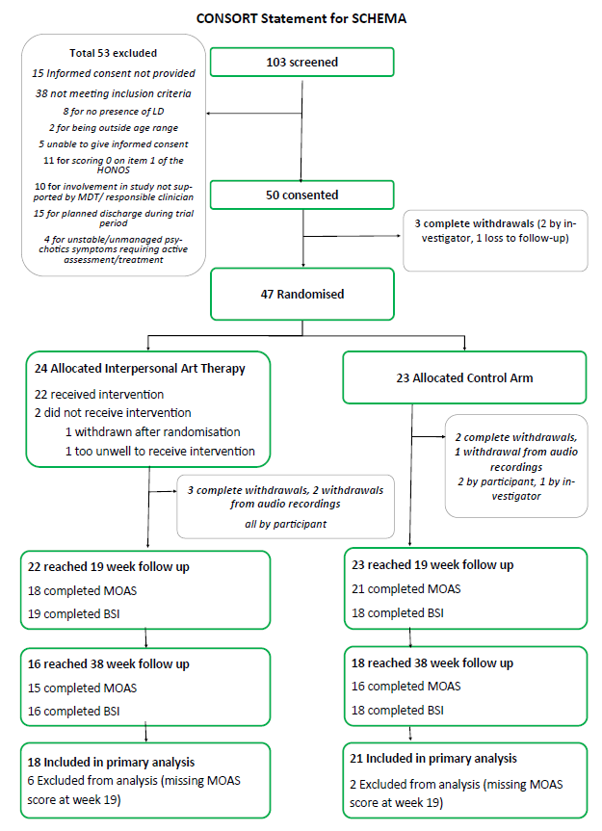
Figure S1.1. Consort diagram

Appendix S2: Baseline demographics and patient characteristics
Demographic, value | Overall | Intervention | Control
Number of people, N (%) | 47 (100) | 24 (51.1) | 23 (48.9)
Age, mean  (median, SD,  min-max) | 36.9  (36, 9.91,  21 to 59) | 35.7  (34.5, 10.7,  21 to 59) | 38.2  (37, 9.1,  24 to 59)
LDSQ, mean  (median, SD,  min-max) | 35.7  (43, 22.8,  0 to 71) | 31.5  (33, 22.2,  0 to 71) | 40.0  (43, 23.1,  0 to 71)
Male, N (%) | 43 (91.5) | 22 (91.7) | 21 (91.3)
Ethnicity, N (%)
- White or British White | 32 (68.1) | 18 (75.0) | 14 (60.9)
- Black: Caribbean or African | 7 (14.9) | 5 (20.8) | 2 (8.7)
- Asian or Asian British | 2 (4.3) | 0 (0.0) | 2 (8.7)
- Mixed or multiple ethnicities | 3 (6.4) | 1 (4.2) | 2 (8.7)
- Other ethnic groups | 3 (6.4) | 0 (0.0) | 3 (13.0)
Primary Mental Health Diagnosis (ICD-10)
- Schizophrenia, schizotypal and delusional disorders | 16 (34.0) | 7 (29.2) | 9 (39.1)
- Disorders of adult personality and behaviour | 12 (15.5) | 5 (20.8) | 7 (30.4)
- Intellectual Developmental Disorder | 9 (19.2) | 6 (25.0) | 3 (13.0)
- Behavioural/emotional disorders onset in childhood/adolescence | 1 (2.1) | 0 (0.0) | 1 (4.4)
- Disorders of psychological development | 1 (2.1) | 0 (0.0) | 1 (4.4)
- Mental/behavioural disorders due to psychoactive substance use | 1 (2.1) | 0 (0.0) | 1 (4.4)
- Two or more diagnoses* | 2 (4.3) | 2 (8.7)) | 0 (0.0)
- None | 4 (8.5) | 3 (12.5) | 1 (4.4)
- Missing | 1 (2.1) | 1 (4.2) | 0 (0.0)
Psychotic illness
- Paranoid schizophrenia | 12 (25.5) | 6 (25.0) | 6 (26.1)
- Schizoaffective disorder, unspecified | 5 (10.6) | 3 (12.5) | 2 (8.7)
- Unspecified nonorganic psychosis | 2 (4.3) | 1 (4.2) | 1 (4.4)
- Schizoaffective disorder | 1 (2.1) | 1 (4.2) | 0 (0.0)
- Dissocial personality disorder | 1 (2.1) | 0 (0.0) | 1 (4.4)
- None | 25 (53.2) | 13 (54.2) | 12 (52.2)
- Missing | 1 (2.1) | 0 (0.0) | 1 (4.4)
Acronyms. ICD-10, International Statistical Classification of Diseases and Related Health Problems 10th Revision; LDSQ, Learning Disability Screening Questionnaire; SD, standard deviation
* One person had 5 and another 2 ICD-10 defined primary mental health diagnoses:
- The five were: Mental and behavioural disorders due to psychoactive substance use; Schizophrenia, schizotypal and delusional disorders; mixed anxiety and depressive disorder; Disorders of adult personality and behaviour; Intellectual Developmental Disorder.
- The two were: Intellectual Developmental Disorder; Disorders of psychological development

Appendix S3: Histograms of outcome measure distributions at baseline across trial arm
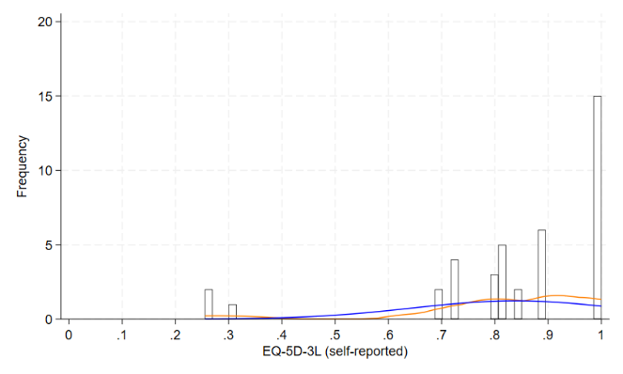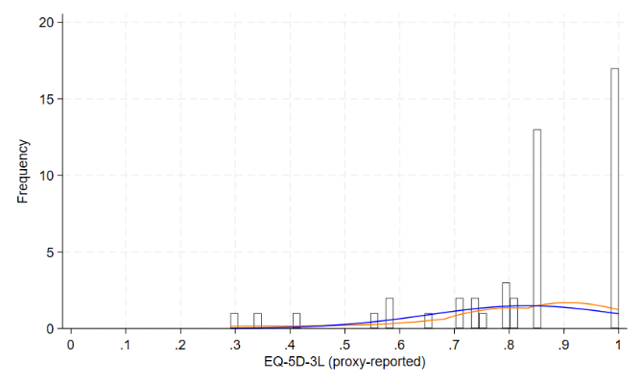
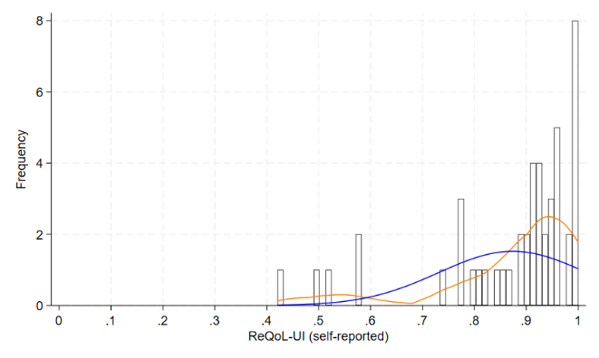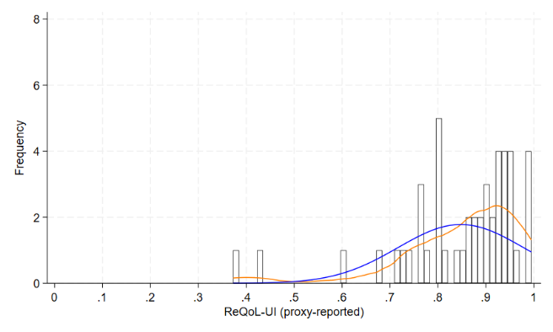
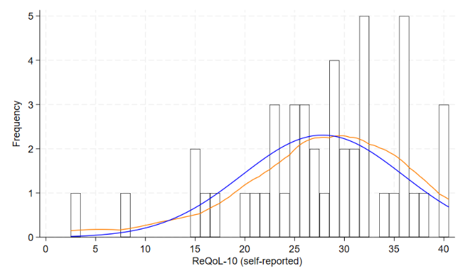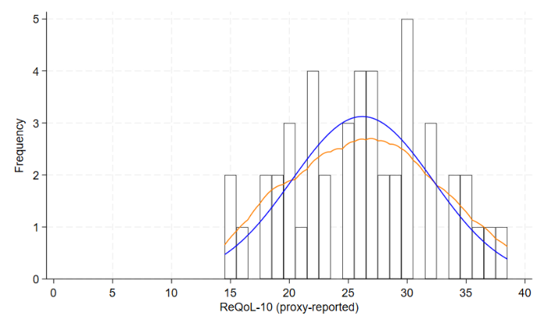
Figure S3.1. EQ-5D-3L, ReQoL-UI, and ReQoL-10 scores at baseline across the whole trial sample
Footnote. Embedded over the histogram is a blue line showing an imposed normal distribution and an orange line showing an imposed kernel density plot, to aid support assessment of the score distributions.
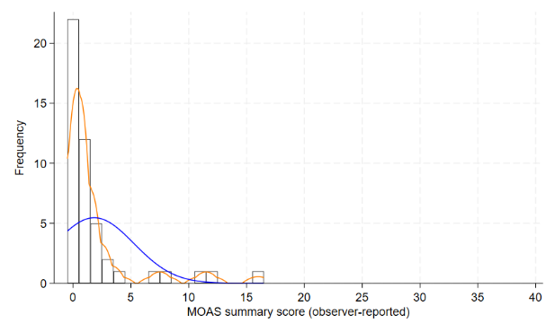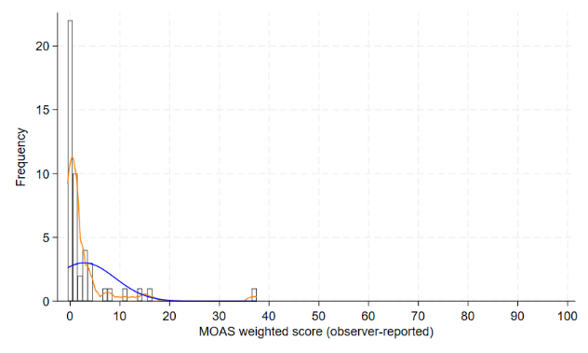
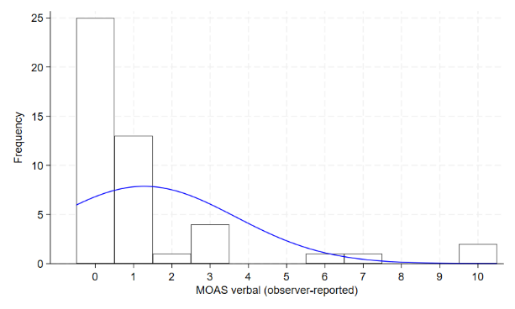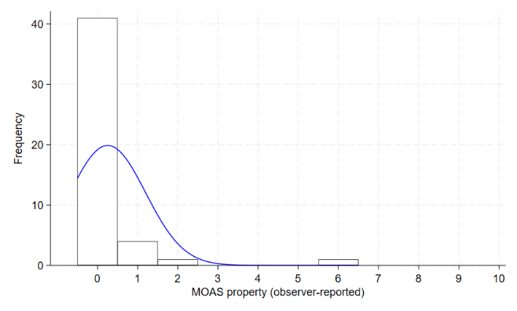
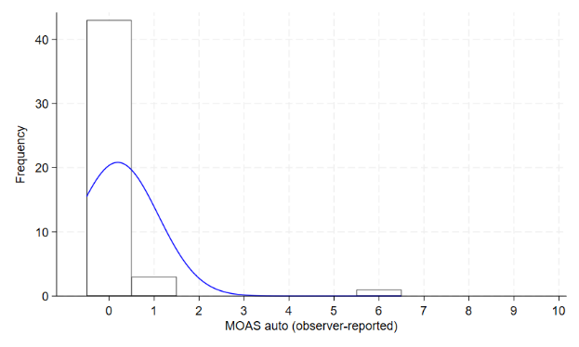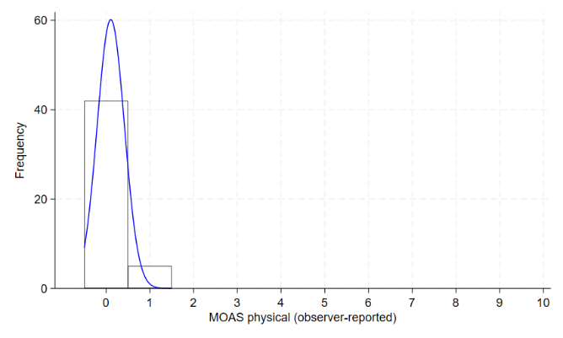
Figure S3.2. MOAS unweighted and weighted summary score and item scores at baseline across the whole trial sample
Footnote. Embedded over the histogram is a blue line showing an imposed normal distribution and an orange line showing an imposed kernel density plot, to aid support assessment of the score distributions. Kernel density plots are not shown for the item scores due to the lack of variability and value in providing the plot.
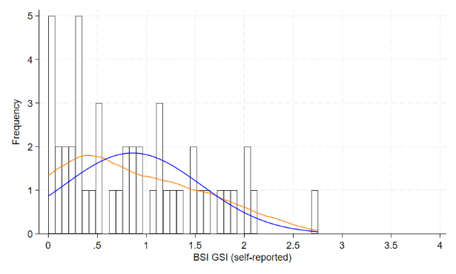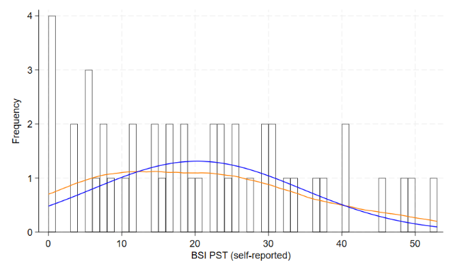
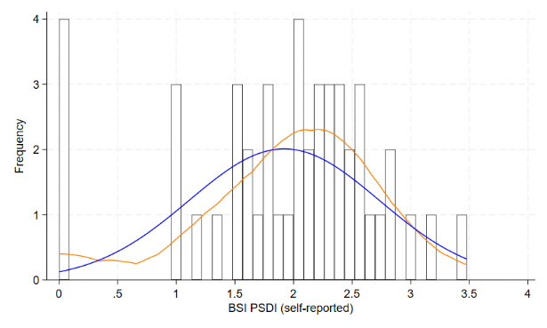
Figure S3.3. BSI grand total scores at baseline across the whole trial sample
Footnote. Embedded over the histogram is a blue line showing an imposed normal distribution and an orange line showing an imposed kernel density plot, to aid support assessment of the score distributions.

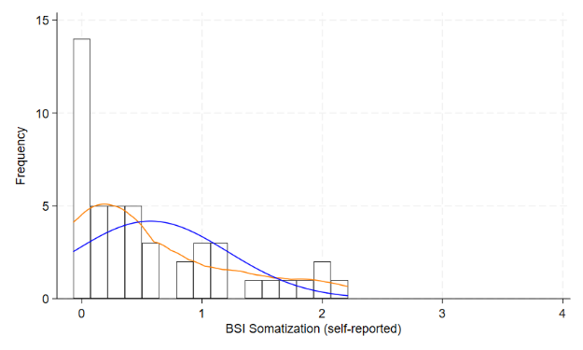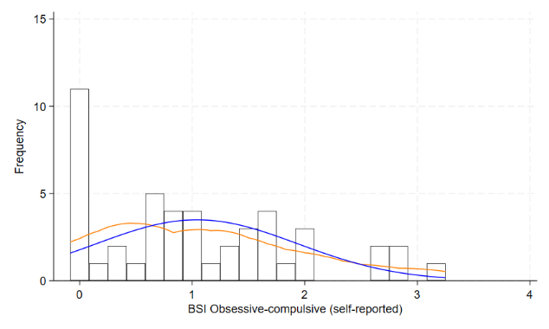
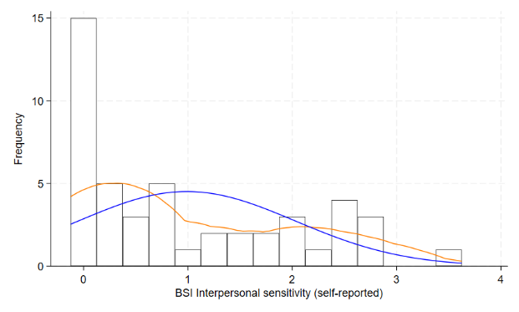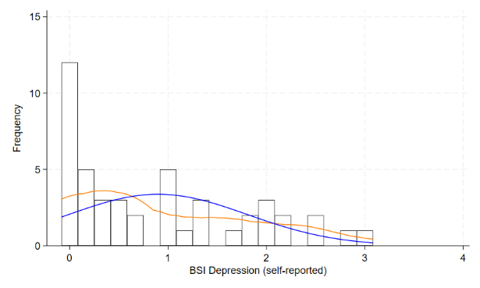
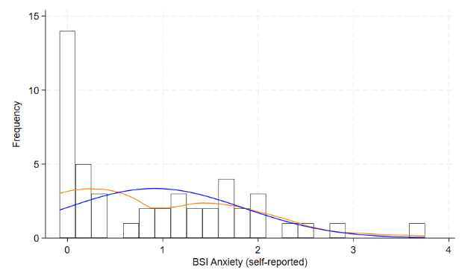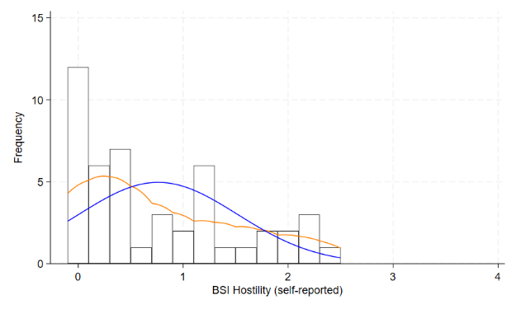
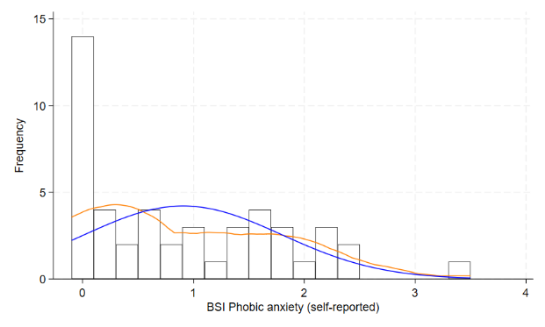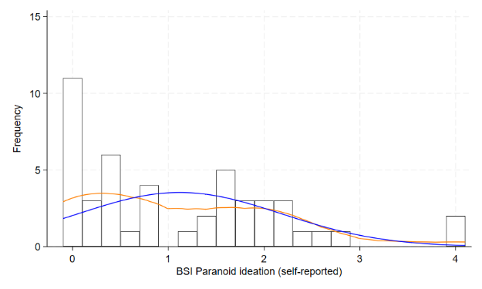
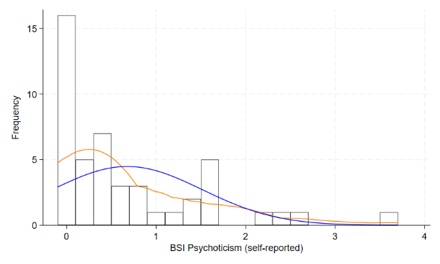
Figure S3.4. BSI symptom scores at baseline across the whole trial sample
Footnote. Embedded over the histogram is a blue line showing an imposed normal distribution and an orange line showing an imposed kernel density plot, to aid support assessment of the score distributions.

Appendix S4: Bland-Altman (BA) plots for assessing agreement
Objective. To use Bland-Altman (BA) plots to assess agreement at the utility/summary score level, to complement the ICCs presented in Table 4 and correlation statistics presented in Table 5 of the main manuscript.
Methods. A BA-plot is a graphical method used to compare two measurement techniques, in our case two different raters (i.e., self- and proxy-reporters), assessing the agreement between them rather than just correlation. It plots the difference between pairs of measurements (y-axis; i.e., self-reported minus the proxy-reported values) against their average (x-axis; i.e., self-reported plus the proxy-reported value, divided by 2).
The graph can be interpreted to assess systematic bias, such that if the mean difference is close to zero then there is low systematic bias on average. Agreement can also be assessed by the extent to which the 95% lower and upper limits are close to the mean difference, whereby the closer they are the better the agreement. In essence, a perfect Bland-Altman plot would show all data points clustered tightly along the horizontal zero-difference line; any spread away from that zero line implies poor agreement at that mean response-pairing value on the y-axis.
When using ICC and BA-plots together, the ICC measures how strongly units in the same group resemble each other (reliability), whereas BA-plots visualize the magnitude of disagreement between two methods (agreement). Both can identify systematic bias, but Bland-Altman plots explicitly show if the disagreement is proportional to the measurement magnitude, e.g., larger values have higher errors). Also, ICC may suggest high agreement even if a large, consistent systematic error exists, whereas a BA-plot will clearly show this as a non-zero mean difference. Additionally, correlation coefficients can support Bland-Altman plot assessment, as stronger correlation strength can lead to BA plots having narrower 95% limits and proportionally closer/more clustering of data points around zero difference; though high correlation does not guarantee good agreement.
Results. Reflecting first on the ICC value in Table 4 of the main manuscript: on average the agreement is defined as poor between the self- and proxy-reported scores for the EQ-5D-3L and ReQoL-UI, whereas agreement for the ReQoL-10 was moderate albeit with broad 95% CIs. In terms of correlations in Table 5, correlations were near zero for the EQ-5D-3L, moderate for the ReQoL-UI, and strong for the ReQoL-10.
Reflecting on the EQ-5D-3L and ReQoL-UI as both being utility-based measures, the limits of agreement are narrower for the ReQoL-UI; albeit, the ReQoL-UI has a narrower scale which will impact this interpretation. Despite this, the ReQoL-UI has more clustering around zero difference particularly at the upper part of the score scale compared to the EQ-5D-3L which has very limited value points at or close to zero; albeit, the ReQoL-UIs score scale is smoother (see Appendix S3) with more possible values than the EQ-5D-3L, for which if there is a difference in item scores this has a larger impact on the utility value. In general, this spread in values potentially explains why the ICC and correlation are near zero for the EQ-5D-3L. For the ReQoL-UI, although correlation was moderate, the interrater reliability was poor, potentially reflecting the high-levels of agreement at the upper part of the scale but poor agreement with broad spread at lower values as shown within the BA-plot.
The ReQoL-10 has a different summary scale, making direct comparisons of the 95% limits difficult to compare with the EQ-5D-3L and ReQoL-UI. Despite this, the spread of difference from zero tends to be reasonably uniform, particularly for x-axis values between 20 to 40. Despite the fact we don’t see as much clustering near zero as we did for the ReQoL-UI for the upper values, this unform spread across the ReQoL-10 score range aids explain the higher ICC, as the ICC reflects consistent systematic difference (i.e., if the difference is consistent, then the reliability /ICC will be higher) despite the Bland-Latman plotting showing a larger proportion of values with systematic bias from zero difference than the other outcome measures like the ReQoL-UI.
Discussion. The reliability, agreement, and correlation between the self-reported and proxy-reported EQ-5D-3L values tells a similar story as also shown on the Bland-Altman plots: the relationship is poor. For the ReQoL-UI and ReQoL-10, the ReQoL-UI has lower reliability and correlation than the ReQoL-10 (higher than the EQ-5D-3L), but for the ReQoL-UI agreement tends to be better at the higher end of the scale (i.e., when people have higher HRQoL) compared to the ReQoL-10 which has a reasonably uniform disagreement across the score range as specifically shown in the BA-plots. Given that the ReQoL-UI comes from a sub-set of ReQoL-10 items to which a utility value set is applied, perhaps it is how the utility value set reflects difference responses at the item score level that is causing this result. However, this is just a hypothesised rationale that we have not fully explored. In general, the ICC and correlation coefficients suggest the self-reported and proxy-reported have a better relationship for the ReQoL-10 than ReQoL-UI, though the relationship is more complicated when also using the BA-plots; the EQ-5D-3L relationship remains poor across all techniques used for assessment.
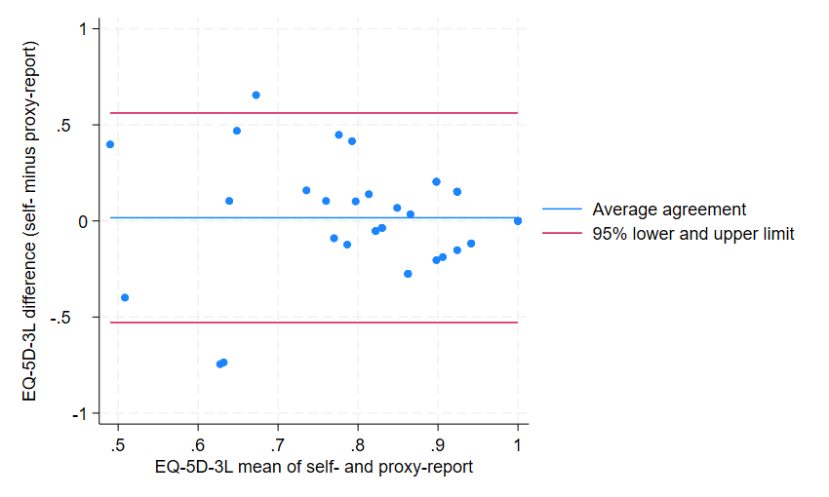

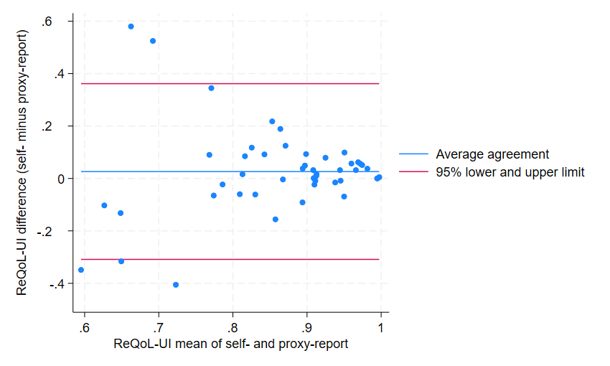

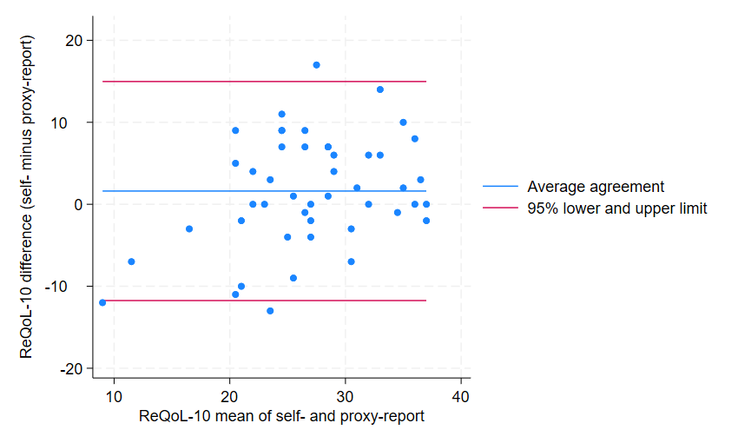

Figure S4.1. Bland-Altman plots for the self- and proxy-reported value pairing for the HRQoL measures

Appendix S5: Assessing Convergent validity using locally weighted scatterplot smoothing (LOWESS) techniques
Objective. To assess the convergent validity of the HRQoL measures (i.e., self- and proxy-reported EQ-5D-3L, ReQoL-UI, and ReQoL-10) against each other and the clinical measures (i.e., MOAS and BSI).
Methods. Convergent validity assesses the relationship strength between measures which can be assessed visually using locally weighted scatterplot smoothing (LOWESS) techniques, which also complements the correlation analysis described in the main manuscript. LOWESS is a form of non-parametric regression which plots a line of central tendency between two variables on a scatterplot, thereby visualising their general relationship across the possible score ranges without making assumptions about the actual relationship. These LOWESS lines are based on outcome measure data collected at baseline across the whole cohort.
Results. The LOWESS graphs presented in Figures S5.1. to S5.24 generally provide a visually means to better understand the correlation analyses in the main manuscript. For example, Figure 5.1. shows the clear, strong strength linear relationship between the self-reported version of the EQ-5D-3L and ReQoL-UI, which greatly worsens with the proxy-version of the same measure. Similarly, Figure S5.13. is a good example showing the better strength correlation / relationship between the self-reported compared to proxy-reported HRQoL scores with the BSI GSI grand total score; whereby the negative linear relationship is more pronounced for the self-reported scores, which improves particularly for the self-reported ReQoL-10.
Conclusion. These LOWESS graphs complement and support the correlation strengths described in the main manuscript, while providing a useful visual presentation of the relationship across the scores ranges of the two measures being compared.
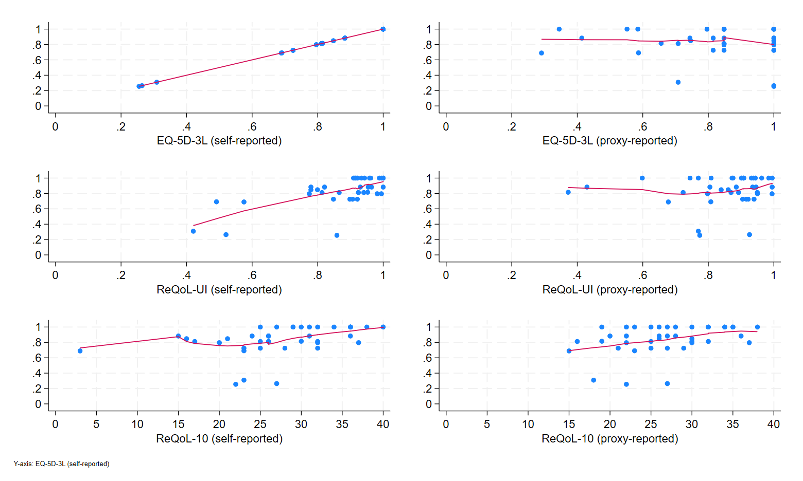
Figure S5.1. LOWESS of self-reported EQ-5D-3L utility score against HRQoL score
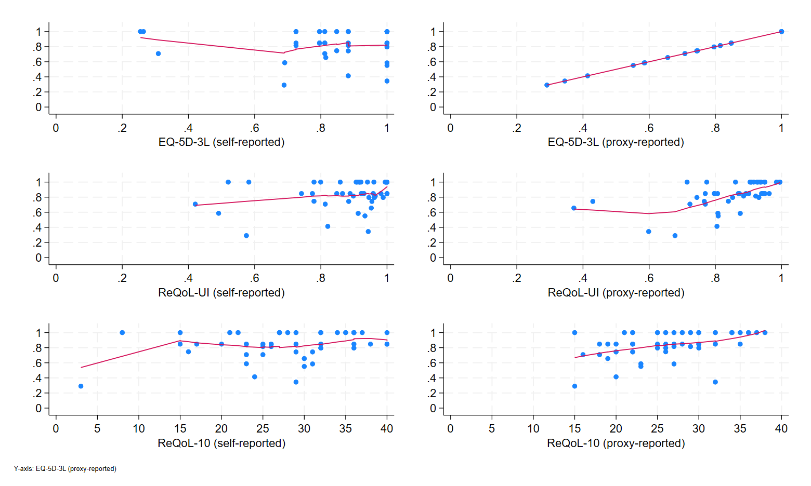
Figure S5.2. LOWESS of proxy-reported EQ-5D-3L utility score against HRQoL score
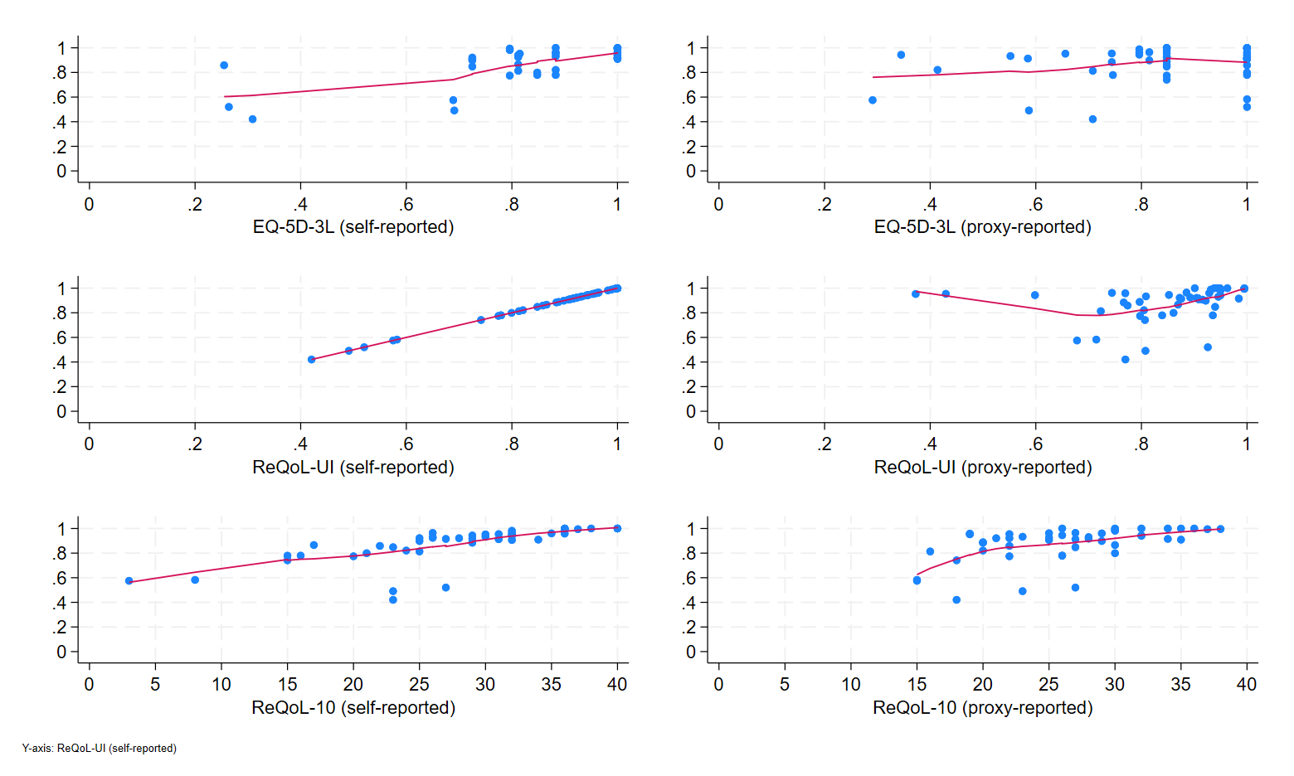
Figure S5.3. LOWESS of self-reported ReQoL-UI utility score against HRQoL score
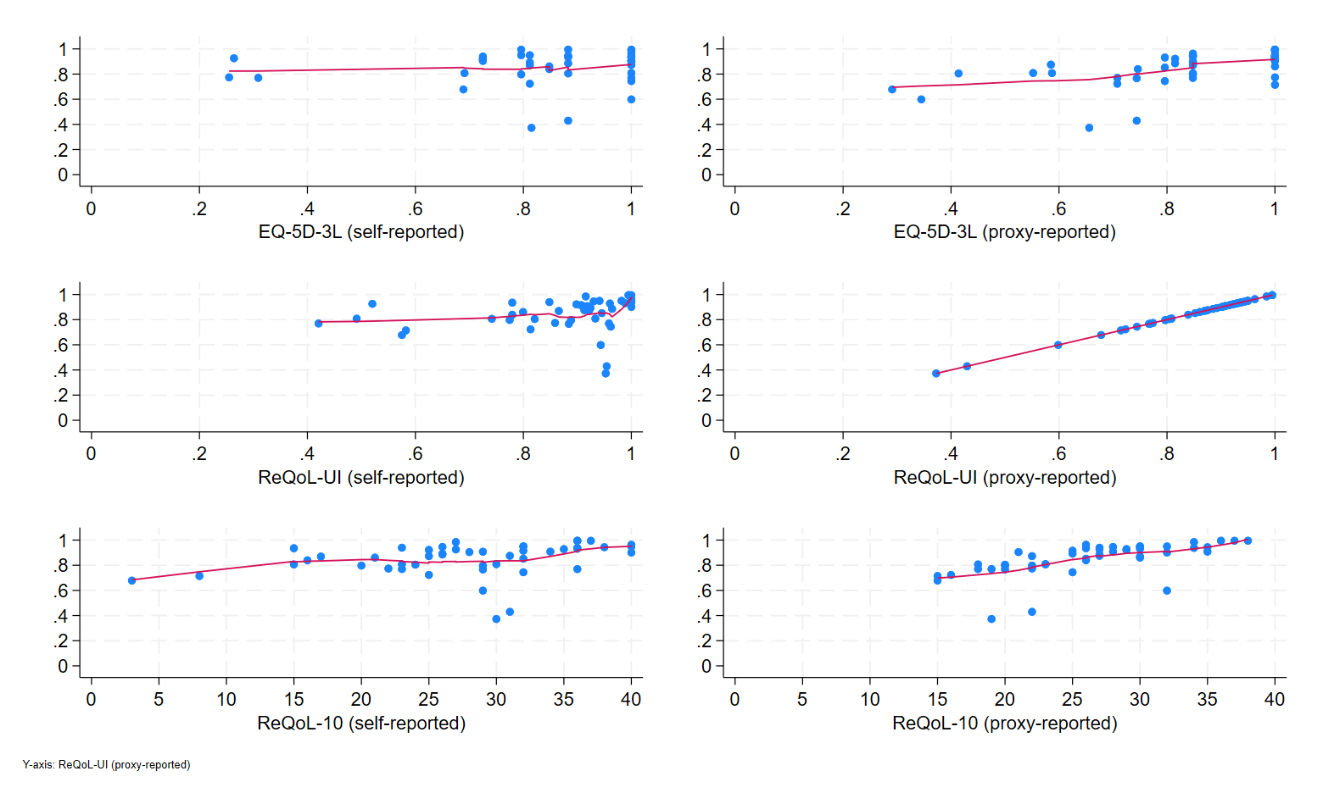
Figure S5.4. LOWESS of proxy-reported ReQoL-UI utility score against HRQoL score
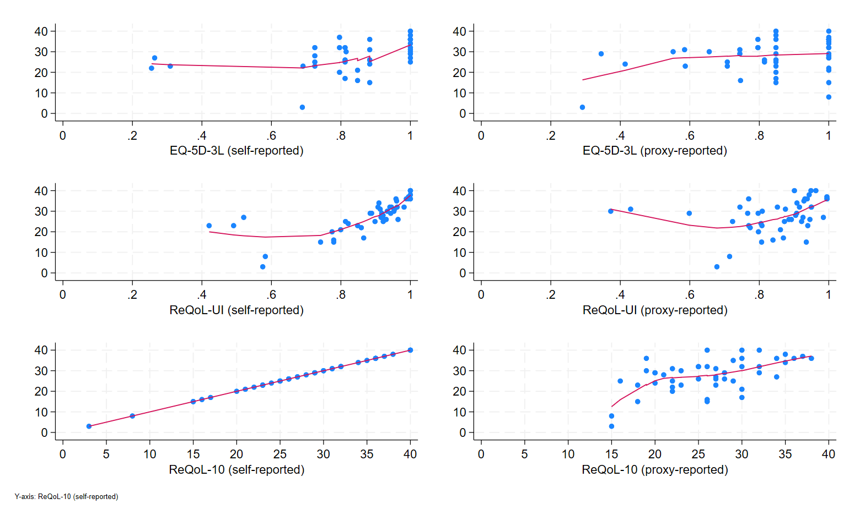
Figure S5.5. LOWESS of self-reported ReQoL-10 summary score against HRQoL score
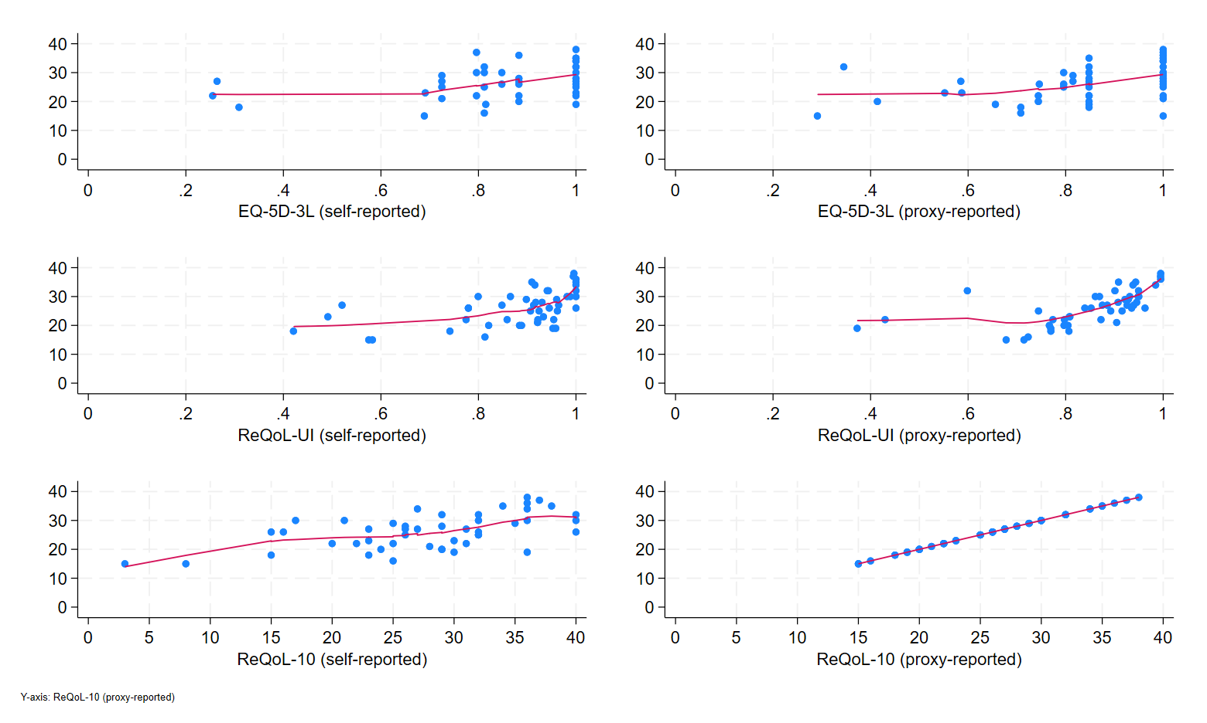
Figure S5.6. LOWESS of self-reported ReQoL-10 summary score against HRQoL score
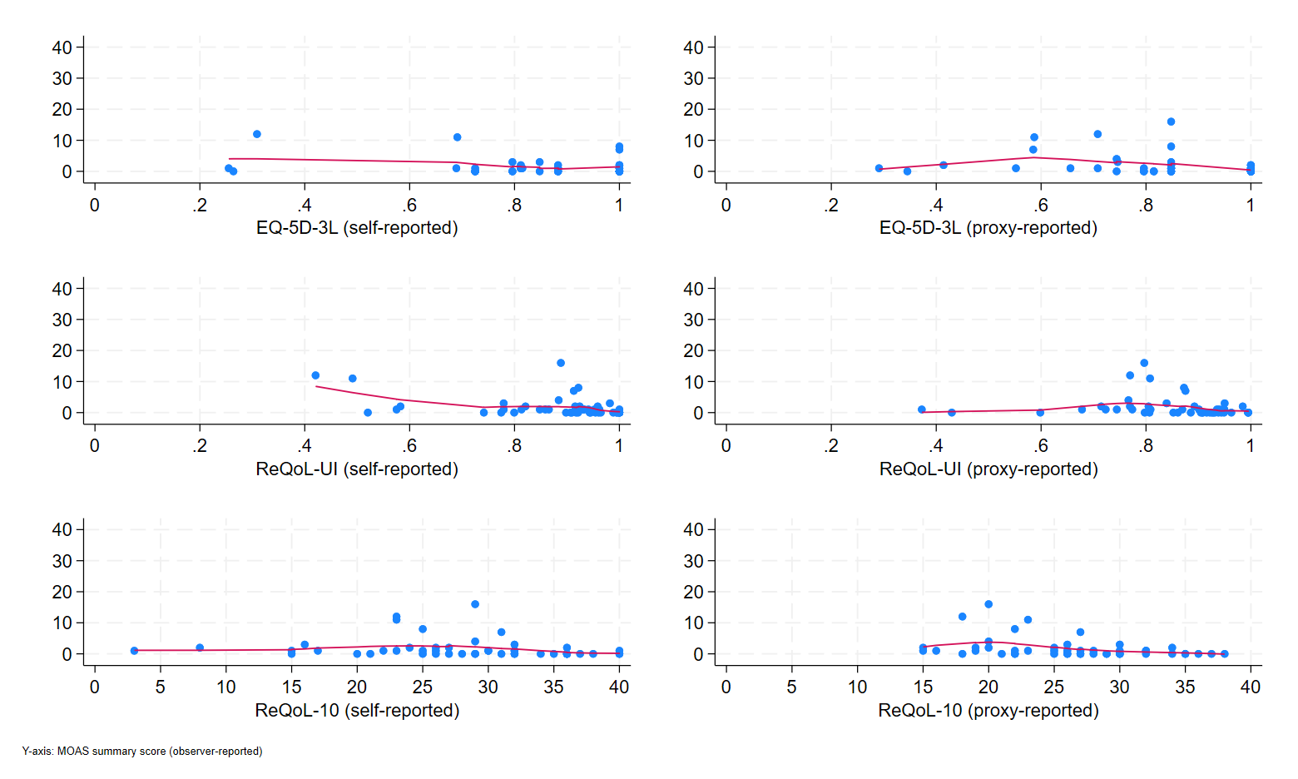
Figure S5.7. LOWESS of MOAS summary score against HRQoL score
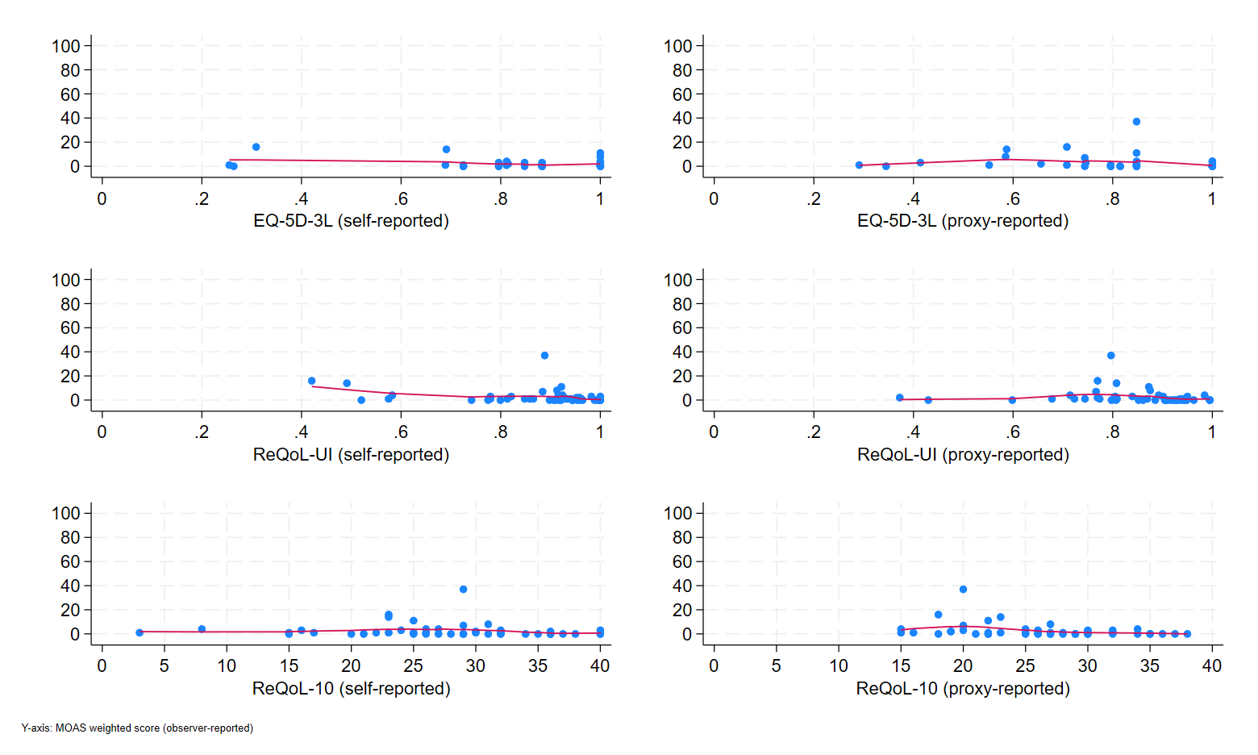
Figure S5.8. LOWESS of MOAS weighted summary score against HRQoL score
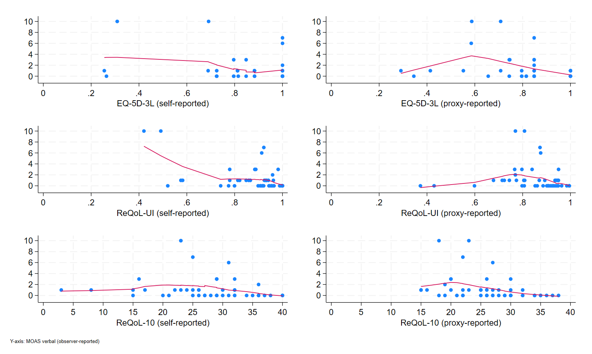
Figure S5.9. LOWESS of MOAS verbal score against HRQoL score
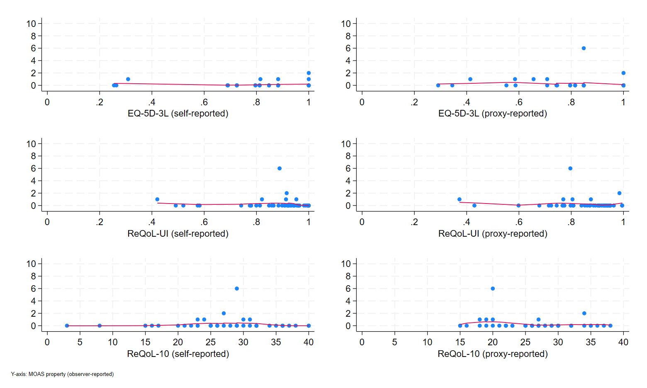
Figure S5.10. LOWESS of MOAS property score against HRQoL score
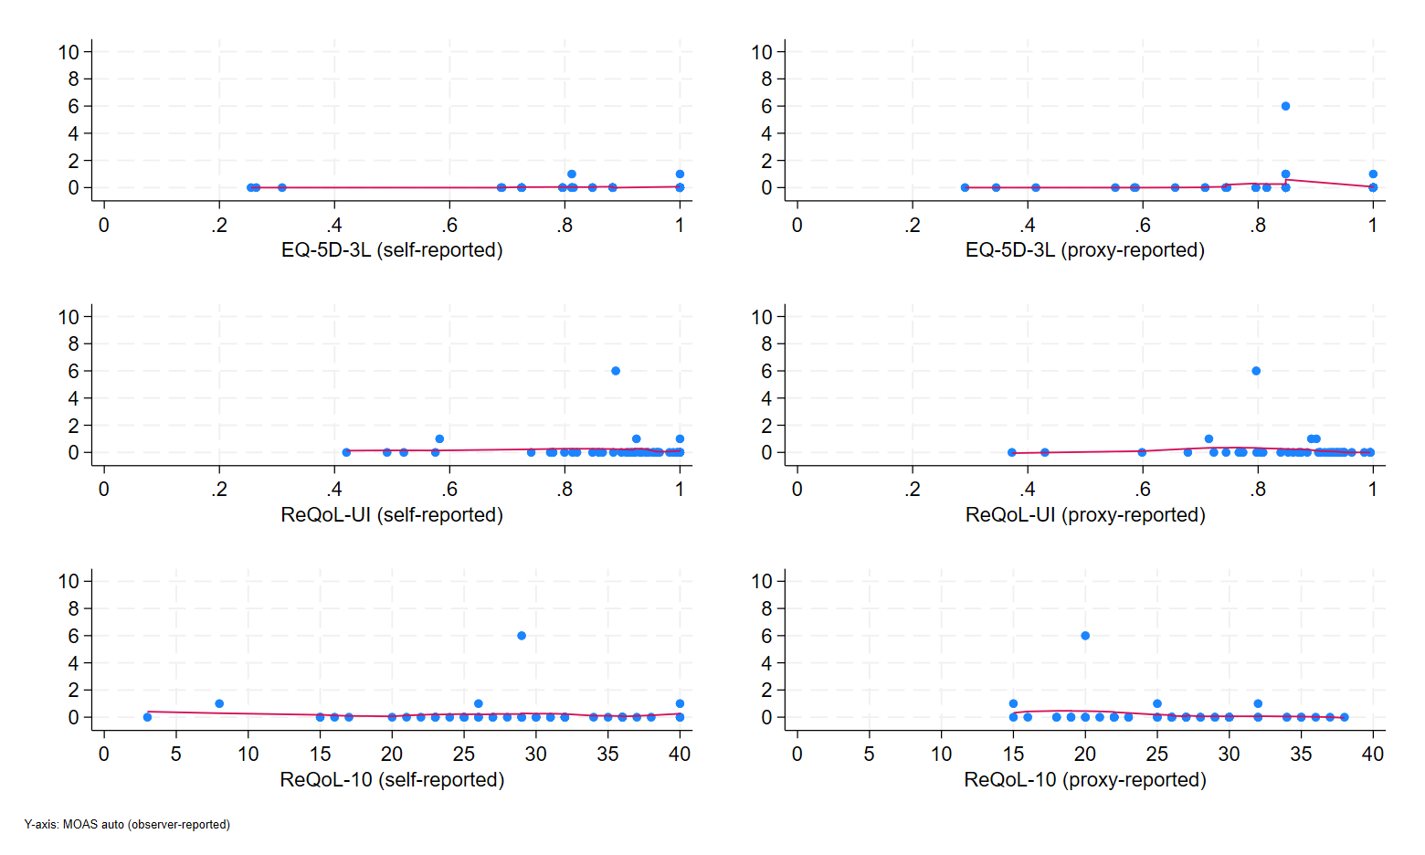
Figure S5.11. LOWESS of MOAS auto score against HRQoL score
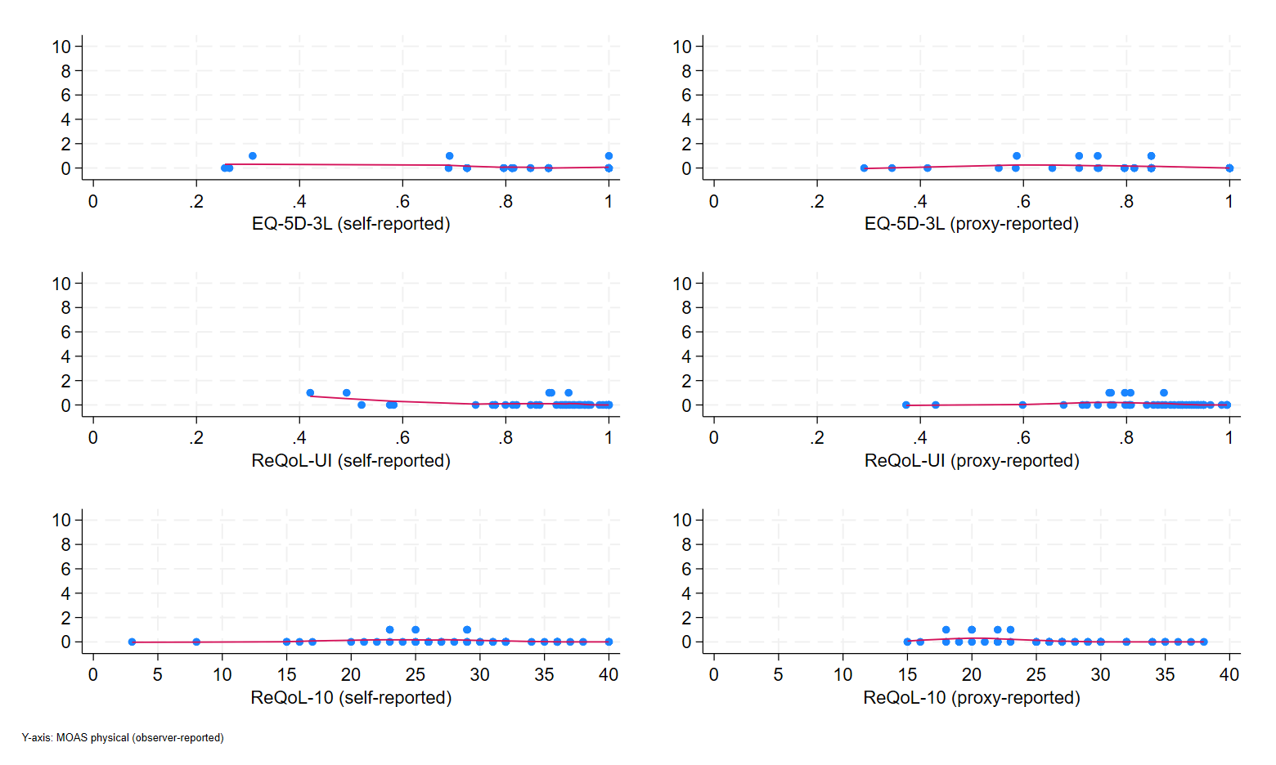
Figure S5.12. LOWESS of MOAS physical score against HRQoL score
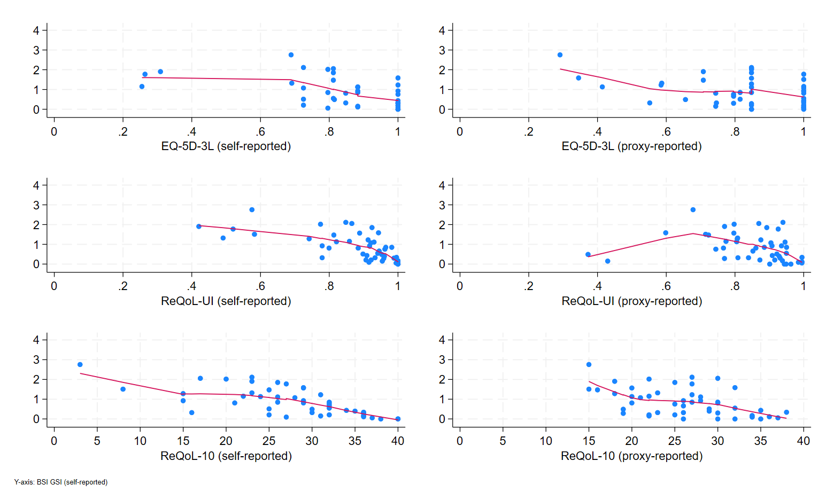
Figure S5.13. LOWESS of BSI GSI score against HRQoL score
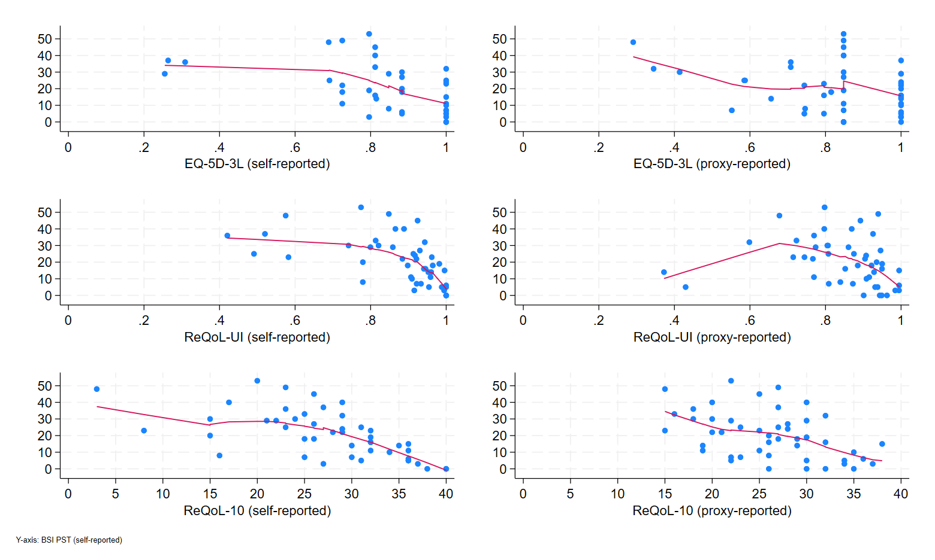
Figure S5.14. LOWESS of BSI PST score against HRQoL score
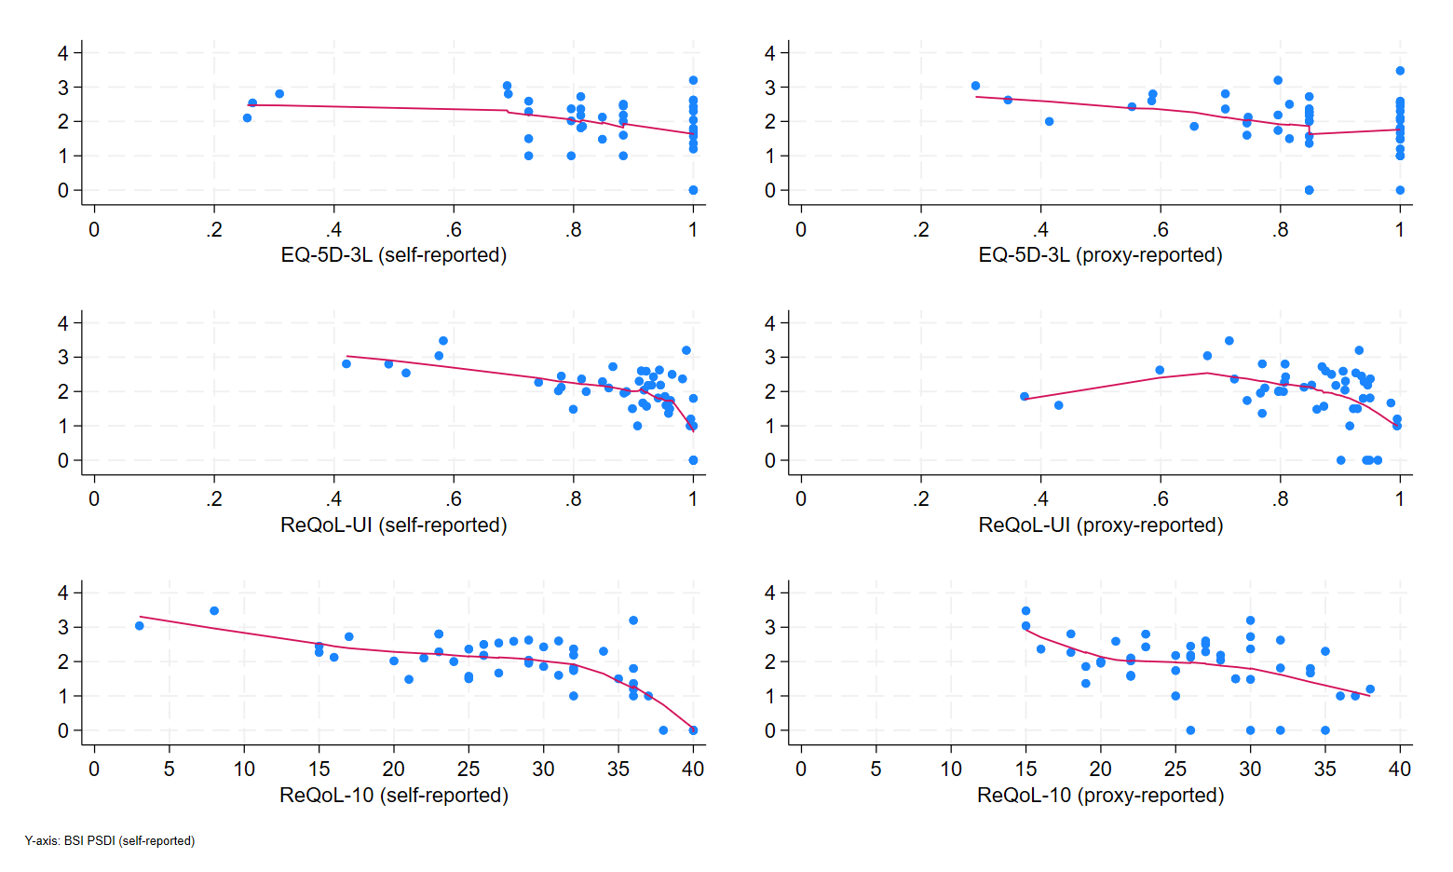
Figure S5.15. LOWESS of BSI PSDI score against HRQoL score
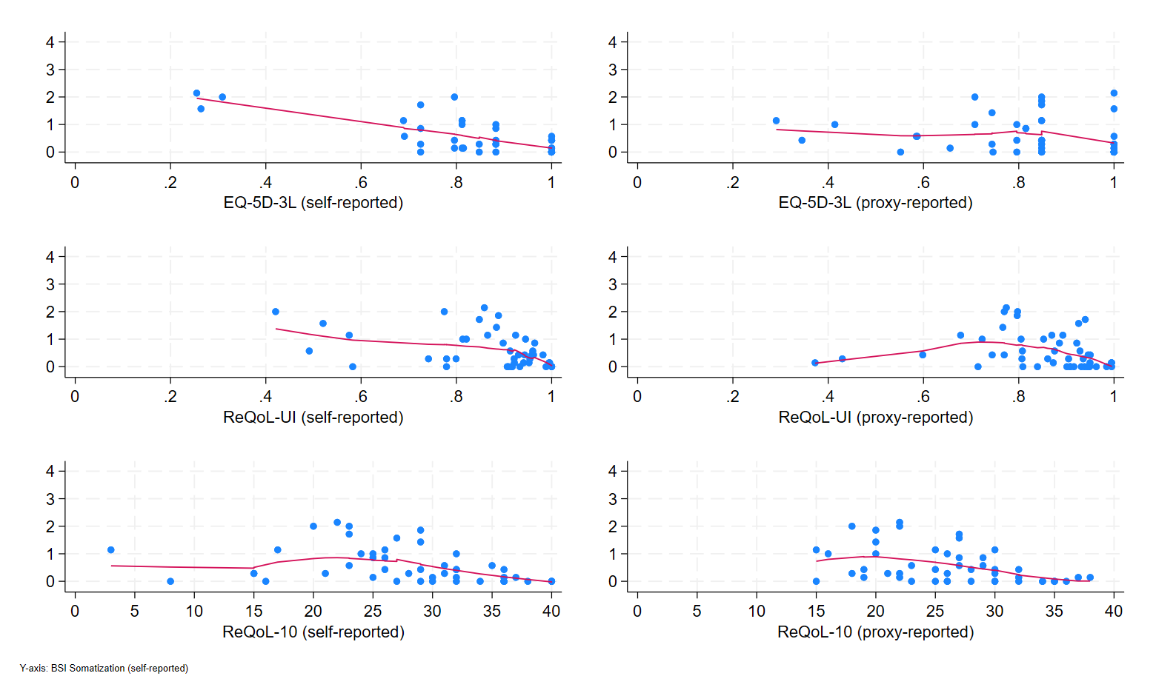
Figure S5.16. LOWESS of BSI Somatization score against HRQoL score
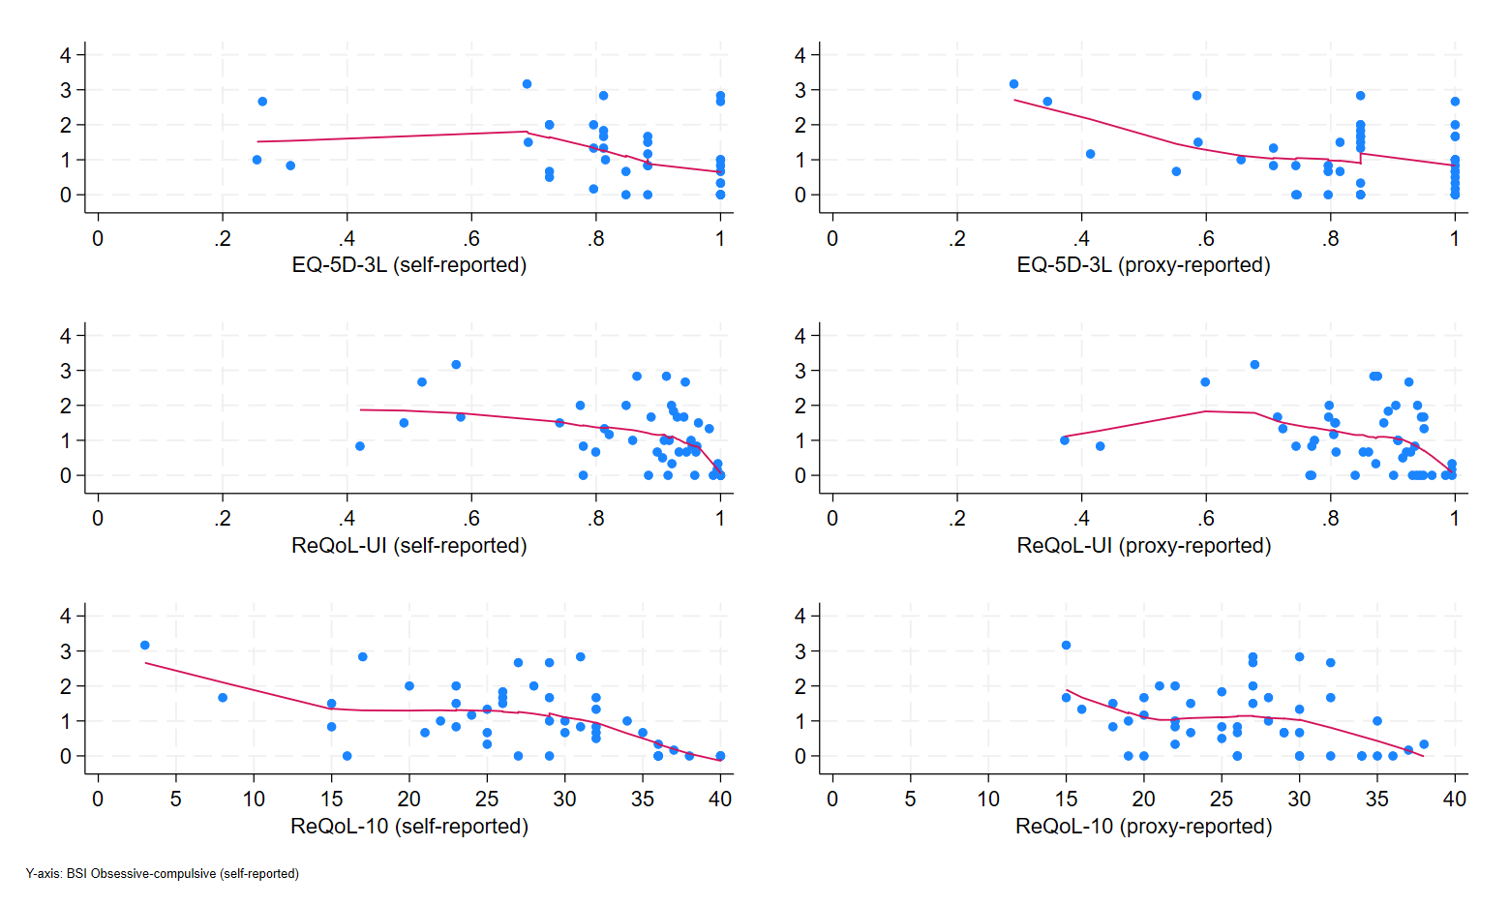
Figure S5.17. LOWESS of BSI Obsessive-compulsive score against HRQoL score
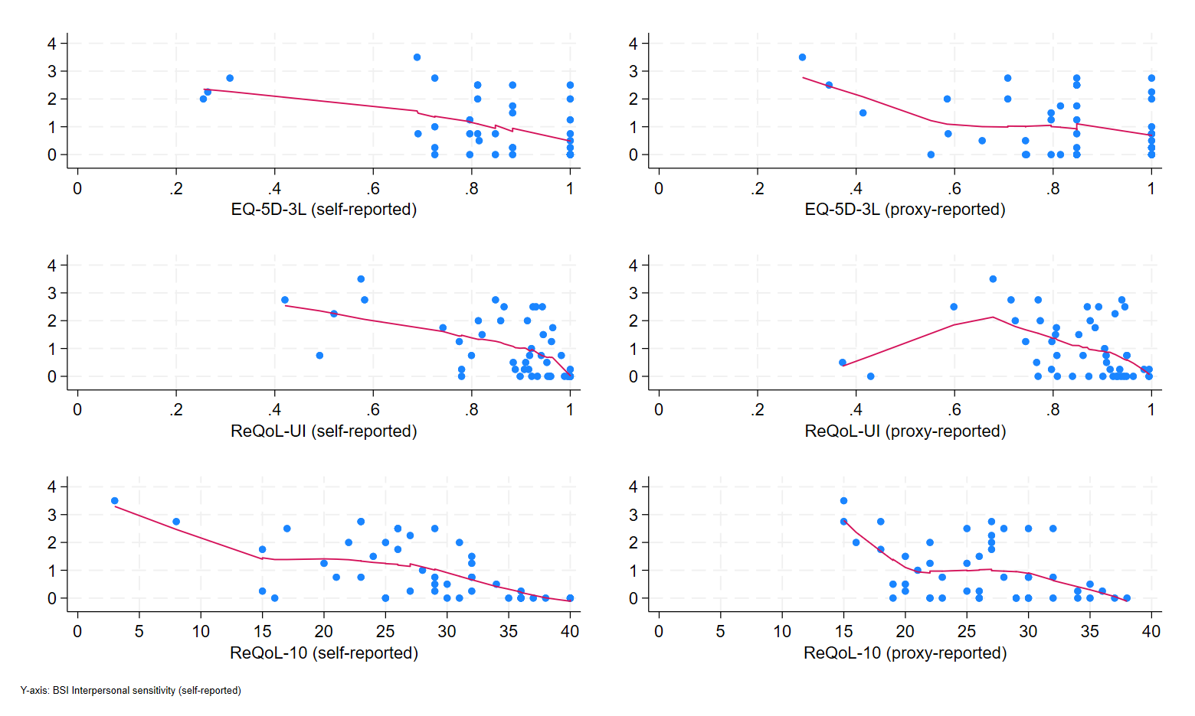
Figure S5.18. LOWESS of BSI Interpersonal sensitivity score against HRQoL score
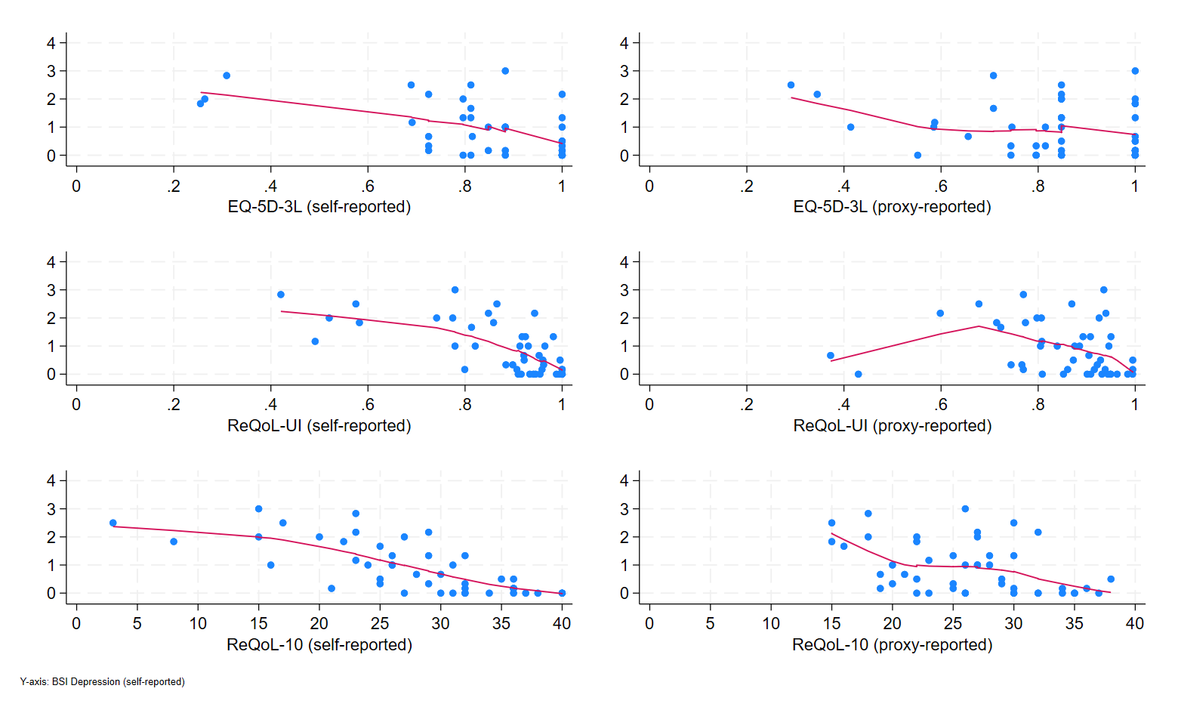
Figure S5.19. LOWESS of BSI Depressio score against HRQoL score
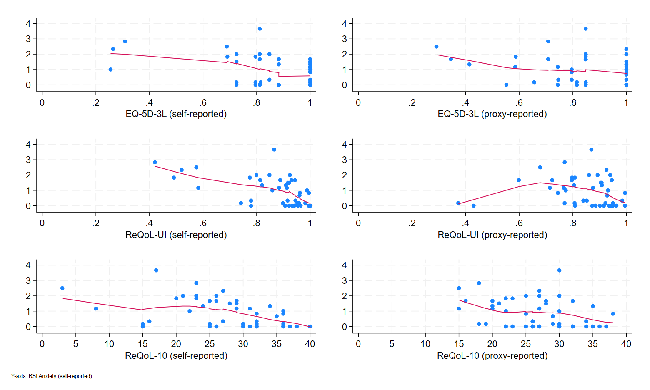
Figure S5.20. LOWESS of BSI Anxiety score against HRQoL score
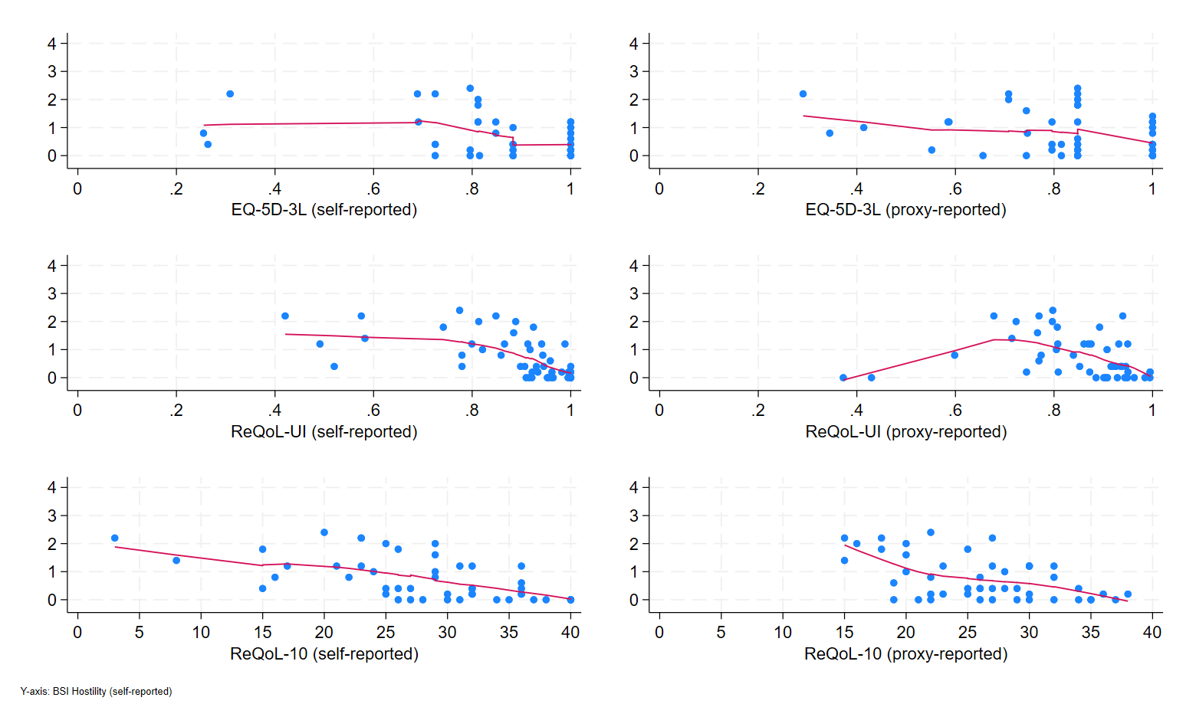
Figure S5.21. LOWESS of BSI Hostility score against HRQoL score
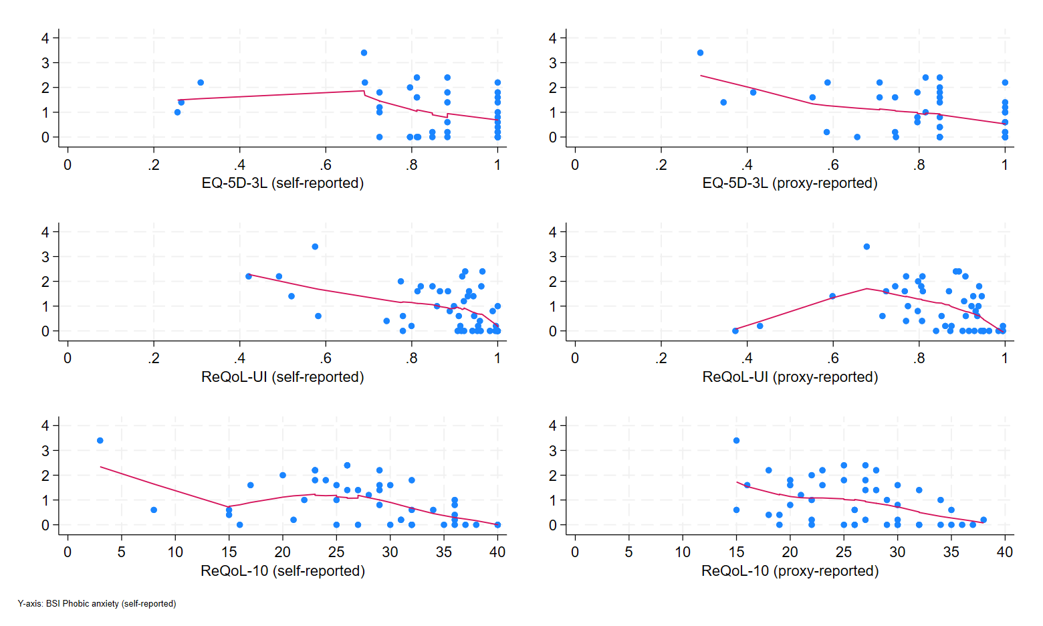
Figure S5.22. LOWESS of BSI Phobic anxiety score against HRQoL score
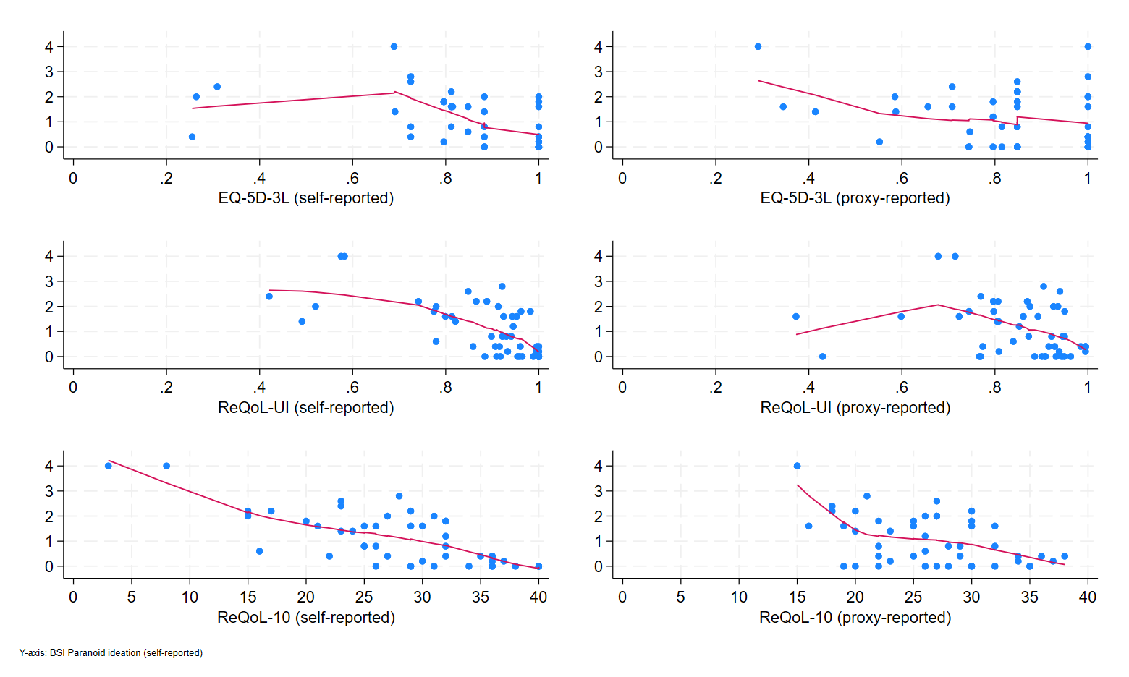
Figure S5.23. LOWESS of BSI Paranoid ideation score against HRQoL score
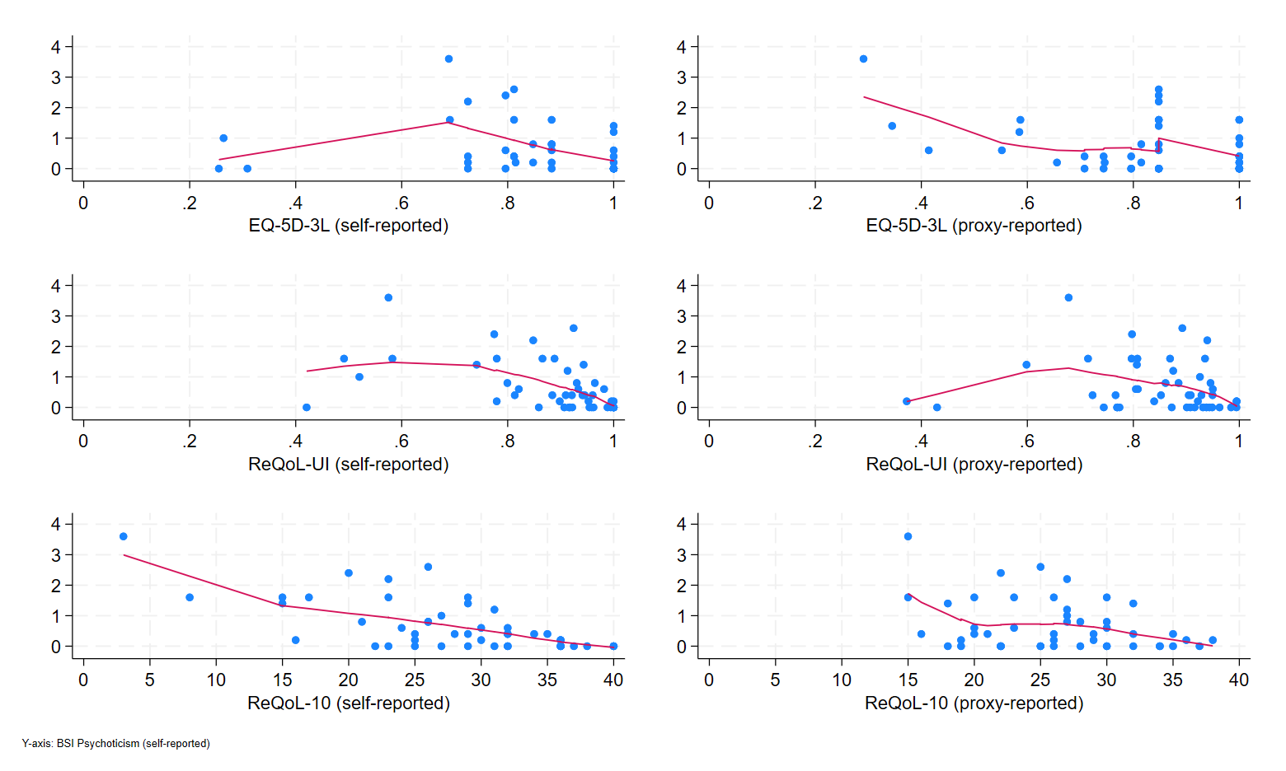
Figure S5.24. LOWESS of BSI Psychoticism score against HRQoL score
References
1. McKenzie, K., Michie, A., Murray, A., & Hales, C. (2012). Screening for offenders with an intellectual disability: The validity of the Learning Disability Screening Questionnaire. Research in developmental disabilities, 33(3), 791-795.
2. Wing, J., Beevor, A., Curtis, R., Park, S., Hadden, J., & Burns, A. (1998). Health of the Nation Outcome Scales (HoNOS): research and development. The British Journal of Psychiatry, 172(1), 11-18.
3. Foscarini-Craggs, P., Iranpour, A., Aafjes-van, D., Franklin, M., Harrison, T., McKinnon, I., McNamara, R., Randell, E., Rose, S., & Zubala, A. (2026). Working with underrepresented groups: Lessons from the SCHEMA Trial. Trials.

