Supplementary Data
- Selection of Representative Biomarker Panels
Method: When multiple multi-transcript panels achieved equivalent classification performance, a representative panel was selected using a predefined hierarchical procedure. First, transcript recurrence was assessed across all panels achieving perfect or near-perfect accuracy, and panels composed of transcripts with the highest recurrence were prioritized, reflecting stable and reproducible biological signals. Second, panels were favored if their constituent transcripts appeared consistently in high-performing models across multiple classification tasks, supporting cross-task generalizability. Third, practical assay considerations were applied, prioritizing transcripts with higher expression levels, lower variance, and established annotation (e.g., RefSeq or Ensembl identifiers). Finally, when panels remained equivalent after applying these criteria, a single representative panel was selected deterministically (lexicographic order) to ensure transparent and reproducible reporting.
2.1. Suppl. Table 1. Complete lists of performance-equivalent panels
Panel ID | Panel
Task 1.1: Hemorrhagic Stroke Diagnosis
1 | ENST00000587014, MSTRG_24342_56, MSTRG_42624_2
2 | ENST00000587014, MSTRG_32734_241, MSTRG_50567_5
3 | ENST00000587014, MSTRG_32734_241, ENST00000465590, MSTRG_50567_5
4 | ENST00000487938, ENST00000587014, ENST00000465590, MSTRG_42624_2
Task 1.2: Ischemic Stroke Diagnosis
1 | MSTRG_7936_41, MSTRG_10294_21, ENST00000397762, ENST00000418132
2 | MSTRG_7936_41, MSTRG_10294_21, ENST00000366610, MSTRG_33000_70
3 | MSTRG_7936_41, ENST00000334478, ENST00000366610, MSTRG_30322_1
4 | MSTRG_10998_6, ENST00000397762, MSTRG_29622_3, MSTRG_30322_1
5 | MSTRG_11605_17, ENST00000418132, MSTRG_34751_3, MSTRG_43616_8
6 | MSTRG_13088_1, MSTRG_31553_5, MSTRG_33000_70, MSTRG_33000_147
7 | ENST00000397762, MSTRG_33000_70, MSTRG_29622_3, MSTRG_34751_3
Task 2: Prediction of actionable time of stroke onset
1 | ENST00000677363, ENST00000531913, MSTRG_11018_26, MSTRG_25098_5
2 | ENST00000677363, MSTRG_11018_26, MSTRG_5155_11, MSTRG_54881_4
3 | ENST00000677363, MSTRG_14566_3, MSTRG_19969_3, MSTRG_25098_5
4 | ENST00000677363, MSTRG_18702_9, MSTRG_25098_5, ENST00000497184
5 | ENST00000677363, MSTRG_19969_3, MSTRG_20625_14, ENST00000497184
6 | ENST00000677363, MSTRG_20625_14, ENST00000497184, MSTRG_48005_8
7 | MSTRG_7273_18, ENST00000531913, MSTRG_11018_26, MSTRG_19969_3
8 | MSTRG_7273_18, ENST00000531913, ENST00000376096, MSTRG_54881_4
9 | ENST00000531913, MSTRG_10525_36, MSTRG_11018_26, MSTRG_19969_3
10 | ENST00000531913, MSTRG_10525_36, MSTRG_11018_26, MSTRG_25098_5
11 | ENST00000531913, MSTRG_10525_36, MSTRG_19969_3, MSTRG_22173_12
12 | ENST00000531913, MSTRG_10525_36, MSTRG_19969_3, ENST00000484880
13 | ENST00000531913, MSTRG_10525_36, MSTRG_19969_3, ENST00000396334
14 | ENST00000531913, MSTRG_10525_36, MSTRG_19969_3, ENST00000506047
15 | ENST00000531913, MSTRG_10525_36, MSTRG_20625_14, ENST00000492439
16 | ENST00000531913, MSTRG_10525_36, MSTRG_20625_14, ENST00000506047
17 | ENST00000531913, MSTRG_10525_36, ENST00000441391, MSTRG_25098_5
18 | ENST00000531913, MSTRG_10525_36, ENST00000484880, ENST00000372390
19 | ENST00000531913, MSTRG_11018_26, MSTRG_14566_3, ENST00000396334
20 | ENST00000531913, MSTRG_11018_26, MSTRG_19969_3, MSTRG_20625_14
21 | ENST00000531913, MSTRG_11018_26, MSTRG_19969_3, ENST00000483414
22 | ENST00000531913, MSTRG_11018_26, MSTRG_19969_3, MSTRG_48392_40
23 | ENST00000531913, MSTRG_11018_26, MSTRG_19969_3, MSTRG_54881_4
24 | ENST00000531913, MSTRG_11018_26, MSTRG_34017_3, ENST00000396334
25 | ENST00000531913, MSTRG_11018_26, ENST00000396334, ENST00000506047
26 | ENST00000531913, MSTRG_14566_3, MSTRG_19969_3, MSTRG_54881_4
27 | ENST00000531913, MSTRG_14566_3, MSTRG_25098_5, MSTRG_48392_40
28 | ENST00000531913, MSTRG_14566_3, ENST00000492439, ENST00000396334
29 | ENST00000531913, MSTRG_19969_3, MSTRG_20625_14, MSTRG_25098_5
30 | ENST00000531913, MSTRG_19969_3, MSTRG_20625_14, MSTRG_48005_8
31 | ENST00000531913, MSTRG_19969_3, MSTRG_20625_14, MSTRG_54881_4
32 | ENST00000531913, MSTRG_19969_3, ENST00000441391, MSTRG_25098_5
33 | ENST00000531913, MSTRG_19969_3, MSTRG_25098_5, MSTRG_5155_11
34 | ENST00000531913, MSTRG_19969_3, MSTRG_25098_5, ENST00000506047
35 | ENST00000531913, MSTRG_19969_3, ENST00000484880, MSTRG_48005_8
36 | ENST00000531913, MSTRG_19969_3, MSTRG_3327_3, ENST00000506047
37 | ENST00000531913, MSTRG_19969_3, MSTRG_5155_11, MSTRG_54881_4
38 | ENST00000531913, MSTRG_19969_3, MSTRG_34017_3, MSTRG_48005_8
39 | ENST00000531913, MSTRG_19969_3, ENST00000492439, ENST00000396334
40 | ENST00000531913, MSTRG_19969_3, ENST00000506047, ENST00000642763
41 | ENST00000531913, MSTRG_19969_3, ENST00000506047, MSTRG_54881_4
42 | ENST00000531913, MSTRG_19969_3, ENST00000376096, ENST00000497184
43 | ENST00000531913, MSTRG_19969_3, ENST00000497184, ENST00000483414
44 | ENST00000531913, MSTRG_19969_3, ENST00000483414, MSTRG_48392_40
45 | ENST00000531913, MSTRG_19969_3, MSTRG_48005_8, MSTRG_48392_40
46 | ENST00000531913, MSTRG_19969_3, ENST00000642763, MSTRG_54881_4
47 | ENST00000531913, MSTRG_22173_12, MSTRG_25098_5, MSTRG_5155_11
48 | ENST00000531913, MSTRG_25098_5, ENST00000484880, ENST00000396334
49 | ENST00000531913, MSTRG_25098_5, ENST00000484880, ENST00000506047
50 | ENST00000531913, MSTRG_25098_5, ENST00000376096, ENST00000642763
51 | ENST00000531913, ENST00000484880, MSTRG_5155_11, ENST00000396334
52 | ENST00000531913, ENST00000484880, ENST00000376096, MSTRG_54881_4
53 | ENST00000531913, MSTRG_5155_11, MSTRG_48005_8, ENST00000372390
54 | ENST00000531913, ENST00000492439, ENST00000396334, MSTRG_54881_4
55 | ENST00000531913, ENST00000492439, MSTRG_48005_8, MSTRG_54881_4
56 | ENST00000531913, ENST00000492439, ENST00000642763, MSTRG_54881_4
57 | ENST00000531913, ENST00000396334, MSTRG_48005_8, ENST00000372390
58 | ENST00000531913, ENST00000506047, ENST00000483414, ENST00000372390
59 | ENST00000531913, ENST00000376096, ENST00000483414, ENST00000372390
60 | ENST00000531913, ENST00000376096, ENST00000642763, ENST00000372390
61 | ENST00000531913, ENST00000376096, ENST00000642763, MSTRG_54881_4
62 | MSTRG_10525_36, MSTRG_20625_14, ENST00000396334, ENST00000642763
63 | MSTRG_11018_26, MSTRG_34017_3, MSTRG_39141_7, MSTRG_54881_4
64 | ENST00000551258, ENST00000484880, MSTRG_5155_11, ENST00000497184
65 | MSTRG_14566_3, MSTRG_22173_12, MSTRG_25098_5, MSTRG_5155_11
66 | MSTRG_14566_3, ENST00000441391, MSTRG_5155_11, ENST00000396334
67 | MSTRG_14566_3, MSTRG_25098_5, ENST00000642763, MSTRG_54881_4
68 | MSTRG_14566_3, MSTRG_25098_5, ENST00000372390, MSTRG_54816_3
69 | MSTRG_14566_3, ENST00000484880, MSTRG_5155_11, ENST00000396334
70 | MSTRG_14566_3, ENST00000396334, MSTRG_48005_8, MSTRG_54881_4
71 | MSTRG_19969_3, MSTRG_20625_14, ENST00000642763, MSTRG_54881_4
72 | MSTRG_20625_14, MSTRG_25098_5, ENST00000396334, MSTRG_54881_4
73 | MSTRG_20625_14, ENST00000497184, ENST00000642763, ENST00000372390
74 | ENST00000396334, ENST00000497184, ENST00000642763, MSTRG_54816_3
Task 3: Prediction of NIHSS stroke severity rating
1 | MSTRG_6960_4, MSTRG_7963_25, ENST00000238721, ENST00000296088
2 | MSTRG_6960_4, MSTRG_10895_4, MSTRG_22220_1, MSTRG_30661_17
3 | MSTRG_6960_4, MSTRG_10895_4, MSTRG_3287_5, ENST00000694921
4 | MSTRG_6960_4, MSTRG_18204_6, MSTRG_28891_22, ENST00000305097
5 | MSTRG_6960_4, MSTRG_3287_5, ENST00000694921, ENST00000450273
6 | MSTRG_7963_25, MSTRG_10613_1, MSTRG_10895_4, ENST00000238721
7 | MSTRG_7963_25, MSTRG_11929_9, MSTRG_575_23, MSTRG_1153_17
8 | MSTRG_7963_25, MSTRG_18204_6, MSTRG_28891_22, ENST00000305097
9 | MSTRG_7963_25, MSTRG_26337_1, ENST00000450273, ENST00000305097
10 | MSTRG_7963_25, ENST00000480825, MSTRG_3287_5, ENST00000694921
11 | MSTRG_7963_25, MSTRG_30661_17, MSTRG_30665_6, ENST00000357266
12 | MSTRG_10611_5, MSTRG_10613_1, MSTRG_10895_4, ENST00000238721
13 | MSTRG_10611_5, MSTRG_11929_9, ENST00000587709, ENST00000694921
14 | MSTRG_10611_5, MSTRG_18204_6, MSTRG_22220_1, ENST00000587709
15 | MSTRG_10611_5, MSTRG_1097_9, MSTRG_28891_22, MSTRG_30661_17
16 | MSTRG_10613_1, MSTRG_10895_4, ENST00000238721, MSTRG_28891_22
17 | MSTRG_10613_1, ENST00000587709, ENST00000480825, MSTRG_28891_22
18 | MSTRG_10613_1, ENST00000587709, MSTRG_28891_22, ENST00000305097
19 | MSTRG_10613_1, MSTRG_26337_1, MSTRG_3287_5, ENST00000694921
20 | MSTRG_10613_1, ENST00000694921, ENST00000489175, ENST00000296088
21 | MSTRG_10895_4, MSTRG_11929_9, ENST00000587709, ENST00000694921
22 | MSTRG_10895_4, MSTRG_18204_6, MSTRG_28891_22, MSTRG_30661_17
23 | MSTRG_10895_4, MSTRG_22220_1, ENST00000238721, MSTRG_28891_22
24 | MSTRG_10895_4, MSTRG_26337_1, ENST00000694921, ENST00000232014
25 | MSTRG_10895_4, MSTRG_26337_1, ENST00000489175, ENST00000232014
26 | MSTRG_10895_4, MSTRG_26337_1, MSTRG_28891_22, ENST00000305097
27 | MSTRG_10895_4, MSTRG_1097_9, MSTRG_1153_17, ENST00000238721
28 | MSTRG_10895_4, ENST00000480825, ENST00000238721, ENST00000305097
29 | MSTRG_11929_9, MSTRG_18204_6, ENST00000489175, ENST00000238721
30 | MSTRG_11929_9, MSTRG_22220_1, MSTRG_575_23, MSTRG_30661_17
31 | MSTRG_11929_9, ENST00000587709, MSTRG_3287_5, ENST00000694921
32 | MSTRG_11929_9, ENST00000587709, MSTRG_28891_22, MSTRG_42624_1
33 | MSTRG_11929_9, MSTRG_3287_5, ENST00000296088, MSTRG_42624_1
34 | MSTRG_11929_9, ENST00000694921, ENST00000489175, MSTRG_28891_22
35 | MSTRG_11929_9, ENST00000238721, MSTRG_42624_1, ENST00000357266
36 | MSTRG_18204_6, ENST00000489175, ENST00000232014, ENST00000357266
37 | MSTRG_22220_1, ENST00000587709, ENST00000480825, ENST00000450273
38 | MSTRG_22220_1, ENST00000008938, MSTRG_3287_5, ENST00000357266
39 | ENST00000587709, ENST00000008938, ENST00000480825, MSTRG_30665_6
40 | ENST00000587709, ENST00000480825, MSTRG_3287_5, MSTRG_28891_22
41 | MSTRG_575_23, MSTRG_1097_9, ENST00000450273, MSTRG_30665_6
42 | MSTRG_1097_9, MSTRG_28891_22, ENST00000296088, ENST00000305097
43 | MSTRG_1153_17, ENST00000694921, MSTRG_30661_17, ENST00000357266

  - Suppl. Table 2: Recurrence and characteristics of transcripts across performance-equivalent biomarker panels. The table summarizes the frequency with which each transcript appears in panels achieving perfect or near-perfect classification accuracy, its presence across multiple classification tasks, and expression characteristics relevant to assay feasibility. These metrics were used as predefined criteria to guide representative panel selection when multiple panels satisfied all performance thresholds.
Panel | Occurrence
Task 1.2: Ischemic Stroke vs. Stroke Mimic
ENST00000587014, MSTRG_24342_56, MSTRG_42624_2 | NA
ENST00000587014, MSTRG_32734_241, MSTRG_50567_5 | NA
ENST00000587014, MSTRG_32734_241, ENST00000465590, MSTRG_50567_5 | NA
ENST00000487938, ENST00000587014, ENST00000465590, MSTRG_42624_2 | NA
Task 1.2: Ischemic Stroke vs. Stroke Mimic
MSTRG_7936_41, MSTRG_10294_21, ENST00000397762, ENST00000418132 | 10
MSTRG_7936_41, MSTRG_10294_21, ENST00000366610, MSTRG_33000_70 | 10
MSTRG_7936_41, ENST00000334478, ENST00000366610, MSTRG_30322_1 | 08
MSTRG_10998_6, ENST00000397762, MSTRG_29622_3, MSTRG_30322_1 | 08
MSTRG_11605_17, ENST00000418132, MSTRG_34751_3, MSTRG_43616_8 | 06
MSTRG_13088_1, MSTRG_31553_5, MSTRG_33000_70, MSTRG_33000_147 | 06
ENST00000397762, MSTRG_33000_70, MSTRG_29622_3, MSTRG_34751_3 | 10
Task 2: Prediction of Actionable Time of Stroke Onset
ENST00000677363, ENST00000531913, MSTRG_11018_26, MSTRG_25098_5 | 92
ENST00000677363, MSTRG_11018_26, MSTRG_5155_11, MSTRG_54881_4 | 47
ENST00000677363, MSTRG_14566_3, MSTRG_19969_3, MSTRG_25098_5 | 67
ENST00000677363, MSTRG_18702_9, MSTRG_25098_5, ENST00000497184 | 33
ENST00000677363, MSTRG_19969_3, MSTRG_20625_14, ENST00000497184 | 58
ENST00000677363, MSTRG_20625_14, ENST00000497184, MSTRG_48005_8 | 35
MSTRG_7273_18, ENST00000531913, MSTRG_11018_26, MSTRG_19969_3 | 103
MSTRG_7273_18, ENST00000531913, ENST00000376096, MSTRG_54881_4 | 83
ENST00000531913, MSTRG_10525_36, MSTRG_11018_26, MSTRG_19969_3 | 112
ENST00000531913, MSTRG_10525_36, MSTRG_11018_26, MSTRG_25098_5 | 98
ENST00000531913, MSTRG_10525_36, MSTRG_19969_3, MSTRG_22173_12 | 102
ENST00000531913, MSTRG_10525_36, MSTRG_19969_3, ENST00000484880 | 108
ENST00000531913, MSTRG_10525_36, MSTRG_19969_3, ENST00000396334 | 115
ENST00000531913, MSTRG_10525_36, MSTRG_19969_3, ENST00000506047 | 108
ENST00000531913, MSTRG_10525_36, MSTRG_20625_14, ENST00000492439 | 85
ENST00000531913, MSTRG_10525_36, MSTRG_20625_14, ENST00000506047 | 88
ENST00000531913, MSTRG_10525_36, ENST00000441391, MSTRG_25098_5 | 88
ENST00000531913, MSTRG_10525_36, ENST00000484880, ENST00000372390 | 84
ENST00000531913, MSTRG_11018_26, MSTRG_14566_3, ENST00000396334 | 96
ENST00000531913, MSTRG_11018_26, MSTRG_19969_3, MSTRG_20625_14 | 113
ENST00000531913, MSTRG_11018_26, MSTRG_19969_3, ENST00000483414 | 106
ENST00000531913, MSTRG_11018_26, MSTRG_19969_3, MSTRG_48392_40 | 105
ENST00000531913, MSTRG_11018_26, MSTRG_19969_3, MSTRG_54881_4 | 119
ENST00000531913, MSTRG_11018_26, MSTRG_34017_3, ENST00000396334 | 88
ENST00000531913, MSTRG_11018_26, ENST00000396334, ENST00000506047 | 94
ENST00000531913, MSTRG_14566_3, MSTRG_19969_3, MSTRG_54881_4 | 117
ENST00000531913, MSTRG_14566_3, MSTRG_25098_5, MSTRG_48392_40 | 89
ENST00000531913, MSTRG_14566_3, ENST00000492439, ENST00000396334 | 89
ENST00000531913, MSTRG_19969_3, MSTRG_20625_14, MSTRG_25098_5 | 118
ENST00000531913, MSTRG_19969_3, MSTRG_20625_14, MSTRG_48005_8 | 109
ENST00000531913, MSTRG_19969_3, MSTRG_20625_14, MSTRG_54881_4 | 118
ENST00000531913, MSTRG_19969_3, ENST00000441391, MSTRG_25098_5 | 109
ENST00000531913, MSTRG_19969_3, MSTRG_25098_5, MSTRG_5155_11 | 116
ENST00000531913, MSTRG_19969_3, MSTRG_25098_5, ENST00000506047 | 115
ENST00000531913, MSTRG_19969_3, ENST00000484880, MSTRG_48005_8 | 106
ENST00000531913, MSTRG_19969_3, MSTRG_3327_3, ENST00000506047 | 98
ENST00000531913, MSTRG_19969_3, MSTRG_5155_11, MSTRG_54881_4 | 116
ENST00000531913, MSTRG_19969_3, MSTRG_34017_3, MSTRG_48005_8 | 100
ENST00000531913, MSTRG_19969_3, ENST00000492439, ENST00000396334 | 110
ENST00000531913, MSTRG_19969_3, ENST00000506047, ENST00000642763 | 108
ENST00000531913, MSTRG_19969_3, ENST00000506047, MSTRG_54881_4 | 115
ENST00000531913, MSTRG_19969_3, ENST00000376096, ENST00000497184 | 103
ENST00000531913, MSTRG_19969_3, ENST00000497184, ENST00000483414 | 101
ENST00000531913, MSTRG_19969_3, ENST00000483414, MSTRG_48392_40 | 97
ENST00000531913, MSTRG_19969_3, MSTRG_48005_8, MSTRG_48392_40 | 101
ENST00000531913, MSTRG_19969_3, ENST00000642763, MSTRG_54881_4 | 117
ENST00000531913, MSTRG_22173_12, MSTRG_25098_5, MSTRG_5155_11 | 87
ENST00000531913, MSTRG_25098_5, ENST00000484880, ENST00000396334 | 99
ENST00000531913, MSTRG_25098_5, ENST00000484880, ENST00000506047 | 92
ENST00000531913, MSTRG_25098_5, ENST00000376096, ENST00000642763 | 92
ENST00000531913, ENST00000484880, MSTRG_5155_11, ENST00000396334 | 91
ENST00000531913, ENST00000484880, ENST00000376096, MSTRG_54881_4 | 90
ENST00000531913, MSTRG_5155_11, MSTRG_48005_8, ENST00000372390 | 83
ENST00000531913, ENST00000492439, ENST00000396334, MSTRG_54881_4 | 96
ENST00000531913, ENST00000492439, MSTRG_48005_8, MSTRG_54881_4 | 89
ENST00000531913, ENST00000492439, ENST00000642763, MSTRG_54881_4 | 91
ENST00000531913, ENST00000396334, MSTRG_48005_8, ENST00000372390 | 89
ENST00000531913, ENST00000506047, ENST00000483414, ENST00000372390 | 78
ENST00000531913, ENST00000376096, ENST00000483414, ENST00000372390 | 76
ENST00000531913, ENST00000376096, ENST00000642763, ENST00000372390 | 82
ENST00000531913, ENST00000376096, ENST00000642763, MSTRG_54881_4 | 92
MSTRG_10525_36, MSTRG_20625_14, ENST00000396334, ENST00000642763 | 50
MSTRG_11018_26, MSTRG_34017_3, MSTRG_39141_7, MSTRG_54881_4 | 35
ENST00000551258, ENST00000484880, MSTRG_5155_11, ENST00000497184 | 28
MSTRG_14566_3, MSTRG_22173_12, MSTRG_25098_5, MSTRG_5155_11 | 42
MSTRG_14566_3, ENST00000441391, MSTRG_5155_11, ENST00000396334 | 40
MSTRG_14566_3, MSTRG_25098_5, ENST00000642763, MSTRG_54881_4 | 58
MSTRG_14566_3, MSTRG_25098_5, ENST00000372390, MSTRG_54816_3 | 39
MSTRG_14566_3, ENST00000484880, MSTRG_5155_11, ENST00000396334 | 46
MSTRG_14566_3, ENST00000396334, MSTRG_48005_8, MSTRG_54881_4 | 54
MSTRG_19969_3, MSTRG_20625_14, ENST00000642763, MSTRG_54881_4 | 73
MSTRG_20625_14, MSTRG_25098_5, ENST00000396334, MSTRG_54881_4 | 64
MSTRG_20625_14, ENST00000497184, ENST00000642763, ENST00000372390 | 39
ENST00000396334, ENST00000497184, ENST00000642763, MSTRG_54816_3 | 37
Task 3: Prediction of NIHSS stroke severity rating
MSTRG_6960_4, MSTRG_7963_25, ENST00000238721, ENST00000296088 | 25
MSTRG_6960_4, MSTRG_10895_4, MSTRG_22220_1, MSTRG_30661_17 | 30
MSTRG_6960_4, MSTRG_10895_4, MSTRG_3287_5, ENST00000694921 | 37
MSTRG_6960_4, MSTRG_18204_6, MSTRG_28891_22, ENST00000305097 | 31
MSTRG_6960_4, MSTRG_3287_5, ENST00000694921, ENST00000450273 | 28
MSTRG_7963_25, MSTRG_10613_1, MSTRG_10895_4, ENST00000238721 | 36
MSTRG_7963_25, MSTRG_11929_9, MSTRG_575_23, MSTRG_1153_17 | 23
MSTRG_7963_25, MSTRG_18204_6, MSTRG_28891_22, ENST00000305097 | 33
MSTRG_7963_25, MSTRG_26337_1, ENST00000450273, ENST00000305097 | 23
MSTRG_7963_25, ENST00000480825, MSTRG_3287_5, ENST00000694921 | 32
MSTRG_7963_25, MSTRG_30661_17, MSTRG_30665_6, ENST00000357266 | 21
MSTRG_10611_5, MSTRG_10613_1, MSTRG_10895_4, ENST00000238721 | 33
MSTRG_10611_5, MSTRG_11929_9, ENST00000587709, ENST00000694921 | 35
MSTRG_10611_5, MSTRG_18204_6, MSTRG_22220_1, ENST00000587709 | 26
MSTRG_10611_5, MSTRG_1097_9, MSTRG_28891_22, MSTRG_30661_17 | 27
MSTRG_10613_1, MSTRG_10895_4, ENST00000238721, MSTRG_28891_22 | 42
MSTRG_10613_1, ENST00000587709, ENST00000480825, MSTRG_28891_22 | 36
MSTRG_10613_1, ENST00000587709, MSTRG_28891_22, ENST00000305097 | 37
MSTRG_10613_1, MSTRG_26337_1, MSTRG_3287_5, ENST00000694921 | 31
MSTRG_10613_1, ENST00000694921, ENST00000489175, ENST00000296088 | 27
MSTRG_10895_4, MSTRG_11929_9, ENST00000587709, ENST00000694921 | 44
MSTRG_10895_4, MSTRG_18204_6, MSTRG_28891_22, MSTRG_30661_17 | 38
MSTRG_10895_4, MSTRG_22220_1, ENST00000238721, MSTRG_28891_22 | 41
MSTRG_10895_4, MSTRG_26337_1, ENST00000694921, ENST00000232014 | 32
MSTRG_10895_4, MSTRG_26337_1, ENST00000489175, ENST00000232014 | 26
MSTRG_10895_4, MSTRG_26337_1, MSTRG_28891_22, ENST00000305097 | 38
MSTRG_10895_4, MSTRG_1097_9, MSTRG_1153_17, ENST00000238721 | 29
MSTRG_10895_4, ENST00000480825, ENST00000238721, ENST00000305097 | 35
MSTRG_11929_9, MSTRG_18204_6, ENST00000489175, ENST00000238721 | 30
MSTRG_11929_9, MSTRG_22220_1, MSTRG_575_23, MSTRG_30661_17 | 25
MSTRG_11929_9, ENST00000587709, MSTRG_3287_5, ENST00000694921 | 39
MSTRG_11929_9, ENST00000587709, MSTRG_28891_22, MSTRG_42624_1 | 36
MSTRG_11929_9, MSTRG_3287_5, ENST00000296088, MSTRG_42624_1 | 25
MSTRG_11929_9, ENST00000694921, ENST00000489175, MSTRG_28891_22 | 39
MSTRG_11929_9, ENST00000238721, MSTRG_42624_1, ENST00000357266 | 27
MSTRG_18204_6, ENST00000489175, ENST00000232014, ENST00000357266 | 19
MSTRG_22220_1, ENST00000587709, ENST00000480825, ENST00000450273 | 26
MSTRG_22220_1, ENST00000008938, MSTRG_3287_5, ENST00000357266 | 21
ENST00000587709, ENST00000008938, ENST00000480825, MSTRG_30665_6 | 21
ENST00000587709, ENST00000480825, MSTRG_3287_5, MSTRG_28891_22 | 37
MSTRG_575_23, MSTRG_1097_9, ENST00000450273, MSTRG_30665_6 | 14
MSTRG_1097_9, MSTRG_28891_22, ENST00000296088, ENST00000305097 | 28
MSTRG_1153_17, ENST00000694921, MSTRG_30661_17, ENST00000357266 | 25

- Performance of Model on excluded samples

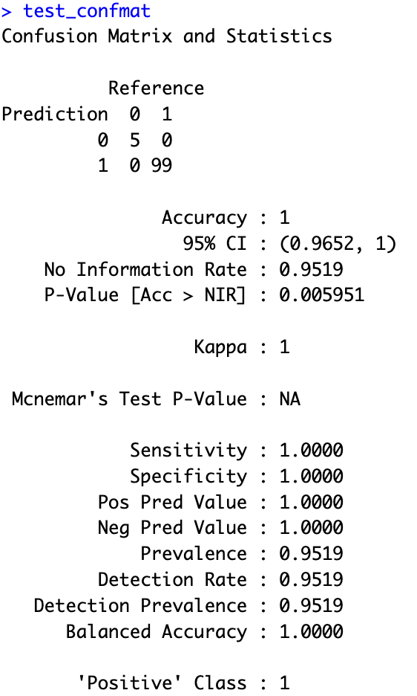
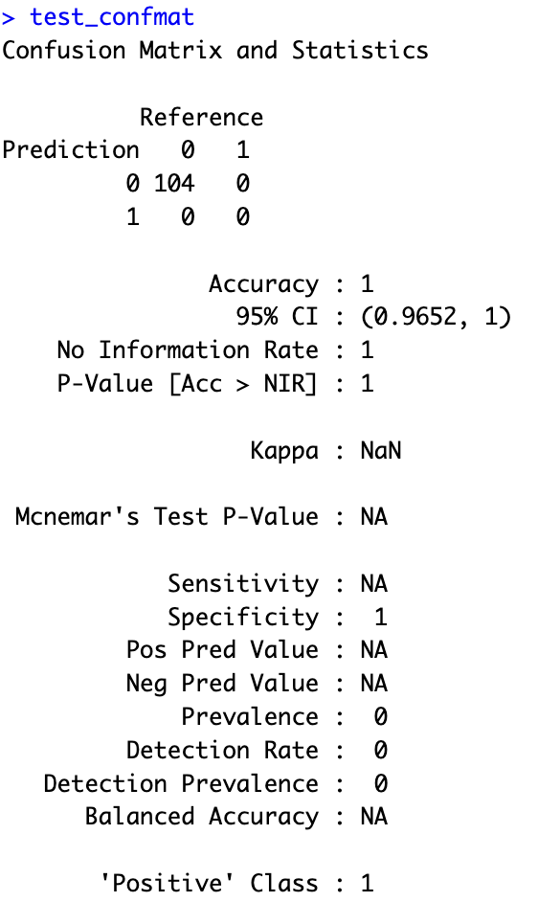
Hemorrhagic Stroke vs. Others Ischemic Stroke vs. Stroke Mimic

