Tackling Non-Canonical Splicing in Arrhythmogenic Cardiomyopathy to Reduce the Uncertain Significance Variants Burden
Rudy Celeghin, PhD*^{1,2}, Giulia Tosato*¹, Serena Pinci^{1,2}, Francesca Dalla Zanna¹, Maria Bueno Marinas, PhD ^{1,2}, Marco Cason, PhD ^{1,2}, Cristina Basso, MD, PhD^{1,2}, Kalliopi Pilichou, PhD^{1,2#}
¹Department of Cardiac-Thoracic-Vascular Sciences and Public Health, University of Padua,
²Cardiovascular Pathology Unit, Azienda Ospedale Università Padova.
Padova, 35128, Italy.
*equally contribution
# corresponding author
Kalliopi Pilichou, PhD
Associate Professor of Genetics
Head of Cardiovascular Genetics Lab
Dept. of Cardiac-Thoracic-Vascular Sciences and Public Health
University of Padua
Via A. Gabelli 61
35121 Padova, Italy
Phone n. +39 049 827 2293
Email: kalliopi.pilichou@unipd.it

Table of contents Supplementary Materials
Supplementary Methods 2
Supplementary Results 4
Supplementary Figures 5
Supplementary Tables 9

Supplementary Methods
Splicing effect prediction
SpliceAI is a deep learning-based splice site predictor employed to evaluate the potential impact of identified splice site variants on the mature mRNA. This computational tool uses a deep neural network trained on large-scale human genome annotations to predict the likelihood of splicing alterations caused by single nucleotide variants and small insertions/deletions, based on genomic sequence context alone, without requiring transcript annotations.⁴
All candidate variants were analyzed using the SpliceAI Lookup web interface (https://spliceailookup.broadinstitute.org), with input coordinates aligned to the GRCh38/hg38 human reference genome. A maximum flanking distance of ±1000 bp was selected, allowing the tool to detect splicing changes occurring up to 1 kb upstream or downstream of the variant.
SpliceAI, for each variant, outputs four distinct scores of probabilities to introduce a splice: Acceptor Gain, Acceptor Loss, Donor Gain, Donor Loss.
This probabilistic model assumes independence between the four predicted outcomes and estimates the overall probability that the variant will lead to any form of splice site disruption.
Variants were classified based on this composite score as follows:
- High likelihood of splicing impact: score > 0·80
- Moderate impact: 0·25 < score ≤ 0·80
- Low likelihood of impact: score ≤ 0·25
This stratification allowed prioritization of variants for functional validation using minigene assays.

Minigene constructs
Peripheral blood samples were stored at -80°C at the Cardiovascular Genetics Laboratory, University of Padua. Genomic DNA was extracted from whole blood using the automated MagCore Super system (Diatech Pharmacogenetics) following the manufacturer’s instructions, yielding high-quality DNA with minimal risk of cross-contamination.
Patient DNA was amplified using specific primers designed to include restriction sites flanking the exons of interest along with 100-200 base pairs of surrounding intronic regions (Tab.S1).
PCR amplification was performed using the PrimeSTAR GXL DNA Polymerase Kit (Takara Bio), optimized for long and Guanine-Cytosine rich templates. The resulting amplicons were purified using the NucleoSpin® Gel and PCR Clean-up Kit (Macherey-Nagel) to remove contaminants such as primers and residual nucleotides.
Both purified PCR products and the pSPL3 plasmid vector (kindly provided by Dr. Peggy Reuter, Fig.S1) were double-digested with two specific restriction enzymes²⁴ and ligated together using the Quick Ligation Kit (New England Biolabs) .
The ligation mix was transformed into NEB® Turbo Competent Escherichia coli cells via heat shock. Transformed cells were cultured overnight at 37°C in Lysogeny Broth containing 100μg/mL ampicillin. Plasmid DNA was extracted using the Qiagen Miniprep kit (QIAGEN).
Construct sequences, of wild-type (WT) and mutant (MUT), were confirmed by Sanger sequencing, and inserts were aligned to the GRCh38 reference genome to verify sequence integrity and exclude the presence of unintended variants.

Cell culture and transfection
Human embryonic kidney 293 (HEK-293T) cells were cultured in Minimum Essential Medium Eagle (DMEM, Stemcell technologies), supplemented with 10% fetal bovine serum (FBS), 1% penicillin (100U/mL)/streptomycin (100mg/ml) and 2 mM L-Glutammin. Cells were maintained at 37°C in a humidified atmosphere with 5% CO₂. Upon reaching approximately 80% confluency, HEK-293T cells were transfected with plasmid constructs using the Nucleofector™ Kit (Lonza, Switzerland), according to the manufacturer's instructions.

RNA isolation and reverse transcription
Seventy-two hours post-transfection, HEK-293T cells were washed with Phosphate Buffered Saline (PBS) 1X, detached using Trypsin (Euroclone), for 5 minutes, and harvested with DMEM media. Cells were pelleted by centrifugation at 300 x g for 5 minutes, the supernatant was removed, and the pellet was immediately kept on ice. Total RNA was extracted using the RNeasy® Mini Kit (Qiagen) following the manufacturer’s protocol.
Reverse transcription (RT-PCR) was carried out with PrimeScript™ RT Master Mix (Takara) using random primer. The resulting cDNA was amplified with Taq DNA polymerase optimized for GC-rich templates emplying a touchdown protocol: initial denaturation at 98°C for 30 seconds; 10 cycles of 98°C for 10 seconds, annealing starting at 65°C for 30 seconds and decreasing 1°C per cycle, extension at 72°C for 60 seconds; followed by 30 cycles of 98°C for 10 seconds, 55°C for 15 seconds, and 72°C for 60 seconds.

Gel electrophoresis and extraction of RT-PCR products
RT-PCR products quality were initially assessed using the Agilent 4200 TapeStation system (Agilent Technologies). When necessary, specific bands were excised following separation on 2% agarose gels prepared in TAE buffer. DNA fragments were purified using the NucleoSpin® Gel and PCR Clean-up (Macherey-Nagel) according to the manufacturer’s protocol. Purified amplicons were subsequently subjected to Sanger sequencing to analyze the impact of variants at the splice sites.

RNA isolation from human tissue
Frozen myocardial tissue from one proband was minced on ice using a sterile scalpel, then immersed in Qiazol reagent (1.0 ml per ~10 mg of tissue; Qiagen) and homogenized with 5-mm steel beads in a TissueLyser instrument (Qiagen) for two cycles of 2 minutes at 25 mHz. Homogenate was incubated with 20μl of Proteinase K (20 mg/mL; Roche Diagnostics GmbH) for 10 minutes at 56°C. Subsequently, 200μl of chloroform was added, and centrifuged at 12,000 x rcf for 15 minutes at 4°C. Total nucleic acids were purified using the spin columns of the RNeasy mini kit (Qiagen) 20-minute on-column DNase I digestion (Qiagen). RNA concentration was quantified using Qubit fluorometer (Life Technologies), and RNA integrity was assessed with Agilent 4200 Tape Station.

Variant re-classification
To support the interpretation of sequencing results, variant pathogenicity was initially assessed according to the guidelines issued by the American College of Medical Genetics and Genomics and Association for Molecular Pathology (ACMG/AMP). A comprehensive evaluation of each variant’s pathogenic potential was performed using three main bioinformatics platforms: Franklin (https://franklin.genoox.com), VarSome (https://varsome.com), and Alamut (Sophia Genetics, Switzerland), which integrate a wide range of public and proprietary databases, as well as multiple in silico predictors.
Following the minigene assay, variants were reclassified according to the ACMG/AMP recommendations as refined by the ClinGen Sequence Variant Interpretation (SVI) Splicing Subgroup. These guidelines support the use of the PVS1_Strength framework for variant demonstrating experimental evidence of splicing induced loss of function (LoF) and the application of BP7_Strong for intronic and synonymous variants with experimentally confirmed absence of splicing impact.
The strength level of the PVS1 code was assigned based on the predicted consequences of the splicing alteration in the protein product as follow:
- PVS1_ Very Strong: applied when the variant leads to an out-of-frame or in-frame deletion that removes a critical functional domain, resulting in the loss of more than 10% of the protein.
- PVS1_ Strong: applied when the variant causes a deletion of more than 10% of the protein, but the affected domain has an unclear or unknown functional role.
- PVS1_Moderate: applied when the alteration results in an in-frame or out-of-frame deletion of less than 10% of the protein in a region not established as essential for function, and the transcript is not predicted to undergo NMD.
In accordance with ClinGen SVI recommendations,²⁵ the PS3/BS3 criteria, typically used for well-established in vitro or in vivo functional assay, were not applied to splicing assay. Instead, splicing assay results were interpreted through the PVS1 and BP7 framework.
To evaluate the potential impact of each identified variant, the PP3 and BP4 criteria were not applied in both the initial and the final ACMG classification. These criteria rely on in silico predictions of splicing alterations generated by computational algorithms, which were intentionally excluded from our analysis to avoid introducing bias from predictive models. Instead, variant interpretation was based exclusively on experimental data obtained from the minigene assays. This approach allowed a direct and reliable assessment of splicing effects, ensuring that the final classification reflected empirically validated functional outcomes rather than theoretical predictions.
Finally, the PP1 criterion was applied at increasing straight when segregation data supported co-segregation of the variant with the arrhythmogenic cardiomyopathy (ACM) phenotype in multiple affected family members.⁵ The strengh of the PP1 criteria was determined based on the probability of segregation calcolated as P = (½)^{m}, where ½ represent the probability of transmitting the variant per meiosis, and m is the number of affected relatives carring the variant.²⁶ The criterion was applied as follow:
- Strong evidence: if P ≤ 1/32
- Moderate evidence: if P ≤ 1/16
- Supporting evidence: if P ≤ 1/8.

Supplementary Results
Effect of variants on mRNA maturation
Exon skipping
Complete exon skipping was observed in 4 out of the 20 variants (Fig.2A):
- DSG2 c.523+2dup: this variant, located at the canonical donor splice site of intron 4 of the DSG2 gene, involves a duplication of a Thymine in position 523+2 and was detected in one proband. The resulting transcript showed complete skipping of the adjacent exon, causing an out-of-frame deletion that introduces a premature termination codon (PTC) after 4 amino acids. The affected region includes the extracellular cadherin-like domain, which is critical for the adhesive function of the desmoglein-2.
- DSP c.597G>A: this synonymous variant, located at the last nucleotide of exon 4 in the DSP gene, results in a Guanine-to-Adenine substitution and was identified in 3 proband. The variant led to the production of two transcript isoforms: one containing exon 4 in the pSPL3 vector (WT) and one lacking exon 4, resulting in an in-frame deletion of 57 amino acids. This deletion removes part of the spectrin repeat domain, which is essential for interaction of desmoplakin with other desmosomal protein.
- FLNC c.3790G>A: this synonymous variant, located at the last base of exon 21 in the FLNC gene, leads to a Guanine-to-Adenine substitution and was observed in 2 proband. Two transcript isoforms were identified: one including exon 21 in pSPL3 vector (WT) and one lacking exon 21 (full skipping), resulting in a frameshift and the introduction of a PTC after 7 amino acids. The skipped exon encodes part of the immunoglobulin-like (Ig-like) domain, crucial for the structural integrity and protein-protein interactions of filamin-C.
- FLNC c.5398+1G>T: this variant affects the canonical splice donor site of intron 32 in the FLNC gene, causing a Guanine-to-Thymine substitution in position 5398+1 was detected in one proband. The splicing defect led to complete skipping of exon 32, resulting in an out-of-frame transcript and a PTC after 25 amino acids. This exon also encodes part of an Ig-like domain with essential structural and interaction roles.
Intron retention
Partial intron retention was observed in 3 out of the 20 variants tested (Fig.2B):
- DSP c.273+5G>A: this variant, located in a non-canonical position within intron 2 of the DSP gene, results in a Guanine-to-Adenine substitution and was observed in 2 proband. The variant produced two transcript isoforms: one WT and one containing an additional 61bp immediately following exon 2, causing a frameshift and the introduction of a PTC after 38 amino acids. Given that the PTC occurs in the N-terminal domain, near the star of the protein, this variant likely compromises full-length protein synthesis, leading to a probable LoF mechanism.
- DSP c.939+1G>A: this variant affects the canonical splice donor site at position 939+1 of intron 7 in the DSP gene, causing a Guanine-to-Adenine substitution, and was detected in 4 proband. The aberrant transcript exhibited partial retention of intron 7 (region not fully sequenced), resulting in a frameshift and the introduction of a PTC after 24 amino acids. Since the PTC lies within the plakin N-terminal domain, which is critical for interactions with other desmosomal proteins such as plakoglobin and plakophilin, this variant likely disrupts full protein synthesis, triggering NMD and a consequent LoF effect.
- PKP2 c.2013+3_2013+6dup: this variant, located at a non-canonical position in intron 9 of the PKP2 gene, consists of a duplication of the nucleotides Guanine-Thymine-Guanine-Adenine in position 2013+3 to +6, was observed in one proband. The resulting transcript displayed retention of four nucleotides immediately following exon 9, causing a frameshift and introduction of a PTC after 28 amino acids. This alteration is predicted to affect the armadillo repeat domain, which is crucial for desmosome assembly and function.
Multiple transcripts
The minigene assay reveal the formation of multiple transcript in only 2 out of the 20 variants tested (Fig.2C):
- DSG2 c.1652+1G>T: this variant affects the canonical splice donor site of intron 12 in the DSG2 gene, causing a Guanine-to-Thymine substitution in position 1652+1. It was identified in 5 proband. The variant generated two distinct aberrant transcript: one exhibiting complete exon skipping of exon 11, resulting in an in-frame deletion of 75 amino acids; and a second transcript characterized by deletion of the first 7 nucleotides and activation of a cryptic splice acceptor site within the exon. The latter leads to a frameshift and a PTC after 19 amino acids. Notably, the skipped/cryptic exon encodes part of the cadherin-like extracellular domain, which is critical for the adhesive function of the desmoglein-2.
- DSP c.423-1G>A: this variant affects the canonical splice acceptor site of intron 3 in the DSP gene, causing a Guanine-to-Adenine substitution in position 423-1, was detected in 2 proband. Four transcript isoforms were identified; sequencing of the predominant transcript revealed skipping of exon 4, causing an in-frame deletion of 57 amino acids. This deletion removes a portion of the spectrin repeat domain, essential for the interaction of desmoplakin with other desmosomal proteins. TapeStation analysis suggested the presence of additional transcripts, likely including the wild-type isoform, partial retention of intron 4, and an intra-exon 4 deletion. This variant has been reported in the literature only once, and no functional studies evaluating its effects have been conducted to date.
Ethical Approval
All patients provided written informed consent, in accordance with the protocol approved by the ethics committee, including for publication of pedigree charts. All investigations were carried out according to the Declaration of Helsinki.
Competing Interests
All other authors declare no competing interest.

Supplementary Figures
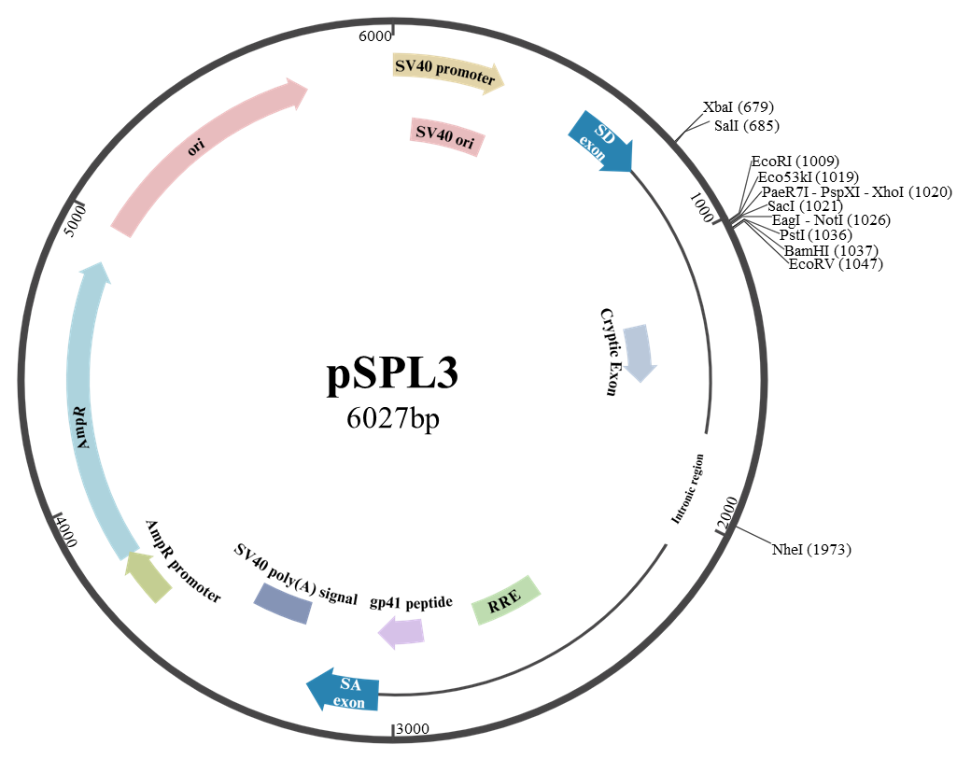
Fig.S1 | Schematic representation showing the main structural features of the pSPL3 plasmid.

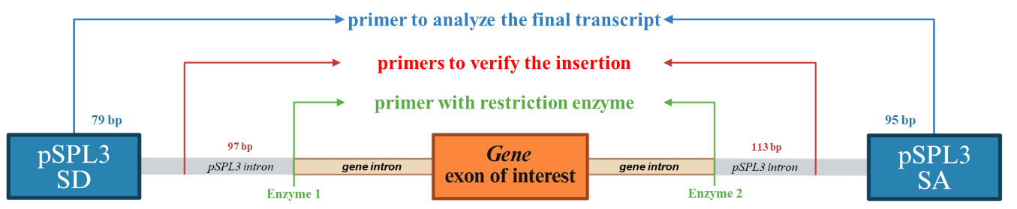
Fig.S2 | Schematic representation of the primers used in the minigene assay.

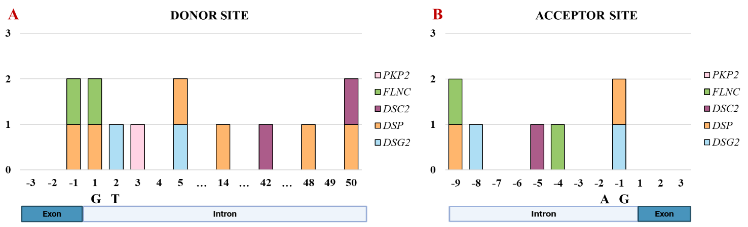
Fig. S3 | Localization of splicing site variants in DSC2, DSG2, DSP, FLNC and PKP2.

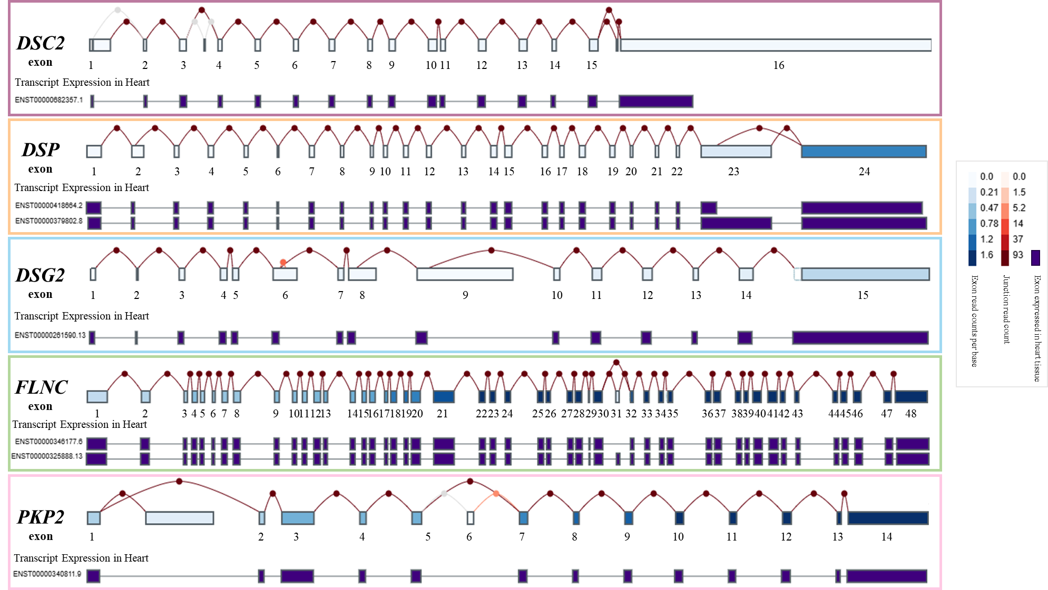
Fig. S4 | Gene-specific exons expression in heart tissue from Genotype-Tissue Expression (GTEx).
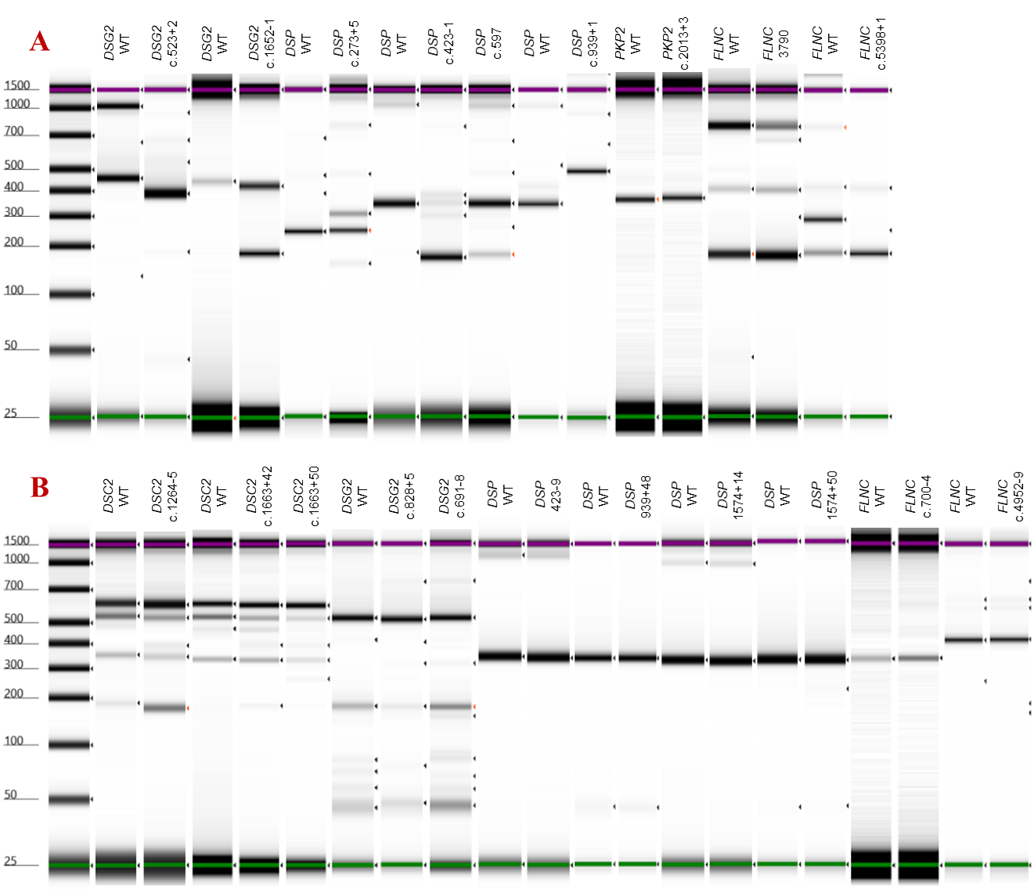
Fig. S5 | Functional assessment of splicing alterations induced by candidate variants using minigene assays.
Capillary electrophoresis (Agilent TapeStation) analysis of RT-PCR products generated from HEK-293T cells transfected with WT or MUT minigene constructs.
A. Variants shown to disrupt normal splicing, as evidenced by the presence of aberrant RT-PCR banding patterns distinct from the WT control. Detected splicing defects include exon skipping, intron retention, and activation of cryptic splice sites, indicating a direct impact of these variants on pre-mRNA splicing fidelity.
B. Variants that did not alter splicing, as demonstrated by RT-PCR profiles indistinguishable from those of the WT construct, suggesting no functional consequence on splicing under the experimental conditions.

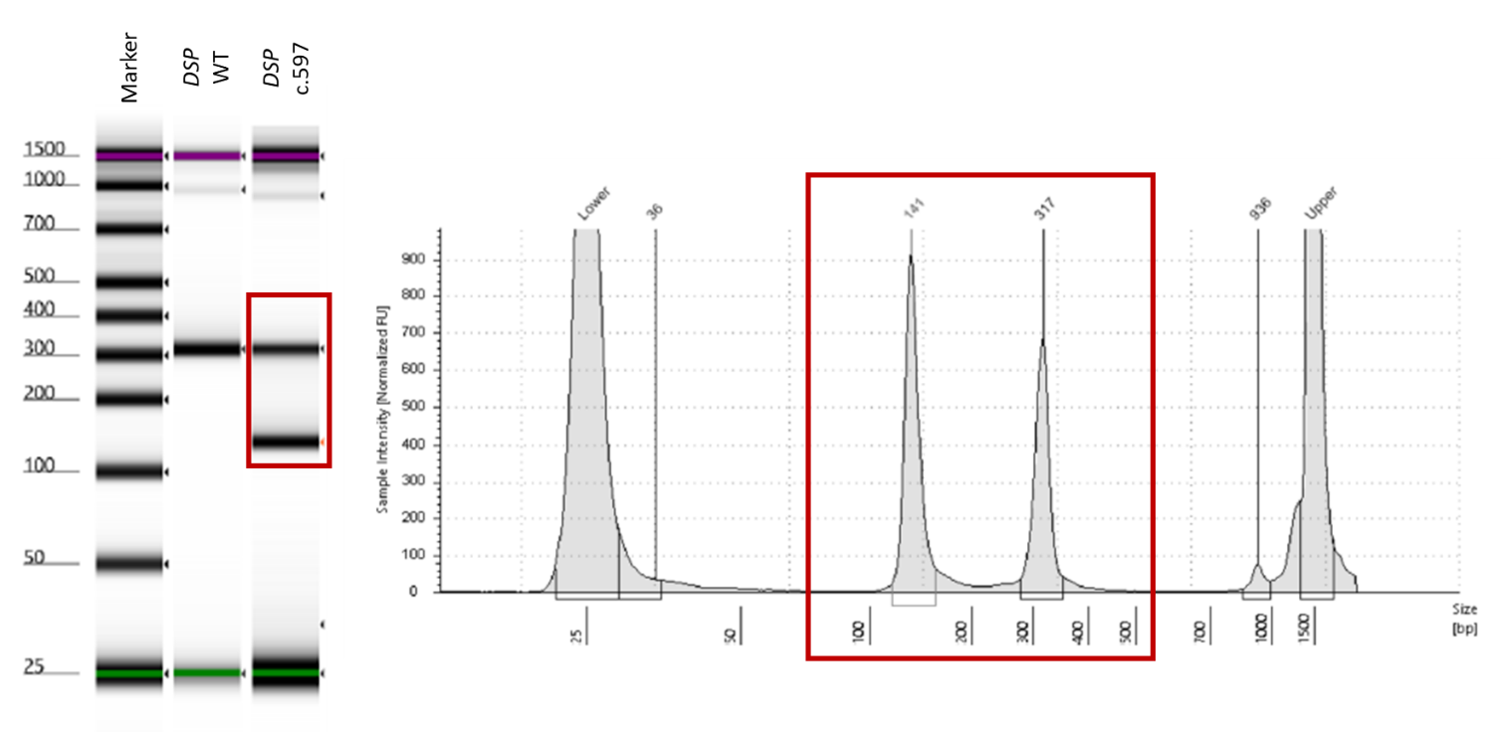Fig. S6 | Functional assessment of splicing alterations in proband’s heart tissue carrying DSP c.597G>A.

Supplementary Tables
Gene | Primer’s name | Sequence |  | Enzime
DSC2 | c.1264-5C>T | For | cttctCTCGAGcgacacagagccaaaccata | XhoI
DSC2 | c.1264-5C>T | Rev | cttctGGATCCtcaagagatatgaaaacagagtgca | BamHI
DSC2 | c.1663+42A>G, c.1663+50C>T | For | cttctCTCGAGcgacacagagccaaaccata | XhoI
DSC2 | c.1663+42A>G, c.1663+50C>T | Rev | cttctGGATCCtacatctaaaactgagaaggctatta | BamHI
DSG2 | c.523+2dup | For | cttctCTCGAGtcaactccactgccattccc | XhoI
DSG2 | c.523+2dup | Rev | cttctGGATCCtgttctgagggtaaaagcaatgg | BamHI
DSG2 | c.691-8C>T, c.828+5C>T | For | cttctCTCGAGactcccgaggcttttctgtt | XhoI
DSG2 | c.691-8C>T, c.828+5C>T | Rev | cttctGGATCCtgtgaccacttcctaaccacag | BamHI
DSG2 | c.1652-1G>T | For | cttctCTCGAGtgcatattcagggcctatagaca | XhoI
DSG2 | c.1652-1G>T | Rev | cttctGGATCCaccctcaaagtgctctagtgt | BamHI
DSP | c.273+5G>A | For | cttctCTCGAGaaagggtctcacaggagtgg | XhoI
DSP | c.273+5G>A | Rev | cttctGGATCCtctgaaaaagcgtgtctctaaa | BamHI
DSP | c.423-1G>A, c.423-9dup, c.597G>A | For | cttctGCGGCCGCacttaagtcctggggtaaagaaa | NotI
DSP | c.423-1G>A, c.423-9dup, c.597G>A | Rev | cttctGGATCCccaagccacactgaaatctca | BamHI
DSP | c.939+1G>A, c.939+48C>G | For | cttctCTCGAGgctgccttcttgttcattgc | XhoI
DSP | c.939+1G>A, c.939+48C>G | Rev | cttctGGATCCccacacggagaagttttcagg | BamHI
DSP | c.1574+14G>T, c.1574+50G>A | For | cttctCTCGAGgcatcggtattgttgggttgt | XhoI
DSP | c.1574+14G>T, c.1574+50G>A | Rev | cttctGGATCCgcaagacaaagtgaaggtgacc | BamHI
FLNC | c.700-4G>A | For | cttctCTCGAGggggcagaggttgggtct | XhoI
FLNC | c.700-4G>A | Rev | cttctGGATCCctacggggcaggagcaga | BamHI
FLNC | c.3790G>A | For | cttctCTCGAGgcactcagtccacagtagca | XhoI
FLNC | c.3790G>A | Rev | cttctGGATCCagagccctcccttcaccc | BamHI
FLNC | c.4952-9G>T | For | cttctCTCGAGcctcaaagcccctccagaa | XhoI
FLNC | c.4952-9G>T | Rev | cttctGCGGCCGCcaggagccctcagagaagtg | NotI
FLNC | c.5398+1G>T | For | cttctCTCGAGagagttaggctgggcagatg | XhoI
FLNC | c.5398+1G>T | Rev | cttctGGATCCgcatcaagagacagcctgtg | BamHI
PKP2 | c.2013+3_2013+6dup | For | cttctCTCGAGggggtgtggagtgttattagga | XhoI
PKP2 | c.2013+3_2013+6dup | Rev | cttctGGATCCtgagaccgaagccctctg | BamHI
pSPL3 | Insertion | For | ATGCTCCTTGGGATGTTGAT | -
pSPL3 | Insertion | Rev | GGTACATAATGTTTGGGCCAC | -
pSPL3 | Final transcript | For | TGGACAACCTCAAAGGCACC | -
pSPL3 | Final transcript | Rev | GATCCATTCGACCAATTCACT | -
Tab.S1 | Primer used for the minigene assay.

Gene | Variants | ACM Alleles | gnomAD controls v.2.1 | Chi-square | p-Value | OR (95% CI)
DSC2 | VUS Splicing | 2 | 68 | 11,35 | p = 0.0008 | 7.744 (1.891–31.70)
DSC2 | Other | 398 | 104788 | 11,35 | p = 0.0008 | 7.744 (1.891–31.70)
DSG2 | VUS Splicing | 3 | 60 | 30,853 | p < 0.0001 | 12.80 (3.998–40.99)
DSG2 | Other | 397 | 101644 | 30,853 | p < 0.0001 | 12.80 (3.998–40.99)
DSP | VUS Splicing | 6 | 121 | 65,65 | p < 0.0001 | 13.59 (5.950–31.02)
DSP | Other | 394 | 107947 | 65,65 | p < 0.0001 | 13.59 (5.950–31.02)
FLNC | VUS Splicing | 3 | 236 | 4.855 | p = 0.0276 | 3.35 (1.07–10.52)
FLNC | Other | 397 | 104712 | 4.855 | p = 0.0276 | 3.35 (1.07–10.52)
PKP2 | VUS Splicing | 1 | 140 | 0.405 | p = 0.5244 | 1.88 (0.26–13.44)
PKP2 | Other | 399 | 104794 | 0.405 | p = 0.5244 | 1.88 (0.26–13.44)
Tab.S2 | Burden test of Splice-Altering VUS Among ACM Cases vs Controls.
VUS: variant of uncertain significance, Other: WT allele, OR: Odd ratio, CI: Confidence interval, Fischer’s exact test and OR calculation were performed for contingency analysis.

