Disentangling the Synergistic Mechanisms of Urban Waterlogging Risks in High-Density Coastal Cities: A Quantitative Contribution Analysis
Yan Long^{a,b} , Shumin Jiang^{a,b}, Tongxin Yang^{c*}, Yikai Hou^{a,b}, Yifan Chen^{d}, Xiaohui Lei^{a,b},
Chenfei Duan^{a,b}
ª School of Water Resources and Electric Power, Hebei University of Engineering, Handan, Hebei Province, 056038, China
^{b} Hebei Key Laboratory of Smart Water Conservancy, Hebei University of Engineering, Handan, Hebei Province, 056038, China
^{c} School of Environment, Beijing Normal University, Beijing, 100875, China
^{d} College of Water Conservancy and Environmental Engineering, Zhejiang University of Water Resources and Electric Power, Hangzhou 310018, China
*Corresponding author: Tongxin Yang
E-mail address: 2793714715@qq.com
Mailing Address: 19 Taiji Road, Handan Economic and Technological Development Zone, Handan City, Hebei Province, 056038, China

Appendix A: Figures and Table
A comparison of the observed and simulated water levels at two shaft water level monitoring stations (Q043 and Q216) is presented in Figs.S1 to S4.
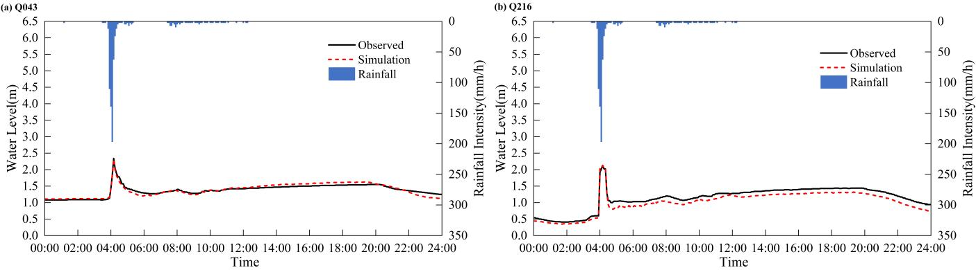
Fig. S1. Comparison results of shaft water level verification for rainfall event 1: (a) Q043 and (b) Q216.
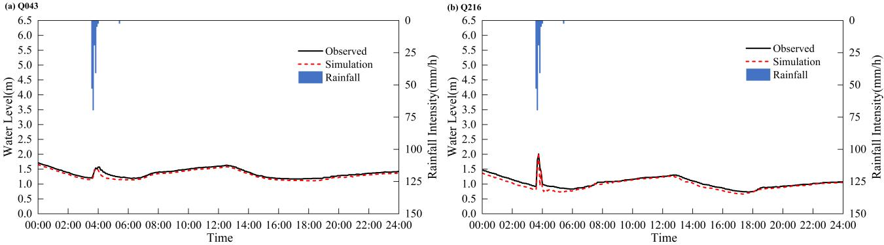
Fig. S2. Comparison results of shaft water level verification for rainfall event 2: (a) Q043 and (b) Q216.
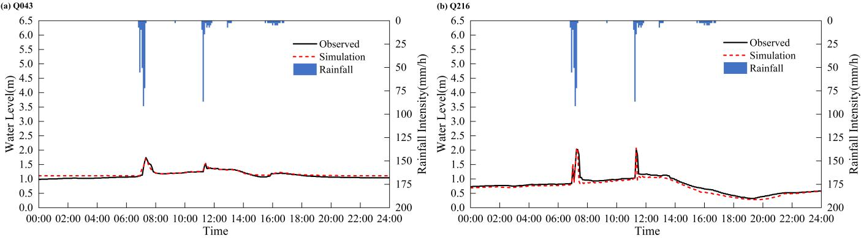
Fig. S3. Comparison results of shaft water level verification for rainfall event 3: (a) Q043 and (b) Q216.
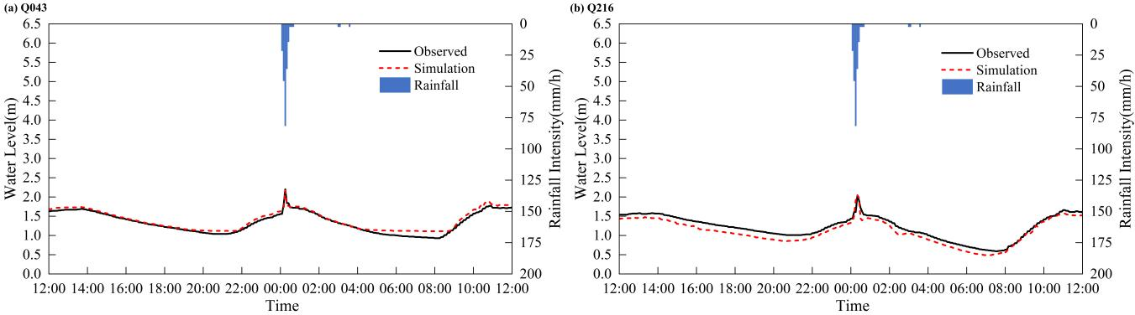
Fig. S4. Comparison results of shaft water level verification for rainfall event 4: (a) Q043 and (b) Q216.
A comparison between the observed and simulated water levels at two shaft water level monitoring stations (Q043 and Q216) before and after calibration, employing three evaluation metrics: relative peak error, peak timing error, and Nash-Sutcliffe efficiency (NSE), as presented in Table S1.
Table S1 Calibration results for shaft water levels.
Rainfall event | Inspection well number | Pre-calibration |  |  |  | Post-calibration
Rainfall event | Inspection well number | Peak timing Error /min | relative peak error /% | NSE |  | Peak timing Error /min | relative peak error /% | NSE
1 | Q043 | 10 | 9.709 | 0.404 |  | 0 | 4.505 | 0.787
1 | Q216 | 40 | 8.079 | 0.669 |  | 40 | 0.932 | 0.755
2 | Q043 | 15 | 12.663 | 0.356 |  | 5 | 5.033 | 0.781
2 | Q216 | 5 | 13.967 | -0.238 |  | 0 | 1.093 | 0.801
3 | Q043 | 5 | 15.398 | 0.460 |  | 0 | 1.497 | 0.767
3 | Q216 | 5 | 10.059 | 0.693 |  | 0 | 0.530 | 0.792
4 | Q043 | 5 | 23.496 | 0.640 |  | 5 | 4.895 | 0.863
4 | Q216 | 5 | 12.467 | 0.354 |  | 0 | 2.557 | 0.754
Based on monitoring data from electronic water gauges provided by local authorities, the observed waterlogging depths were compared against simulated waterlogging depths, as illustrated in Figs. S5 and S6.
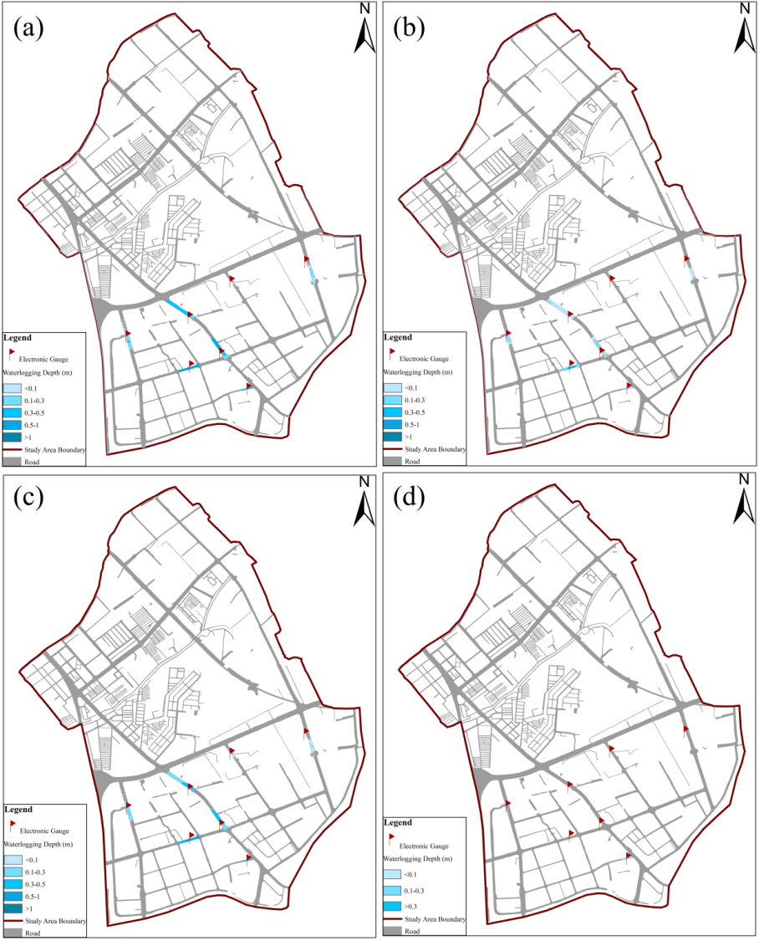
Fig. S5. Simulation results of waterlogging depths under different rainfall events: (a) Event 1, (b) Event 2, (c) Event 3 and (d) Event 4.
Fig. S6. Comparison results of waterlogging depths under different rainfall events: (a) Event 1, (b) Event 2, (c) Event 3 and (d) Event 4.

