Supporting Information

Research and Development of a Multi-Target HER2 Inhibitor (CPD 1) and Its Mechanism and Application in Combating HER2-Positive Breast Cancer

Jianchao Pan and Wenqing Zhang* and Xiang Yang

College of Chemistry and Molecular Engineering, East China University of Science and Technology, Shanghai 200237, China

- The chemical reaction flowchart for CPD 1 API is shown in the figure.
CPD 1 API undergoes three chemical reactions followed by micronization to obtain the final API. Appropriate testing is performed at all critical process control points during preparation.
Step 1: CPD B-1 reacts with N-hydroxyphthalimide, triphenylphosphine, and diisopropyl azodicarboxylate in a tetrahydrofuran/toluene solution to yield CPD B-1-1. This intermediate is then deprotected with methylhydrazine solution to obtain CPD B. CPD B undergoes deprotection and salt formation with p-toluenesulfonic acid monohydrate in a tetrahydrofuran/toluene solution. The mixture is then subjected to azeotropic distillation to remove water, followed by cooling and crystallization to yield CPD B·2TsOH.
Step 2: CPD A-6 was reacted with N-methylmorpholine, cuprous chloride, tri(dibenzylideneacetone)dipalladium(0), N, N-dimethylglycine, 4,5-diphenylphosphine-9,9-dimethyloxanthrene, N-methylmorpholine hydroiodic acid DMSO complex, carbon monoxide, and propyne. Acetonitrile and mesylate were then added to yield CPD A·MsOH. CPD A·MsOH was neutralized with N-methylmorpholine, dissolved in N-methyl-2-pyrrolidone, treated with trisulfocyanide and activated carbon for palladium removal, then crystallized with water addition and pulverized with methanol to obtain CPD A.
Step 3: CPD A reacts with CPD B·2TsOH and p-toluenesulfonic acid monohydrate in a tetrahydrofuran/N-methylpyrrolidone/water mixture. The product undergoes alkalization and extraction, followed by activated carbon treatment. After concentration with water, it is purified by salt formation with hydrochloric acid in an ethyl acetate/isopropanol solution to yield crude CPD 1. The crude CPD 1 was further subjected to alkalization, extraction, and activated carbon treatment. After concentration with water, it was purified by salt formation with concentrated hydrochloric acid in an ethyl acetate/isopropanol solution to yield the pure CPD 1.
Step 4: The pure CPD 1 was micronized to obtain CPD 1, the target compound API.

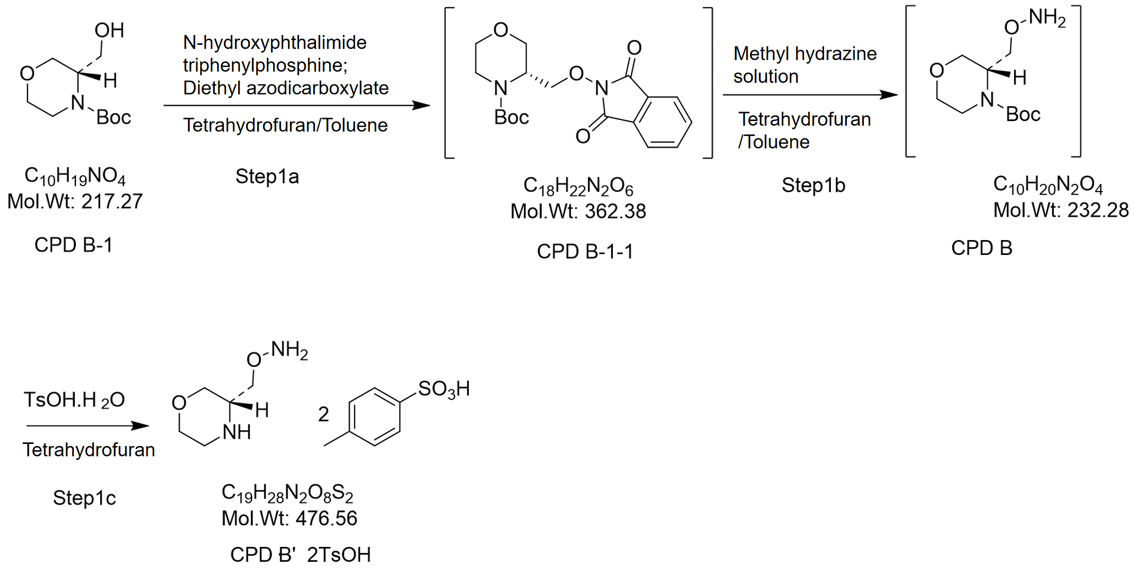
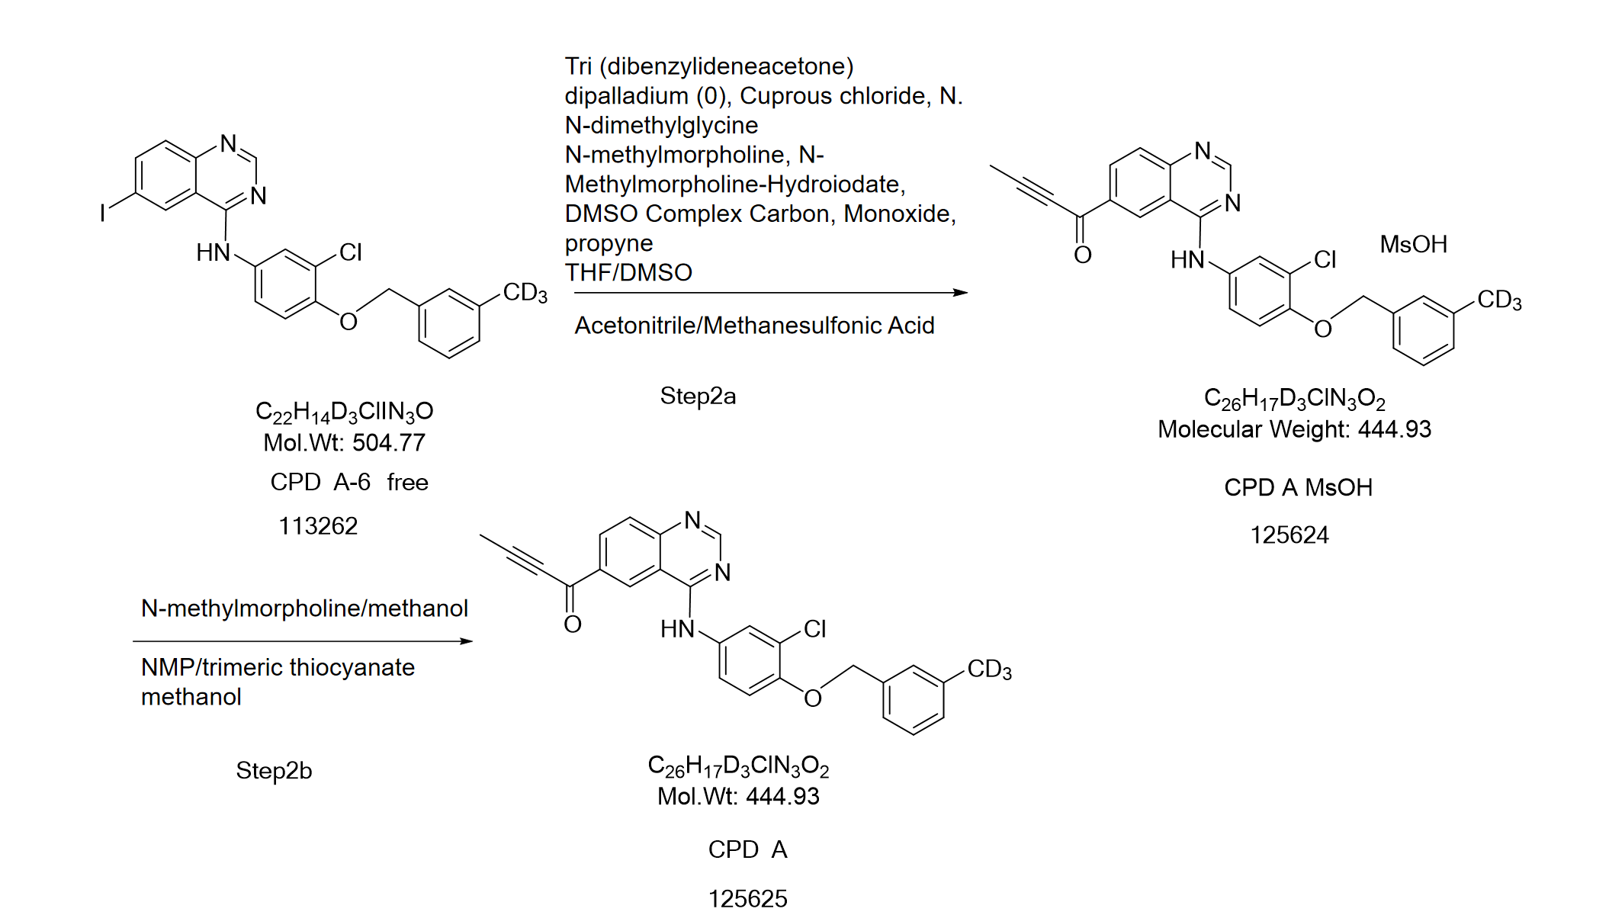
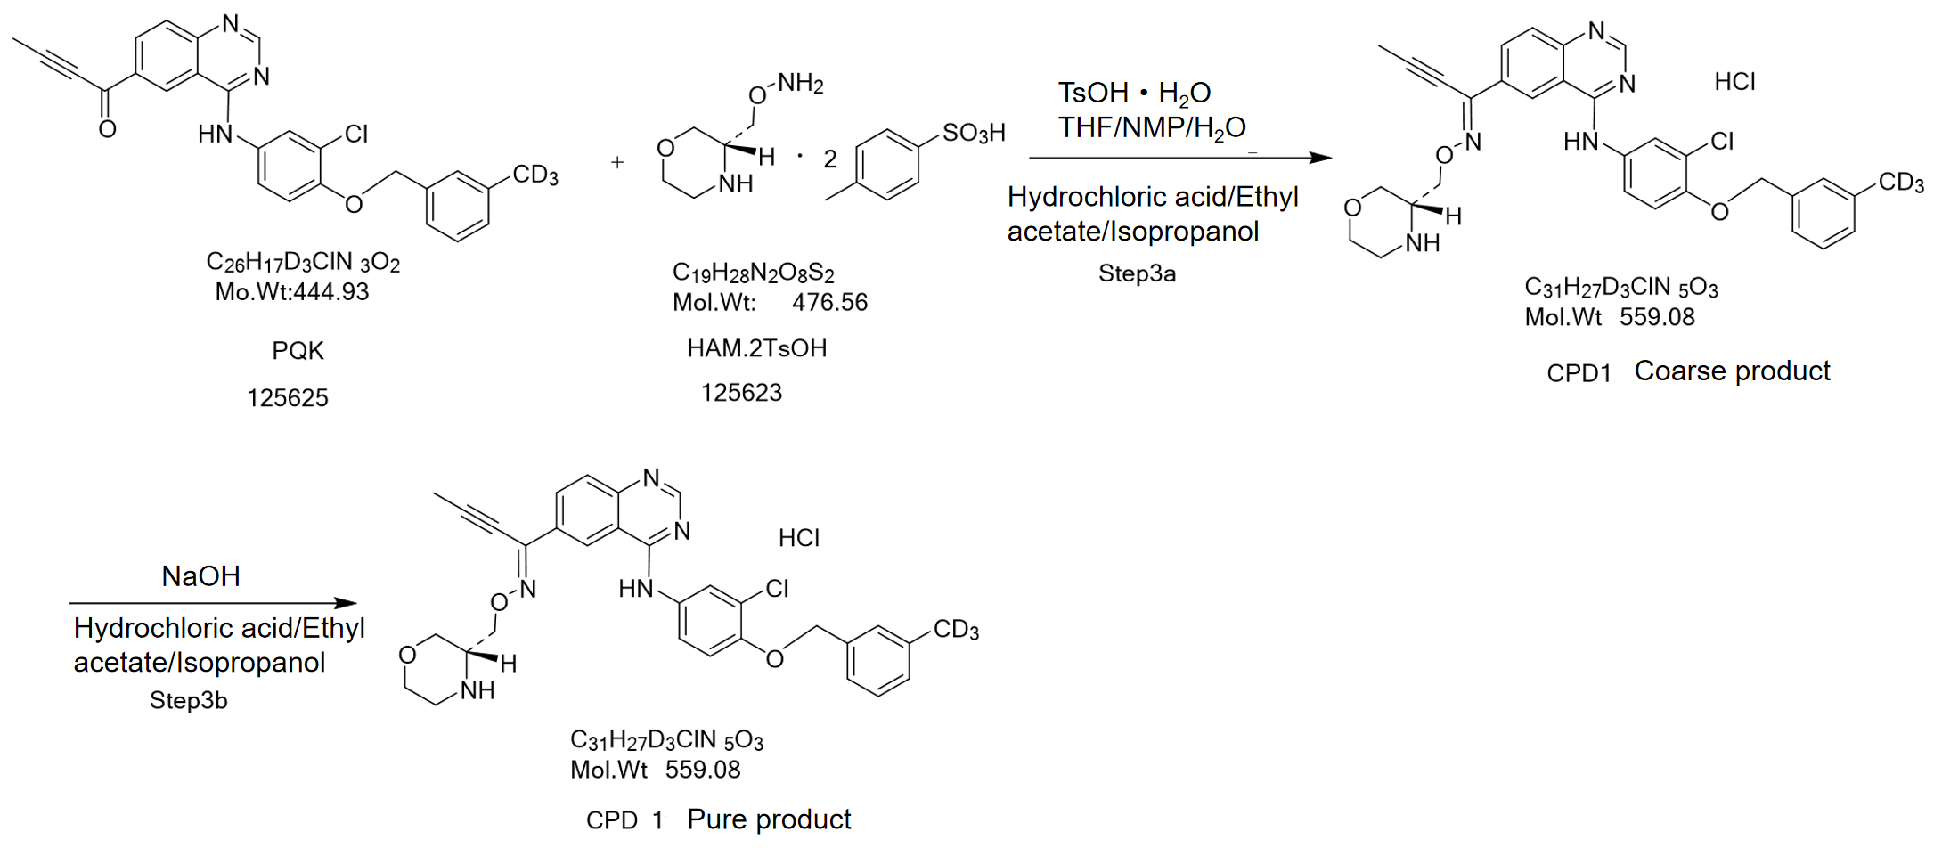
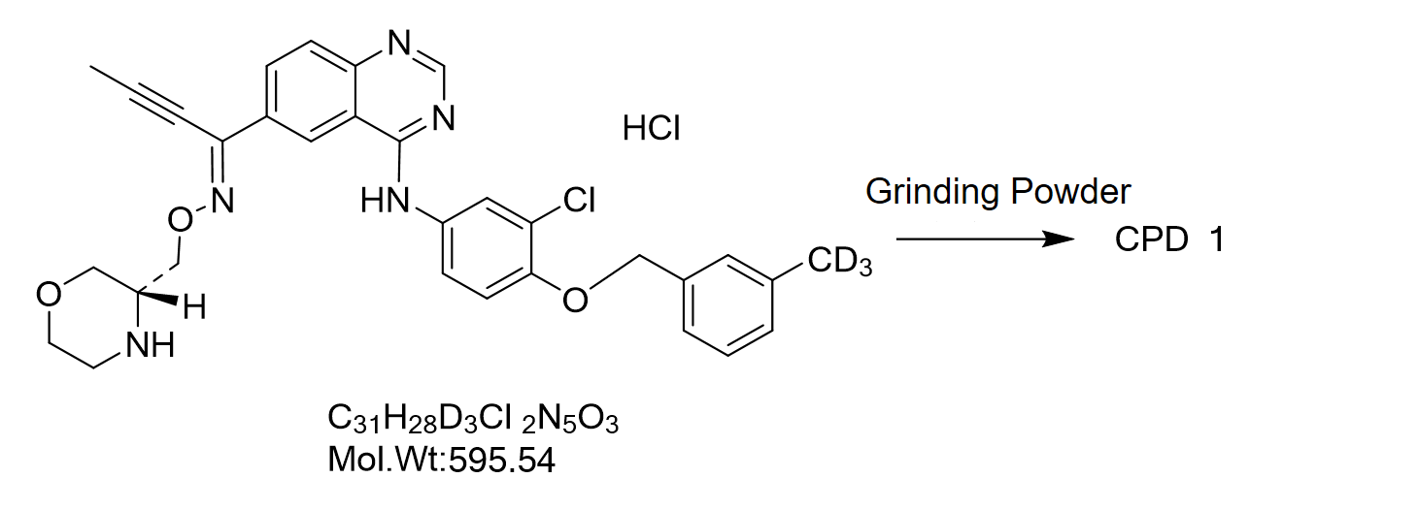
Scheme 1. The entire process of CPD1 synthesis

