Supplemental Information
Magnetic Force Imaging of 2D Topological Insulators
Carlson et al.

- Synthesis and characterization of crystalline Bi₂Te₃ nanoplates

In this work, we focus on solvothermally synthesized Bi₂Te₃ platelets as described extensively in our previous publications [1,2]. Briefly, bismuth nitrate pentahydrate (BiH₁₀N₃O₁₄) and sodium tellurite (Na₂TeO₃) precursors with sodium hydroxide (NaOH) as a reducer are added to a flask under reflux and vigorously stirred in an ethylene glycol solution for one hour. Then, polyvinylpyrrolidone (PVP) is added, and the entire solution is stirred overnight in an argon atmosphere at 180 °C. Once the reaction is complete, the product is centrifuged multiple times to eliminate unreacted components and crystals of very large or very small sizes. The final solution thus contains Bi₂Te₃ crystals with similar lateral dimensions.

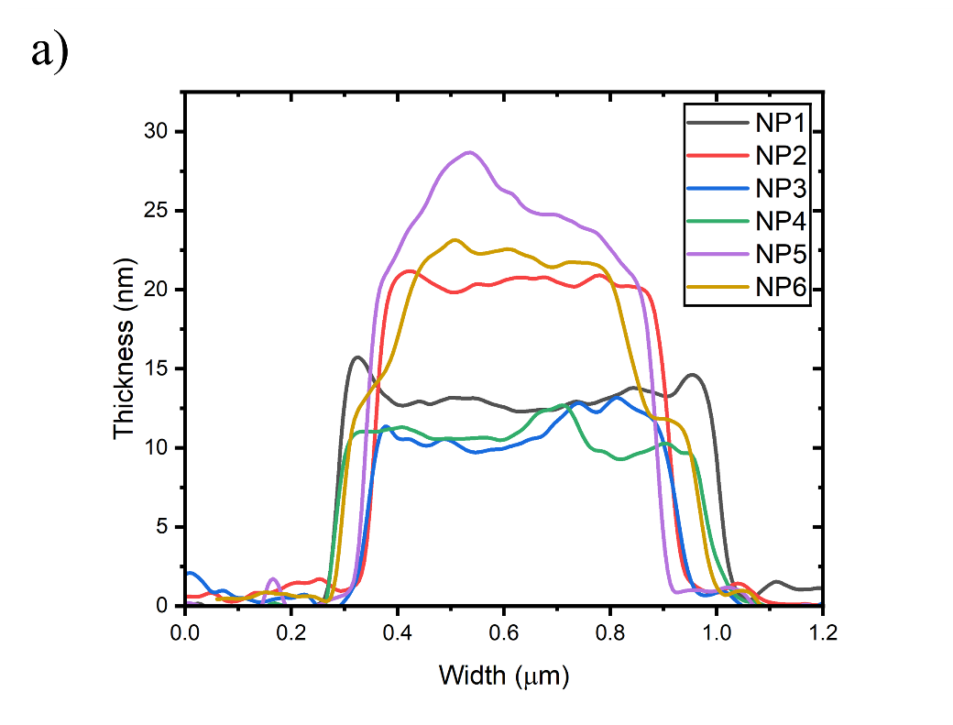
Figure S1: (a) Line scans of topographical images of Bi₂Te₃ nanoplates (NP).

To ensure the structure and crystallinity of the Bi₂Te_{3,} the resulting nanomaterial structure was characterized thoroughly. A Thermo Fisher Titan 80-300 STEM using a 200 keV beam irradiation was used. Firstly, the average nanoplate diameter was 0.68 ± 0.08 µm as obtained from 6 nanoplates (Figure S1 (a)). At high resolution, high-angle annular dark-field (HAADF) images show defect-free crystalline nanoplates (Figure S2 (a-c)) with a crystal plane spacing of 0.35 nm, which corresponds to the (110) plane. The selective area diffraction (SAED) further confirms the prototypical Bi₂Te₃ set of crystal planes, with the brightest ring diameter in the diffraction pattern measuring 3.34$\frac{1}{nm}$ , indicating an interplanar distance of 0.59 nm (Figure S2 (d) ) [1]. Next, energy dispersive analytical X-ray analysis (EDAX) was conducted, and we see that the overall stoichiometry of Bi₂Te₃ was consistent with the atomic ratios measured (Figure S2 (g)).
X-ray photoelectron spectroscopy (XPS) [PHI 570 with RBD upgrades, Al K-alpha line Ex = 0.25 eV base pressure 10⁻¹¹ Torr] was carried out to examine bonding characteristics and determine the phase of the Bi₂Te₃. This is shown in Figure S2 (h) with two tellurium peaks (3d5/2, 3d3/2) at 578 eV and 589 eV and the bismuth peaks (4f7/2, 4f5/2, 4d5/2, 4d3/2) at 165 eV, 171 eV, 448 eV, and 472 eV consecutively, as expected for Bi₂Te₃. Finally, micro-Raman measurements [Horiba Lab Spec using a 532 nm line at 210 μW] show no significant excess of Te, Bi or other features associated with defects (Figure 2 (i)). Therefore, we obtained exceptionally clean and crystalline Bi₂Te₃.
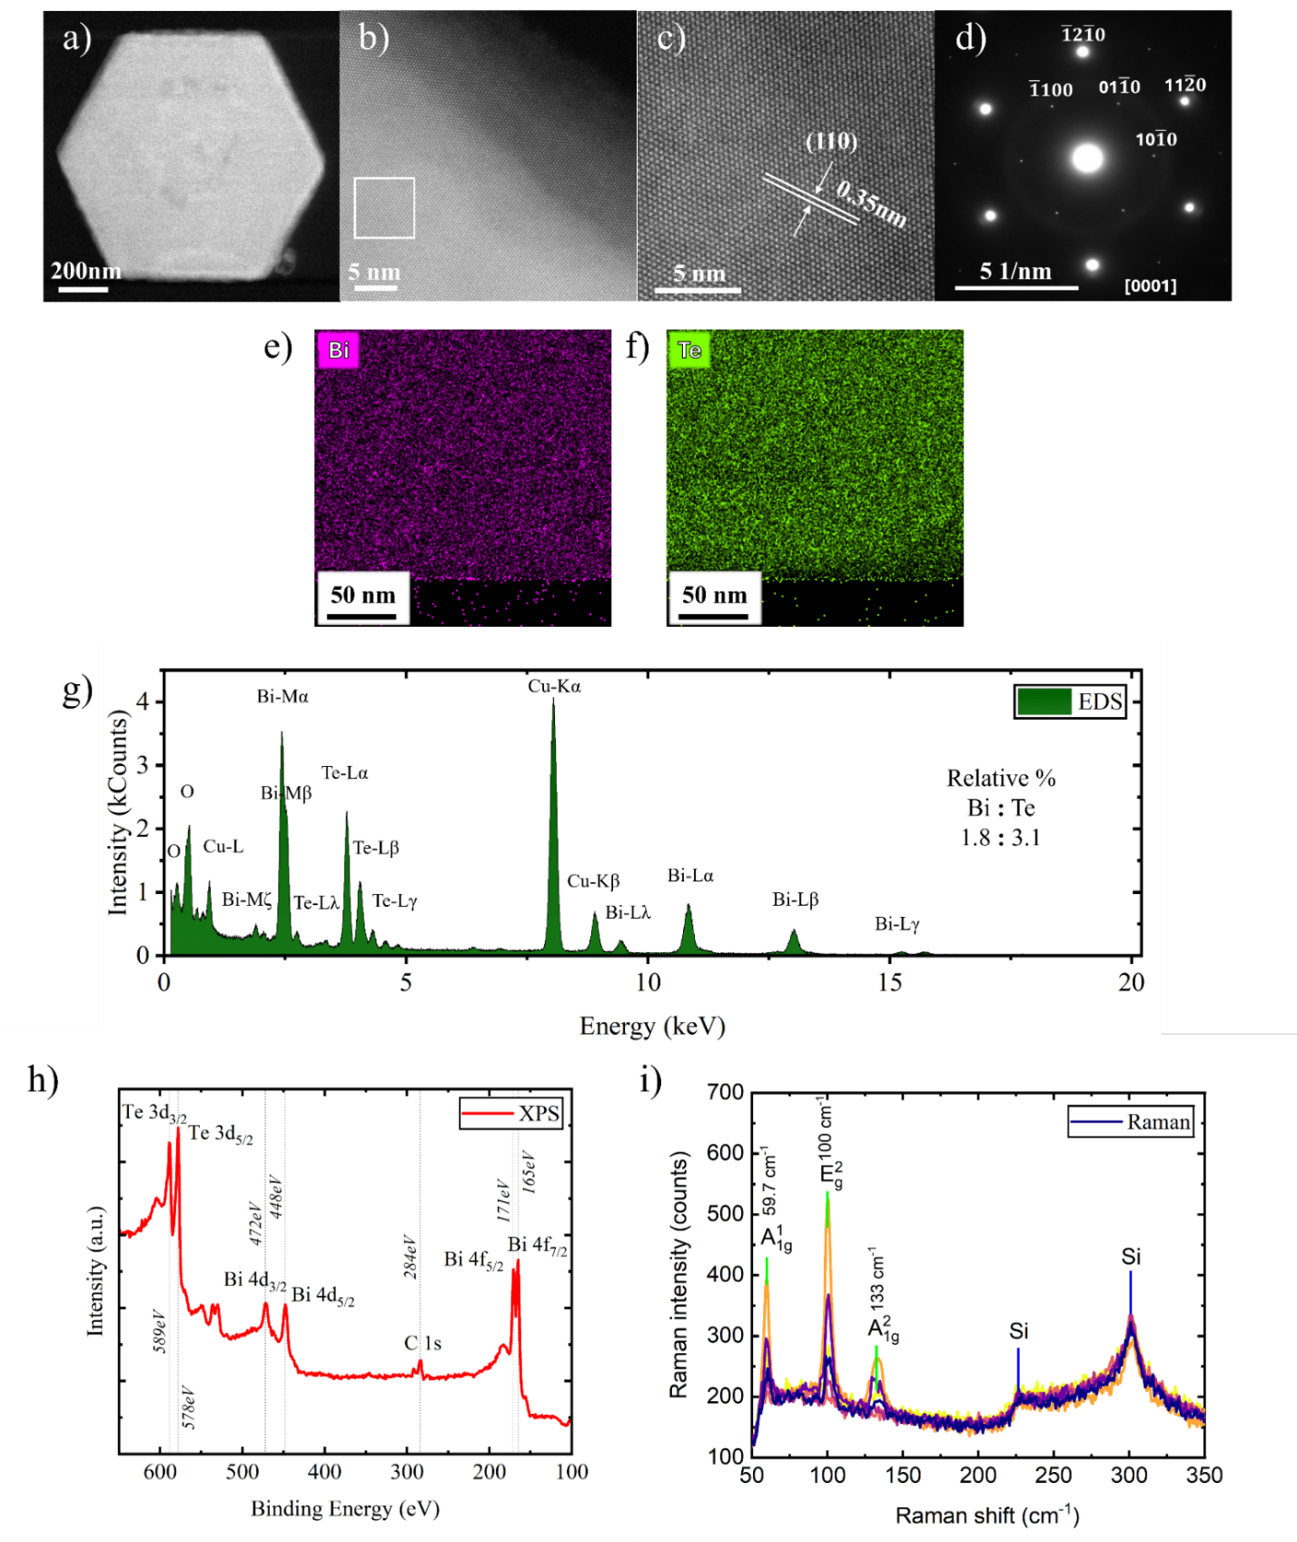

Figure S2: (a-d) HAADF and SAED images show a high degree of crystallinity in our synthesis, with relatively little lattice strain. (e-g) EDAX shows the materials to be stoichiometric, generally. (h) The phase of the materials is further confirmed by XPS to be Bi₂Te₃. (i) Raman spectroscopy also confirms the formation of defect-free Bi₂Te₃.

- EELS Identification of Edge States

A ThermoFisher Titan 80-300 probe aberration-corrected STEM with 80 kV accelerating voltage was used. The beam was aligned with a 19.3 mrad convergence semi-angle and 71 mrad collection semi-angle. The energy resolution of the beam was 25 meV, and the beam energy loss up to 45 eV was acquired. The sample was prepared by drop casting the Bi₂Te₃ nanoplates from the ethanol solution onto Lacey Formvar Carbon reinforced TEM grids from Ted Pella. After sufficient air-drying, the nanoplates were directly inserted into the HR-TEM, avoiding annealing under Ar/H₂ because of the fragility of the TEM grids. Nanoplate thickness was extracted following the methods by Williams and Carter [3]. EELS spectra were sampled from a 14 x 14 pixel area on the EELS maps using the Digital Micrograph Software by Gatan. A fitted logarithmic tail method was used for the zero-loss peak subtraction using a fitting range from 0.25 eV to 3 eV. The edge spectrum was acquired 5 nm from the edge of the nanoplate, while the center spectrum was acquired in the center of the nanoplate, equidistant from each edge.
As a preliminary check for the observation of spin-selective, electron states that are confined to the edges of the crystal, we performed electron energy loss spectroscopy (EELS). EELS is increasingly being used to probe the spatially resolved plasmonic modes of low-dimensional materials for photonic applications [4,5]. In a particular study, comparing the EELS peak energies of Bi₂Te₃ platelets with the dielectric loss function derived from atomic-structure calculations revealed a one-to-one correspondence with spin–orbit coupling. This correspondence indicates a directional dependence on electron scattering that could originate only from the nanoplate’s topological character. In extension to this study, the authors also observed that the EELS peak vanished when the platelet started becoming amorphous [6]. Keeping in mind that the precursors used in our chemical synthesis were different compared to these two studies, we performed a similar EELS analysis to define the spatial resolution of the topological states in the Bi₂Te₃ platelet.
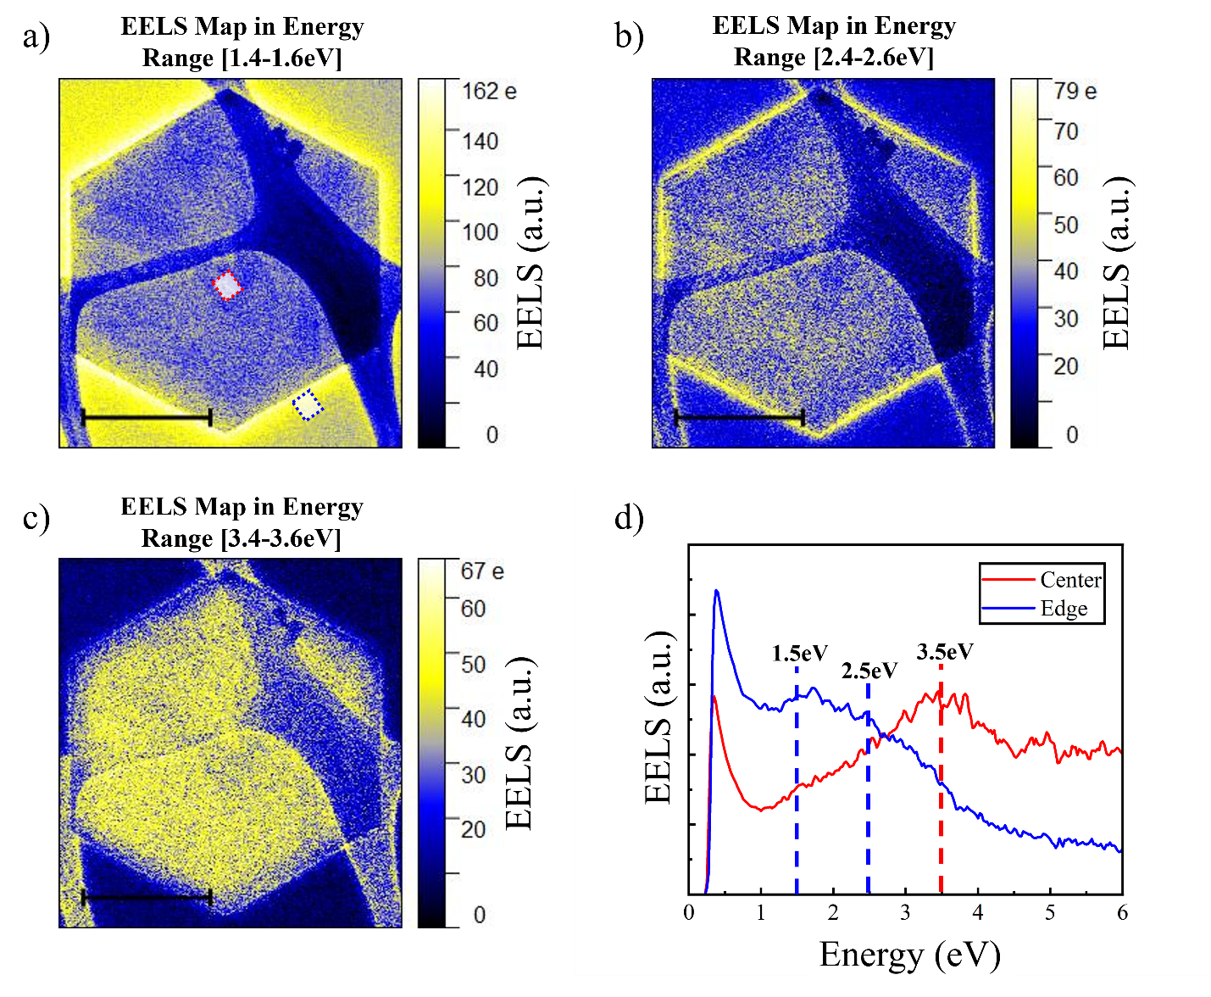
Figure S3: EELS on Bi₂Te₃ nanoplates. (a-c) Energy-filtered EELS maps of a Bi₂Te₃ nanoplate with a thickness of ~24 nm. EELS maps were created with pixel contrast set to an energy range of 0.25 eV and centered on the energies 1.5 eV, 2.5 eV, and 3.5 eV. Scale bars in the inset are 200 nm. g) Zero-loss-peak-subtracted EELS spectrum obtained from the center and the edge of the nanoplate.

Figure S3 shows the EELS maps of a 24 nm thick Bi₂Te₃ nanoplate. As the electron beam is moved from the edge to the center of the nanoplate, we see three distinct energy loss bands centered at 1.5, 2.5 and 3.5 eV electron energy loss. In energy-filtered imaging, a noticeable uniform bright edge contrast was observed at 1.5 eV (Figure S3 (a)) and 2.5 eV (Figure S3 (b)). As energy loss increases to 3.5 eV (Figure S3 (c)), the contribution from the center starts increasing, showing a clear resolution of the edge and surface contribution of the plasmon. We also confirm the spatial contrast by comparing the three spectral intensities at the center and the edge of the nanoplate Figure S3 (d)). While our observation matches previous reports, such plasmonic modes at the edge [4,7] are also proposed to be associated with the so-called Dyakonov plasmons [8], a signature of topological edge states. This is remarkable, as it indicates that even a nanoplatelet thickness corresponding to 32 quintuple layers can reflect a 2D TI character.

- Instrument Operation
3.1. Topographical feature optimization
AC atomic force microscopy has long been regarded as a highly-sensitive technique operating at scan speeds limited to about $250 μm s^{-1} ADDIN ZOTERO_ITEM CSL_CITATION \{"citationID":"3jkCFlYs","properties":\{"formattedCitation":"[9,10]","plainCitation":"[9,10]","noteIndex":0\},"citationItems":[\{"id":64,"uris":["http://zotero.org/users/local/pDbnfNUs/items/7GNEWTWG"],"itemData":\{"id":64,"type":"article-journal","container-title":"Journal of Vacuum Science \& Technology B","DOI":"https://doi.org/10.1116/1.1614252","issue":"6","journalAbbreviation":"J. Vac. Sci. Technol B","title":"Micromachined atomic force microscopy sensor with integrated piezoresistive sensor and thermal bimorph actuator for high-speed tapping-mode atomic force microscopy phase-imaging in higher eigenmodes","URL":"https://pubs.aip.org/avs/jvb/article/21/6/3102/1069594/Micromachined-atomic-force-microscopy-sensor-with","volume":"21","author":[\{"family":"Pedrak","given":"R."\},\{"family":"Ivanov","given":"Tzv."\},\{"family":"Ivanova","given":"K."\},\{"family":"Gotszalk","given":"T."\},\{"family":"Abedinov","given":"N."\},\{"family":"Rangelow","given":"I.W."\},\{"family":"Edinger","given":"K."\},\{"family":"Tomerov","given":"E."\},\{"family":"Schenkel","given":"T."\},\{"family":"Hudek","given":"P."\}],"accessed":\{"date-parts":[["2024",1,11]]\},"issued":\{"date-parts":[["2003"]]\}\}\},\{"id":52,"uris":["http://zotero.org/users/local/pDbnfNUs/items/JS9MIU6N"],"itemData":\{"id":52,"type":"article-journal","abstract":"We present experimental results on the characterization of commercially available magnetic force microscopy (MFM) thin film tips as a function of an external magnetic field. Well defined magnetic stray fields are produced using current carrying rings with radii ranging between 603 and 2369 nm fabricated by electron-beam lithography directly imaged by MFM. Treating the MFM tip as a point probe, the analysis of the image contrast as a function of both the magnetic stray field and the lift height allows for a quantitative determination of effective magnetic dipole and monopole moments of the tip as well as their imaginary location within the real physical tip. Our systematic study gives a quantitative relationship on how absolute values of the magnetic dipole and monopole moments and their location within the tip depend on a characteristic decay length of the z component of the magnetic field being detected. From this we can estimate the effective tip volume of the real physical thin film tip relevant in MFM imaging.","container-title":"Journal of Applied Physics","DOI":"10.1063/1.371222","ISSN":"0021-8979","issue":"6","journalAbbreviation":"Journal of Applied Physics","page":"3410-3417","source":"Silverchair","title":"Quantitative determination of effective dipole and monopole moments of magnetic force microscopy tips","volume":"86","author":[\{"family":"Lohau","given":"J."\},\{"family":"Kirsch","given":"S."\},\{"family":"Carl","given":"A."\},\{"family":"Dumpich","given":"G."\},\{"family":"Wassermann","given":"E. F."\}],"issued":\{"date-parts":[["1999",9,15]]\}\}\}],"schema":"https://github.com/citation-style-language/schema/raw/master/csl-citation.json"\}$[9,10]. $ADDIN ZOTERO_ITEM CSL_CITATION \{"citationID":"lIYEpOcU","properties":\{"formattedCitation":"\backslash \backslash super 1\backslash \backslash nosupersub\{\}","plainCitation":"1","dontUpdate":true,"noteIndex":0\},"citationItems":[\{"id":64,"uris":["http://zotero.org/users/local/pDbnfNUs/items/7GNEWTWG"],"itemData":\{"id":64,"type":"article-journal","container-title":"Journal of Vacuum Science \& Technology B","DOI":"https://doi.org/10.1116/1.1614252","issue":"6","journalAbbreviation":"J. Vac. Sci. Technol B","title":"Micromachined atomic force microscopy sensor with integrated piezoresistive sensor and thermal bimorph actuator for high-speed tapping-mode atomic force microscopy phase-imaging in higher eigenmodes","URL":"https://pubs.aip.org/avs/jvb/article/21/6/3102/1069594/Micromachined-atomic-force-microscopy-sensor-with","volume":"21","author":[\{"family":"Pedrak","given":"R."\},\{"family":"Ivanov","given":"Tzv."\},\{"family":"Ivanova","given":"K."\},\{"family":"Gotszalk","given":"T."\},\{"family":"Abedinov","given":"N."\},\{"family":"Rangelow","given":"I.W."\},\{"family":"Edinger","given":"K."\},\{"family":"Tomerov","given":"E."\},\{"family":"Schenkel","given":"T."\},\{"family":"Hudek","given":"P."\}],"accessed":\{"date-parts":[["2024",1,11]]\},"issued":\{"date-parts":[["2003"]]\}\}\}],"schema":"https://github.com/citation-style-language/schema/raw/master/csl-citation.json"\}$This upper threshold is limited by the time constant of the piezo feedback loop, which keeps the cantilever’s amplitude constant.
Although the SPM 5200 instrument was installed with a scanner capable of measuring vertical feature sizes ~3 µm and remarkable scan speeds up to $4 x {10}^{6} μm s^{-1}$, the quality of the images were seen to deteriorate noticeably beyond a speed of $20 μm s^{-1}$. As such, a control experiment was implemented to determine the tip’s lateral speed effect on the quality of the image and then make a comparison for the scale of the error we may experience with the induced magnetic response (Figure S4). As the thickness of the nanoplate was known, the topographical images obtained from the MFM scan were plotted with respect to the tip scanning speed to compare the accuracy of the measured height. The exact velocity components for the tip will be addressed later, but for brevity it was determined that although the dithering motion of the cantilever far surpassed that of the lateral motion, varying the lateral motion had a noticeable effect on the quality of the topographical image.
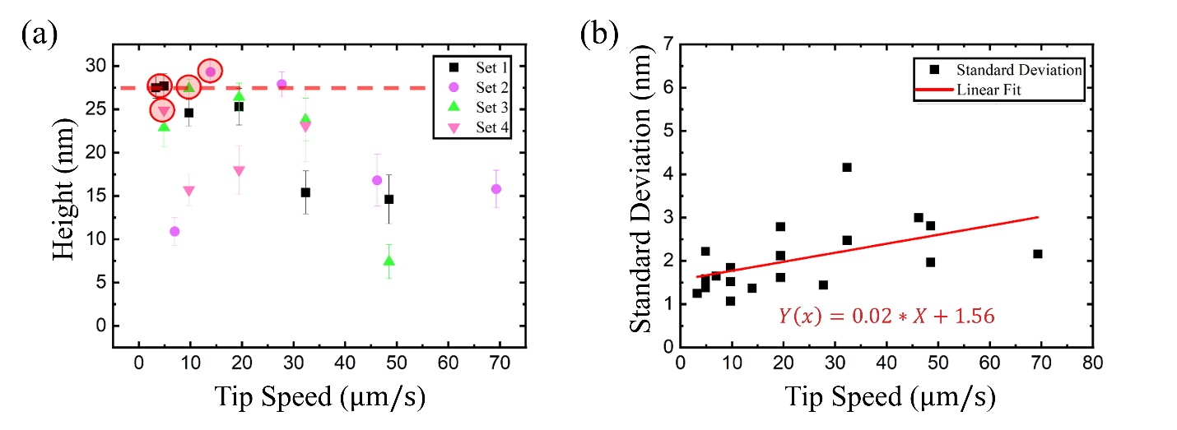
Figure S4: (a) Scatterplot of lateral tip speed versus nanoplate mean height in topographical mode and its (b) standard deviation. Each image was taken sequentially on the same nanoplate. Values were calculated by taking six line plots across the center of the nanoplate rotated by 45 degrees. Mean height variation across individual line plots is represented by one standard deviation from the mean. Points circled in red represent the lowest standard deviation per set. The dotted horizontal red line in (a) is the average of four points circled in red and represents the most probable lift height.

It was found that the machine produces the most accurate images with tip lateral speeds 5-15 $μm s^{-1}$. Accuracy was determined by implementing a statistical analysis of the images and ranking the measurements by their standard deviation. It should be noted that the microscope settings (gain, cantilever driving voltage, etc.), the dimensions and characteristics of the cantilever used, the support substrate, and the surface nature of the nanoplate can also affect the quality of the image. For this reason all sets were taken sequentially to maintain the same variables besides the lateral tip speed.

3.2. MFM feature optimization
It should be noted that there are several ways MFM imaging can be carried out. We use point by point scanning in the MFM-AC mode where, for each pixel two measurements are performed. Cantilever dynamics were sensed using slope detection where resonance shifts due to force gradients were observed with the change in vibration amplitude. The first measurement gives topographical information with the tip-sample distance set once the Wan der Waals forces become significant. This measurement uses the difference in the amplitude of cantilever oscillation to image the topography. The second measurement is completed by first raising the cantilever to a designated lift height (LH) off the surface and then measuring the phase difference of the cantilever frequency to the driver frequency. At significant LHs, the only forces present should be magnetic. To begin, the LH was set to 0 nm and then the line scan time, scan area, gain, and cantilever driving voltage were adjusted to optimize magnetic contrasts in the images. After settings were established a sequence of images were taken with varying LHs. Polycrystalline, cobalt-coated cantilevers with resonance frequency 60 kHz and force constant $1N m^{-1}$ were used for the MFM imaging. Silicon cantilevers with resonance frequency of 90 kHz and force constant $1N m^{-1}$ were used for the AFM imaging. All cantilevers were purchased from NT-MDT Spectrum Instruments and prepared with a 30 s re-magnetization with a niobium magnet before insertion into the AFM head. Images shown in this report were taken with lift heights from 0nm up to 150 nm and scan speeds of 4$μm s^{-1}$ to 48$μm s^{-1}$. Calculations for the swing amplitude of the tip using the dimensions of the piezo element on the AFM head, the cantilever and the cantilever’s resonance frequency and quality factor will be discussed in a later section. When the cantilever is driven just off its resonance frequency, the temporal difference of its vertical motion far surpasses the time the tip moves between the measurement steps.

3.3. Cantilever Dynamics
Calculations based on the dimensions of the bimorph driving the cantilever and the cantilever’s physical properties show the cantilever swing can be lower than 10 nm and up to 50 nm or higher[11]. Using this feature of the instrument, experiments were done (Figure 3 (d) and Figure S5 (b)) by fixing the lift height at 100, 150 and 200 nm and varying the cantilever amplitude as an alternative technique for detecting the magnetic field.
The cantilever amplitude can be plotted vs. cantilever voltage [11].
$$A(V)$$ | = | $$\frac{A_{Bimorph}*V*Q}{\sqrt{{Q^{2}\left(1-{\left(\frac{ω}{ω_{0}}\right)}^{2}\right)}^{2}+{\left(\frac{ω}{ω_{0}}\right)}^{2}}}$$ | (1)
Here, $A_{Bimorph}$ is the bimorph amplitude, V is the applied voltage, Q is the quality factor $ω$ is the frequency of oscillation, and $ω_{0}$ is the natural resonance frequency of the cantilever. The instrument sets the ratio of $\frac{ω}{ω_{0}}=0.965$ and so the equation can be plotted as shown.

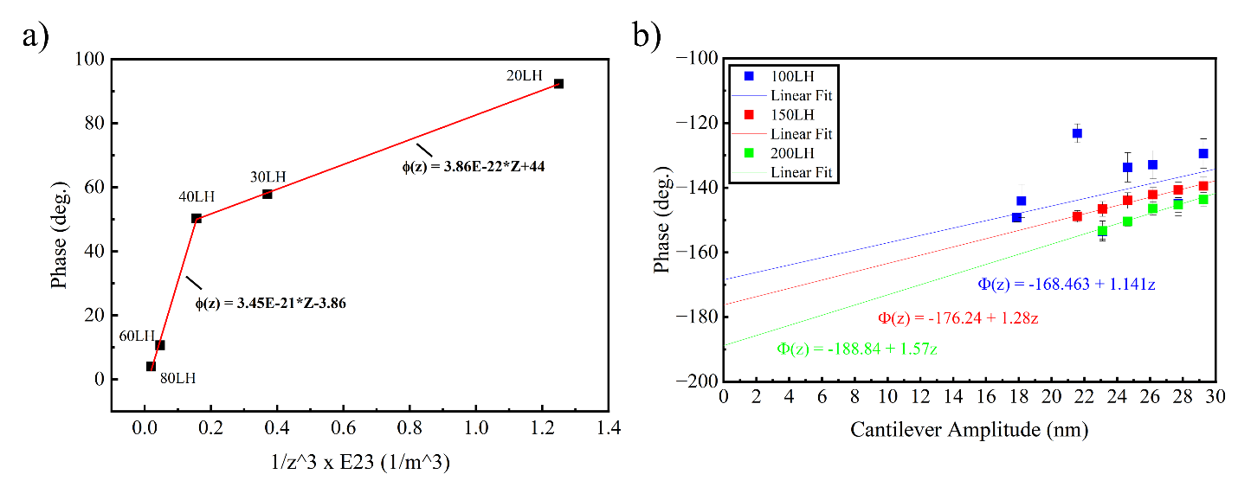
Figure S5: (a) Lift height vs. edge phase from data in Figure 2 (a). (b) Cantilever amplitude vs. edge phase with lift heights 100, 150, and 200 nm. Cantilever amplitudes maintain a linear relationship with applied voltage to bimorph.

The contrast on the edges of the Bi₂Te₃ nanoplates was thought to be attributed to two sources of magnetic field- the induced current and the persistent, edge current. The induced current originated from the Faraday induction dynamics of the magnetic tip relative to the platelet edge. The persistent current originated from spin-to-charge current conversion activated by the presence of a symmetry-breaking magnetic tip. For the induced current mechanism, the tip had four contributions to the contrast as can be seen in Figure S6.

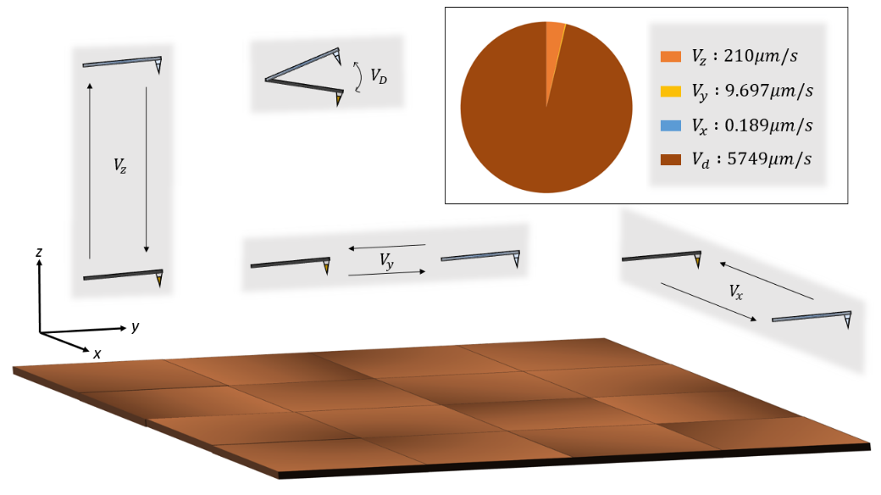
Figure S6: Lift height was set to 100 nm. The resonance frequency was set to 77.7 kHz. The scan area was set to $3.5 μm x 3.5 μm$. The scan line time was set to 0.333 s. The image was saved with the resolution 256 x 256 pixels.

The $V_{d}$ contribution was calculated by multiplying the resonance frequency by double the cantilever amplitude. The $V_{z}$ contribution was calculated by using the time per line scan, divided by the number of pixels, and then divided by the number (3) of steps per pixel. The $V_{y}$ and $V_{x}$ contributions were taken from the metadata saved on the image file. It should be noted that the $V_{z}$ contribution will change by $±21 μm s^{-1}$ with a LH change of $±10 nm.$

3.4. Optimizing the magnetic force contribution
To eliminate the possible contribution of the capacitive force to the observed MFM contrast, we imaged Bi₂Te₃ nanoplates with a non-magnetic tip at a lift height. The cantilevers were purchased from NT-MDT Spectrum Instruments and had resonance frequency of 90 kHz and force constant 1 N m⁻¹. The images of the nanoplates showed a sharp contrast on the edges as is common when imaging in AFM phase images. Additionally, the mean phase of the edge and the substrate approached 0 degrees with increase in lift height suggesting a diminishing interaction between the tip and the scanned surface. The dark contrast observed in Figure S7 confirmed the presence of attractive, surface forces between these layered materials and the cantilever which is a strong distinction from the bright contrast as seen with the MFM images of the Bi₂Te₃ nanoplates.
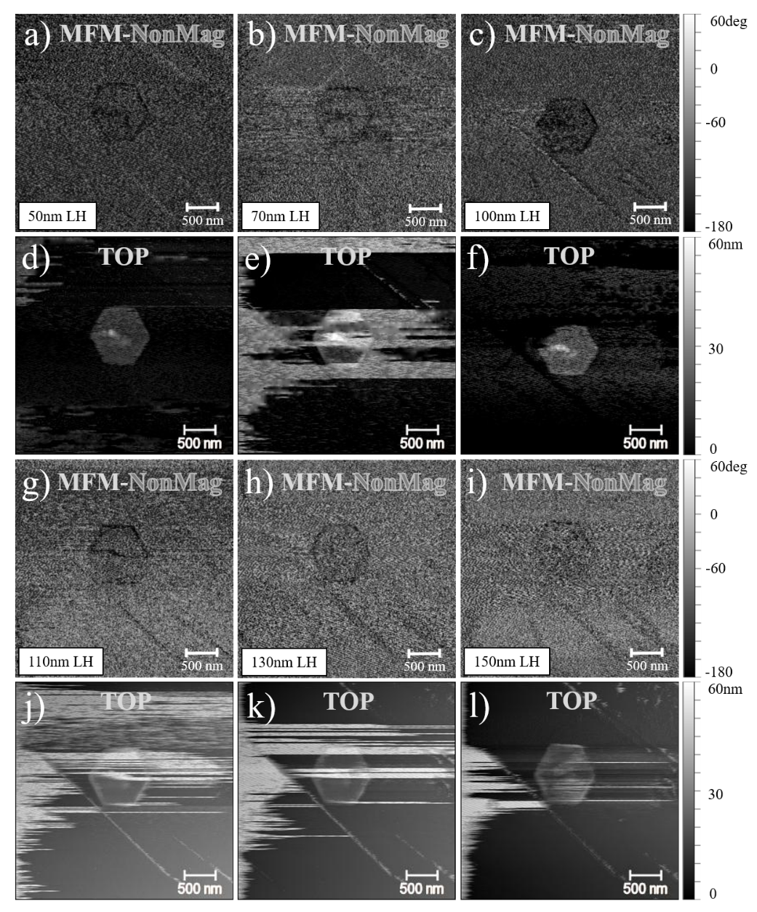
Figure S7: MFM on Bi₂Te₃ with nonmagnetic AFM tip. Magnetic (a-c, g-i) and topographical (d-f, j-l) images taken of a Bi₂Te₃ nanoplate with a non-magnetic tip in MFM mode with lift heights 50-150 nm.

Scanning parameters such as gain, feedback, cantilever tip velocity, and lift amp voltage were kept constant throughout. Cleaved graphite was used as the support substrate.

3.5. Optimizing cantilever swing amplitude

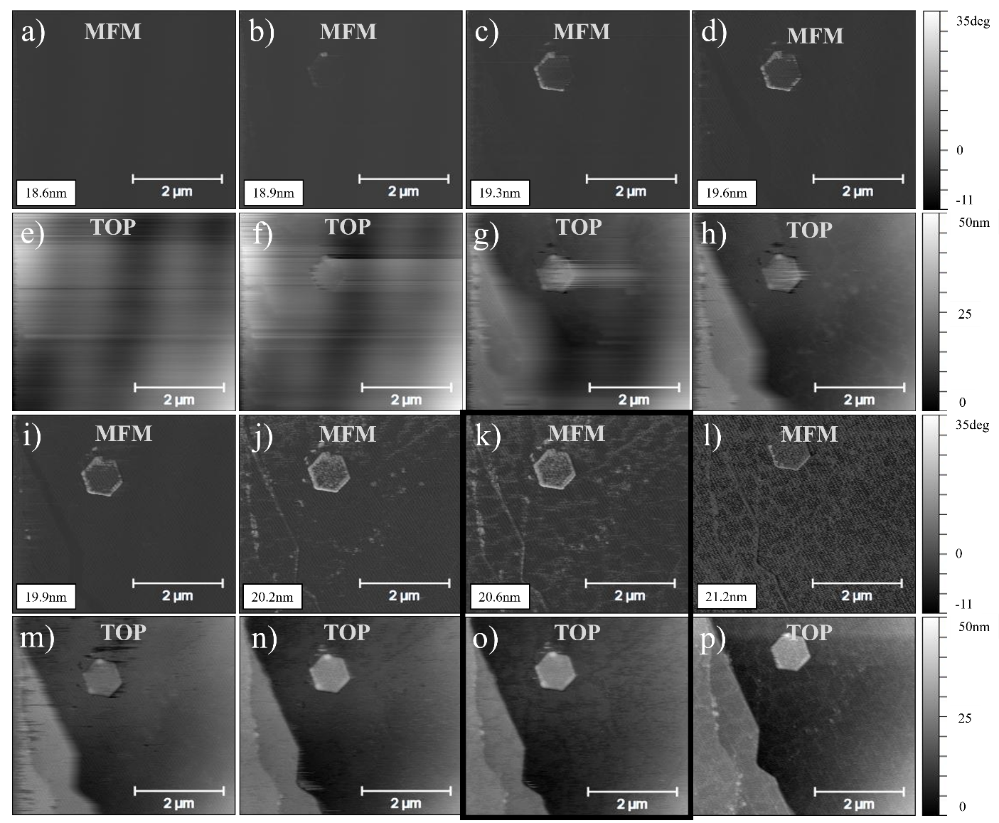
Figure S8: MFM on Bi2Te3 with varying cantilever amplitude. Magnetic (a-d, i-l) and topographical (e-h, m-p) images taken of a Bi₂Te₃ nanoplate with a magnetic tip in MFM mode with a constant lift height of 100 nm. The cantilever voltage was varied from 570 mV to 660 mV which resulted in cantilever amplitudes from 17.9 nm to 29.3 nm. The system will auto set the cantilever’s driving voltage when it determines the resonance frequency of the tip. In this case the system set the voltage to 650 mV and the corresponding images are highlighted in the box. The quality factor of the MFM tip was measured to be 181.809. Cleaved graphite was used as the support substrate.

3.6. Electrostatic Forces
The electrostatic forces in the MFM are F_{electro} ~ F_{VdW} + F_{cap} where we use the geometric associated with Figure 3(a):
$$F_{VdW}$$ | = | $$- \frac{A_{H}R}{6z^{2}}$$ | (2)

A_{H} is the Hamaker constant, R is the radius of a spherical tip, and z is the height from a planar surface [12]. For the capacitive derived force:
$$F_{cap}$$ | = | $$- \frac{π ε_{o}U^{2}R}{z}$$ | (3)

when the probe is over the graphite surface. It is:
$$F_{cap}$$ | = | $$- \frac{π ε_{eff}U^{2}R}{z}$$ | (4)

when over the Bi₂Te₃ plate. The R in both of these equations is the radius of the tip over a flat surface. The dielectric constant changes as the probe scans from the graphite to the Bi₂Te₃ sample. The effective dielectric constant ε_{eff} is approximated as the ratio: ε_{eff} = {[ε_{BiTe} t] + [ε_{o} z]}/ (z+t), where z is the scan height, t is the thickness of the plate, and the dielectric constant of Bi₂Te₃ (ε_{BiTe}) is taken as the bulk value. U is taken to be the contact potential plus any applied voltage between tip and sample. U = U_{contact} + U_{applied} [11].
$$F_{electro}$$ | = | $$- \frac{A_{Hi}R}{6z^{2}}- \frac{π {\{ε}_{BiTe}t+ ε_{o}z\}{{(U}_{c}+ U_{a})}^{2}R}{z (z+t)}$$ | (5)

In this expression when t goes to zero, the tip is over the HOPG and A_{Hi} is that of HOPG. When over the Bi₂Te₃, the ε and A_{Hi} is that of Bi₂Te₃.
$$\frac{dF_{electro}}{dz}$$ | = | $$\frac{A_{H}R}{3z^{3}}- \frac{π R {{(U}_{c}+ U_{a})}^{2}[ -{ε_{o}z}^{2}-2ε_{BiTe}tz- {ε_{BiTe}t}^{2}]}{z^{2}{(z+t)}^{2}}$$ | (6a)

 | = | $$\frac{A_{H}R}{3z^{3}}+ \frac{π ε_{BiTe}R {{(U}_{c}+ U_{a})}^{2}[ {\frac{1}{ε_{r}}z}^{2}+2tz+ t^{2}]}{z^{2}{(z+t)}^{2}}$$ | (6b)

Looking at the relative contributions of the components we note that: A_{H (HOPG) ~} 23.8 x 10⁻²⁰ J, ε_{r(BiTe)} ~ 37, and ε_{BiTe} ~ ε_{o}ε_{r} ~ (8.854 x 10⁻¹² F/m) x (37). So, we can approximate:
$$\frac{dF_{electro}}{dz}$$ | $$\sim$$ | $$\frac{π ε_{BiTe}R {{(U}_{c}+ U_{a})}^{2}[ {\frac{1}{ε_{r}}z}^{2}+2tz+ t^{2}]}{z^{2}{(z+t)}^{2}}$$ | (7)

Over HOPG this looks like:
$$\frac{dF_{electro}}{dz}$$ | $$\sim$$ | $$\frac{π ε_{o}R {{(U}_{c}+ U_{a})}^{2}}{z^{2}}$$ | (8)
Over Bi₂Te₃ (for low lift heights):
$$\frac{dF_{electro}}{dz}$$ | $$\sim$$ | $$\frac{π ε_{BiTe}R {{(U}_{c}+ U_{a})}^{2}}{z^{2}}$$ | (9)

But generally, over the plate, the full expression should be used above.

The contact potential U_{c} stays roughly the same over the plate and over the HOPG. The phase shift associated with the capacitive forces goes roughly as: (U_{a})². The relation is used in Kelvin probe force microscopy (KPFM) [13].

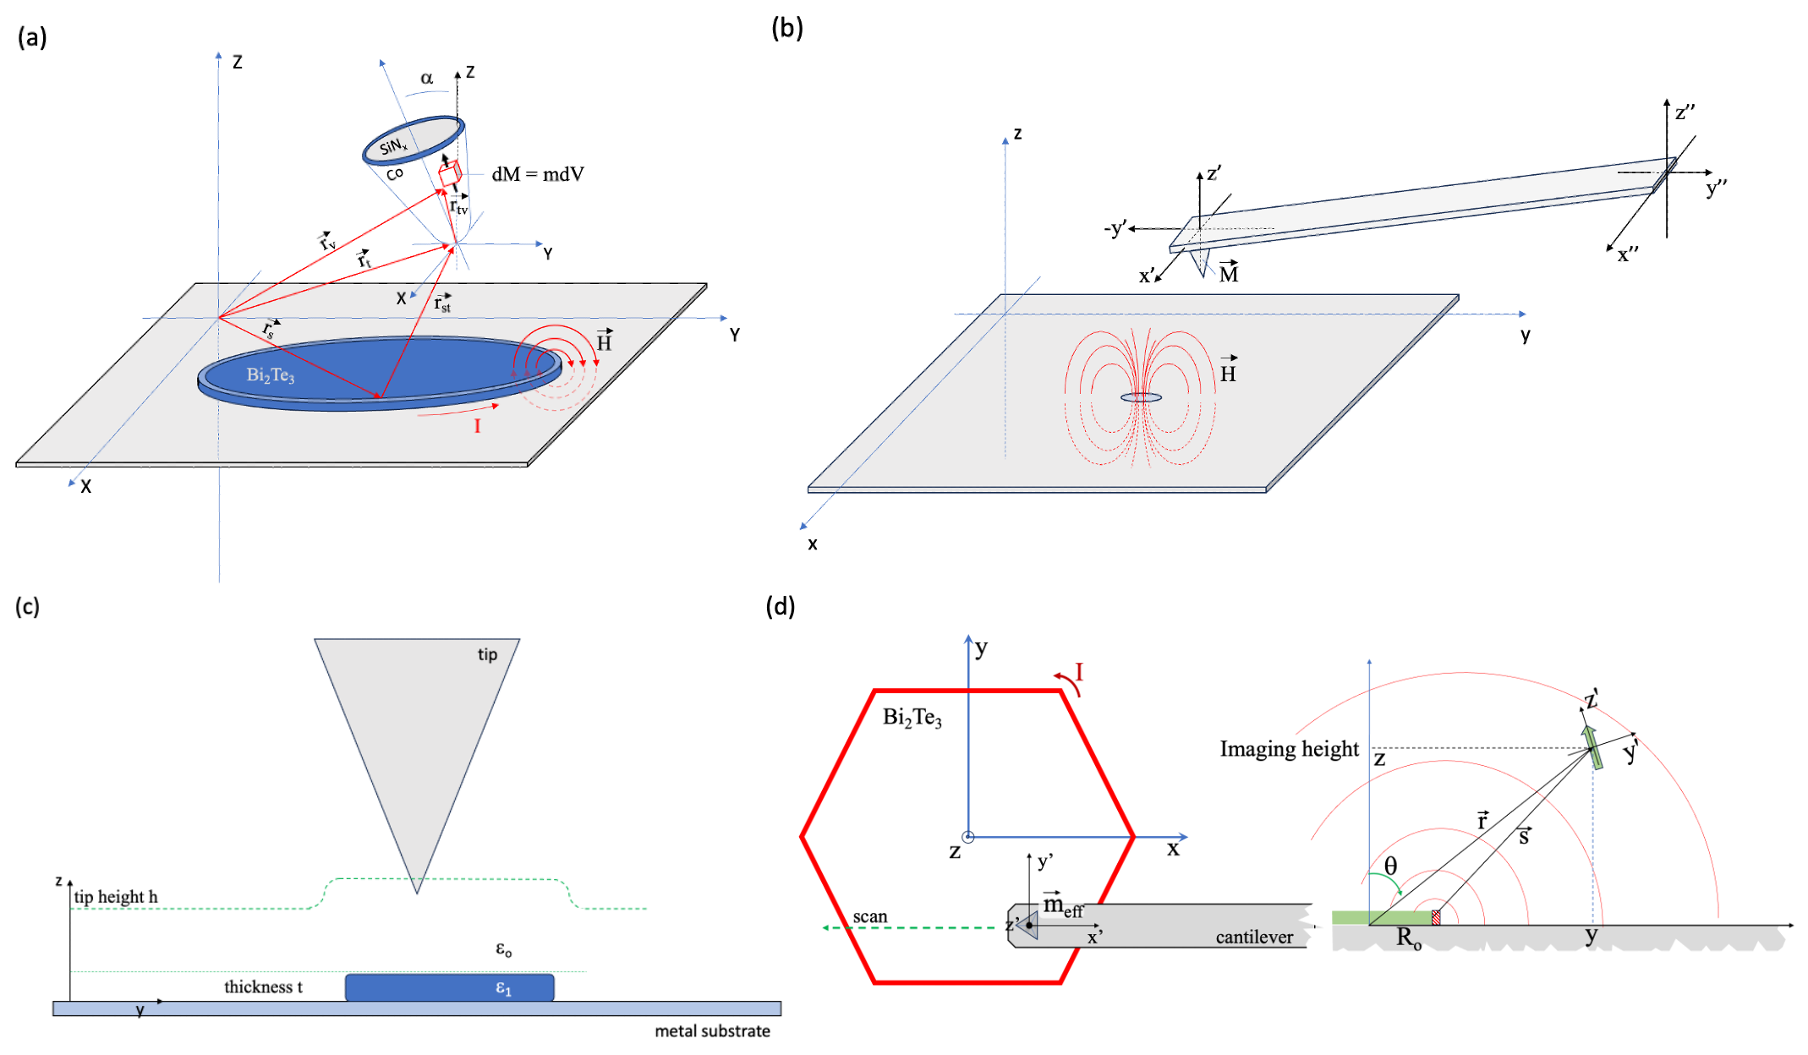
Figure S9: (a) The small-tip problem where the current ring source with a spatially extensive magnetic field interacts with the whole of the conical tip. (b) A dipole interaction approximation where the tip has an effective dipole moment, and the ring does as well. So, we have two dipole magnets that try to align. (c) Our approach is a combination of (a and (b). Thia also allows for a simplified consideration of the capacitor formed below the tip where the metal support substrate is one electrode and the metal coated tip is the other. There are two dielectrics in this system, the air and the plate [14]. (d) Our simplified geometric approximation “sees” the tip as an effective dipole with a sphere-plane capacitor. The current ring is treated as an isolated wire wherein the significant interaction comes from the wire-segment closest to the tip.

In Figure S10 (a), we vary the voltage for a 0LH (as close as possible without touching), 5LH, and 10LH The applied potential is plotted as U², and the linear trend is seen in all three cases as proposed by Equation S9. Keep in mind that the plate being imaged in this data set is ~ 6 nm thick, so at 0LH the capacitor is essentially all dielectric, at 5LH the capacitor is roughly 11 nm in spacing, and the dielectric portion is roughly ½ of the space between plates. At 10LH, the spacing of the capacitor is ~ 16 nm, and ~1/3 of the space is filled with dielectric. For each of the LH values, the change in capacitance due to the change in average dielectric response within the gap leads to the marginal changes in slope. However, the U² dependence is maintained. This situation is quite different for the larger LHs, as shown in Figure S10 (b). Again, the mean phase contrast is plotted vs. U_{app}² for LHs of 20nm, 30nm, and 40nm. In this case, we note that the U² behavior does not appear to be observed. Indeed, for 20LH, we observed a linear decrease with voltage U² starting around ΔΦ = 80 °, dropping off rapidly with U². For 30LH and 40LH the change in ΔΦ is even more dramatic. For 30LH, from U = 0.5 V to 2.5 V, the trend is linear as expected, but with a much smaller slope (a much weaker response). For 40LH, ΔΦ ~ linear with zero slope for 0.5 V < U < 2.5 V. At these LH values, there is very little capacitive force. We note that for the larger lift heights seen in Figure S10 (b), there is a jump in ΔΦ when the first voltage (0.5 V) is applied. We interpret this as being related to the cancellation of the contact potential, thereby magnifying the sample’s magnetic response. We further test this idea by looking at the ΔΦ as a function of LH with increasing applied voltages (Figure S11 (a)). We note that at LH < 20 nm, where the dielectric polarization plays a larger role in creating a capacitive response to the applied field, larger voltages typically have more of an effect in contrast. For the medium LHs (20-30 nm), this trend seems to collapse such that only the largest voltages have any effect at all. At the LH > 30 nm, there is little to no dependence of the applied field on ΔΦ.
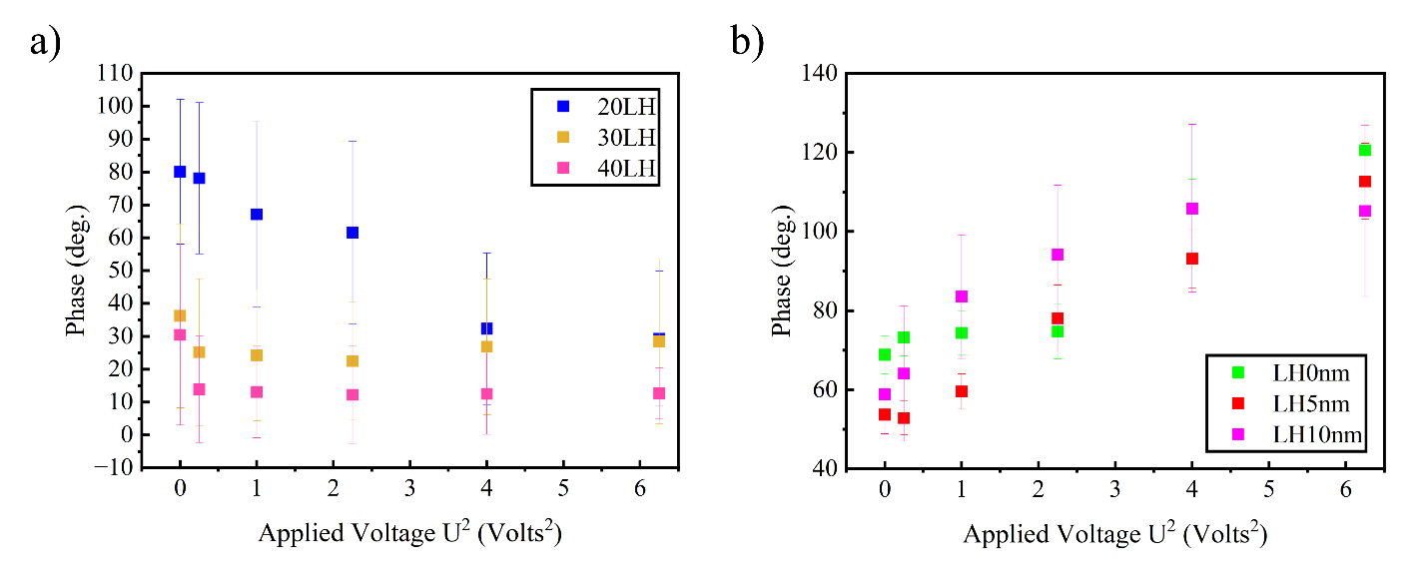
Figure S10: (a) The phase contrast: ${∆∅}_{HOPG}$ (over the HOPG) – ${∆∅}_{BiTe}$ (over the plate) = ${∆∅}_{Tot}$, as a function of applied voltage for three low lift height imaging conditions. The U² dependence is clearly seen as predicted in Equation S9 above. (b) That phase contrast does not show any such U² dependence for the larger lift heights.
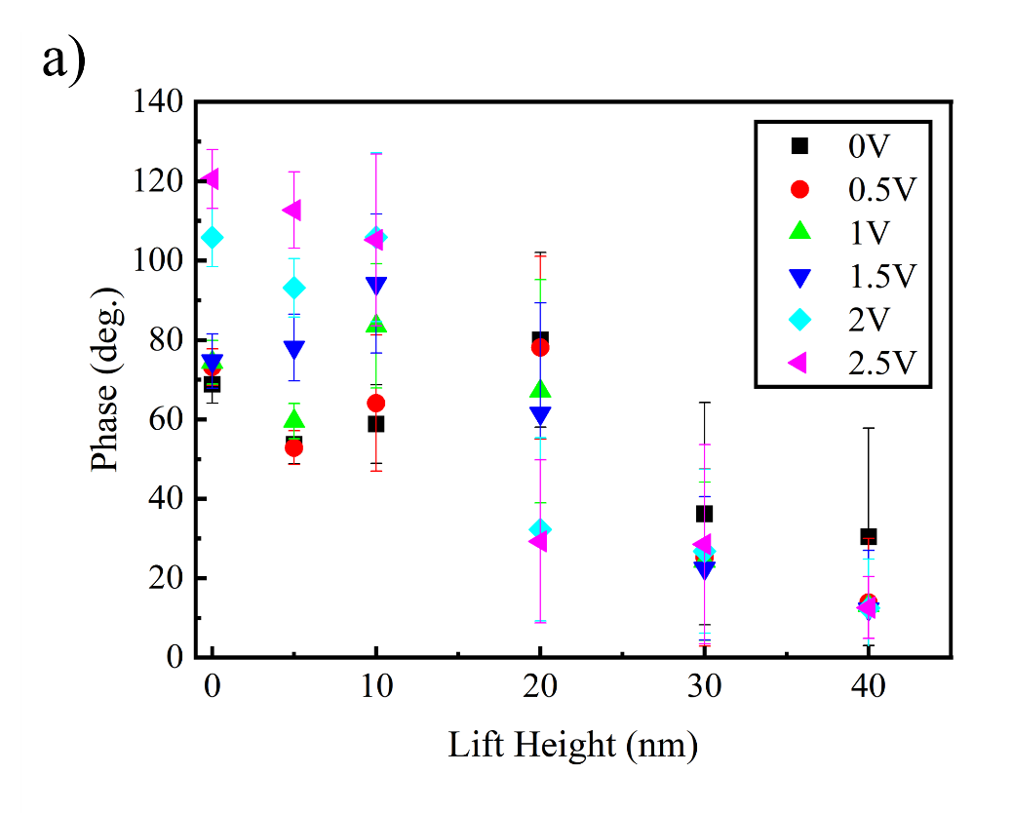
Figure S11: (a) Phase contrast as a function of LH when a voltage (U_{a}) is applied.

As we have already noted, our model is only an approximation. With higher LHs, the whole cantilever becomes involved in the formation of a capacitive force against the larger HOPG substrate or nanoplate and our simplified imaging geometry in Figure S9 is no longer applicable. However, within the window of applicable approximations, we can now understand the contrast mechanisms to allow for direct interpretation of the magnetic components of the imaging. In Figure S12, a 6 nm thick, 1 μm diameter plate is imaged in an LH region for which a strong U² dependence is expected. In the left panel sequence (Figure S12 (a)), 5LH, so the electrostatic interaction (U_{c}) influences the ΔΦ of the whole plate, dominating other contrast mechanisms. Moreover, the contrast between the edge and the center is not observed even at a -2 V bias, suggesting that a van der Waals interaction is dominant at this LH. In the right panel (Figure S12 (b)), at 10LH, we notice that ΔΦ on the edge, as compared to the ΔΦ in the nanoplate bulk, is now much more pronounced. At 0 V and 1 V, the effect of the capacitive forces ‘washes out’ the edge contrast. However, the contrast difference between the center of the nanoplate and the edge increases with increasing U_{a}, suggesting that the contact potential difference is minimal and the dominant force is magnetic. Imaging at a greater LH for another set of plates is shown in Figure S13. At these heights, we anticipate the dominant contrast mechanisms to involve magnetic interactions. Curiously, the thickness of the nanoplates has little effect on the edge contrast. Moreover, electrostatic interactions are negligible at this LH, suggesting that our identification of the edge contrast as the signature of a persistent current in a topologically protected state is likely correct.
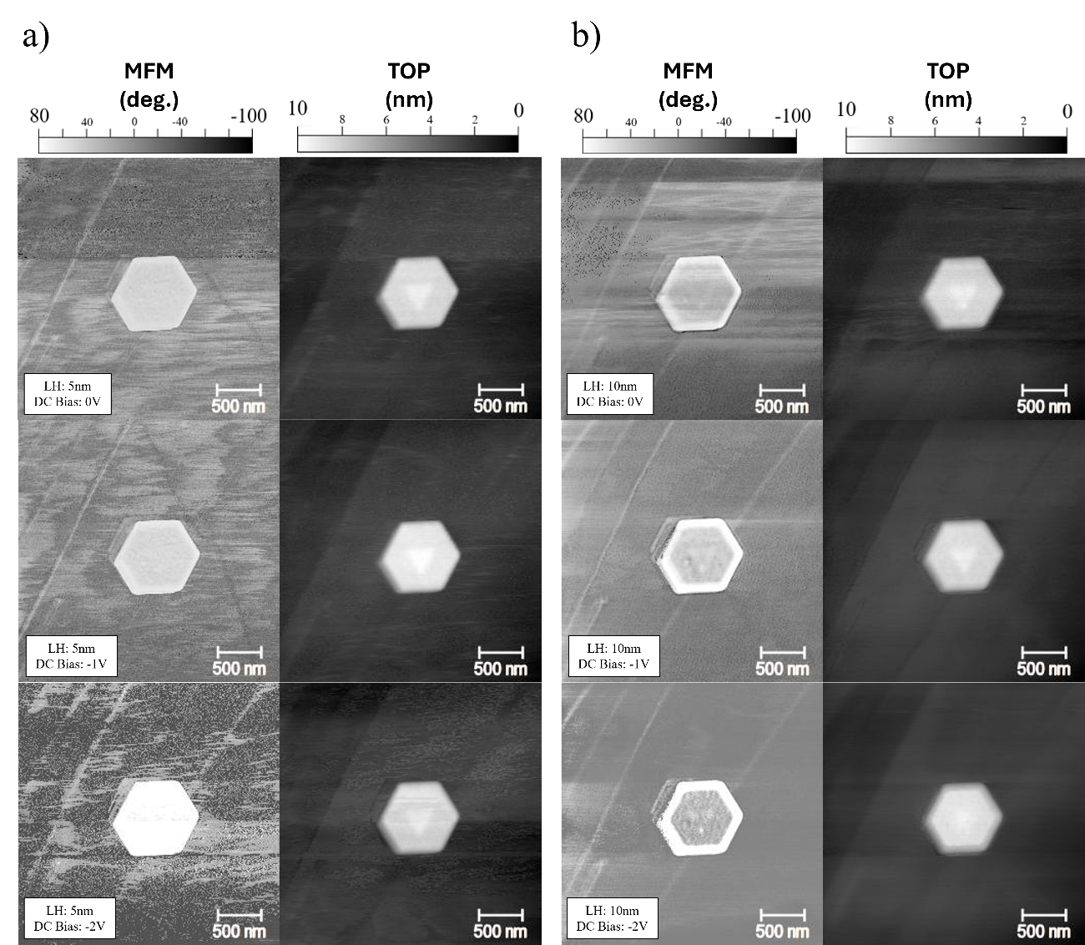
Figure S12: MFM images of the same Bi₂Te₃ nanoplates on HOPG as in Figure 2 (b) but with varying U_{a} and LH. (a) MFM and topographic (TOP) images of a Bi₂Te₃ nanoplate with increasing U_{a} (0 to -2 V) with 5 nm cantilever LH. (b) Same measurement as in (a) but with 10 nm cantilever LH on the same nanoplate. Clearly, the edge state can be observed now. In particular, the background noise has also reduced significantly. Both observations indicate that the magnetic force gradient is dominating.
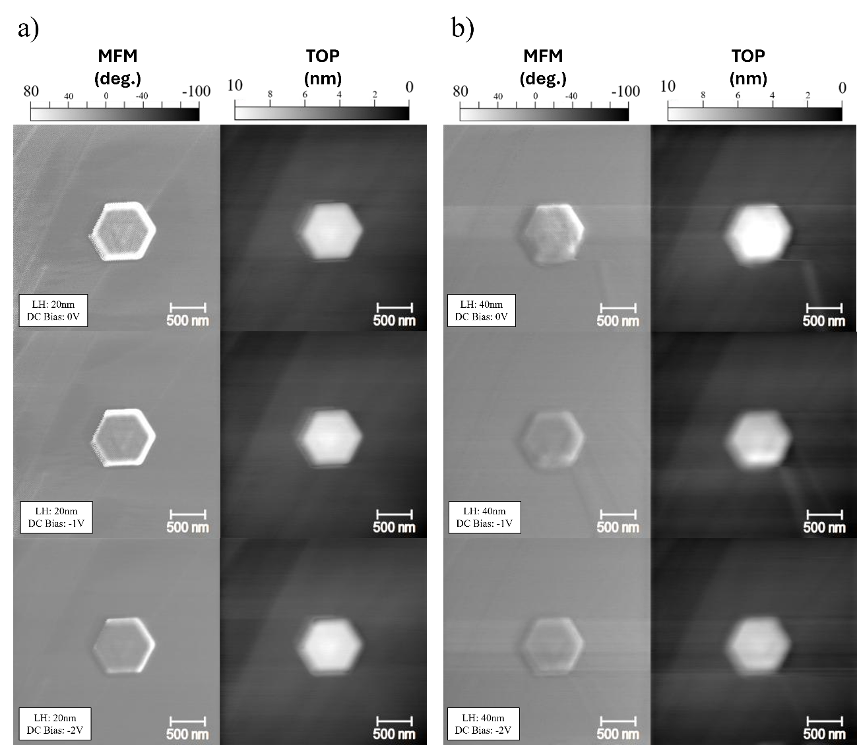
Figure S13: MFM images of the same Bi₂Te₃ nanoplates on HOPG as in Figure S12 (b) but with varying U_{a} and LH. (a) MFM and topographic (TOP) images of a Bi₂Te₃ nanoplate with increasing U_{a} (0 to -2 V) with lift height 20 nm. (b) Same measurement as in (a) but with lift height 40 nm.

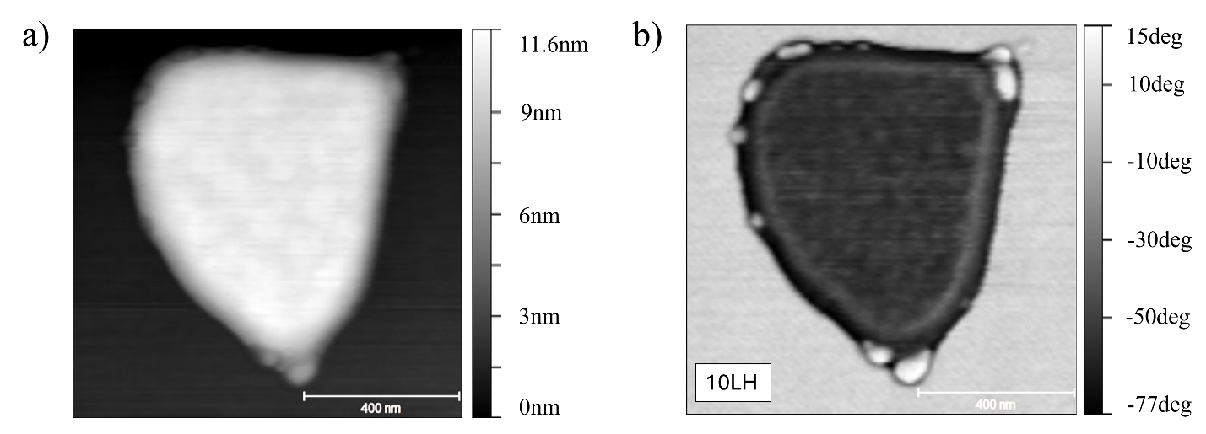
Figure S14: (a) Topographical image of gold nanoplate imaged under similar settings as the Bi₂Te₃ system. (b) Magnetic image of gold nanoplate at a lift height of 10 nm.

As a final check, we also distinguish the persistent current state and a Faraday current induced by the tip in a metallic edge channel. Such Faraday induction in metallic nanoparticles is well known, and we show an example of this in Figure S14. Firstly, in this MFM image, the contrast is in reverse of the edge states we see in the TI systems. Lenz’s law assures us that the Faraday-induced currents in the Au nanoparticle will oppose the introduction of a field. Thus, we should always see a repulsive force in the MFM when imaging a metallic particle as seen in literature [15,16]. But this is NOT what we see in the edge states of the Bi₂Te₃ nanoplate. In this case, we have developed the current state not through induction, but rather through the interaction with two existing states at the edge [17], which should give a current direction that produces an attractive force.

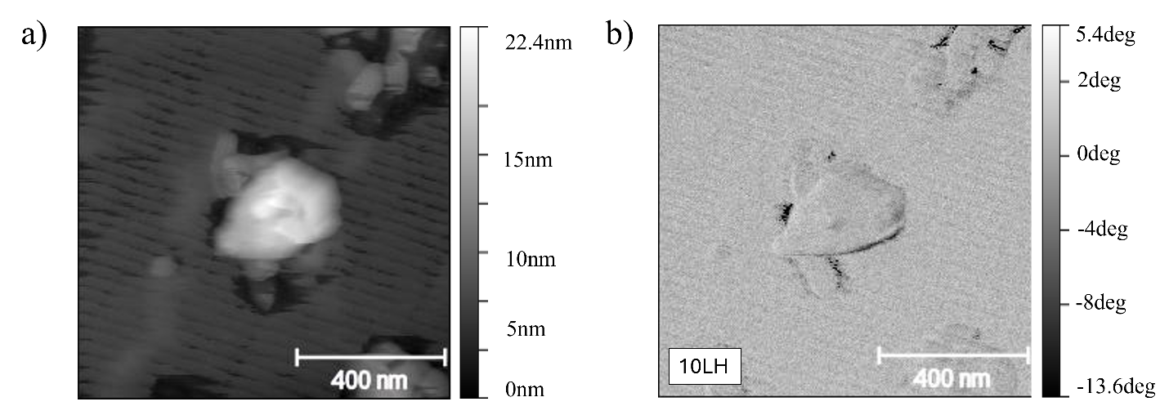
Figure S15: (a) Topographical image of MoS₂ nanoflake. (b) Magnetic image of MoS₂ nanoflake at lift height of 10 nm.

Further, when we compare the MFM contrasts of nanoscale dielectric materials that have similar chemical reactivity, but are known to be trivial insulators, we do not see any edge enhancement in the imaging. This is shown in Figure S15 for the example of a MoS₂ flake with dimensions similar to those of the TIs under study here. However, the role of the dielectric in creating an enhanced capacitive force is evident by the subtle shadowing of the flake in the phase image. What is important here is that there is no significant edge contrast enhancement, even though this MoS₂ flake is exposed to air and certainly has oxygen contamination around the edges. While this would naturally lead to artefacts in STM/STS it doesn’t show up in MFM.

General Flux Estimate

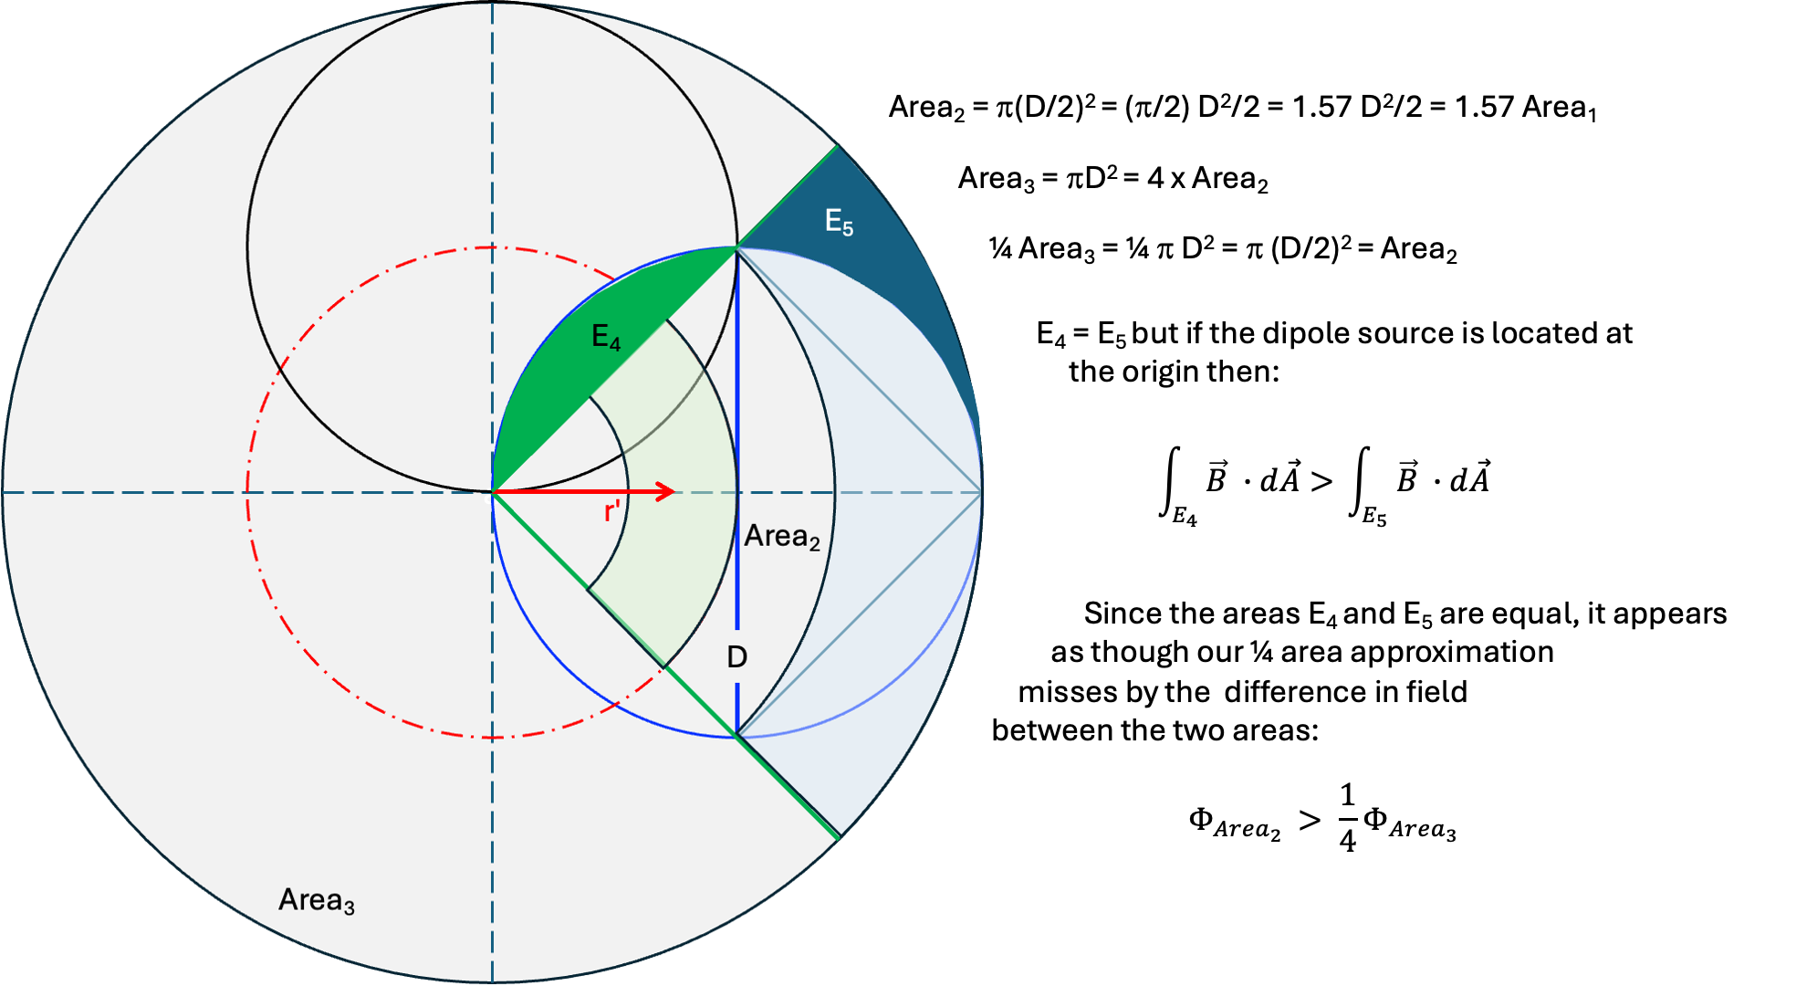

Figure S15: Schematic showing geometrical relationships. Areas inscribed within larger areas can be used to provide a good estimate of the flux of a dipole source at the edge of a circular shaped platelet.

Sample nanoplates vary in shape and size. And we are interested in measuring the phase response when the tip (the magnetic source of the Faraday flux) is dithered near the platelet edge, not at the center of the area as the integral above calculates. This makes the overall flux messy to compute for each sample and it doesn’t provide a general statement of flux behavior. Instead, a reasonable estimate of the generalized flux can be made by starting with a symmetrically placed source, and then sectioning the surrounding area into inscribed polyhedral shapes that approximate the real samples. Such an estimate allows us to express the time dependent flux in two terms, one of which depends only on the height and symmetry of the source (imaging parameters), the other is only dependent on the geometry of the platelet. This means comparisons between samples of different sizes and shapes can be made more easily by varying imaging parameters.

Using this approach, note that in Figure S15 the small circle (Area₂) is inscribed within Area₃ (the large circle) and its diameter (2r = D) is the radius of Area₃. In this case Area₂ is 1/4Area₃ and Area₄ = Area₅. But while these areas are equal, the fluxes through Area₄ and Area₅ are different because the shapes of the areas are different, and they occur at different distances from the dipole source.

It is easier to account for this by comparing the ¼ pie-slice defined by green lines with the inscribed circle of r = D/2. While the two areas are the same, the pie-slice has more of its area located at the edge of the large Area₃ whereas the circle has more of its area near the center of Area₃. The field from the dipole is much stronger near the center of Area₃ than at the edge of Area₃. This means that even though the two shapes have the same area, the inscribed circle has a larger flux than the pie-slice.

Thus, if we allow the limits of integration above r → D then we get the flux associated with the area πD². We relate the fluxes between the symmetric larger area and the off-axis placement on a smaller circle as:
$$Φ_{E_{5}}$$ | $$=$$ | $$\int_{E_{5}}{B_{5}^{||}}dA$$ | (10a)

And
$$Φ_{E_{4}}$$ | $$=$$ | $$\int_{E_{4}}{B_{4}^{||}}dA$$ | (10b)

But both Φ’s compose Area₃ and so the integral can be written as:
$$Φ_{sample}$$ | $$=$$ | $$\frac{1}{4}Φ_{D}- Φ_{E_{5}}+ Φ_{E_{4}}$$ | (11a)
 | $$=$$ | $$\frac{1}{4}{γΦ}_{D}$$ | (11a)

as shown in Figure S15.

References
1. Dun, C. et al. Bi2Te3 Plates with Single Nanopore: The Formation of Surface Defects and Self-Repair Growth. Chem. Mater. 30, 1965–1970 (2018).
2. Marcus, G. E., Carlson, T. W., Swathi, K. & Carroll, D. L. Solution-based iron doping of solvothermally grown 2D hexagonal bismuth telluride. APL Mater. 12, (2024).
3. Williams, D. B. & Carter, C. B. Transmission Electron Microsocpy: Basics I. (Springer Science+Business Media, 233 Springer Street, New York, 1996).
4. Zhao, M. et al. Visible Surface Plasmon Modes in Single Bi2Te3 Nanoplate. Nano Lett. 15, 8331–8335 (2015).
5. Schlomer, H., Jiang, Z. & Haas, S. Plasmons in two-dimensional topological insulators. Phys. Rev. B 103, (2021).
6. Zhao, M. et al. Actively Tunable Visible Surface Plasmons in Bi2Te3 and their Energy-Harvesting Applications. Ad. Mater. 28, 3138–3144 (2016).
7. La, H. et al. Edge-Induced excitations in Bi2Te3 from spatially-resolved electron energy-gain spectroscopy. Ultramicroscopy 254, (2023).
8. Talebi, N. et al. Wedge Dyakonov Waves and Dyakonov Plasmons in Topological Insulator Bi2Se3 Probed by Electron Beams. ACS Nano 10, 6417–7224 (2016).
9. Pedrak, R. et al. Micromachined atomic force microscopy sensor with integrated piezoresistive sensor and thermal bimorph actuator for high-speed tapping-mode atomic force microscopy phase-imaging in higher eigenmodes. J. Vac. Sci. Technol B 21, (2003).
10. Lohau, J., Kirsch, S., Carl, A., Dumpich, G. & Wassermann, E. F. Quantitative determination of effective dipole and monopole moments of magnetic force microscopy tips. Journal of Applied Physics 86, 3410–3417 (1999).
11. Sarid, D. Scanning Force Microscopy: With Applications to Electric, Magnetic, and Atomic Forces. (Oxford University Press, New York, 1994).
12. Israelachvili, J. N. Intermolecular and Surface Forces. (Elsevier, 2011).
13. Jaafar, M. et al. Distinguishing magnetic and electrostatic interactions by a Kelvin probe force microscopy-magnetic force microscopy combination. J. Nanotechnol. 2, 552–560 (2011).
14. Griffiths, D. J. Introduction to Electrodynamics. (Pearson Education).
15. Denisov, S. I., Lyutyy, T. V., Pedchenko, B. O. & Babych, H. V. Eddy current effects in the magnetization dynamics of ferromagnetic metal nanoparticles. J. Appl. Phys. 116, (2014).
16. Shanks, W. E. Persistent Currents in Normal Metal Rings. (Yale University, 2011).
17. Tkachov, G. Topological Quantum Materials: Concepts, Models, and Phenomena. (CRC Press, 2022).

