Toward High-Performance Biosensing: Dual-Mode Detection of Biological Thiols via Synergistic Passivation of Perovskite Quantum Dots
Songbing Gaoª, Qianfeng Liª, Haifa Zhaiª, Gongke Wang^{a,b *}

ª School of Materials Science and Engineering, Henan Engineering Research Center of Design and Recycle for Advanced Electrochemical Energy Storage Materials, Henan Normal University, Xinxiang, Henan 453007, P. R. China
^{b} School of Chemistry and Chemical Engineering, Key Laboratory of Green Chemical Media and Reactions, Ministry of Education, Collaborative Innovation Center of Henan Province for Green Manufacturing of Fine Chemicals, Henan Normal University, Xinxiang, Henan 453007, P. R. China

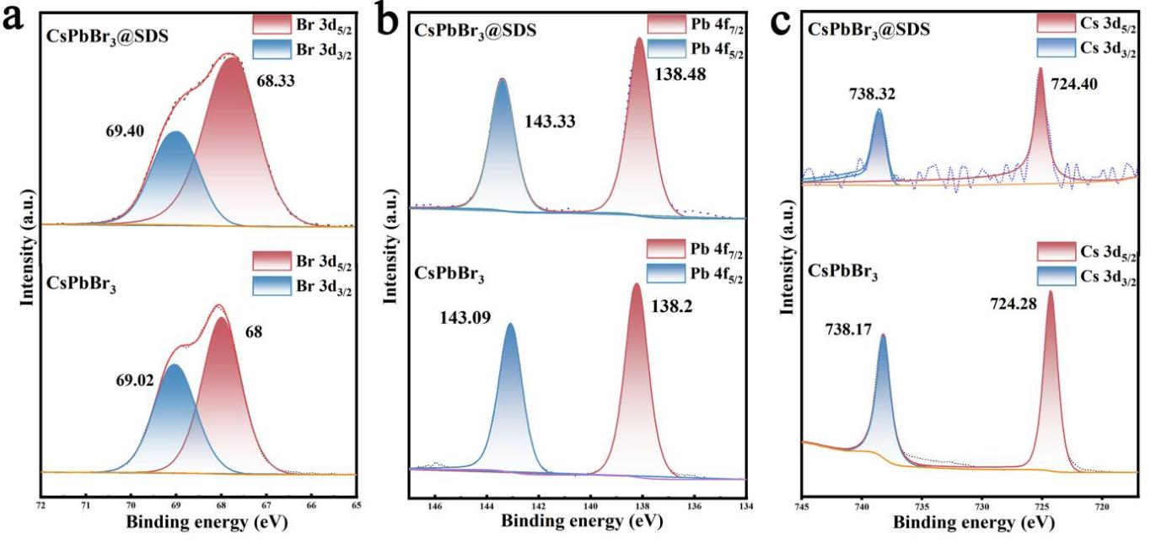Fig. S1 XPS spectra of CsPbBr₃ and CsPbBr₃@SDS QDs for (a) Br, (b) Pb, and (c) Cs.

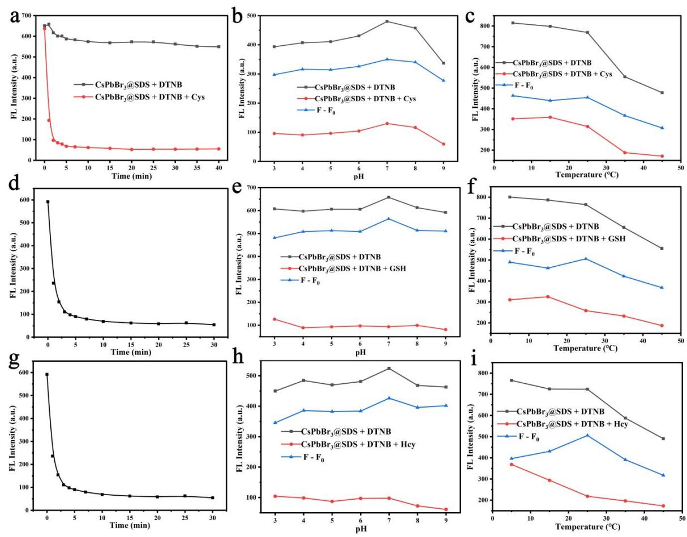
Fig. S2 (a,b,c) Optimization of Cys detection conditions (pH, temperature and incubation time); (d,e,f) Optimization of GSH detection conditions (pH, temperature and incubation time); (g,h,i) Optimization of Hcy detection conditions (pH, temperature and incubation time).

Table S1 Comparison of Biological Mercaptans Detected by Different Sensors
Method | LOD （µM） |  |  | Ref.
Method | Cys | GSH | Hcy | Ref.
Carbon dots，fluorescence | 4.9 | 9.4 | 6.1 | [1]
Au NCs, fluorescence | 8.3 | 9.4 | 14.9 | [2]
GQDs, fluorescence | 6.2 | 4.1 | 4.5 | [3]
GQDs-Hg²⁺, fluorescence | 2.5 | 5 | 5 | [4]
Binaphthalene-maleimide，fluorescence | 42.6 | 52.8 | 16.7 | [5]
DNA-ligand and Ag cluster | 63 | 63 | 28 | [6]
Chromenoquinoline，fluorescence | 19.4 | 23.1 | 14.6 | [7]
CsPbBr₃@SDS QDs, fluorescence | 2.63 | 3.09 | 2.15 | This work

References
1. Zhou L, Lin Y, Huang Z, et al (2012) Carbon nanodots as fluorescence probes for rapid, sensitive, and label-free detection of Hg²⁺ and biothiols in complex matrices. Chem Commun 48:1147–1149. https://doi.org/10.1039/C2CC16791C
2. Park KS, Kim MI, Woo M-A, Park HG (2013) A label-free method for detecting biological thiols based on blocking of Hg2+-quenching of fluorescent gold nanoclusters. Biosensors and Bioelectronics 45:65–69. https://doi.org/10.1016/j.bios.2013.01.047
3. Ran X, Sun H, Pu F, et al (2013) Ag Nanoparticle-decorated graphene quantum dots for label-free, rapid and sensitive detection of Ag+ and biothiols. Chem Commun 49:1079. https://doi.org/10.1039/c2cc38403e
4. Wu Z, Li W, Chen J, Yu C (2014) A graphene quantum dot-based method for the highly sensitive and selective fluorescence turn on detection of biothiols. Talanta 119:538–543. https://doi.org/10.1016/j.talanta.2013.11.065
5. Zhang Y, Huo F, Yin C, et al (2015) An off–on fluorescent probe based on maleimide for detecting thiols and its application for bioimaging. Sensors and Actuators B: Chemical 207:59–65. https://doi.org/10.1016/j.snb.2014.09.091
6. Cao F, Ju E, Liu C, et al (2016) Coupling a DNA–ligand ensemble with Ag cluster formation for the label-free and ratiometric detection of intracellular biothiols. Chem Commun 52:5167–5170. https://doi.org/10.1039/C5CC10606K
7. Kand D, Kalle AM, Varma SJ, Talukdar P (2012) A chromenoquinoline-based fluorescent off–on thiol probe for bioimaging. Chem Commun 48:2722. https://doi.org/10.1039/c2cc16593g

