Appendix A
Microsoft Forms Student Survey with Informed Consent
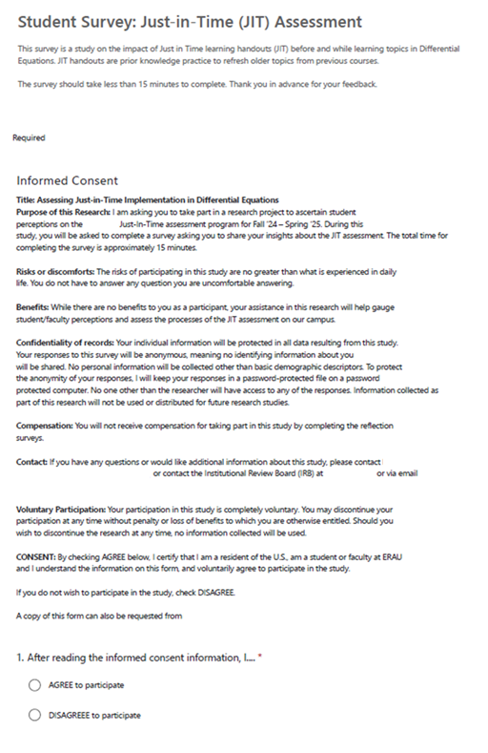
Continued
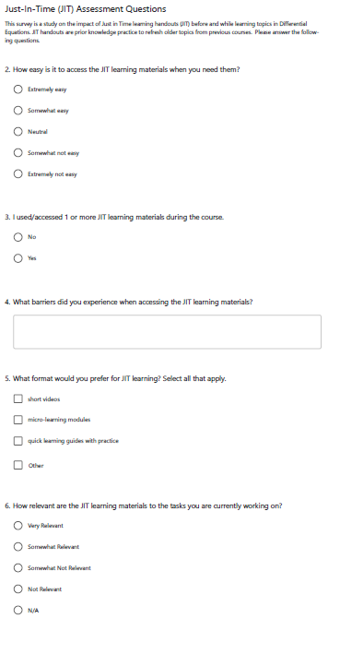

Continued
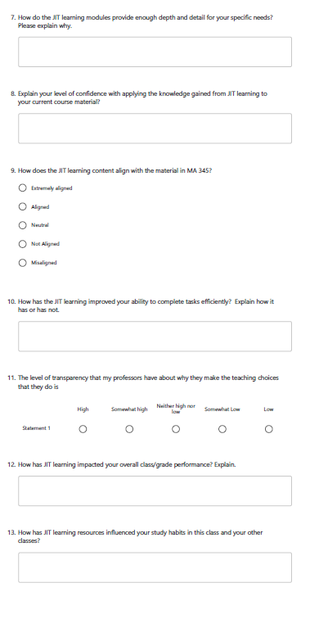

Continued
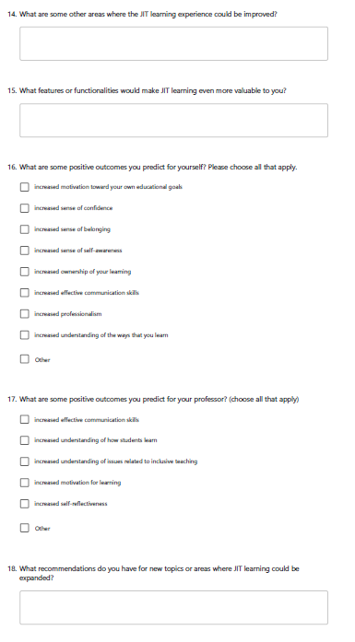

Continued

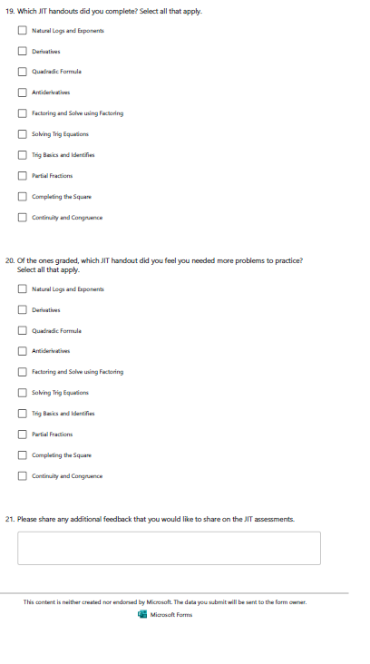

Appendix B
Canvas End of the Course Evaluation Questions Spring 2025
  - 1) Did you participate in 1 or more JIT bonuses?
  - Yes (go to question 2a link)
  - No (go to question 2b link)

  - 2) Divided question parts
  - a) How did JIT resources influence your study habits? [blank space to type]
b) Why did you not participate in 1 or more JOT bonuses? Please check all that apply.
- I did not have enough time.
- I did not want to do them.
- I didn’t think they would benefit me.
- I already knew the material.
- Other, please explain:

