Ultrafast Heating Unveils Hidden Liquid–Liquid Phase Separation

Min Kyung Kwak^{a,b,*}, Robin E. Schäublinª, Jürgen E.K. Schaweª, Eun Soo Park^{b,*}, Jörg F. Löffler^{a,*}
ª Laboratory of Metal Physics and Technology, Department of Materials, ETH Zurich, 8093 Zurich, Switzerland
^{b} Department of Materials Science and Engineering, Research Institute of Advanced Materials & Institute of Engineering Research, Seoul National University, Seoul 08826, Republic of Korea

Content

Supplementary Table 1. EDS analysis showing compositional variations of the domains and matrix during heating under different heating rate conditions……………………………………………………………………S3

Supplementary Table 2. Alloy composition of as-spun ribbon obtained by APT…………………………...….....S4

Supplementary Table 3. Key characteristic temperatures for phase transformation in Pd-Au-Si metallic glass at two different heating rates...…………………………… ………………………………………….……….……S5

Supplementary Figure 1 Structural analysis by TEM diffraction of crystallization behavior in Pd–Au–Si induced by heating at 100 K s⁻¹………………………………………………………………………………...…...S6

Supplementary Figure 2. TEM nanodiffraction structural characterization in Pd–Au–Si of Au-rich domains at induced by heating at 20,000 K s⁻¹ to T_{g,endset}.…………………………………………………………………........S7

Supplementary Figure 3. Bright-field TEM micrographs of Pd–Au–Si in the four investigated conditions: (a) T_{g,endset} (499 ℃), (b) T_{event} (525 ℃), (c) T_{SCL} (550 ℃), and (d) T_{c,endset} (700 ℃) at heating rate of 20,000 K s⁻¹…...S8

Supplementary Figure 4. Lattice parameter measurement of the Au-rich domains’ FCC phase….……....……S9

Supplementary Figure 5. Structural analysis by TEM diffraction of crystallization behavior in Pd–Au–Si induced by ultrafast heating at 20,000 K s⁻¹ ………………………………………………………………………S11

Supplementary Figure 6. STEM characterization of intrinsically non-amorphizable Pd–Au–Si domain material.……………………………….…………………………………….…………………………...…………S12

Supplementary Note 1. EDS results error correction…………………………………………………….….…...S13

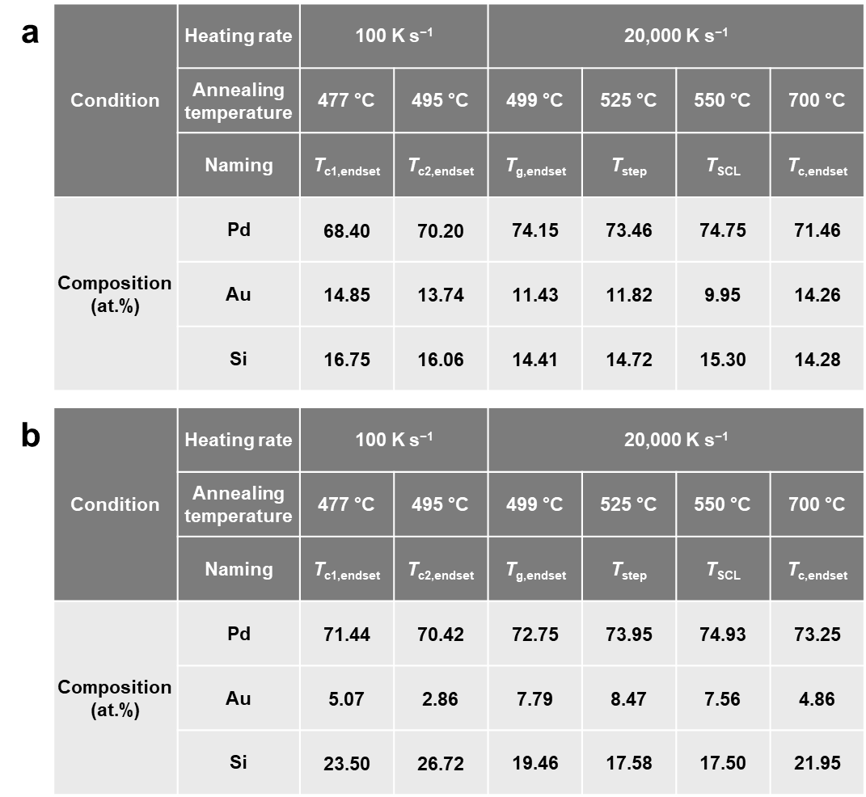

Supplementary Table 1. EDS analysis showing compositional variations of the domains and matrix during heating under different heating conditions. Elemental composition (Pd, Au, Si) of (a) Au-rich domains and (b) the matrix for each heating condition examined.

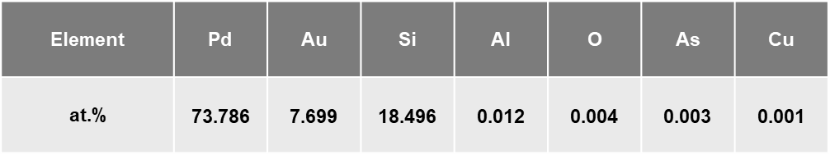

Supplementary Table 2. Alloy composition of as-spun ribbon obtained by APT. The major alloy components were identified as Pd, Au, and Si, making an alloy Pd_{73.8}Au_{7.7}Si_{18.5} (at.%), which agrees well with the nominal composition. Minor impurity elements were Al (0.012 at.%), and C, O, and As (each ≤ 0.004 at.%), indicating a negligible contamination and thus an alloy of high purity. It underscores the reliability of the processing method.

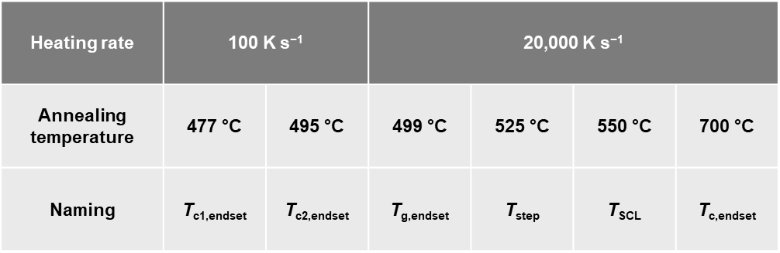

Supplementary Table 3. Key characteristic temperatures for phase transformation in Pd−Au−Si at two different heating rates. Summary of characteristic temperatures for phase transformation used in TEM sample processing using FDSC at two different heating rates: 100 K s⁻¹ and 20,000 K s⁻¹, as referenced throughout the study.

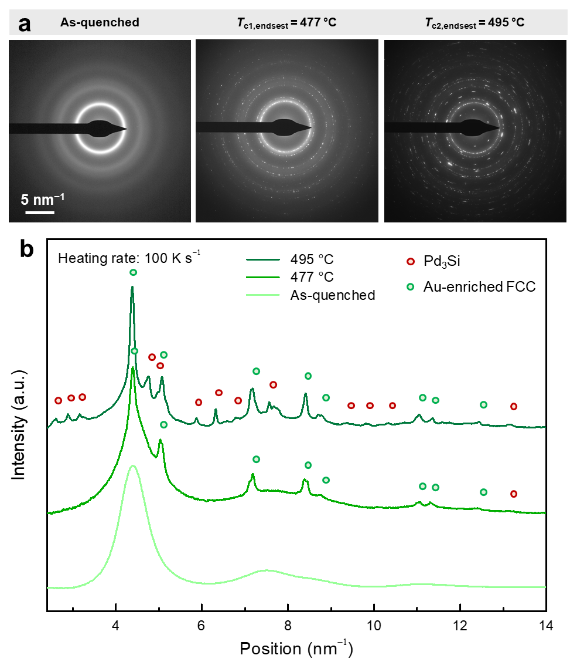

Supplementary Fig. 1. Structural analysis by TEM diffraction of crystallization behavior in Pd–Au–Si induced by heating at 100 K s⁻¹. (a) TEM selected-area electron diffraction patterns (SADPs) acquired in the as-quenched condition, after heating to T_{c1,endset} = 477 ℃, and T_{c2,endset} = 495 ℃, and (b) corresponding profiles obtained by radial averaging of the SADPs. The as-quenched sample was fully amorphous. At T_{c1,endset} = 477 ℃, the sample presents Au-rich domains that have crystallized in the FCC structure in a matrix that remains in an amorphous phase. At T_{c2,endset} = 495 ℃, the matrix has also crystallized, forming an orthorhombic structure.

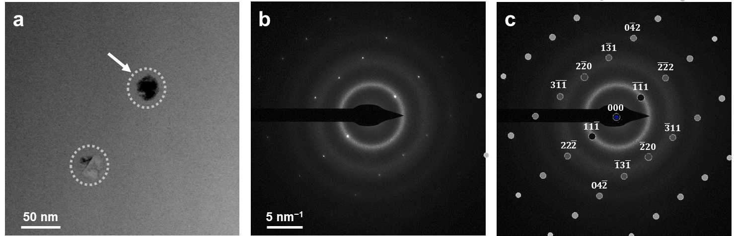

Supplementary Fig. 2. TEM results and phase analysis of Au-rich domains formed by heating at 20,000 K s⁻¹ to T_{g,endset} in Pd–Au–Si. (a) TEM bright-field displaying two distinct Au-rich domains (outlined by dashed circles) exhibiting strong yet variable diffraction contrast, indicating a crystalline structure with imperfections. (b) Nanodiffraction pattern acquired from one of the domains (marked by the arrow in (a)) using an electron beam focused to a few nanometers in diameter. The pattern exhibits diffuse rings from the surrounding amorphous matrix and distinct diffraction spots from the domain, confirming its crystalline nature. (c) Simulated pattern matching and spot indexing were performed using jEMS software. The observed pattern corresponds to a face-centered cubic (FCC) structure viewed along the [112] zone axis.

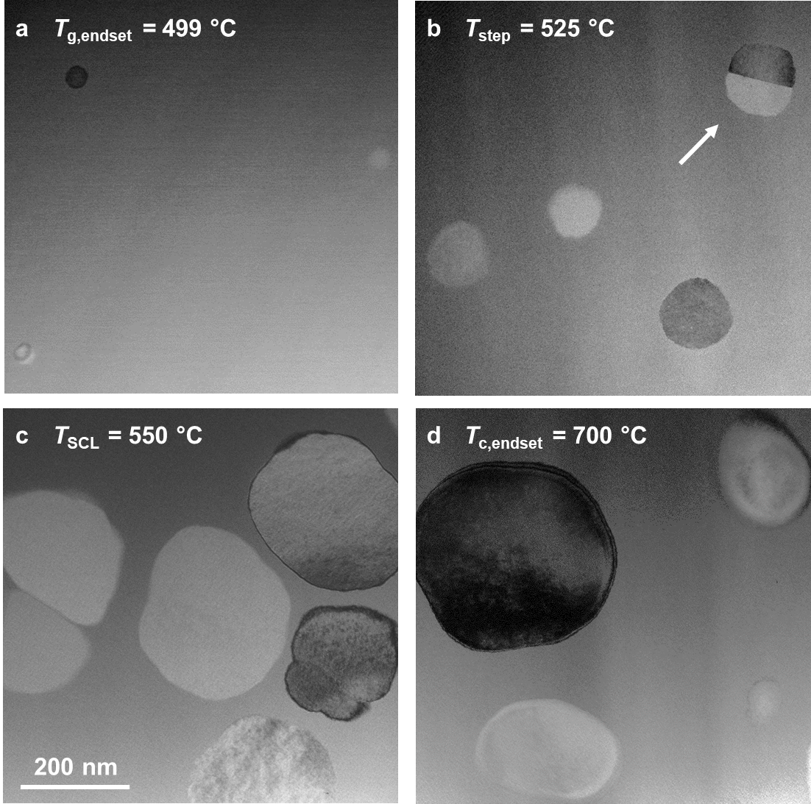

Supplementary Fig. 3. TEM Bright-field micrographs of Pd–Au–Si in the four investigated conditions: (a) T_{g,endset} (499 ℃), (b) T_{event} (525 ℃), (c) T_{SCL} (550 ℃), and (d) T_{c,endset} (700 ℃) at a heating rate of 20,000 K s⁻¹. They reveal the Au-rich globular domains embedded within a continuous matrix showing the smooth, slowly varying contrast typical of amorphous materials. Their size increases with increasing temperature. The Au-rich domains exhibit diffraction contrast that varies strongly between domains due to crystal orientation. Within domains, the contrast is relatively uniform, indicating they are mostly single crystalline, although occasionally they are polycrystalline. See the one marked with an arrow in (b), which exhibits two grains separated by a straight grain boundary. Moreover, the occasionally brighter contrast of the domains relative to the matrix indicates that they have a lower density than the matrix: indeed, since the domains are Au-rich, thus with a higher Z element, they should promote high-angle scattering and appear darker in the TEM bright field. However, one should consider the competition between different contrast mechanisms: there is Z contrast, which is proportional to Z², and absorption, which depends on density (g cm⁻³). Some of the domains, appearing brighter than the matrix despite a higher Z, indicate a lower density.

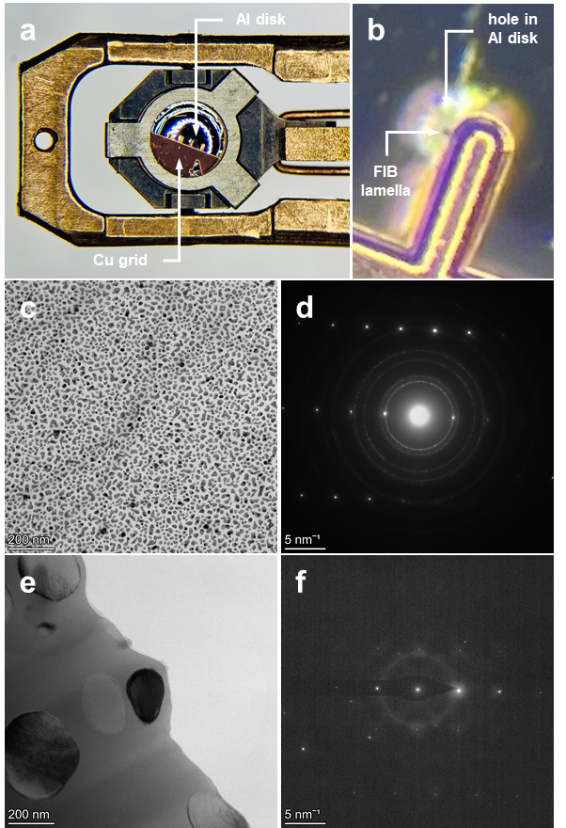

Supplementary Fig. 4. Lattice parameter measurement of the FCC phase in the Au-rich domains.
(a, b) Light microscope image showing the experimental setup allowing for the accurate measurement of the lattice parameter of the Au-rich domain FCC phase: (a) a 3 mm Al disk electropolished to electron transparency and coated with Au nanoparticles in the TEM sample holder, which was covered with the Cu grid holding the FIB lamella of Pd–Au–Si. (b) The Cu grid was positioned to ensure the FIB lamella was precisely over the hole in the Al disk, allowing measurements on both samples with the same TEM settings by slightly adjusting the holder position. Fine dispersion of gold nanoparticles over the Al foil: (c) TEM bright-field and (d) SADP with the sharp rings corresponding to the Au NP and the spot pattern corresponding to the Au foil. Au-rich domain in Pd–Au–Si: (e) Bright-field TEM and (f) SADP with the diffuse rings corresponding to the amorphous matrix and the spot pattern corresponding to the domain with the dark contrast in the center of the image in (e).

The crystalline structure of the Au-rich domains was investigated by diffraction in the TEM. For that purpose, the sample in the T_{c,endset} (700 ℃) condition, exhibited domains large enough for SADP. The sample was tilted to obtain SADPs along high-symmetry zone axes. These experimental patterns were then compared with simulated patterns generated using jEMS software¹, and the best match, including the best match to the experimental angle of tilt between patterns, was obtained for a face-centered cubic (FCC) structure. This is consistent with Turnbull’s findings². The lattice parameter was measured from the SADPs, using as a reference an SADP of a separate sample of pure Au nanoparticles acquired under precisely the same TEM experimental conditions to ensure accuracy. For that purpose, both samples were mounted on top of each other in the sample holder, which allowed maintaining the same excitation of the microscope's electromagnetic lenses. The only change was the sample holder height and lateral position, allowing the SADP to be obtained from either the Pd–Au–Si FIB lamella or the Au nanoparticles. Using this method, an accuracy of approximately 10⁻⁴ nm was achieved. The resulting lattice parameter for the domain FCC structure was 0.3925 ± 0.0002 nm, in good agreement with a previous report³.

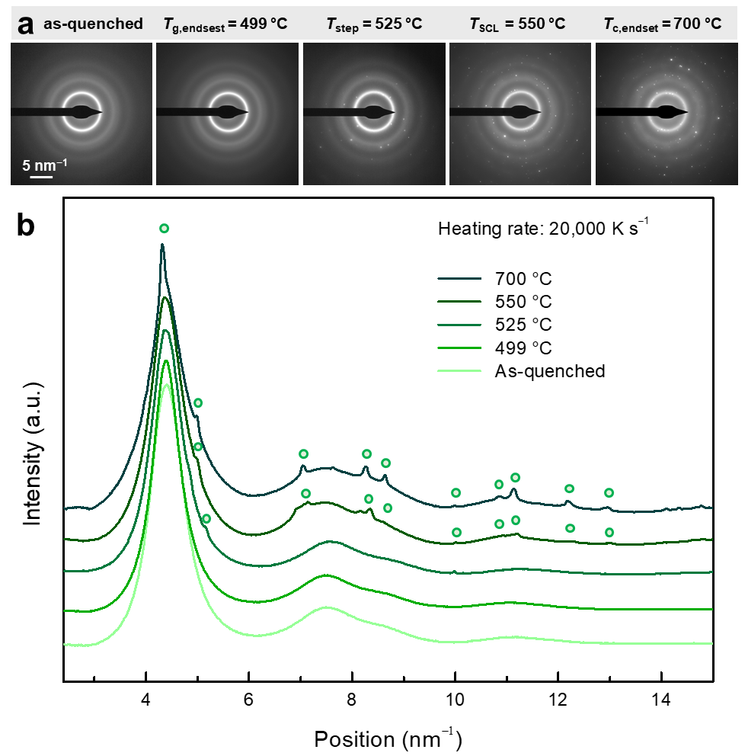

Supplementary Fig. 5. Structural analysis by TEM diffraction of crystallization behavior in Pd–Au–Si induced by ultrafast heating at 20,000 K s⁻¹. (a) TEM selected-area electron diffraction patterns (SADPs) acquired in the as-quenched condition, after cooling from T_{g,endset} = 499 °C), after the weak thermal event (T_{event} = 525 °C), within the SCL (T_{SCL} = 550 °C), and after crystallization (T_{c,endset} = 700 °C, and (b) corresponding profiles obtained by radial averaging of the SADPs. The as-quenched material was completely amorphous as indicated by the diffuse rings. At 499 °C, the material presented the early nanoscale Au-rich domains in a matrix that remained amorphous. Their volume fraction was insufficient to yield diffraction spots, as evidenced by the presence of only diffuse rings in the SADP and the corresponding smooth profile. At 525 °C, Au-rich domains generated diffraction spots in the SADP in addition to diffuse rings, with a volume fraction just sufficient for detecting the FCC phase in the profile. At 550 °C, the material presented larger Au-rich domains that yielded diffraction spots in a sufficient number to mark the sharp diffraction rings of the FCC structure, in addition to the diffuse rings of the matrix. These sharp rings are clearly marked by corresponding peaks in the profile. At 700 °C, the SADP and the corresponding profile were similar to the ones at 550 °C, but the height of the peaks corresponding to the FCC structure relative to the profile of the diffuse rings is higher. It relates to the larger volume fraction of domains.

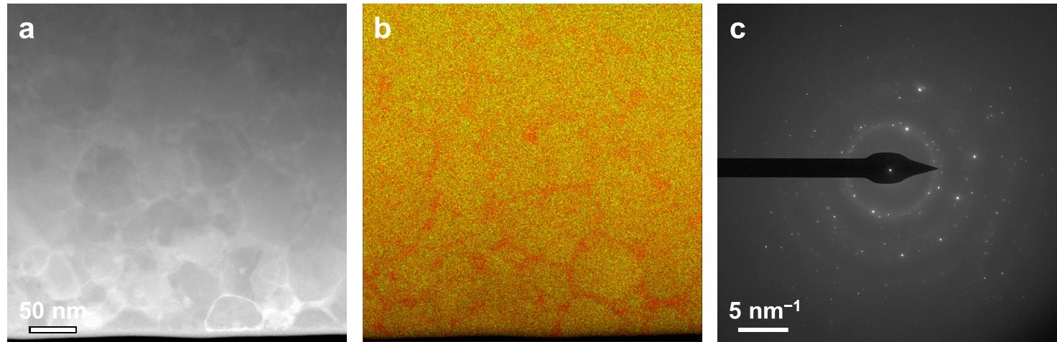

Supplementary Fig. 6. STEM characterization of intrinsically non-amorphizable as-spun Pd–Au–Si domain material. (a) High-angle annular dark-field (HAADF) STEM image revealing a tightly packed globular structure. (b) Corresponding chemical map with Pd shown in red and Au in green, evidencing an interglobular phase that is rich in Pd. (c) The selected-area diffraction pattern (SADP) shows diffuse rings from the Pd-rich phase between the domain material globules, indicating it is amorphous, and spots from the domain material that align with fcc diffraction rings. It shows that the domain material exhibits crystalline order even in as-spun ribbons, indicating its intrinsic non-amorphizability.

Supplementary Note 1. EDS results error correction

The absolute uncertainties in the EDS results were ± 2.5, 1.0, and 2.0 at.% for Pd, Au, and Si, respectively, as determined by the analysis software VELOX.

The chemical composition obtained by EDS was cross-checked by APT on an as-quenched sample, using the method developed in APT⁴. The APT tip with an apex about 50 nm in diameter was prepared by FIB. After the APT measurement, the tip was then further milled by FIB in the form of a lamella about 10 nm thick for EDS measurement in the TEM. This ensured that the same area was evaluated by both methods. It indicated that EDS systematically overestimated the Si content in the thin areas of interest for EDS measurement (about 5−10 nm thick) by about 2 at.%. This was due to Si redeposition on the free surfaces of the lamella during the FIB process. All EDS measurements of the Pd, Au, and Si content reported in this work were then corrected according to the following approach. The Si content was measured over a large area (including domains), giving a value $C_{Si_measured_bulk}$. The Si true bulk content, $C_{Si_true_bulk}$, was taken as 18 at.%. This allowed deducing a correction factor r:

$$r = (C_{Si_measured_bulk} - C_{Si_true_bulk}) / (1 - C_{Si_measured_bulk})$$

This correction factor r was applied to the measured contents in Pd, Au and Si, respectively, $C_{Pd_measured}$, $C_{Au_measured}$, and $C_{Si_measured}$, in at.%, in both the domains and the matrix, yielding respectively $C_{Pd_corrected}$, $C_{Au_corrected}$, and $C_{Si_corrected}$ using the following formulas:

$$C_{Pd_corrected} = C_{Pd_measured}× (1 + r)$$
$$C_{Au_corrected} = C_{Au_measured}× (1 + r)$$
$$C_{Si_corrected} = C_{Si_measured}× (1 + r)- r$$

This ensured that the total composition summed to 100 at.%.

The Ga⁺ content implanted by the FIB in the thin lamella was controlled by TEM EDS, at the very edge of the sample at the bottom of the lamella, where the highest Ga deposition was expected. It was at most 1 at.%.

References

1. Stadelmann P. EMS-a software package for electron diffraction analysis and HREM image simulation in materials science. Ultramicroscopy 1987, 21(2): 131-145.

2. Peter Chou CP, Turnbull D. Transformation behavior of Pd–Au–Si metallic glasses. J Non-Cryst Solids 1975, 17(2): 169-188.

3. Suzuki RO, Osamura K. SAXS study on crystallization of an amorphous Pd76Au6Si18 alloy. Journal of Materials Science 1984, 19(5): 1476-1485.

4. Schäublin R, Becker M, Cihova M, Gerstl SS, Deiana D, Hébert C, et al. Precipitation in lean Mg–Zn–Ca alloys. Acta Mater 2022, 239: 118223.

