Wireless lightweight implantable pulse generators enable chronic dual-target deep brain stimulation in rodent disease models

Raik Paulat*^{#1}, Leif Koschützke*^{#1,2} Jens Haumesser^{1,3}, Lukas Maurer⁴, Jennifer Altschüler^{1,5}, Hui Tang⁴, Harold Hounchonou^{4,6}, Amido Daugardt^{1,2}, Daniel Harnack^{1,7}, Verena Just^{8,9}, Gino Schulz¹, Christoph Harms^{1,2}, Andrea A. Kühn¹, Nikolaus Wenger^{##1} & Christoph van Riesen^{##10,11}

Supplementary material
Supplementary Table 1
References | Stimulation - Parameters |  |  |  | Stimulation - Hardware |  |  |  |  |  |  |  |  | Stimulation - Features |  | Rodent model
 | Intensity  [μA] | Frequency  [Hz] | Puls width  [µs] | Waveform / Paradigm | Electrode |  |  |  |  |  | Stimulator |  |  | Board Dimension / Weight  [mm] / [g] | Supply / Consumption | Species | Target
 |  |  |  |  | R / Z,  in vitro  [kΩ] | Z_{STIM}  in vivo  [kΩ] | Diameter  [µm] | Charge Density, (Charge per Phase) | Manufacturer | Tip / Material | Type | Channel / Duration | Application
Kolbl et al., 2015 [1] | 400 | 130 | 60 | current mode, charge balanced stimulation | - | - | .008 mm bare, .0110 mm coated | - | Phymep, France | needle-like two wire electrodes of twisted tungsten | wireless, | 2 ch,  6d | head-stage | - /  13.8 | 3 x Zinc-Air, battery changing / 1.9 mA average current consumption 17.6 V | rat | bilateral STN
Fluri et al., 2017 [2] | 20, 40, 60, 80, 120, 300 | 30, 70, 130 | 60 | monophasic pulses, transient pulse net charge is zero | - | - | - | - | - | - | wireless | 1 ch/ 30 d | implant | 21 x 11 x 7 / 2.5 | 3.1 V / 2 x 1.55V, ~20 µA | rat | unilateral mesencephalic locomotor region
Lee et al. 2019 [3] | 60 – 1860 | 13 -414 | 9.5 - 304 | biphasic, charge balanced, constant current | - | - | - | - | - | - | wireless &  hardwired | 4 stim. ch.&  32 recording channels  /  unlimited | head-stage | 19 x 19 x 30 /  5.7 | Inductively powered 35 mW @ 1 V | rat | HP
Fleischer et al., 2020 [4] | 0 - 300 | 10 - 500 | 60 - 500 | monophasic pulses, transient pulse net charge is zero | 1 + | - | 50 | - | Science Products GmbH, Hofheim | Pt – Ir | wireless | 1 ch / 30d | implant | ca. 10 x 10 x 2.5 / 2.8 | 3.1 V / 2 x 1.55V ~20 µA | mouse | NAc
Burton et al. 2021 [5] | 1.5 – 5.5 V  @ 1600 | up to 50,000 | 20 – n/a | symmetric biphasic, tristate, charge balanced stimulation | 10 | - | 50 | current density threshold @ 5V pulses >0.97mA/cm | custom-made and  16 ch. 50µm  Laminar Microprobes for life | bipolar/ Pt | wireless | 1 stim. ch. &  16 record. ch. /  long-term (36 d) | implant | ca. 15 x 7.5 x 1 / 0.046 | Harvesting  2 – 10 W /  6 mA | rat | MFB
Plocksties et al. 2022 [6] | 42 – 100  setting (2)  (2 x 50) | 10 - 5000 | 1 – 100% duty cycle | uni- & bipolar, passive charge balanced | 0.329 / - | - | 100 | - | bipolar, Science Products GmbH, Hofheim /  unipolar, Microprobes Inc. PlasticsOne Inc. | concentric MicroProbes (PI-SNEX-100) /  - | magnet | 2 ch. /  126 d  A STELLA | implant | Ø13 x 3.3 / 2.5 | CR1216, 2.1 – 34 V /  (2) 7.6 µA 3.1 V | rat & hamster | unilateral STN / uni- & bilateral EPN
Milner Paul et al. 2022 [7] | 10 – 400 | 50 – 500 | 90 | monophasic cathodic, constant current | 3, 5, 7, 9 / - |  | 125 / 127 | - | Micro Probe | monopolar coated tungsten, bipolar, covered electrode | wireless | 1 ch. /  2 months | backpack + electrode head-stage | 21 x 13 x 3mm / 8.5 | 2.9 V / - | rat | Motor cortex region
Grotemeyer et al. 2024 [8] | 10 – 500 | 10 – 200 | 60 – 500 | constant-current, monophasic, | - /< 50 | - | 100 | - | custom-made,  Thomas RECORDING GmbH | conical quartz glass and IrOx-coated platinum–tungsten electrode | wireless | 1 ch.,nc 2.ch. /  52 days | implant | 18 × 16 × 5 mm | 3 V | mouse | STN
herein presented systems | 1 –100 /  set to cathodic 100, anodic 8 | 2 – 257/ set to 20-130 & (burst) 100 [9] | 50 – 700 /  set to cathodic 60, anodic 670 | biphasic, cohesive, negatively charge imbalanced, bipolar, constant current | 1.85 / 2.96 | max. 29.2 @ 130 Hz | 150 /  75 (NAc test tips) | 0,93 µC / cm²,  (-2,2 µC), [log₁₀], @ 130 Hz | custom-made, CWW – Charité-Universitätsmedizin Berlin | Monopolar, Ir.-electrode, stainless steel - lead wires | wireless | 2 ch. delayed /  62 d or 49 d (in voltage compliance) | head-stage | 12.6 x 12.6 x 5.2, 9.8 x 9.8 x 2.6 / 1.6, 0.9 | 3 V lithium /  250 nA -21.9 µA,  850 nA – 21.3 µA | rat & mouse | STN  & NAc
Supplementary Table 1: Selection of experimental microstimulators. Additional information on experimental systems can be found in Knorr et al. 2022 [10]. “-“: not available, µA: microAmpere, µs: microseconds, ANT: anterior thalamic nucleus, ch: channel(s), d: day(s), EPN: entopeduncular nucleus, h: hour(s), P: hippocampus, Hz: Hertz, Ir: Iridium, max.: maximum, MFB: medial forebrain bundle, mAh: milliampere hour, min.: minimum, m: minute(s), NAc: Nucleus Accumbens, Pt: Platinum, s: seconds, SN: substantia nigra, STN: subthalamic nucleus

Supplementary Figure 1

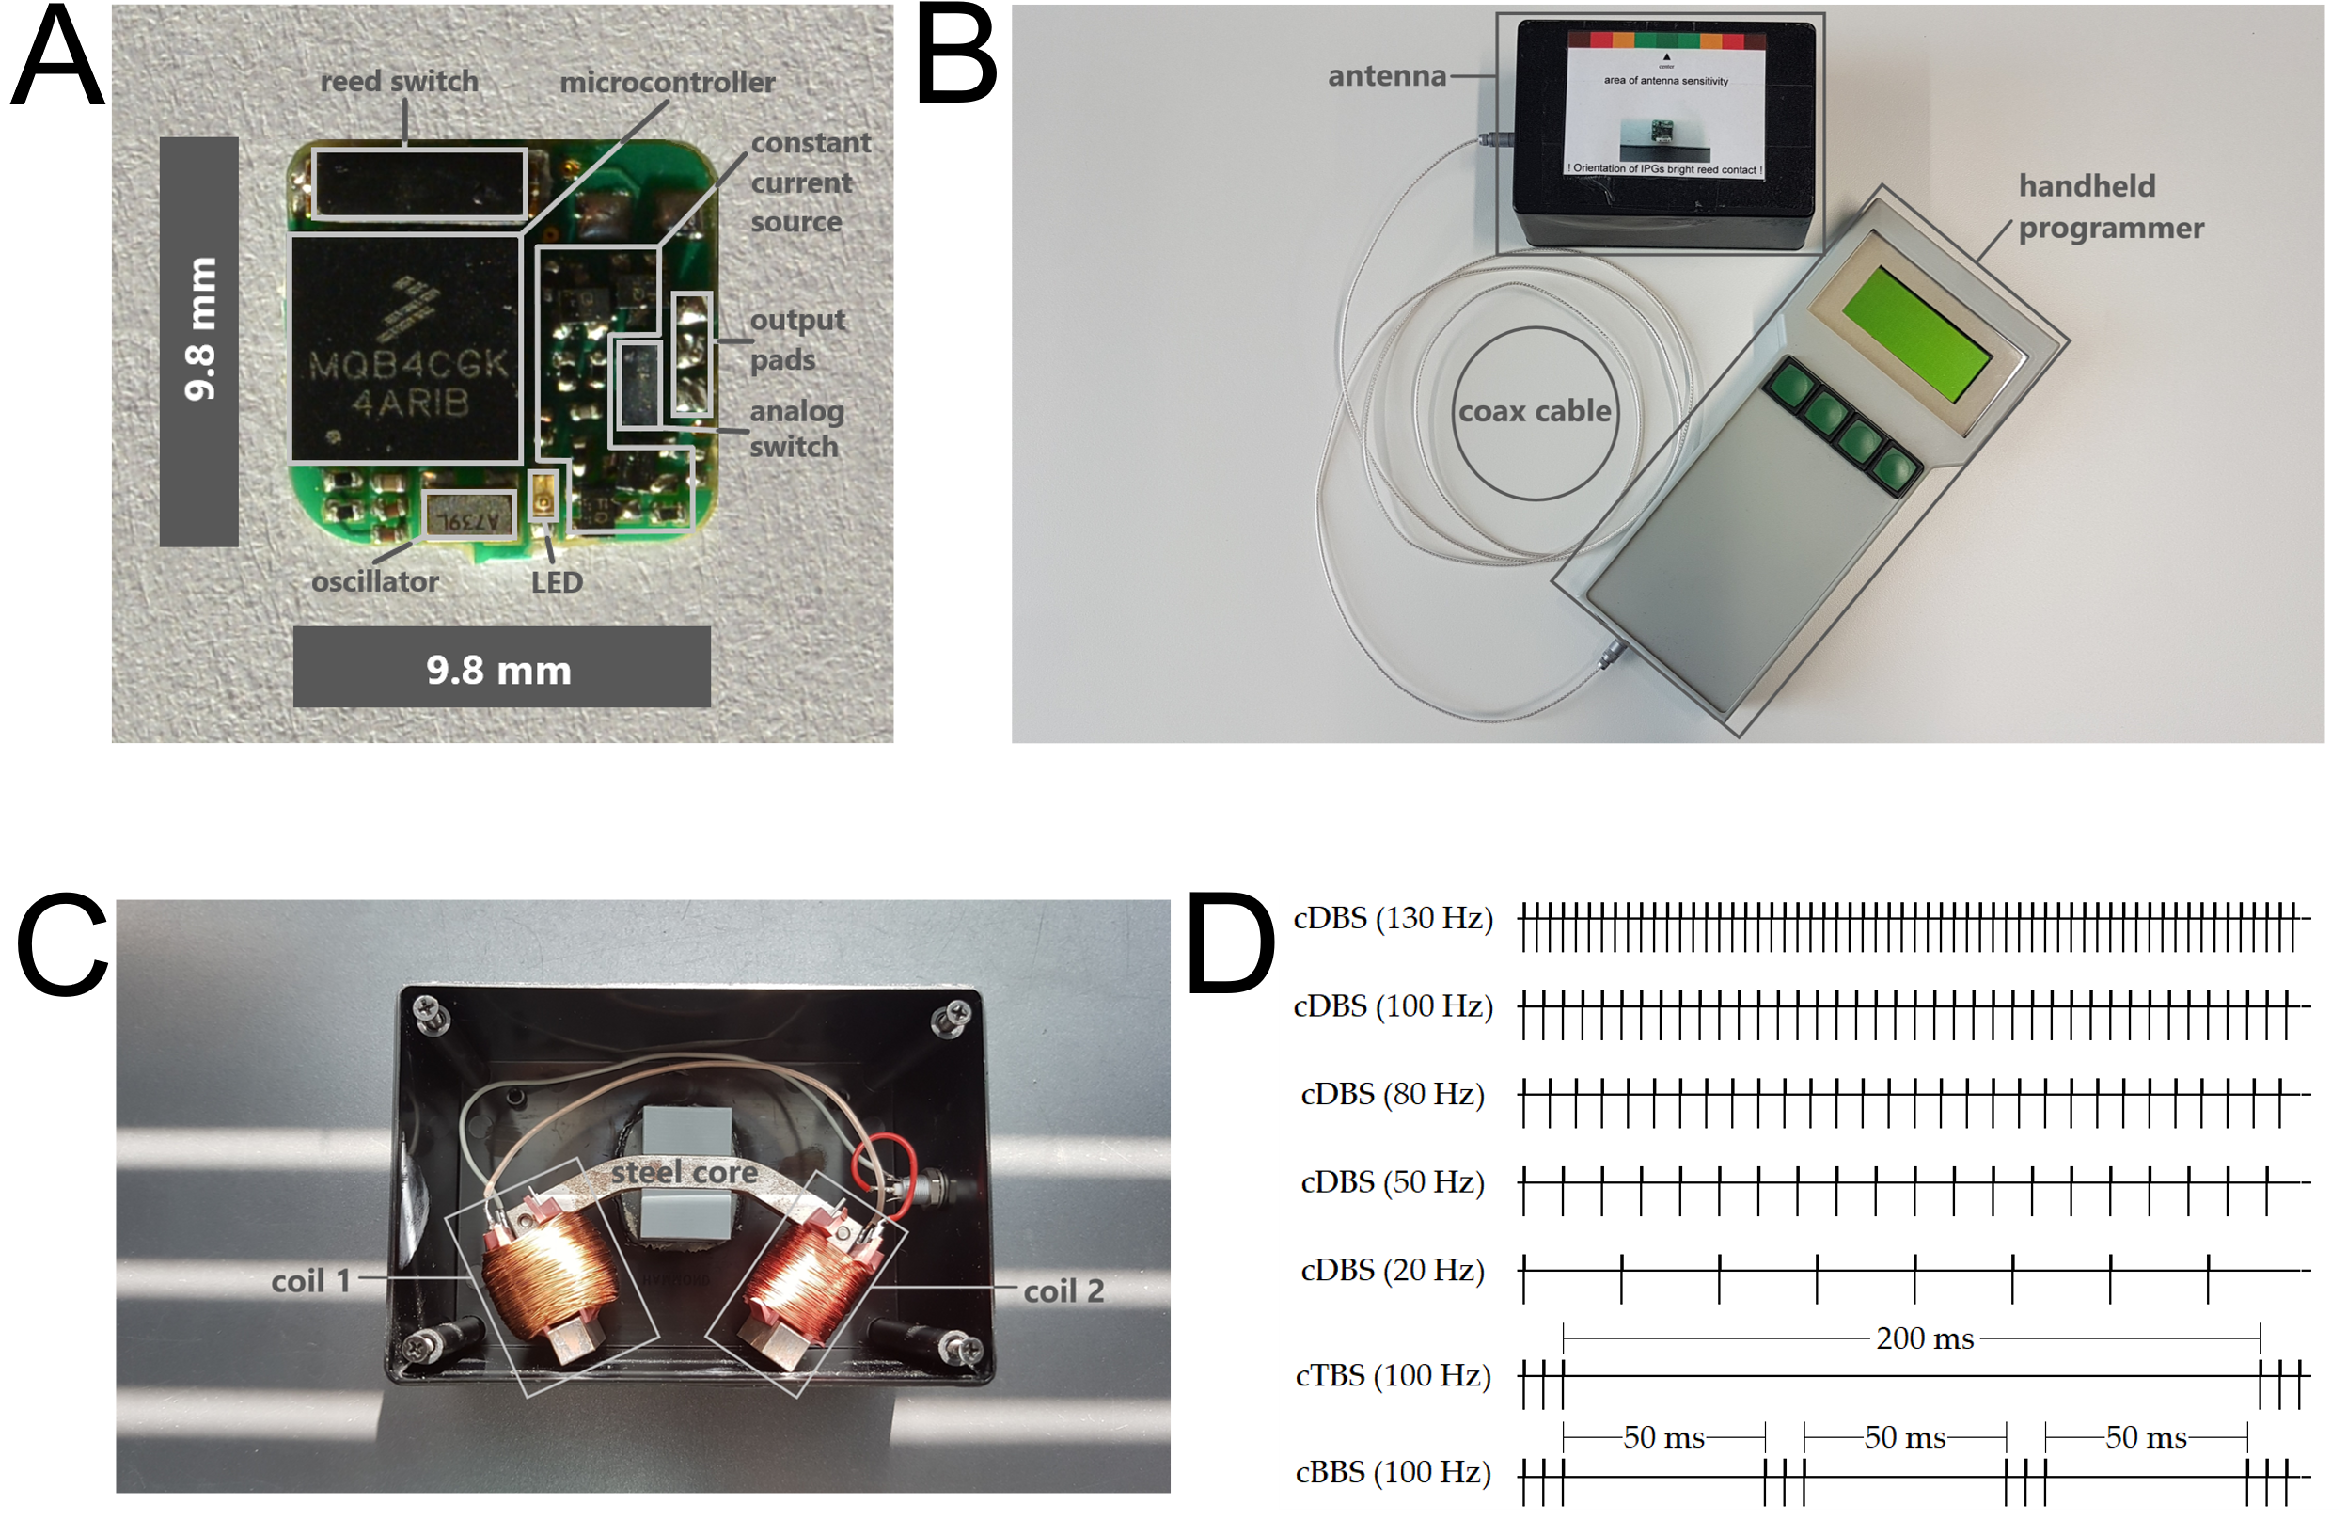
Supplementary Figure 1. (A) Board dimensions of the tiny IPG. (B) Transmitting coil and interconnected programmer. (C) Close up of the transmitting coil. (D) Programmed several different stimulation paradigms, including 20/50/80/100/130 Hz continuous deep brain stimulation (cDBS), as well as two modified burst paradigms: continuous Theta- and Beta-burst- stimulation (cTBS, cBBS) at 100 Hz pulse frequency (please also see coils effectively near-field to an IPG in 2D in FEM-simulation in GitHub folder https://github.com/RPaulat/expDBS).

Supplementary Table 2

Measured current consumption and calculated duration in bench top testing using different stimulation paradigms for small microstimulators (n=16, s-IPG).

Paradigm cDBS cDBS cDBS cTBS cBBS Standby

Frequency 130Hz 100Hz 20Hz 100Hz 100Hz -

Consumption [I] 21.9µA 17.8µA 6.1µA 18.4µA 20.6µA 250nA

Duration* (hours/days) 1826.5h/76.1d 2247.2h/93.6d 6557.4h/273.2d 2173.9h/90.6d 1941.8h/80.9d >18y

IPG-Information, LED flashing 7x short 5x short 3x short 11x short 9x short 1x long

*calculated with Q = I * d and t = Q / I = (nominal capacity) / (individual measured current consumption), where Q was 40 mAh (manufacturer coin cell capacity for the CR1220) and I was the corresponding average current consumption of each set paradigm.

Supplementary Table 3

Measured current consumption and calculated duration in bench top testing using different stimulation paradigms for tiny microstimulators (n=9, t-IPG).

Paradigm cDBS cDBS cDBS cDBS cDBS cTBS cBBS Standby

Frequency 130 100 80 50 20 100 100 -

Consumption [I] 21.3µA 17.4µA 14.5µA 10.5µA 6.4µA 18.0µA 19.9µA 850nA

Duration*, (hours/days) 1407.7h/58.7d 1721.9h/71.7d 2065.8h/86.1d 2863.2h/119.3d 4695.7h/195.7d 1666.7h/69.4d 1509.2h/62.9d 35294.1h/1470.6d

IPG-Information, LED flashing 7x short 5x short 15x short 13x short 3x short 11x short 9x short 1x long

*calculated with Q = I * d and t = Q / I = (nominal capacity) / (individual measured current consumption), where Q was 30 mAh (manufacturer coin cell capacity for the CR927) and I was the corresponding average current consumption of each set paradigm.

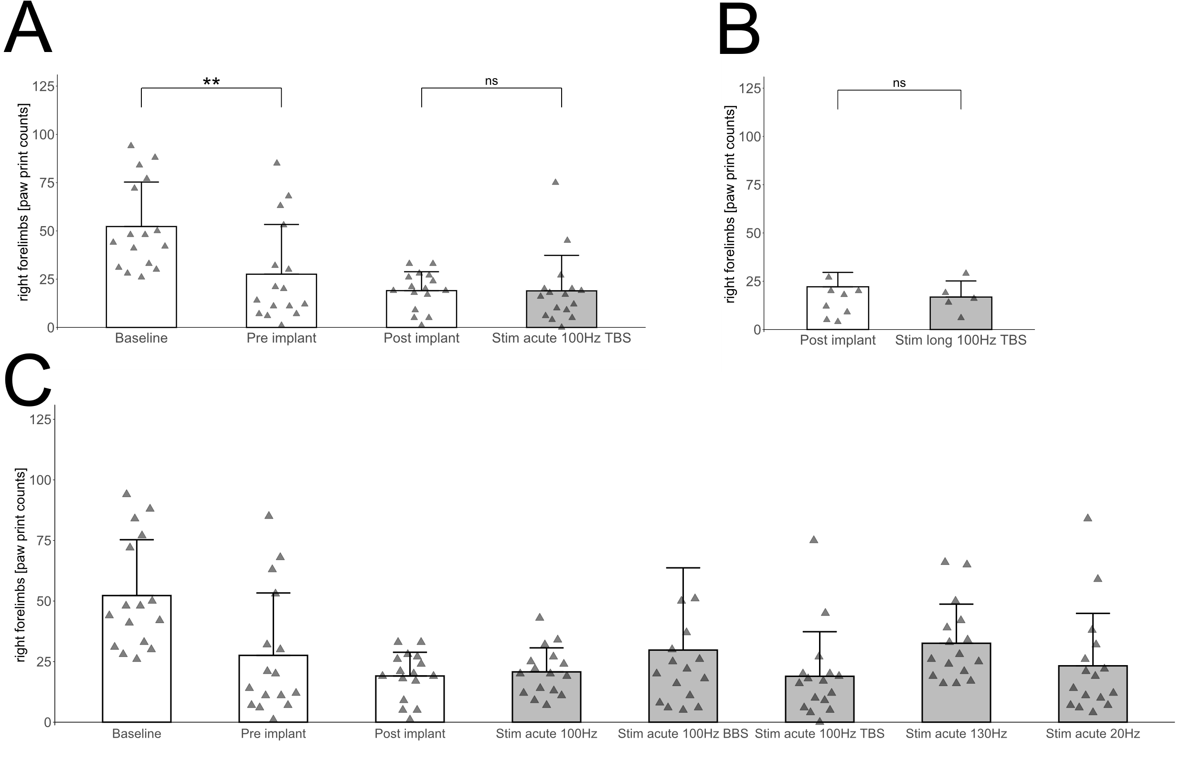
Supplementary Figure 2
Supplementary Figure 2. (A & B) showing results (in contrast to manuscript Figure 2B and 2C) of parametric analysis of 4 different treatment days of n = 16 animals also from baseline over 6-OHDA phase to acute phase of not significant theta-burst-stimulation with 100Hz. In (B) we also show results of the parametric analysis. In this second case we tested for behavior in pairs from post implantation to final long-term 100Hz theta-burst-stimulation. Stimulation did not show increased motor behavior in acute and throughout the long-term treatment (n = 8 to n = 5). Statistical analysis in (A&B) as pairwise Student’s t-tests (p-values please see text). More statistical details in the GitHub folder https://github.com/RPaulat/expDBS. The acute trail comprehension in (C) shows all results before post implant (white bars) in contrast to the different acute paradigms (grey bars) for the cylinder tests (n = 16). The acute stimulation phase (grey bars) was randomized and spitted into different delayed groups.
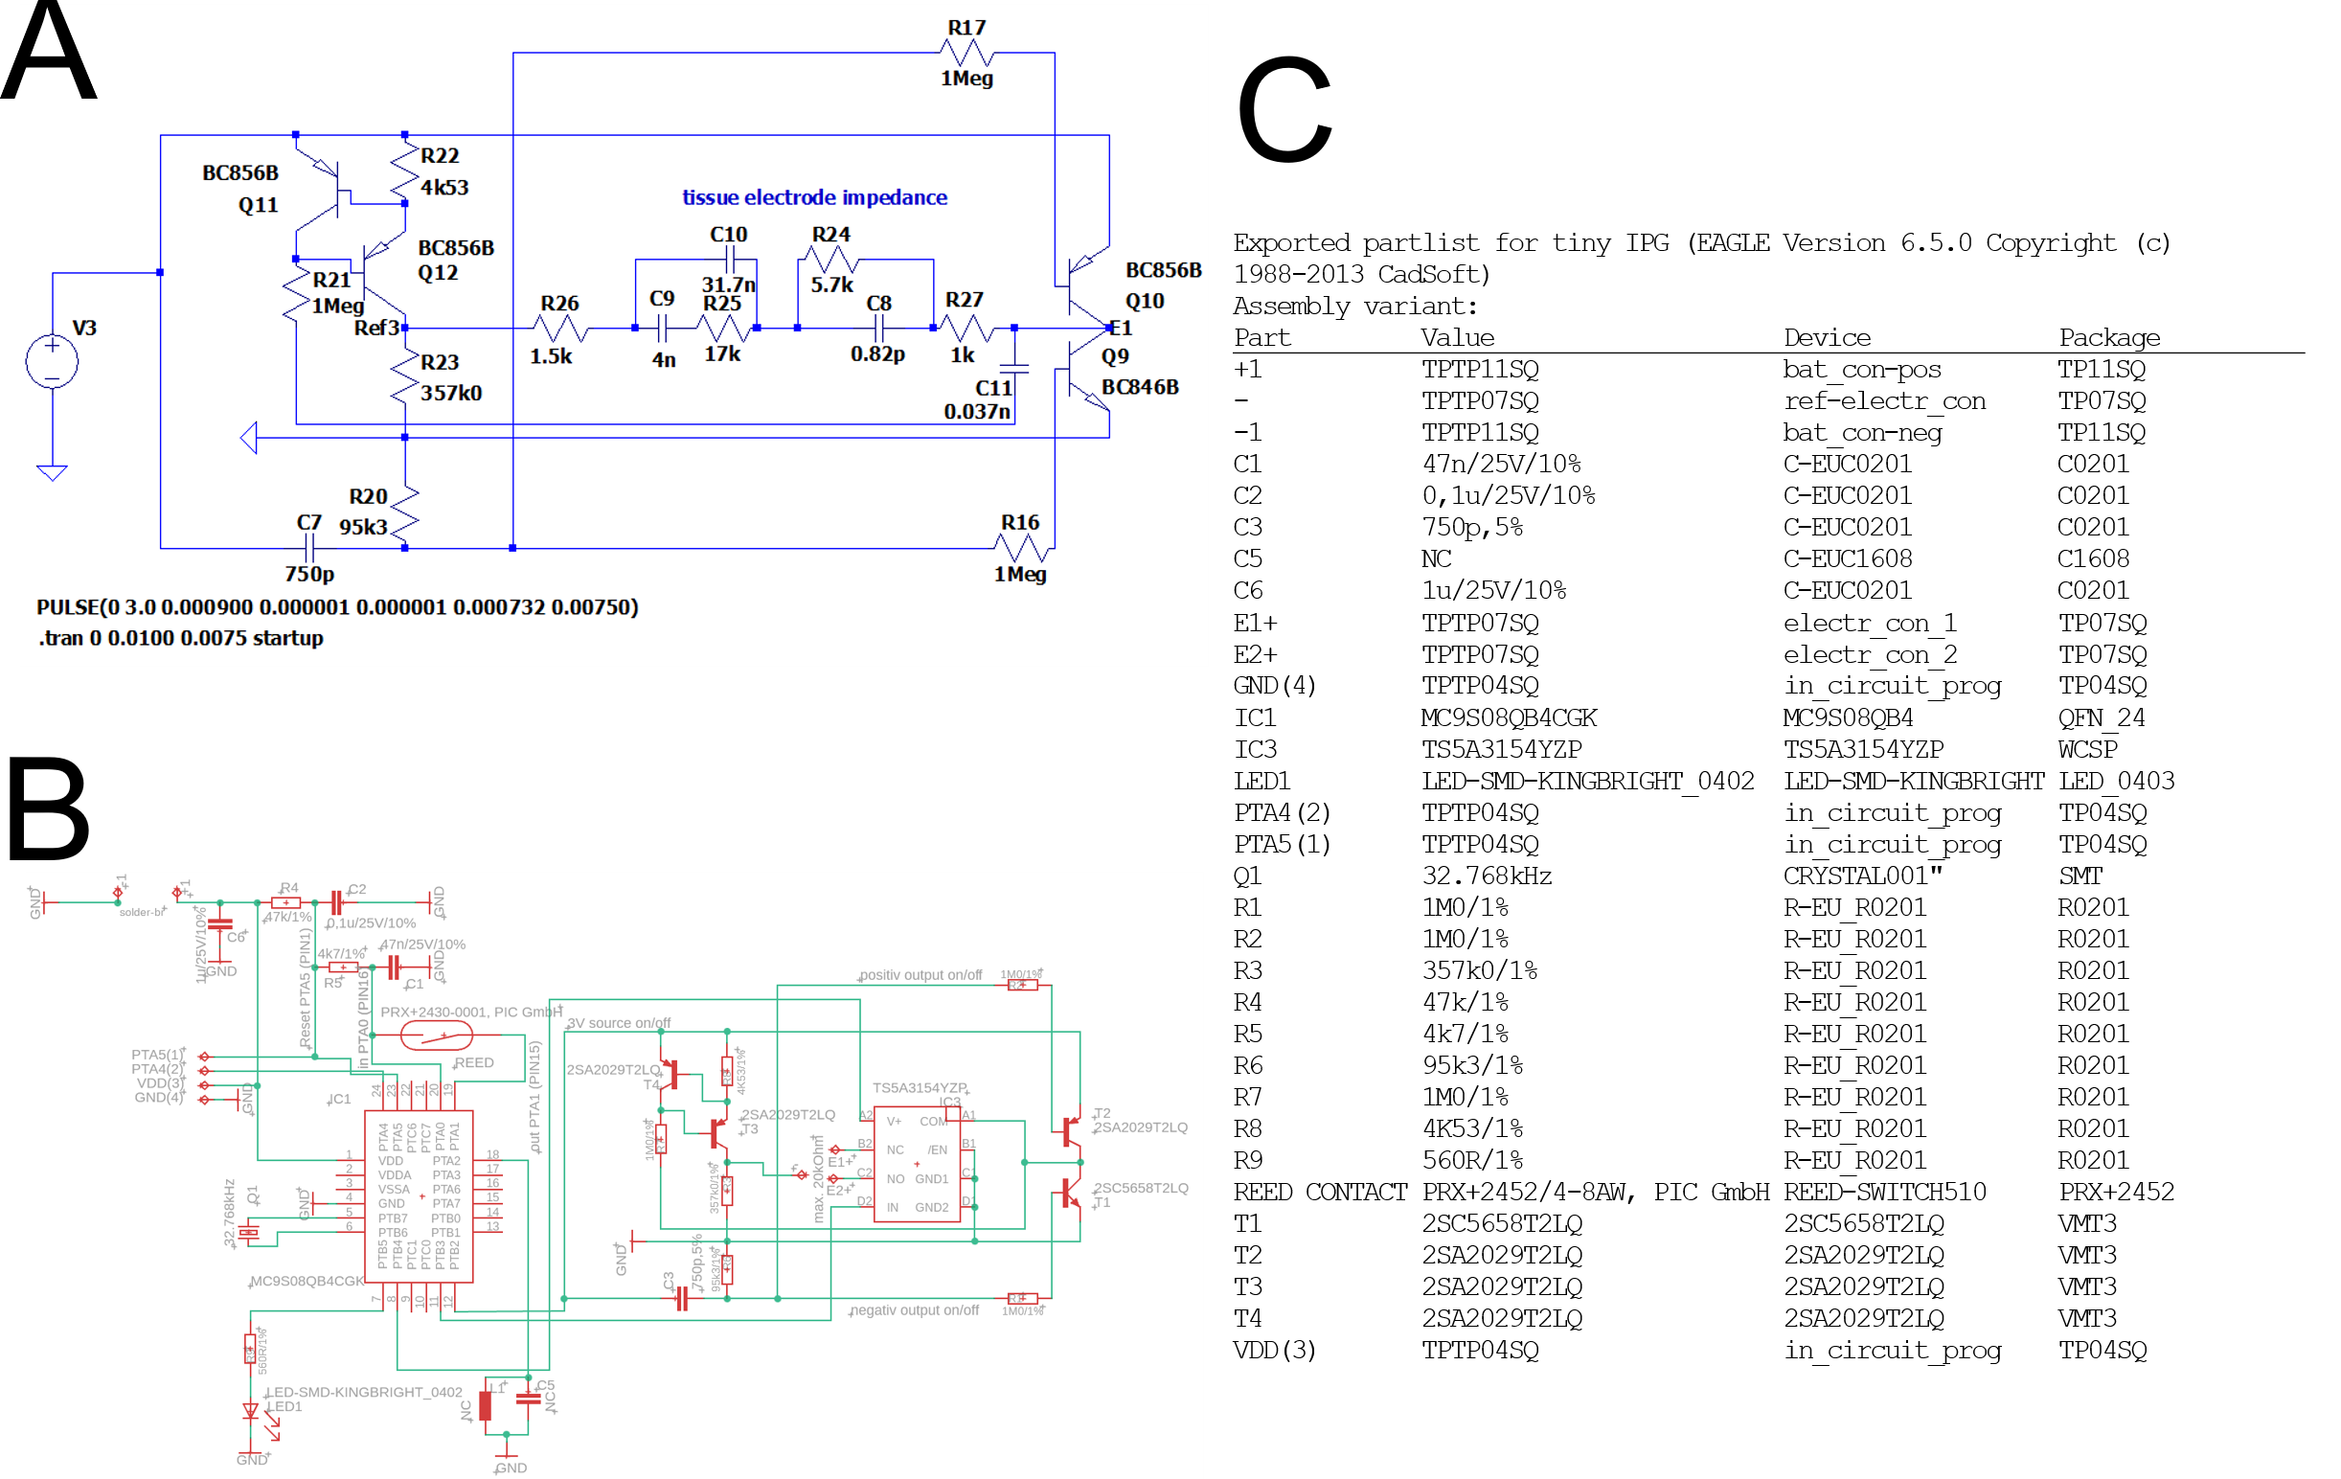

Supplementary Figure 3
Figure 3. Schematics of the electrical circuitry of the IPG. (A) The schematic spice simulation (Ltspice XVII (x86), Jul 15, 2019, Analog Devices, USA) of the V_{BE}-referenced h-bridge transistor current source for the in vivo output waveforms of voltage and current (between E1 and Ref3). The voltage source V3 got a PULSE source function and transition setting as LTspice directives set as follows: PULSE consisted of (Vinitial [V] “0”, Von [V] “3.0”, Tdelay [s] “0.000”, Trise [s] “0.000001”, Tfall [s] “0,000001”, Ton [s] “0.000732”, Tperiod [s] “0.00750” (The simulation command for transient was: .tran with - start external DC supply voltages at 0V “0”, stop time “0.20475”, time to start saving data “0.20225”, start frequency “startup”)). (B) Schematic and the additional exported partlist from EAGLE in (C).

Supplementary Figure 4

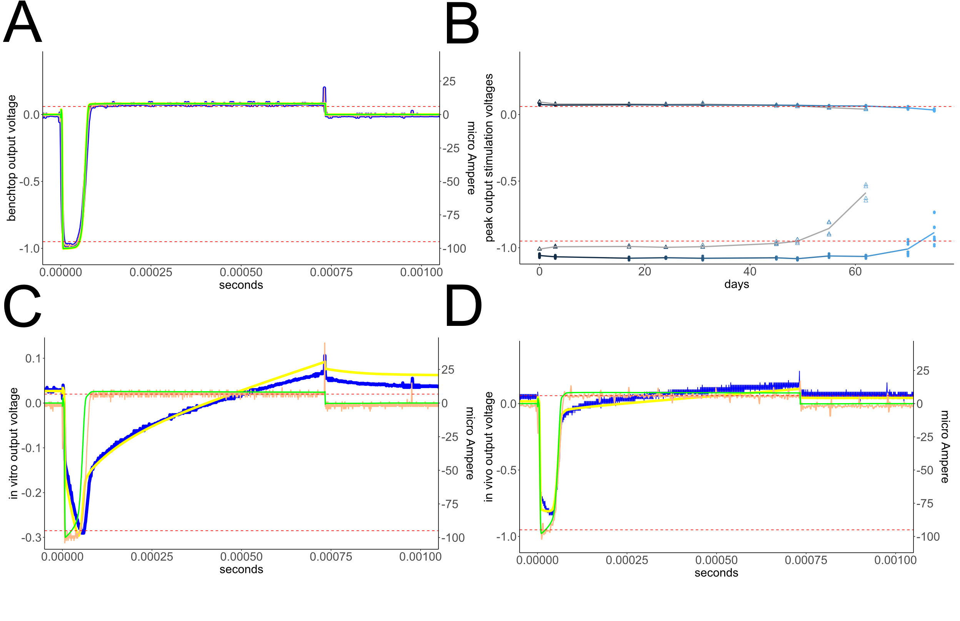
Supplementary Figure 4. Current vs. voltage outputs for benchtop (A) and in vivo (D), each versus their corresponding circuit simulations. In (C) it is in vitro outputs versus their corresponding circuit simulation output signals. In (B), the graphs represent the respective maximum values of signal output voltages versus the bench-top battery run duration of the IPGs that were set to 100 µA (for cathodic currents, neg. values) and 8µA (for anodic currents, pos. values) at ohmic load resistances of 10kOhm (±0.01% tolerance) at the dual output of small- & tiny-IPGs (please see frequency behavior of some waveforms in Supplementary analysis). Graphical outcomes were accomplished with RStudio, version 2023.09.1+494 (Posit Software, PBC, Boston US).
Graphs legend: Red dashed lines are confidence levels within 5% of cathodic and anodic max. peak values. (A, D, C) green > simul. current, orange > meas. current, yellow > simul. voltage, blue > meas. voltage. Colors legend for (B): dark blue - with means of max. cath. & anod. output voltages on small-IPGs with CR1220; grey - with means of max. cath. & anod. output voltages on tiny-IPGs with CR927.

Notice: The microstimulation system delivers two biphasic delayed waveforms, each with a first short cathodic current impulse followed by a longer low amplitude anodic current impulse with a slight imbalance toward the cathodic part side, resulting in a negative resting charge. Detailed information, simulations of waveforms, electronic developments and methods can be found in https://github.com/RPaulat/expDBS. Despite the reasonable slight discrepancy between simulated and measured waveforms, and tiny differences concerning the loads, we also used different hardware for tiny and small IPGs to measure these waveforms. Additionally, the very small time-delay for in vitro and in vivo signals between I and U is a function of frequency and dependent from inductance and capacitance. Moreover, the biased voltage output level is caused by the designed custom hardware circuit in interaction with impedance loads [11]. Finally, (in A, D, C) there is a little crosstalk peak in distance to the end of the anodic period (after the inter-stimulus delay of first channel) as an analogue switching effect, that indicates the falling edge of the second stimulation channel.
Supplementary video

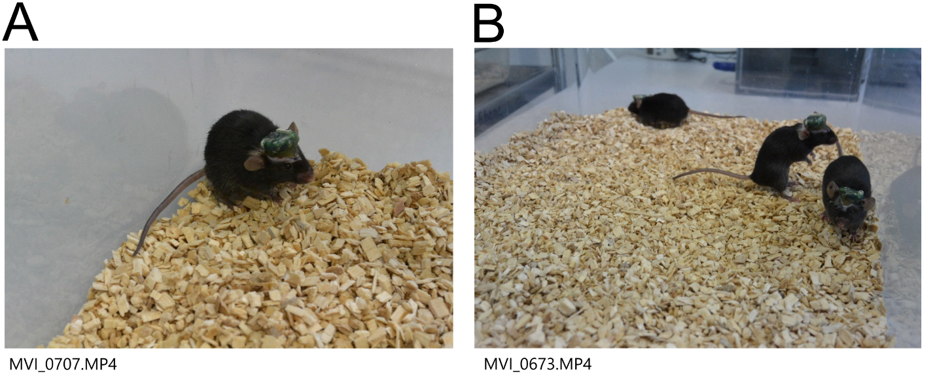
Supplementary video: The video shows freely moving mice with implanted s‑IPG systems. During the feasibility study (5 vs. 5 mice) 7 days before the end of the long‑term experiment, we recorded individual and group behavior under continuous 130 Hz DBS. The mice interacted socially, moved freely, and exhibited normal behavior, including grooming and exploration, without visible signs of pain or distress. SupplementaryVideo.mp4

References

1. Kolbl, F., et al., An Embedded Deep Brain Stimulator for Biphasic Chronic Experiments in Freely Moving Rodents. IEEE Trans Biomed Circuits Syst, 2016. 10(1): p. 72-84.
2. Fluri, F., et al., Development of a head-mounted wireless microstimulator for deep brain stimulation in rats. Journal of Neuroscience Methods, 2017. 291: p. 249-256.
3. Lee, B., et al., An Inductively-Powered Wireless Neural Recording and Stimulation System for Freely-Behaving Animals. IEEE Transactions on Biomedical Circuits and Systems, 2019. 13(2): p. 413-424.
4. Fleischer, M., et al., Development of a Fully Implantable Stimulator for Deep Brain Stimulation in Mice. Front Neurosci, 2020. 14: p. 726.
5. Burton, A., et al., Wireless, battery-free, and fully implantable electrical neurostimulation in freely moving rodents. Microsystems & Nanoengineering, 2021. 7(1): p. 62.
6. Plocksties, F., et al., The software defined implantable modular platform (STELLA) for preclinical deep brain stimulation research in rodents. J Neural Eng, 2021. 18(5).
7. Milner Paul, V., et al., 11 - Biomedical data visualization and clinical decision-making in rodents using a multi-usage wireless brain stimulator with a novel embedded design, in Predictive Modeling in Biomedical Data Mining and Analysis, S. Roy, et al., Editors. 2022, Academic Press. p. 187-206.
8. Grotemeyer, A., et al., Standardized wireless deep brain stimulation system for mice. npj Parkinson's Disease, 2024. 10(1): p. 153.
9. Huang, Y.-Z., et al., Theta Burst Stimulation of the Human Motor Cortex. Neuron, 2005. 45(2): p. 201-206.
10. Knorr, S., et al., Experimental deep brain stimulation in rodent models of movement disorders. Experimental Neurology, 2022. 348: p. 113926.
11. Cogan, S.F., Neural stimulation and recording electrodes. Annu Rev Biomed Eng, 2008. 10: p. 275-309.

