Supporting information for
Human Adrenal Gland Charts within the Common Coordinate Framework From CT-based Imaging
Hao Tang¹†, Jiao Li²†, Yuxuan Qiao³†, Lei Qiao³†, Qiang Xu¹, Kangjia Chen², Xian Zhou⁴, Wenji Ni⁵, Yong Zhong⁵, Xiao Hu⁶, Jing Sun¹, Jianrui Li¹, Zhiliang Long⁷, Ya Liu¹, Chen Chen¹, Chi Zhang⁸, Hongju Wu¹, Ming Sun¹, Xufang Sun¹, Yuting Feng¹, Dan Wu¹, Zicheng Xiong⁹, Yinghuan Shi⁹, Liang Jiang¹⁰, Xiaoqing Cheng¹, Xiaoping Yang³, Ziwei Nie^{3,} , Wei Liao^{2,} , Zhiqiang Zhang^{1,9}

¹Department of Radiology, Affiliated Jinling Hospital, Medical School, Nanjing University, Nanjing, China.
²The Clinical Hospital of Chengdu Brain Science Institute, School of Life Science and Technology, University of Electronic Science and Technology of China, Chengdu, China.
³School of Mathematics, Nanjing University, Nanjing, China.
⁴Health Management Center, Jiangsu Province Hospital of Chinese Medicine, Nanjing, China.
⁵Department of Health Medicine, Jinling Hospital, Affiliated Hospital of Medical School, Nanjing University, Nanjing, China.
⁶Department of Radiology, The Affiliated Brain Hospital of Nanjing Medical University, Nanjing, China.
⁷School of Psychology, Southwest University, Chongqing, China
⁸Department of Radiology, Liyang People's Hospital, Changzhou, Jiangsu Province, China.
⁹School of Computer Science, Nanjing University, Nanjing, China.
¹⁰Department of Radiology, Nanjing First Hospital, Nanjing Medical University, Nanjing, China.

† These authors contributed equally to this work.
Corresponding authors:
Ziwei Nie (nieziwei@nju.edu.cn), Wei Liao (weiliao.wl@gmail.com), Zhiqiang Zhang (zhangzq2001@126.com)

Supplementary Methods
Healthy participants. The inclusion criteria were as follows: (1) Age older than 18 years. (2) No history of adrenal-related diseases (e.g., Cushing’s syndrome, primary aldosteronism, pheochromocytoma, etc.), with no abnormal findings on computed tomography (CT) reports. (3) No history of major diseases, including malignant tumors, major organ surgery, severe hepatic or renal dysfunction, autoimmune diseases, etc.; no obvious infection within the past 3 months; and no exposure to glucocorticoids, sex hormones, or other related medications.

Participants with pathological conditions. (1) Hypertension was diagnosed in accordance with Chinese guidelines¹ as a systolic blood pressure ≥140 mmHg and/or diastolic blood pressure ≥90 mmHg, based on multiple repeated measurements. (2) Inflammatory bowel disease (IBD), including ulcerative colitis and Crohn’s disease, was diagnosed according to the World Gastroenterology Organisation (WGO) guidelines², with the diagnosis established by colonoscopy, histopathological biopsy, and integrated clinical, endoscopic, and pathological evidence. (3) Depression was diagnosed using the diagnostic criteria of the Diagnostic and Statistical Manual of Mental Disorders, Fifth Edition (DSM-5)³. (4) Stroke was diagnosed was diagnosed according to Chinese guidelines for diagnosis and treatment of acute ischemic stroke 2023⁴, based on the clinical presentation of acute focal or global neurological deficits, confirmed by corresponding lesions on magnetic resonance imaging (MRI).

Supplementary Figures
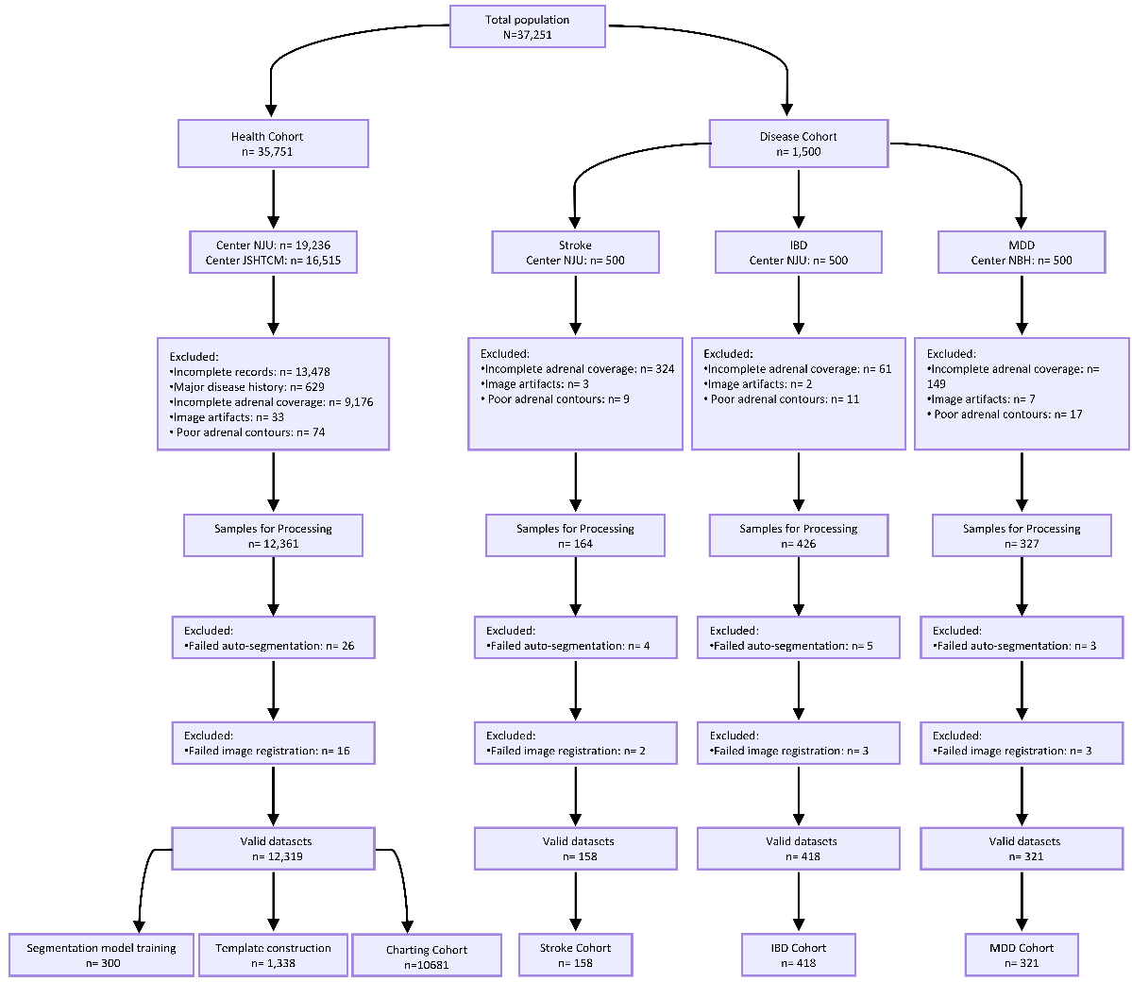
Figure S1. Flowchart of data quality control. The flowchart outlines the screening and grouping procedures for the healthy and disease cohorts. A total of 37,251 participants were initially enrolled, including 35,751 individuals in the healthy cohort [NJU, Affiliated Jinling Hospital, Medical School of Nanjing University (NJU); Jiangsu Provincial Hospital of Traditional Chinese Medicine (JSHTCM)], of whom 6,727 had a documented history of hypertension, and 1,500 individuals in the disease cohort [500 each for stroke, inflammatory bowel disease (IBD), and major depressive disorder (MDD) from the Affiliated Brain Hospital of Nanjing Medical University (NBH)]. Following sequential exclusions, the final healthy cohort comprised 12,319 subjects eligible for downstream analysis: among these, 300 were allocated to the segmentation model training set, 1,338 to the template construction set, and 10,681 to the healthy statistical analysis (charting) cohort, which included 2,010 individuals with hypertension. In the disease cohort, the final sample sizes were 158 for stroke, 418 for IBD, and 321 for MDD. Additionally, the combined pathological cohort initially included 8,227 individuals, of whom 2,907 were retained after screening.

Figure S2. Charts of adrenal volume and density across the lifespan and between sexes within specific regions. a, The adrenal gland were segmented into inner and outer regions using clustering analysis. b & c, Nonlinear associations between age and morphometric measures in the adrenal inner and outer regions. Red and blue colors represent females and males, respectively. Dotted lines indicate 95% confidence intervals.

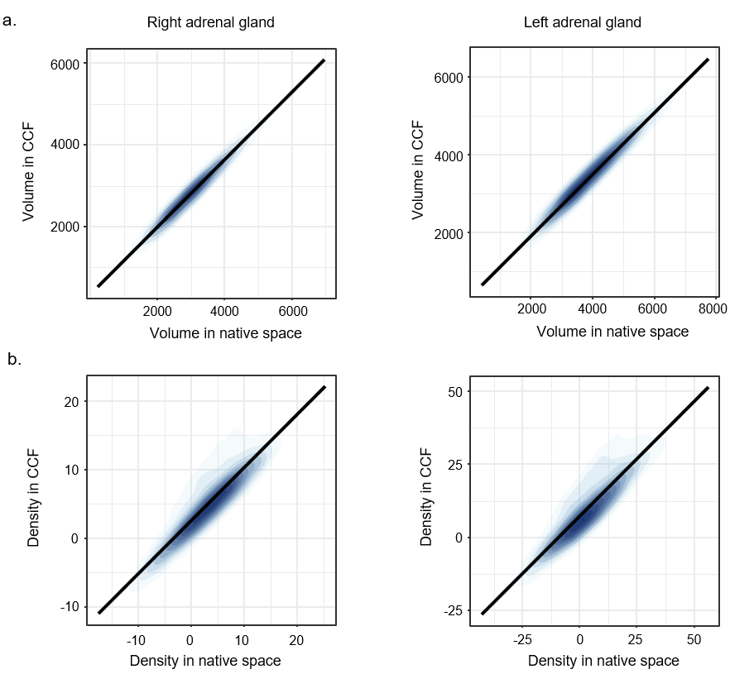
Figure S3. Correlations of adrenal gland metrics between the common coordinate framework and native space. a, Scatterplot of the relationship between volume in the common coordinate framework (CCF, y-axis) and native space (x-axis). b, Scatterplot of the relationship between density in CCF (y-axis) and native space (x-axis).

Supplementary Tables
Table S1. Characteristics of the health screening participants.
Variable | Center A (NJU)  (N=4298) | Center B (JSHTCM)  (N=6383)
Age, years | 43.0(31.0,57.0) | 52.0(40.0,61.0)
Sex, n (%);Female / Male | 1702(39.6)/2596(60.4) | 2472/3911
Height, cm | 168.0(161.0,174.0) | 168.0(162.5,174.0)
Weight, kg | 66.0(58.0,74.0) | 68.0(59.0,76.0)
BMI, kg/m² | 23.39(21.26,25.39) | 23.78(21.64,26.06)
HTN, n(%) | 940(21.87%) | 1070(16.76%)
RBC, ×10¹²/L(n=626 / 6330) | 4.26(3.93,4.69) | 4.75(4.41,5.10)
NLR(n=425 / 5643) | 1.82(1.45,2.37) | 1.69(1.39,2.09)
HR,bpm(n=0 / 6126) | __ | 70(66.0,75.0)
Abbreviations: NJU, Affiliated Jinling Hospital, Medical School of Nanjing University; JSHTCM, Jiangsu Provincial Hospital of Traditional Chinese Medicine; BMI, Body Mass Index; HTN, Hypertension; RBC, Red Blood Cell (count); NLR, Neutrophil-to-Lymphocyte Ratio; HR, Heart Rate.
Note: Continuous variables are presented as median (P25, P75) and compared using the Mann-Whitney U test. Categorical variables are presented as numbers (percentages) and compared using the Chi-square test.For variables with incomplete data, the valid sample sizes are indicated in parentheses after the variable name (format: n=[Center A]/[Center B]). A dash (—) indicates that the data were not collected or are completely missing for that center.
Table S2. Characteristics of cases and matched controls.
Condition | Variable | Present | Control | U or χ² value | P-value
HTN  (n=2010/8671) | Age | 61.0(53.0,72.0) | 45.0(35.0,57.0) | U = 3802288.50 | <0.0001
HTN  (n=2010/8671) | Sex ,n(%)  Female / Male | 578(28.8)/1432(71.2) | 3596(41.5)/5075(58.5) | χ²=110.91 | <0.0001
Stroke  (n=158/316) | Age | 66.0(58.0,74.0) | 66.0(58.0,74.0) | U = 24964.00 | ＞0.999
Stroke  (n=158/316) | Sex ,n(%)  Female / Male | 50(31.6)/108(68.4) | 100(31.6)/216(68.4) | χ²＜0.0001 | ＞0.999
IBD  (n=418/836) | Age | 34.0(25.0,47.0) | 34.0(25.0,47.0) | t ＜ 0.0001 | ＞0.999
IBD  (n=418/836) | Sex ,n(%)  Female / Male | 167(40.0)/251(60.0) | 334(40.0)/502(60.0) | χ² ＜ 0.0001 | ＞0.999
MDD  (n=321/642) | Age | 56.0(45.0,64.0) | 56.0(45.0,64.0) | t ＜ 0.0001 | ＞0.999
MDD  (n=321/642) | Sex ,n(%)  Female / Male | 106(33.0)/215(67.0) | 212(33.0)/430(67.0) | χ² ＜ 0.0001 | ＞0.999
Abbreviations: HTN, Hypertension; IBD, Inflammatory Bowel Disease; MDD, Major Depressive Disorder.
Note: For hypertension, the control group includes all participants without hypertension. For Stroke, IBD, and MDD, the control group consists of healthy participants matched 1:2 to the Present group on sex and age. For variables with incomplete data, the valid sample sizes are indicated in parentheses after the variable name (format: n = [condition group] / [control group]). Continuous variables were compared using the two-sample t-test or the Mann-Whitney U test, as appropriate. Categorical variables were compared using the Chi-square test.

Table S3. Scan parameters of CT data for each center.
Center | Scanner | Tube Voltage（kV） | Tube Current  (mA) | Scan Mode | Pitch | Reconstruction Slice Thickness  (mm) | Reconstruction Interval  (mm) | Reconstruction Algorithm | Recon FOV  (mm) | Reconstruction Matrix
NJU | SIEMENS,  SOMATOM Definition Flash | 120 | ATCM,  CARE Dose 4D | Helical Scan | 1.2 | 1.0 | 1.0 | B31f | 300-400 | 512×512
NJU | SIEMENS,  SOMATOM Definition | 120 | ATCM,  CARE Dose 4D | Helical Scan | 1.2 | 1.0 | 1.0 | B30f | 300-400 | 512×512
NJU | Anke,  ANATOM 32 Fit Es | 120 | ATCM | Helical Scan | 1.4 | 1.25 | 1.25 | Standard | 300-400 | 512×512
NJU | SIEMENS,  SOMATOM Perspective | 130 | ATCM,  CARE Dose 4D | Helical Scan | 1.2 | 1.0 | 1.0 | I31s | 300-400 | 512×512
NJU | UIH,  uCT 760 | 120 | ATCM | Helical Scan | 1.0 | 1.0 | 1.0 | B SOFT B | 300-400 | 512×512
NJU | NMS,  NeuViz 128 | 120 | ATCM, | Helical Scan | 1.0 | 1.0 | 1.0 | F20 | 300-400 | 512×512
JSHTCM | SIEMENS,  SOMATOM Definition AS+ | 120 | ATCM,  CARE Dose 4D | Helical Scan | 1.2 | 1.0 | 1.0 | I31f | 300-400 | 512×512
NBH | SIEMENS,  SOMATOM Definition AS+ | 120 | ATCM,  CARE Dose 4D | Helical Scan | 1.2 | 1.0 | 1.0 | B31f | 300-400 | 512×512
NBH | GE,  Optima CT660 | 120 | ATCM,  Auto mA | Helical Scan | 1.0 | 1.0 | 1.0 | Standard | 300-400 | 512×512
Abbreviations: NJU, Affiliated Jinling Hospital, Medical School of Nanjing University; JSHTCM, Jiangsu Province Hospital of Chinese Medicine; NBH, the Affiliated Brain Hospital of Nanjing Medical University; SIEMENS, Siemens Healthineers; UIH, United Imaging Healthcare; NMS, Neusoft Medical Systems(Neusoft Corporation); GE, General Electric Company; ATCM, Automated Tube Current Modulation; Recon FOV, Reconstruction Field of View.

Supplementary Reference
1. Wang, J. G. Chinese guidelines for the prevention and treatment of hypertension (2024 revision). J Geriatr Cardiol 22, 1-149 (2025).
2. Bernstein, C. N. et al. World gastroenterology organisation global guidelines inflammatory bowel disease: Update August 2015. J Clin Gastroenterol 50, 803-818 (2016).
3. First, M. B. Diagnostic and statistical manual of mental disorders, 5th edition, and clinical utility. J Nerv Ment Dis 201, 727-729 (2013).
4. Liu, L. et al. Chinese stroke association guidelines for clinical management of ischaemic cerebrovascular diseases: executive summary and 2023 update. Stroke Vasc Neurol 8, e3 (2023).

