Supplementary Materials
Supp. Table 1. Linear mixed model for C pool change as a function of field age, depth, vegetation composition, species richness, and above- and below-ground biomass. Field with soil sampling location nested inside was used as the random effect of the model. A PCA with the biomass fraction of functional groups (C4 grass, C3 grass, forbs) was also performed, and the PC1 was used in place of individual functional groups in a linear mixed model to check if collinearity, which did not yield different results than the full model showed in the table.
Fixed Effect Test
Variables | F | Df | Df.res | Pr(>F)
Field age | 5.622 | 1 | 21.067 | 0.0274 | *
Depth | 37.9607 | 1 | 86.273 | 0.0000 | ***
C3 grass | 0.1413 | 1 | 73.339 | 0.7081
C4 grass | 0 | 1 | 67.21 | 0.9971
Forb | 0.1147 | 1 | 71.96 | 0.7359
Sedge | 0.2398 | 1 | 73.717 | 0.6258
Legume | 0.6645 | 1 | 72.255 | 0.4177
Aboveground biomass | 0.2503 | 1 | 78.955 | 0.6182
Species richness | 0.0728 | 1 | 76.434 | 0.7881
Root biomass | 0.7131 | 1 | 128.548 | 0.4000
Field age×depth | 4.0589 | 1 | 75.073 | 0.0475 | *
Depth×C3 grass | 0.5454 | 1 | 72.762 | 0.4626
Depth×C4 grass | 1.8331 | 1 | 76.351 | 0.1798
Depth×forb | 2.3727 | 1 | 72.735 | 0.1278
Depth×legume | 0.4165 | 1 | 72.382 | 0.5207
Depth×sedge | 1.386 | 1 | 74.915 | 0.2428
Depth×abovegroundbiomass | 1.4596 | 1 | 78.603 | 0.2306
Depth×species richness | 0.4427 | 1 | 75.489 | 0.5079
Depth×root biomass | 0.0174 | 1 | 121.631 | 0.8954
Parameter Estimates
Variables | Estimate | Std. Errot | t
(Intercept) | 1646.00 | 1211.00 | 1.359
Field age | -9.01 | 9.79 | -0.92
Depth | -2043.00 | 1310.00 | -1.56
C3 grass | -964.00 | 1329.00 | -0.725
C4 grass | -1221.00 | 1667.00 | -0.733
Forb | -1667.00 | 3050.00 | -0.547
Sedge | -455.90 | 2265.00 | -0.201
Legume | 1132.00 | 3310.00 | 0.342
Aboveground biomass | -0.98 | 3.29 | -0.297
Species richness | -29.02 | 48.25 | -0.601
Root biomass | 0.10 | 0.21 | 0.445
Field age×depth | -20.58 | 10.20 | -2.017
Depth×C3 grass | 1076.00 | 1457.00 | 0.739
Depth×C4 grass | 2513.00 | 1853.00 | 1.356
Depth×forb | 5120.00 | 3324.00 | 1.541
Depth×legume | 2347.00 | 3637.00 | 0.645
Depth×sedge | 2981.00 | 2529.00 | 1.179
Depth×abovegroundbiomass | 4.37 | 3.61 | 1.212
Depth×species richness | 35.62 | 53.46 | 0.666
Depth×root biomass | 0.04 | 0.27 | 0.134

Supp. Table 2. Linear mixed model for N pool change as a function of field age, depth, vegetation composition, species richness, and above- and below-ground biomass. Field with soil sampling location nested inside was used as the random effect of the model. A PCA with the biomass fraction of functional groups (C4 grass, C3 grass, forbs) was also performed, and the PC1 was used in place of individual functional groups in a linear mixed model to check if collinearity, which did not yield different results than the full model showed in the table.
Fixed Effect Test
 | F | Df | Df.res | Pr(>F)
Field age | 5.4093 | 1 | 21.922 | 0.02968 | *
Depth | 31.5724 | 1 | 89.653 | 2.14E-07 | ***
C3 grass | 0.6664 | 1 | 68.972 | 0.417119
C4 grass | 0.0123 | 1 | 76.94 | 0.911865
Forb | 0.0223 | 1 | 68.686 | 0.881599
Sedge | 0.4994 | 1 | 70.987 | 0.482098
Legume | 0.282 | 1 | 62.16 | 0.597311
Aboveground biomass | 0.0003 | 1 | 69.842 | 0.985366
Species richness | 0.0348 | 1 | 67.423 | 0.85261
Root biomass | 1.7194 | 1 | 138.784 | 0.19194
Field age×depth | 10.3418 | 1 | 75.613 | 0.001914 | **
Depth×C3 grass | 0.1534 | 1 | 73.004 | 0.696474
Depth×C4 grass | 9.1369 | 1 | 77.258 | 0.003398 | **
Depth×forb | 3.0733 | 1 | 72.949 | 0.08379
Depth×legume | 0.0448 | 1 | 72.566 | 0.833001
Depth×sedge | 4.2337 | 1 | 75.575 | 0.043078 | *
Depth×abovegroundbiomass | 1.8702 | 1 | 79.376 | 0.175315
Depth×species richness | 0.145 | 1 | 76.095 | 0.704388
Depth×root biomass | 0.0089 | 1 | 133.045 | 0.924922
Parameter Estimates
Variables | Estimate | Std. Errot | t
(Intercept) | 162.800 | 113.400 | 1.436
Field age | -0.597 | 1.116 | -0.535
Depth | -125.500 | 130.100 | -0.964
C3 grass | -104.800 | 117.000 | -0.896
C4 grass | -281.300 | 151.700 | -1.854
Forb | -321.300 | 269.500 | -1.192
Sedge | -133.400 | 201.500 | -0.662
Legume | 79.420 | 284.300 | 0.279
Aboveground biomass | -0.257 | 0.286 | -0.898
Species richness | 0.393 | 4.205 | 0.093
Root biomass | 0.016 | 0.021 | 0.755
Field age×depth | -3.252 | 1.010 | -3.219
Depth×C3 grass | 56.690 | 144.700 | 0.392
Depth×C4 grass | 554.200 | 183.100 | 3.028
Depth×forb | 578.900 | 330.200 | 1.753
Depth×legume | 76.500 | 361.500 | 0.212
Depth×sedge | 515.400 | 250.300 | 2.06
Depth×abovegroundbiomass | 0.489 | 0.357 | 1.371
Depth×species richness | -2.016 | 5.288 | -0.381
Depth×root biomass | 0.002 | 0.026 | 0.096

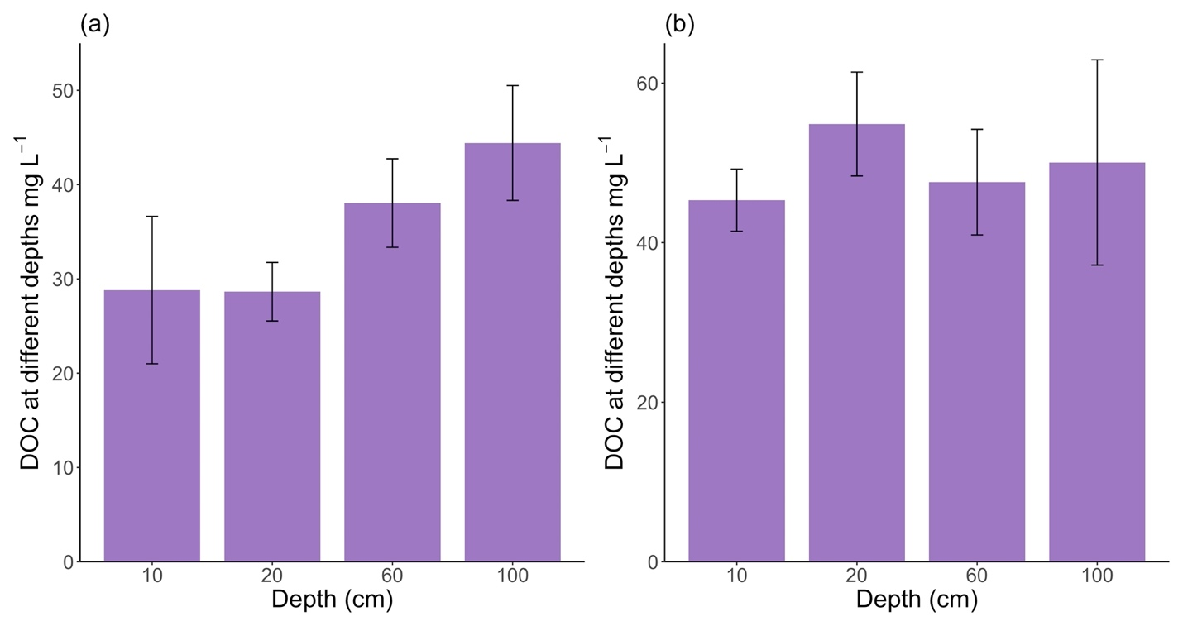
Supp. Fig. 1. DOC concentration in spring (a) and fall (b) at different depths in the old fields. Soil solution samples were collected in 8 of the 21 old fields in 2017. Data shown are the means ± 1 SE. The results showed that there was no significant difference at P<0.05 of DOC concentration in different depths, which indicate little DOC was absorbed by the subsurface soil during rain events.

