Supporting informations: Inline Gamma Spectroscopy and Liquid Scintillation HPLC Reveal Daughters in ²²⁵Ac-Radiopharmaceutical
Guilhem Claude*, Matthias Balzer, Winfried Brenner, Frank Bruchertseifer, Alfred Morgenstern, David Thonon, Sarah Spreckelmeyer.

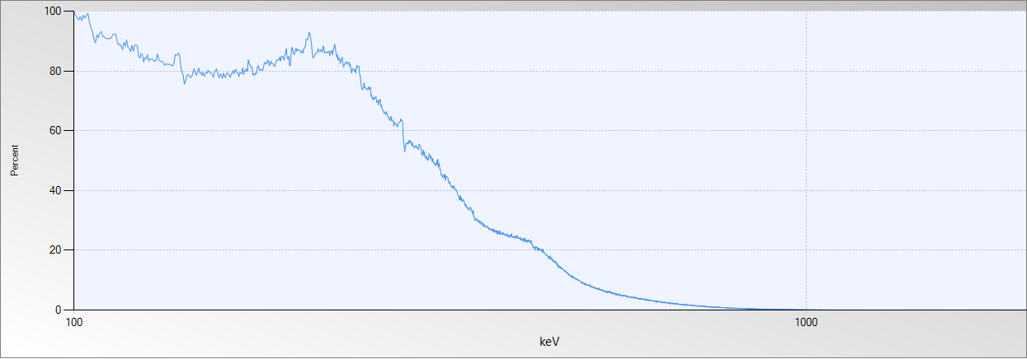
Figure S1: Liquid scintillation beta spectrum of isolated [²⁰⁹Pb]Pb-PSMA-I&T.

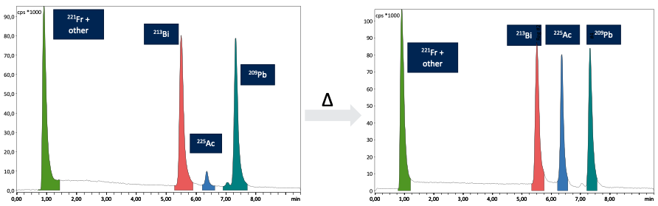
Figure S2: HPLC chromatogram of reaction mixture prior and after heating.

