Supplementary Information of
ArcMol Enables Task-Adaptive Spherical Representation Learning for Molecular Property Prediction
Yurong Zou¹, Zhongning Guo¹, Zihan Zou¹, Duanyang Qin¹, Dingguo Xu³, Taijin Wang^{2,*}and Lijuan Chen^{1,2,}*
¹State Key Laboratory of Biotherapy and Collaborative Innovation Center of Biotherapy, West China Hospital, Sichuan University, Chengdu, 610041, China
²Chengdu Zenitar Biomedical Technology Co., Ltd., Chengdu, 610045, China
³MOE Key Laboratory of Green Chemistry and Technology, College of Chemistry, Sichuan University, Chengdu, 610064, China
*Corresponding author: State Key Laboratory of Biotherapy and Collaborative Innovation Center of Biotherapy, West China Hospital, Sichuan University, Chengdu, 610041, China and Chengdu Zenitar Biomedical Technology Co., Ltd., Chengdu, 610045, China
E-mail addresses: chenlijuan125@163.com.

Supplementary Notes

Calculation of Physicochemical Descriptors
Physicochemical descriptors were calculated using the open-source cheminformatics toolkit RDKit¹ (version 2023.9.4). Molecular structures were converted into canonical SMILES representations and processed to generate a total of 210 molecular descriptors, covering physicochemical and topological features, such as molecular weight (MolWt), octanol-water partition coefficient (MolLogP), topological polar surface area (TPSA), hydrogen bond donors and acceptors, rotatable bonds, ring-related descriptors, and other connectivity- and shape-related indices. All molecules were sanitized prior to descriptor calculation to ensure chemically valid structures.

Molecular Representations in ArcMol
ArcMol integrates 14 complementary molecular representations across four categories: knowledge-based fingerprints, molecular language models, 2D graph-based self-supervised representations, and 3D geometry-aware representations, enabling multi-level molecular characterization. Knowledge-based fingerprints include RDKit fingerprints encoding topological substructures,¹ MACCS keys capturing predefined functional patterns,² and EState fingerprints describing atomic electrotopological environments.³ Molecular language model representations are derived from MolT5⁴ and BioT5,⁵ which are transformer-based models pretrained on SMILES sequences, with BioT5 incorporating additional biochemical knowledge. The 2D graph-based representations are generated using self-supervised learning methods, including AttrMask,⁶ GPT-GNN,⁷ GraphCL,⁸ MolCLR,⁹ GraphMVP,¹⁰ and GROVER,¹¹ which learn structural features through attribute masking, autoregressive modeling, contrastive learning, and 2D&3D multi-view pretraining. Finally, 3D geometry-aware representations are obtained from UniMol variants that explicitly encode atomic coordinates and spatial relationships, with UniMolV2 providing enhanced model capacity and improved geometric learning.

Symbolic Regression
Symbolic regression was performed using RDKit molecular descriptors as input features to construct task-specific descriptors for comparison, as discussed in the Complementarity in Molecular Representation Space section of the main text. The symbolic regression models¹² were implemented using the gplearn library based on genetic programming, where a SymbolicTransformer was trained to evolve analytical expressions capturing nonlinear transformations of the original descriptors. The model was trained with a population size of 100,000 over 1,000 generations, using a function set comprising basic arithmetic and nonlinear operators (e.g., add, subtract, multiply, divide, logarithmic, trigonometric, and inverse functions). To control expression complexity and improve interpretability, a parsimony coefficient of 0.0001 was applied. The task type (classification or regression) was automatically determined based on the target variable, and generated symbolic features were evaluated using AUC for classification tasks or absolute correlation for regression tasks. Duplicate symbolic expressions were removed, and symbolic features were ranked according to their evaluation scores, with the top-K symbolic features selected for downstream analysis. All symbolic regression procedures were conducted exclusively within the training set of each task to prevent information leakage.

Feature Selection and Importance Ranking
Feature importance ranking and descriptor selection were performed using mutual information-based and correlation-based ranking methods as implemented in scikit-learn,¹³ where mutual information captures both linear and nonlinear dependencies between descriptors and the target property. The top-K descriptors were selected for subsequent analysis to evaluate descriptor relevance and complementarity, as described in the Complementarity in Molecular Representation Space section of the main text.

Evaluation Metrics and Analysis
Model performance was evaluated using the area under the receiver operating characteristic curve (AUC) for classification tasks, and the root mean square error (RMSE) and coefficient of determination (R²) for regression tasks. Beyond predictive accuracy, representation-level analyses were conducted to characterize geometric structure and semantic complementarity in the molecular representation space. Permutation invariance tests were used to assess prediction stability with respect to feature ordering. Clustering quality in latent spaces was evaluated using the silhouette coefficient¹⁴ and Davies-Bouldin index,¹⁵ measuring cluster compactness and separation, respectively. Complementarity analysis was performed to quantify synergistic effects between different molecular representations across tasks, and centered kernel alignment (CKA)¹⁶ was employed to assess pairwise semantic similarity and orthogonality between representation spaces.

Compound Library for Virtual Screening
The virtual screening was performed using the MCE Bioactive Compound Library (MedChemExpress), which comprises structurally diverse small molecules with experimentally validated biological activities and annotated biological targets. The library is designed for drug discovery and virtual screening applications and has been widely used in both academic and industrial studies.

Virtual Screening Setup and Biochemical Assays
Similarity-based virtual screening was performed using ArcMol latent representations, with pexidartinib and ponatinib used as reference anchor compounds. Molecular similarity was quantified using cosine similarity in the ArcMol latent space of IRAK4 task, and retrieved the 1000 most similar molecules from the MCE bioactive compound library, resulting in a comprehensive set of candidates. Subsequently, molecular docking was performed between the candidate compounds and the inactive IRAK4 conformation using AutoDock Vina software. The search thoroughness was increased during molecular docking by setting the exhaustiveness parameter to 64, generating a maximum of 9 binding conformations per ligand (num_modes = 9), and using an energy range of 5 kcal/mol. Compounds with docking scores higher than that of ponatinib were retained, yielding a total of 284 candidate compounds.. Predicted binding poses were further analyzed by manual inspection to assess compatibility with a type II binding mode, including key interactions and overall pose geometry.
Based on molecular docking performance and binding mode consistency, 15 compounds were identified as candidates for experimental evaluation, and their chemical structures are shown in Fig. S10. Taking into account chemical diversity and commercial availability, six candidates were further selected for full dose–response biochemical analysis to determine their IC₅₀ values.

Biological Assay Methods
IRAK4 Kinase Inhibition Assay: IRAK4 inhibitory activity was evaluated using a time-resolved fluorescence resonance energy transfer (TR-FRET)–based LANCE Ultra kinase assay. Recombinant human IRAK4 kinase was obtained from a commercial source (Carna Biosciences). The assay was conducted in 384-well plates under ATP concentrations corresponding to the Michaelis constant (K_{M}) of the enzyme. The kinase reaction was carried out in assay buffer containing 50 mM HEPES (pH 7.5), 10 mM MgCl2, 0.01% Triton X-100, 0.01% BSA, and 2 mM DTT. Test compounds were initially prepared as 1000 $μ$M stock solutions in DMSO and transferred into assay plates using an Echo 650 acoustic liquid handler to achieve a final screening concentration of 10 $μ$M, unless otherwise specified. Staurosporine was included as a positive control inhibitor. For the kinase reaction, IRAK4 enzyme solution was dispensed into assay wells and pre-incubated with test compounds at room temperature for 10 min. The reaction was initiated by the addition of substrate and ATP mixture and allowed to proceed for 60 min at room temperature. Reactions were terminated by the addition of a 2×stop solution containing europium-labeled anti-phospho-p70 S6K (Thr389) antibody and ULight-labeled peptide substrate, followed by incubation at room temperature for 60 min to allow signal development.
Time-resolved fluorescence signals were measured using an EnVision 2104 multilabel plate reader, and the LANCE signal ratio (665 nm / 615 nm) was calculated for each well. Percent inhibition was calculated according to Equation (1):
Equation (1): inh %=( Max-Signal)/ (Max-Min)*100
where Max represents the signal from DMSO-treated control wells and Min represents the signal from enzyme-free control wells. Dose–response curves were generated by nonlinear regression using a four-parameter logistic model, and IC₅₀ values were determined according to Equation (2):
Equation (2): Y=Bottom + (Top-Bottom)/(1+(IC50/X)*HillSlope)
where Y is the percent inhibition and X is the compound concentration. Curve fitting and IC₅₀ calculations were performed using XLFit (IDBS) software. All biochemical assays were conducted as a non-GLP study by Shanghai ChemPartner Co., Ltd.

Supplementary Figures

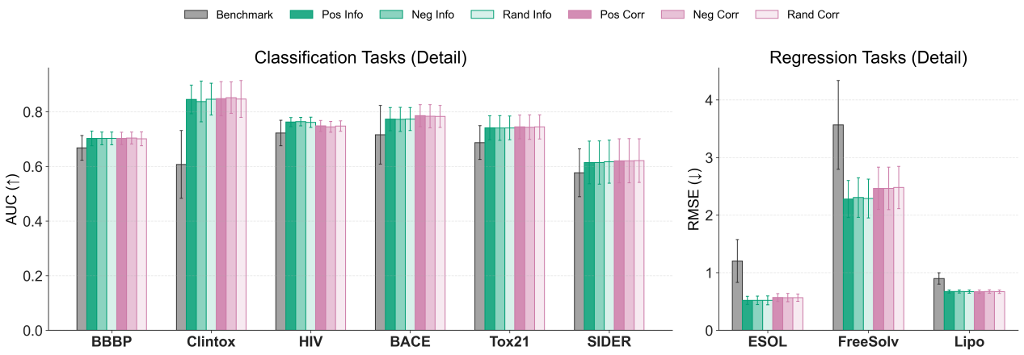
Figure S1. Details of permutation invariance and feature ordering analysis. This panel evaluates the model's prediction stability across different feature input sequences. The performance is compared across nine molecular property prediction tasks, divided into classification (left, metric: ROC-AUC) and regression (right, metric: RMSE). The evaluation contrasts the Benchmark method (gray) against sequences ordered by Mutual Information (Info, green shades) and Correlation (Corr, purple shades). For each ordering metric, three permutation strategies are tested: descending order (Pos), ascending order (Neg), and randomized order (Rand) to rigorously assess the model's sensitivity to feature permutation. The height of each bar represents the mean performance across independent runs, with error bars indicating the standard deviation.

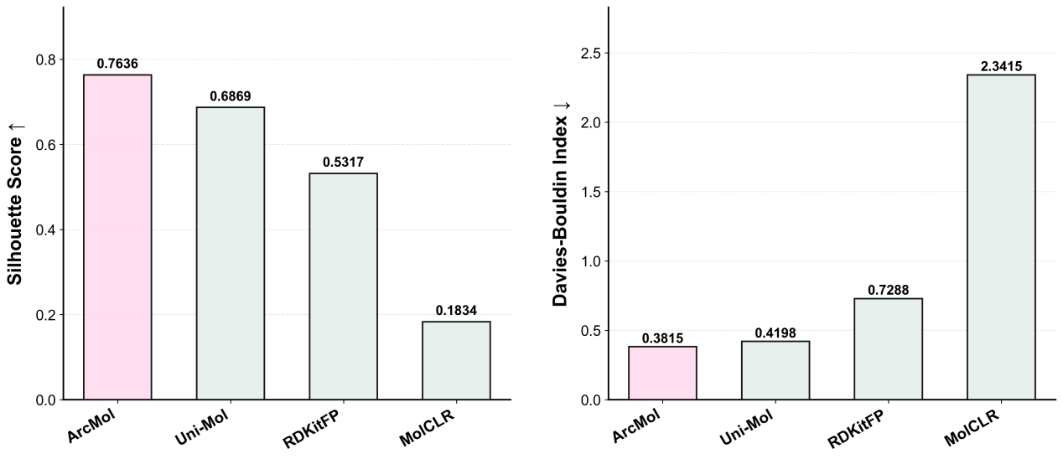
Figure S2. Quantitative evaluation of clustering quality in the latent representation space.
Silhouette score (left) and Davies–Bouldin index (right) computed on t-SNE projections of the learned latent representations after training, comparing ArcMol, Uni-Mol, RDKFingerprint, and MolCLR.

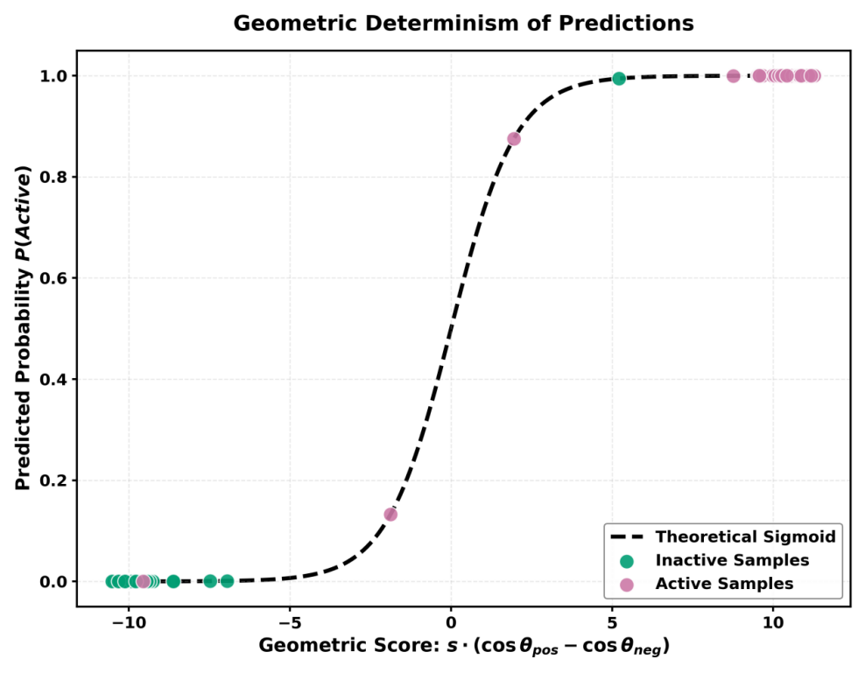
Figure S3. Quantitative evaluation of clustering quality in the latent representation space. Illustration of the mapping between the geometric discriminant score $sigmoid·(\cos{θ_{pos}}−\cos{θ_{neg}})$ and the predicted probability of activity in ArcMol. The dashed curve denotes the theoretical sigmoid function, while the scatter points correspond to predictions on the test set. Teal points indicate inactive molecules and pink points indicate active molecules. The close alignment of all samples with the theoretical curve indicates that predicted probabilities are determined by angular distances of latent representations on the hypersphere.

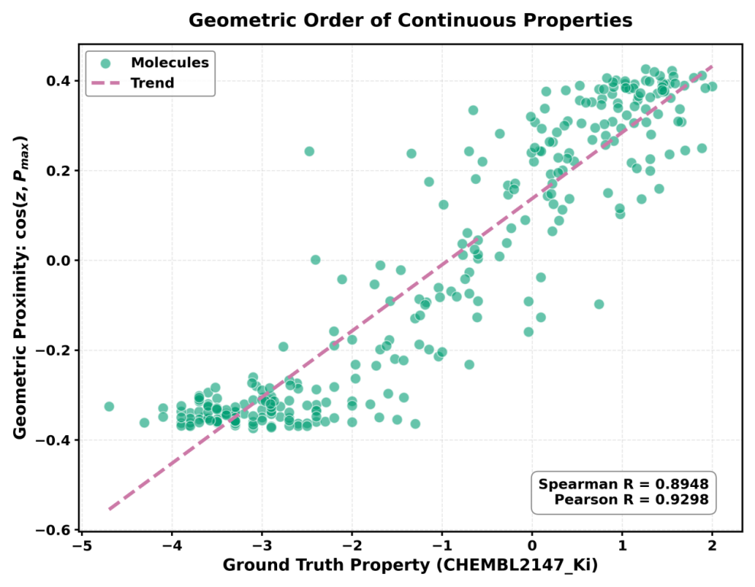
Figure S4. Geometric ordering of continuous properties in the latent space. Correlation between ground-truth activity and cosine similarity to the highest-activity proxy(P_{max}). Each point represents a molecule, and the dashed line indicates the fitted trend.

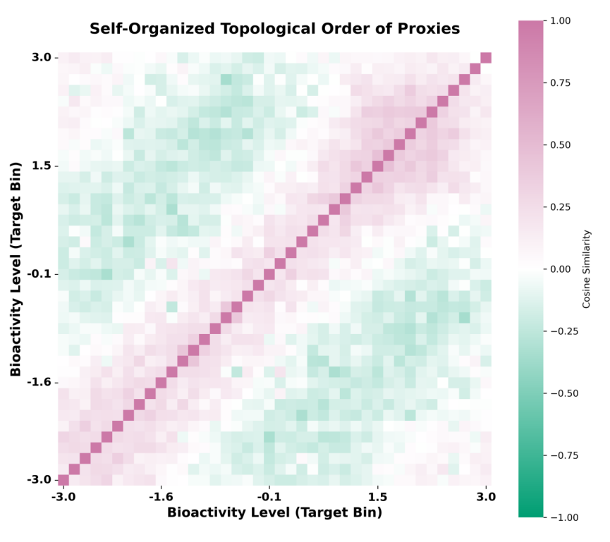
Figure S5. Cosine similarity heatmap of proxy anchors in the latent space. Heatmap showing pairwise cosine similarities between proxy anchors in the regression task. Each proxy corresponds to a bin of biological activity. Proxies associated with similar activity levels exhibit higher similarity, whereas proxies corresponding to more distant activity levels show lower similarity, indicating an ordered arrangement of proxies along the activity scale.

Figure S6. Representation similarity across property cliffs. Comparison of molecular similarity computed using conventional fingerprints (ECFP4, RDKit, and MACCS) and ArcMol latent representations for structurally similar molecules exhibiting divergent properties.

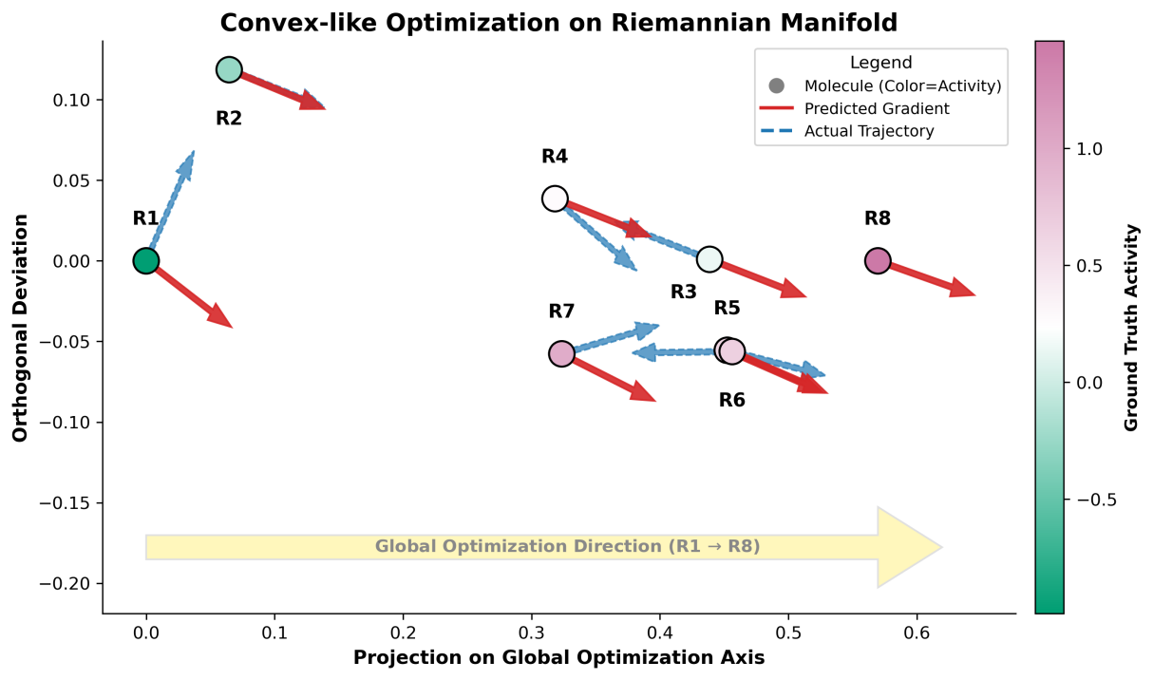
Figure S7. Latent-space trajectories during lead optimization. Visualization of a lead optimization sequence (R1 → R8) in the hyperspherical latent space. Red arrows denote the gradient direction toward the highest-activity proxy anchor (P_{max}) , and blue arrows show the observed optimization trajectory.

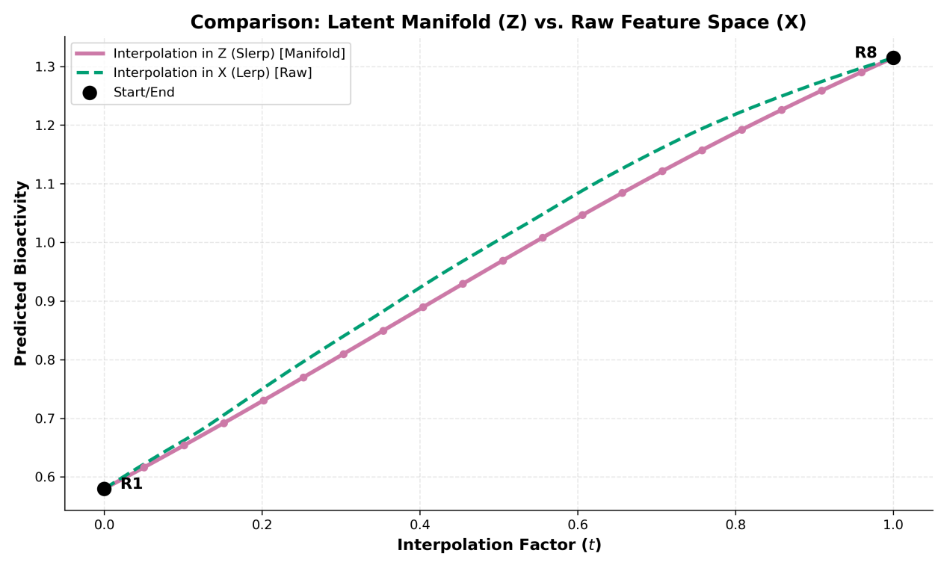
Figure S8. Interpolation in latent and raw feature spaces. Predicted bioactivity along spherical interpolation (Slerp) in the latent space Z and linear interpolation (Lerp) in the raw feature space X between R1 and R8.

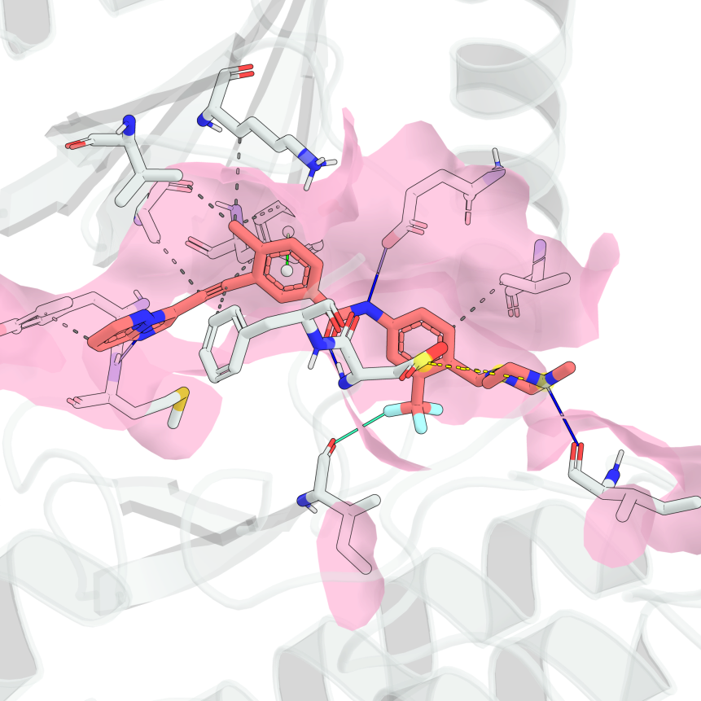
Figure S9. Structural basis of type II binding of ponatinib to inactive IRAK4. The crystal structure of IRAK4 in the DFG-out inactive conformation (PDB ID: 6EG9) is shown. Ponatinib binds to the ATP-binding cleft and extends into the hydrophobic back pocket exposed upon DFG motif rearrangement. The terminal substituent of ponatinib occupies the solvent-accessible cavity adjacent to the ATP-binding site, a defining structural feature of type II kinase inhibitors, thereby stabilizing the inactive conformation of IRAK4.

Figure S10. Chemical structures of the selected IRAK4 inhibitor candidates. The six compounds selected for biochemical assays are highlighted in pink.

Supplementary Tables

Supplementary Table 1. FDA-approved and reported IRAK4 inhibitors excluded from drug repurposing analysis.
Name | CAS Number | SMILES | pIC₅₀(Ref)
Staurosporine (AM-2282) | 62996-74-1 | CNC1CC2OC(C)(C1OC)n1c3ccccc3c3c4c(c5c6ccccc6n2c5c31)C(=O)NC4 | 8.155
Ponatinib (AP24534) | 943319-70-8 | Cc1ccc(C(=O)Nc2ccc(CN3CCN(C)CC3)c(C(F)(F)F)c2)cc1C#Cc1cnc2cccnn12 | 7.17
Quizartinib (AC220) | 950769-58-1 | CC(C)(C)c1cc(NC(=O)Nc2ccc(-c3cn4c(n3)sc3cc(OCCN5CCOCC5)ccc34)cc2)no1 | 8.69
Bosutinib (SKI-606) | 380843-75-4 | COc1cc(Nc2c(C#N)cnc3cc(OCCCN4CCN(C)CC4)c(OC)cc23)c(Cl)cc1Cl | 6.24

Supplementary Table 2. Top 20 drug repositioning candidates predicted by ArcMol
CAS Number | Name | Prediction
1211441-98-3 | Ribociclib (LEE011) | 8.610
557795-19-4 | Sunitinib (SU11248) | 8.404
1029044-16-3 | Pexidartinib (PLX3397) | 8.393
877399-52-5 | Crizotinib (PF-02341066) | 8.301
937272-79-2 | Pacritinib (SB1518) | 8.189
87760-53-0 | Tandospirone | 8.054
443913-73-3 | Vandetanib (ZD6474) | 8.047
75975-70-1 | Cephradine monohydrate | 7.938
120685-11-2 | Midostaurin (PKC412) | 7.896
1446321-46-5 | Voxelotor (GBT440) | 7.88
1108743-60-7 | Entrectinib (RXDX-101) | 7.747
1254053-43-4 | Gilteritinib (ASP2215) | 7.743
194798-83-9 | Fosfluconazole | 7.713
367514-87-2 | lurasidone | 7.690
2097132-94-8 | Pralsetinib (BLU-667) | 7.661
571190-30-2 | Palbociclib | 7.636
1229194-11-9 | Edoxaban tosylate Monohydrate | 7.632
856866-72-3 | Tedizolid (TR-700) | 7.632
93479-97-1 | Glimepiride | 7.629
69408-81-7 | Amonafide | 7.623

Supplementary Table 3. Ablation study of ArcMol components.
Method | Avg. AUC (Class) | Δ | Avg. RMSE (Reg) | Δ
Full Model | 82.38 (1.50) | - | 0.989 (0.027) | -
w/o Task-Adaptive Spherical Readout | 74.95 (2.51) | -7.43% | 1.206 (0.059) | +21.9%
w/o Multi-View Descriptor Fusion | 71.18 (4.58) | -11.20% | 1.096 (0.065) | +10.8%
w/o Physicochemical Descriptors | 67.03 (4.22) | -15.35% | 1.439 (0.226) | +45.5%
w/o Task-Adaptive MoE | 74.93(1.99) | -7.45% | 1.201(0.057) | +21.4%
Dense Task-Adaptive MoE | 72.60(3.88) | -9.78% | 1.161(0.053)_ | +17.4%
Performance comparison of ArcMol and its ablated variants on classification and regression tasks. Average AUC is reported for classification tasks and average RMSE for regression tasks, with standard deviations shown in parentheses. Performance differences (Δ) are reported relative to the full model.

Supplementary Table 4. Hyperparameter search for ArcMol.
Category | Hyperparameter | Search range / options
Optimization | Optimizer | AdamW
Optimization | Learning rate | {1e-5, 3e-5, 1e-4, 3e-4}
Optimization | Weight decay | {1e-4, 3e-4, 1e-3, 3e-3}
Optimization | Batch size | {48, 64, 96}
Optimization | Max epochs | 100
Optimization | Early stopping patience | 20
Optimization | Gradient clipping | 1.0
Optimization | Dropout rate | {0.1, 0.2, 0.3}
Mixture-of-Experts | Top-K experts | {2, 3, 4}
Mixture-of-Experts | MoE sparsity weight (λ_sparse) | {0.01, 0.05, 0.1}
Spherical projection | Embedding dimension | 128
Spherical projection | Activation | PReLU
Classification head | Angular margin (m) | {0.2, 0.3, 0.4}
Classification head | Logit scale (κ) | {20, 30, 40}
Classification head | Proxy orthogonality weight (λ_o) | {1e-3, 5e-3, 1e-2}
Classification head | Distillation temperature (τ) | {2, 4, 8}
Classification head | Distillation weight (λ_kd) | {0.1, 0.3, 0.5}
Regression head | Number of proxy anchors (K) | {10, 20, 30}
Regression head | Angular margin (m_arc) | {0.1, 0.2, 0.3}
Regression head | Arc loss weight (λ_arc) | {0.1, 0.3, 0.5}
Regression head | Soft label bandwidth (σ_soft) | {0.1, 0.2, 0.3}
Regression head | Distillation weight (λ_kd) | {0.1, 0.3, 0.5}
Reproducibility | Random seeds | {0, 1, 2, 3, 4}
Hardware | GPU | NVIDIA A100 (80 GB)

Supplementary Information References
1. Landrum, G. RDKit: A software suite for cheminformatics, computational chemistry, and predictive modeling. https://www.rdkit.org/ (2013).
2. Willett, P. Similarity-based virtual screening using 2D fingerprints. Drug Discovery Today 11, 1046-1053 (2006).
3. Cereto-Massagué, A., et al. Molecular fingerprint similarity search in virtual screening. Methods 71, 58-63 (2015).
4. Edwards, C., et al. Translation between Molecules and Natural Language. in Proceedings of the 2022 Conference on Empirical Methods in Natural Language Processing 375-413 (Association for Computational Linguistics, Abu Dhabi, United Arab Emirates, 2022).
5. Pei, Q., et al. BioT5: Enriching Cross-modal Integration in Biology with Chemical Knowledge and Natural Language Associations. in Proceedings of the 2023 Conference on Empirical Methods in Natural Language Processing 1102-1123 (Association for Computational Linguistics, 2023).
6. Lin, W. & Fung, C.C.A. Rethinking the Masking Strategy for Pretraining Molecular Graphs from a Data-Centric View. ACS Omega 9, 20832-20838 (2024).
7. Hu, Z., Dong, Y., Wang, K., Chang, K.-W. & Sun, Y. GPT-GNN: Generative Pre-Training of Graph Neural Networks. in Proceedings of the 26th ACM SIGKDD Conference on Knowledge Discovery and Data Mining (2020).
8. You, Y., et al. Graph Contrastive Learning with Augmentations. in Advances in Neural Information Processing Systems, Vol. 33 (eds. Larochelle, H., Ranzato, M., Hadsell, R., Balcan, M.F. & Lin, H.) 5812-5823 (Curran Associates, Inc., 2020).
9. Wang, Y., Wang, J., Cao, Z. & Barati Farimani, A. Molecular contrastive learning of representations via graph neural networks. Nature Machine Intelligence 4, 279-287 (2022).
10. Liu, S., et al. Pre-training Molecular Graph Representation with 3D Geometry. in International Conference on Learning Representations (2022).
11. Rong, Y., et al. Self-Supervised Graph Transformer on Large-Scale Molecular Data. Advances in Neural Information Processing Systems 33(2020).
12. Raghav, S.S., Kumar, S.T., Balaji, R., Sanjay, M. & Shunmuga, C. Interactive Symbolic Regression - A Study on Noise Sensitivity and Extrapolation Accuracy. in Proceedings of the Genetic and Evolutionary Computation Conference Companion 2076–2082 (Association for Computing Machinery, Melbourne, VIC, Australia, 2024).
13. Pedregosa, F., et al. Scikit-learn: Machine Learning in Python. 12, 2825–2830 (2011).
14. Lai, H., Huang, T., Lu, B., Zhang, S. & Xiaog, R. Silhouette coefficient-based weighting k-means algorithm. Neural Computing and Applications 37, 3061-3075 (2025).
15. Xiao, J., Lu, J. & Li, X. Davies Bouldin Index based hierarchical initialization K-means. Intelligent Data Analysis 21, 1327-1338 (2017).
16. Wang, T., Zhao, D. & Tian, S. An overview of kernel alignment and its applications. Artificial Intelligence Review 43, 179-192 (2015).

