Supplementary Material 1
Monotonicity analysis
Monotonicity analysis was performed prior data analysis and was assessed by examining whether conditional item means increased as a function of the rest score. Adjacent violations were defined as decreases in the conditional mean between successive rest-score groups. For each item, the total number of adjacent violations and the maximum observed adjacent drop in conditional means were recorded to quantify the extent and magnitude of local non-monotonicity. For each item, a rest score was computed as the sum of all remaining items within the same scale. Respondents were then grouped by their rest scores, and the conditional mean of the target item was calculated within each rest-score group. To complement the group-based evaluation, rank-order associations between each item and its rest score were estimated using Kendall’s τ and Spearman’s ρ. These coefficients provide scale-free indices of monotonic association that do not assume linearity or normality. Table S1 summarises monotonicity diagnostics across the four AI apprehension scales.
Table S1
Monotonicity diagnostics across AI apprehension scales
Scale | Rest-score groups (range) | Adjacent violations (range) | Max adjacent drop (range) | Kendall’s τ (range) | Spearman’s ρ (range)
General AI | 41-44 | 15-20 | 1.00-2.07 | 0.44-0.59 | 0.57-0.74
LLM AI | 45-50 | 17-23 | 1.20-2.35 | 0.53-0.63 | 0.66-0.79
Personal AI | 48-55 | 16-23 | 1.10-2.70 | 0.56-0.68 | 0.71-0.83
Institutional AI | 48-53 | 15-21 | 1.40-2.77 | 0.62-0.69 | 0.76-0.83
Note. Rest-score groups indicate the number of distinct summed rest-score values used to estimate conditional item means within each scale. Adjacent violations refer to the number of decreases in conditional item means between neighbouring rest-score groups. Maximum adjacent drop represents the largest observed decrease in conditional item means between adjacent groups. Kendall’s τ and Spearman’s ρ summarise the strength of the monotonic association between item scores and their corresponding rest scores. All values are reported as ranges across items within each scale

Across all scales, items showed positive monotonic associations with their rest scores, with Kendall’s τ ranging from 0.44 to 0.69 and Spearman’s ρ from 0.57 to 0.83. Adjacent monotonicity violations were observed for all scales, reflecting the fine-grained rest-score partitioning, but maximum adjacent drops were limited in magnitude (1-3 points on a 0-10 scale). Institutional and personal AI scales showed the strongest monotonic structure, followed by the LLM and general AI scales. Overall, departures from monotonicity were not systematic, supporting the ordinal coherence of all four scales (see Supplementary Material 1 for complete report).
Supplementary Material 2
Table S2_1. Distributions of items of Apprehension general AI scale
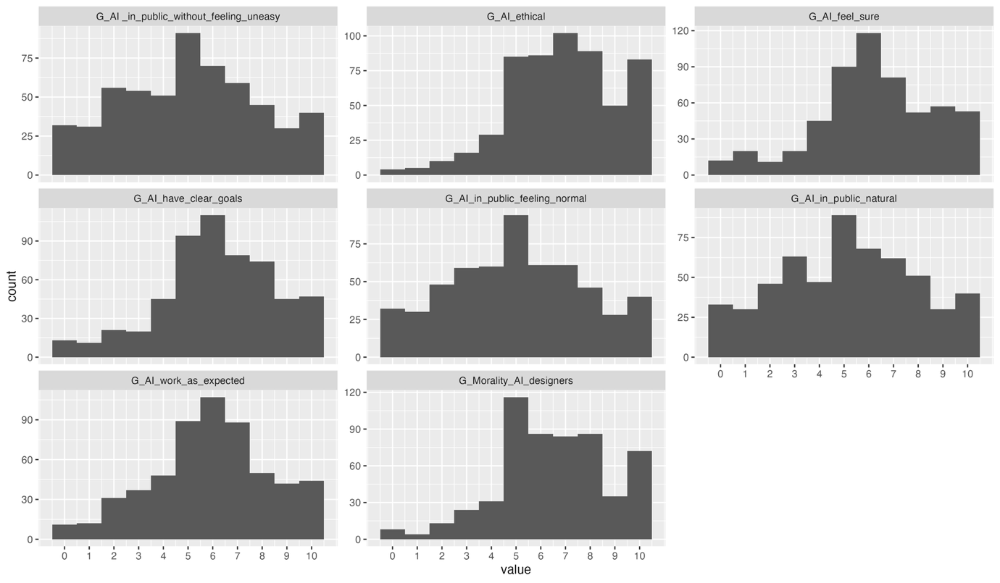
Table S2_2. Distributions of items of Apprehension institutional AI scale
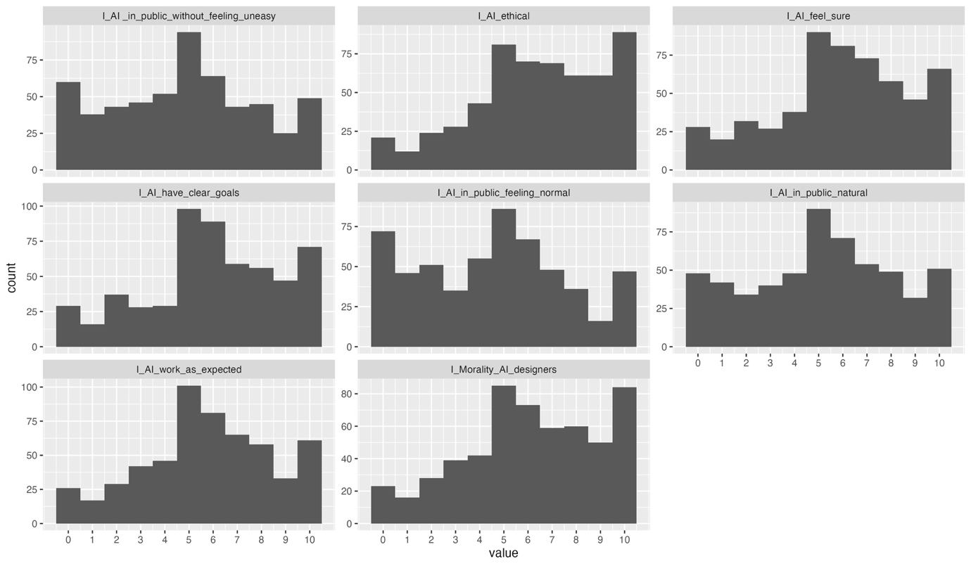
Table S2_3. Distributions of items of Apprehension personal AI scale
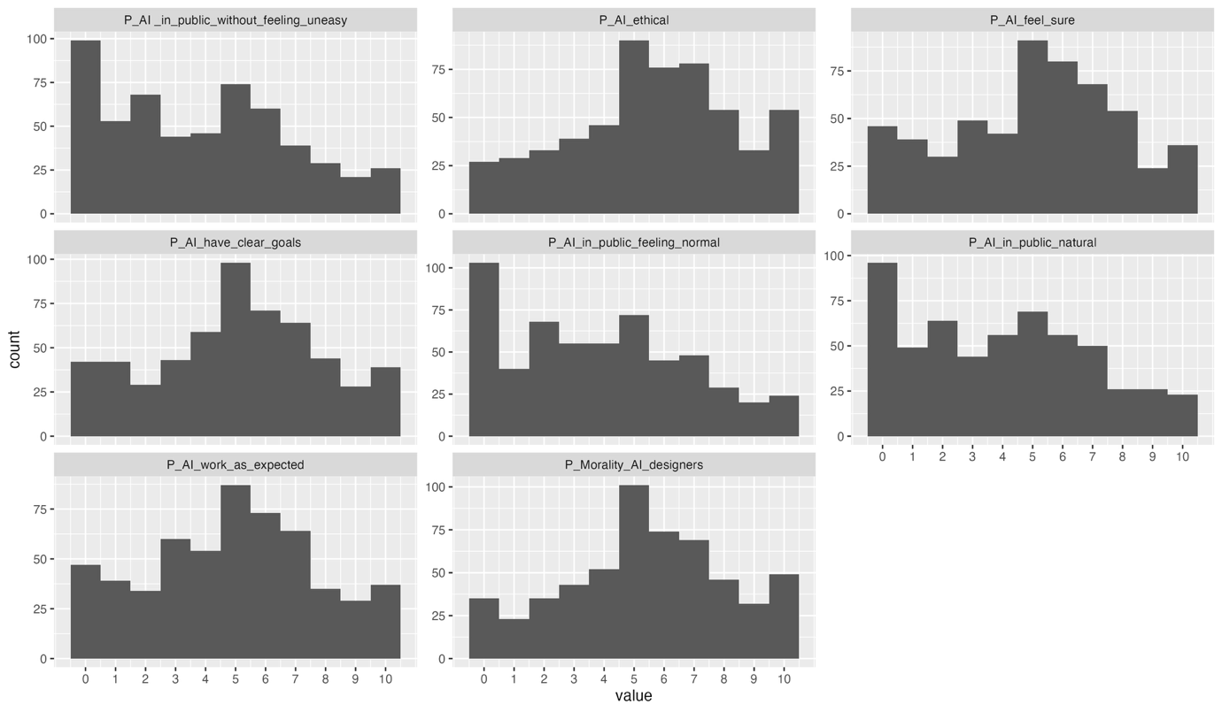
Table S2_4. Distributions of items of Apprehension LLM AI scale
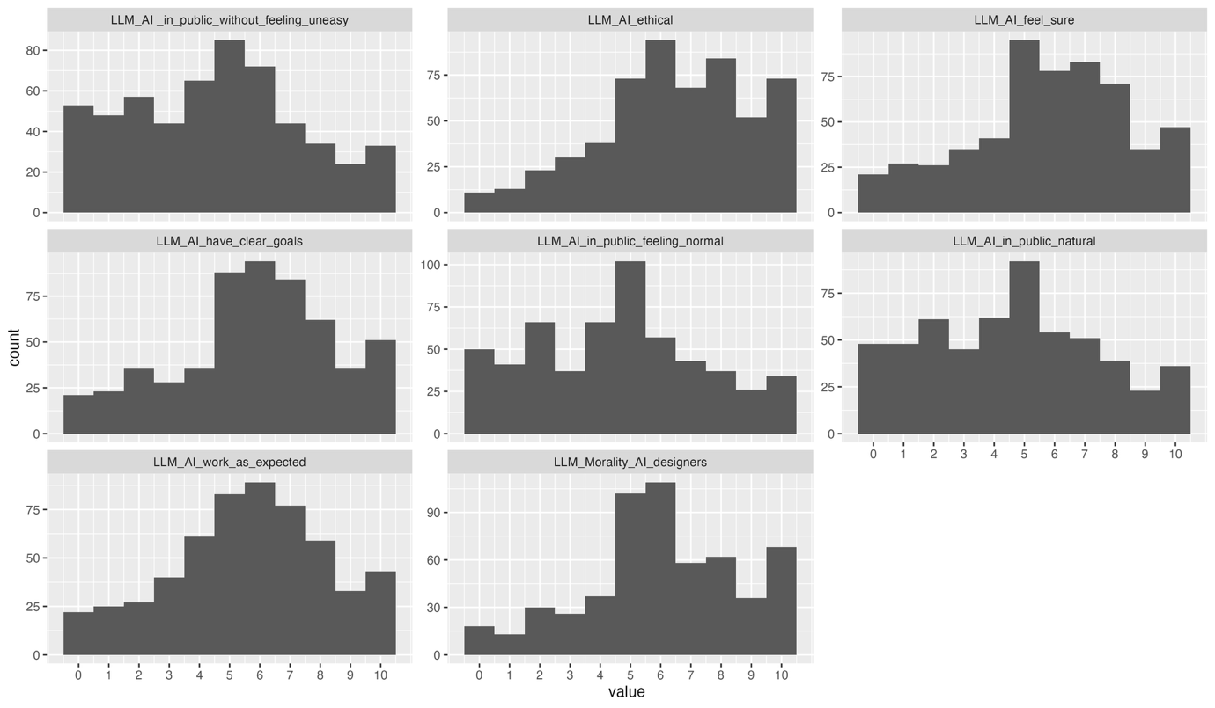

Supplementary Material 3

Table S3. Reliability indices by factor and AI type
AI | Factor | Items | α | Mean r | r (2-item) | Spearman–Brown | CR (ωc) | AVE | H
General AI | Implied Malice | 2 | 0.864 | 0.761 | 0.761 | 0.864 | 0.864 | 0.761 | 0.568
 | Undesirability | 3 | 0.942 | 0.843 | — | — | 0.943 | 0.845 | 0.683
 | Unpredictability | 3 | 0.889 | 0.727 | — | — | 0.895 | 0.736 | 0.597
LLM | Implied Malice | 2 | 0.891 | 0.804 | 0.804 | 0.892 | 0.891 | 0.804 | 0.561
 | Undesirability | 3 | 0.969 | 0.913 | — | — | 0.970 | 0.914 | 0.798
 | Unpredictability | 3 | 0.914 | 0.779 | — | — | 0.924 | 0.796 | 0.629
Personal AI | Implied Malice | 2 | 0.917 | 0.846 | 0.846 | 0.917 | 0.917 | 0.847 | 0.595
 | Undesirability | 3 | 0.973 | 0.924 | — | — | 0.974 | 0.924 | 0.807
 | Unpredictability | 3 | 0.936 | 0.830 | — | — | 0.944 | 0.840 | 0.666
Institutional AI | Implied Malice | 2 | 0.941 | 0.889 | 0.889 | 0.941 | 0.941 | 0.889 | 0.677
 | Undesirability | 3 | 0.947 | 0.856 | — | — | 0.951 | 0.860 | 0.674
 | Unpredictability | 3 | 0.942 | 0.843 | — | — | 0.948 | 0.853 | 0.697
Note. α = Cronbach’s alpha; Mean r = mean inter-item correlation; r (2-item) = Pearson inter-item correlation for two-item factors; Spearman–Brown = Spearman–Brown reliability coefficient; CR (ωc) = composite reliability derived from confirmatory factor analysis; AVE = average variance extracted; H = construct replicability (MaxR(H)). Spearman–Brown and r (2-item) are reported only for two-item factors; dashes indicate indices not applicable to three-item factors

Supplementary Material 4
Demographic correlates of apprehension toward four AI types
Method
The aim of this analysis was to estimate the associations between demographic characteristics (age group, gender, education level, religious beliefs) and total scores on four types of AI apprehension (General AI, LLMs, Personal AI, and Institutional AI), using robust regression models. Single-predictor models were used because several demographic variables were categorical with multiple levels and uneven group sizes, and combining predictors in a single model would have resulted in sparse or unstable cross-classified cells.
Prior to analysis, the demographic data were screened and re-coded to ensure interpretability and robustness of the models. Four participants who identified as non-binary were excluded from gender analyses due to the very small cell size. For education, respondents reporting no formal education were excluded for the same reason (N=9). Responses about religion believes were merged intro 2 categories (religion believes (N=159) and no religion believes (n=366), and 34 participants with missing responses were excluded from the education analysis). Age was recoded into three categories (18-24 (N=138), 25-34 (n=235), and 35-44 (N=186) years).
All models were estimated using ordinary least squares with heteroskedasticity-consistent (HC3) robust standard errors. Regression coefficients were reported with robust standard errors, t statistics, p values, and 95% confidence intervals. For predictors with more than two levels, HC3-based robust Wald tests were used to evaluate overall associations. Model fit was summarised using R² and adjusted R². For the religious-beliefs analyses, non-parametric bootstrap percentile confidence intervals (5,000 resamples) were computed as a robustness check.

Results
Gender
Gender differences across four AI apprehension scales were examined using four separate robust linear regression models with gender coded as a continuous variable (0 = female, 1 = male). The analyses were conducted on a sample of 555 participants, comprising 276 females and 279 males.
The Wald tests indicated significant gender effects for General AI and LLMs apprehension, but not for Personal AI or Institutional AI apprehension. Specifically, male participants reported lower levels of General AI and LLMs apprehension relative to female participants. No evidence of a gender difference was observed for Institutional and Personal AI apprehension (Table S4-1). Across all four models, the proportion of variance explained by gender was small (R² range = .001-.018), indicating that while statistically detectable gender differences were present for some AI domains, gender accounted for only a modest share of overall variability in AI apprehension.

Table S4-1

Gender differences across AI apprehension scales
Outcome | β (male vs female) | 95% CI | p | R²
General AI | −3.24 | [−5.81, −0.67] | .014 | .011
LLMs | −4.76 | [−7.68, −1.84] | .001 | .018
Personal AI | −3.07 | [−6.29, 0.15] | .062 | .006
Institutional AI | −0.97 | [−4.23, 2.28] | .558 | .001
Note. Gender coded as 0 = female, 1 = male. Estimates reflect the difference for male relative to female participants. Robust standard errors (HC3) used throughout.

Age
Age was examined first as a continuous predictor in robust linear regression models (HC3 standard errors), estimated separately for each of the four apprehension scales (N = 550 for each model). Across the four models, there was no evidence that age was associated with any apprehension domain: General AI apprehension (p = .964), LLMs apprehension (p = .506), Personal AI apprehension (F(1, 548) = 0.12, p = .730), or Institutional AI apprehension (p = .198). Model fit was negligible across outcomes (R² = .000-.003), indicating that age alone explained little variance in any of the four scales (Table S4-2).
Table S4-2. Associations between age and AI apprehension across four AI types
AI type | β (age) | p | R²
General AI apprehension | −0.005 | .964 | .000
LLM AI apprehension | −0.074 | .506 | .001
Personal AI apprehension | −0.043 | .730 | .000
Institutional AI apprehension | 0.153 | .198 | .003
Note. Age was entered as a continuous predictor in age-only robust linear regression models (HC3 standard errors)

Age was also examined as a categorical variable using three groups: 18-24 years (n = 136), 25-34 years (n = 231), and 35-44 years (n = 183). Across all four AI types, age group explained a negligible proportion of variance. Specifically, age group accounted for little variance in General AI apprehension (R² = .003), LLMs apprehension (R² = .005), Personal AI apprehension (R² = .003) and Institutional AI apprehension (R² = .003) with adjusted R² values close to or below zero in all cases. These results indicate that categorising age into groups did not reveal meaningful differences in AI apprehension scores.
Education
Associations between education level and AI apprehension were tested across the four AI types (General, LLMs, Personal, Institutional), using the following education groups: postgraduate (n = 103), undergraduate (n = 264), vocational/technical (n = 88), and secondary/high school (n = 95). There was no evidence of an association between education and apprehension for any AI type (joint tests: General p = .207; LLMs p = .220; Personal p = .234; Institutional p = .715), and the variance explained was small in all cases (R² range = .003-.009). Consistent with these joint tests, none of the education-category contrasts reached statistical significance for any AI type (Table S4-3).
Table S4-3. Associations between education and AI apprehension across four AI types
AI type | R² | Joint test of education (F) | p
General AI apprehension | .009 | F(3, 546) = 1.52 | .207
LLM AI apprehension | .009 | F(3, 546) = 1.47 | .220
Personal AI apprehension | .008 | F(3, 546) = 1.43 | .234
Institutional AI apprehension | .003 | F(3, 546) = 0.45 | .715

Religious beliefs
Associations between religious beliefs (0 = no religious beliefs (N=398); 1 = religious beliefs (N=138) and AI apprehension were examined using separate linear regression models with heteroskedasticity-consistent (HC3) standard errors (N = 527 in each analysis). Robust Wald tests were used to evaluate the null hypothesis that the regression coefficient for religious beliefs equals zero. In addition, non-parametric bootstrap procedures (5,000 resamples) were applied to derive percentile-based 95% confidence intervals for the focal coefficients.
Religious beliefs were positively associated with Institutional AI apprehension (β = 3.67, p = .044, R² = .008) and Personal AI apprehension (β = 3.75, p = .041, R² = .008), with bootstrap confidence intervals excluding zero in both cases. In contrast, associations with General AI apprehension (β = 2.48, p = .075, R² = .006) and LLM AI apprehension (β = 2.10, p = .190, R² = .003) were not significant; bootstrap confidence intervals for these models included zero. Across domains, the proportion of variance explained by religious beliefs was small (R² range = .003-.008), indicating limited explanatory contribution.

Discussion
Associations between demographic characteristics and AI apprehension were limited and varied by AI type. Gender differences emerged for General AI and LLMs, and absent for Personal AI and Institutional AI, indicating that gender-related variation is context-specific rather than a general feature of AI apprehension. Religious belief was associated with higher apprehension for Personal and Institutional AI, but not for General AI or LLMs. These findings may reflect differences in how these AI types intersect with moral agency and authority (Chimakonam, 2024; Zhang et al., 2025). Personal and Institutional AI are more directly involved in decisions about individuals, including personal data and institutional power, which may activate concerns about responsibility, accountability, and the legitimacy of decision-making authority. These considerations may be less salient for more general or conversational systems. The absence of similar effects for age and education suggests that the observed associations are not driven by general differences in experience or knowledge, but by value-based concerns that become relevant in specific AI contexts.

