Supplementary Materials
- Supplementary Methods

1.1 Appendix S1. Definitions of the Clinical, Demographic, and Morphological Aneurysm Variables
1.2 Appendix S2. Image Preprocessing and VOI Segmentation
1.3 Appendix S3. Radiomic Feature Extraction
1.4 Appendix S4. Standard Operating Procedure for Endovascular Aortic Repair of Abdominal Aortic Aneurysm
1.5 Appendix S5. Imaging Criteria for Type II Endoleaks After Endovascular Aortic Repair
1.6 Appendix S6. Intra- and Inter-Observer Reproducibility
1.7 Appendix S7. Least Absolute Shrinkage and Selection Operator (LASSO) Regression Analysis
1.8 Appendix S8. Descriptions of the Support Vector Machine Algorithms
- Supplementary Results
2.1 Appendix S9. Performance of the Models Based on the Clinical, Intra-Tumoral, and Peritumoral Radiomic Features
- Supplementary Tables
3.1 Table S1. Comparison of the Clinical Characteristics in the Training, Internal Validation, and External Validation Cohorts
3.2 Table S2. Results of the Radiomic Model Feature Selection
3.3 Table S3. CTA Scanning and Reconstruction Parameters
- Supplementary Figures
4.1 Figure S1. Confusion Matrices of the Three Models Across the Four Sets
4.2 Figure S2. Feature Importance Coefficient Plot After LASSO Regression for the Six Models
Supplementary Methods

Appendix S1. Definitions of the Clinical, Demographic, and Morphological Aneurysm Variables
This appendix details the standardized criteria and measurement protocols for all variables collected in this multicenter study. The definitions were established a priori and applied uniformly across all participating centers to ensure data consistency and reproducibility.
S1.1 Demographic and Clinical Variables
Patient demographic and clinical data were extracted from structured electronic medical records. Age was recorded in years at the time of the index endovascular aneurysm repair (EVAR). Sex was documented as male or female. Body mass index was calculated from the height and weight measured during the preoperative evaluation (weight in kilograms divided by height in meters squared). Smoking status was categorized as current (active smoking within 6 months prior to EVAR), former (history of regular smoking but quit >6 months prior), or never. For statistical analysis, this was dichotomized into ever smoker (combining current and former) versus never smoker. Comorbidities were defined using a combination of diagnostic codes, medication use, and laboratory criteria. Diabetes mellitus was defined by a prior diagnosis, use of glucose-lowering agents, or a hemoglobin A1c level of ≥6.5%. Hypertension required a documented diagnosis, use of antihypertensive medications, or repeated measurements of a systolic blood pressure of ≥140 mmHg or a diastolic blood pressure of ≥90 mmHg. Hyperlipidemia was defined by a prior diagnosis, use of lipid-lowering therapy, or a fasting low-density lipoprotein cholesterol level of ≥3.4 mmol/L. Coronary artery disease was confirmed by a documented history of myocardial infarction, coronary revascularization, or significant coronary stenosis (>50%) on angiography. Chronic kidney disease (CKD) was defined as an estimated glomerular filtration rate of <60 mL/min/1.73 m² for at least 3 months, calculated using the CKD-EPI equation. Iliac artery involvement was determined from preoperative imaging and defined as an aneurysmal dilation (maximum diameter of ≥18 mm) of the common or internal iliac artery ipsilateral to the abdominal aortic aneurysm.
S1.2 Morphological Aneurysm Variables (Based on Computed Tomography Angiography [CTA])
All quantitative measurements of aneurysm anatomy were performed on preoperative CTA scans by two independent vascular radiologists blinded to clinical outcomes, using a dedicated 3D analysis workstation (3D Slicer, version 5.0.3). The maximum aneurysm diameter was measured as the largest outer-to-outer wall perpendicular diameter on axial images. Proximal neck morphology was characterized by the neck diameter (minimum inner diameter of 5 mm below the lowest renal artery), neck length (distance from the lowest renal artery to the proximal aneurysm origin along the centerline), and neck angulation (maximum angle between the neck and aneurysm body axes). The inferior mesenteric arterial diameter was measured at its origin. The number of patent lumbar arteries was counted from L1 to L4 and was subsequently categorized for analysis as low flow burden (≤2 arteries) or high flow burden (>2 arteries). The presence of nodular neck calcification was assessed visually and defined as focal, protrusive calcification involving ≥50% of the vessel circumference within the proximal 15-mm sealing zone. Thrombus characteristics included thrombus thickness (maximum radial thickness), thrombus area (cross-sectional area at the level of the maximum diameter), and thrombus volume (total volume within the sac). Total aneurysm volume and lumen volume were also computed from the segmentations. The presence of an aortic bifurcation aneurysm was recorded if the bifurcation diameter measured ≥30 mm.
S1.3 Data Quality Assurance
A centralized variable dictionary and measurement protocol were disseminated across all sites before data collection. The two radiologists involved in the image analysis underwent a joint calibration session using 10 training cases to harmonize measurement techniques. All data collectors and analysts were blinded to the endpoint of type II endoleaks during the extraction and measurement phases. The reliability of continuous anatomical measurements was formally assessed by calculating the intra-class correlation coefficient (ICC) using a two-way random-effects model for absolute agreement. As reported in the main manuscript, only variables demonstrating excellent inter-observer agreement (ICC > 0.80) were carried forward for inclusion in the predictive modeling.

Appendix S2. Image Preprocessing and VOI Segmentation
Patients were positioned supine with head-first entry into the CT scanner. Throughout the examination, steady breathing and head immobility were maintained. The scanning coverage extended from the level of the aortic arch to the cranial vertex. For the SOMATOM Force CT scanner, the acquisition parameters were set as follows: tube voltage of 100 kV, automatic tube current modulation enabled, pitch of 0.80, tube rotation time of 0.5 s, and collimation width of 192 × 0.6 mm. Images were reconstructed with a slice thickness and interval of 1.0 mm. For the Toshiba Aquilion ONE CT scanner, the parameters were as follows: tube voltage of 100 kV, automatic tube current modulation enabled, pitch of 0.87, tube rotation time of 0.5 s, and collimation width of 320 × 0.5 mm. Reconstruction was similarly performed with a slice thickness and interval of 1.0 mm.
A bolus of 40–50 mL of iodinated contrast agent was administered intravenously at a rate of 5.0 mL/s, followed by a 40 mL saline chaser injected at the same rate. Scan initiation was controlled using bolus-tracking technology, with the monitoring plane placed at the aortic arch. The acquisition was automatically triggered when the intra-luminal signal intensity reached a predefined threshold of 100–150 Hounsfield units.
All CTA image datasets were resampled to an isotropic voxel size of 1.0 × 1.0 × 1.0 mm³ to standardize spatial resolution. During discretization, a fixed number of 25 gray levels was applied to standardize voxel intensity values and control image noise. Furthermore, the gray values of all image volumes were scaled to a fixed range of 0–255, following the exclusion of outlier pixels, to minimize voxel intensity heterogeneity attributable to differences between the two scanner platforms.

Appendix S3. Radiomic Feature Extraction
Radiomic feature extraction was performed using the Python-based PyRadiomics software package (version 3.0.1), in accordance with the guidelines established by the Image Biomarker Standardisation Initiative(6). Initially, for each patient, the final feature set comprised a total of 939 radiomic features derived from each parameterized image, culminating in an aggregate of 5634 features per patient across the dataset. These 939 extracted radiomic features were categorized into four distinct groups: 1) 18 first-order features (also referred to as histogram features), which quantify the distribution of voxel intensities within the volume of interest, including metrics such as energy, entropy, mean, and median; 2) 14 shape features, which describe the three-dimensional morphological characteristics and size of the segmented region, encompassing parameters such as mesh surface, pixel surface, perimeter, and maximum diameter; 3) 75 texture features, which assess intra-regional heterogeneity through matrices including the gray-level co-occurrence matrix, gray-level dependence matrix, gray-level run-length matrix, gray-level size zone matrix, and neighboring gray tone difference matrix; and 4) 853 filter- and wavelet-based features, obtained through the application of filter banks and wavelet transforms to the original images. This latter category comprised intensity and texture features derived from filtered (e.g., exponential, gradient, logarithmic, square, square root, lbp-2D, and lbp-3D) and wavelet-transformed images, processed using eight distinct frequency band combinations: low-high-low, low-high-high, high-low-low, low-low-high, high-low-high, high-high-high, high-high-low, and low-low-low.

Appendix S4. Standard Operating Procedure for Endovascular Aortic Repair of Abdominal Aortic Aneurysm
The standard protocol for elective endovascular aortic repair of an abdominal aortic aneurysm comprises a series of systematic steps, beginning with comprehensive preprocedural imaging assessment and patient selection. Under general or regional anesthesia, bilateral femoral artery access is established via surgical cutdown or a percutaneous approach. Following placement of a super-stiff guidewire above the level of the celiac trunk, the main body endograft delivery system is advanced to the infrarenal abdominal aorta. Under fluoroscopic guidance, the main graft is deployed, ensuring precise positioning immediately distal to the renal artery ostia. A subsequent critical step involves cannulation of the contralateral gate from the contralateral femoral access. After successful cannulation, an iliac limb component is introduced, deployed, and connected to the main body graft. Additional iliac limb extensions may be utilized to achieve an adequate distal seal within the external iliac artery. Following graft deployment, balloon molding is mandatory at the proximal landing zone, all graft junctions, and distal fixation sites to ensure apposition of the graft fabric to the vessel wall and mitigate the risk of type Ia and type III endoleaks. The procedure is concluded with a completion angiogram to confirm technical success, which includes evaluation of renal artery patency, graft configuration, and the absence of significant endoleaks. Subsequently, all sheaths are withdrawn, and the arterial access sites are surgically repaired.

Appendix S5. Imaging Criteria for Type II Endoleaks After Endovascular Aortic Repair
According to the reporting standards of the Society for Vascular Surgery, the diagnosis of a type II endoleak is established on follow-up computed tomography angiography after endovascular aortic repair. It is definitively diagnosed when contrast enhancement is observed within the excluded aneurysm sac, and this enhancement cannot be attributed to direct perfusion from proximal or distal seal zones (i.e., type I endoleak), a defect in graft material or junction (i.e., type III endoleak), or graft fabric porosity (i.e., type IV endoleak). Crucially, the enhancement must be supplied by patent branch vessels, such as the inferior mesenteric or lumbar arteries, with no evidence of direct communication with the main graft body.
The key imaging characteristic is the persistence of contrast within the sac on delayed-phase imaging (typically ≥60 s post-injection), which distinguishes its low-flow, retrograde nature from the high-flow patterns of other endoleak types. If a type II endoleak is accompanied by a continuous increase in the aneurysm sac diameter (commonly defined as >5 mm) on sequential imaging studies, it is classified as a “clinically significant type II endoleak” and typically warrants intervention.

Appendix S6. Intra- and Inter-Observer Reproducibility
Intra- and inter-observer reproducibility was assessed using intra-class correlation coefficients (ICCs) to quantify feature stability. For intra-observer evaluation, Observer A (10 years of vascular imaging experience) repeated volumetric segmentation on 50 randomly selected patient images at a 2-week interval. For inter-observer evaluation, images from 30 randomly selected patients from the training cohort were independently segmented by Observer A and Observer B (25 years of experience), generating two resegmented datasets. ICC values were calculated accordingly, with thresholds interpreted as follows: >0.80 (excellent agreement), 0.61–0.80 (good agreement), 0.41–0.60 (moderate agreement), 0.11–0.40 (low agreement), and <0.10 (poor agreement). Only features demonstrating excellent reproducibility (ICC > 0.80) in both analyses were retained for subsequent radiomic modeling.

Appendix S7. Least Absolute Shrinkage and Selection Operator (LASSO) Regression Analysis
LASSO regression analysis was performed to regularize the feature selection process, employing a 10-fold cross-validated LASSO method. The optimal tuning parameter (λ) was determined by minimizing the mean squared error. Under this optimal λ, the coefficients of a subset of candidate features were shrunk to zero, while those with non-zero coefficients were retained. Ultimately, the radiomic features with non-zero coefficients across the four parametric images from the secondary LASSO analysis were selected to establish the final optimal feature set.

Appendix S8. Descriptions of the Support Vector Machine Algorithms
Support vector machine is a machine learning algorithm grounded in the principle of structural risk minimization from statistical learning theory. It operates by mapping data into a high-dimensional space and constructing a hyperplane to perform classification(11). Its effectiveness in handling high-dimensional spaces makes it particularly well suited for managing the complex feature sets commonly encountered in radiomic data.

Supplementary Results
Appendix S9. Performance of the Models Based on the Clinical, Intra-Tumoral, and Peritumoral Radiomic Features
Predictive models were built using a logistic regression classifier. The features selected through the previously described pipeline—corresponding to the Clinical model, the intra-tumoral (Intra) model, and the five Intra + Peri fusion models (Intra + Peri 2 mm to Intra + Peri 10 mm)—were used as input for model construction. As shown in Table 2, the Intra + Peri fusion models generally outperformed the Clinical and Intra models across all cohorts. Among the various peritumoral margins evaluated, the Intra + Peri 6 mm model demonstrated superior and more consistent performance (e.g., AUCs of 0.910, 0.907, 0.886, and 0.859 in the training, validation, Test 1, and Test 2 cohorts, respectively) compared with the models using other margin sizes. Given its robust performance, the Intra + Peri 6 mm model was selected for further integration with the Clinical model. This integration led to the development of the Clinical + Intra + Peri 6 mm fusion model, which achieved the highest overall performance in the training cohort, with an AUC of 0.954 (95% CI = 0.913–0.986), a sensitivity of 0.862, a specificity of 0.880, an accuracy of 0.875, and an F1-score of 0.794. The model also demonstrated strong generalizability in both internal and external validation cohorts, with AUCs of 0.933 (95% CI = 0.838–0.995) and 0.924/0.896 in Test 1 and Test 2, respectively. These results confirm the value of incorporating peritumoral features and support the selection of the Clinical + Intra + Peri 6 mm model as the optimal model for further clinical application.

1.Supplementary Tables

Table S1.Comparison of clinical characteristics in the training,internal validation,and external validation cohorts
Characteristics | Training cohort  (N = 104) | Internal validation cohort  (N = 44) | External validation cohort 1  (N = 110) | External validation cohort 2  (N =97) | P value
Age, years* | 63.75 ± 6.35 | 66.18 ± 6.91 | 65.32 ± 6.32 | 64.50 ± 6.80 | 0.140
BMI, kg/m2* | 23.12 ± 2.52 | 23.07 ± 2.87 | 23.48 ± 3.28 | 22.94 ± 2.67 | 0.574
Gender(%) |  |  |  |  | 0.336
Female | 27 (25.96) | 11 (25.00) | 31 (28.18) | 35 (36.46)
Male | 77 (74.04) | 33 (75.00) | 79 (71.82) | 61 (63.54)
Smoking (%) |  |  |  |  | 0.498
No | 34 (32.69) | 18 (40.91) | 42 (38.18) | 29 (30.21)
Yes | 70 (67.31) | 26 (59.09) | 68 (61.82) | 67 (69.79)
Diabetes (%) |  |  |  |  | 0.645
No | 56 (53.85) | 26 (59.09) | 66 (60.00) | 60 (62.50)
Yes | 48 (46.15) | 18 (40.91) | 44 (40.00) | 36 (37.50)
Hypertension (%) |  |  |  |  | 0.936
No | 35 (33.65) | 17 (38.64) | 38 (34.55) | 35 (36.46)
Yes | 69 (66.35) | 27 (61.36) | 72 (65.45) | 61 (63.54)
Hyperlipidemia (%) |  |  |  |  | 0.604
No | 41 (39.42) | 21 (47.73) | 51 (46.36) | 46 (47.92)
Yes | 63 (60.58) | 23 (52.27) | 59 (53.64) | 50 (52.08)
CAD (%) |  |  |  |  | 0.497
No | 51 (49.04) | 19 (43.18) | 54 (49.09) | 54 (56.25)
Yes | 53 (50.96) | 25 (56.82) | 56 (50.91) | 42 (43.75)
Involving iliac artery (%) |  |  |  |  | 0.160
No | 61 (58.65) | 20 (45.45) | 63 (57.27) | 63 (65.62)
Yes | 43 (41.35) | 24 (54.55) | 47 (42.73) | 33 (34.38)
Nodular neck calcification |  |  |  |  | 0.795
No | 47 (45.19) | 22 (50.00) | 46 (41.82) | 45 (46.88)
Yes | 57 (54.81) | 22 (50.00) | 64 (58.18) | 51 (53.12)
Number of arteriae lumbales |  |  |  |  | 0.735
≤2 | 80 (76.92) | 32 (72.73) | 84 (76.36) | 68 (70.83)
＞2 | 24 (23.08) | 12 (27.27) | 26 (23.64) | 28 (29.17)
AAA Maximum diameter,mm* | 50.94 ± 7.22 | 51.64 ± 5.41 | 52.19 ± 5.75 | 52.39 ± 5.83 | 0.155
Nodule neck angle, °* | 27.58 ± 2.93 | 27.69 ± 2.51 | 26.82 ± 2.77 | 27.08 ± 2.43 | 0.123
Nodule neck length,mm* | 2.69 ± 0.38 | 2.62 ± 0.52 | 2.72 ± 0.51 | 2.76 ± 0.61 | 0.428
IMA diameter, mm* | 3.10 ± 0.35 | 3.03 ± 0.49 | 3.00 ± 0.43 | 3.11 ± 0.37 | 0.168
Thrombus thickness, mm* | 2.54 ± 0.38 | 2.49 ± 0.33 | 2.49 ± 0.30 | 2.55 ± 0.17 | 0.444
Thrombus area,mm²* | 21.43 ± 3.50 | 20.01 ± 3.94 | 20.72 ± 4.24 | 20.07 ± 3.81 | 0.129
BMI, body mass index; CAD, coronary artery disease; IMA, inferior mesenteric artery; AAA, abdominal aortic aneurysm.
Table S2. Radiomics models feature selection results
 | Feature | Coefficient
Intra | Intra_wavelet-HL_firstorder_Mean | -0.0067
 | Intra_logarithm_glszm_SmallAreaLowGrayLevelEmphasis | -0.0099
 | Intra_square_glcm_Imc1 | -0.0812
 | Intra_square_gldm_DependenceNonUniformityNormalized | 0.1384
 | Intra_square_gldm_SmallDependenceLowGrayLevelEmphasis | -0.0081
 | Intra_wavelet-HH_gldm_SmallDependenceLowGrayLevelEmphasis | -0.0044
 | Intra_squareroot_glcm_ClusterShade | 0.0067
 | Intra_wavelet-LL_gldm_SmallDependenceLowGrayLevelEmphasis | -0.0195
 | Intra_exponential_ngtdm_Busyness | -0.0019
 | Intra_wavelet-LH_glcm_Correlation | -0.0148
 | Intra_logarithm_ngtdm_Complexity | 0.0219
 | Intra_wavelet-HL_firstorder_Skewness | -0.0264
Intra+Peri2mm | Intra_wavelet-HL_firstorder_Mean | -0.0061
 | Intra_square_glcm_Idn | 0.0042
 | Intra_logarithm_glszm_SmallAreaLowGrayLevelEmphasis | -0.0143
 | Intra_square_glcm_Imc1 | -0.0818
 | Intra_square_gldm_DependenceNonUniformityNormalized | 0.1314
 | Intra_square_gldm_SmallDependenceLowGrayLevelEmphasis | -0.0082
 | Intra_wavelet-HH_gldm_SmallDependenceLowGrayLevelEmphasis | -0.0015
 | Intra_squareroot_glcm_ClusterShade | 0.0065
 | Intra_wavelet-LL_gldm_SmallDependenceLowGrayLevelEmphasis | -0.0200
 | Peri2mm_square_glszm_SizeZoneNonUniformityNormalized | -0.0074
 | Peri2mm_wavelet-HH_glcm_Idm | 0.0105
 | Peri2mm_logarithm_firstorder_InterquartileRange | -0.0151
 | Intra_wavelet-LH_glcm_Correlation | -0.0101
 | Intra_logarithm_ngtdm_Complexity | 0.0214
 | Peri2mm_exponential_firstorder_90Percentile | -0.0027
 | Intra_wavelet-HL_firstorder_Skewness | -0.0239
Intra+Peri4mm | Intra_wavelet-HL_firstorder_Mean | -0.0262
 | Intra_square_glcm_Idn | 0.0054
 | Intra_exponential_gldm_SmallDependenceLowGrayLevelEmphasis | -0.0045
 | Intra_square_glcm_Imc1 | -0.0679
 | Intra_logarithm_gldm_DependenceVariance | -0.0170
 | Intra_square_gldm_DependenceNonUniformityNormalized | 0.1119
 | Intra_squareroot_glcm_ClusterShade | 0.0228
 | Intra_square_gldm_SmallDependenceLowGrayLevelEmphasis | -0.0087
 | Intra_logarithm_gldm_SmallDependenceLowGrayLevelEmphasis | -0.0344
 | Intra_logarithm_firstorder_RobustMeanAbsoluteDeviation | 0.0335
 | Intra_wavelet-HL_gldm_SmallDependenceLowGrayLevelEmphasis | -0.0100
 | Intra_gradient_glszm_SmallAreaLowGrayLevelEmphasis | 0.0061
 | Peri4mm_original_shape2D_Elongation | -0.0171
 | Intra_wavelet-LH_glcm_Correlation | -0.0118
 | Peri4mm_logarithm_glszm_LargeAreaHighGrayLevelEmphasis | 0.0400
Intra+Peri6mm | Intra_wavelet-HL_firstorder_Mean | -0.0140
Intra+Peri6mm | Intra_wavelet-HH_ngtdm_Contrast | -0.0027
 | Intra_square_glcm_Idn | 0.0004
 | Intra_square_glcm_Imc1 | -0.0832
 | Intra_logarithm_glszm_SmallAreaLowGrayLevelEmphasis | -0.0223
 | Peri6mm_exponential_glszm_ZoneVariance | 0.1066
 | Intra_wavelet-LH_firstorder_10Percentile | 0.0031
 | Intra_wavelet-LL_gldm_SmallDependenceLowGrayLevelEmphasis | -0.0110
 | Peri6mm_gradient_glcm_Correlation | 0.0201
 | Peri6mm_logarithm_glszm_LargeAreaHighGrayLevelEmphasis | 0.0484
 | Intra_original_gldm_SmallDependenceLowGrayLevelEmphasis | -0.0046
 | Intra_exponential_ngtdm_Busyness | -0.0103
 | Intra_wavelet-HL_glszm_LargeAreaHighGrayLevelEmphasis | 0.0153
 | Intra_wavelet-LH_glcm_Correlation | -0.0175
 | Intra_square_gldm_DependenceNonUniformityNormalized | 0.0268
Intra+Peri8mm | Intra_wavelet-HL_firstorder_Mean | -0.0087
Intra+Peri8mm | Intra_square_glcm_Idn | 0.0112
 | Intra_square_glcm_Imc1 | -0.0767
 | Intra_logarithm_glszm_SmallAreaLowGrayLevelEmphasis | -0.0137
 | Intra_square_gldm_DependenceNonUniformityNormalized | 0.1066
 | Intra_wavelet-LH_firstorder_10Percentile | 0.0011
 | Intra_squareroot_glcm_ClusterShade | 0.0011
 | Intra_wavelet-LL_gldm_SmallDependenceLowGrayLevelEmphasis | -0.0058
 | Peri8mm_gradient_glcm_Correlation | 0.0207
 | Peri8mm_exponential_glszm_ZoneVariance | 0.0552
 | Intra_original_gldm_SmallDependenceLowGrayLevelEmphasis | -0.0102
 | Peri8mm_wavelet-LL_firstorder_Kurtosis | 0.0046
 | Intra_exponential_ngtdm_Busyness | -0.0056
 | Intra_wavelet-HL_glszm_LargeAreaHighGrayLevelEmphasis | 0.0103
 | Intra_wavelet-LH_glcm_Correlation | -0.0066
 | Peri8mm_original_shape2D_Elongation | -0.0197
Intra+Peri10mm | Intra_wavelet-HL_firstorder_Mean | -0.0054
 | Intra_square_glcm_Idn | 0.0099
 | Intra_logarithm_glszm_SmallAreaLowGrayLevelEmphasis | -0.0173
 | Intra_square_glcm_Imc1 | -0.0741
 | Intra_square_gldm_DependenceNonUniformityNormalized | 0.1121
 | Intra_squareroot_glcm_ClusterShade | 0.0051
 | Peri10mm_wavelet-LL_glcm_ClusterShade | -0.0118
 | Peri10mm_wavelet-LL_firstorder_Minimum | -0.0213
 | Peri10mm_wavelet-LL_glcm_MCC | 0.0036
 | Peri10mm_square_glszm_SizeZoneNonUniformity | 0.0163
 | Peri10mm_exponential_glszm_ZoneVariance | 0.0399
 | Peri10mm_wavelet-LH_glcm_MCC | 0.0035
 | Peri10mm_wavelet-LH_firstorder_Maximum | 0.0085
 | Intra_logarithm_ngtdm_Complexity | 0.0036
 | Peri10mm_squareroot_glcm_MCC | 0.0032
 | Intra_wavelet-HL_firstorder_Skewness | -0.0080

Table S3. CTA Scanning and Reconstruction Parameters
Parameters | Center 1 | Center 2 | Center 3
Vendor | Siemens Healthcare | Siemens Healthcare | Toshiba Medical Systems
Scanner type | Somatom Force CT scanner | Somatom Force CT scanner | Aquilion One CT scanner
Tube voltage | 100 kV | 100 kV | 100 kV
Tube current | Auto | Auto | Auto
Helical pitch | 0.80 | 0.80 | 0.87
Rotation time (s) | 0.5 | 0.5 | 0.5
Detector collimation | 192 × 0.6 mm | 192 × 0.6 mm | 320 × 0.5 mm
Contrast agent volume | 40-50 mL | 40-50 mL | 40-50 mL
Saline flush volume | 40 mL | 40 mL | 40 mL
Injection rate | 5.0 mL/s | 5.0 mL/s | 5.0 mL/s
Bolus tracking trigger threshold | 100-150 HU (Aortic arch) | 100-150 HU (Aortic arch) | 100-150 HU (Aortic arch)
Scan range | Aortic arch to vertex | Aortic arch to vertex | Aortic arch to vertex
Reconstruction section thickness (mm) | 1.0 | 1.0 | 1.0
Reconstruction section interval (mm) | 1.0 | 1.0 | 1.0
Abbreviations: CTA, computed tomography angiography; HU, Hounsfield Units.

2. Supplementary Figures

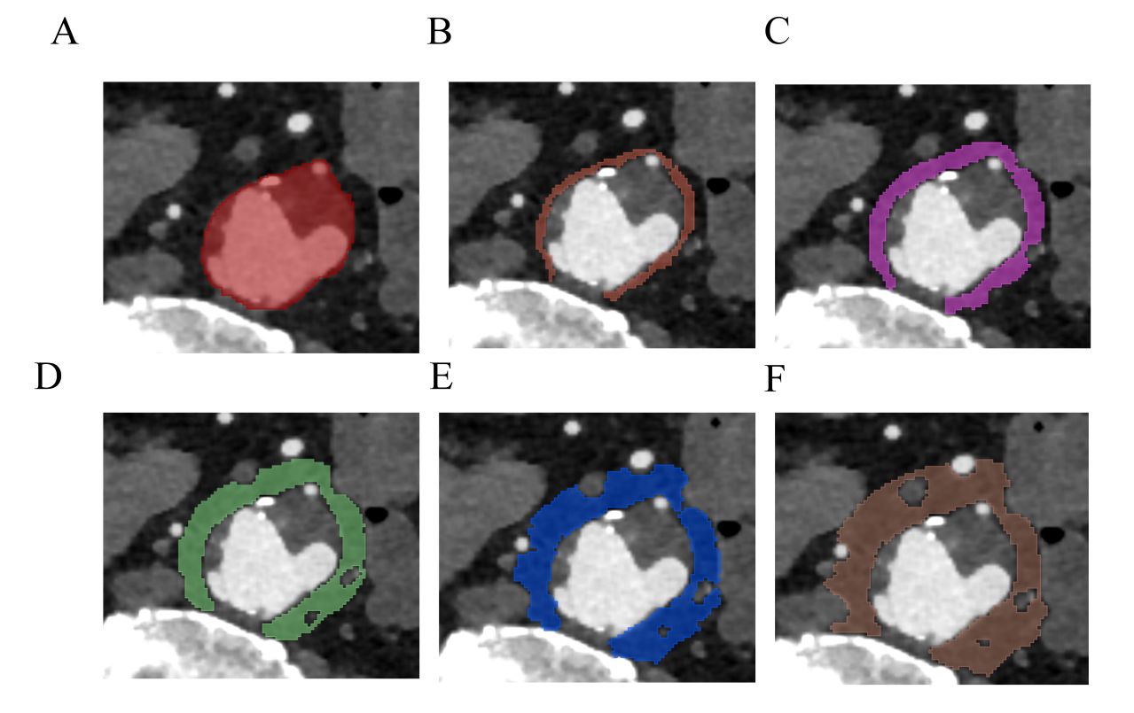
Figure S1. Volume of interest segmentation for radiomic feature extraction in AAA and schematic of the six radiomic prediction models. Intra Model （A）, Peri 2mm Model （B）, Peri 4mm Model （C）, Peri 6mm Model （D）, Peri 8mm Model （E）and Peri 10mm Model （F）.

Figure S2. Confusion matrices of the three models across the four sets, the training set (A), internal validation set 1 (B), external validation set 1 (C), and external validation set 2 (D).
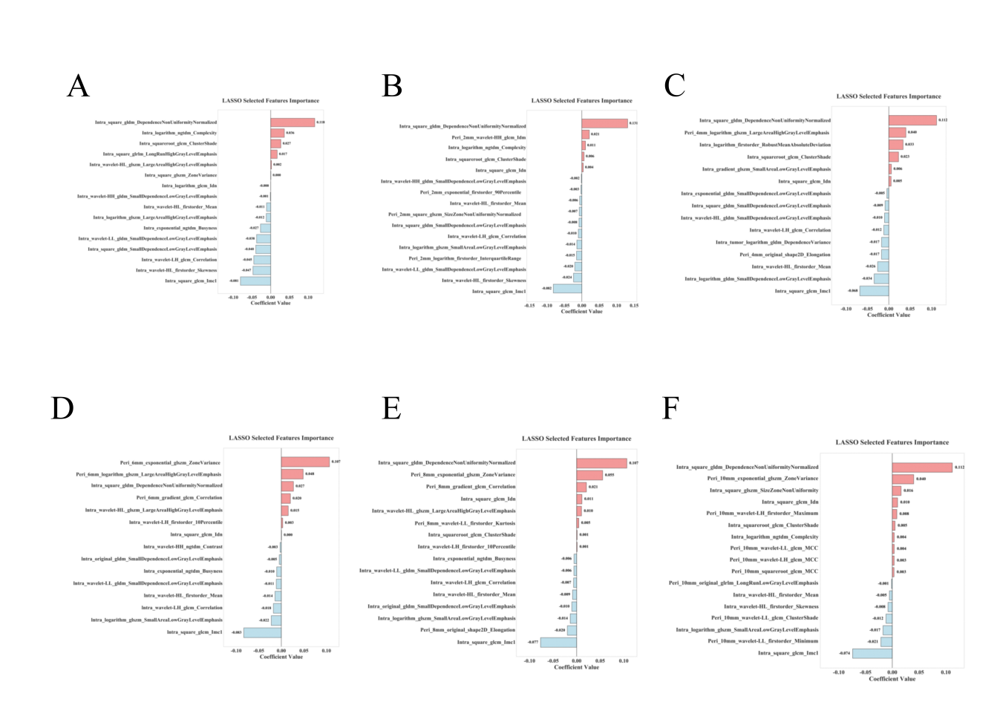

Figure S3. Feature Importance Coefficient Plot After LASSO Regression for Six Models, Intra Model （A）, Peri 2mm Model （B）, Peri 4mm Model （C）, Peri 6mm Model （D）, Peri 8mm Model （E）and Peri 10mm Model （F）.

