- Bioenergetics of lung cancer predicts treatment response and adaptive capacity.
Juan Alberto Pérez-Valencia^{1*}, Annika Pätzold², Till Plönes^{1,3*}.

Supplementary figures:

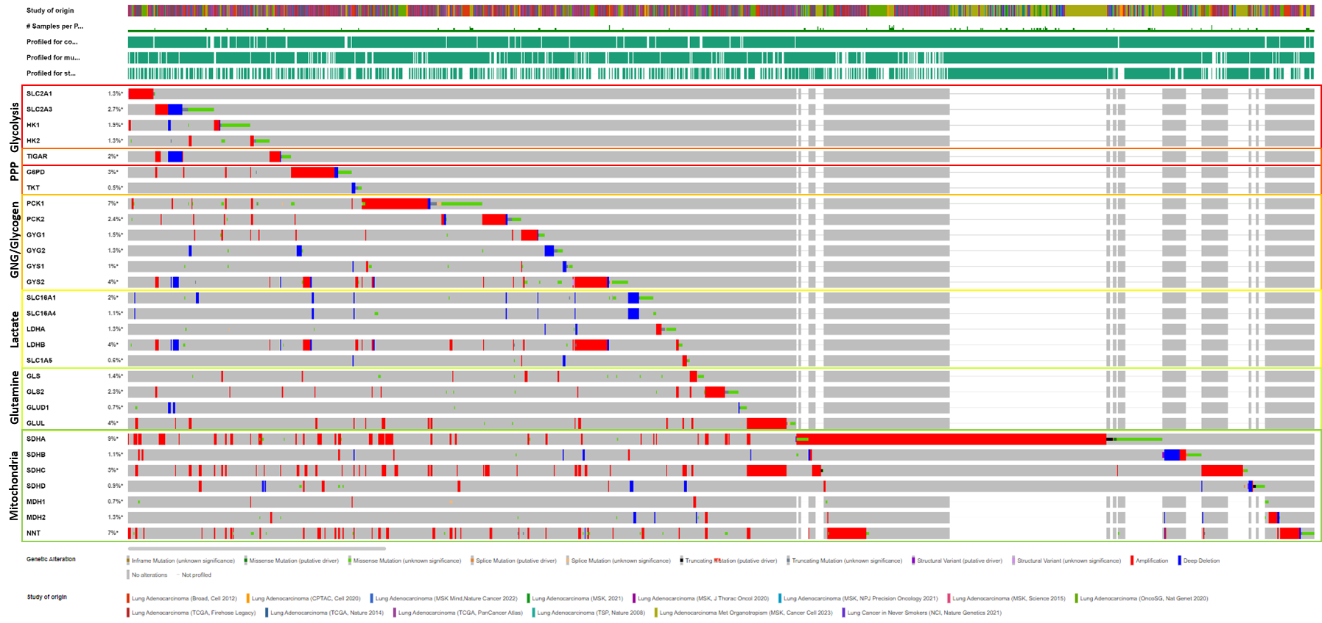
Supplementary figure 1A: cBioportal (https://www.cbioportal.org/) analysis of TCGA data on genetic alterations of key proteins and transporters related to energetic metabolism pathways in lung adenocarcinoma (6526 samples from 6076 patients). Each colored box indicates the metabolic pathway related to the set of genes, labeled on the left. In front of each gene, genetic alteration frequency. Below, type of mutation and study of origin. PPP: pentose phosphate pathway; GNG: gluconeogenesis.

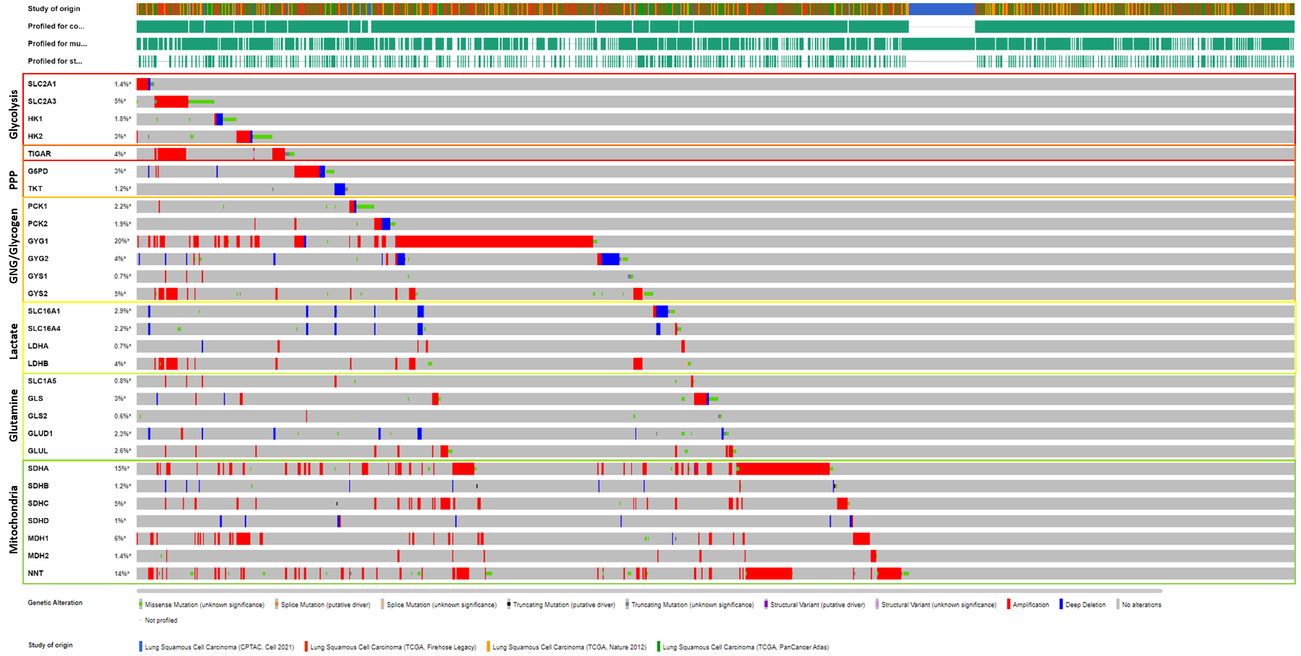
Supplementary figure 1B: cBioportal (https://www.cbioportal.org/) analysis of TCGA data on genetic alterations of key proteins and transporters related to energetic metabolism pathways in lung squamous cell carcinoma (1256 samples from 1256 patients). Each colored box indicates the metabolic pathway related to the set of genes, labeled on the left. In front of each gene, genetic alteration frequency. Below, type of mutation and study of origin. PPP: pentose phosphate pathway; GNG: gluconeogenesis.

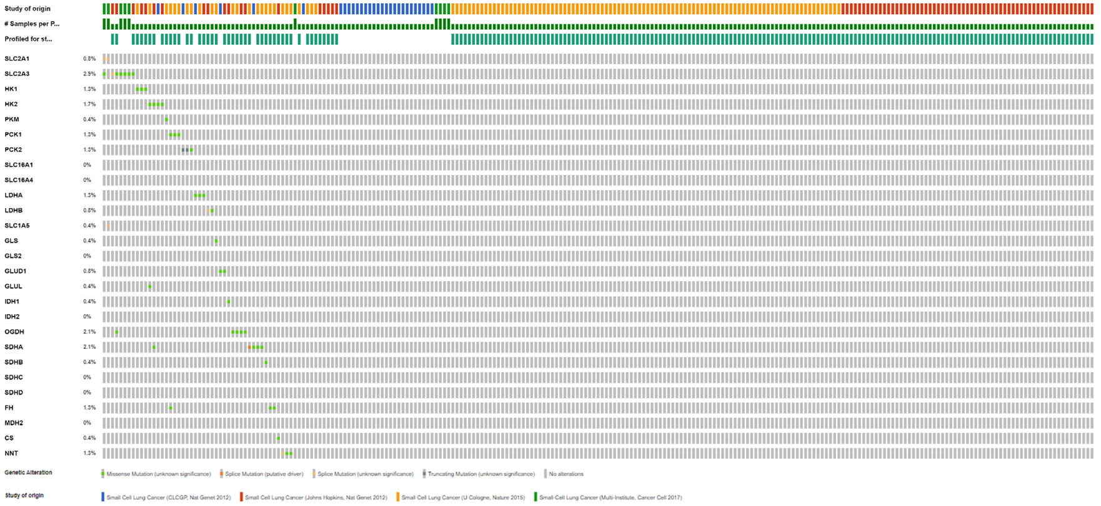
Supplementary figure 1C: cBioportal (https://www.cbioportal.org/) analysis of TCGA data on genetic alterations of key proteins and transporters related to energetic metabolism pathways in small cell lung cancer (249 samples from 239 patients). Each colored box indicates the metabolic pathway related to the set of genes, labeled on the left. In front of each gene, genetic alteration frequency. Below, type of mutation and study of origin. PPP: pentose phosphate pathway; GNG: gluconeogenesis.

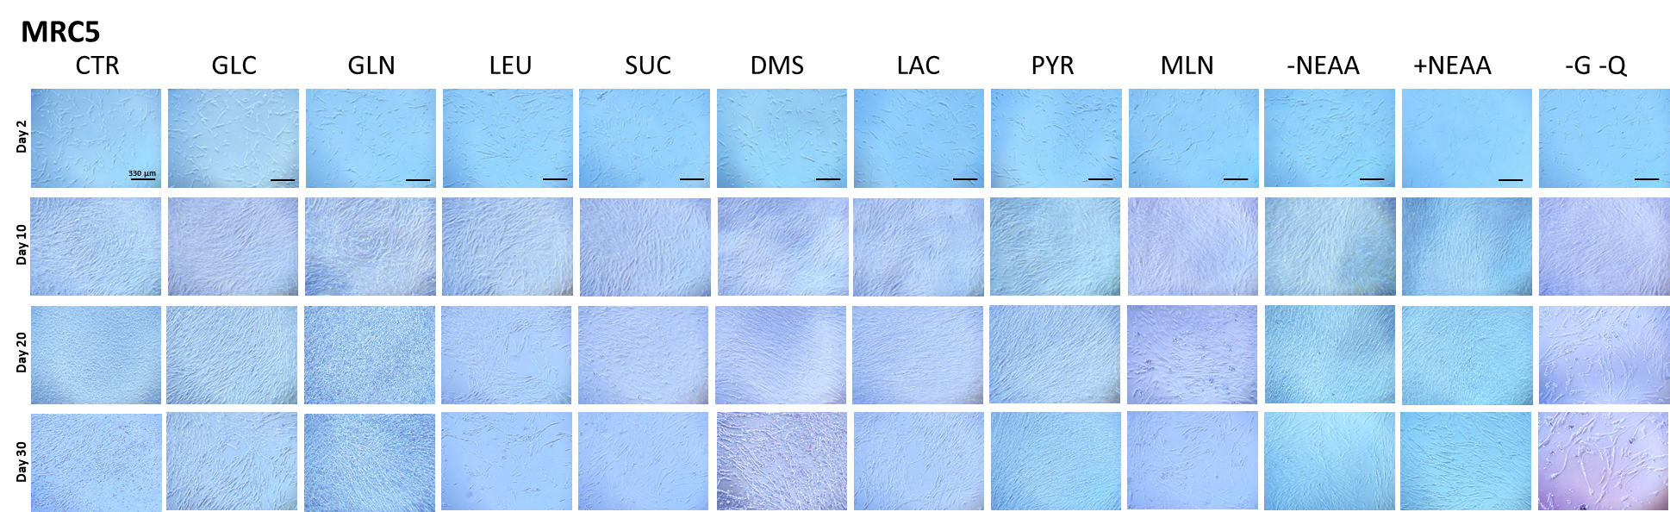
Supplementary figure 1D: Bright field images of MRC5 cell growth (4X) along long term starvation experiments, on the days indicated. Each experimental medium is indicated above each set of pictures. Scale bar: 330 µm. CTR: control; GLC: glucose; GLN: glutamine; LEU: leucine; SUC: succinate; DMS: dimethyl-succinate; LAC: lactate; PYR: pyruvate; MLN: malonate; -NEAA: MEM without non-essential amino acids; +NEAA: MEM with non-essential amino acids; -G –Q: DMEM without glucose or glutamine, with pyruvate 1 mM and FBS 20%.

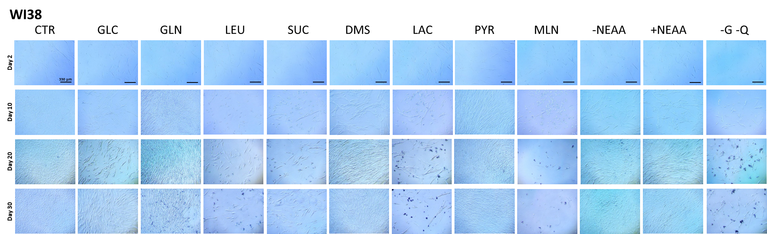
Supplementary figure 1E: Bright field images of WI38 cell growth (4X) along long term starvation experiments, on the days indicated. Each experimental medium is indicated above each set of pictures. Scale bar: 330 µm. CTR: control; GLC: glucose; GLN: glutamine; LEU: leucine; SUC: succinate; DMS: dimethyl-succinate; LAC: lactate; PYR: pyruvate; MLN: malonate; -NEAA: MEM without non-essential amino acids; +NEAA: MEM with non-essential amino acids; -G –Q: DMEM without glucose or glutamine, with pyruvate 1 mM and FBS 20%.

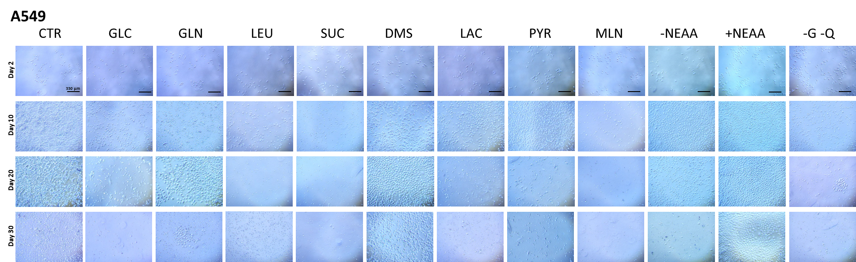
Supplementary figure 1F: Bright field images of A549 cell growth (4X) along long term starvation experiments, on the days indicated. Each experimental medium is indicated above each set of pictures. Scale bar: 330 µm. CTR: control; GLC: glucose; GLN: glutamine; LEU: leucine; SUC: succinate; DMS: dimethyl-succinate; LAC: lactate; PYR: pyruvate; MLN: malonate; -NEAA: MEM without non-essential amino acids; +NEAA: MEM with non-essential amino acids; -G –Q: DMEM without glucose or glutamine, with pyruvate 1 mM and FBS 10%.

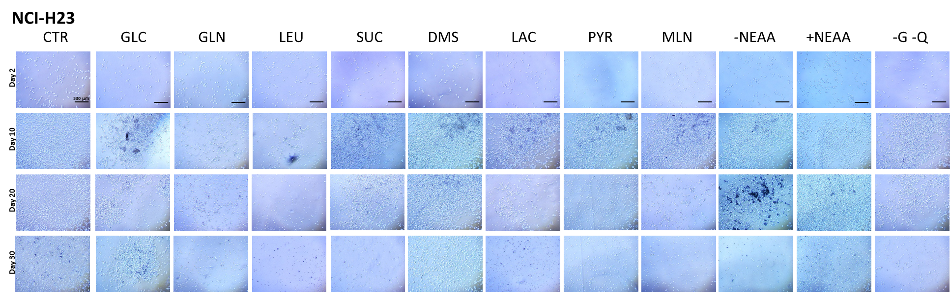
Supplementary figure 1G: Bright field images of NCI-H23 cell growth (4X) along long term starvation experiments, on the days indicated. Each experimental medium is indicated above each set of pictures. Scale bar: 330 µm. CTR: control; GLC: glucose; GLN: glutamine; LEU: leucine; SUC: succinate; DMS: dimethyl-succinate; LAC: lactate; PYR: pyruvate; MLN: malonate; -NEAA: MEM without non-essential amino acids; +NEAA: MEM with non-essential amino acids; -G –Q: DMEM without glucose or glutamine, with pyruvate 1 mM and FBS 10%.

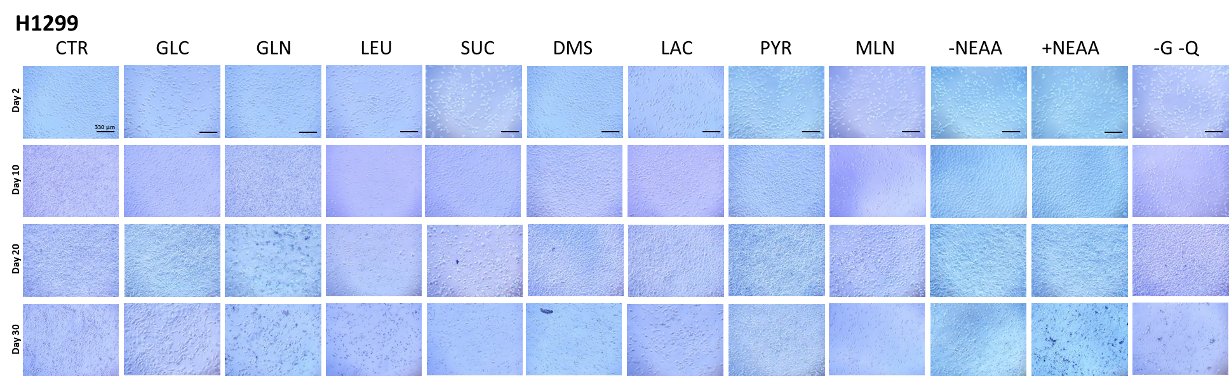
Supplementary figure 1H: Bright field images of H1299 cell growth (4X) along long term starvation experiments, on the days indicated. Each experimental medium is indicated above each set of pictures. Scale bar: 330 µm. CTR: control; GLC: glucose; GLN: glutamine; LEU: leucine; SUC: succinate; DMS: dimethyl-succinate; LAC: lactate; PYR: pyruvate; MLN: malonate; -NEAA: MEM without non-essential amino acids; +NEAA: MEM with non-essential amino acids; -G –Q: DMEM without glucose or glutamine, with pyruvate 1 mM and FBS 10%.

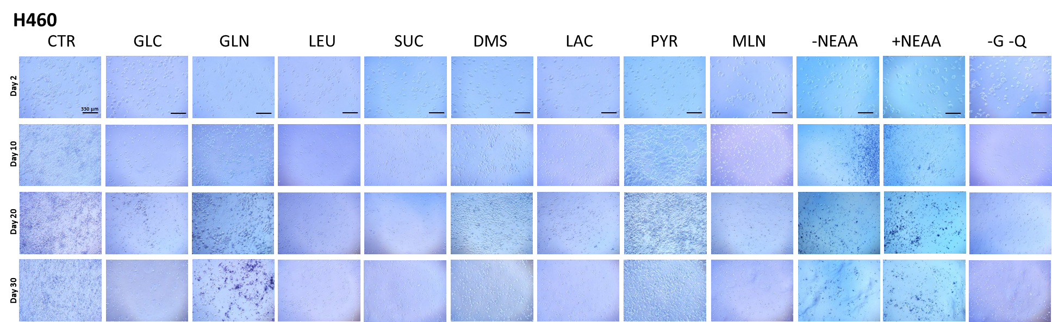
Supplementary figure 1I: Bright field images of H460 cell growth (4X) along long term starvation experiments, on the days indicated. Each experimental medium is indicated above each set of pictures. Scale bar: 330 µm. CTR: control; GLC: glucose; GLN: glutamine; LEU: leucine; SUC: succinate; DMS: dimethyl-succinate; LAC: lactate; PYR: pyruvate; MLN: malonate; -NEAA: MEM without non-essential amino acids; +NEAA: MEM with non-essential amino acids; -G –Q: DMEM without glucose or glutamine, with pyruvate 1 mM and FBS 10%.

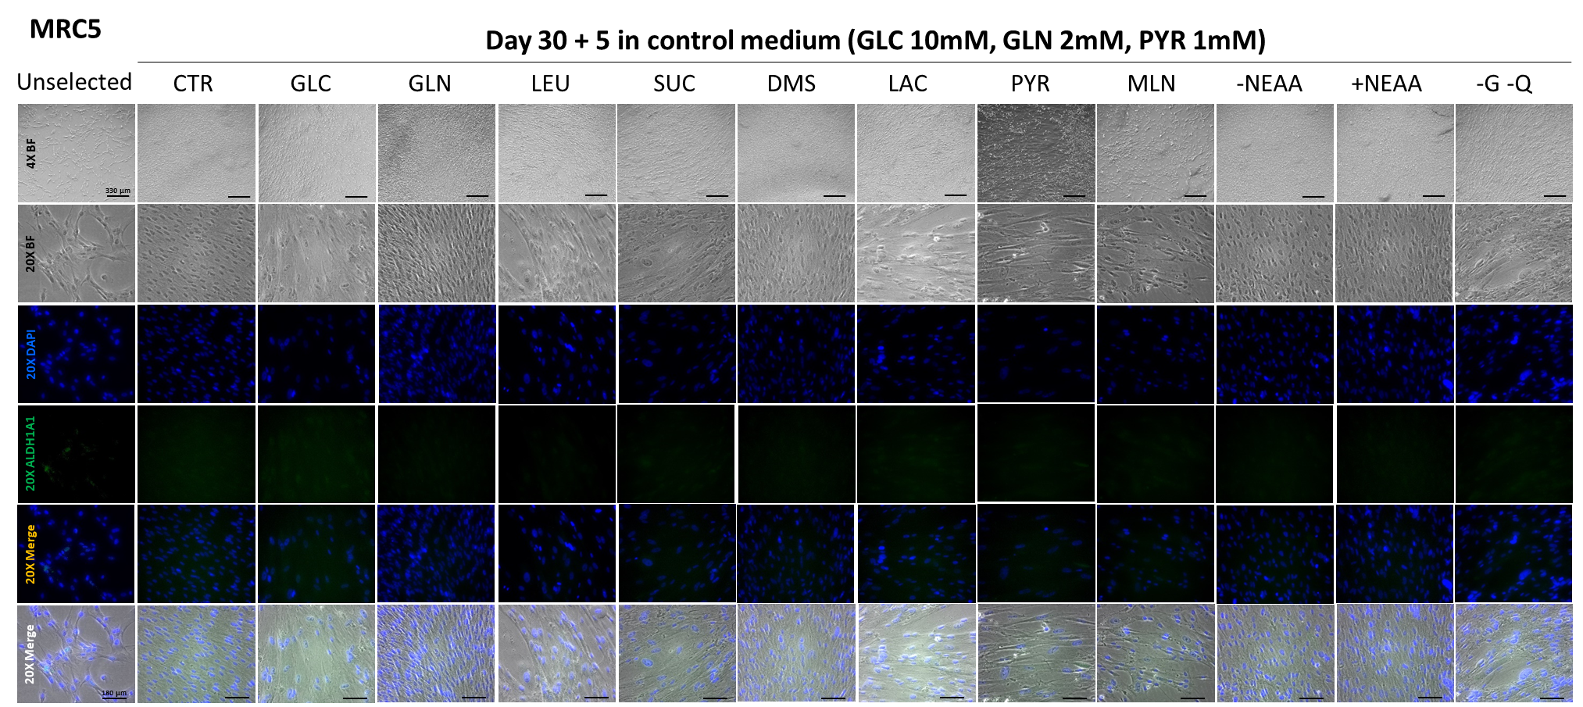
Supplementary figure 2A: Bright field (4X and 20X) and fluorescence images (20X) of MRC5 cells, before (Unselected) and after selection (day 30 + 5) under long term starvation experiments. In blue, DAPI staining, in green, ALDH1A1 in FITC channel. Merged images of DAPI and FITC channels, and with bright field are shown. Each experimental medium is indicated above each set of pictures. Scale bars: 330 µm (4X) and 180 µm (20X). CTR: control; GLC: glucose; GLN: glutamine; LEU: leucine; SUC: succinate; DMS: dimethyl-succinate; LAC: lactate; PYR: pyruvate; MLN: malonate; -NEAA: MEM without non-essential amino acids; +NEAA: MEM with non-essential amino acids; -G –Q: DMEM without glucose or glutamine, with pyruvate 1 mM and FBS 20%.

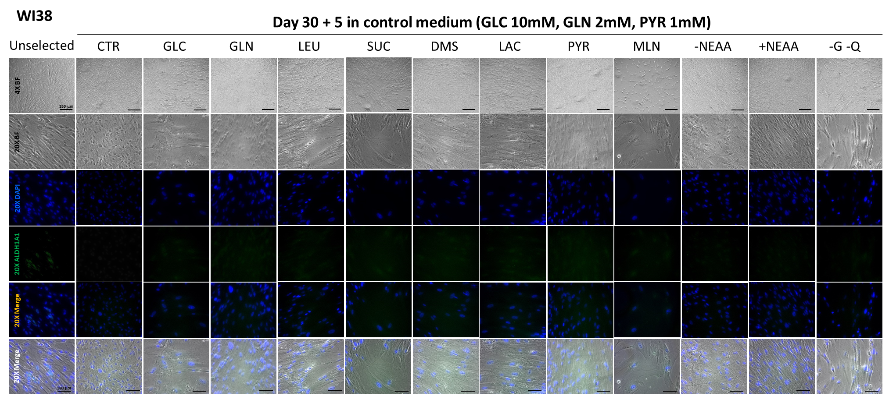
Supplementary figure 2B: Bright field (4X and 20X) and fluorescence images (20X) of WI38 cells, before (Unselected) and after selection (day 30 + 5) under long term starvation experiments. In blue, DAPI staining, in green, ALDH1A1 in FITC channel. Merged images of DAPI and FITC channels, and with bright field are shown. Each experimental medium is indicated above each set of pictures. Scale bars: 330 µm (4X) and 180 µm (20X). CTR: control; GLC: glucose; GLN: glutamine; LEU: leucine; SUC: succinate; DMS: dimethyl-succinate; LAC: lactate; PYR: pyruvate; MLN: malonate; -NEAA: MEM without non-essential amino acids; +NEAA: MEM with non-essential amino acids; -G –Q: DMEM without glucose or glutamine, with pyruvate 1 mM and FBS 20%.

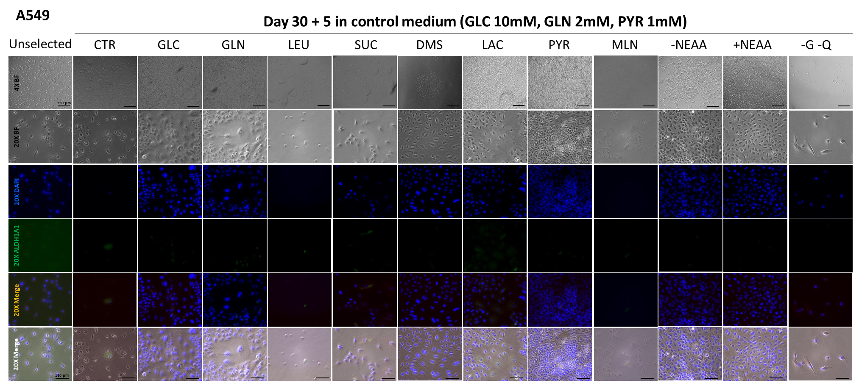
Supplementary figure 2C: Bright field (4X and 20X) and fluorescence images (20X) of A549 cells, before (Unselected) and after selection (day 30 + 5) under long term starvation experiments. In blue, DAPI staining, in green, ALDH1A1 in FITC channel. Merged images of DAPI and FITC channels, and with bright field are shown. Each experimental medium is indicated above each set of pictures. Scale bars: 330 µm (4X) and 180 µm (20X). CTR: control; GLC: glucose; GLN: glutamine; LEU: leucine; SUC: succinate; DMS: dimethyl-succinate; LAC: lactate; PYR: pyruvate; MLN: malonate; -NEAA: MEM without non-essential amino acids; +NEAA: MEM with non-essential amino acids; -G –Q: DMEM without glucose or glutamine, with pyruvate 1 mM and FBS 10%.

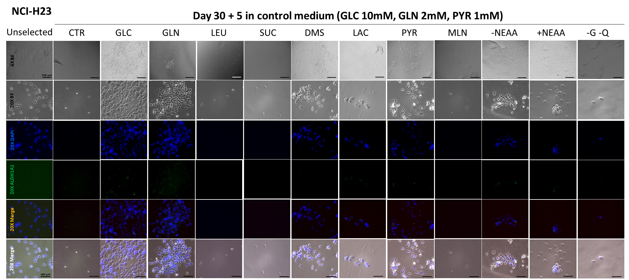
Supplementary figure 2D: Bright field (4X and 20X) and fluorescence images (20X) of NCI-H23 cells, before (Unselected) and after selection (day 30 + 5) under long term starvation experiments. In blue, DAPI staining, in green, ALDH1A1 in FITC channel. Merged images of DAPI and FITC channels, and with bright field are shown. Each experimental medium is indicated above each set of pictures. Scale bars: 330 µm (4X) and 180 µm (20X). CTR: control; GLC: glucose; GLN: glutamine; LEU: leucine; SUC: succinate; DMS: dimethyl-succinate; LAC: lactate; PYR: pyruvate; MLN: malonate; -NEAA: MEM without non-essential amino acids; +NEAA: MEM with non-essential amino acids; -G –Q: DMEM without glucose or glutamine, with pyruvate 1 mM and FBS 10%.

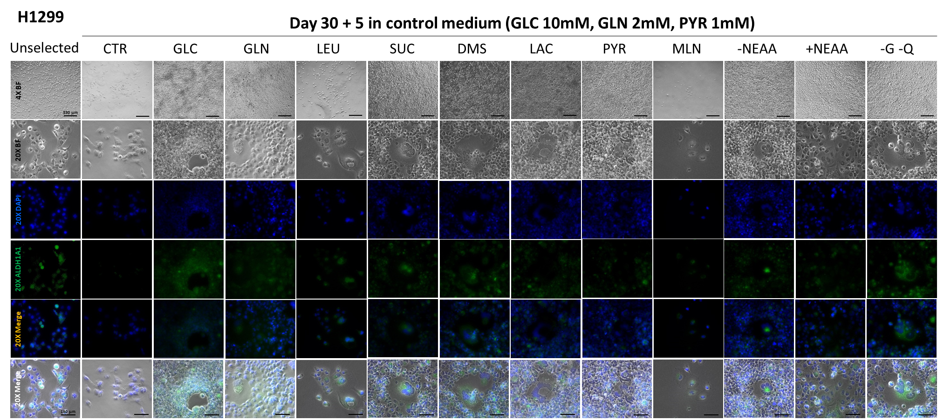
Supplementary figure 2E: Bright field (4X and 20X) and fluorescence images (20X) of H1299 cells, before (Unselected) and after selection (day 30 + 5) under long term starvation experiments. In blue, DAPI staining, in green, ALDH1A1 in FITC channel. Merged images of DAPI and FITC channels, and with bright field are shown. Each experimental medium is indicated above each set of pictures. Scale bars: 330 µm (4X) and 180 µm (20X). CTR: control; GLC: glucose; GLN: glutamine; LEU: leucine; SUC: succinate; DMS: dimethyl-succinate; LAC: lactate; PYR: pyruvate; MLN: malonate; -NEAA: MEM without non-essential amino acids; +NEAA: MEM with non-essential amino acids; -G –Q: DMEM without glucose or glutamine, with pyruvate 1 mM and FBS 10%.

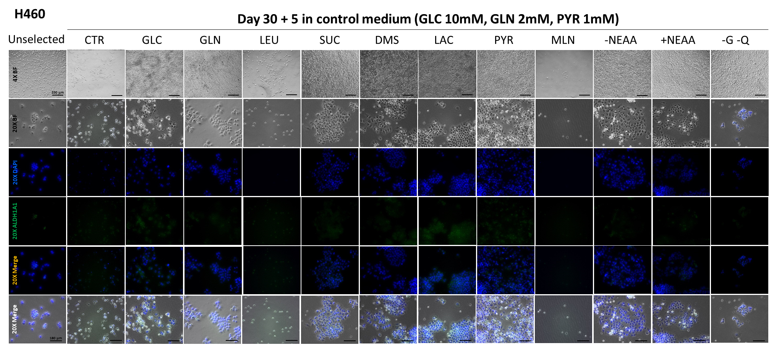
Supplementary figure 2F: Bright field (4X and 20X) and fluorescence images (20X) of H460 cells, before (Unselected) and after selection (day 30 + 5) under long term starvation experiments. In blue, DAPI staining, in green, ALDH1A1 in FITC channel. Merged images of DAPI and FITC channels, and with bright field are shown. Each experimental medium is indicated above each set of pictures. Scale bars: 330 µm (4X) and 180 µm (20X). CTR: control; GLC: glucose; GLN: glutamine; LEU: leucine; SUC: succinate; DMS: dimethyl-succinate; LAC: lactate; PYR: pyruvate; MLN: malonate; -NEAA: MEM without non-essential amino acids; +NEAA: MEM with non-essential amino acids; -G –Q: DMEM without glucose or glutamine, with pyruvate 1 mM and FBS 10%.

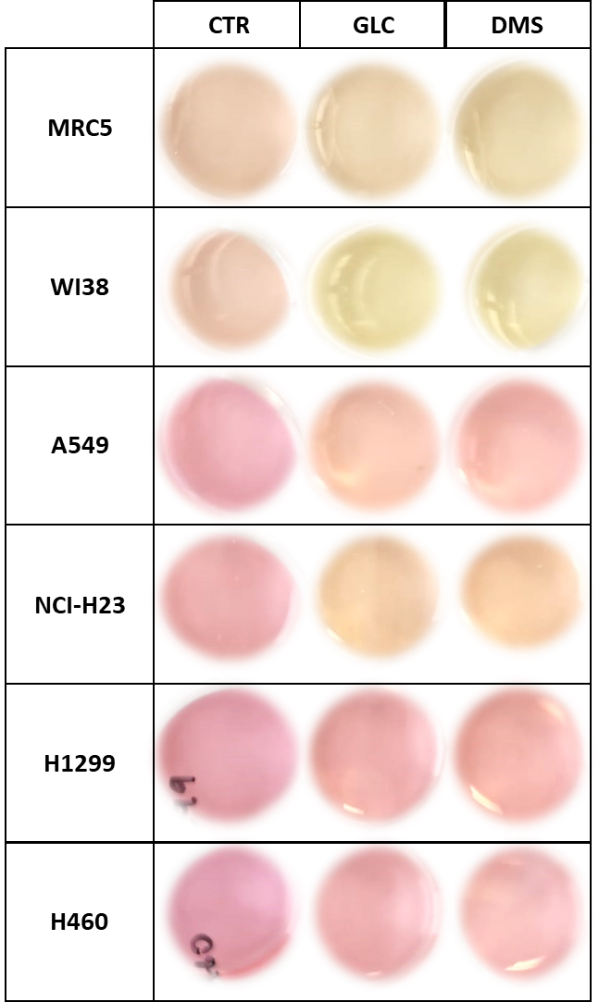
Supplementary figure 3: Pictures of long-term starvation experiments under control (CTR), glucose (GLC) and di-methyl succinate (DMS), after 30 days of treatment.

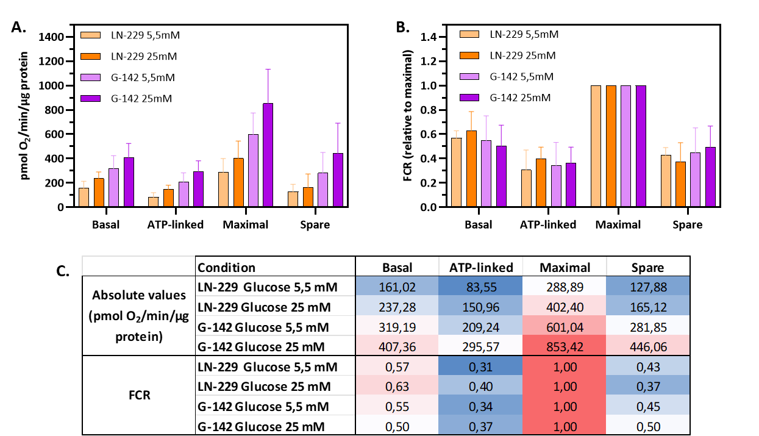
Supplementary figure 4: Normalization of published data on a glioblastoma model (for more information, see reference 31, source at https://www.life-science-alliance.org/content/9/2/e202503529#sec-11). Briefly, custom media was prepared with glucose low (5,5 mM) and high (25 mM) concentrations, and the respirometric experiments were performed using a Seahorse XF (Agilent) platform. A. Reproduction of their analysis (published figure 3C in the original manuscript), but we calculated the SD of all the published data (n= 31- 47), while they used only the final measurement of each respiratory parameter (phase is called in their manuscript). B. FCR normalization performed by us, using the same data on A.. It can be seen that the differences observed in A. are lost after normalization. C. Table in heat map format showing the media of the published measurements and our normalization by FCR. Red and blue colors indicate high and low values, respectively.

