Table 1 Clinical and molecular characterization of enrolled patients in the study
No. | Study ID | Age (year) | Sex | MSI  (% Somatic sites) | TMB | IHC | Gene Variant and class | Sequencing Artifacts | Pedigree
1 | 140F4SD | 39 | M | H (14%) | 49 | MSH2, MSH6  LS pattern | None | MSH2,chr2:47,641,377-48,033,551(GRCh37), Lg Del (~390 kb, by rough computational mapping of potentially deleted regions identified by CNVkit). | 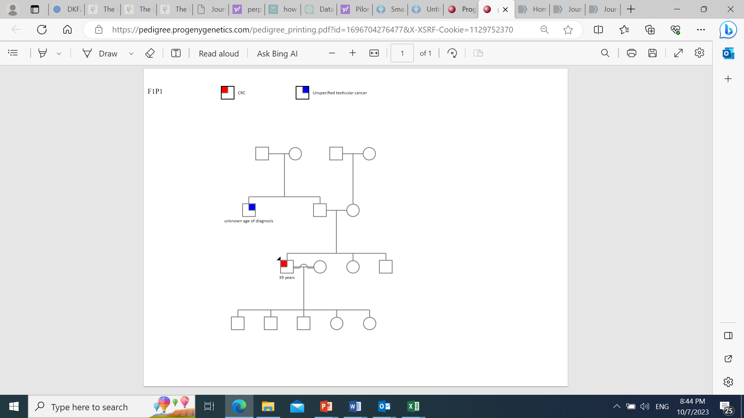  NA  39 years
Mutational Signature |  |  |  |  |  |  | None
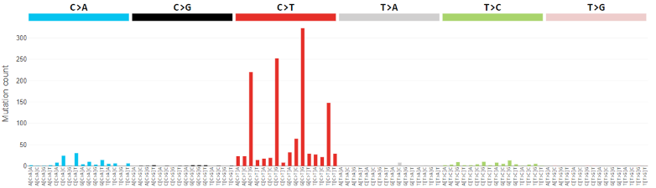 |  |  |  |  |  |  | None
2 | 140F12SD | 30 | F | H (16.35%) | 38 | MSH2, MSH6  LS pattern | Confirmed MSH2 exon 7 deletion by MLPA | MSH2, chr2:47,635,736-47,710,309(GRCh37), Lg Del(~74 kb, by rough computational mapping of potentially deleted regions identified by CNVkit). | 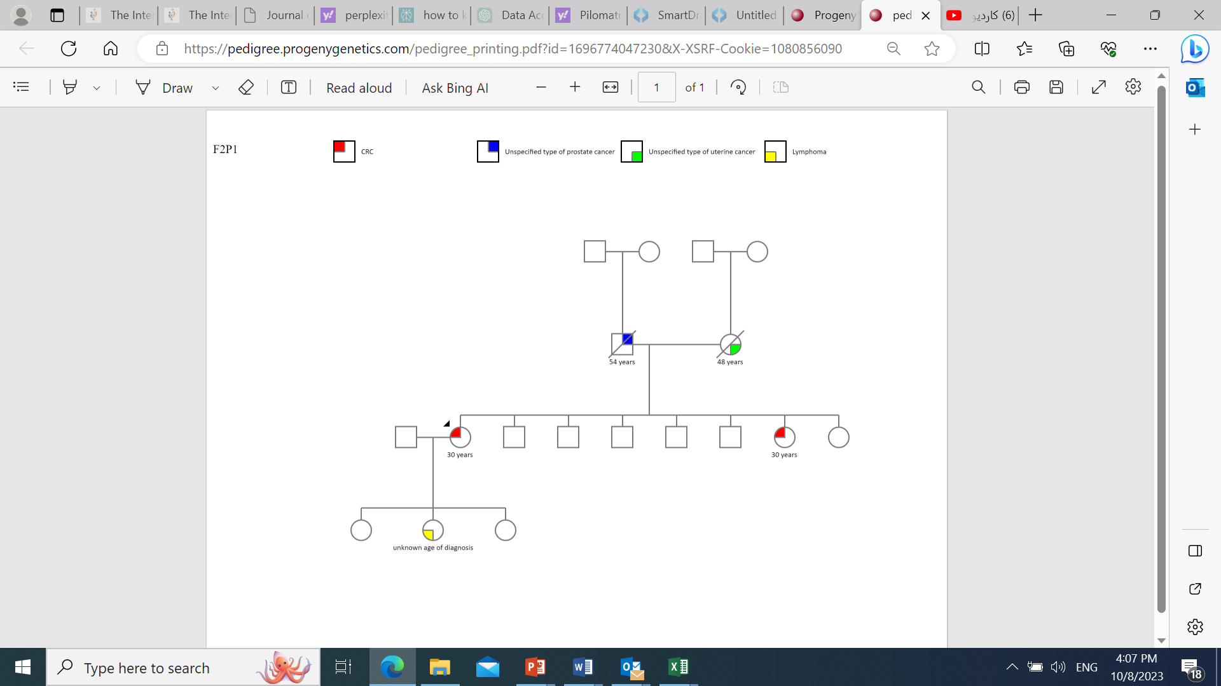  In addition to more than 7 people from paternal side relatives (exact relation not available) affected with:  - Lung cancer  - Gastric cancer  - Bone cancer  - CRC  NA  54 years  48 years  30 years  30 years
Mutational Signature |  |  |  |  |  |  | Confirmed MSH2 exon 7 deletion by MLPA
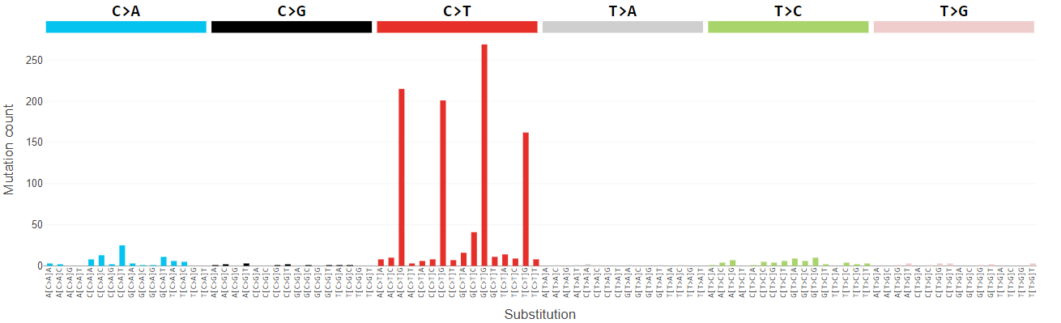 |  |  |  |  |  |  | Confirmed MSH2 exon 7 deletion by MLPA
No. | Study ID | Age (year) | Sex | MSI  (% Somatic sites) | TMB | IHC | Gene Variant and Class | Sequencing Artifacts | Pedigree
3 | 140F24SD | 44 | M | H (21.95%) | 42.73 | PMS2, MLH1 LS pattern | None | MLH1, chr3:g.37,037,285-37,090,106(GRCh37), Lg Del(~53 kb, by rough computational mapping of potentially deleted regions identified by CNVkit). | 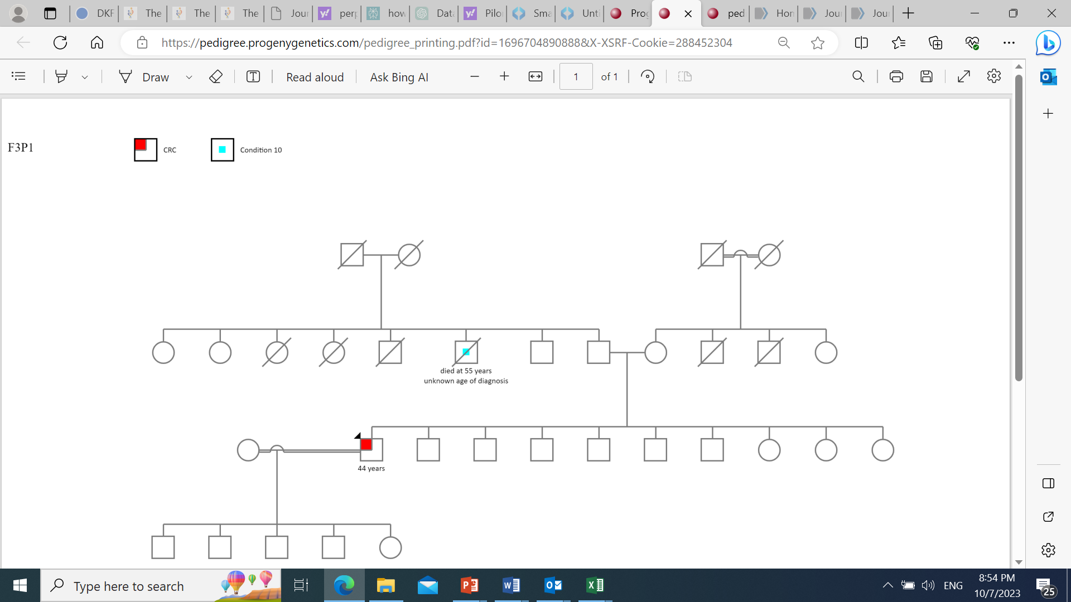  NA  passed away at 55 years  44 years  NA
Mutational Signature |  |  |  |  |  |  | None
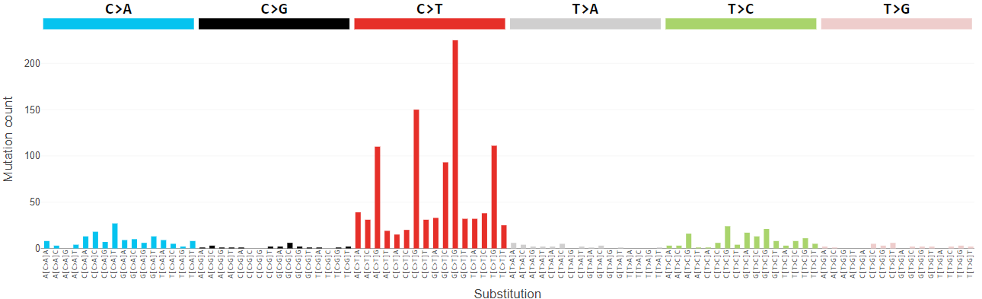 |  |  |  |  |  |  | None
4 | 140F2SD | 33 | M | NA | NA | MSH2, MSH6,  LS pattern | MSH2 (NM_000251.3):c.1321dup (p.Thr441fs), P |  | 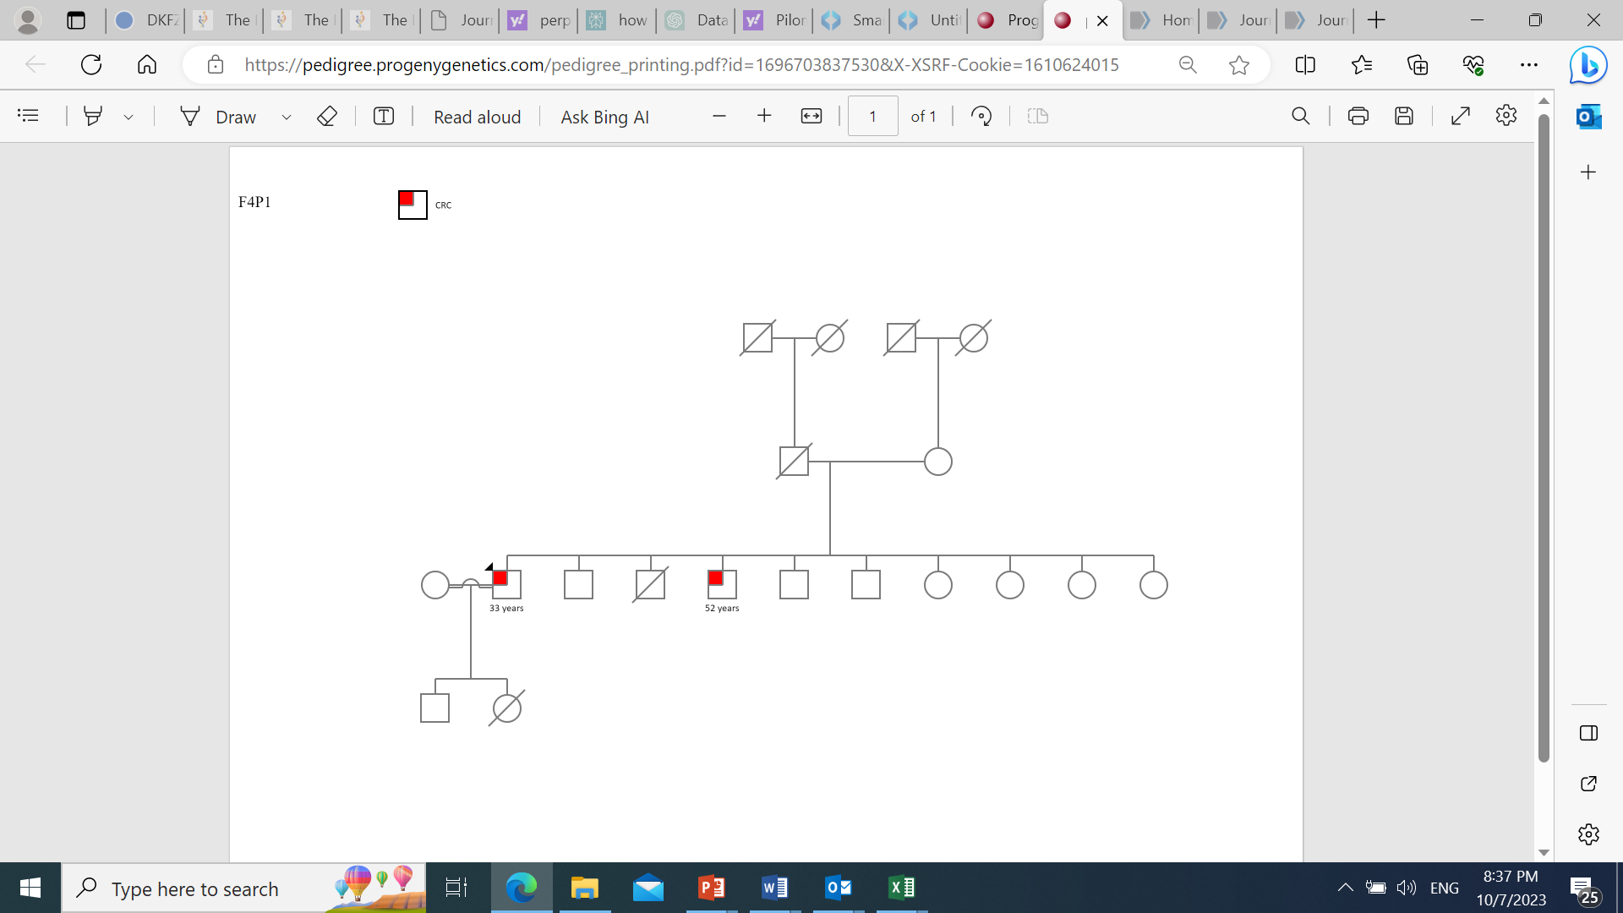  33 years  52 years
Mutational Signature (primary tumor on top and relapse at bottom) |  |  |  |  |  |  | MSH2 (NM_000251.3):c.1321dup (p.Thr441fs), P
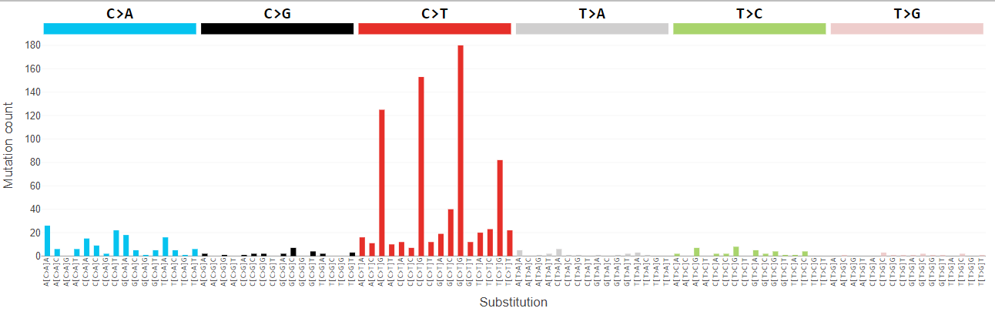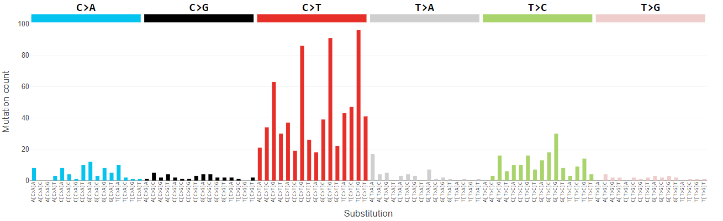 |  |  |  |  |  |  | MSH2 (NM_000251.3):c.1321dup (p.Thr441fs), P
No | Study ID | Age (years) | Sex | MSI  (% Somatic sites) | TMB | IHC | Gene Variant and class | Sequencing Artifacts | Pedigree
5 | 140F30SD | 28 | M | L (5.8%) | 25 | PMS2, MLH1  LS pattern | MLH1(ENST00000231790.2):c.1164_1165insGAAT(p.Ser388fs), P |  | 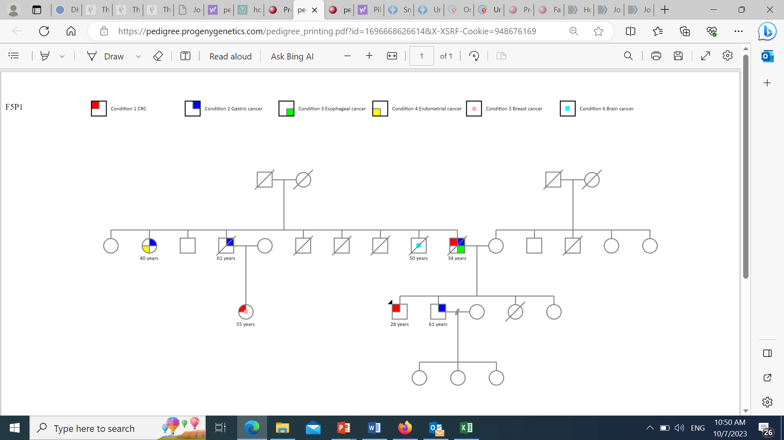  28 years  61 years  55 years  34 years  50 years  61 years  40 years
Mutational Signature |  |  |  |  |  |  | MLH1(ENST00000231790.2):c.1164_1165insGAAT(p.Ser388fs), P
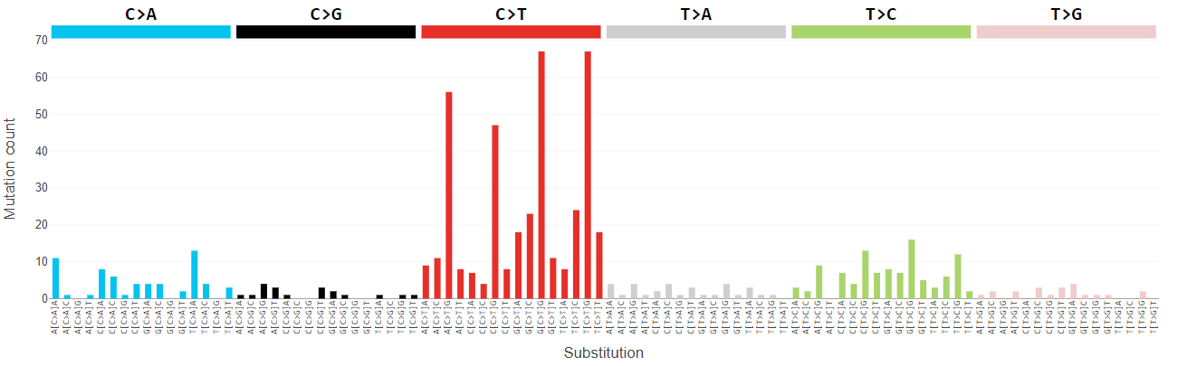 |  |  |  |  |  |  | MLH1(ENST00000231790.2):c.1164_1165insGAAT(p.Ser388fs), P
6  &  7 | 140F29S1D & 140F29S2D | 13 & 15 | F & F | L  (8.75%)  &  L (4.35%) | 19 & 5 | PMS2, CMMRD pattern  (Both siblings) | PMS2(NM_000535.7):c.903G>T (p.Lys301Asn), LP |  | 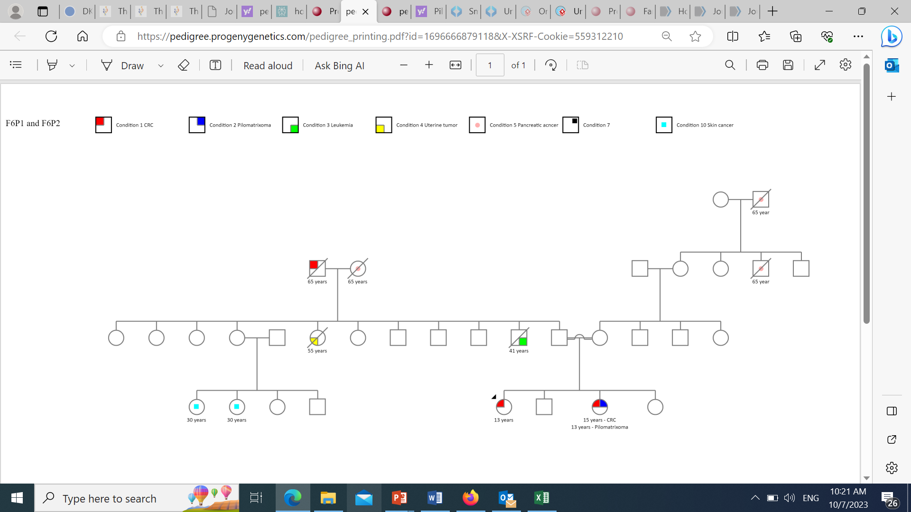  13 years  13 years - Pilomatrixoma  15 years - CRC  30 years  30 years  65 years  65 years  65 years  65 years  55 years  41 years
Mutational Signatures (140F29S1D on top and 140F29S2D at bottom) |  |  |  |  |  |  | PMS2(NM_000535.7):c.903G>T (p.Lys301Asn), LP
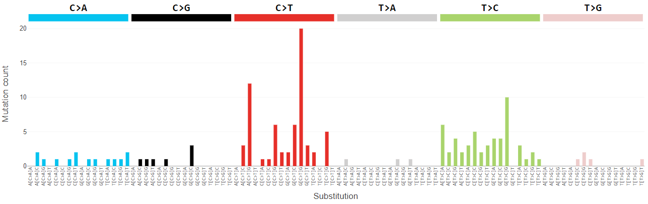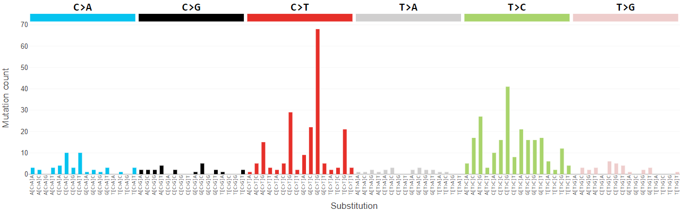 |  |  |  |  |  |  | PMS2(NM_000535.7):c.903G>T (p.Lys301Asn), LP
No | Study ID | Age (year) | Sex | MSI  (% Somatic sites) | TMB | IHC | Gene Variant and class | Sequencing Artifacts | Pedigree
8 | 140F19SD1 | 37 | M | H (18.52%) | 40 | PMS2, MLH1 & MSH6  LS pattern | MLH1(NM_000249.4):c.901del (p.(Gln301ArgfsTer66)), P |  | 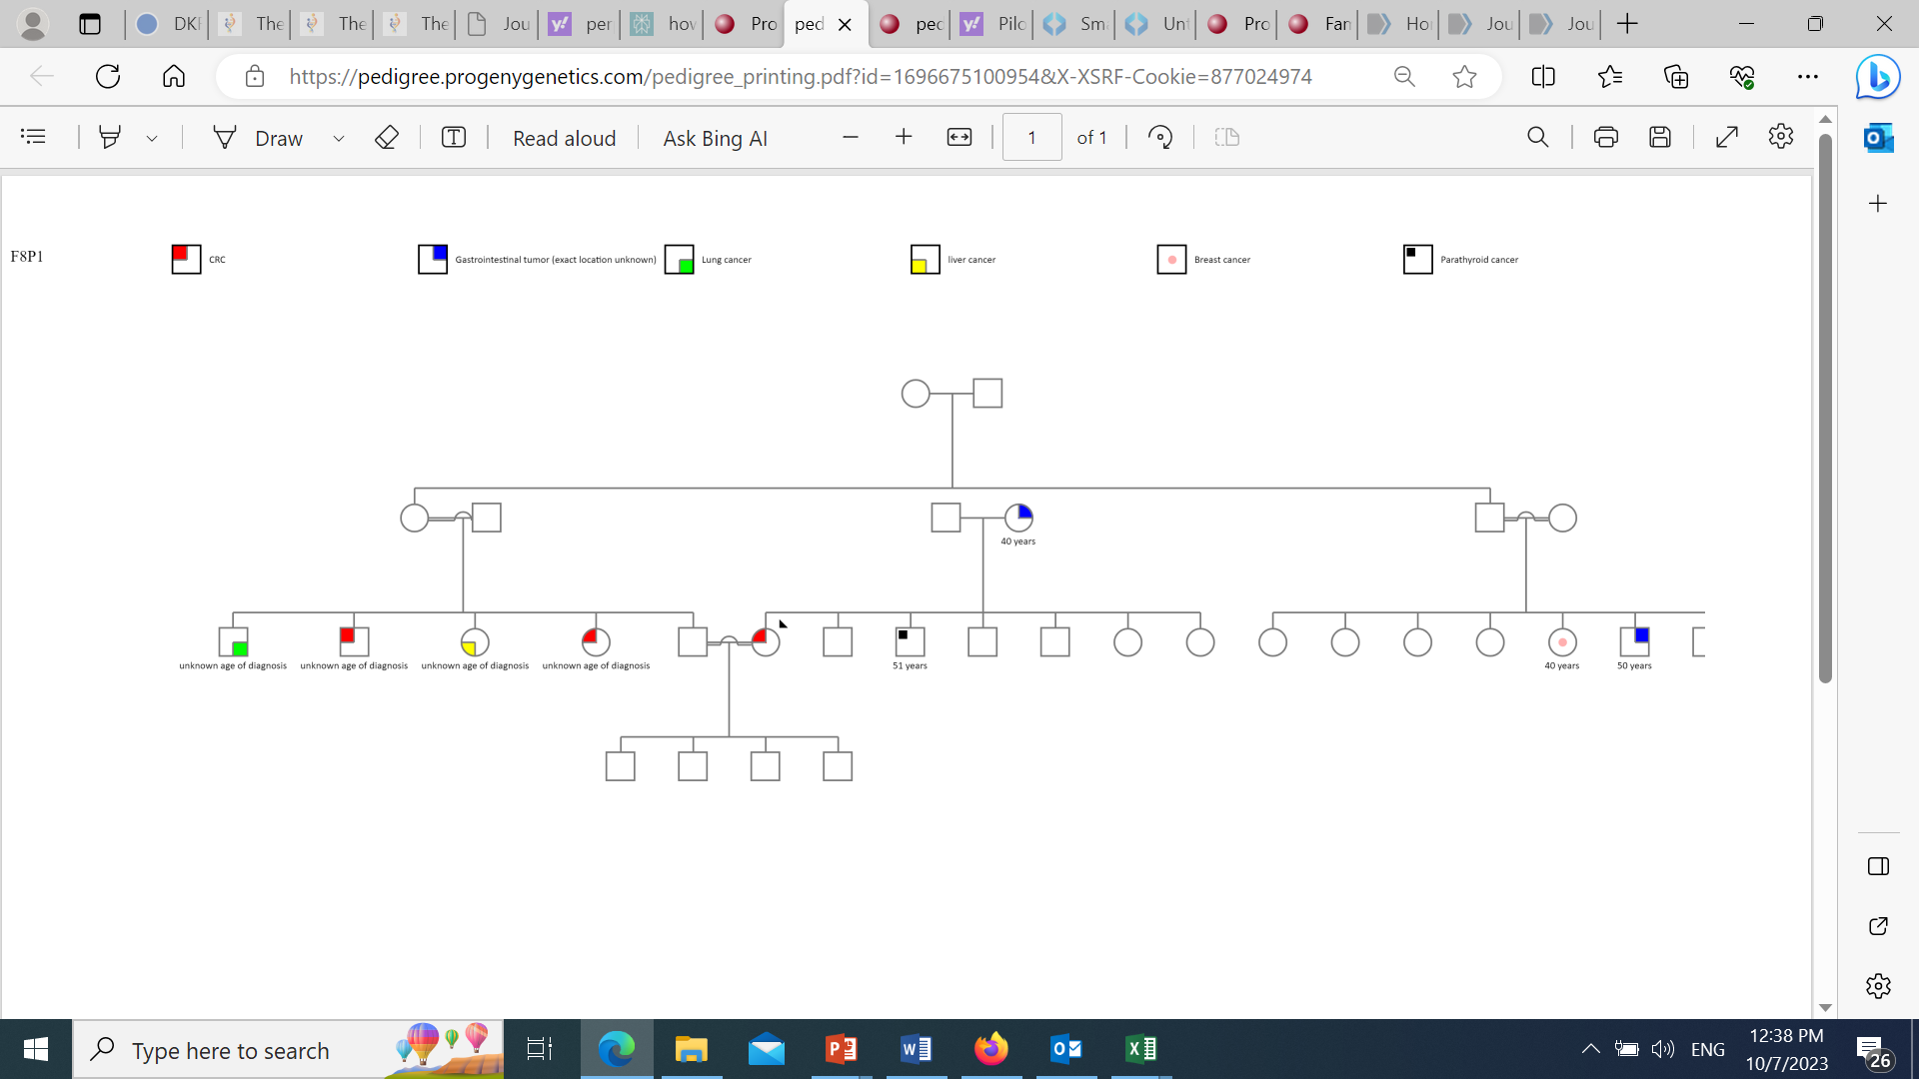  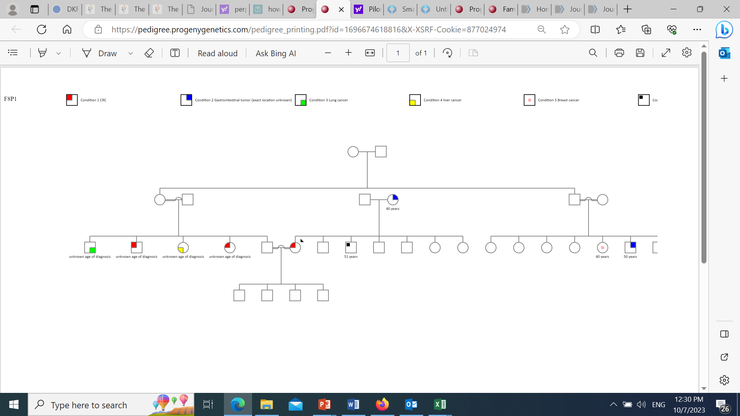  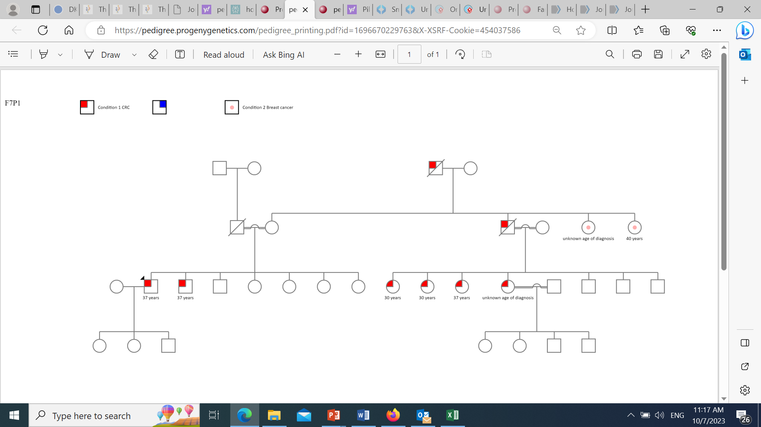  50 years  40 years  40 years  NA NA NA NA  43 years  51 years  37 years  37 years  30 years  30 years  37 years  40 years  NA  NA  NA  NA diagnosis
Mutational Signature (primary tumor on top, relapse at bottom) |  |  |  |  |  |  | MLH1(NM_000249.4):c.901del (p.(Gln301ArgfsTer66)), P
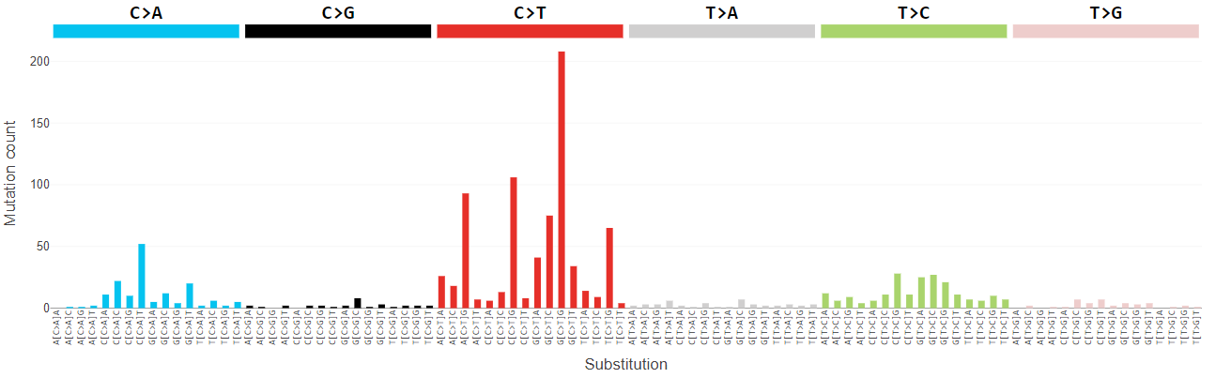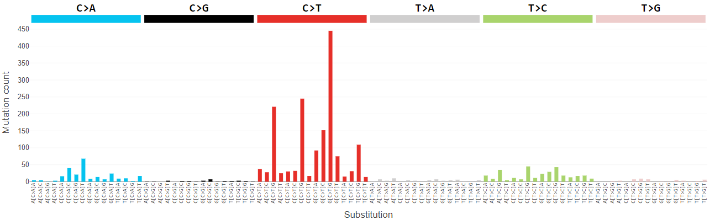 |  |  |  |  |  |  | MLH1(NM_000249.4):c.901del (p.(Gln301ArgfsTer66)), P
9 | 140F25SD | 43 | F | H (26.6%) | 46 | PMS2, MLH1 LS pattern | MLH1(NM_000249.4):c.1836_1839del (p.(Val612del)), LP
Mutational Signature |  |  |  |  |  |  | MLH1(NM_000249.4):c.1836_1839del (p.(Val612del)), LP
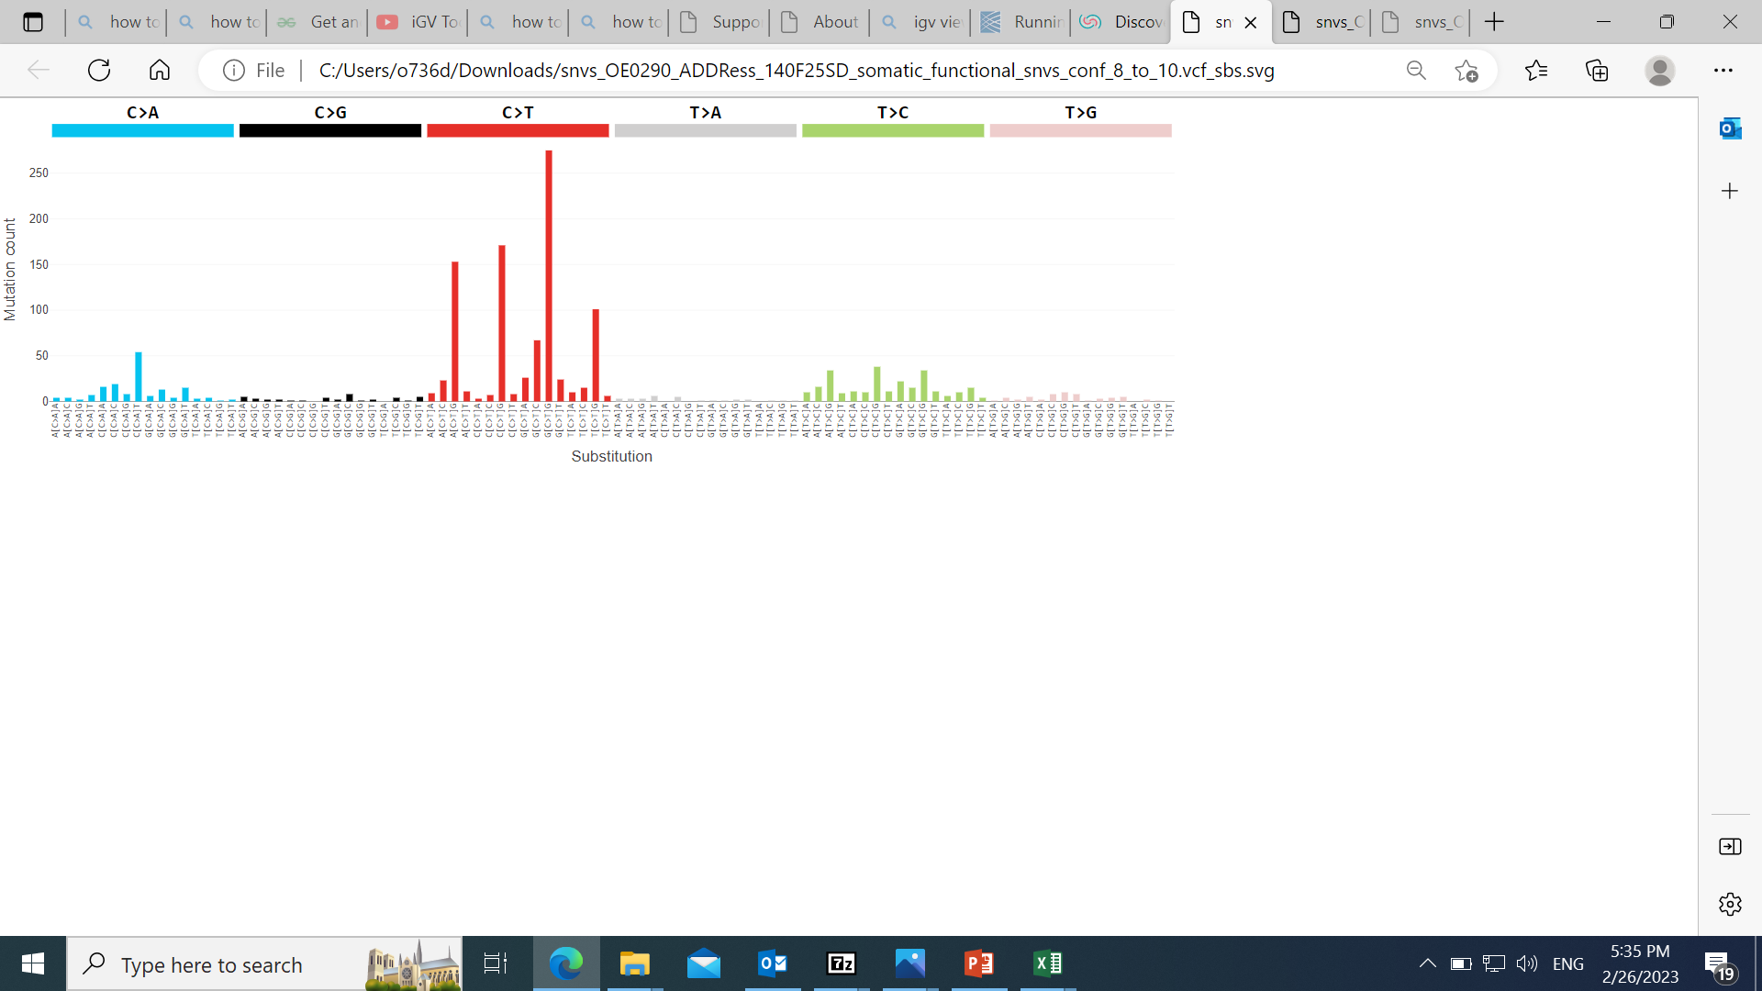 |  |  |  |  |  |  | MLH1(NM_000249.4):c.1836_1839del (p.(Val612del)), LP
No | Study  ID | Age (year) | Sex | MSI  (% Somatic sites) | TMB | IHC | Gene Variant and class | Sequencing Artifacts | Pedigree
10 | 140F20SD | 38 | M | L (0.13%) | 2.1 | MSH2, MSH6  LS pattern | none | MSH2, chr2:g.47635736_47748646del, Lg del (~112 kb, by rough computational mapping of potentially deleted regions identified by CNVkit). | 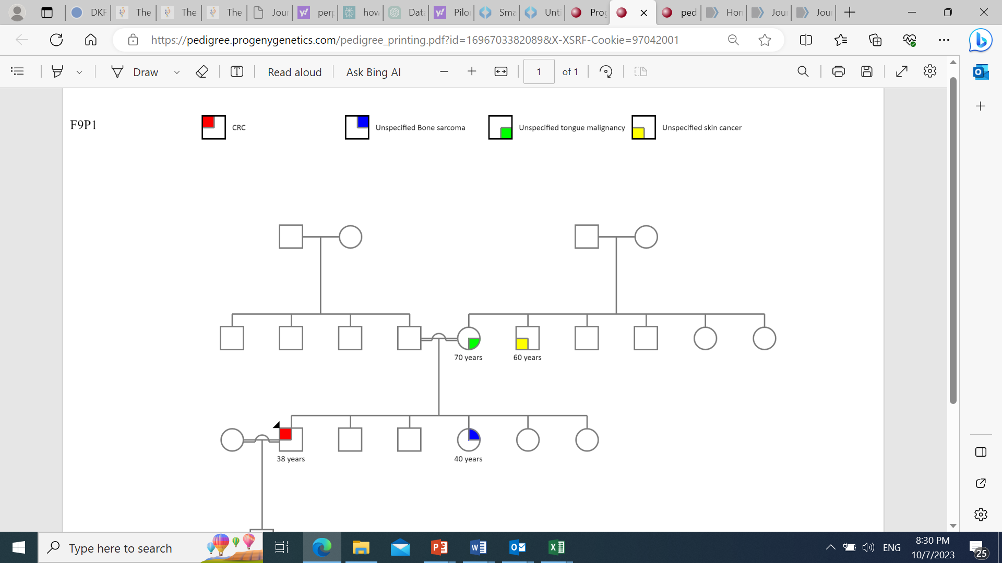  40 years  38 years  70 years  60 years
Mutational Signature |  |  |  |  |  |  | none
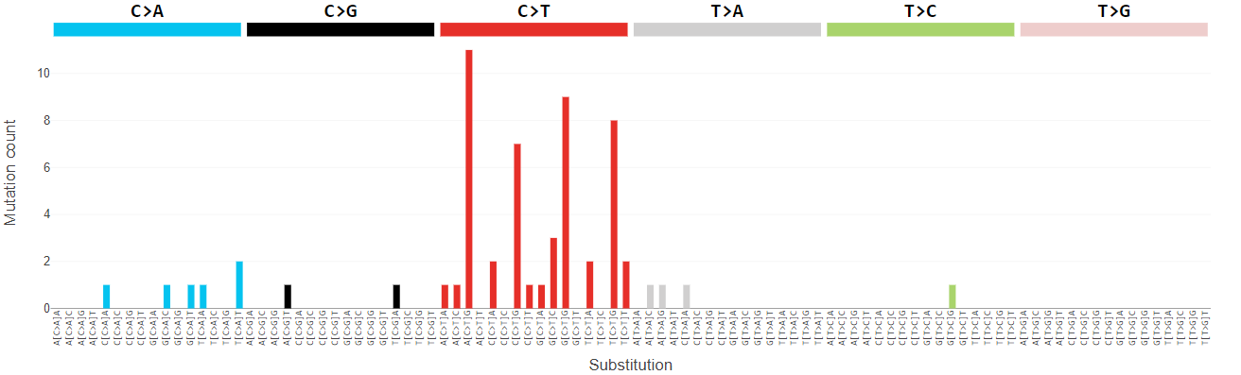 |  |  |  |  |  |  | none
11 | 140F46SD | 17 | F | L  (1.5%) | 15.3 | MSH6  LS pattern | MSH6 (ENST00000234420.5):c.2314C>T (p.(Arg772Trp)), P | chr3:g.37038204_37091970del, MLH1 exons 2-19, Lg del (~54 kb, by rough computational mapping of potentially deleted regions identified by CNVkit). | 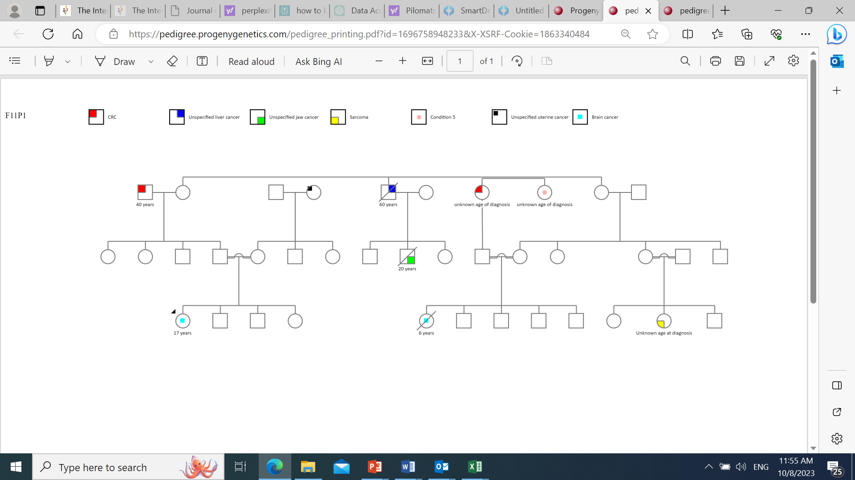  65 years  NA NA  NA  17 years  6 years  20 years  65 years  60 years  40 years
Mutational Signature |  |  |  |  |  |  | MSH6 (ENST00000234420.5):c.2314C>T (p.(Arg772Trp)), P
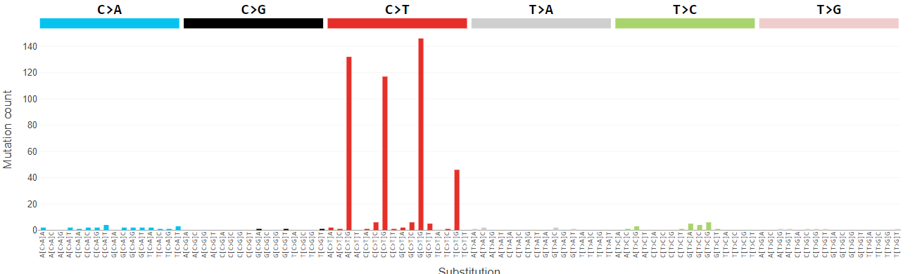 |  |  |  |  |  |  | MSH6 (ENST00000234420.5):c.2314C>T (p.(Arg772Trp)), P
No | Study  ID | Age (years) | Sex | MSI  (% Somatic sites) | TMB | IHC | Gene Variant and class | Sequencing Artifacts | Pedigree
12  &  13 | 140F42S1D & 140F42S2D | 22  &  13 | M  &  F | L (7%)  &  L (2%) | 22.8 & 352 | Nl  (Both siblings) | Both siblings have the same variant: MSH6(ENST00000234420.10): c.1217G>A (p.Cys406Tyr), VUS | None &  chr3:g.37038204_37170640del, MLH1 intron 2–3'UTR, Lg del (~132 kb, by rough computational mapping of potentially deleted regions identified by CNVkit). | 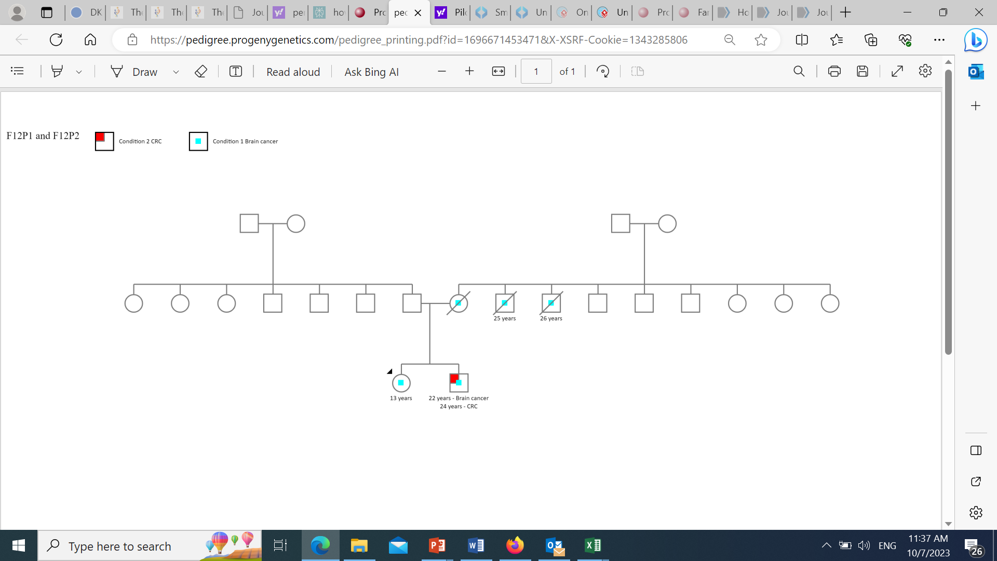  13 years  22 years - Brain  24 years - CRC  25 years  26 years  NA
Mutational Signature (140F42S1D on top and 140F42S2D at bottom)

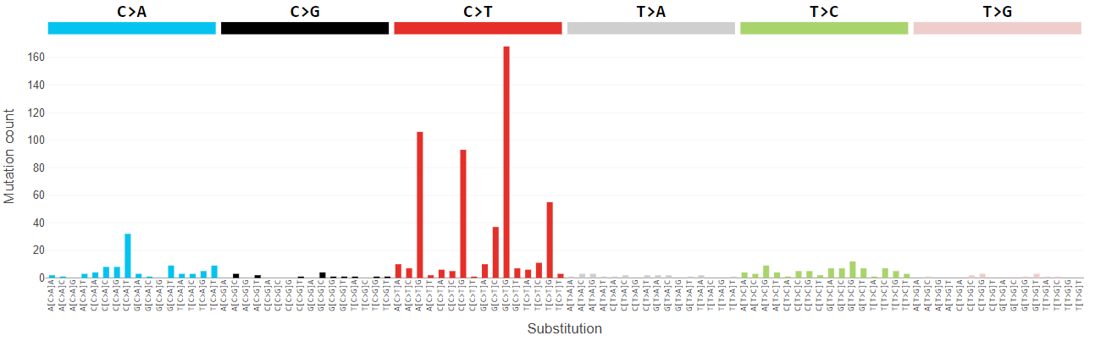

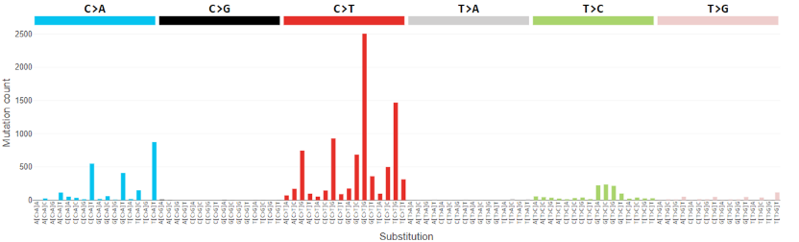
14 | 140F45SD | 9 | F | L (4.5%) | 7.6 | PMS2, CMMRD pattern | PMS2 (ENST00000441476.2):c.1269dup (p.(Gln424AlafsTer12)) |  | 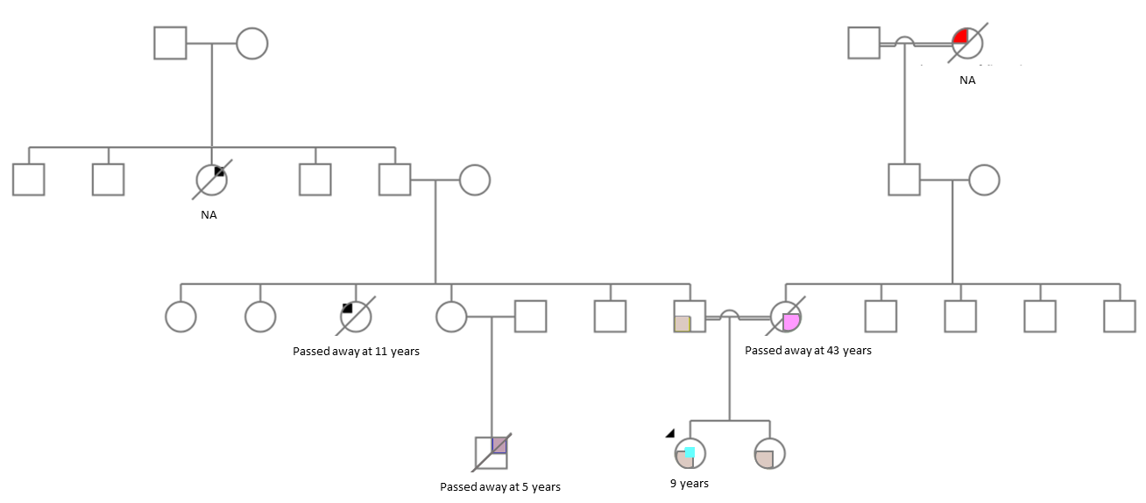
Mutational Signature  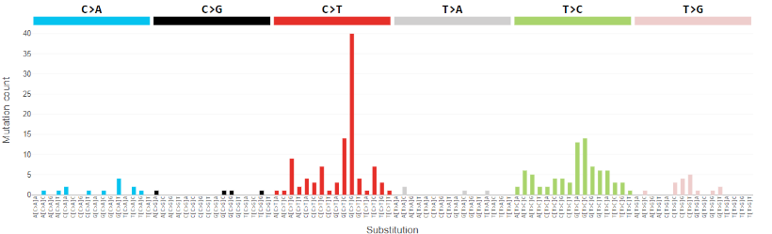 |  |  |  |  |  |  | PMS2 (ENST00000441476.2):c.1269dup (p.(Gln424AlafsTer12))

Table abbreviations:
Number (No), Identifier (ID), Microsatellite Instability (MSI), and Tumor Mutational Burden (TMB), Immunohistochemistry (IHC), Colorectal Cancer (CRC), Lynch Syndrome (LS), Male (M), High (H), Chromosome (Chr), Large (lg), Deletion (Del), Genome Reference Consortium Human Build 37 (GRCh37), Not available (NA), Kilo base (kb), Codon (c.), Protein (p.), MLPA (Multiplex Ligation-dependent Probe Amplification), Duplication (Dup), Frameshift (Fs), Insertion (ins), Low (L), Likely Pathogenic (LP), Missense Mutation (ms), Untranslated region (UTR), Pathogenic (P), Constitutional Mismatch Repair Deficiency (CMMRD).

Pedigrees’ Key:
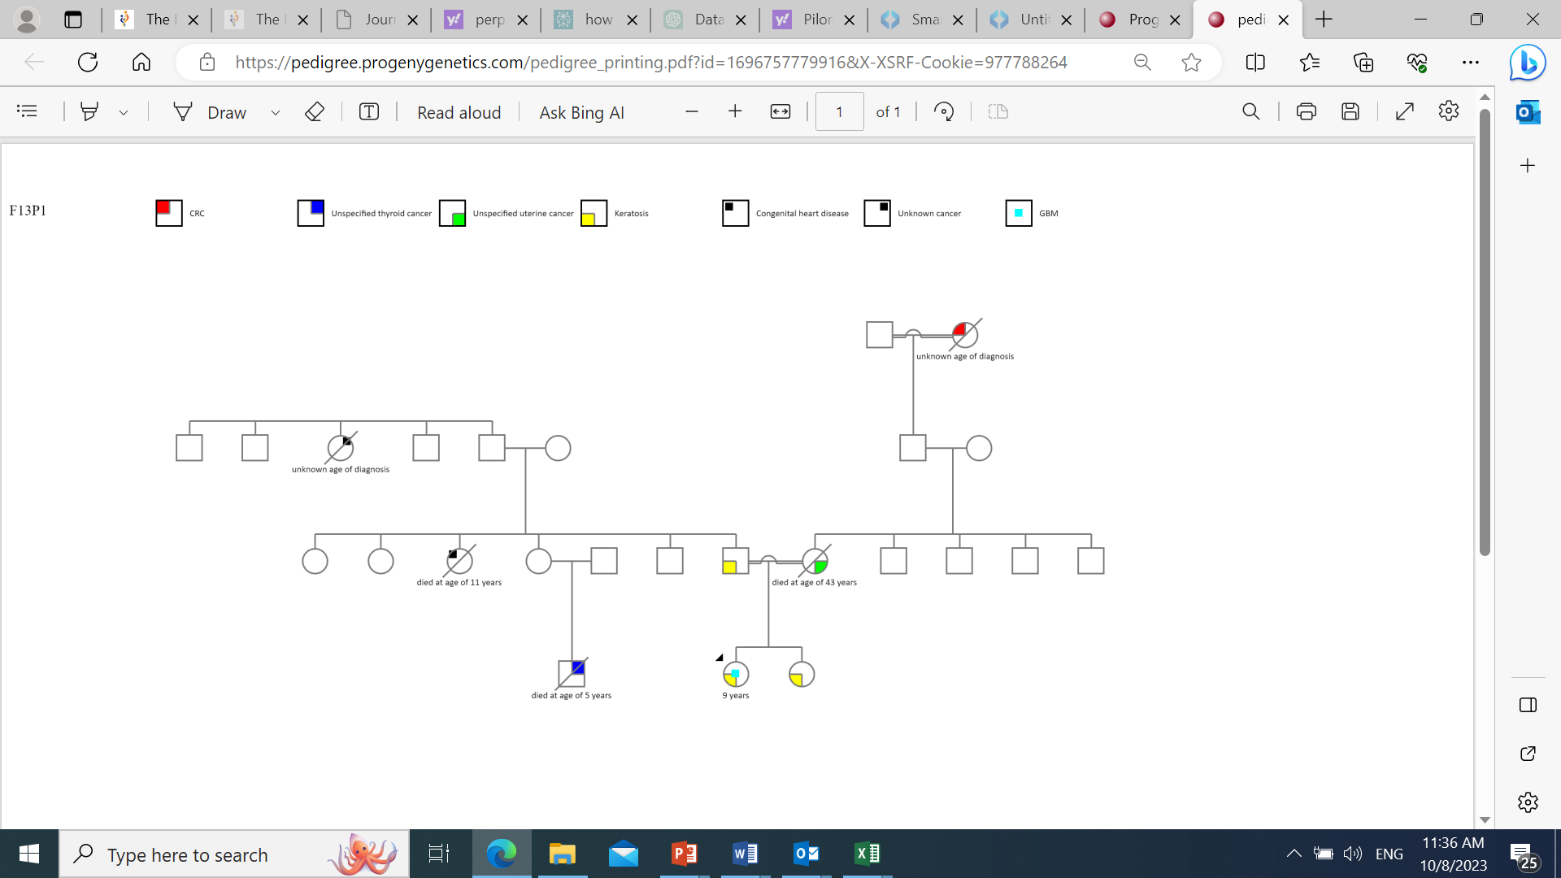

Testicular malignancy
Gastric malignancy
Uterine malignancy
Prostate malignancy
Esophageal malignancy
Lymphoma
Pancreatic cancer
Brain tumor
Breast cancer
Colorectal carcinoma
Skin malignancy
Pilomatixoma
Leukemia
Liver malignancy
Lung cancer
Parathyroid tumor
Unspecified gastrointestinal tumor
Unspecified bone sarcoma
Unspecified tongue malignancy
Unspecified tumor in the jaw
Unspecified sarcoma
Thyroid tumor
Keratosis
Unknown malignancy
Congenital heart disease

