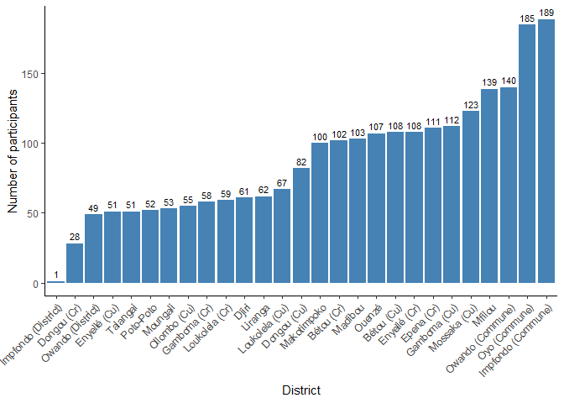
Figure 1 : Study participants per district

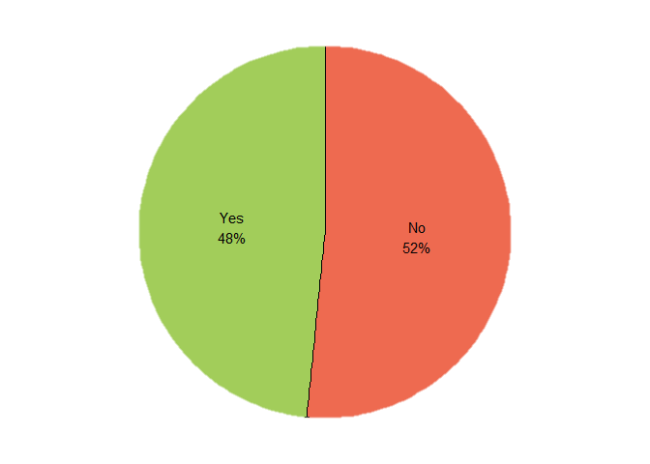
Figure 2 : Mpox Message exposure
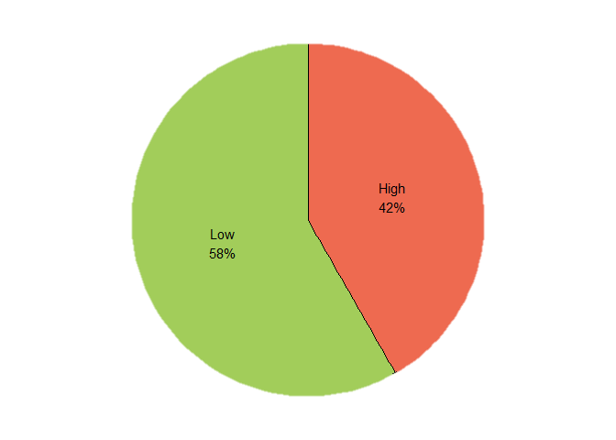
Figure 3: Mpox Geographical Risk Categorization

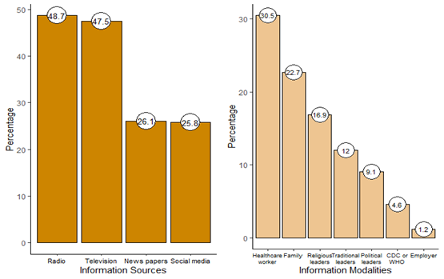

Figure 4: Trust in Modalities and Sources of Information on Mpox

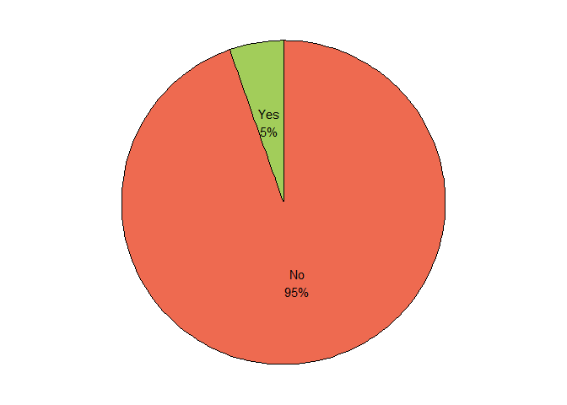

Figure 5: Mpox comprehensive knowledge

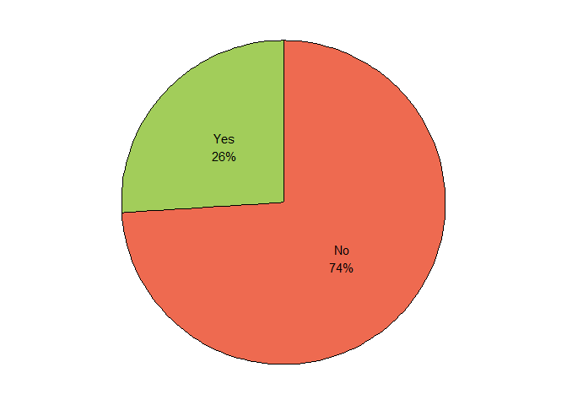
Figure 6: Mpox Prevention and Control practices

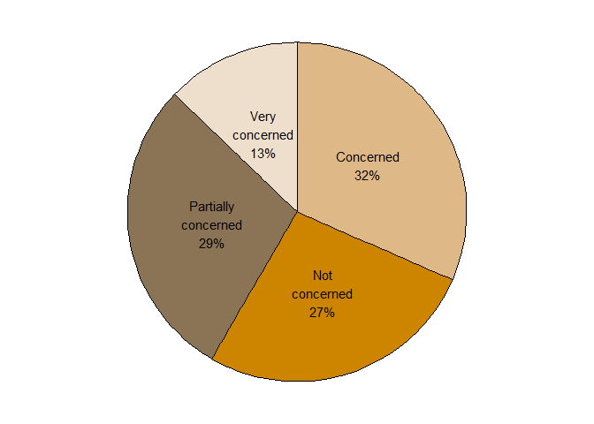
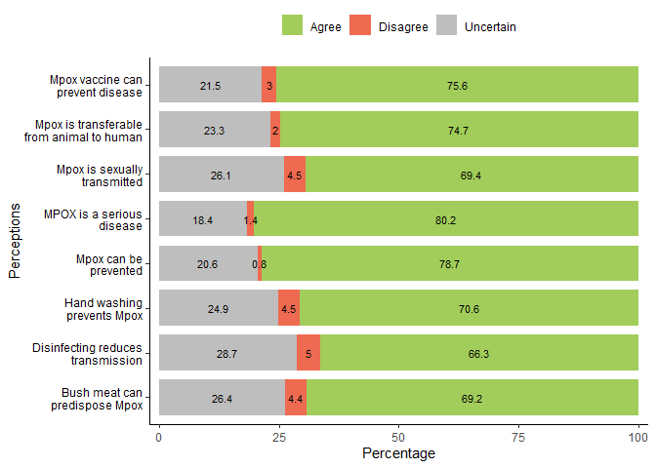

Figure 7: Study Participants’ Concerns About Contracting Mpox

Figure 8: Study Participants’ Response to Knowledge Measures of Mpox

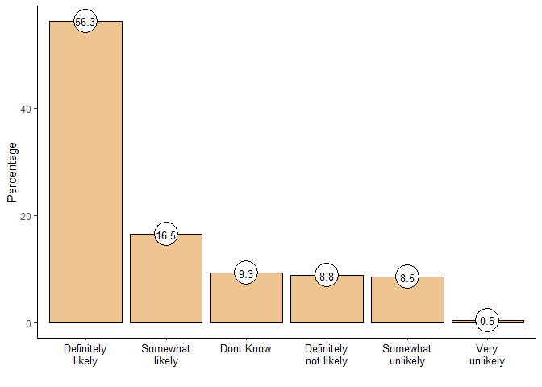

Figure 9: Study Participants’ Perception of Willingness to Accept Mpox Vaccine

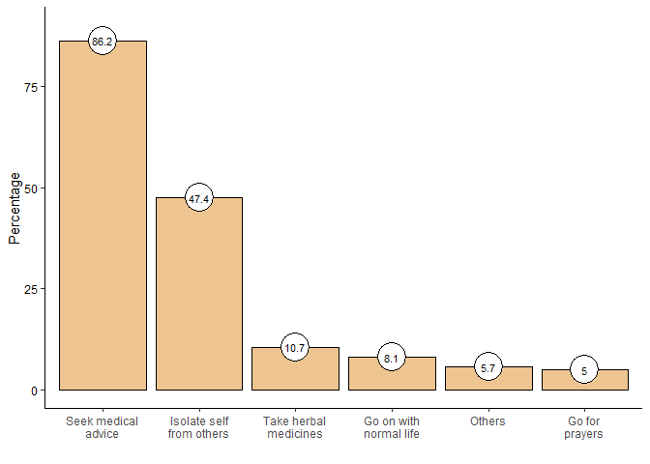
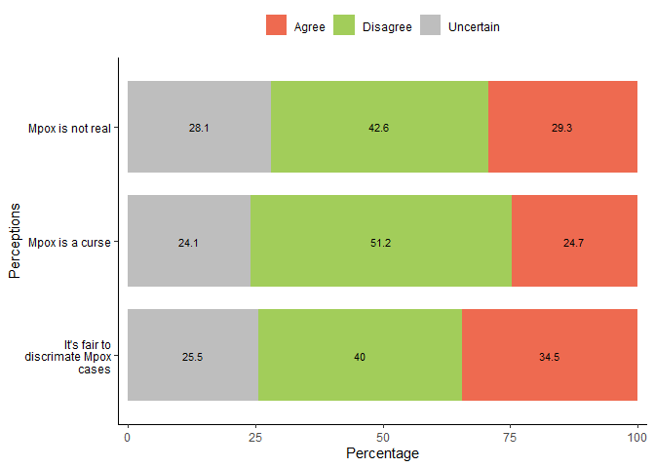

Figure 11: Study Participants’ Perceptions of Actions to Be Taken Following Symptoms of Mpox

Figure 10: Study Participants’ Response to Misconception Measures of Mpox

