Supporting Information
Fig. S1 Basal area increment (BAI) in relation to stem diameter at breast height (DBH) for the 4 investigated tree species. (a) Betula platyphylla, (b) Populus davidiana, (c) Quercus mongolica, (d) Larix gmelinii. In each panel, the grey lines show linear regression for data of each individual tree and the black line shows the linear regression based on pooled data of all sampled individuals for each tree species
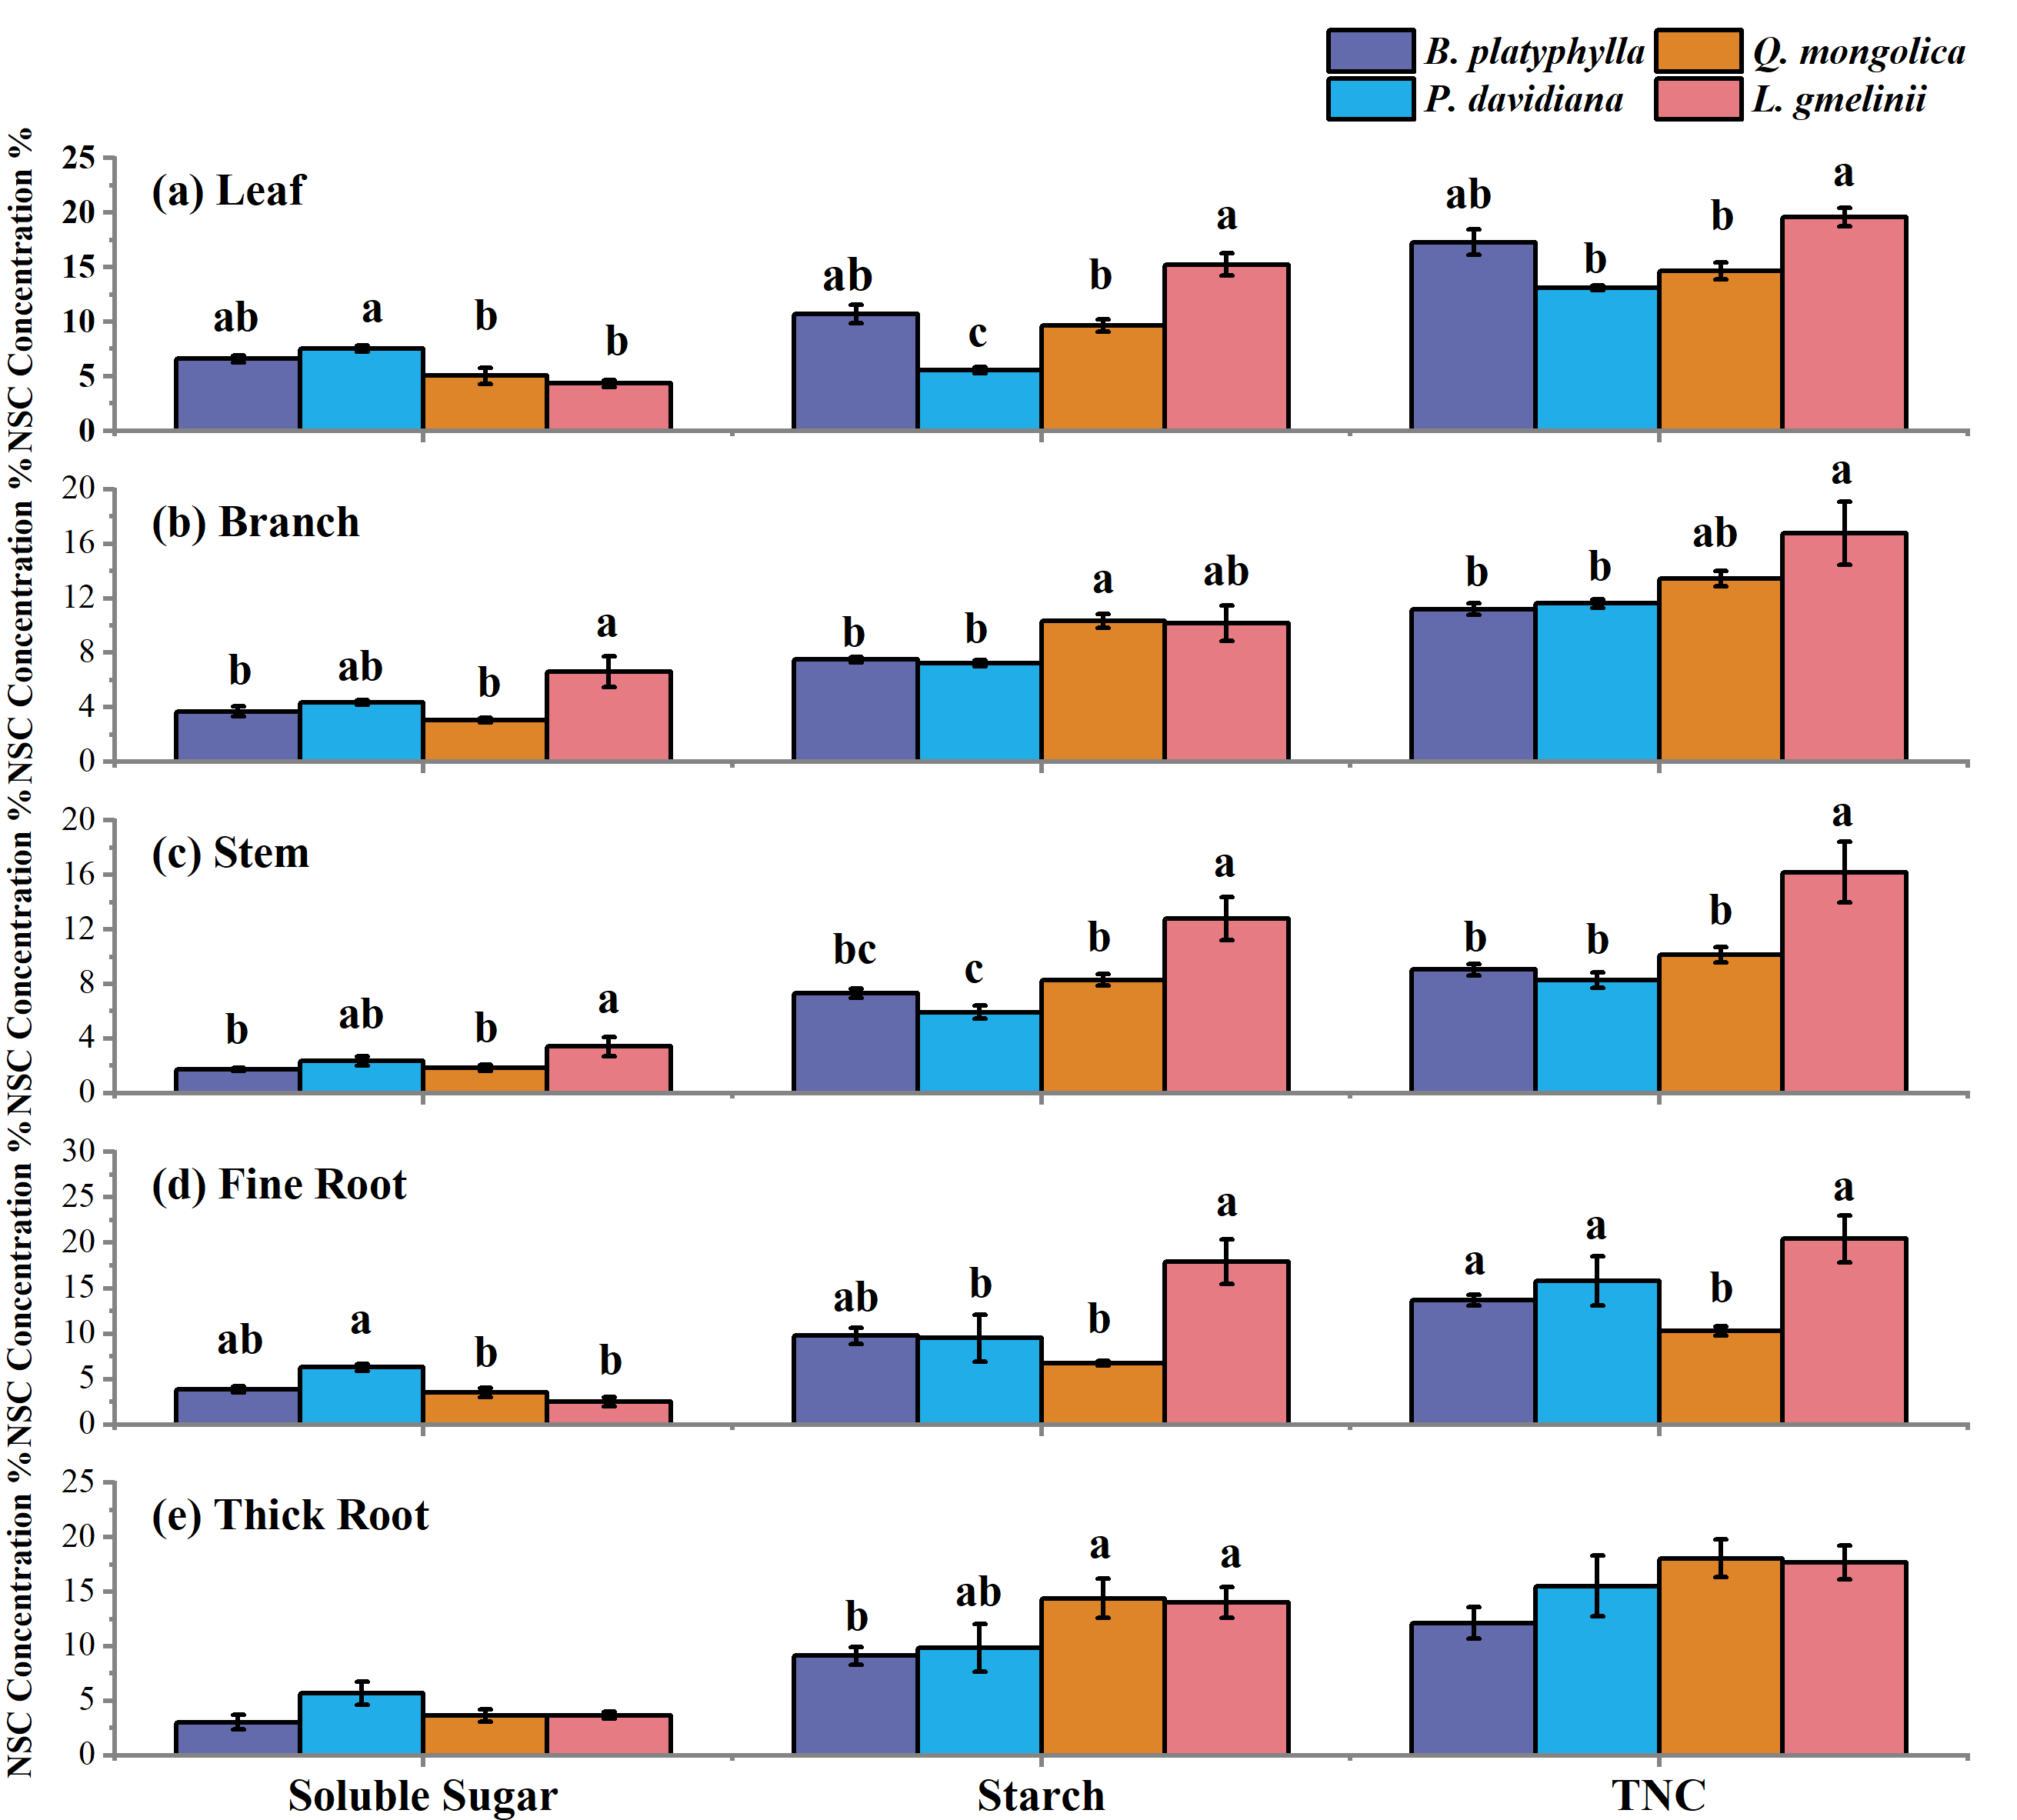
Fig. S2 NSC concentrations (divided into soluble sugar and starch) of five organs in the four species. Different lower-case letters above the horizontal lines indicate significant differences between species (P < 0.05); no letters indicate non-significant differences (P > 0.05); error bars show 1 SE

