Supplementary materials
Elevated concentrations of vanadium in maternal hair and umbilical cord blood with an increased risk of offspring congenital heart defects: a multi-hospital case-control study

Ting Lai ¹, Liu Yang ¹, Shengli Li ², Jing Tao ³, Zhen Liu ^{3†}, Jun Zhu ^{3†}
1 Department of Healthcare, Chengdu Women's and Children's Central Hospital, School of Medicine, University of Electronic Science and Technology of China, Chengdu, Sichuan 611731, China.
2 Department of Ultrasound, Shenzhen Maternity and Child Healthcare Hospital, Shenzhen, Guangdong 518028, China.
3 National Center for Birth Defects Monitoring, West China Second University Hospital, Sichuan University, Chengdu, Sichuan 610041, China.
†Corresponding author:
Zhen Liu, Email: liuzhen5_1@163.com
Jun Zhu, Email: zhujun028@163.com
Supplementary materials include the following:
Total figures: 6 Total tables: 10
Figure S1. Directed acyclic graph (DAG) of vanadium in maternal hair and umbilical cord blood and congenital heart defects in offspring for all potential confounders considered.
Figure S2. A priori sample size calculation using G*Power
Table S1. Covariance parameter estimates of the empty model.
Table S2. Descriptive statistics for hair vanadium level in the case and control groups.
Table S3. Descriptive statistics for umbilical cord blood vanadium level in the case and control groups.
Table S4. Normality tests of metals concentrations data
Figure S3. Histograms of hair vanadium concentrations (ng/mg) and Ln-transformed hair vanadium concentrations (ln ng/mg).
Figure S4. Q-Q plots of raw hair vanadium concentrations (ng/mg) and ln-transition hair vanadium concentrations (ln ng/mg).
Figure S5. Histogram of cord blood vanadium concentrations (µg/L)
Figure S6. Q-Q plot of cord blood vanadium concentrations (µg/L)
Table S5. Spearman rank correlation of heavy metals in maternal hair
Table S6. Spearman rank correlation of heavy metals in umbilical cord blood
Table S7. Interaction effects between V and Ni, As, Cd, Pb, and Ti in maternal hair on the risk of CHD in offspring.
Table S8. Interaction effects between V and Ni, As, Cd, Pb, Ti in umbilical cord blood on the risk of CHD in offspring.
Table S9. Sensitivity analyses for association of maternal hair vanadium concentrations and fetal CHD in the subgroup of the mothers aged <35 years
Table S10. Sensitivity analyses for association of umbilical cord blood vanadium concentrations and fetal CHD in the subgroup of the mothers aged <35 years

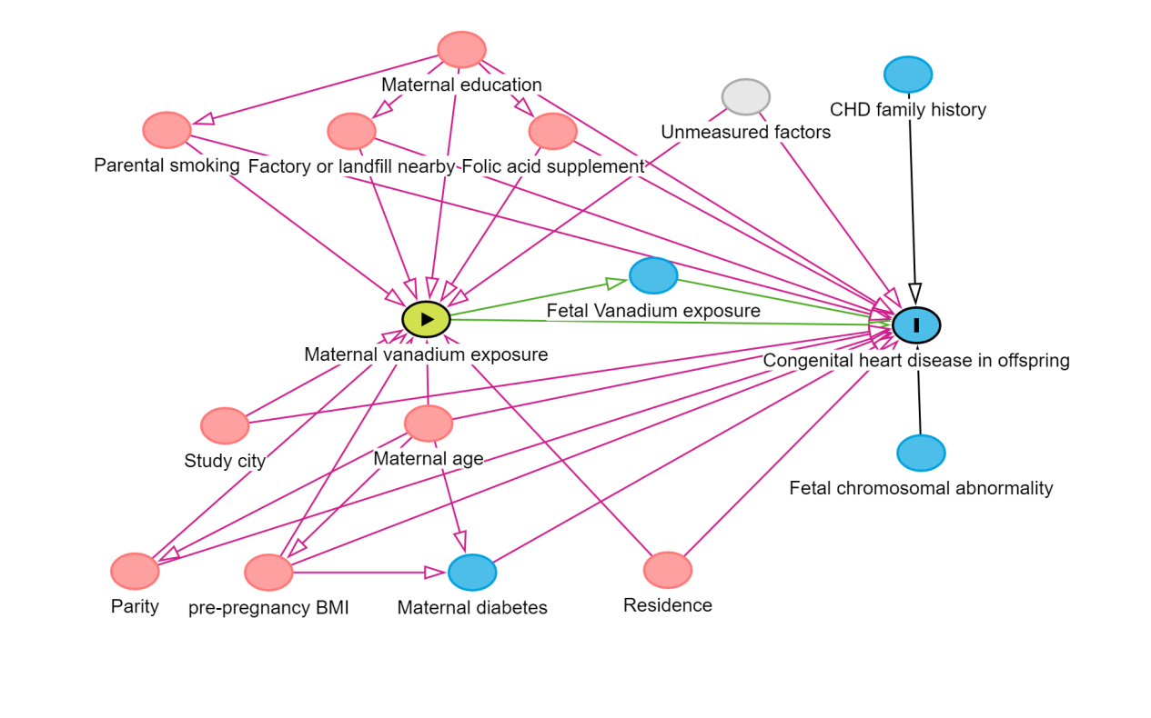

Figure S1. Directed acyclic graph (DAG) of vanadium in maternal hair and umbilical cord blood and congenital heart defects in offspring for all potential confounders considered.

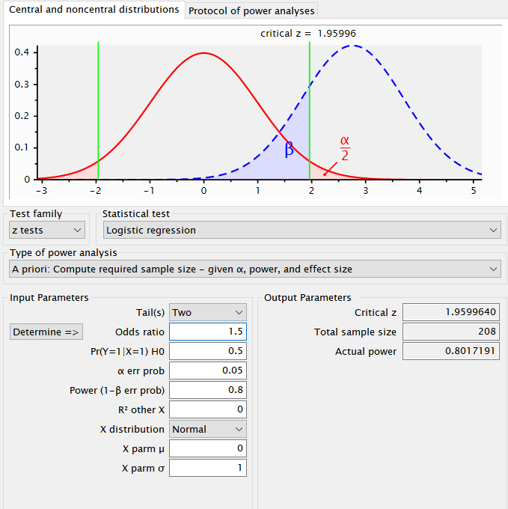
Figure S2. A priori sample size calculation using G*Power
Table S1. Covariance parameter estimates of the empty model.
Random-effects Parameters | Estimate value | Std. Err. | 95%CI | P-value | Intraclass Correlation Coefficient, ICC
var(_cons) | 0.0285684 | 0.0196976 | 0.0073959~0.1103517 | ＜0.001 | 0.0107
ICC =0.107, which means that approximately 10.7% of the total variation comes from differences between hospitals.
ICC >0.1 indicates that variation between hospitals has a significant impact on the results, and hospital random effects need to be controlled in the model.

Table S2. Descriptive statistics for hair vanadium level in the case and control groups.
Hair vanadium(ng/mg) | N | Mean ± SD | Geometric mean | P5 | P25 | P50 | P75 | P95 | Z | P value
control | 377 | 0.041± 0.037 | 0.028 | 0.006 | 0.017 | 0.031 | 0.052 | 0.119 | — | —
case | 361 | 0.091±0.092 | 0.064 | 0.016 | 0.039 | 0.064 | 0.107 | 0.263 | -11.737 | 0.0000
Septal defects | 247 | 0.087±0.084 | 0.062 | 0.016 | 0.037 | 0.063 | 0.107 | 0.225 | -8.100 | 0.0000
Conotruncal defects | 173 | 0.092±0.099 | 0.065 | 0.017 | 0.038 | 0.070 | 0.107 | 0.225 | -7.031 | 0.0000
Left ventricular outflow tract obstruction | 147 | 0.085±0.080 | 0.061 | 0.016 | 0.036 | 0.063 | 0.107 | 0.225 | -5.572 | 0.0000
Right ventricular outflow tract obstruction | 73 | 0.114±0.131 | 0.074 | 0.019 | 0.041 | 0.073 | 0.115 | 0.403 | -4.878 | 0.0000
Anomalous pulmonary venous return | 57 | 0.106±0.108 | 0.077 | 0.023 | 0.043 | 0.072 | 0.115 | 0.333 | -4.846 | 0.0000
Other heart defects | 88 | 0.112±0.118 | 0.073 | 0.017 | 0.041 | 0.077 | 0.140 | 0.333 | -5.746 | 0.0000

Table S3. Descriptive statistics for umbilical cord blood vanadium level in the case and control groups.
Umbilical cord blood vanadium (µg/L) | N | Mean ± SD | Geometric mean | P5 | P25 | P50 | P75 | P95 | Z | P value
control | 201 | 3.242±0.75 | 3.148 | 2.222 | 2.811 | 3.265 | 3.653 | 4.222 | — | —
case | 96 | 3.588±0.794 | 3.500 | 2.458 | 3.100 | 3.518 | 4.010 | 5.268 | -3.643 | 0.0003
Septal defects | 66 | 3.573±0.784 | 3.498 | 2.642 | 3.055 | 3.454 | 3.841 | 5.268 | -2.226 | 0.0260
Conotruncal defects | 50 | 3.716±0.850 | 3.627 | 2.642 | 3.122 | 3.528 | 4.173 | 5.461 | -3.245 | 0.0012
Left ventricular outflow tract obstruction | 39 | 3.687±0.711 | 3.628 | 2.783 | 3.122 | 3.530 | 4.043 | 5.268 | -3.005 | 0.0027
Right ventricular outflow tract obstruction | 18 | 3.269±0.884 | 3.126 | 1.155 | 2.642 | 3.403 | 3.864 | 4.626 | -0.085 | 0.9323
Anomalous pulmonary venous return | 11 | 3.727±1.082 | 3.596 | 2.254 | 2.992 | 3.576 | 4.173 | 6.231 | -1.165 | 0.2442
Other heart defects | 29 | 3.523±0.914 | 3.395 | 2.254 | 3.018 | 3.512 | 3.977 | 4.626 | -1.310 | 0.1902

Table S4. Normality tests of metals concentrations data
 | Mean | P50 | Skewness | Kurtosis | P-value
V in maternal hair | 0.065 | 0.045 | 0.5457 | 5.8167 | ＜0.001
V in umbilical cord blood | 3.354 | 3.314 | 3.876 | 25.3811 | ＜0.001
P value < 0.05 indicated that both hair vanadium and umbilical cord blood vanadium data significantly deviated from a normal distribution. Skewness value > 0 confirmed a positive skewness for both datasets.
Figure S3. Histograms of hair vanadium concentrations (ng/mg) and ln-transformed hair vanadium concentrations (ln ng/mg).

Figure S4. Q-Q plots of raw hair vanadium concentrations (ng/mg) and ln-transition hair vanadium concentrations (ln ng/mg).
Figure S5. Histogram of cord blood vanadium concentrations (µg/L)
Figure S6. Q-Q plot of cord blood vanadium concentrations (µg/L)

Table S5. Spearman rank correlation of metals in maternal hair
 | V | Ni | As | Cd | Pb | Ti
V | — | 0.0000 | 0.0000 | 0.0000 | 0.0000 | 0.0000
Ni | 0.5430* | — | 0.0000 | 0.0000 | 0.0000 | 0.0000
As | 0.3247* | 0.1975* | — | 0.0009 | 0.0000 | 0.0000
Cd | 0.2004* | 0.3362* | 0.1216* | — | 0.0000 | 0.0014
Pb | 0.4181* | 0.4734* | 0.3694* | 0.5914* | — | 0.0000
Ti | 0.6894* | 0.4304* | 0.3340* | 0.1174* | 0.3574* | —
Note, Lower left presents spearman rank correlation coefficients, upper right presents P-values for correlations, * means P <0.05.
V, vanadium; Ni, nickel; As, arsenic; Cd, cadmium; Pb, lead; Ba, barium; Al, aluminum and Ti, titanium.

Table S6. Spearman rank correlation of metals in umbilical cord blood
 | V | Ni | As | Cd | Pb | Ti
V | — | 0.0004 | 0.0404 | 0.0990 | 0.2420 | 0.0000
Ni | 0.2030* | — | 0.2069 | 0.0000 | 0.0000 | 0.1055
As | -0.1190* | 0.0734 | — | 0.6927 | 0.5353 | 0.8016
Cd | 0.0959 | 0.2631* | -0.0230 | — | 0.0000 | 0.1616
Pb | 0.0681 | 0.2481* | 0.0361 | 0.2661* | — | 0.0099
Ti | 0.3925* | 0.0941 | 0.0146 | 0.0814 | 0.1496* | —
Note, Lower left presents spearman rank correlation coefficients, upper right presents P-values for correlations, * means P <0.05.
V, vanadium; Ni, nickel; As, arsenic; Cd, cadmium; Pb, lead; Ba, barium; Al, aluminum and Ti, titanium.

Table S7. Interaction effects between V and Ni, As, Cd, Pb, and Ti in maternal hair on the risk of CHD in offspring.
Maternal hair | case(%) | AOR(95%CI) | P-value | S | AP | RERI | P
V/Ni category
Low V and low Ni | 88(11.92) | Ref. |  | 2.753 | 0.536 | 3.392 | 0.009
Low V and high Ni | 26(3.52) | 0.648(0.363~1.157) | 0.143
High V and low Ni | 62(8.40) | 3.287(1.938~5.576) | 0.000
High V and high Ni | 185(25.07) | 6.327(4.033~9.927) | 0.000
Cross-Product term for interaction |  | 2.971(1.372~6.432) | 0.006
V/As category
Low V and low As | 54(7.32) | Ref. |  | 2.016 | 0.462 | 5.534 | 0.03
Low V and high As | 60(8.13) | 2.211(1.329~3.679) | 0.002
High V and low As | 84(11.38) | 5.235(3.131~8.753) | 0.000
High V and high As | 163(22.09) | 11.980(7.113~20.177) | 0.000
Cross-Product term for interaction |  | 1.035(0.516~2.075) | 0.923
V/Cd category
Low V and low Cd | 68(9.21) | Ref. |  | 0.628 | -0.457 | -2.005 | 0.189
Low V and high Cd | 46(6.23) | 0.756(0.452~1.265) | 0.287
High V and low Cd | 109(14.77) | 6.635(4.000~11.008) | 0.000
High V and high Cd | 138(18.70) | 4.387(2.762~6.969) | 0.000
Cross-Product term for interaction |  | 0.874(0.434~1.759) | 0.706
V/Pb category
Low V and low Pb | 73(9.89) | Ref. |  | 1.560 | 0.300 | 1.809 | 0.170
Low V and high Pb | 41(5.56) | 0.812(0.478~1.381) | 0.443
High V and low Pb | 81(10.98) | 4.419(2.650~7.369) | 0.000
High V and high Pb | 166(22.49) | 6.040(3.789~9.630) | 0.000
Cross-Product term for interaction |  | 1.682(0.824~3.437) | 0.153
V/Ti category
Low V and low Ti | 87(11.79) | Ref. |  | 17.679 | 0.852 | 8.837 | 0.000
Low V and high Ti | 27(3.66) | 1.019(0.546~1.901) | 0.953
High V and low Ti | 36(4.88) | 1.511(0.833~2.741) | 0.175
High V and high Ti | 211(28.59) | 10.366(6.460~16.635) | 0.000
Cross-Product term for interaction |  | 6.733(2.733~16.590) | 0.000
Analyses were adjusted for tudy city, maternal age, parity, pre-pregnancy body mass index, education, residence, folic acid supplement, parental smoking, and factory or landfill nearby.
Low: equal or below median level; High: above median level

Table S8. Interaction effects between V and Ni, As, Cd, Pb, Ti in umbilical cord blood on the risk of CHD in offspring.
Umbilical cord blood | case(%) | AOR(95%CI) | P-value | S | AP | RERI | P
V/Ni category
Low V and low Ni | 24(8.08) | ref. |  | 0.448 | -0.561 | -1.027 | 0.425
Low V and high Ni | 15(5.05) | 1.754(0.687~4.481) | 0.240
High V and low Ni | 24(8.08) | 2.104(0.834~5.305) | 0.115
High V and high Ni | 33(11.11) | 1.832(0.784~4.279) | 0.162
Cross-Product term for interaction |  | 0.496(0.135~1.822) | 0.291
V/As category
Low V and low As | 22(7.41) | Ref. |  | -0.604 | -3.969 | -1.591 | 0.155
Low V and high As | 17(5.72) | 0.585(0.233~1.470) | 0.254
High V and low As | 43(14.48) | 2.407(1.028~5.633) | 0.043
High V and high As | 14(4.71) | 0.401(0.144~1.114) | 0.080
Cross-Product term for interaction |  | 0.285(0.074~1.089) | 0.066
V/Cd category
Low V and low Cd | 25(8.42) | Ref. |  | 0.173 | 0.325 | 0.305 | 0.572
Low V and high Cd | 14(4.71) | 0.424(0.160~1.121) | 0.084
High V and low Cd | 30(10.10) | 1.208(0.532~2.741) | 0.651
High V and high Cd | 27(9.09) | 0.936(0.387~2.266) | 0.884
Cross-Product term for interaction |  | 1.829(0.504~6.639) | 0.358
V/Pb category
Low V and low Pb | 17(5.72) | Ref. |  | 0.025 | -1.078 | -1.108 | 0.277
Low V and high Pb | 22(7.41) | 1.040(0.418~2.587) | 0.933
High V and low Pb | 25(8.42) | 2.097(0.922~4.770) | 0.077
High V and high Pb | 32(10.77) | 1.029(0.404~2.622) | 0.953
Cross-Product term for interaction |  | 0.472(0.131~1.692) | 0.249
V/Ti category
Low V and low Ti | 28(9.43) | Ref. |  | 0.233 | -0.716 | -0.916 | 0.395
Low V and high Ti | 11(3.70) | 1.017(0.398~2.600) | 0.972
High V and low Ti | 25(8.42) | 2.178(0.888~5.339) | 0.089
High V and high Ti | 32(10.77) | 1.279(0.583~2.805) | 0.540
Cross-Product term for interaction |  | 0.577(0.161~2.077) | 0.400
Analyses were adjusted for tudy city, maternal age, parity, pre-pregnancy body mass index, education, residence, folic acid supplement, parental smoking, and factory or landfill nearby.
Low: equal or below median level; High: above median level

Table S9. Sensitivity analyses for association of maternal hair vanadium concentrations and fetal CHD in the subgroup of the mothers aged <35 years
Group | Total Ln (hairV) | hair low N=226 | hair medium  N=223 | hair high  N=221
Group | Total Ln (hairV) | 0.031≤ng/mg | 0.032~0.065ng/mg | >0.065ng/mg
Control (%) | 336 | 170(50.60) | 110(32.74) | 56(16.67)
Case (%) | 334 | 56(16.77) | 113(33.83) | 165(49.40)
Crude OR(95 CI) | 3.066(2.455~3.828)*** | Ref. | 3.119(2.090-4.653)*** | 8.945(5.831-13.721)***
Adjusted OR(95% CI)‡ | 3.575(2.709-4.717)*** | Ref. | 3.312(2.072-5.295)*** | 12.093(7.077-20.662)***
Adjusted OR(95% CI) (metals)† | 2.046(1.453-2.881)*** | Ref. | 1.775(1.046-7.514)* | 3.856(1.979-7.514)***
Septal defects (N) | 228 | 42(18.42) | 77(33.77) | 109(47.81)
Adjusted OR(95% CI)‡ | 2.340(1.819-3.010)*** | Ref. | 2.166(1.338-3.505)** | 5.060(3.011-8.504)***
Adjusted OR(95% CI) (metals)† | 1.439(1.032-2.005)* | Ref. | 1.292(0.755-2.211) | 1.898(0.976-3.689)
Conotruncal defects (N) | 164 | 30(18.29) | 47(28.66) | 87(53.05)
Adjusted OR(95% CI)‡ | 2.302(1.771-2.992)*** | Ref. | 1.909(1.093-3.334)* | 4.916(2.817-8.580)***
Adjusted OR(95% CI) (metals)† | 1.704(1.165-2.492)** | Ref. | 1.297(0.714-2.354) | 2.444(1.196-4.998)*
Left ventricular outflow track obstruction (N) | 135 | 22(16.30) | 46(34.07) | 67(49.63）
Adjusted OR(95% CI)‡ | 2.004(1.527-2.631)*** | Ref. | 2.324(1.267-4.262)** | 4.487(2.398-8.394)***
Adjusted OR(95% CI) (metals)† | 1.244(0.857-1.806) | Ref. | 1.491(0.787-2.827) | 1.766(0.810-3.849)
Right ventricular outflow track obstruction (N) | 69 | 11(15.94) | 19(27.54) | 39(56.52)
Adjusted OR(95% CI)‡ | 2.039(1.467-2.834)*** | Ref. | 2.144(0.939-4.893) | 3.865(1.777-8.404)**
Anomalous pulmonary venous return (N) | 53 | 5(9.43) | 17(32.08) | 31(58.49)
Adjusted OR(95% CI)‡ | 2.018(1.379-2.952)*** | Ref. | 4.159(1.324-13.066)* | 7.136(2.355-21.621)**
Adjusted OR(95% CI) (metals)† | 1.419(0.794-2.535) | Ref. | 2.887(0.899-9.274) | 4.244(1.178-15.294)*
Other heart defects (N) | 82 | 10(12.20) | 26(31.71) | 46(56.10)
Adjusted OR(95% CI)‡ | 2.099(1.526-2.889)*** | Ref. | 3.807(1.544-9.386)** | 7.998(3.208-19.940)***
Adjusted OR(95% CI) (metals)† | 1.199(0.719~2.000) | Ref. | 2.426(0.915-6.432) | 3.355(1.044-10.776)*

‡Adjusted for study city, maternal age, parity, pre-pregnancy body mass index, education, residence, folic acid supplement, parental smoking, and factory or landfill nearby.
†Adjusted for potential confounders described above, and the Ln-transformed metals concentrations of nickel (Ni), arsenic (As), cadmium (Cd), lead (Pb) and titanium (Ti).
*P < 0.05, **P < 0.01, ***P< 0.001.

Table S10. Sensitivity analyses for association of umbilical cord blood vanadium concentrations and fetal CHD in the subgroup of the mothers aged <35 years
Group | Total V µg/L | blood low N=91 | blood medium  N=91 | blood high  N=91
Group | Total V µg/L | 3.030≤µg/L | 3.051~3.602 µg/L | >3.602 µg/L
Control (%) | 185 | 72(38.92) | 59(31.89) | 54(29.19)
Case (%) | 88 | 19(21.59) | 32(36.36) | 37(42.05)
Crude OR(95 CI) | 1.744(1.223-2.485)** | Ref. | 2.055(1.058-3.992)* | 2.596(1.347-5.004)**
Adjusted OR(95% CI)‡ | 1.581(1.037-2.410)* | Ref. | 1.324(0.569-3.081) | 1.998(0.897-4.451)
Adjusted OR(95% CI) (metals)† | 1.823(1.134-2.932)* | Ref. | 1.527(0.618-3.772) | 2.231(0.902-5.518)
Septal defects (N) | 58 | 14(24.14) | 24(41.38) | 20(34.48)
Adjusted OR(95% CI)‡ | 1.358(0.891-2.069) | Ref. | 1.511(0.671-3.404) | 1.231(0.531-2.854)
Adjusted OR(95% CI) (metals)† | 1.699(1.073-2.688)* | Ref. | 2.095(0.870-5.045) | 1.702(0.659-4.395)
Conotruncal defects (N) | 46 | 9(19.57) | 17(36.96) | 20(43.48)
Adjusted OR(95% CI)‡ | 1.665(1.050-2.641)* | Ref. | 1.325(0.499-3.519) | 1.997(0.779-5.118)
Adjusted OR(95% CI) (metals)† | 2.136(1.299-3.513)** | Ref. | 1.653(0.576-4.746) | 2.867(0.983-8.364)
Left ventricular outflow track obstruction (N) | 38 | 5(13.16) | 15(39.47) | 18(47.37)
Adjusted OR(95% CI)‡ | 2.146(1.243-3.706)** | Ref. | 2.971(0.905-9.750) | 4.114(1.263-13.404)*
Adjusted OR(95% CI) (metals)† | 2.511(1.425-4.426)** | Ref. | 4.807(1.281-18.032)* | 7.064(1.825-27.352)**
Right ventricular outflow track obstruction (N) | 18 | 6(33.33) | 5(27.78) | 7(38.89)
Adjusted OR(95% CI)‡ | 0.688(0.326-1.450) | Ref. | 0.555(0.132-2.323) | 0.759(0.204-2.829)
Adjusted OR(95% CI) (metals)† | 0.702(0.300-1.646) | Ref. | 0.588(0.123-2.815) | 0.694(0.152-3.174)
Anomalous pulmonary venous return (N) | 10 | 3(30.00) | 2(20.00) | 5(50.00)
Adjusted OR(95% CI)‡ | 2.230(0.778-6.391) | Ref. | 0.173(0.011-2.719) | 1.291(0.180-9.259)
Adjusted OR(95% CI) (metals)† | 1.767(0.552-5.656) | Ref. | 0.056(0.002-1.619) | 0.326(0.021-4.999)
Other heart defects (N) | 28 | 7(25.00) | 9(32.14) | 12(42.86)
Adjusted OR(95% CI)‡ | 1.250(0.669-2.233) | Ref. | 0.875(0.273-2.799) | 1.240(0.404-3.807)
Adjusted OR(95% CI) (metals)† | 1.339(0.740-2.424) | Ref. | 0.923(0.258-3.302) | 1.553(0.440-5.479)

‡Adjusted for study city, maternal age, parity, pre-pregnancy body mass index, education, residence, folic acid supplement, parental smoking, and factory or landfill nearby.
†Adjusted for potential confounders described above, and the metals concentrations of nickel (Ni), arsenic (As), cadmium (Cd), lead (Pb) and titanium (Ti).
*P < 0.05, **P < 0.01, ***P< 0.001.

