Table 1 Analysis of the MYB DNA-binding domains in 2R-MYB and 3R-MYB proteins of R.officinalex
Motif | Width | Logo | Consensus sequence
1 | 50 |  | JKRGNFTPEEEDLIIRLHALLGNRWSLIARRLPGRTDNEIKNYWNTHLKK
2 | 21 | 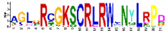 | AGLGRCGKSCRLRWLNYLRPD
3 | 21 | 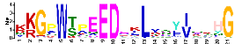 | KKGPWTPEEDEKLVSYIQKHG
4 | 11 |  | MGRAPCCDKAG
5 | 8 | 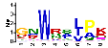 | GNWRSLPK
6 | 18 | 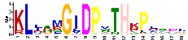 | KLJSMGIDPVTHKPLSDL
7 | 29 | 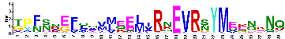 | TPFSNEFQQVMEELIRNEVRSYMEKNKNQ
8 | 41 |  | AKQLNAEVNSPQFKDAIRHFYMPTLVEKIEANSGPSTPSDY
9 | 48 |  | GGWTPEEDETLRAAVQTYGGKNWKKIAEVFPDRSEVQCLHRWQKVLNP
10 | 50 |  | DQDEDQYHGSPNSWLLPDLQGDHPHDYTTFCYYDHSFHECKIISSTSHEM

Table 2 Analysis of the MYB DNA-binding domains in 1R-MYB proteins of R. officinale.
Motif | Width | Logo | Consensus sequence
1 | 15 | 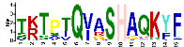 | TKTPTQVASHAQKYF
2 | 23 | 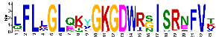 | LFLLGLQKYGKGDWRSISRNFVT
3 | 15 | 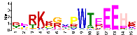 | RERKKGVPWTEEEHK
4 | 21 | 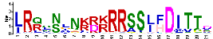 | LRQSNLNKRKRRSSJFDITTD
5 | 26 | 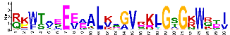 | RKWTAEEEAALKAGVRKLGSGKWRTI
6 | 15 | 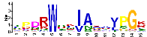 | TPDRWSKIAKAVPGK
7 | 50
  EMGFEFYKRTPTSVSLHEFDPQLGMKVERTYKILNILEFNITRKRMSVII | MEME-7 | 50
8 | 29 | 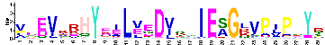 | VEEVKRHYEILVEDVSRIESGLVPIPNYR
9 | 50
  FDNAKHRTYVDLKDKWKTLVHTARISPQQRRGEPVPQELLDRVLAAHAYW | MEME-
10 | 41 |  | NPQTPKRNEKHGSLNGLAEGEETAAEPKLHSVSSFSDKLHF

