Supporting Information
Hydrogel Microparticles Preserve Cell Secretome and Extracellular Vesicle Bioactivity for Improved Cell-Based Therapy Deployment

Li Ching Wong^{a #}, Craig Jun Kit Wong^{b,c,d #}, Kwan Yu Wu^{b,c,d}, Serene Ming En Chongª, Yee Kit Tai^{b,c,d,e}*, Rufaihah Abdul Jalil^{b,f,g}, Arif Z. Nelsonª*, and Alfredo Franco-Obregón^{b,c,d,e,h}*

ªFood, Chemical and Biotechnology Cluster, Singapore Institute of Technology, Singapore
^{b}Department of Surgery, Yong Loo Lin School of Medicine, National University of Singapore, Singapore;
^{c}Institute of Health Technology and Innovation (iHealthtech), National University of Singapore, Singapore;
^{d}Biolonic Currents Electromagnetic Pulsing Systems Laboratory (BICEPS), National University of Singapore, Singapore
^{e}NUS Centre for Cancer Research, Yong Loo Lin School of Medicine, National University of Singapore, Singapore
^{f}Healthy Longevity Translational Research Programme, Yong Loo Lin School of Medicine, National University of Singapore, Singapore;
^{g}School of Applied Science, Temasek Polytechnic, Singapore
^{h}Competence Center for Applied Biotechnology and Molecular Medicine, University of Zürich, Switzerland
#Li Ching Wong and Craig Jun Kit Wong contributed equally to this work.
*Corresponding author
e‑mail: afo@nus.edu.sg (Alfredo Franco‑Obregón); arif.nelson@singaporetech.edu.sg (Arif Z. Nelson); alextao@nus.edu.sg (Tai Yee Kit)
Postal address: Institute for Health Innovation and Technology, National University of Singapore, MD6, 14 Medical Drive, #14-01, Singapore 117599 (Alfredo Franco‑Obregón and Tai Yee Kit);
Singapore Institute of Technology, SIT Kwek Leng Beng University Tower (E1), 1 Punggol Coast Road, Singapore 828608 (Arif Z. Nelson)
Telephone: +65 66016143 (Alfredo Franco‑Obregón and Tai Yee Kit); +65 6592 4613 (Arif Z. Nelson)
Table S1 List of antibodies, vendors and dilution factors
Protein target and catalogue number | Vendor, Country | Dilution Factor
Cyclin-dependent kinase inhibitor (P21) (sc-6246) | Santa Cruz Biotechnology, Texas, USA | 1:300
Cyclin B1 (CB1) (CST 4138) | Cell Signaling Technology, Massachusetts, USA | 1:1,000
Cyclin D1 (CD1) (sc-8396) | Santa Cruz Biotechnology, Texas, USA | 1:300
Transient receptor potential canonical 1 (TRPC1) (sc-133076) | Santa Cruz Biotechnology, Texas, USA | 1:300
Glyceraldehyde-3-phosphate dehydrogenase (GAPDH) (60004-1-lg) | Proteintech, Chicago, USA | 1:10,000
Phospho-JNK (sc-6254) and Total JNK (sc-7345) | Santa Cruz Biotechnology, Texas, USA | 1:300
Phospho-ERK (sc-7383) and Total ERK (s-514302) | Santa Cruz Biotechnology, Texas, USA | 1:300
Desmin (ab907) | Merck Millipore, USA | 1:1000
Myoblast determination protein 1 (MyoD) | Santa Cruz Biotechnology, Texas, USA | 1:300
Myogenin (MyoG) (immunofluorescence and western blotting) (sc-12732) | Santa Cruz Biotechnology, Texas, USA | 1:300

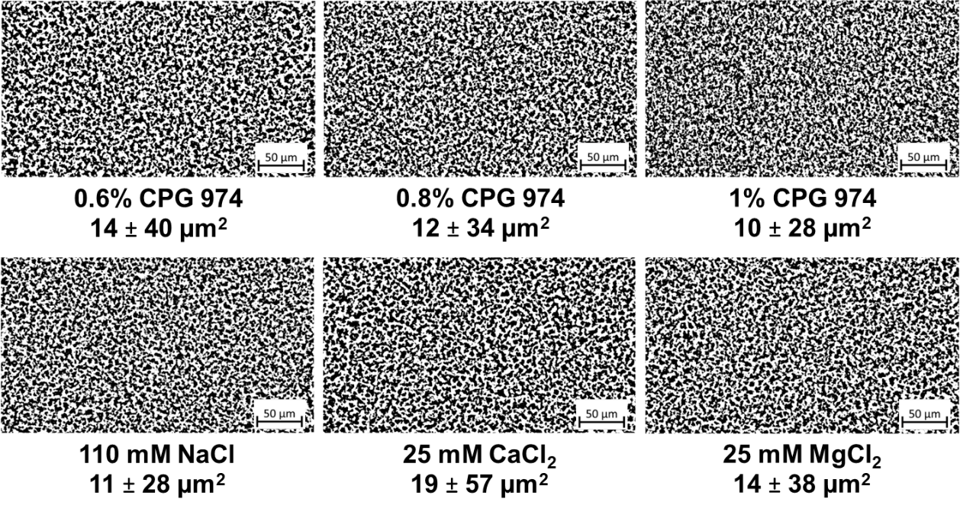
Figure S1 Microstructural morphology of CP aggregates (40× magnification). (A) CP aggregates in 0.6 – 1% CPG suspensions. (B) CP aggregates in 0.8% CPG incorporated with 25 mM of CaCl₂, 25 mM of MgCl₂, and 110 mM of NaCl. The mean size area (black area) for n = 5 and the standard deviation are indicated.

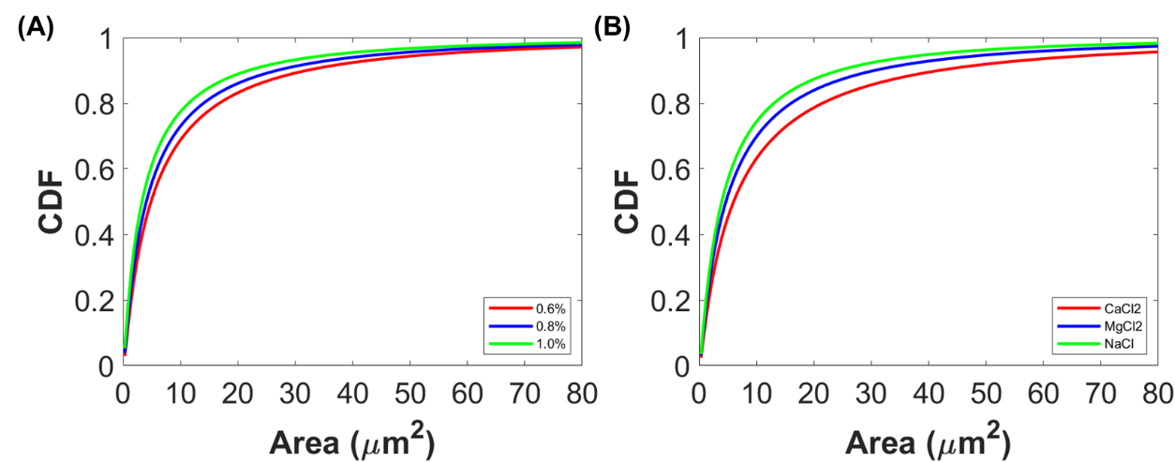
Figure S2 Cumulative distribution function (CDF) of CP aggregate area. (A) CP aggregate sizes in 0.6 – 1% CPG suspensions. (B) CP aggregate sizes in 0.8% CPG incorporated with 25 mM of CaCl₂, 25 mM of MgCl₂, and 110 mM of NaCl.

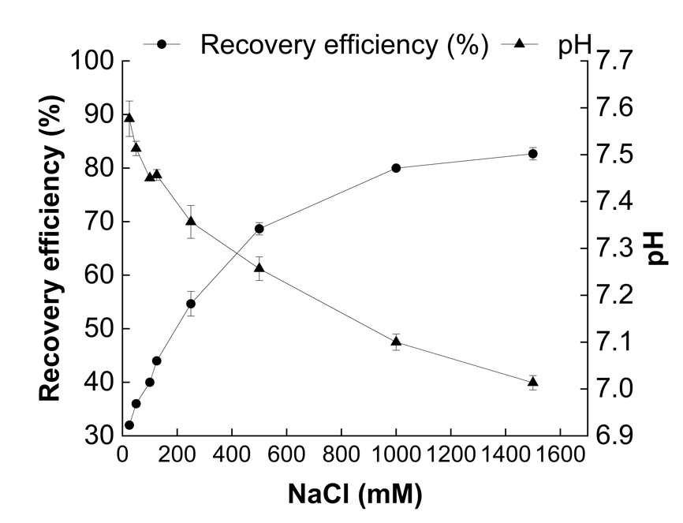
Figure S3 The recovery efficiency and pH of the CPS derived from 0.8% CPG deswelled under varying NaCl concentrations (mean ± standard deviation; n = 3).

Figure S4 The recovery efficiency and pH of the CPS derived from 0.8% CPG deswelled under varying CaCl₂ concentrations (mean ± standard deviation; n = 3).

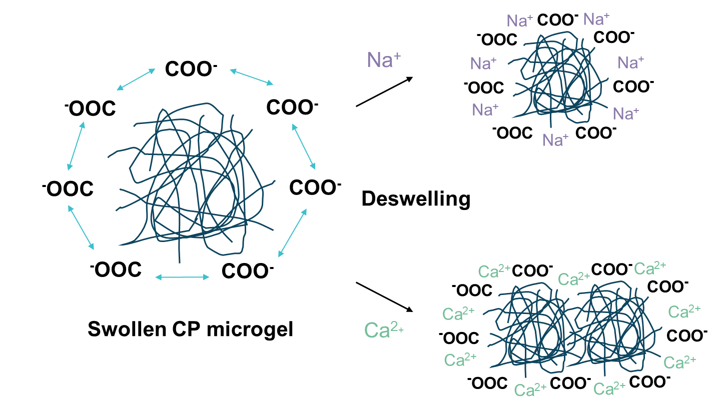
Figure S5 Proposed mechanisms of CPG deswelling in response to monovalent (NaCl) and divalent (CaCl₂) salts.
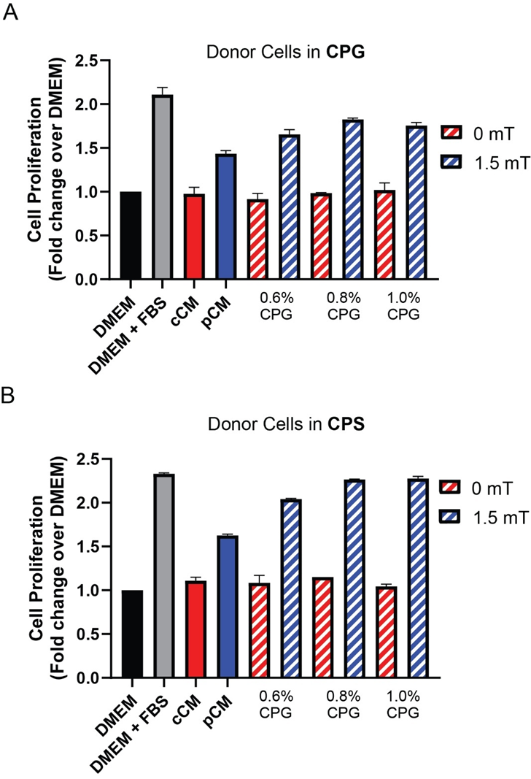
Figure S6 Recipient cell growth response to varying concentration of CP formulations in CPG and CPG as conditioning substrates. Bar charts show recipient cell growth responses to (A) donor cells stimulated in CPG or (B) donor cells stimulated in CPS. For both scenarios, final donor cell conditioned CPS was generated using 25 mM CaCl₂. Data represents the average of n = 2 biological replicates, with 3 technical replicates each. The error bars represent the standard error of the mean.

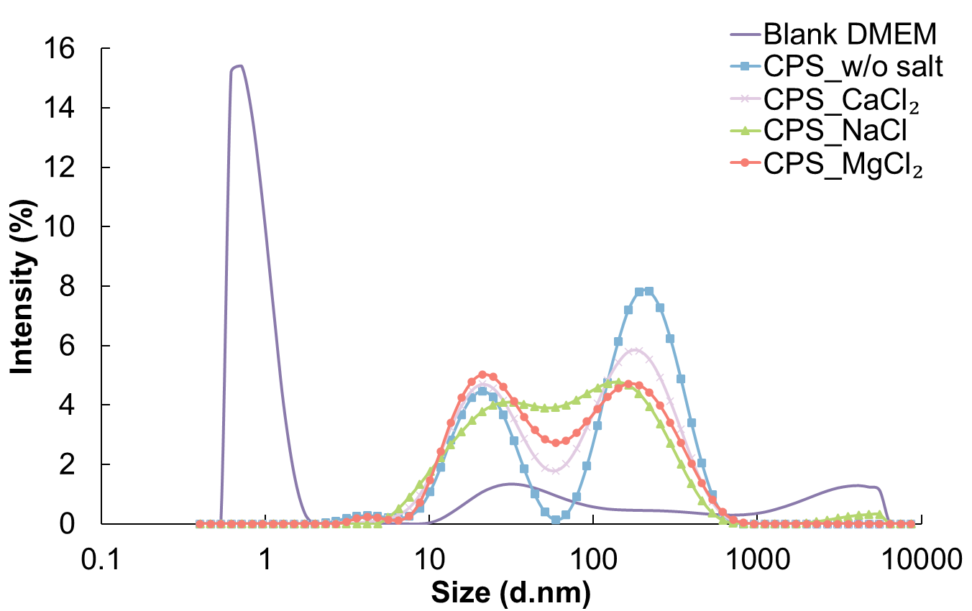
Figure S7 DLS spectra of blank DMEM and CPS with and without salt addition (mean; n = 3). The presence of CP residues in the CPS is confirmed by the overlap of particle size peaks with the CPS without salt addition (at ~20 and ~200 nm) and the lack of these peaks in blank DMEM.

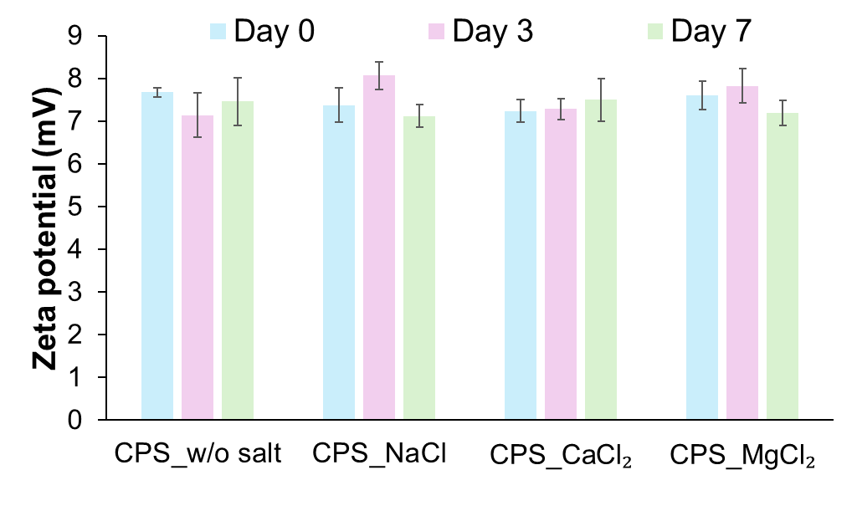
Figure S8 Zeta potential results of CPS with and without salt addition over seven days of storage at 4°C (mean ± standard deviation; n = 5). The positive charge of CPS is most likely derived from the constituents of DMEM media, with negligible changes observed over seven days of measurements.

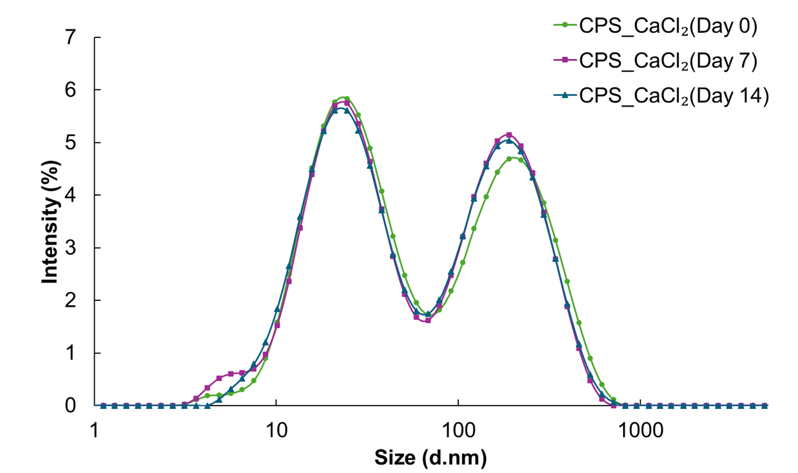
Figure S9 DLS spectra of CPS with added CaCl2 over 14 days of storage at 4°C (mean; n = 3). The minimal changes observed across measurements indicate that the CPS residues remain stable.

