Tailoring Antimicrobial Polypropylene with Dual-Metal Oxide Systems: Hydrothermal Versus Commercial Approaches Against Key Bloodstream Pathogens

G Ambarasan Govindasamy¹, Srimala Sreekantan^{2,*}, Geethaa Sahgal³, Priscilla Jayanthi Thavamany⁴, Ming Thong Ong⁴, Khairul Arifah Saharudin⁵, Aik Aun Tan⁶

¹Ann Joo Steel Bhd, Lot 1236, Prai Industrial Estate, 13600 Prai, Penang, Malaysia
²School of Materials and Mineral Resources Engineering, Engineering Campus, Universiti Sains Malaysia, 14300 Nibong Tebal, Penang, Malaysia
³Faculty of Pharmacy, AIMST University, Bedong, 08100 Semeling, Kedah, Malaysia
⁴Institute for Research in Molecular Medicine (INFORMM), Universiti Sains Malaysia, 11800 Pulau Pinang, Malaysia
⁵Qdos Interconnect Sdn Bhd, PMT 743, Persiaran Cassia Selatan 4, Batu Kawan Industrial Park, 14110 Batu Kawan, Pulau Pinang, Malaysia
⁶B. Braun Medical Industries Sdn Bhd, P.O. Box 880,10810 Pulau Pinang, Malaysia

*Address all correspondence to this author. e-mail: srimala@usm.my

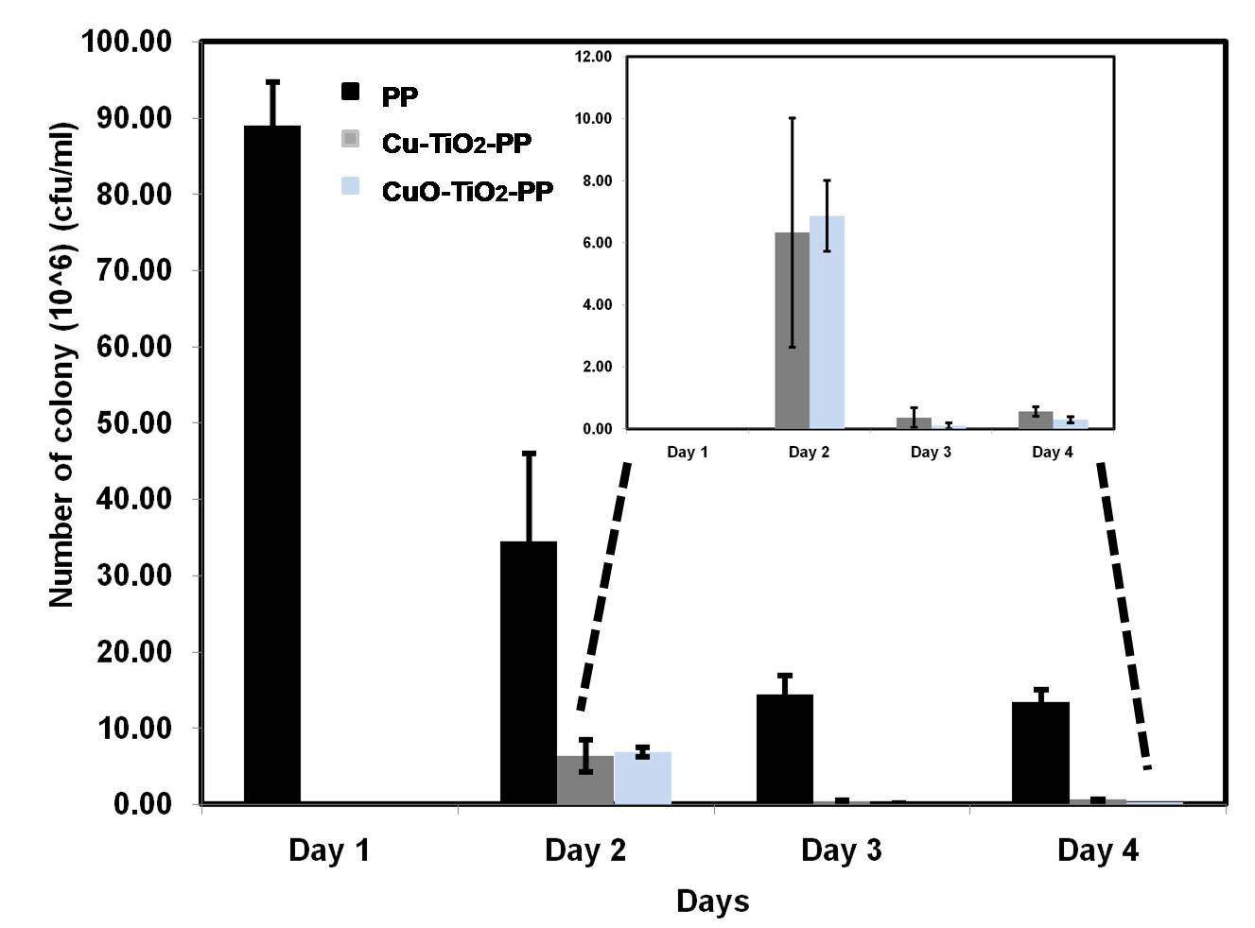

Figure 1. Candida albicans attachment on control PP, Cu-TiO₂-PP and CuO-TiO₂-PP for 4 days

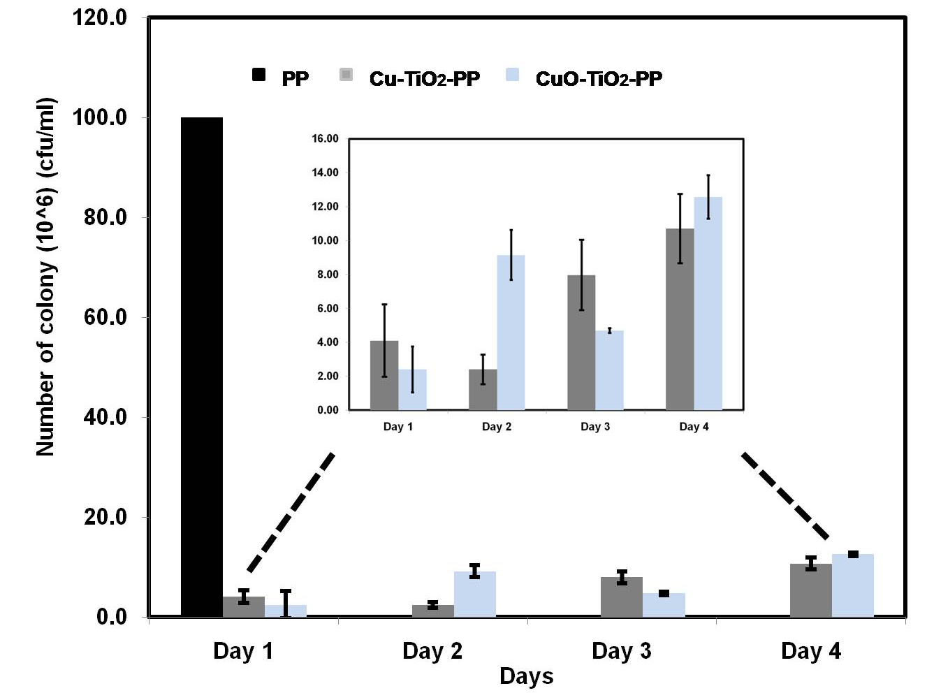

Figure 2. Staphylococcus epidermidis attachment on control PP, Cu-TiO₂-PP and CuO-TiO₂-PP for 4 days

