Self-foaming Fe-Sn powder Beds for Durable Hydrogen Storage and Release
Dingchang Zhang,*, Jie Qi, David C. Dunand,*

Department of Materials Science and Engineering, Northwestern University, Evanston, IL 60208, USA

* Corresponding authors: dunand@northwestern.edu; Phone number: +1-847-491-5370
dingchangzhang2020@u.northwestern.edu; Phone number: +1-773-865-9150

Supplementary Table 1. Standard free energies of reaction
Reaction | $∆G^{°}(kJ {mol}^{-1})$ | Reference
$$Sn+O_{2}=SnO_{2}$$ | -576.30+0.20T (K) | ¹
$$3/2Fe+O_{2}=1/2{Fe}_{3}O_{4}$$ | -553.44+0.16T (K) | ²
$$2Fe+O_{2}=2FeO$$ | -529.78+0.13T (K) | ²
$$6FeO+O_{2}=2{Fe}_{3}O_{4}$$ | -624.42+0.25T (K) | ²
$$Fe+Sn=FeSn$$ | -12.31 (570 ˚C); -6.70 (700 ˚C); -3.55 (770 ˚C) | ThermalCalc
$$2FeSn+ O_{2}=2FeO+2Sn$$ | -394.87 (570 ˚C); -389.09 (700 ˚C); -386.24 (770 ˚C) | Caculated
$$3Fe+2Sn={Fe}_{3}{Sn}_{2}$$ | -21.48 (610 ˚C); -15.81 (700 ˚C); -8.95 (800 ˚C) | ThermalCalc
$$2/3{Fe}_{3}{Sn}_{2}+ O_{2}=2FeO+4/3Sn$$ | -399.94 (610 ˚C); -391.95 (700 ˚C); -383.44 (800 ˚C) | Caculated

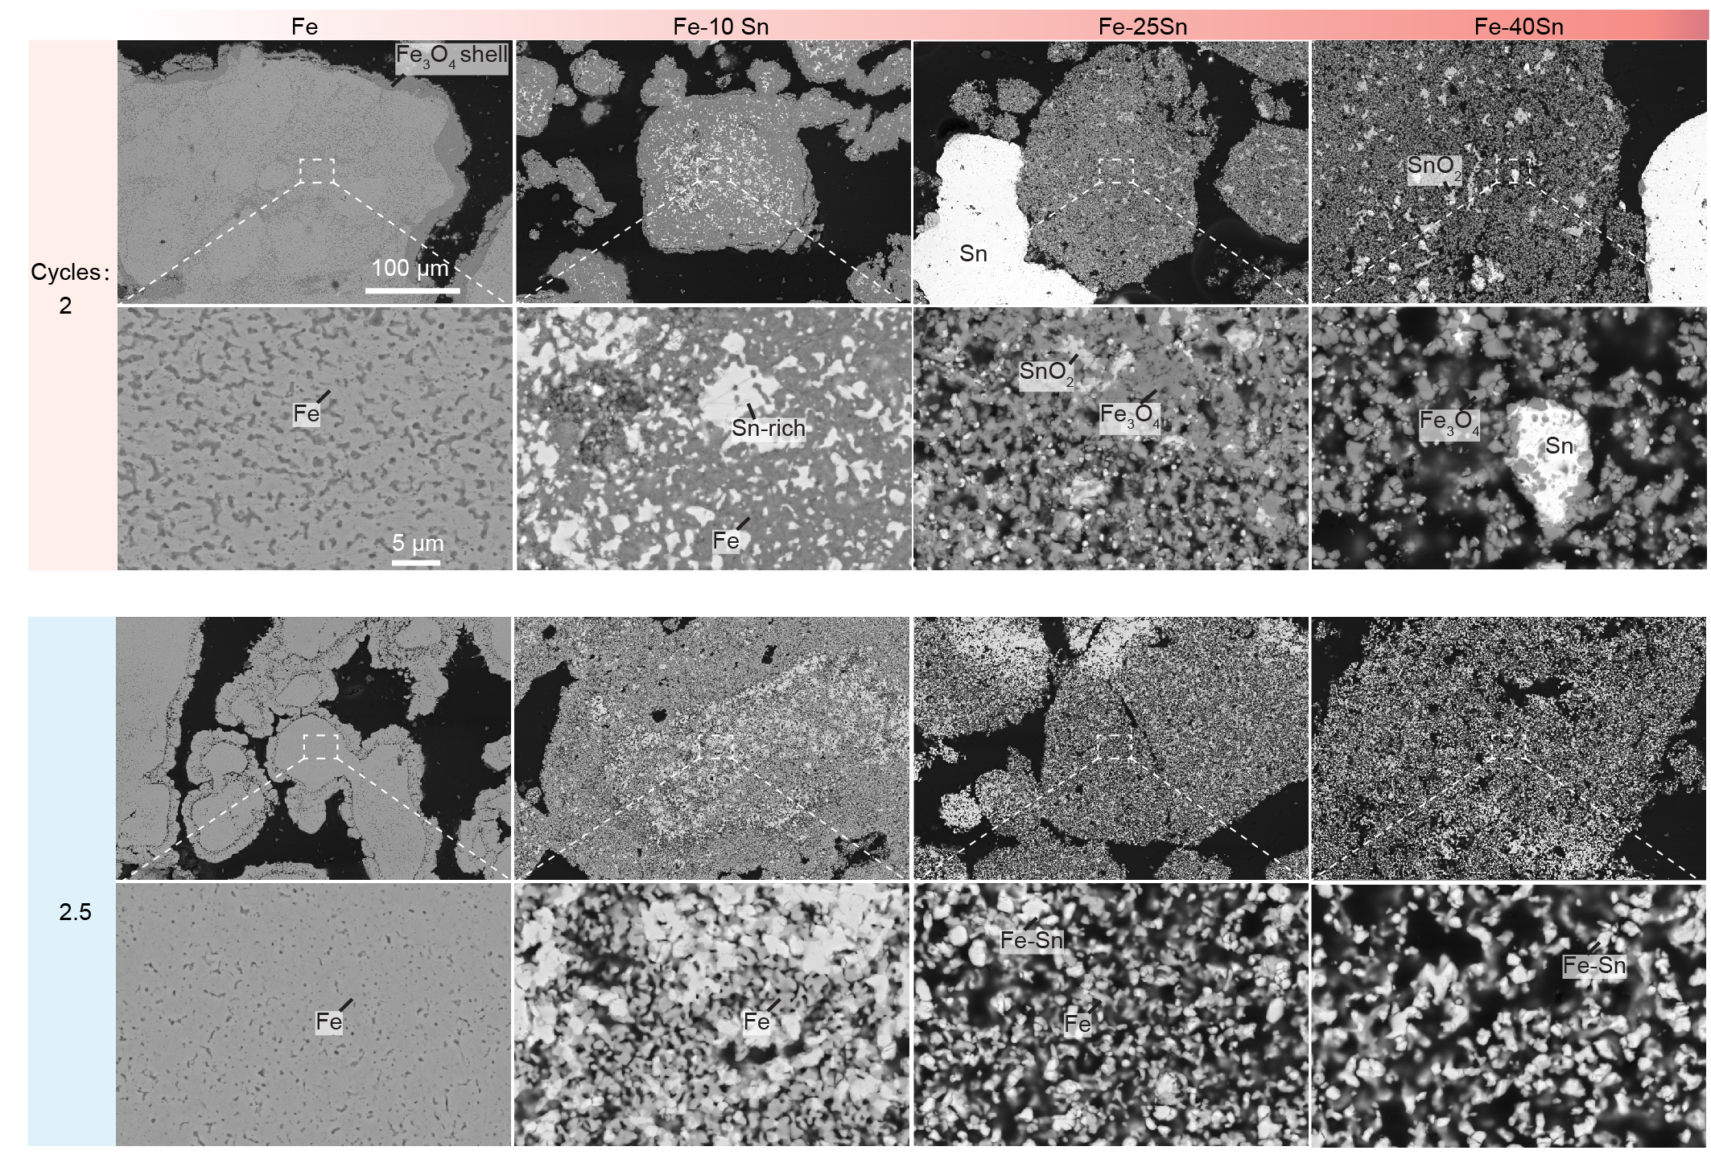
Figure S1. SEM-BSE cross-section images of Fe, Fe–10Sn, Fe–25Sn, and Fe–40Sn powder beds after the 2 cycle (steam oxidized) and after subsequent H₂ reduction (2.5 cycle).

Figure S2. SEM-BSE cross-section images of Fe, Fe–10Sn, Fe–25Sn, and Fe–40Sn powder beds after the 10 cycles (steam oxidized) and after subsequent H₂ reduction (10.5 cycles).

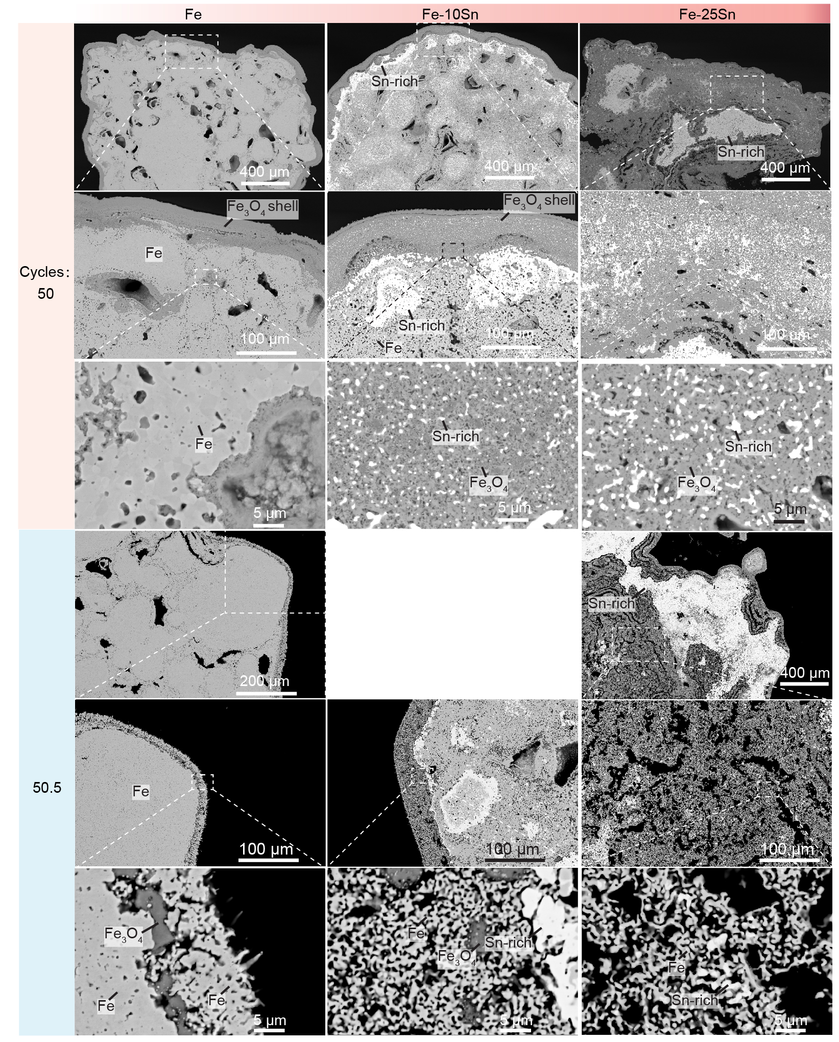
Figure S3. SEM-BSE cross-section images of Fe, Fe–10Sn, Fe–25Sn, and Fe–40Sn powder beds after the 50 cycles (steam oxidized) and after subsequent H₂ reduction (50.5 cycles).
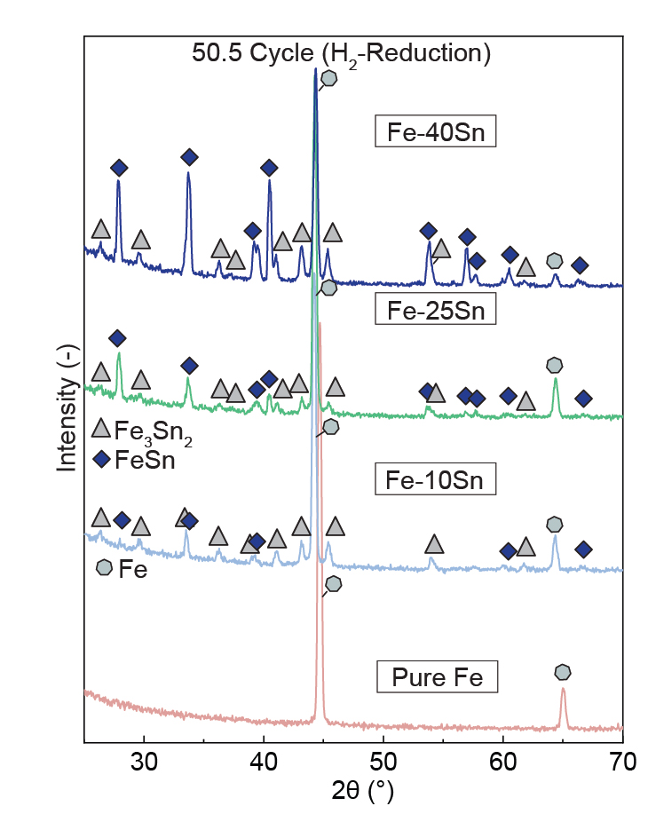
Figure S4. XRD patterns of cross-sections of the H₂ reduced powder beds (Fe, Fe-10Sn, Fe-25Sn, and Fe-40Sn) after 50.5 redox cycles

Reference:
1. Petot-Ervas G, Farhi R, Petot C. Standard Gibbs free energy of formation of SnO2 from high-temperature e.m.f. measurements. The Journal of Chemical Thermodynamics 7, 1131-1136 (1975).

2. Young DJ. High temperature oxidation and corrosion of metals. Elsevier (2008).

