SUPPLEMENTARY MATERIAL

Serum amyloid A protein related to short-term adverse cardiovascular events in older patients with STEMI: a prospective study

Xinying Yang¹, Xinhui Wang¹, Chen Chen², Xianjing Xu¹, Xuanchao Cao¹, Yunfei Wang¹, Peng Qian¹*, Hongyan Duan¹*

¹Department of Geriatrics, Henan Provincial People’s Hospital, People’s Hospital of Zhengzhou University, Zhengzhou, China
²Department of Emergency Medicine, Henan Provincial People’s Hospital, People’s Hospital of Zhengzhou University, Zhengzhou, China

Corresponding author
*Hongyan Duan, PhD
Department of Geriatrics, Henan Provincial People’s Hospital,
People’s Hospital of Zhengzhou University
No. 7, Weiwu Road, Zhengzhou, Henan Province, China
Tel: 0086-0371-67129620
Fax: 0086-0371-65964376
Email: dhy13526553388@zzu.edu.cn

*Peng Qian, PhD
Department of Geriatrics, Henan Provincial People’s Hospital,
People’s Hospital of Zhengzhou University
No. 7, Weiwu Road, Zhengzhou, Henan Province, China
Tel: 0086-0371-67129620
Fax: 0086-0371-65964376
Email: hnsqqp@163.com
Supplementary Table S1. STROBE Statement—checklist of items that should be included in reports of observational studies.
 | Item No | Recommendation
Title and abstract | √1 | (a) Indicate the study’s design with a commonly used term in the title or the abstract  The title explains the study design (title page, pg 1)
Title and abstract | √1 | (b) Provide in the abstract an informative and balanced summary of what was done and what was found  Abstract pg 2 manuscript
Introduction
Background/rationale | √2 | Explain the scientific background and rationale for the investigation being reported (pg 4)
Objectives | √3 | State specific objectives, including any prespecified hypotheses (pg 5)
Methods
Study design | √4 | Present key elements of study design early in the paper (pg 5-6)
Setting | √5 | Describe the setting, locations, and relevant dates, including periods of recruitment, exposure, follow-up, and data collection (pg 5-6)
Participants | √6 | (a) Cohort study—Give the eligibility criteria, and the sources and methods of selection of participants. Describe methods of follow-up (pg 5-8)  Case-control study—Give the eligibility criteria, and the sources and methods of case ascertainment and control selection. Give the rationale for the choice of cases and controls  Cross-sectional study—Give the eligibility criteria, and the sources and methods of selection of participants
Participants | √6 | (b) Cohort study—For matched studies, give matching criteria and number of exposed and unexposed  Case-control study—For matched studies, give matching criteria and the number of controls per case
Variables | √7 | Clearly define all outcomes, exposures, predictors, potential confounders, and effect modifiers. Give diagnostic criteria, if applicable (pg 5-8)
Data sources/ measurement | √8* | For each variable of interest, give sources of data and details of methods of assessment (measurement). Describe comparability of assessment methods if there is more than one group Detection methods for SAA on page 6
Bias | √9 | Describe any efforts to address potential sources of bias (pg 5-8)
Study size | 10 | Explain how the study size was arrived at (n.s.)
Quantitative variables | √11 | Explain how quantitative variables were handled in the analyses. If applicable, describe which groupings were chosen and why Each variable was analysed using SPSS and R. The descriptive statistical analysis is reported in this paper pg 8-9
Statistical methods | √12 | √(a) Describe all statistical methods, including those used to control for confounding (pg 8)
Statistical methods | √12 | (b) Describe any methods used to examine subgroups and interactions (pg 8)
Statistical methods | √12 | (c) Explain how missing data were addressed (n.s.)
Statistical methods | √12 | (d) √Cohort study—If applicable, explain how loss to follow-up was addressed (pg 8)  Case-control Study—If applicable, explain how matching of cases and controls was addressed  Cross-sectional study—If applicable, describe analytical methods taking account of sampling strategy
Statistical methods | √12 | (e) Describe any sensitivity analyses (n.s.)
Continued on next page

Results
Participants | 13* | (a) Report numbers of individuals at each stage of study—eg numbers potentially eligible, examined for eligibility, confirmed eligible, included in the study, completing follow-up, and analysed (n.s.)
Participants | 13* | (b) Give reasons for non-participation at each stage
Participants | 13* | (c) Consider use of a flow diagram (n.s.)
Descriptive data | √14* | (a) Give characteristics of study participants (eg demographic, clinical, social) and information on exposures and potential confounders  A description of the study participants is provided with demographic data and clinical data pg 9
Descriptive data | √14* | (b) Indicate number of participants with missing data for each variable of interest (n.s.)
Descriptive data | √14* | (c) Cohort study—Summarise follow-up time (eg, average and total amount) (pg 7)
Outcome data | √15* | Cohort study—Report numbers of outcome events or summary measures over time (pg 10-11)
Outcome data | √15* | Case-control study—Report numbers in each exposure category, or summary measures of exposure
Outcome data | √15* | Cross-sectional study—Report numbers of outcome events or summary measures
Main results | √16 | (a) Give unadjusted estimates and, if applicable, confounder-adjusted estimates and their precision (eg, 95% confidence interval). Make clear which confounders were adjusted for and why they were included  Descriptive data analysis findings were presented in this paper pg 10
Main results | √16 | (b) Report category boundaries when continuous variables were categorized (Figure 2)
Main results | √16 | (c) If relevant, consider translating estimates of relative risk into absolute risk for a meaningful time period (n.s.)
Other analyses | √17 | Report other analyses done—eg analyses of subgroups and interactions, and sensitivity analyses  (Figure 4)
Discussion
Key results | √18 | Summarise key results with reference to study objectives  Summarise of the key findings were provided pg 11-12
Limitations | √19 | Discuss limitations of the study, taking into account sources of potential bias or imprecision. Discuss both direction and magnitude of any potential bias  Limitations were described pg 15
Interpretation | √20 | Give a cautious overall interpretation of results considering objectives, limitations, multiplicity of analyses, results from similar studies, and other relevant evidence (pg 11-14)
Generalisability | 21 | Discuss the generalisability (external validity) of the study results (n.s.)
Other information
Funding | √22 | Give the source of funding and the role of the funders for the present study and, if applicable, for the original study on which the present article is based  Funding was associated with this project pg 15
*Give information separately for cases and controls in case-control studies and, if applicable, for exposed and unexposed groups in cohort and cross-sectional studies.

Supplementary Table S2. Baseline clinical characteristics in HCs and older STEMI patients.
Characteristics | HCs  (n=327) | Old STEMI  (n=327) | P Value
Age, years | 67.11±4.57 | 66.85±5.03 | 0.207
Male, n (%) | 261(79.82) | 270(82.57) | 0.368
SBP, mmHg | 116.22±15.08 | 120.18±16.49 | 0.003
DBP, mmHg | 72.11±5.10 | 74.33±11.58 | 0.007
Triglyceride, mmol/L | 1.14±0.66 | 1.69±1.14 | <0.001
Total cholesterol, mmol/L | 4.59±0.77 | 4.43±1.06 | 0.011
HDL cholesterol, mmol/L | 1.35±0.30 | 1.04±0.25 | <0.001
LDL cholesterol, mmol/L | 2.80±0.70 | 2.77±0.87 | 0.526
Fasting Glucose, mmol/L | 5.23±0.68 | 7.45±2.99 | <0.001
Current smoking, n (%) | 196(59.94) | 201(61.47) | 0.689
Hypertension, n (%) | 178(54.43) | 195(59.63) | 0.179
Hyperlipidaemia, n (%) | 166(50.76) | 170(51.99) | 0.754
Diabetes mellitus, n (%) | 98(29.97) | 105(32.11) | 0.554
Data are presented as absolute number (percentage) or mean ± standard deviation. Bold indicates P <0.05. DBP, diastolic blood pressure; HDL, high-density lipoprotein; HCs: healthy control subjects; LDL, low-density lipoprotein; SBP, systolic blood pressure; STEMI: ST-segment elevation myocardial infarction.

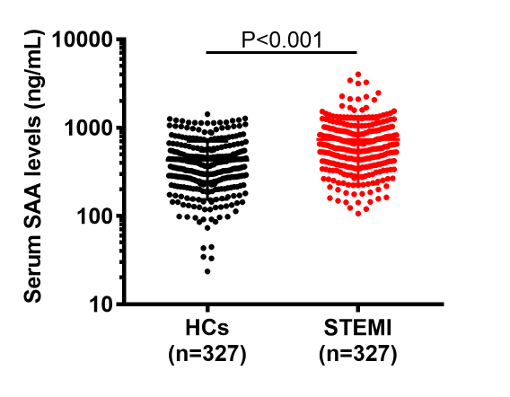
Supplementary Figure S1. Serum SAA differentially expressed in HCs and older STEMI patients.
The values in the figure represent older STEMI patients (red) and HCs (black), respectively.
HCs: healthy control subjects; STEMI: ST-segment elevation myocardial infarction.

Supplementary Table S3. Univariate and multivariate COX regression analyses for the association between SAA and adverse cardiovascular events within 30 days of STEMI
Event | Model | SAA Median groups (HR  compared to the low Median group) | Continuous  SAA
 |  | Median2 | HR per 1-SD increase
HF events | Unadjusted | 4.399(2.119-9.134) P<0.001 | 3.595(2.384-5.420) P<0.001
HF events | Adjusted for model1 | 2.833(1.320-6.084) P=0.008 | 2.694(1.754-4.136) P<0.001
HF events | Adjusted for model2 | 2.735(1.275-5.867) P=0.010 | 2.676(1.736-4.126) P<0.001
HF events | Adjusted for model3 | 2.903(1.366-6.172) P=0.006 | 2.694(1.777-4.086) P<0.001
CS and/or cardiac death | Unadjusted | 4.017(1.5000-10.758) P=0.006 | 3.032(1.774-5.183) P<0.001
CS and/or cardiac death | Adjusted for model1 | 2.843(1.020-7.922) P=0.046 | 2.508(1.413-4.452) P=0.002
CS and/or cardiac death | Adjusted for model2 | 2.824(1.019-7.821) P=0.046 | 2.639(1.465-4.754) P=0.001
CS and/or cardiac death | Adjusted for model3 | 3.056(1.098-8.505) P=0.032 | 2.181(1.282-3.713) P=0.004
Univariate (unadjusted) and multivariate (adjusted) hazard ratios (HRs) obtained by Cox proportional hazards regression analysis for major adverse cardiac events at 30-days follow-up according to the categorical variables (median) and continuous variables (a natural-log transformation, expressed per 1 SD increase) of SAA levels. Model 1 was adjusted for GRACE score and three risk biomarkers (NT-proBNP, hs-CRP, and hs-cTnI at admission); model 2 was adjusted for TIMI risk score and three same three risk biomarkers. Model 3 was adjusted for clinical variables included age, male, frailty, anterior MI, Killip class>1, and LVEF. TIMI: Thrombolysis In Myocardial Infarction; GRACE: Global Registry of Acute Coronary Events.

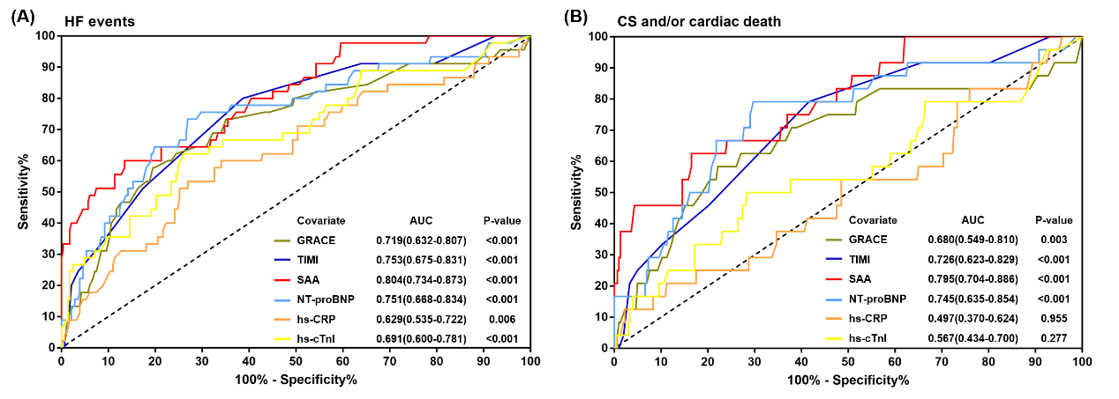

Supplementary Figure S2. Discrimination between patients with or without adverse clinical events in older STEMI patients.

Receiver-operating characteristic (ROC) curves for discriminating between patients with or without HF events (A) and CS and/or cardiac death (B) during a 30-day period after STEMI. Curves were generated per baseline SAA levels，GRACE score, TIMI risk score and three risk biomarkers (NT-proBNP, hs-CRP, and hs-cTnI at admission). AUC, area under the curve.

Supplementary Figure S3. Serum SAA was differentially expressed in older STEMI patients with or without frailty
The values in the figure represent frail elderly STEMI patients (red) and non-frail patients (black), respectively. STEMI: ST-segment elevation myocardial infarction.

