Supplementary information for

Laser-Induced Atomic Engineering Activates and Stabilizes Single and Paired Metal Sites for Efficient Electrocatalytic H₂O₂ Production
Huize Wang^{1,2*}, Chengxi Li³, Xiangyu You², Andreas Hutzler¹, Yi-Hsuan Wu¹, Mattis Goßler^{1,2}, Matheus S. Kronka^{2,4}, Hikmet Sezen⁵, Jan P. Hofmann⁵, Karl J. J. Mayrhofer^{1,6}, Serhiy Cherevko^{1,} Guilherme V. Fortunato^{2*}, Shuzhou Li^{3*}, Marc Ledendecker^{1,2*}.
¹ Forschungszentrum Jülich GmbH, Helmholtz Institute Erlangen-Nürnberg for Renewable Energy (IET-2), Cauerstraße 1, 91058 Erlangen, Germany.
² Sustainable Energy Materials, Technical University of Munich, Campus Straubing, Schulgasse 22, 94315 Straubing, Germany.
³ School of Materials Science and Engineering, Nanyang Technological University, 50 Nanyang Avenue, Singapore, 639798, Singapore.
⁴ Institute of Chemistry of Araraquara, São Paulo State University, Av. Prof. Francisco Degni, 55 - Jardim Quitandinha, Araraquara - SP, 14800-900, Brasil.
⁵ Surface Science Laboratory, Department of Materials-and Geosciences, Technical University of Darmstadt, Peter-Grünberg-Straße 4, 64287 Darmstadt, Germany.
⁶ Department Chemical and Biological Engineering, Friedrich-Alexander-Universität Erlangen-Nürnberg, Immerwahrstraße 2a, 91058 Erlangen, Germany.

*Correspondence to E-mail: huiz.wang@fz-juelich.de; g.fortunato@tum.de; lisz@ntu.edu.sg; marc.ledendecker@tum.de

Table of Contents

Methods 3
Figure S1-S10 8
Figure S11-S20 13
Figure S21-S34 18
Table S1-S2 25
Supplementary References 26

Methods
Materials and chemicals
Platinum (II)-acetylacetonate (97%, Sigma-Aldrich), Palladium (II)-acetylacetonate (99%, Umicore), Ketjenblack EC-300J carbon black (Fuel Cell Store), Propan-2-ol (≥99.8%, Fisher Chemical), ethanol (≥99,8%, Thermo Fisher), acetone (≥99.8%, Fisher Chemical), and ultrapure water (18.2 MΩ·cm, Milli-Q, Merck). All chemicals were used as received without further purification.
Preparation of laser-engineered catalysts on RRDE electrode
Carbon black ink (3.27 mg mL⁻¹) was prepared in isopropanol/ethanol/water (3:1:1, v/v/v). A 12 µL aliquot was drop-cast onto the RRDE disk and dried to obtain a carbon-black loading of 200 µg cm⁻². Pt(acac)₂ was dissolved in acetone (0.016 mg mL⁻¹), and 12 µL was drop-cast onto the carbon layer and dried, giving a Pt loading of 1 µg cm-2. Higher Pt loadings (1-10 µg cm⁻²) were obtained by varying the Pt(acac)₂ concentration while keeping the deposition volume constant. The dried electrodes were then laser processed over the full disk area using a laser engraving system (Speedy 400 flexx, Trotec) equipped with a 10,600 nm CO₂ laser and a 1,060 nm fiber laser; the CO₂ laser was used at 1,000 Hz with a scanning speed of 30% (of 420 cm s⁻¹) and a power setting of 0.19% (of 80 W). Finally, Nafion was applied by diluting 1.6 µL of 20 wt% Nafion solution in 1 mL isopropanol and drop-casting 3 µL onto the electrode to give an ionomer-to-carbon ratio of 0.05.
Lis_Pd_{sac} and Lis_Pt-Pd electrodes were prepared following the same procedure, except that Pd(acac)₂ was used to obtain a Pd loading of 1 µg cm⁻² for Lis_Pd_{sac} , and mixed Pt(acac)₂/Pd(acac)₂ precursors were used to obtain a total (Pt+Pd) loading of 1 µg cm⁻² for Lis_Pt-Pd.
Preparation of laser-engineered catalysts on carbon paper GDL
The same carbon black ink described above was used to coat carbon paper GDLs (Freudenberg H23C8) by airbrushing. Circular electrodes (25 mm diameter) were spray-coated to a carbon-black loading of 200 µg cm⁻² and dried. Metal precursor solutions were then drop-cast onto the carbon-black layer to reach a total noble-metal loading of 1 µg_{PGM} cm⁻², followed by drying. Laser processing was performed over the entire electrode area using the CO₂ laser at 1,000 Hz with a scanning speed of 30% (of 420 cm s⁻¹) and a power setting of 0.19% (of 80 W). Finally, the diluted Nafion solution was drop-cast to obtain an ionomer-to-carbon ratio of 0.05.
Operando mass spectroscopy
Mass spectrometry (Pfeiffer Omni Star GSD 320 Gas Analysis System) was used to monitor gas-phase species evolved during laser treatment. Two samples were examined: carbon black loaded with Pt(acac)₂ on a Ti support, and carbon black on Ti as the reference. Sample preparation followed the same procedure described above. The MS inlet was connected to a sealed laser reaction chamber via a silica tube. A ZnSe optical window allowed the CO₂ laser beam to enter the chamber and irradiate the sample, while an Ar carrier stream transported volatile products from the chamber to the MS.
Before measurements, the MS was baked at 110 °C for 24 h to minimize background signals. Data were acquired in selected ion monitoring mode with multiple-ion detection (1120 V); the capillary inlet pressure was maintained at ~3 × 10-6 mbar and the inlet temperature at 90 °C. The monitored m/z values were H₂O⁺ (18), CO₂⁺ (44), CO⁺ (28), O⁺ (16), O₂⁺ (32) and H₂⁺ (2). The scan interval was 50 ms per cycle. Prior to laser irradiation, the system was purged with Ar for ~30 min to stabilize baselines. Laser irradiation was then applied; signal increases were typically observed within 5-10 min, and the laser-induced reaction period lasted ~100 s. After irradiation, Ar flow and MS acquisition were continued for an additional 15 min to capture residual volatile species.
XRD analysis
Rigaku SmartLab SE was used with a wavelength of Cu Kα = 1.54059 Å. Measurements were taken in a 2-theta range from 10° to 90° with a measurement speed of 1.5°/min using a background-free silicon sample holder.
HAADF-STEM measurements
HAADF-STEM characterization of synthesized nanomaterials was conducted using a Thermo Fischer Scientific Talos F200i operated at an acceleration voltage of 200 kV. The nanomaterials were treated with remote air plasma for 1 min using a PIE Scientific Tergeo EM plasma cleaner.
Infrared Spectroscopy
Infrared (IR) spectra were recorded on a Shimadzu IR Prestige-21 Fourier-transform infrared (FT-IR) spectrometer. Measurements were carried out at room temperature in the mid-infrared region (400–4000 cm⁻¹). Spectra were collected with a spectral resolution of ~ 2 cm⁻¹. Background spectra were recorded under identical conditions prior to each measurement. Powdered samples were measured directly (ATR mode) without further modification. After each measurement, the ATR crystal was cleaned with IPA to prevent cross-contamination.
UV-Vis spectroscopy
The measurements were performed at a Shimadzu UV-1900i using a glass cuvette with a path length of 10 mm. The spectra were recorded within a range of 200 to 500 nm within 2 mins.
Nitrogen Physisorption (BET Surface Area and Pore Size Distribution)
Nitrogen adsorption/desorption measurements were performed to determine the specific surface area and pore size distribution of Ketjenblack EC-300J carbon black before and after laser treatment. Measurements were carried out at 77 K using N₂ as adsorptive gas. Prior to analysis, samples were degassed under vacuum at elevated temperature (160 °C) overnight to remove physiosorbed moisture and contaminants. The specific surface area was determined according to the Brunauer–Emmett–Teller (BET) method using adsorption data in the relative pressure range where the BET plot showed linear behavior. The pore size distribution was calculated using non-local density functional theory (NLDFT). The adsorption branch of the N₂ isotherm was analyzed using the 'HS-2D-NLDFT, Carbon, N2, 77' kernel model, which assumes slit-shaped pores in carbon materials and employs a heterogeneous surface. The differential and cumulative pore size distributions were obtained from the model fit.
XPS measurements
The Thermo Fisher ESCALab-250 instrument was used for XPS measurement with monochromatic Al Kα X-ray source with an energy of 1486.6 eV, an operational power of 200 W, and a spot size of 650 µm. The vacuum level in the XPS measuring chamber is better than 5 × 10−10 mbar. Pass energies of 50 and 20 eV were used to yield survey spectra and high-resolution core-level, respectively. The Ag Fermi edge and Cu 2p3/2, Ag 3d5/2, and Au 4f7/2 core levels were used in a linearity test to calibrate the XPS equipment. The powder samples are pressed into high purity indium foils.
XAS measurements
Pt L3 and Pd K edge XAS were measured at the Debye beamline at SLS2.0 operating in top-up mode at 400 mA ring current and 2.7 GeV. The beam originating from the 2.1 T bending magnet source was collimated with a Rh- and Pt-coated mirror at 2.38 mrad for the Pt and Pd edges, respectively, and then monochromatized by an LN-cooled channel-cut Si 111 QEXAFS monochromator. The beam was further focused with a Rh- and Pt-coated toroidal mirror at the Pt and Pd edges, respectively, resulting in an X-ray beam size on the sample of 100 μm × 100 μm. Gas-filled ionization chambers with 2 bar N₂ and 1 bar N₂ + 1 bar Ar were used to measure the incident and transmitted beam intensities at the Pt and Pd edges, respectively. Samples were measured in fluorescence yield using a PIPS detector for the Pt edge and a 7-element SDD for the Pd edge. The sample absorption was measured simultaneously with a Pt or Pd reference foil.
RRDE measurements
Electrochemical measurements were performed in a three-electrode glass cell using an automated workstation equipped with dual potentiostats (BioLogic SP-300) and a rotating electrode system (PINE Research Instrumentation, WaveVortex). All experiments were conducted at 25 °C in 0.1 M HClO₄. A graphite rod and an Ag/AgCl electrode (Metrohm, saturated KCl solution) were used as the counter and reference electrodes, respectively. The working electrode was a rotating ring-disk electrode (RRDE) (PINE Research Instrumentation, AFE6R1PT) comprising a 5.0 mm glassy carbon disk (geometric area 0.196 cm²) and a 0.5 mm-thick Pt ring housed in PTFE, with a 1.0 mm ring-disk gap. Potentials are reported versus RHE unless otherwise noted.
The RRDE collection efficiency was determined to be 20.3% (average of four tips) using the [Fe(CN)₆]⁴⁻/[Fe(CN)₆]³⁻ redox couple at different rotation rates. Before ORR measurements, the Pt ring was electrochemically cleaned by cycling between 0.1 and 1.4 V_{RHE} at 100 mV s⁻¹ in Ar-saturated electrolyte until stable CVs were obtained. Background currents were recorded in Ar-saturated electrolyte by scanning 0.1-1.0 V_{RHE} at 50 mV s⁻¹. After O₂ saturation, ORR polarization curves were collected at 50 mV s⁻¹ and 1,600 r.p.m. During ORR measurements, the Pt ring was held at 1.4 V_{RHE} to oxidize generated H₂O₂. All RRDE measurements were performed without iR compensation.
The H₂O₂ selectivity S_{H2O2}was calculated from the ring current (I_{ring}), disk current (I_{disk}) and the collection efficiency (N) using:
$S_{H_{2}O_{2} \left(\%\right)}=200\frac{I_{ring}}{N\left|I_{disk}\right|+I_{ring}}$ (1)
For accelerated stress testing (AST), a square-wave potential-step protocol was applied for 7,000 cycles between 0.60 and 1.00 V versus RHE (lower and upper potential limits), a commonly used aqueous RDE durability screening window for ORR catalysts. These repeated potential steps drive rapid redox transitions of the surface and can accelerate degradation processes (for example, oxide formation/reduction, dissolution and restructuring), which may lead to activity decay and selectivity changes. Performance was quantified at the beginning of life (BOL) and end of life (EOL) using identical electrochemical measurements before and after cycling.
CFC-ICP-MS measurements
Operando inductively coupled plasma mass spectrometry (ICP-MS, PerkinElmer NexION 2000) was employed to investigate the potential-resolved dissolution of Pd and Pt. The outlet of a customized channel flow cell was directly coupled to the peristaltic pump of the ICP-MS system. The de-aerated electrolyte (0.1 M HClO₄, ROTIPURAN® Ultra 70%, Carl Roth) containing dissolved species was continuously delivered to the ICP-MS for time-resolved analysis. A catalyst-loaded glassy carbon disk (Φ 5 mm) served as the working electrode, while a Mini HydroFlex (Gaskatel) hydrogen reference electrode and a graphite rod were used as the reference and counter electrodes, respectively. Quantification of metal dissolution was achieved by external calibration using a series of standard solutions prior to measurement. 103Rh and 187Re were applied as internal standards for 106Pd and 195Pt, respectively.
H₂O₂ electrochemical synthesis
H₂O₂ production was evaluated using a modified gas-diffusion electrode (GDE) configuration (Fig. 6a). A platinized Ti mesh anode was placed against an Au flow field, and 0.1 M HClO₄ was circulated on the anode side. An Ag/AgCl electrode (Metrohm, saturated KCl solution) was used as the reference and placed in the cathode compartment. The cathode used a custom, movable GDE module immersed in 150 mL of 0.1 M HClO₄. O₂ was supplied from the top and exited from the bottom through the gas-diffusion layer. Carbon paper (Freudenberg H23C8, 25 mm diameter) served as the cathode GDL, with a 20 mm effective catalyst area exposed to the electrolyte. The anode and cathode compartments were separated by a Nafion 117 proton-exchange membrane. A dedicated H₂O₂ diffusion connection channel was placed between the membrane and the cathode GDL to facilitate transport of freshly generated H₂O₂ into the bulk catholyte and reduce local accumulation. Cathode catalysts were prepared in situ on the carbon paper GDL by spray-coating carbon black (200 µg cm⁻²), drop-casting Pt/Pd precursor solutions to a total noble-metal loading of 1 µg_{PGM} cm⁻², drying, and laser processing under the conditions described above. The processed GDL was assembled into the device directly without post-treatment.
The GDE cathode was first characterized by cyclic voltammetry under Ar and O₂, scanning from -0.6 to 1.0 V versus RHE. H₂O₂ production rate and Faradaic efficiency were then quantified by potentiostatic electrolysis at -0.4, -0.2, 0.2 and 0.4 V versus RHE, holding each potential for 1 h. Catholyte aliquots were withdrawn every 15 min for analysis.
H₂O₂ was quantified by UV-vis using the Ce(SO₄)₂ method, which is based on the reduction of Ce⁴⁺ to Ce³⁺ by H₂O₂:
2Ce⁴⁺ + H₂O₂ → 2Ce³⁺ + O₂ + 2H⁺
The decrease of the Ce⁴⁺ absorbance (at 320 nm) was converted to H₂O₂ concentration using a calibration curve. Faradaic efficiency was calculated from the amount of H₂O₂ formed and the total charge passed as:
FE_{H2O2 (%)} = (nH₂O₂ × z × F / Q) × 100
where nH₂O₂ is the number of moles of H₂O₂, z = 2, F is the Faraday constant, and Q is the charge. H₂O₂ production rates were obtained from the concentration-time profiles and normalized to catalyst loading as shown in the main text. Note: for Faradaic-efficiency calculations, the net charge was obtained as Q_{net} = Q_{O2} − Q_{Ar} at the same applied potential to remove the non-ORR background contribution. For long-term H₂O₂ electrosynthesis tests (> 24h), however, the total charge was used without subtracting Q_{Ar}.
DFT
All density functional theory (DFT) calculations were performed using the Vienna ab initio Simulation Package (VASP).¹ Exchange–correlation energies were calculated using the revised Perdew–Burke–Ernzerhof (revPBE) functional within the generalized gradient approximation (GGA).^{2,3} Ion–electron interactions were described using the projector-augmented plane-wave (PAW) method.⁴ The PtPd4O@C model was constructed from 88 carbon atoms, 4 oxygen atoms, 1 Pd atom, and 1 Pt atom in a supercell with dimensions of 14.76 × 17.04 × 20.00 Å³. For comparison, Pd2O and Pt4O moieties were each embedded into a 6 × 8 graphene supercell and denoted as Pd2O@C and Pt4O@C, respectively. To avoid interlayer interactions, a vacuum layer of 20 Å was applied along the surface normal direction. For geometry optimizations, a plane-wave cut-off energy of 600 eV was employed, and the Brillouin zone was sampled using a 3 × 3 × 1 k-point mesh. All atomic structures were fully relaxed until the total energy and atomic forces converged to 10⁻⁵ eV and 0.03 eV Å⁻¹, respectively. Spin-polarized calculations were performed for all systems. The van der Waals interactions were taken into account using the DFT-D3 method.⁵
The free energy change (ΔG) in the electrochemical reaction was calculated as follows:
$$ΔG = ΔE + {ΔE}_{ZPE} - TΔS - eU$$
where ΔE is the DFT reaction energy, ΔE_{zpe} and ΔS represent the zero-point energy and entropy differences, respectively, T is the system temperature, which is 298.15 K in our work, and U is potential. The free energy corrections for adsorbed intermediates were computed via vibrational frequency calculations. The corrections for free molecules H2 and H2O were also calculated with the same calculation method. VESTA 3 was employed to realize the visualization of optimized structures in the main text and Supplementary Information. ⁶

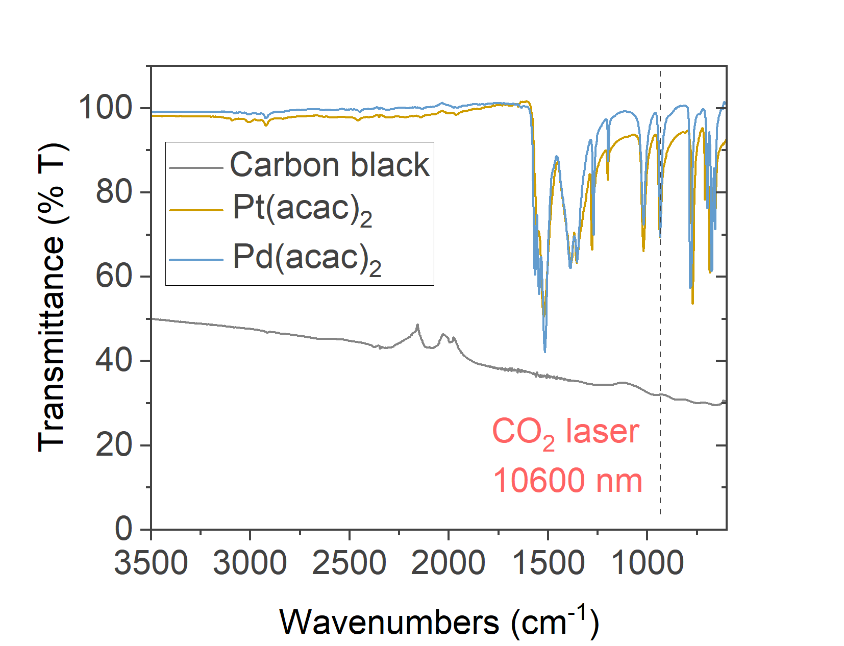

Supplementary Figure 1. Infrared transmittance spectra of Ketjenblack EC-300J, Pt(acac)₂ and Pd(acac)₂. The carbon support exhibits much stronger absorption at 10,600 nm than the molecular precursors.

Supplementary Figure 2. Schematic of operando mass-spectrometry (MS) setup coupling a gas-tight laser reactor to MS for monitoring gaseous species evolved during laser processing

Supplementary Figure 3. Real-time thermal response of Pt(acac)₂/C during CO₂ laser irradiation, monitored by an infrared (IR) camera. a. Infrared image of the sample at cursor 1. b. Corresponding maximum temperature profile at cursor 1 as the laser beam passes.

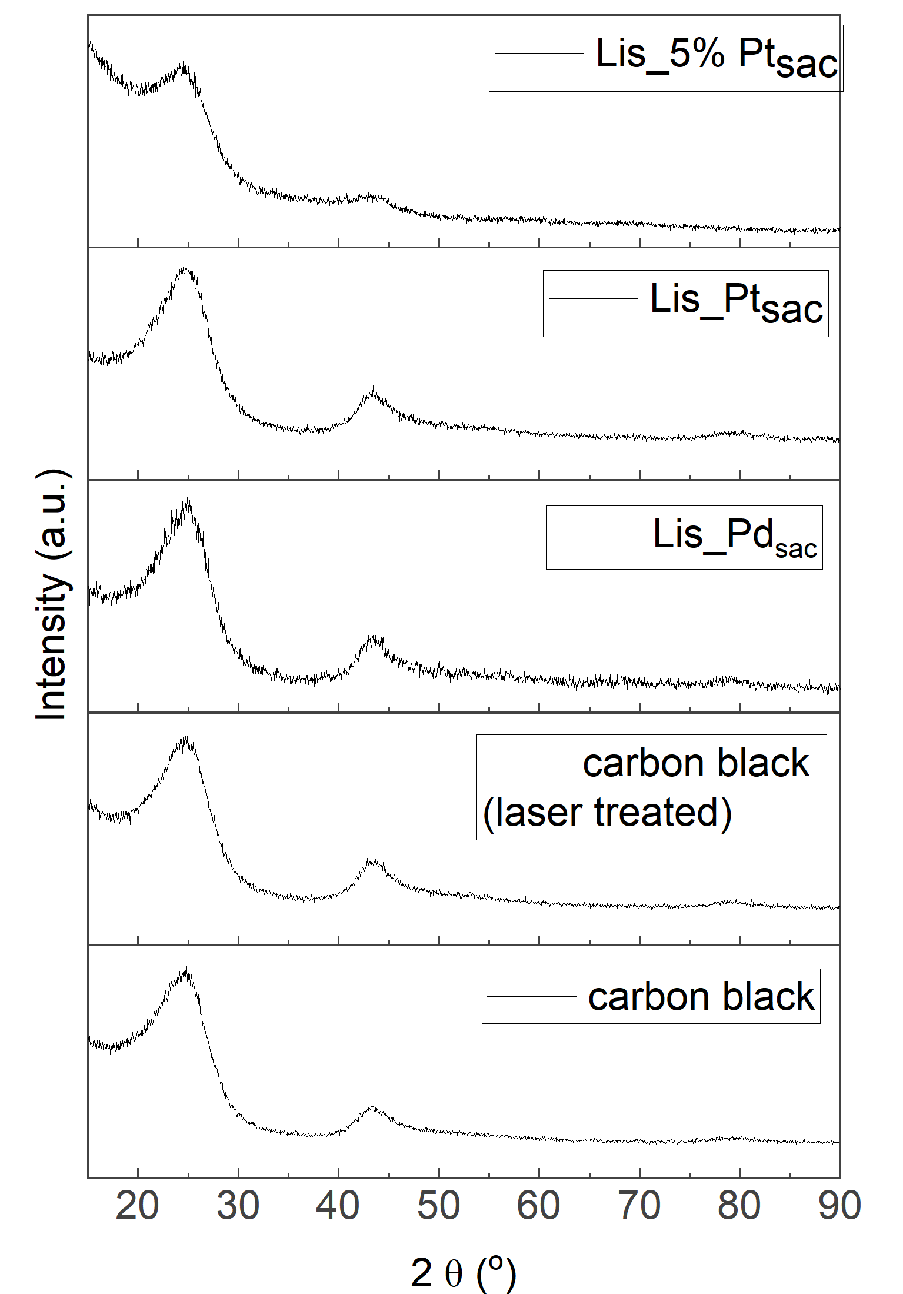
Supplementary Figure 4. XRD patterns of pristine carbon black, laser-treated carbon black, Lis_Pt_{sac} (0.5% Pt/C), Lis_Pd_{sac} (0.5%Pd/C) and Lis_5%Pt_{sac} (5%Ptsac/C, corresponding to the 10µg_{Pt} cm⁻² in the in-situ RRDE measurements). The diffraction profiles are essentially unchanged after laser processing, indicating that the carbon framework is preserved without laser-induced graphitization. No crystalline Pt or Pd reflections are observed, consistent with the absence of metal nanoparticles and the formation of atomically dispersed sites.

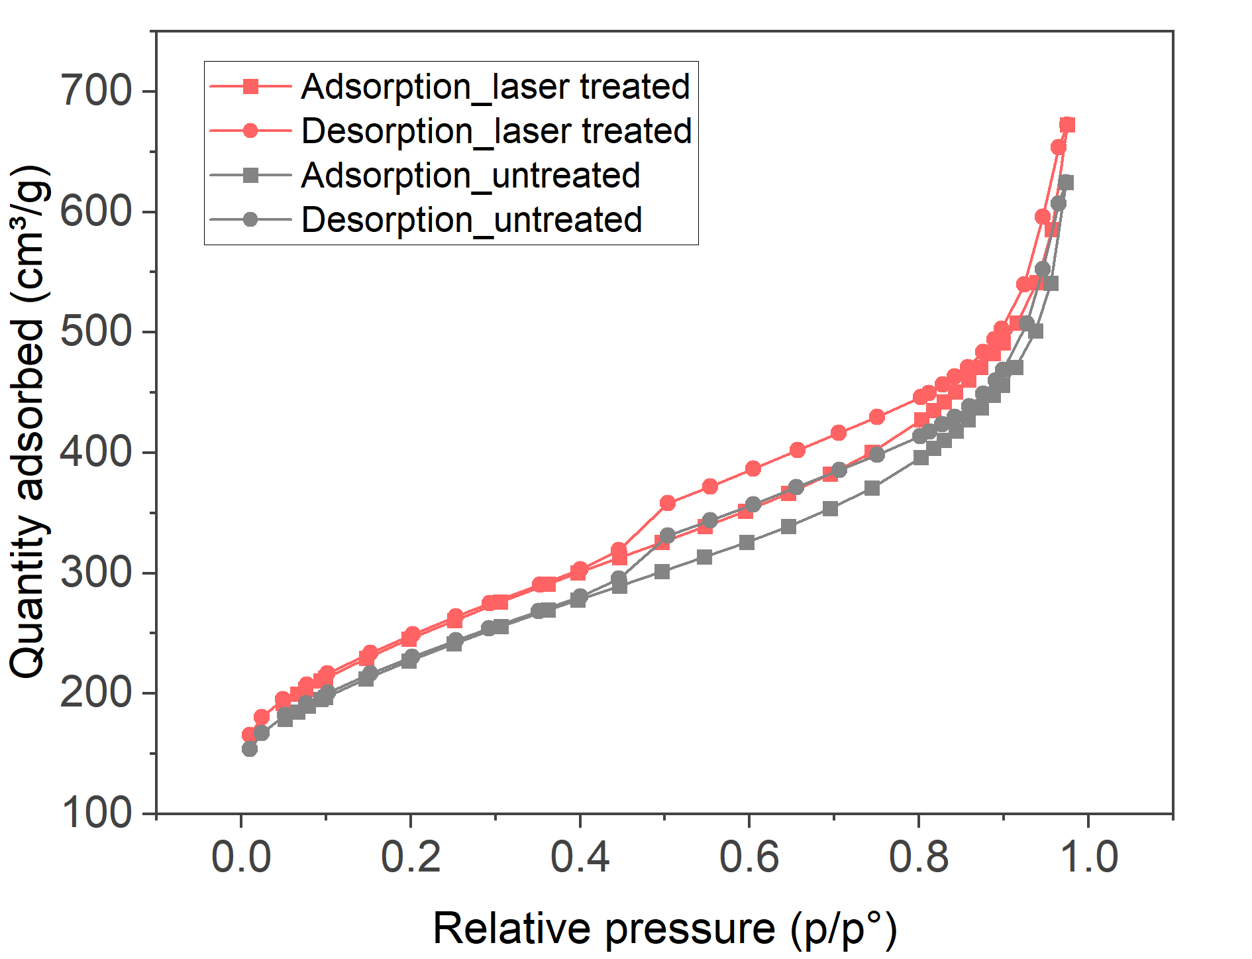
Supplementary Figure 5. N₂ physisorption isotherm of pristine carbon black, laser-treated carbon black.
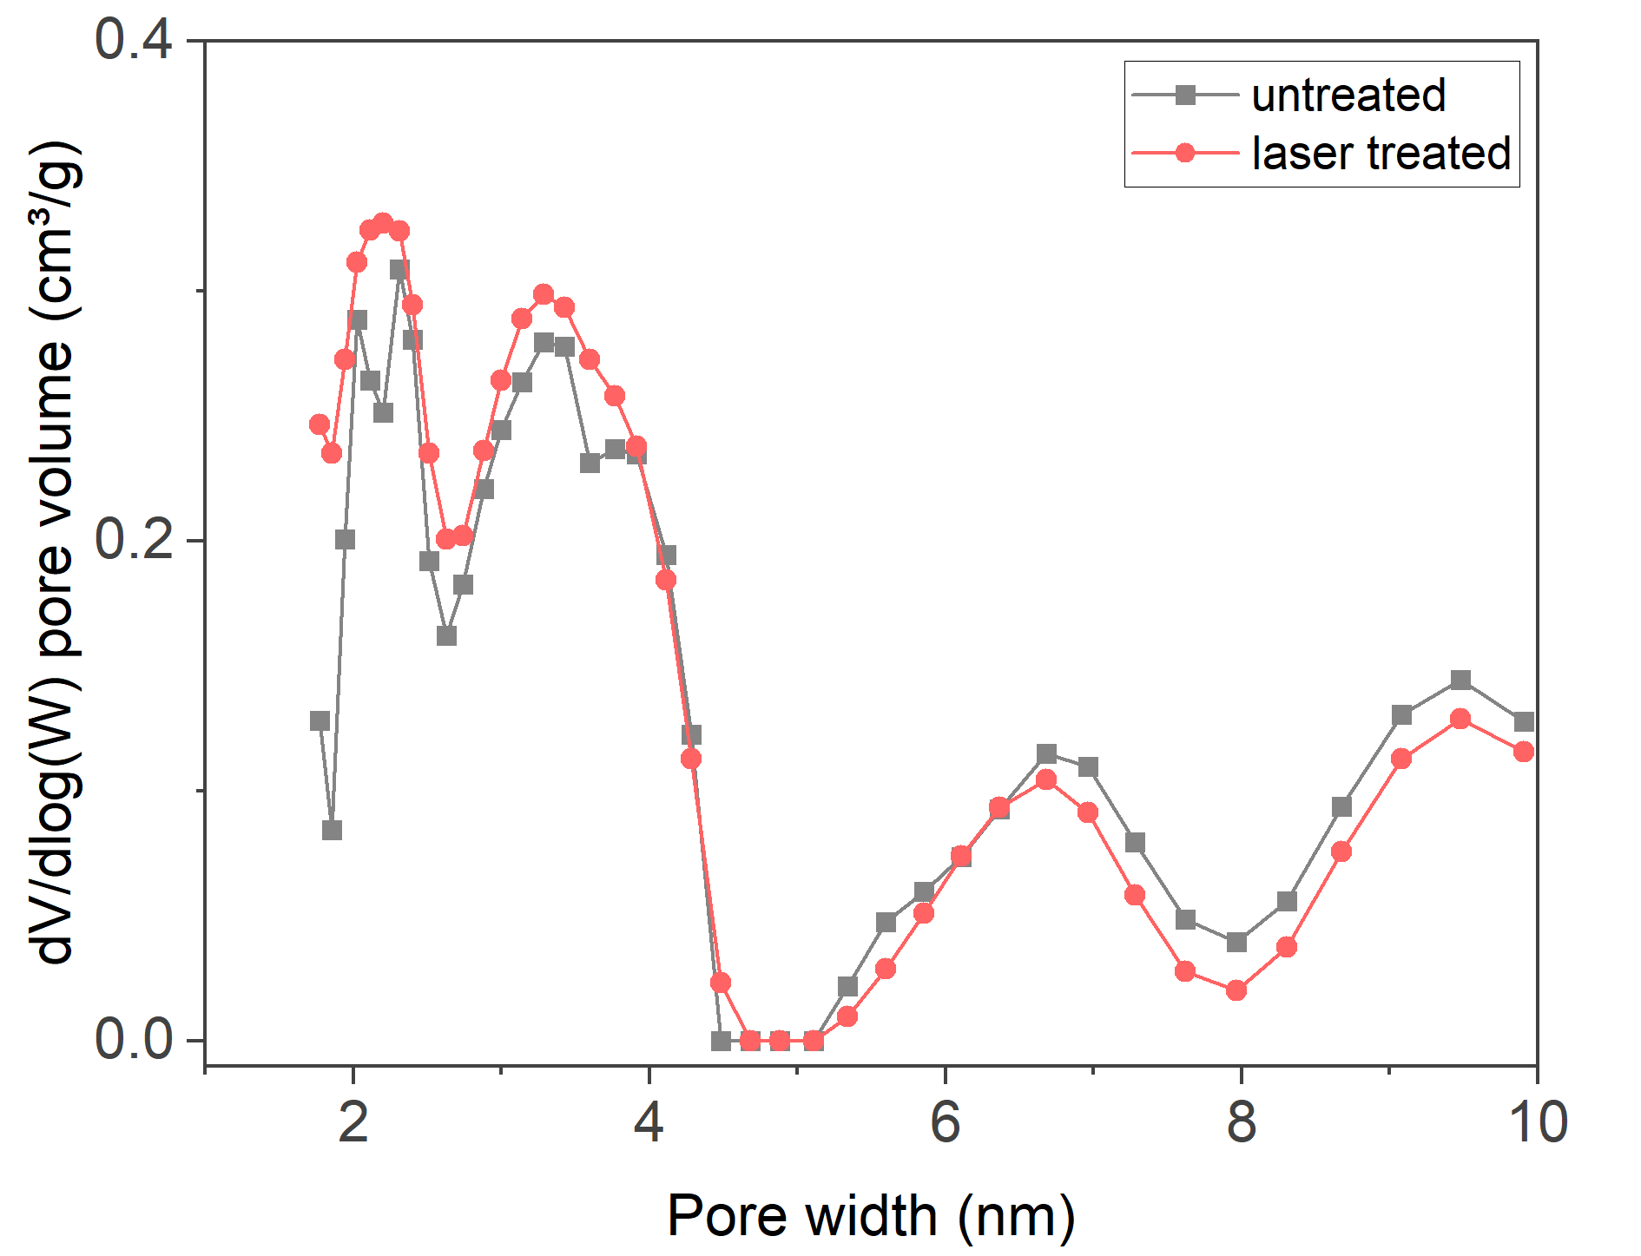
Supplementary Figure 6. Pore size distribution of pristine carbon black, laser-treated carbon black.

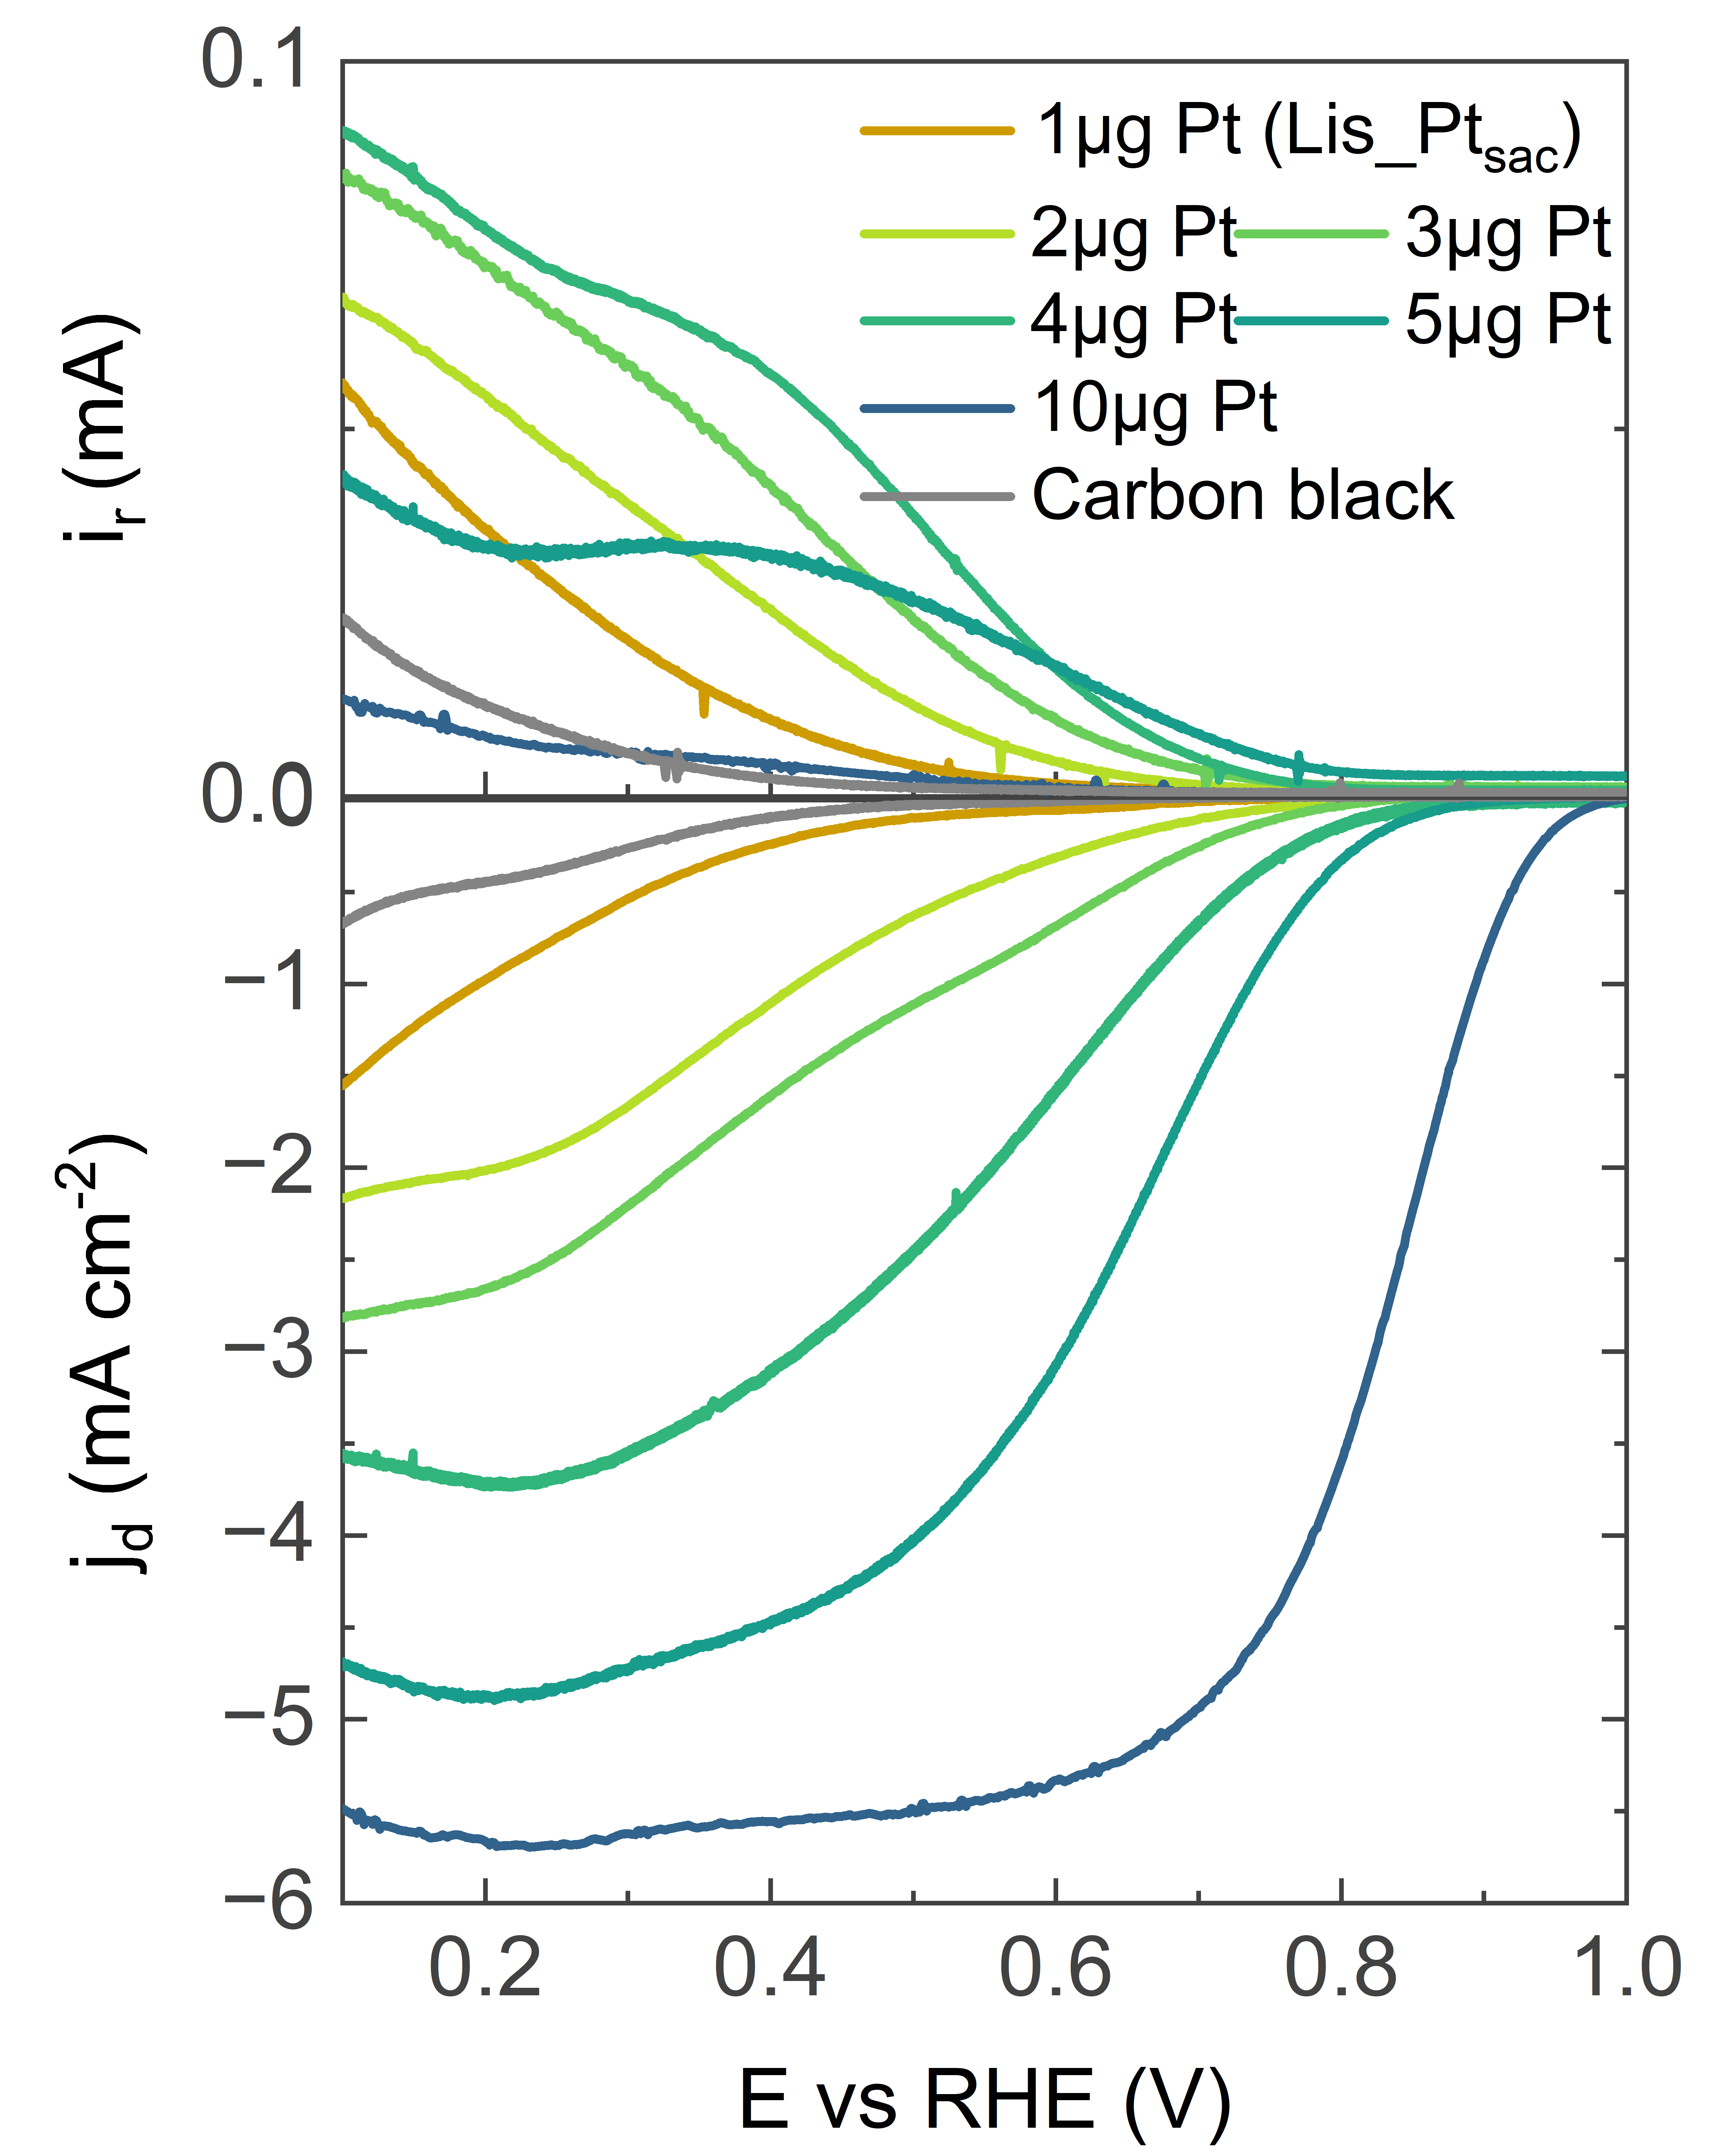
Supplementary Figure 7. RRDE LSV curves of bare carbon black, laser-engineered Pt SACs with Pt loadings of 1-10 µg_{Pt} cm⁻², recorded in O₂-saturated 0.1 M HClO₄ at 1,600 rpm.
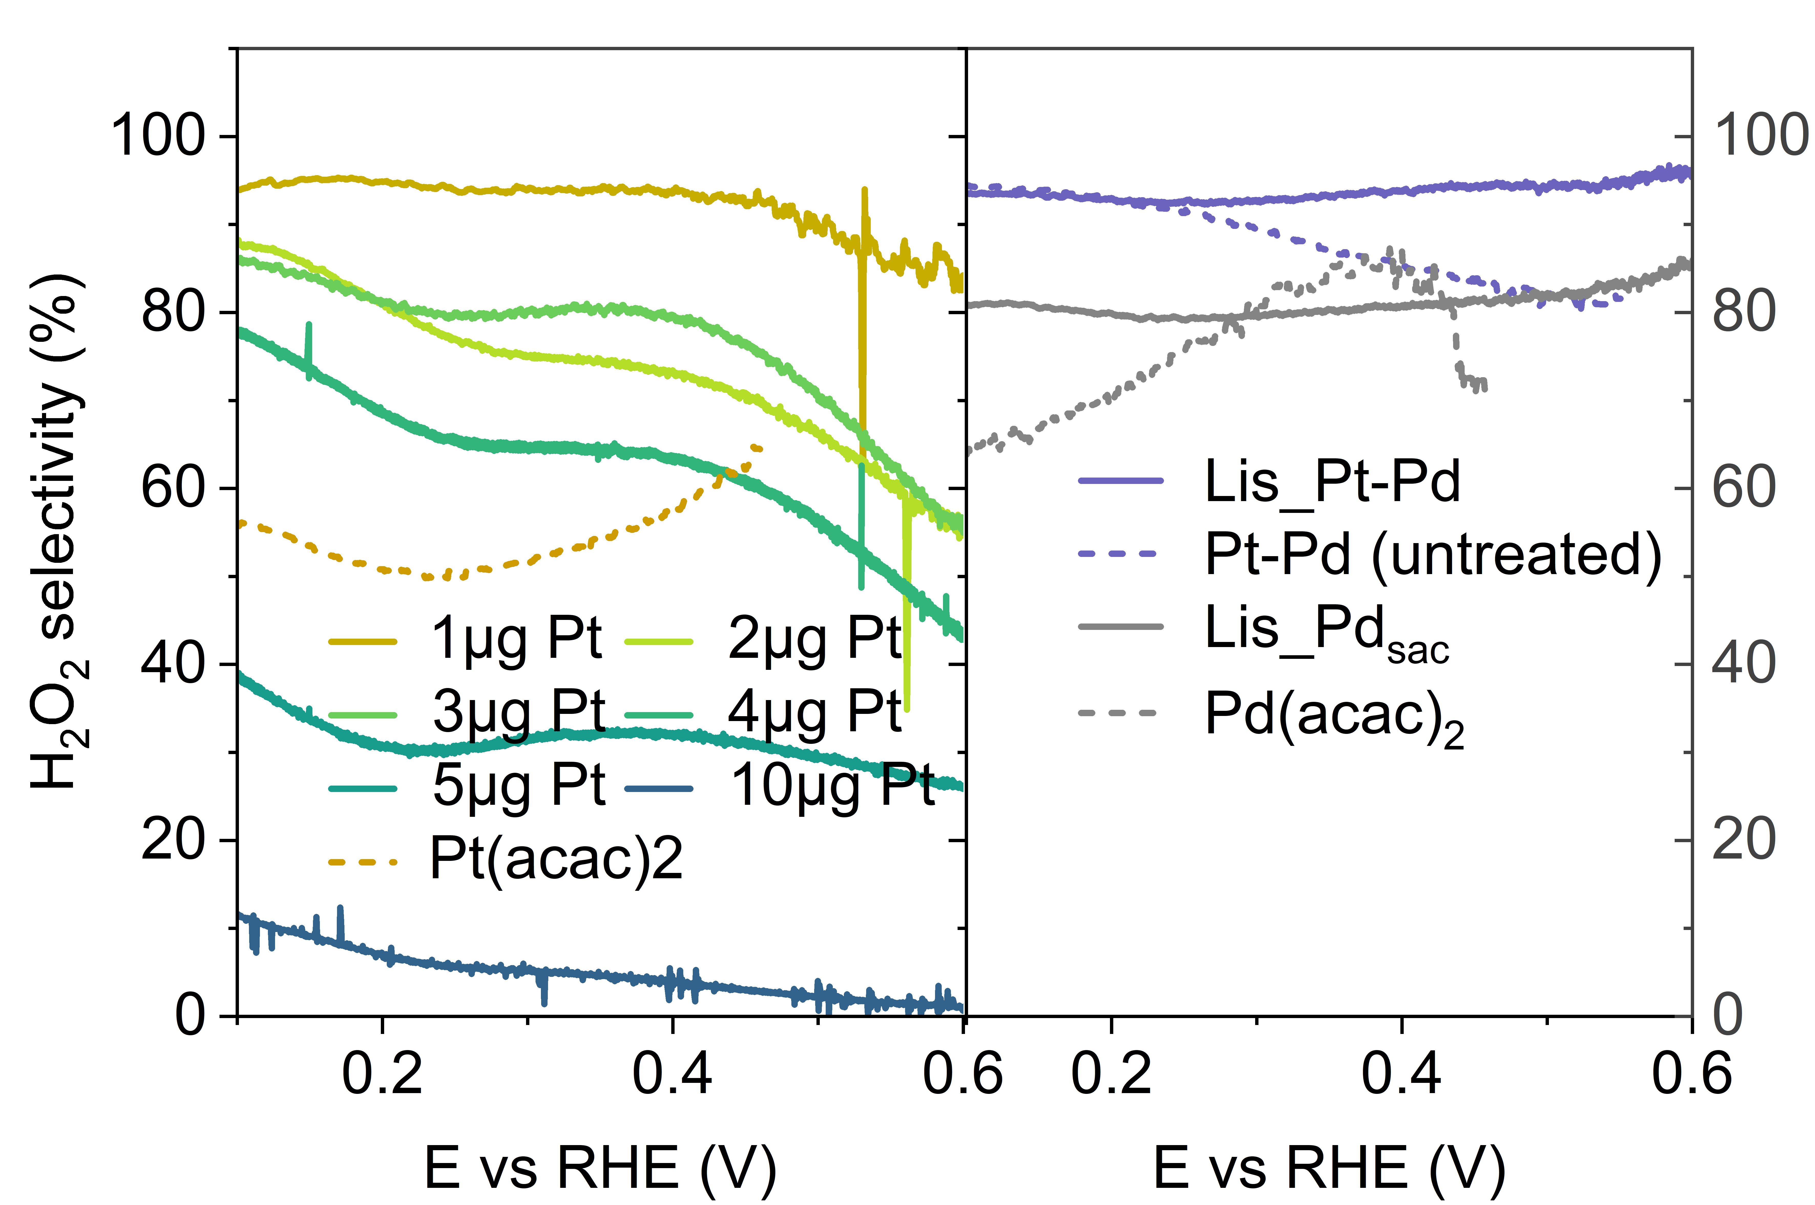
Supplementary Figure 8. H₂O₂ selectivity of all laser-engineered Pt, Pd SACs and untreated samples.
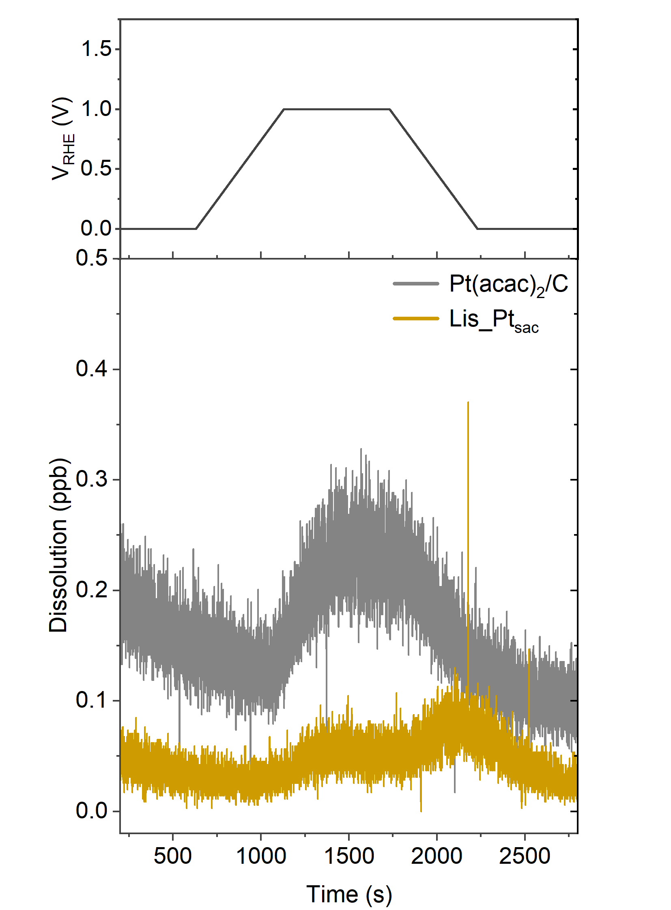
Supplementary Figure 9. Online metal dissolution profiles measured by CFC-ICP-MS for Pt(acac)₂/carbon (untreated), and Lis_Pt_{sac,} quantifying time-resolved Pd and Pt dissolution under the applied potential protocol

Supplementary Figure 10. HAADF-STEM image of Lis_Pt-Pd and statistical distribution of Pt-Pd pair distances extracted from atom-pair analysis.

Supplementary Figure 11. XPS C 1s spectra of precursor sample (not laser treated), Lis_Pd_{sac}, Lis_Pt_{sac}, Lis_5%Pt_{sac} (corresponding to the 10µg_{Pt} cm⁻² in the in-situ RRDE measurements), and Lis_Pt-Pd.

Supplementary Figure 12. XPS O 1s spectra of precursor sample (not laser treated), Lis_Pd_{sac}, Lis_Pt_{sac}, Lis_5%Pt_{sac} (corresponding to the 10µg_{Pt} cm⁻² in the in-situ RRDE measurements), and Lis_Pt-Pd.
Supplementary Figure 13. EXAFS spectra in k-space of laser-engineered catalysts and references. a. Pt L3-edge EXAFS spectra in k-space . b. Pd K-edge EXAFS spectra in k-space.

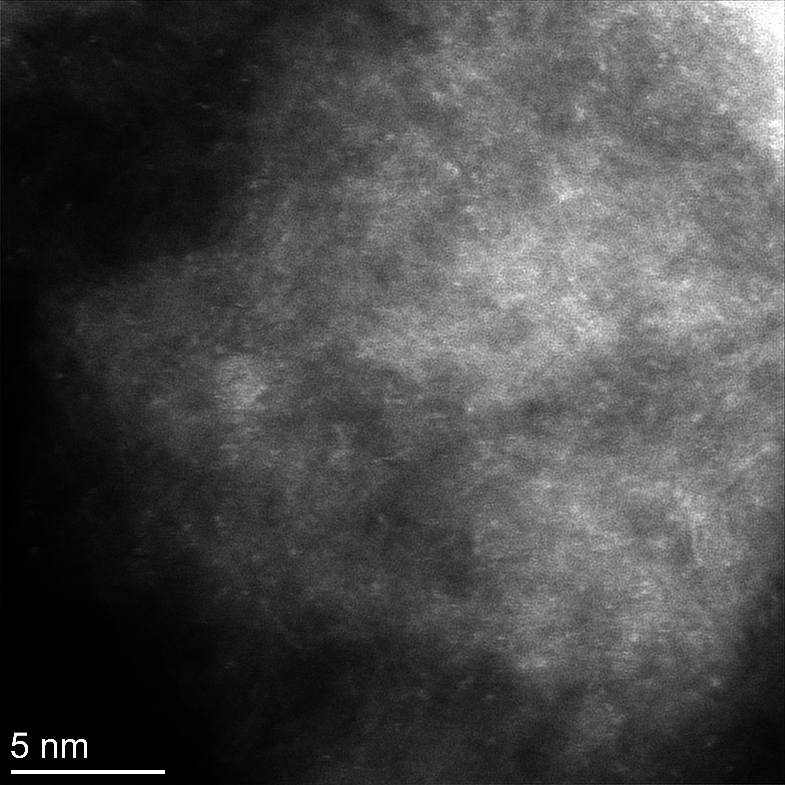
Supplementary Figure 14. HAADF-STEM image of Lis_Pt-Pd_AST (after AST measurement).

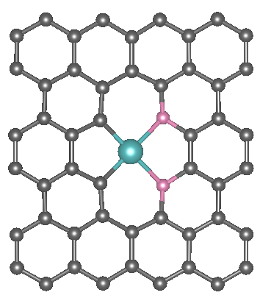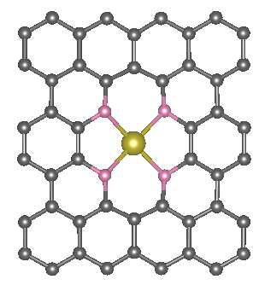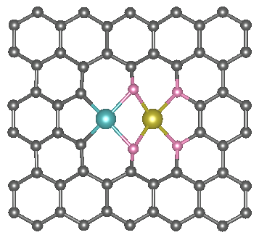
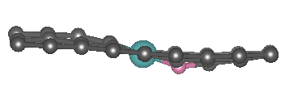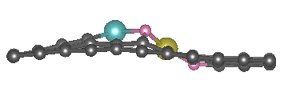
Supplementary Figure 15. Optimized Structural models. The optimized structures of Pd-O₂ (Lis_Pd_{sac}), Pt-O₄ (Lis_Pt_{sac}) and Pt-Pd-O₄ (Lis_Pt-Pd)
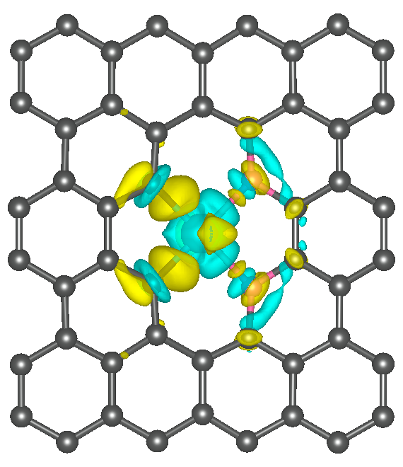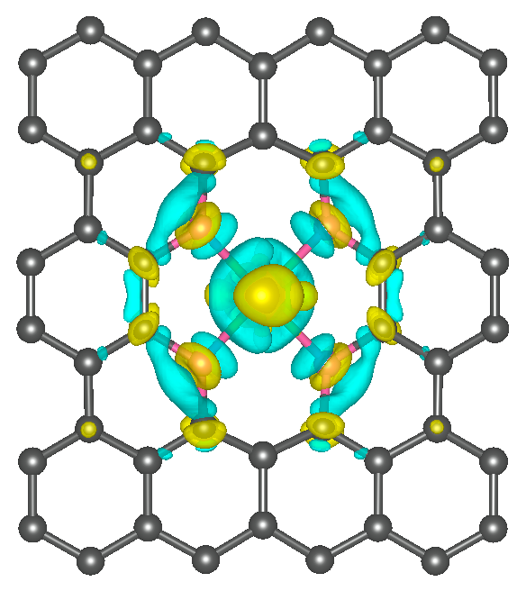
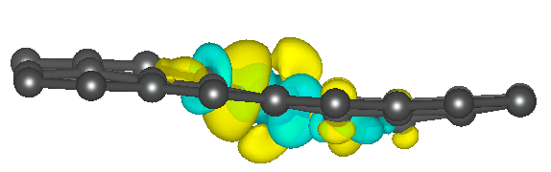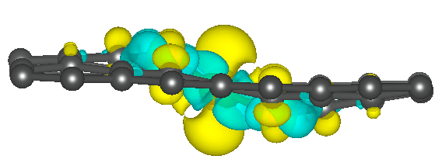
Supplementary Figure 16. Differential charge density of Pd-O₂ (Lis_Pd_{sac}), Pt-O₄ (Lis_Pt_{sac}), isosurface is 0.004 e Å−3.

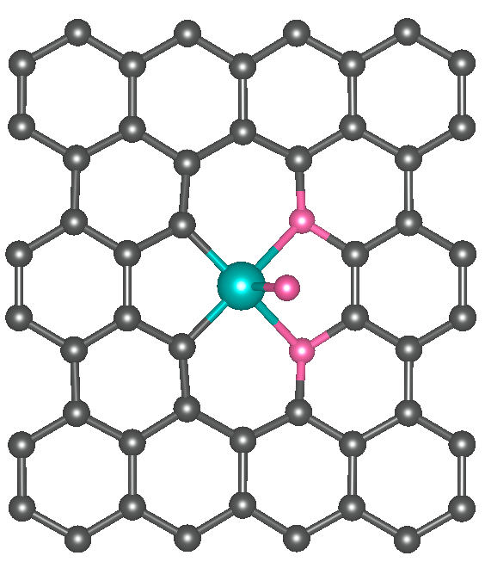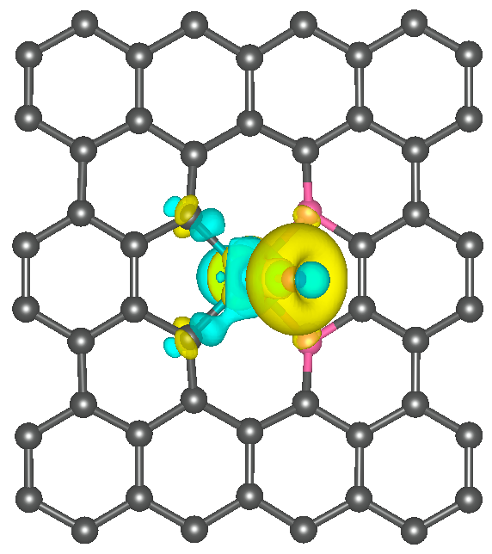
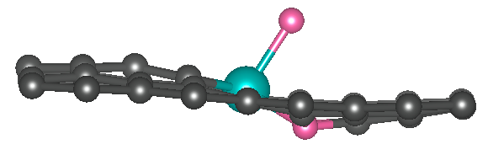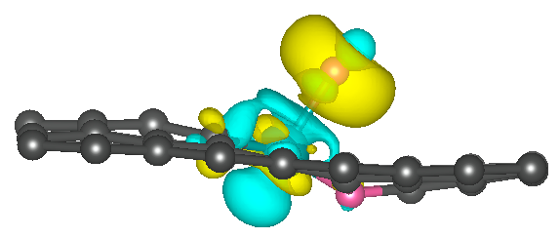
Supplementary Figure 17. Illustration of *O adsorption on Pd-O₂ and relevant Charge density difference map.

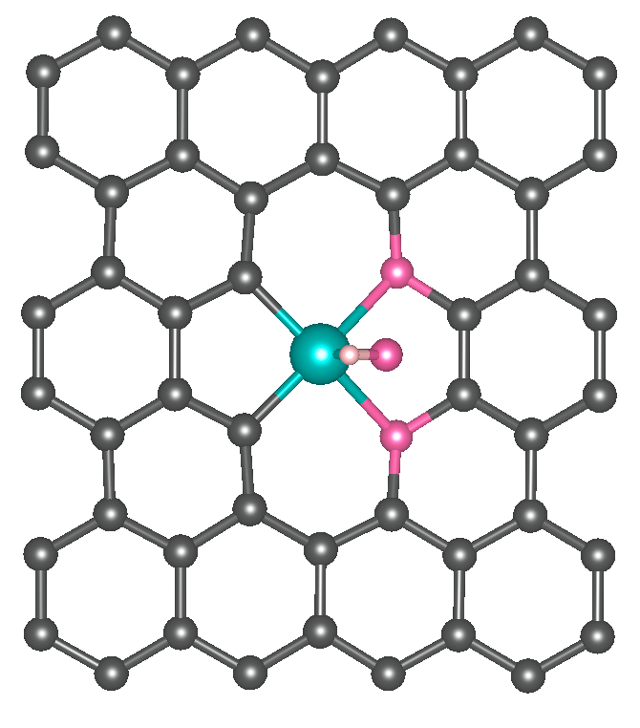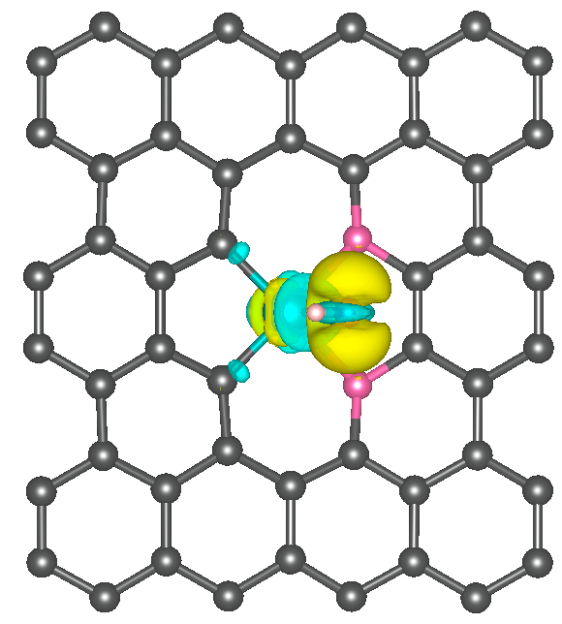
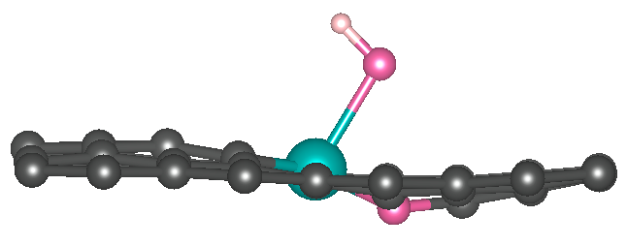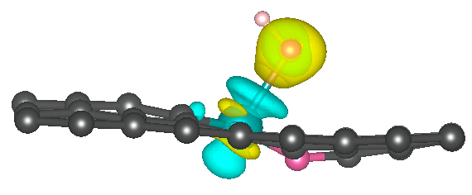
Supplementary Figure 18. Illustration of *OH adsorption on Pd-O₂ and relevant Charge density difference map.

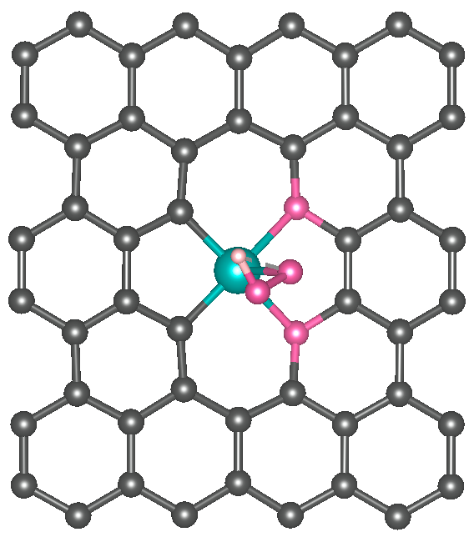
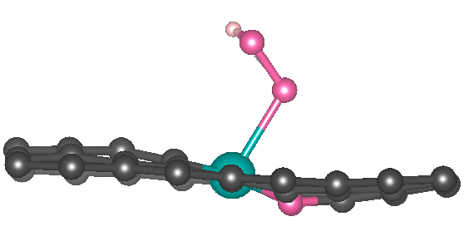
Supplementary Figure 19. Illustration of *OOH adsorption on Pd-O₂.
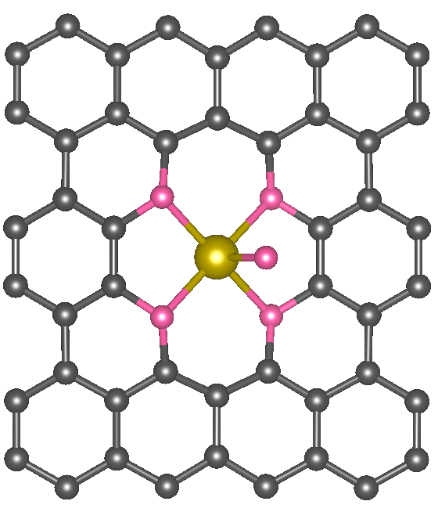
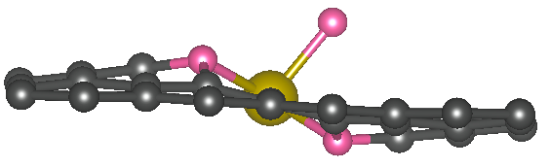
Supplementary Figure 20. Illustration of *O adsorption on Pt-O₄.

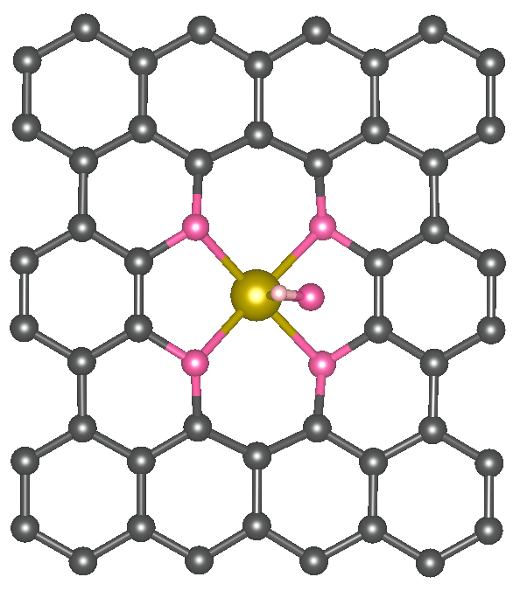
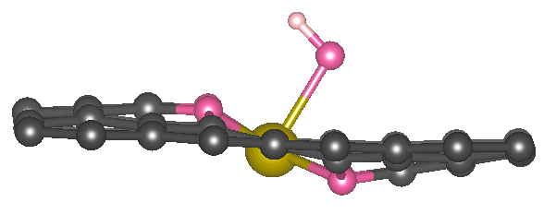
Supplementary Figure 21. Illustration of *OH adsorption on Pt-O₄.

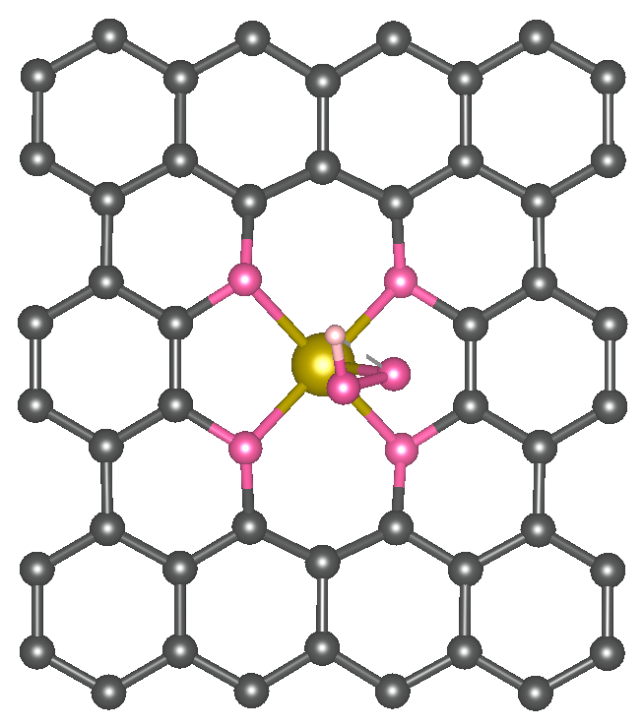
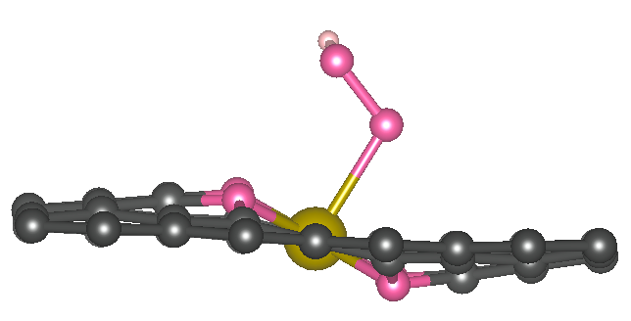
Supplementary Figure 22. Illustration of *OOH adsorption on Pt-O₄.

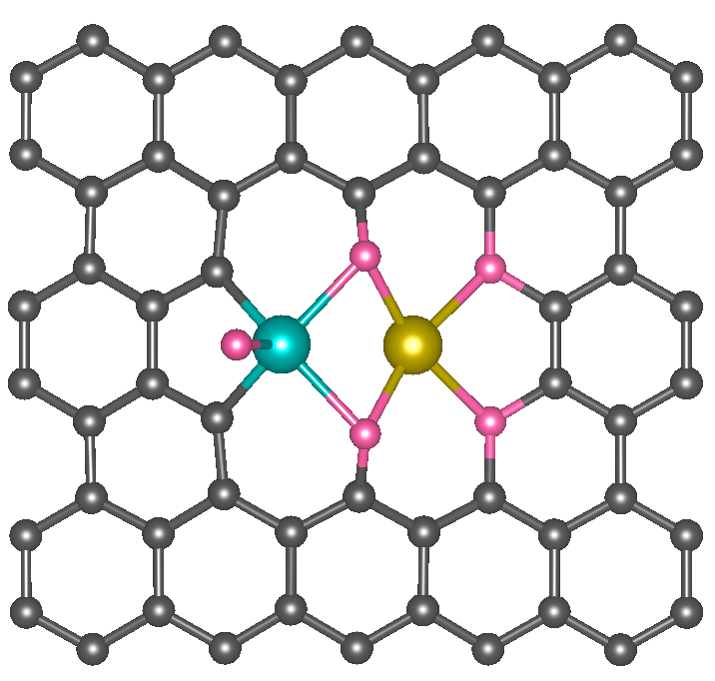
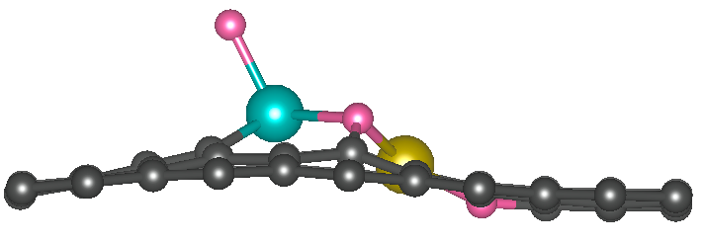
Supplementary Figure 23. Illustration of *O adsorption on Pd in Pt-Pd-O₄ (Lis_Pt-Pd).

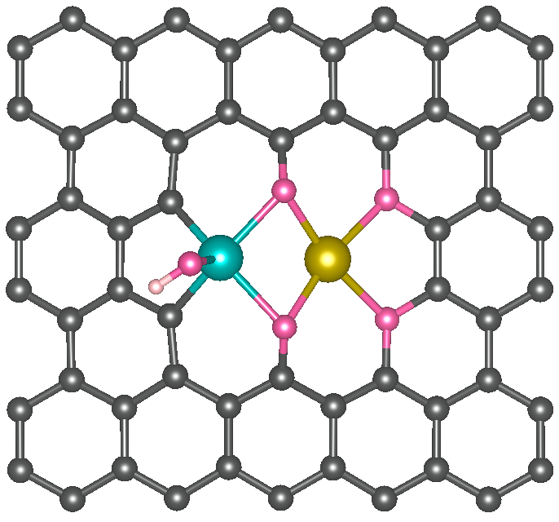
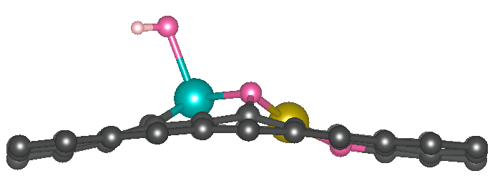
Supplementary Figure 24. Illustration of *OH adsorption on Pd in Pt-Pd-O₄ (Lis_Pt-Pd).

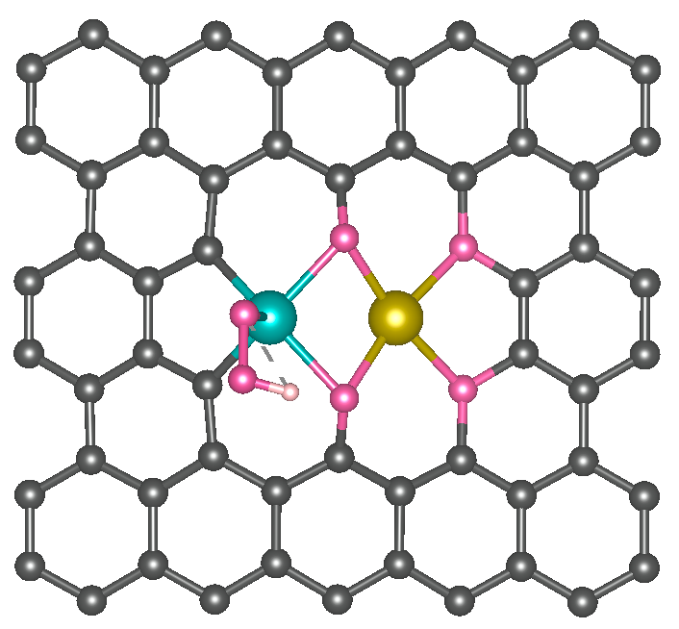
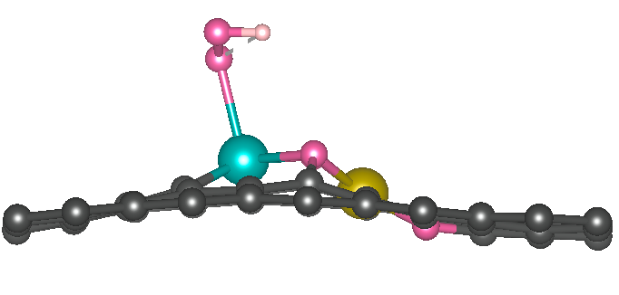
Supplementary Figure 25. Illustration of *OOH adsorption on Pd in Pt-Pd-O₄ (Lis_Pt-Pd).
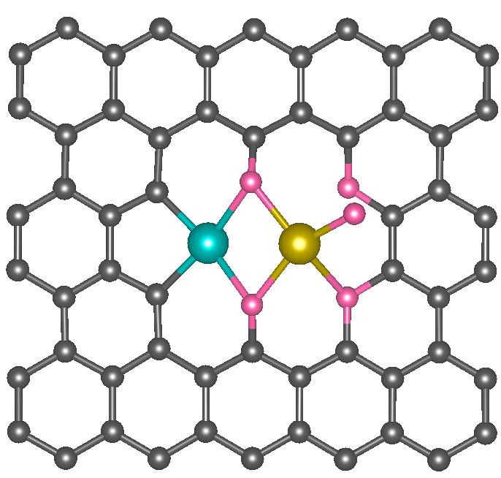
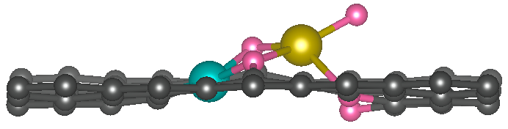
Supplementary Figure 26. Illustration of *O adsorption on Pt in Pt-Pd-O₄ (Lis_Pt-Pd).

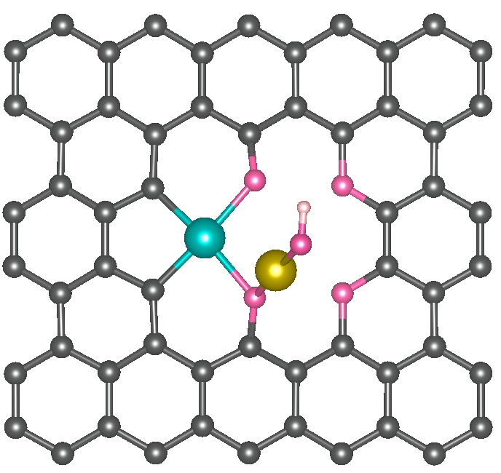
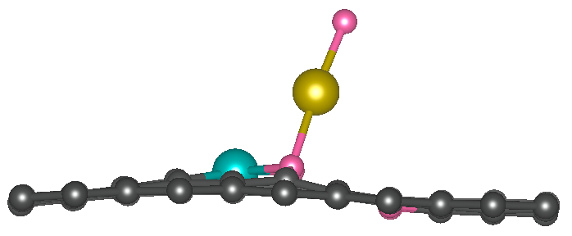
Supplementary Figure 27. Illustration of *OH adsorption on Pt in Pt-Pd-O₄ (Lis_Pt-Pd).

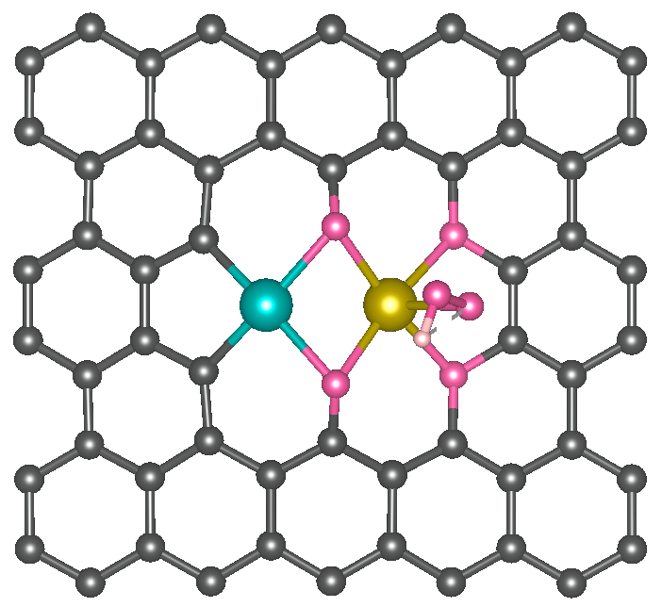
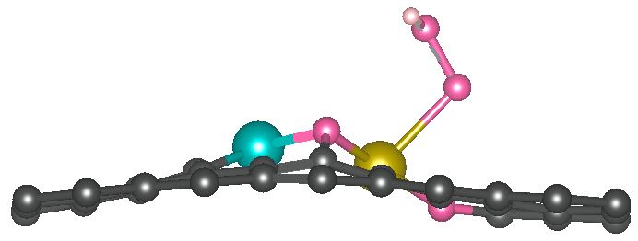
Supplementary Figure 28. Illustration of *OOH adsorption on Pt in Pt-Pd-O₄ (Lis_Pt-Pd).

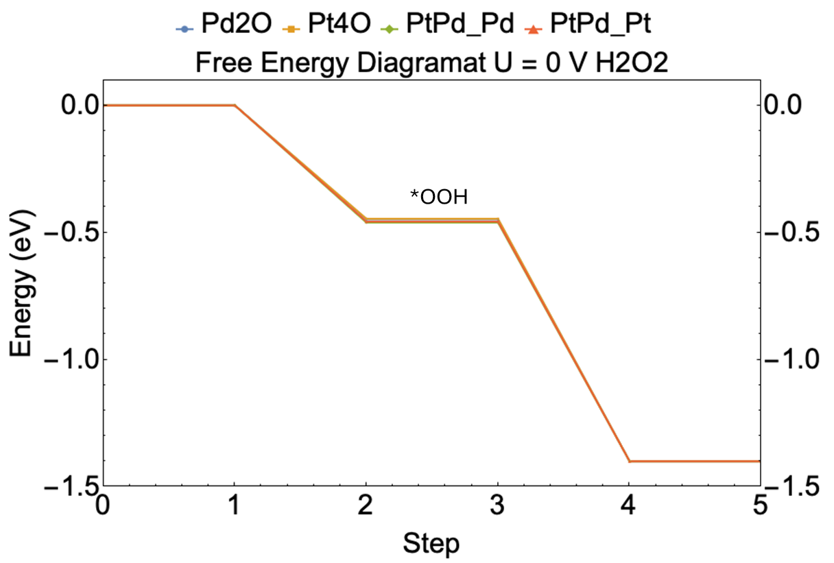
Supplementary Figure 29. Free-energy diagram for the ORR pathway at U= 0 V.

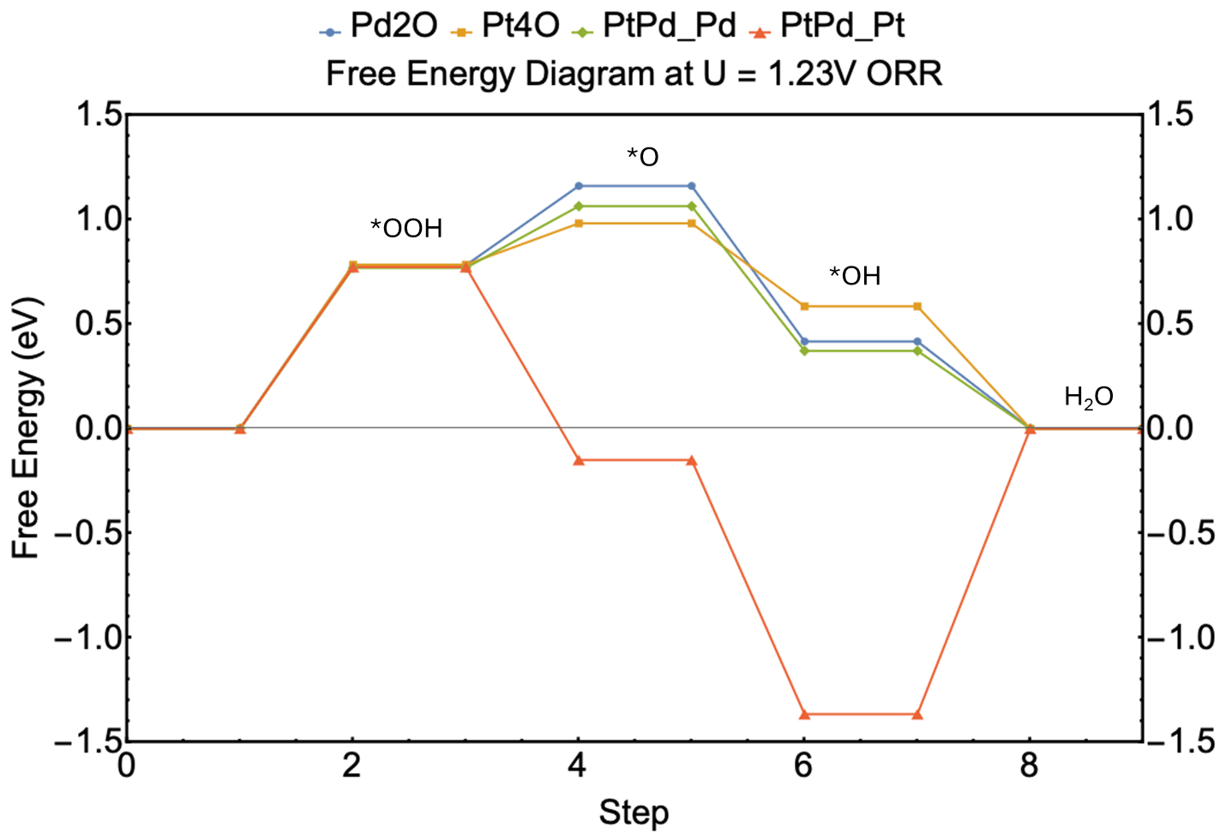
Supplementary Figure 30. Free-energy diagram for the ORR pathway at U= 1.23 V.

Supplementary Figure 31. UV-vis calibration for H₂O₂ quantification using the Ce(SO₄)₂ method. a. UV-vis absorption spectra (200–500 nm) obtained for standard H₂O₂ solutions (0, 1, 2, 5, 10 and 15 ppm). b. Calibration plot of absorbance at 320 nm as a function of H₂O₂ concentration. Experimental details: H₂O₂ standards (0, 1, 2, 5, 10 and 15 ppm) were prepared in 0.1 M HClO₄. A 0.2 mM Ce(SO₄)₂ solution was prepared in 0.5 M H₂SO₄. For each standard, 0.2 mL of the H₂O₂ solution was mixed with 1.5 mL of 0.2 mM Ce(SO₄)₂ solution. After the redox reaction, 0.7 mL of the mixture was transferred to a glass cuvette for UV-vis measurement.
Supplementary Figure 32. Current–time profiles during potentiostatic GDE electrolysis under O₂ in 0.1 M HClO₄ (150 mL catholyte). The cell was held at 0.4, 0.2, 0, -0.2 and -0.4 V versus RHE for 1 h at each potential, and the corresponding current responses are shown in five panels. Note: for Faradaic-efficiency calculations, the net charge was obtained as Q_{net} = Q_{O2} − Q_{Ar} at the same applied potential to remove the non-ORR background contribution.
Supplementary Figure 33. Time-resolved UV–vis analysis during GDE electrolysis. Absorbance changes (A_{t} − A₀) are plotted as a function of time, based on aliquots collected every 15 min during potentiostatic operation at the different applied potentials shown in Supplementary Fig. 14.

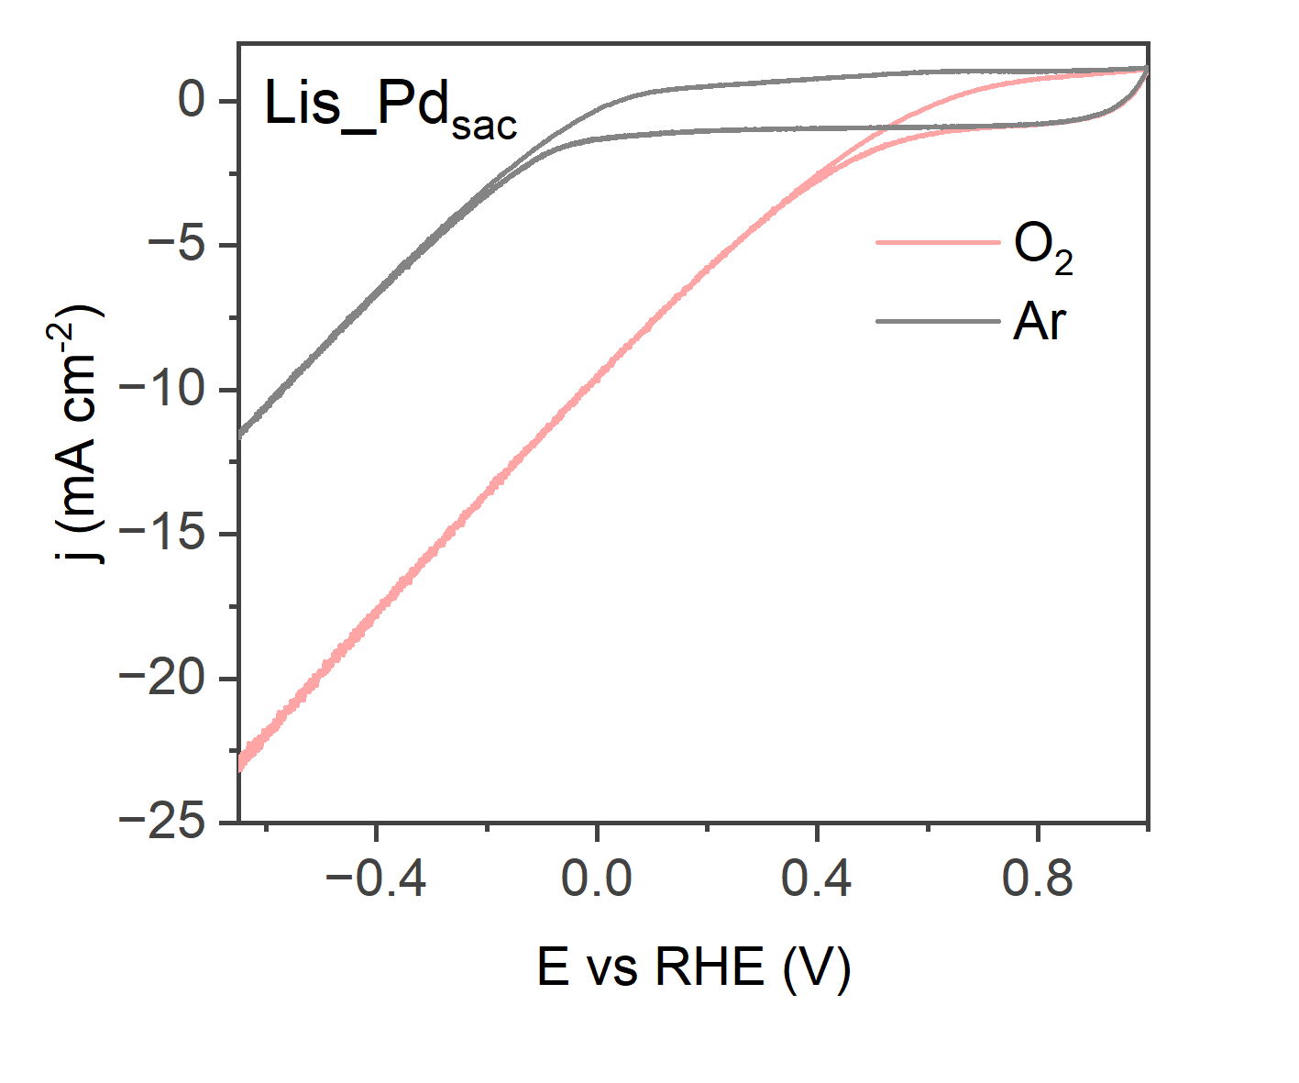
Supplementary Figure 34. CVs of Lis_Pd_{sac} recorded under Ar and O₂ in 0.1 M HClO₄ (150 mL catholyte) with 85% iR compensation.

Supplementary Table 1. Elemental composition of laser-engineered catalysts.
Materials | XPS (wt%) |  |  |  | ICP-OES (wt%)
Materials | C | O | Pd | Pt | Pd | Pt
Lis_Pt-Pd | 97.34 | 2.29 | 0.27 | 0.10 | 0.16 | 0.21
Lis_5%Pt_{sac} | 95.64 | 1.59 |  | 2.77 |  | 2.47
Lis_Pd_{sac} | 98.03 | 1.54 | 0.42
Lis_Pt_{sac} | 98.00 | 1.78 |  | 0.22 |  | 0.15

Supplementary Table 2. Best-fit EXAFS parameters at the Pt L₃-edge and Pd K-edge for the laser-engineered catalysts. Fits were performed in R-space over 1.1-2.5 Å (Pt) and 1.1-2.1 Å (Pd), using k-space ranges of 3.0-10.5 Å⁻¹ (Pt) and 3.0-11.0 Å⁻¹ (Pd) with a Hanning window (dk = 0.5 Å⁻¹, dR = 0.5 Å). The amplitude reduction factors were fixed at S₀^2 = 1.0 (Pt) and 0.77 (Pd). Debye–Waller factors (σ^2) for the Pt-O and Pd-O shells were fixed to 0.003 and 0.002, respectively, unless noted otherwise.
Material | Scattering path | σ²  (Å²) | ΔE  (eV) | CN | R  (Å) | R factor
Pt(acac)₂ | Pt–O | 0.003 | 13(1) | 4.0(6) | 1.98(1) | 0.028
Lis_Pt_{sac} | Pt–O | 0.003 | 11(1) | 3.0(2) | 1.97(1) | 0.016
Lis_5%Pt_{sac} | Pt–O | 0.003 | 12(1) | 3.1(2) | 1.97(1) | 0.018
Lis_Pt-Pd | Pt–O | 0.003 | 13(1) | 3.7(2) | 1.98(1) | 0.016
Lis_Pt-Pd_AST | Pt–O | 0.003 | 16(2) | 2.8(2) | 2.00(1) | 0.035
Pd(acac)₂ | Pd–O | 0.002 | 3(2) | 4.2(3) | 1.98(1) | 0.013
Lis_Pd_{sac} | Pd–O | 0.003 | 1(2) | 3.1(2) | 1.98(1) | 0.012
Lis_Pt-Pd | Pd–O | 0.002 | 2(2) | 4.0(3) | 1.98(1) | 0.010
Lis_Pt-Pd_AST | Pd–O | 0.002 | 4(3) | 2.8(3) | 2.00(2) | 0.037

Reference
1. Kresse, G. & Furthmüller, J. Efficient iterative schemes for ab initio total-energy calculations using a plane-wave basis set. Phys. Rev. B 54, 11169–11186 (1996).
2. Hammer, B., Hansen, L. B. & Nørskov, J. K. Improved adsorption energetics within density-functional theory using revised Perdew-Burke-Ernzerhof functionals. Phys. Rev. B 59, 7413–7421 (1999).
3. Perdew, J. P., Burke, K. & Ernzerhof, M. Generalized Gradient Approximation Made Simple. Phys. Rev. Lett. 77, 3865–3868 (1996).
4. Blöchl, P. E. Projector augmented-wave method. Phys. Rev. B 50, 17953–17979 (1994).
5. Grimme, S., Antony, J., Ehrlich, S. & Krieg, H. A consistent and accurate ab initio parametrization of density functional dispersion correction (DFT-D) for the 94 elements H-Pu. J. Chem. Phys. 132, (2010).
6. Momma, K. & Izumi, F. VESTA 3 for three-dimensional visualization of crystal, volumetric and morphology data. J. Appl. Crystallogr. 44, 1272–1276 (2011).

