TABLES

Table 1
Comparison of system features and functionalities between version 1.0 and version 2.0.
Iteration Aspects | version 1.0 | version 2.0
Interface | 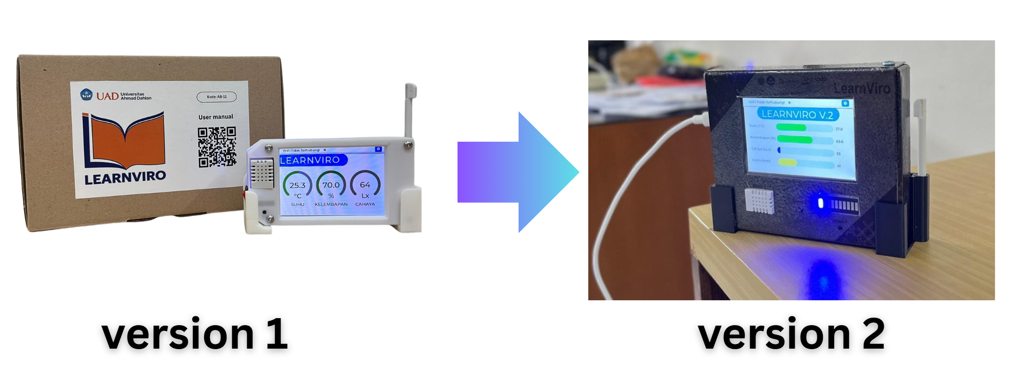
Sensors | Temperature, humidity, light intensity | Temperature, humidity, light intensity, noise
Recommendations | Recommendation to regulate the classroom temperature, light, and humidity through room intervention | Recommendations to regulate the classroom temperature, light, and humidity through room intervention and reducing the noise by managing the students in the classroom.
Website features | IoT Dashboard  Learning style instruments  School account  Teachers’ account  Students’ account | IoT Dashboard  Learning style instruments  Students’ progress instruments  School’s account  Teachers’ account

Table 2.
Environmental parameters and threshold ranges used for classroom condition classification in the IoT-based classroom management system.
Parameters | Color Category | Threshold Range | nterpretation of Conditions | Classroom Management Recommendations
Temperature (°C) | Blue | 10 – < 20 | Too cold | Reduce the AC temperature, close the windows, and keep the students away from direct exposure to the AC
 | Green | 20 – 26 | Comfortable | The temperature is good; learning can run optimally
 | Red | > 26 – 40 | Too hot | Turn on the AC, open the cross ventilation, and direct the fan outward.
Humidity (%) | Blue | 20 – < 40 | Too dry | Open the ventilation, add indoor plants, and put a small water container in the classroom
 | Green | 40 – 70 | Comfortable | Humidity is good; no need for specific intervention
 | Red | > 70 – 90 | Too humid | Open cross ventilation, make sure there is no water source, and use a fan for air circulation
Light Intensity (Lux) | Blue | 100 – < 300 | Too dark | Open the curtain and move the learning activities to a lighter area.
 | Green | 300 – 500 | Comfortable | The lighting is good for learning activities and observation
 | Red | > 500 – 700 | Too bright | Close a part of the curtain, use a light diffuser, and change the orientation of the board/display
Noise (dB) | Blue | 0 – < 40 | Quiet / Calm | The condition is good; maintain the classroom atmosphere
 | Green | 40 – 60 | Normal | The classroom noise is in a normal category for learning
 | Yellow | > 60 – 80 | Noisy | Rearrange the seating, use non-verbal signs (call-and-response claps, jingles, hand movements), assign structured tasks, and reinforce appropriate behavior.
 | Red | > 80 | Too noisy | Immediate interventions: rearrange the classroom, stop activities causing noise, and apply intensive behavioral management.

