Supplementary Information for “Multiomics Profiling Supports Cathepsin B as a Protective Factor in Cerebral Small Vessel Disease”

This appendix provides supplementary figures for “Multiomics Profiling Supports Cathepsin B as a Protective Factor in Cerebral Small Vessel Disease”.
Supplementary Figures 2
Figure S1 | Associations between a PRS of WMH and 2,923 circulating protein levels. 2
Figure S2 | Mendelian Randomization Results of ECHDC3 expression on CSVD traits. 3
Figure S3 | Inverse Mendelian Randomization Results of CTSB expression on CSVD traits. 4
Figure S4 | Inverse Mendelian Randomization Results of ECHDC3 expression on CSVD traits. 5
Figure S5 | Proportion of cell types found in Control vs VaD samples. 6

Supplementary Figures

Figure S1 | Associations between a PRS of WMH and 2,923 circulating protein levels.
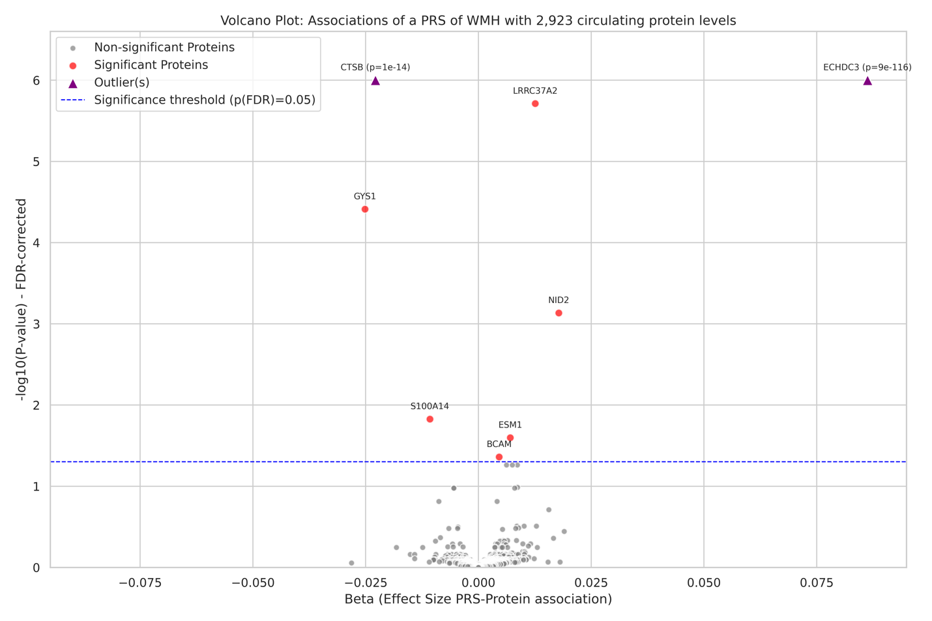

Volcano plot presenting the association between a polygenic risk score for white matter hyperintensities and 2,923 circulating protein levels measured in the UK Biobank. The x-axis represents the beta effect size from the linear regression models adjusted for age, sex, the first 10 genetic PCs, while the y-axis displays the –log₁₀-transformed p-values after FDR correction. Median N_{samples} = 44,480. Red circles indicate proteins that reach statistical significance (p < 0.05) after FDR correction, with smaller gray dots representing non-significant proteins. Extreme outlier proteins with exceptionally low p-values are shown as purple triangles and are annotated with their respective FDR p-values.
Source data are provided as a Source Data file.

Figure S2 | Mendelian Randomization Results of ECHDC3 expression on CSVD traits.
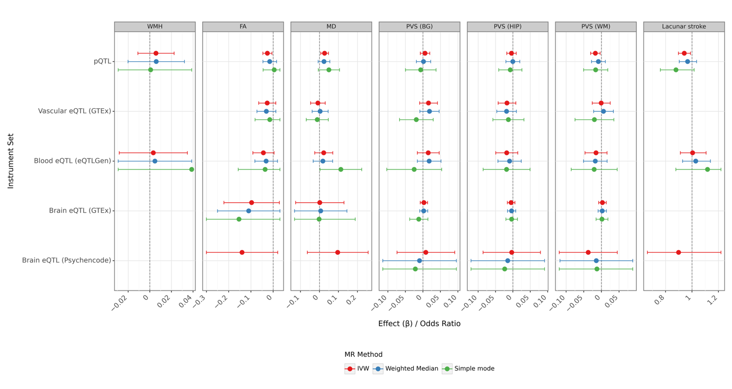
Forest plot of Mendelian randomization estimates and 95% confidence intervals for the protein ECHDC3 on seven markers of cerebral small vessel disease: white matter hyperintensities (WMH), fractional anisotropy (FA), mean diffusivity (MD), perivascular spaces in the basal ganglia (PVS (BG)), hippocampus (PVS (HIP)), and white matter (PVS (WM)), and lacunar stroke. The analysis uses five distinct instrument sets: pQTL, vascular eQTL (GTEx), blood eQTL (eQTLGen), brain eQTL (GTEx), and brain eQTL (PsychEncode). Within each panel, point estimates are colored by the MR method used: inverse-variance weighted (IVW; red), weighted median (blue), and simple mode (green). The horizontal bars represent the 95% confidence intervals. The dashed vertical line indicates the null effect (an effect of β=0 for the first six outcomes and an Odds Ratio of 1 for lacunar stroke). No valid ECHDC3 instruments were found for certain combinations of instrument set and outcome.
Source data are provided as a Source Data file.

Figure S3 | Inverse Mendelian Randomization Results of CTSB expression on CSVD traits.
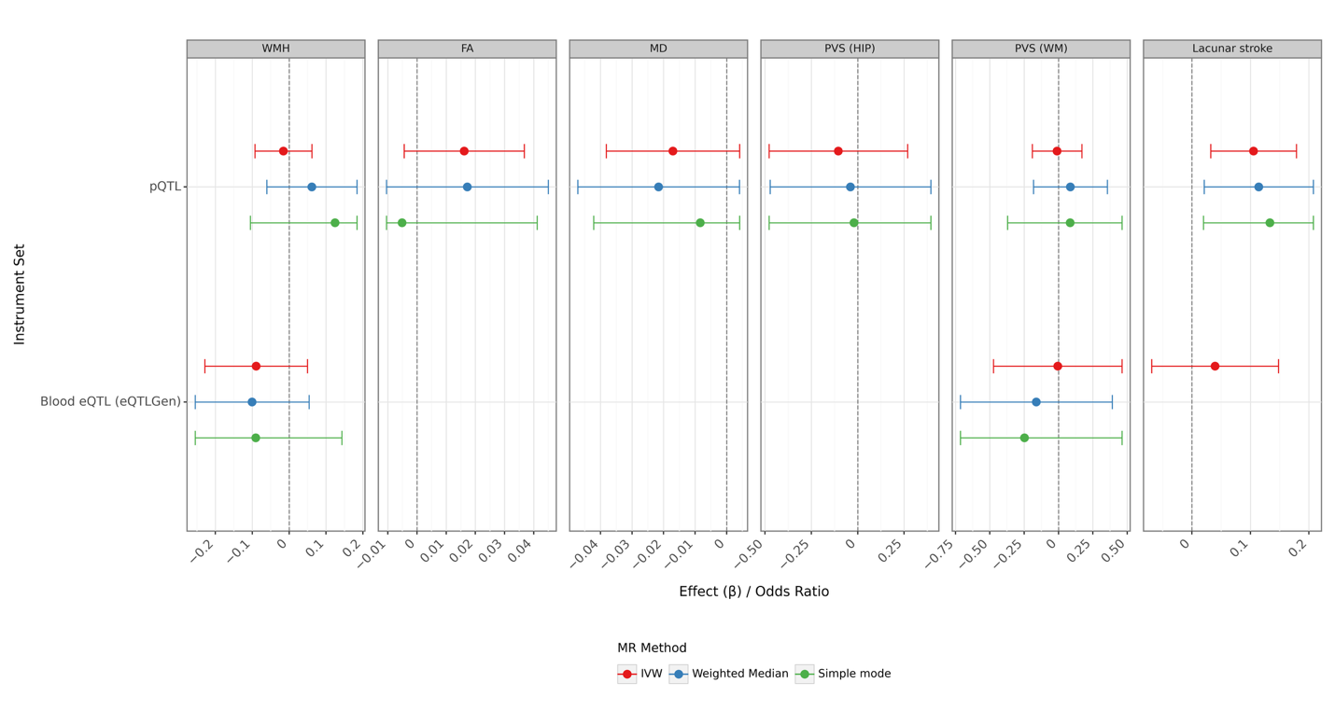
Forest plot of Mendelian randomization estimates and 95% confidence intervals for six markers of cerebral small vessel disease on CTSB expression. The CSVD markers are white matter hyperintensities (WMH), fractional anisotropy (FA), mean diffusivity (MD), perivascular spaces in the hippocampus (PVS (HIP)) and white matter (PVS (WM)), and lacunar stroke. The analysis uses two distinct instrument sets: pQTL and blood eQTL (eQTLGen). Within each panel, point estimates are colored by the MR method used: inverse-variance weighted (IVW; red), weighted median (blue), and simple mode (green). The horizontal bars represent the 95% confidence intervals. The dashed vertical line indicates the null effect (β = 0). No valid instruments were found for certain combinations of instrument set and exposure. Source data are provided as a Source Data file.

Figure S4 | Inverse Mendelian Randomization Results of ECHDC3 expression on CSVD traits.
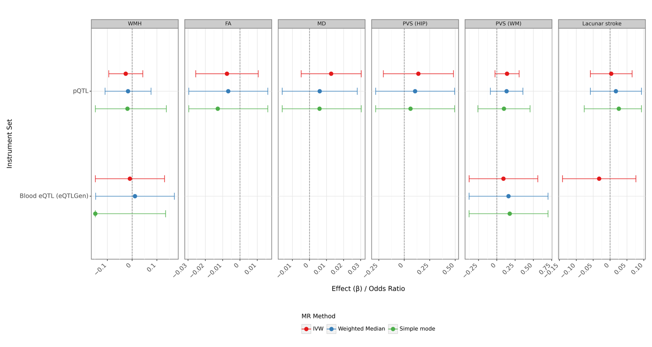
Forest plot of Mendelian randomization estimates and 95% confidence intervals for six markers of cerebral small vessel disease on ECHDC3 expression. The CSVD markers are white matter hyperintensities (WMH), fractional anisotropy (FA), mean diffusivity (MD), perivascular spaces in the hippocampus (PVS (HIP)) and white matter (PVS (WM)), and lacunar stroke. The analysis uses two distinct instrument sets: pQTL and blood eQTL (eQTLGen). Within each panel, point estimates are colored by the MR method used: inverse-variance weighted (IVW; red), weighted median (blue), and simple mode (green). The horizontal bars represent the 95% confidence intervals. The dashed vertical line indicates the null effect (β = 0). No valid instruments were found for certain combinations of instrument set and exposure. Source data are provided as a Source Data file.

Figure S5 | Proportion of cell types found in Control vs VaD samples.
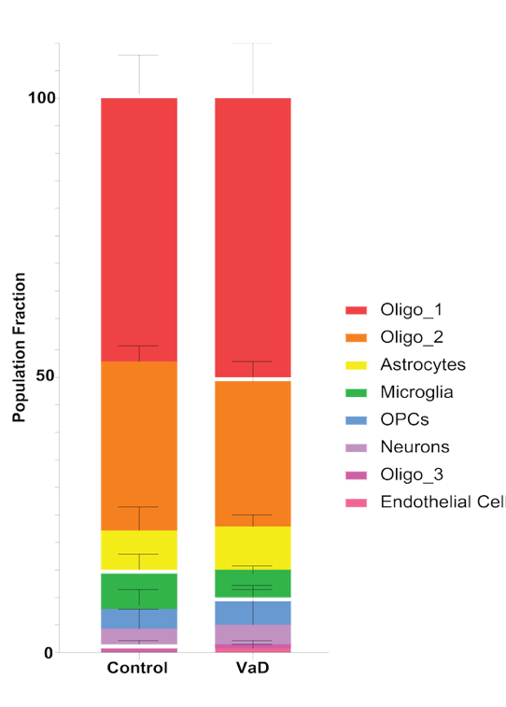
Stacked bar chart showing the relative proportions of different cell populations in Control samples versus VaD (Vascular Dementia) samples. The height of each colored segment represents the mean fraction of that specific cell type within the total population for each condition.
Source data are provided as a Source Data file.

