Supplemental Information for:

The Automated Bulk Sampling System (ABSS), a low-cost solution for integrated nitrous oxide emission quantification in the field.

Authors: Randy Clark¹, Nick Friedenberg¹, Dan Chamberlain², Chris Parry¹, Timothy Hart¹, Jessica Garcia¹, Julie Abendroth,¹ Courtland Kelly¹
¹ Farming Solutions and Digital, Research & Development, Corteva Agriscience, Johnston IA
² Trait Characterization and Development, Research & Development, Corteva Agriscience, Johnston IA

Contents:
- Supplemental Methods:
- SM1. Details on the Automated Bulk Sampling System: Parts and Deployment
- SM2. Details on the Flux Calculations from 2-Point Bulk Sampling Method
- SM3. Details on the Laboratory Validation Experiment
- SM4. Details on the Field Validation Experiment
- SM5. Details on the Gas Collection Bag Cleaning Procedure

- Supplemental Figures:
- SF1: ABSS system diagram
- SF2: ABSS circuit board schematic
- SF3: Graphical representation of ABSS sampling operation
- SF4: Lab validation dosing experimental setup
- SF5: Comparison with “simulated Bulk” flux estimates
- SF6: Supporting figures for air density error estimations

- Supplemental Tables:
- ST1. Synchronized Dosing Cycle Timetable for a Single Cycle in Lab Dosing experiment
- ST2. Synchronized Field Chamber Sampling Timetable for a Single Cycle in 2023
- ST3. Paired t-test of N2O concentrations in ABSS bags compared to real-time analyzer
- ST4. N2O gas stability in collection bag results

Supplemental Methods

SM1. Details on the Automated Bulk Sampling System: Parts and Deployment
The Automated Bulk Sampling System (ABSS) is a standalone gas collection system that is controlled by an ESP32 development board (Chendu Heltec Automation Technology Co. Wireless Stick Lite V2) mounted on a circuit board that contains solar power management, motor control, relay switches, and terminal ports to power, control and communicate with connected hardware and sensors (Supplemental Figure SF1). A peristaltic pump with a solenoid valve system allows gas from the headspace of an automated chamber to be sampled and routed to separate 5L multi-layer foil gas collection bags (Supelco 20228-U) that are secured within a thermally insulated weatherproof enclosure (CatorGator CG65SPG) along with the electronics and flow control hardware (Supplemental Figures SF1 and SF2). An integrated LoRa transceiver module (Semtech SX1276) sends system status and sensor data to a cellular-enabled gateway that publishes the data to the cloud for storage and monitoring (Supplemental Figure SF1).

SM2. Details on the Flux Calculations from 2-Point Bulk Sampling Method
To measure soil N₂O fluxes, the ABSS uses a 2-point bulk sampling method that is similar to 3-point trace gas collection methods first introduced by Ambus et al. (2010). Reduction to two points simplifies the system and reduces cost, but requires consideration of chamber closure time to minimize non-linearity due to chamber headspace saturation (Korhonen et al., 2010). During standard field sampling experiments, the GHG chamber operation and chamber headspace gas collection is synchronized by the ABSS using a control program running a pre-defined operational sequence. The 2-point bulk sampling method and operational sequence is shown in Supplemental Figure S3 and is detailed as follows: Sampling cycles repeat hourly over 2-week sample collection periods, where open-chamber (OC) gas is collected after the GHG chamber has been open for 50 minutes (point 1) and closed-chamber (CC) gas is collected after the GHG chamber has been closed for 10 minutes (point 2). Prior to each sampling event, the gas flow path between the GHG chamber and collection bags is purged with 260 ml of chamber gas, followed by sampling of 6.5 ml of either OC or CC gas into respective gas collection bags. The hourly sampling cycles repeat for the duration of the sample collection period, allowing the samples to accumulate in the collection bags. At the end of each sample collection period, the bags are retrieved and replaced with clean, empty bags (cleaning process detailed below in SM5) prior to beginning the next sample collection period. The accumulated gas in the OC and CC collection bags were transported to the lab and measured by using Picarro G2508 (Picarro, Inc. , Santa Clara, CA, USA). N₂O concentrations were determined by averaging ≥ 2 minutes of individual analyzer readings (≥ 160 data points) after the N₂O readings stabilize.
Atmospheric data used to calculate the air density coefficient in Equation (1) were obtained from an on-site weather station that transmitted weather data every 15 minutes (Davis Vantage Pro2 with an EnviroMonitor).

SM3. Details on the Laboratory Validation Experiment
To determine soil N₂O fluxes, the ABSS bulk sampling method relies on the ability of the system to capture the average N₂O concentration changes between open-chamber (OC) and closed-chamber (CC) gases from multiple samplings. To empirically evaluate the system, chamber dosing experiments were conducted in the laboratory where “doses” of N₂O calibration gas were injected into the closed-chamber headspace over multiple cycles, and the final OC and CC bulk samples were compared to average real-time (RT) chamber measurements. For each experiment, the individual dosing cycles were performed approximately 336 times over 2.8 days. Thirteen dosing experiments with varying target concentration changes were completed. Additionally, spike experiments were performed where high N₂O dosage rates were applied during a consecutive subset of the individual dosing cycles (Supplemental Figure SF4) to mimic short-term periods of increased N₂O flux found in field settings, known as ‘hot moments’ (Bernhardt et al., 2017).
The experimental setup consisted of 4 ABSS units attached to cylindrical chambers each with a connected N₂O dosing system that could inject controlled amounts of N₂O calibration gas (Gasco Affiliates LLC, Oldsmar, FL) into the chamber headspace (Supplemental Figure SF4). The chamber headspaces were connected in parallel to a Picarro G2508 analyzer with a valve system that allowed each chamber to be isolated in closed loop with the analyzer during the real-time measurement. A CR1000 control datalogger (Campbell Scientific, Logan, UT) synchronized the real-time chamber measurement in coordination with the chamber lid operation, the N₂O calibration gas dosing and the ABSS samplings, such that only one chamber was being sampled and measured in real-time at any given time. A detailed timeline of the synchronized dosing cycle can be found in Supplemental Table ST1 and consisted of the following main steps for each chamber: 1) the chamber lid is opened and the headspace gas is allowed to mix with ambient air for 350 seconds; 2) real-time measurement of the OC gas is made concurrently while purging 260 ml then sampling 6.5 ml of OC gas into the OC collection bag; 3) the chamber lid is closed and after 90 seconds the N₂O calibration gas is injected into the chamber headspace; 4) after mixing for 260 seconds, real-time measurement of the CC gas is concurrently made while purging 260 ml then sampling 6.5 ml of CC gas into the CC collection bag; 5) the chamber lid is opened starting the next dosing cycle. At the end of each experiment, the accumulated gas in the OC and CC collection bags were measured with a Picarro G2508 gas analyzer and the N₂O concentrations were determined by averaging readings after levels had stabilized,
The average N₂O concentration change in ABSS bulk samples was computed as the difference in concentration (ppm) between CC and OC samples.
To compute average real-time concentration change for comparison with the ABSS, the difference between real-time OC and CC concentrations were averaged over dosing cycles.

SM4. Details on the Field Validation Experiment
The 2-point bulk sampling method and robustness of the ABSS under field conditions were empirically tested during the spring and summer of 2023. In this evaluation, the average soil N₂O fluxes captured by the ABSS were compared to average soil N₂O flux computed from averaging real-time flux measurements taken over 2-week sample collection periods.
Soil gas measurements were collected from a corn field in Johnston, IA at the Corteva Agriscience Research Farm from September to October 2023. The average temperature during the sampling period was 18.9°C and rainfall totaled 6.2 cm in September. The soil is classified as a Wiota silty clay loam. Field validation testing consisted of two 2-week sample collection periods, where 8 ABSS were connected to separate GHG chambers that were part of an ongoing 12 chamber real-time N₂O measurement experiment. In this design, ABSS gas samples were collected from the same chambers that were being monitored by a real-time N₂O analyzer system that consisted of an LGR-ICOS™ GLA151- N₂O M1 portable N₂O /CH₄ analyzer (LGR/ABB Inc., Zurich, Switzerland) with a custom multiplex valve system that allowed each chamber to be isolated in closed-loop with the analyzer during the real-time measurements. A CR1000 control datalogger synchronized the ABSS samplings in coordination with the chamber lid operation and the real-time chamber measurement cycles. A timeline for the 4-point real-time measurement process and synchronized ABSS samplings is outlined in Supplemental ST2.
The system operated on 2-hour cycles, where all chambers started in an open state. The valve system was controlled by CR1000 that was programmed to cycle through each chamber 4 times over the course of 1 hour after the chambers were closed. During each cycle, the chambers were measured in-order and separately for 76 seconds. After the 4 cycles were complete, all chambers were opened for ~ 60 minutes. At the end of each 2-week sample collection period, all 76 second intervals were visually inspected for proper chamber function and analysis quality, and the last 30 seconds of stable N₂O concentration readings were averaged for use during flux calculation.
To synchronize the ABSS to the chamber lid operations, the CR1000 triggered the ABSS with a 5V spike signal approximately 2 minutes before the chamber lids were closed. After receiving the trigger, the ABSS ran a standard sample collection routine that consisted of purging 260 ml then sampling 6.5 ml of OC gas into the OC collection bags, followed by a 10 minute closed-chamber wait period, followed by purging 260 ml then sampling 6.5 ml of CC gas into the CC collection bags, where the 260 ml purge represented approximately 2 complete flushes of the gas flow path. After triggering the ABSS, the CR1000 was programmed to wait 2 minutes before closing the chamber lids to correspond with end of the ABSS OC sample collection and the beginning of real-time N₂O data collection. At the end of each 2-week sample collection period, the accumulated gas in the OC and CC collection bags were then measured by a GHG analyzer and the N₂O concentrations were determined by averaging ≥ 1.5 minutes of individual analyzer readings (≥ 120 data points) after the N₂O readings had stabilized.

S-M5. Gas Collection Bag Cleaning Procedure
The gas collection bags used in the Automated Bulk Sampling System (ABSS) are reusable and thus need to be cleaned and emptied prior to re-use. Before re-use, the manufacturer recommends 3 rinsing cycles of filling and vacating of the gases to clean the bags. In our application the residual amount and N2O concentration of the chamber gas can vary greatly across bags and thus an initial rinse with lab room (ambient) air is additionally performed. During this initial rinse, a vacuum pump (GAST Manufacturing INC, DAA-V7-15-EB) is first used to vacate the remaining residual gas contents from the bag. The bag is then filled one third of the way full of ambient air and vacated right away using the vacuum pump. The initial rinse helps ensure all bags have been pre-rinsed and emptied before proceeding to the inert, non-target gas rinses. The gas collection bags are then filled one third of the way full of Nitrogen (N2) gas (Linde Gas and Equipment, Des Moines, IA), making sure that all four corners of the collection bag are filled. The vacuum pump is used to vacate and empty the bag. This filling and vacating procedure is repeated three times. On the final rinse, extra care is taken to gently pull the corners of the bag to flat when vacating the gas, ensuring that the bag is evacuated fully.
Supplemental Figures

SF1. Schematic diagram of ABSS controls and sampling system. Solid lines (━) show the power and electronics wiring, solid arrowed lines (➞) show the gas sampling pathway and the dashed line (╌) shows the LoRa wireless communication (LoRa Alliance, 2015) to the cellular-enabled data communication gateway.
SF2. ABSS circuit board A) components B) front and back layout
A)
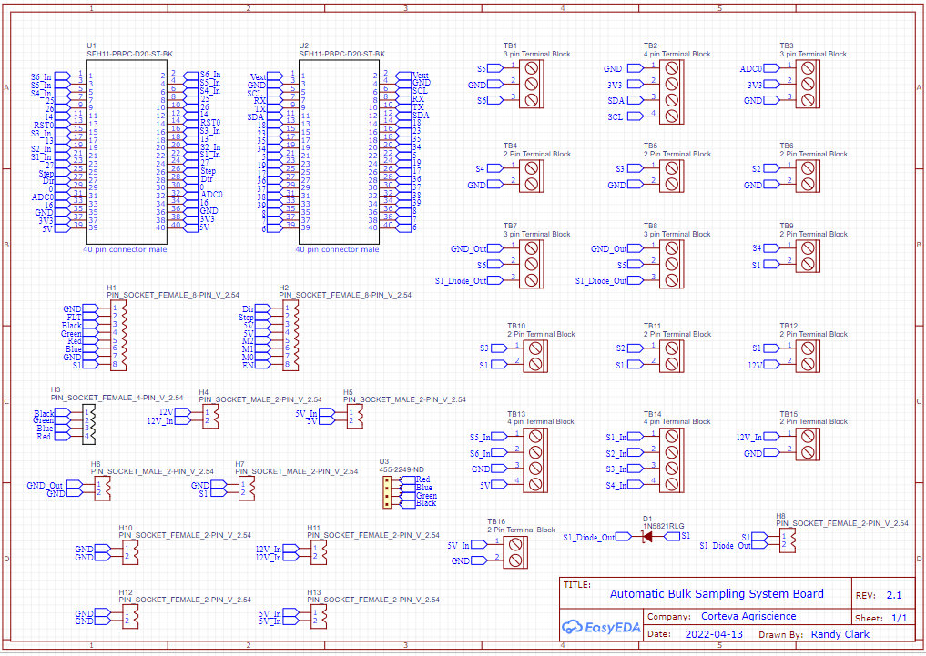
B)
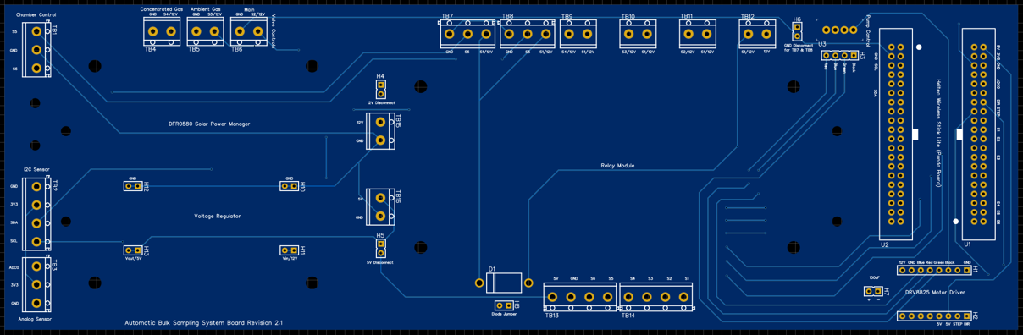
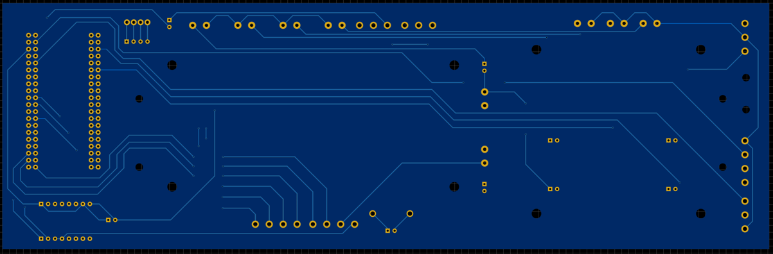

SF3. Schematic of ABSS sampling deployment

SF4. Chamber dosing experiment setup
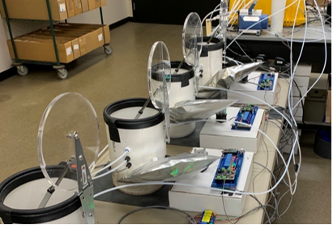

SF5. Assessment of flux results using estimated bulk 2-point samples derived from real-time analyzer data, which as estimates of “expected” bag N2O concentrations given the real-time flux data collected for each chamber. Each point represents a mean hourly flux of N2O over a 2-week period. Circles are sampling period 1; squares are sampling period 2. (A) Mean flux estimated from “expected” bulk versus real-time samples and (B) mean flux estimated from ABSS versus “expected” bulk samples.
Reconstructed bulk samples underestimated N₂O flux by 6% compared with the mean of real-time 4-point flux estimate over the sampling period (slope of difference: -0.063, std error: 0.002, p<0.001, R²: 0.99, Figure SF5A; Table 3). By relying on a common underlying dataset, we can conclude that this error is derived exclusively from the different flux calculation approaches. Comparing hourly flux estimated from ABSS samples with that of reconstructed bulk samples, ABSS displayed high precision (R²: 0.97, Figure 4B) but had an underestimation bias of 20% (slope of difference: -0.196, std error: 0.044, p=0.002, R²: 0.68).

SF6. (A) Map of location used to estimate potential air density variation effect on ABSS N2O flux measurements (i.e. 2-point bulk sampling methodology). Red dots correspond to locations where weather data was extracted. At each point, hourly air density from 2-week periods across 10 years (2013-2023) was sampled for use in simulation modeling. The map areas are outlined and colored by USDA Land Resource Region (https://www.nrcs.usda.gov/resources/data-and-reports/major-land-resource-area-mlra). (B) Histogram of hourly flux readings from field experiment. Each color represents a different binned flux rate category. The distribution of flux rates within each category was used in combination with variations in air density to estimate potential error contribution from air density variability over 2-week sampling periods. (C) Estimated error (% of 2-week flux) of ABSS flux measurements due to air density variation using actual 2-week weather data across 49 different locations in the U.S. (D) Simulation results air density variation effect on ABSS N2O flux measurements. Each color corresponds to a different flux rate category as described in (B). Actual flux rates varied in each category according to the sampled flux data, contributing to the dispersion of the point cloud. Flux error was calculated as the difference between simulated flux measurements with and without accounting for air density variation.

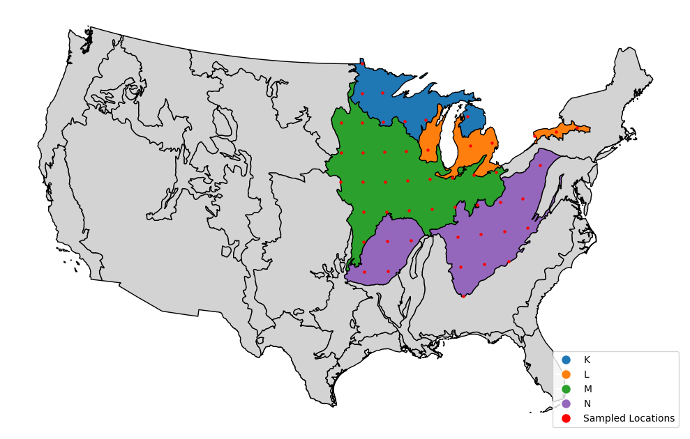

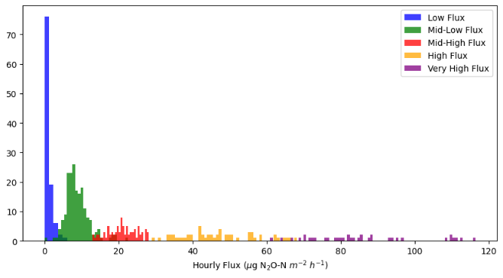

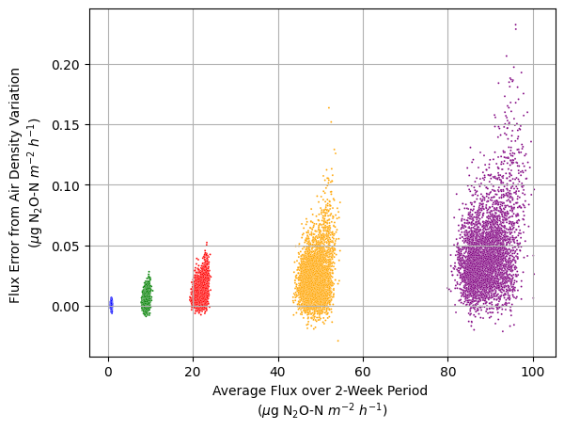
Supplemental Tables

ST1. Synchronized Dosing Cycle Timetable for a Single Cycle in Lab Dosing experiment
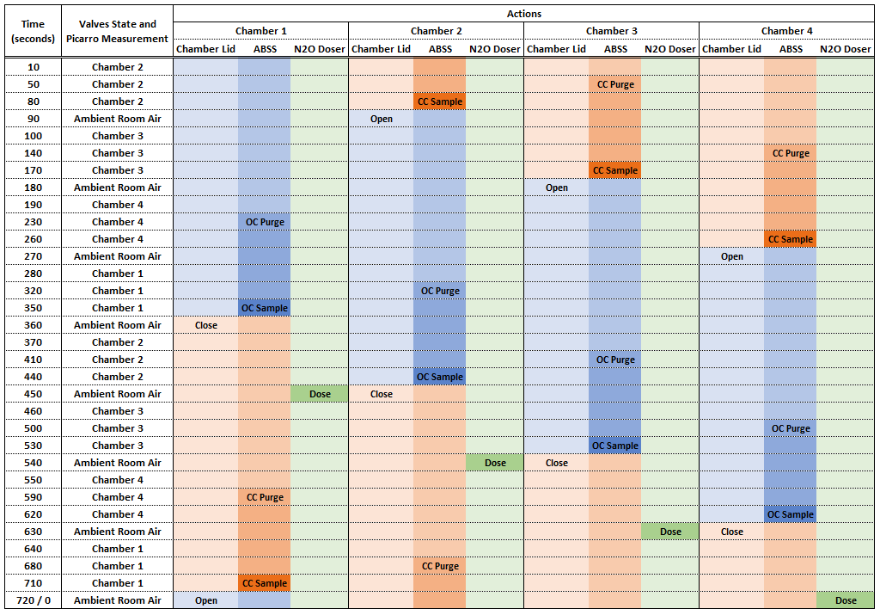

ST2. Synchronized Field Chamber Sampling Timetable for a Single Cycle in 2023
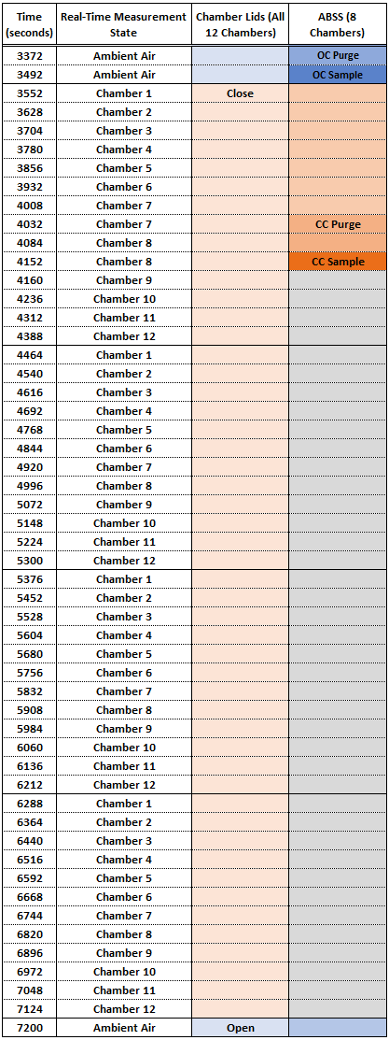
ST3. Paired t-test of N₂O concentrations in ABSS bags compared to real-time analyzer measurements for ambient (open-chamber) readings in lab dosing experiments. The t-statistic and p-value for the difference between the two methods is shown below.
Measurement method | N₂O Concentration (ppb)
ABSS bag | 329.4
Real-time analyzer | 328.2
t₄₄ | 4.56
p | < 0.0001

ST4. Results from N₂O gas stability assessment in ABSS gas collection bags
Days After Filling | Mean N₂O Concentration Change  (ppb) | Standard Deviation of N₂O Concentration Change  (ppb) | Count | Lower 95% CI  (ppb) | Upper 95% CI  (ppb)
1 | -1.240 | 2.747 | 3 | -8.065 | 5.585
7 | 1.087 | 1.124 | 3 | -1.704 | 3.879
15 | 1.034 | 2.431 | 3 | -5.006 | 7.074

