Table of Contents
Supplementary Figures 2
Figure S1: Ancestry forest plots for significant genes 2
Figure S2: Carrier vs. non-carrier comparison for all endophenotypes 23
Figure S3: Allele Age of 40 Significant Genes 43
Figure S4: PC plots 45
Figure S5: Overview of the ADSP R5 callset. 46
Supplementary Material 47
Whole-Genome Sequencing Quality 47
Variant Quality Control 47
Comparisons with Existing Callsets 48
Acknowledgment statement for any data distributed by NIAGADS 48

Supplementary Figures

Figure S1: Ancestry forest plots for significant genes
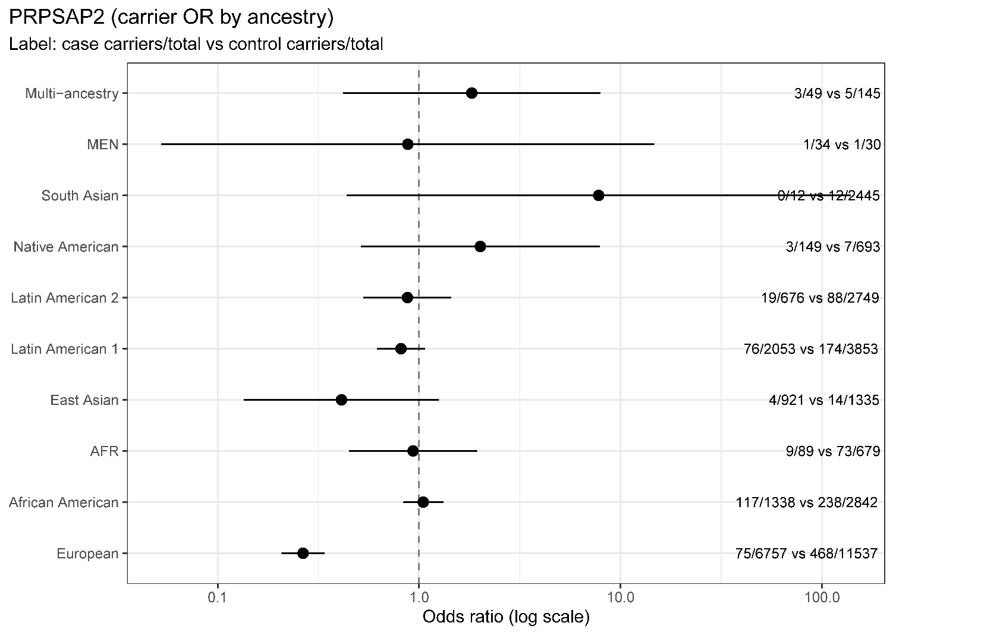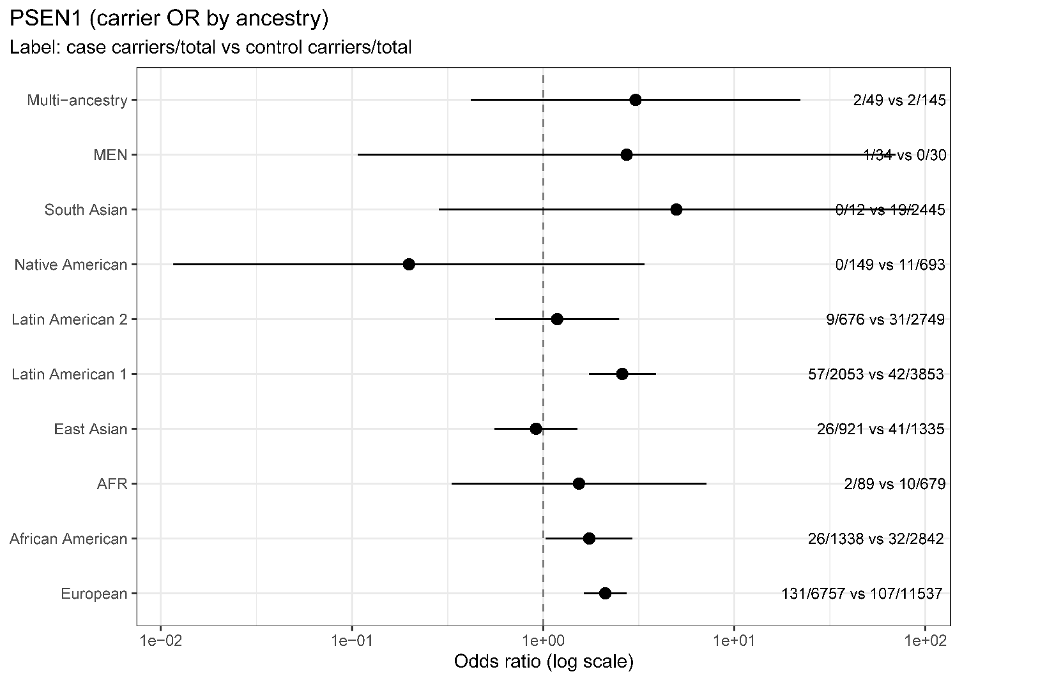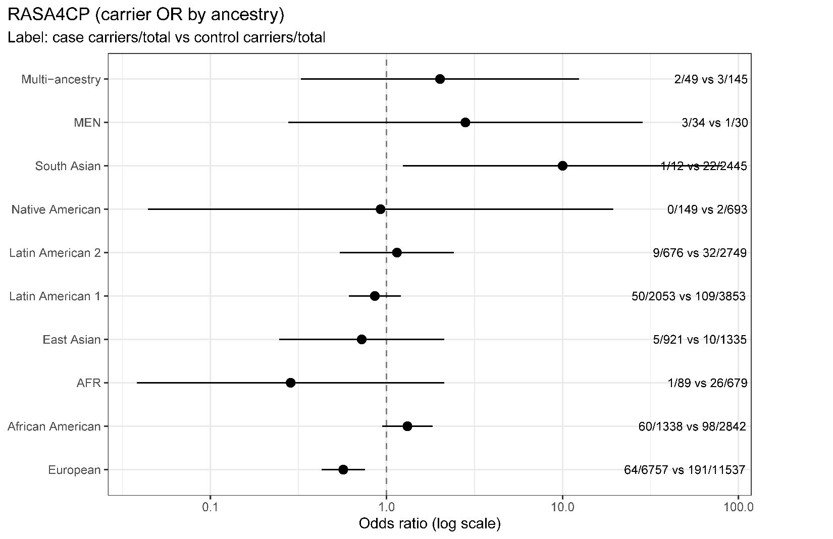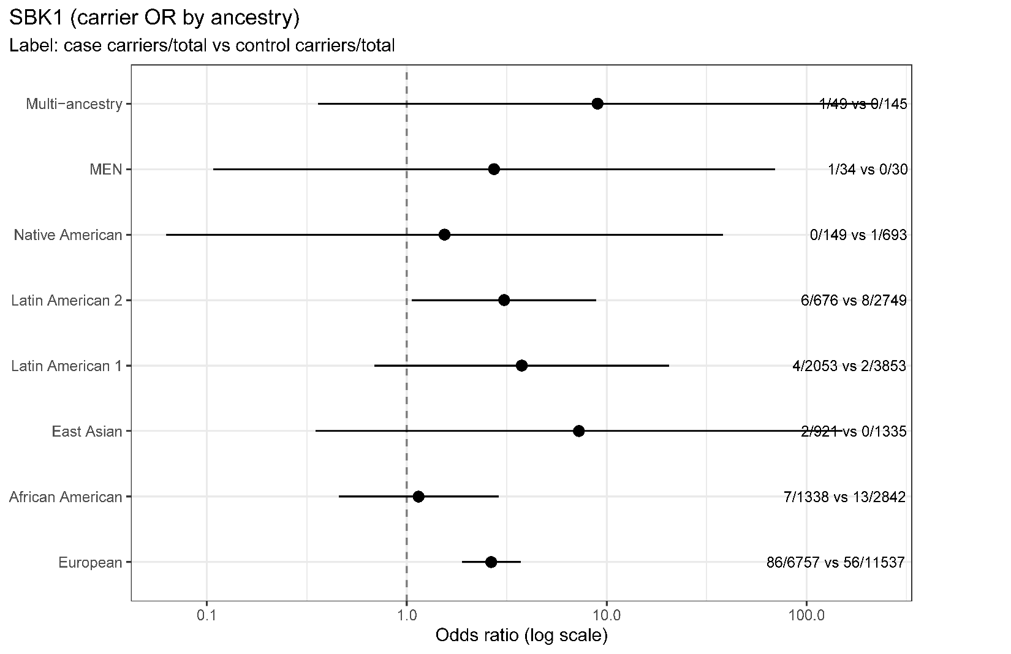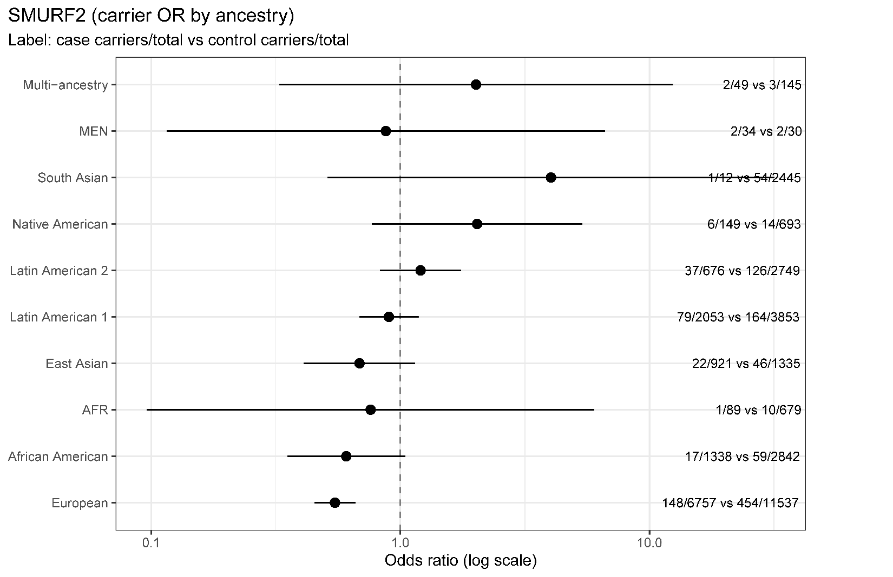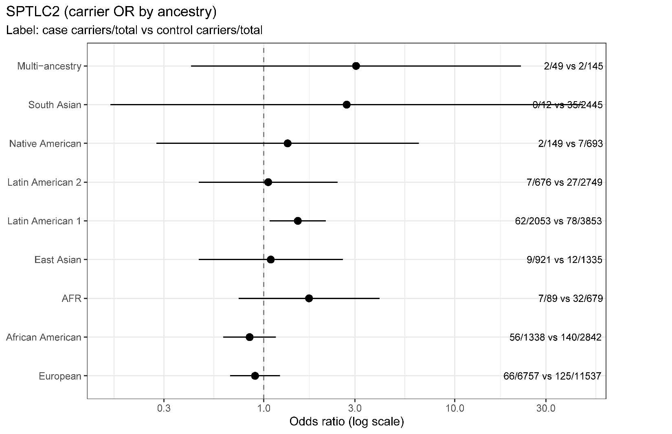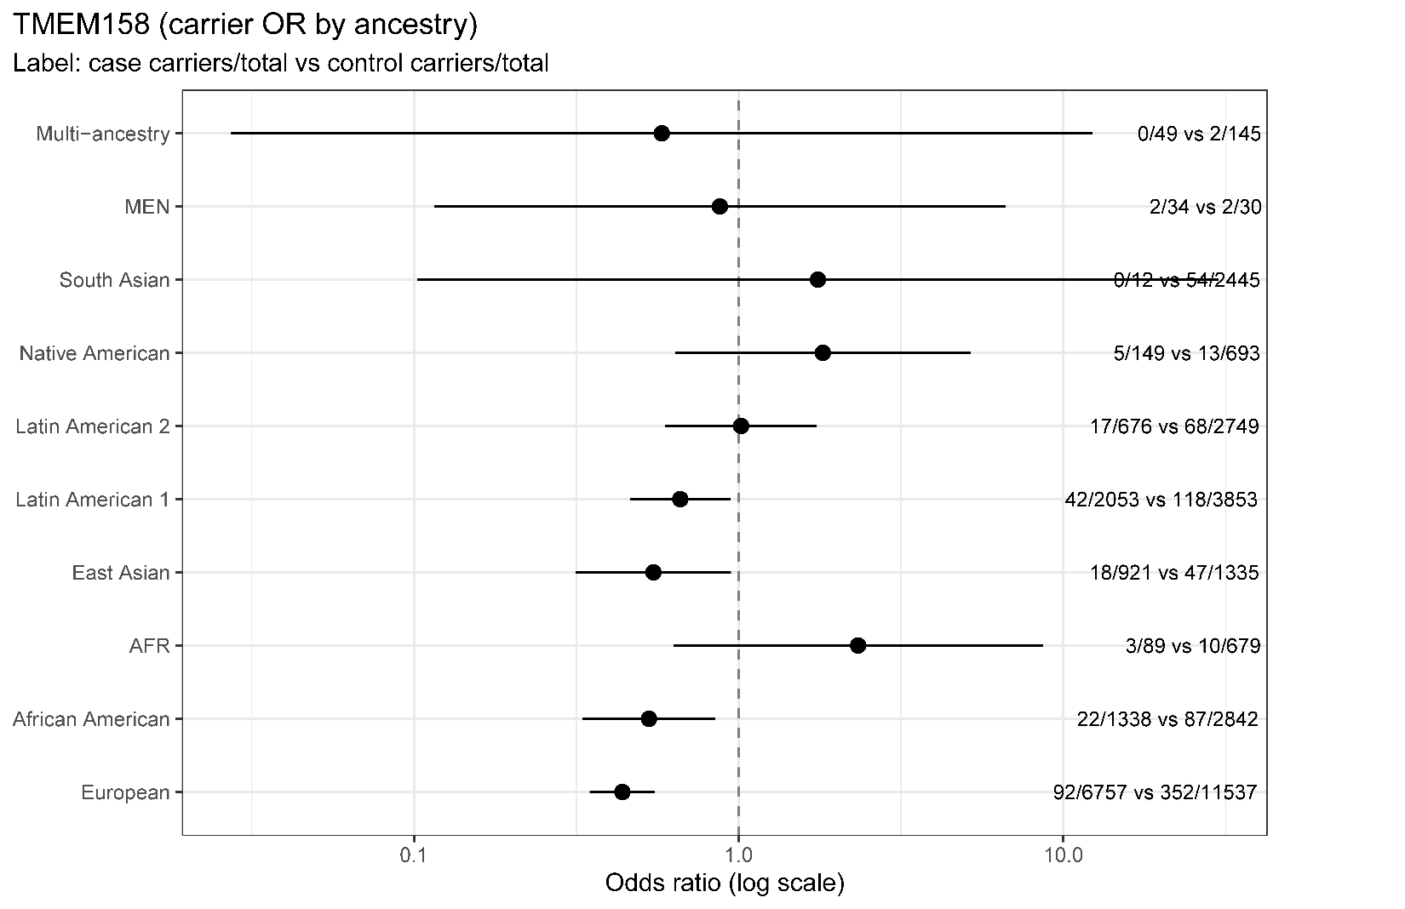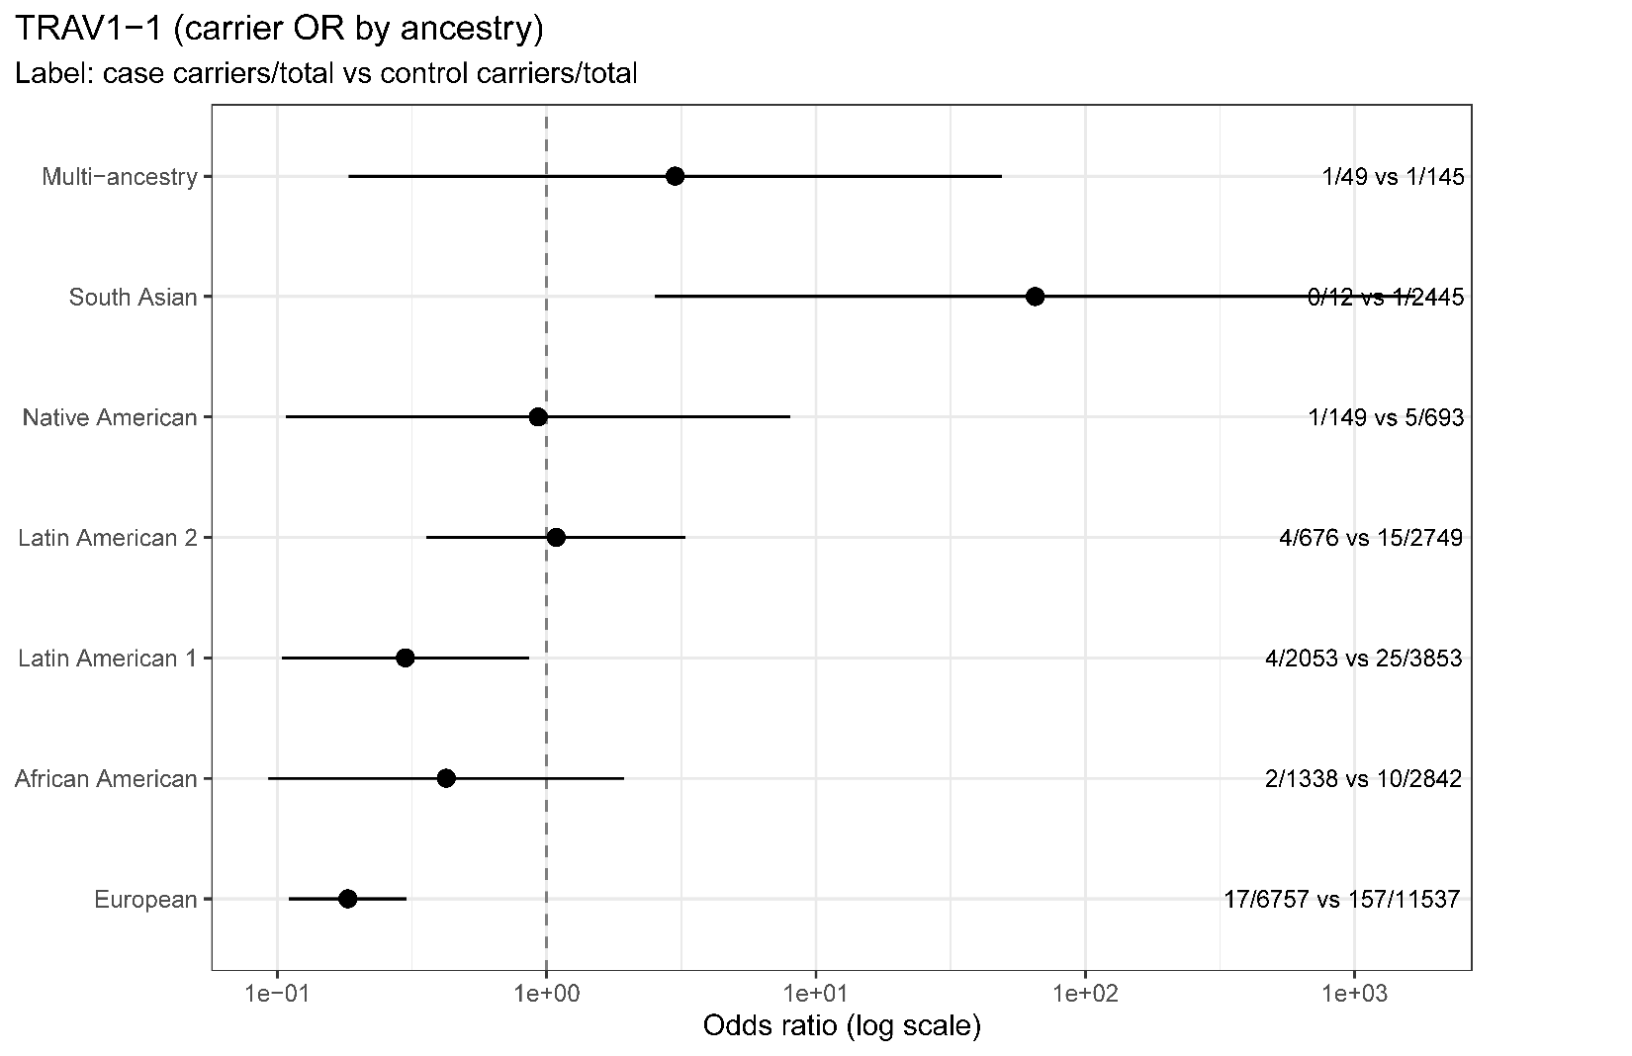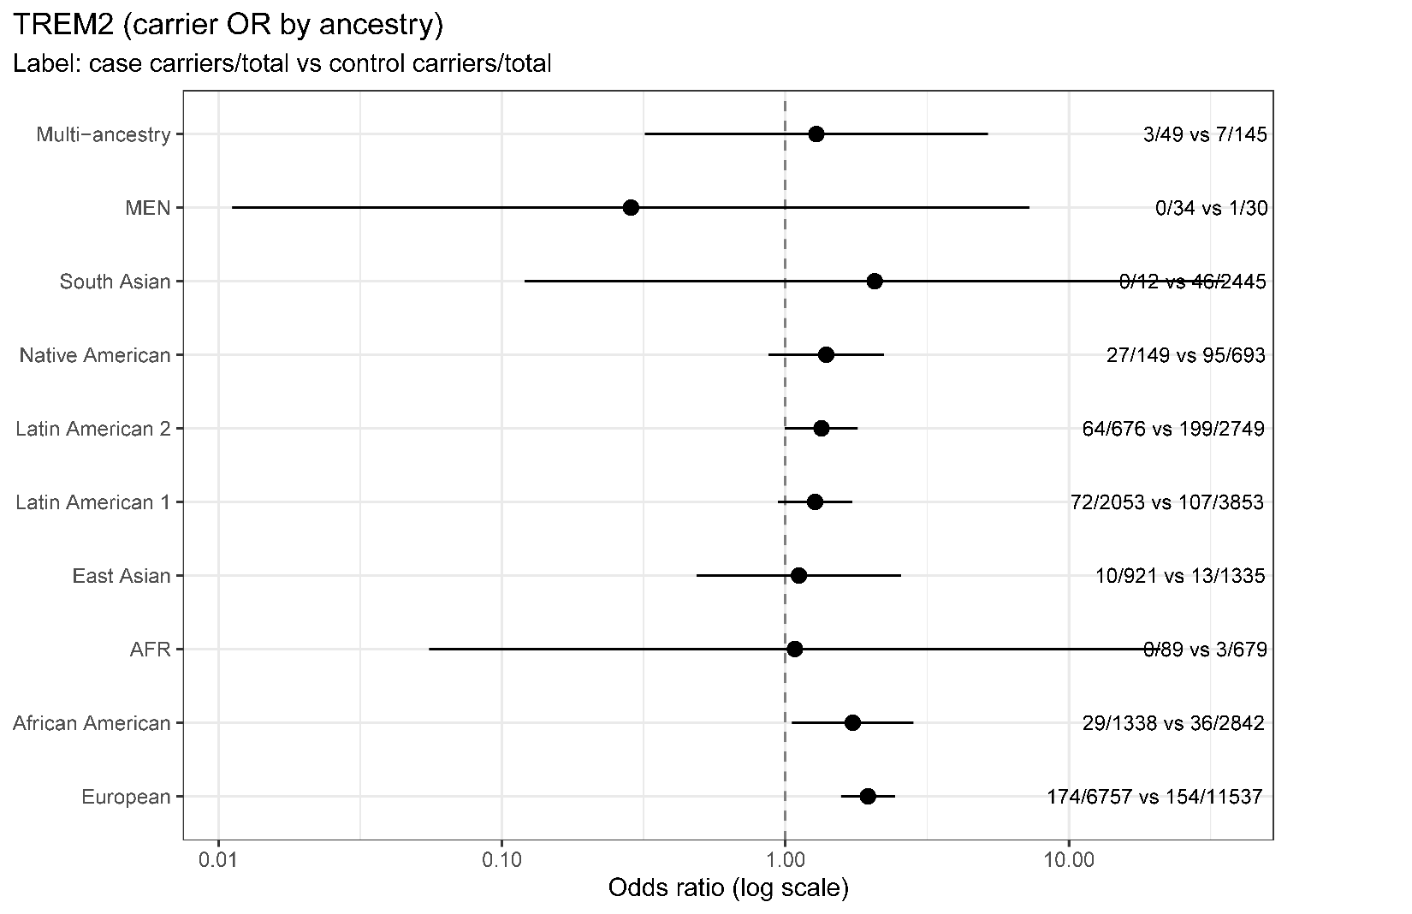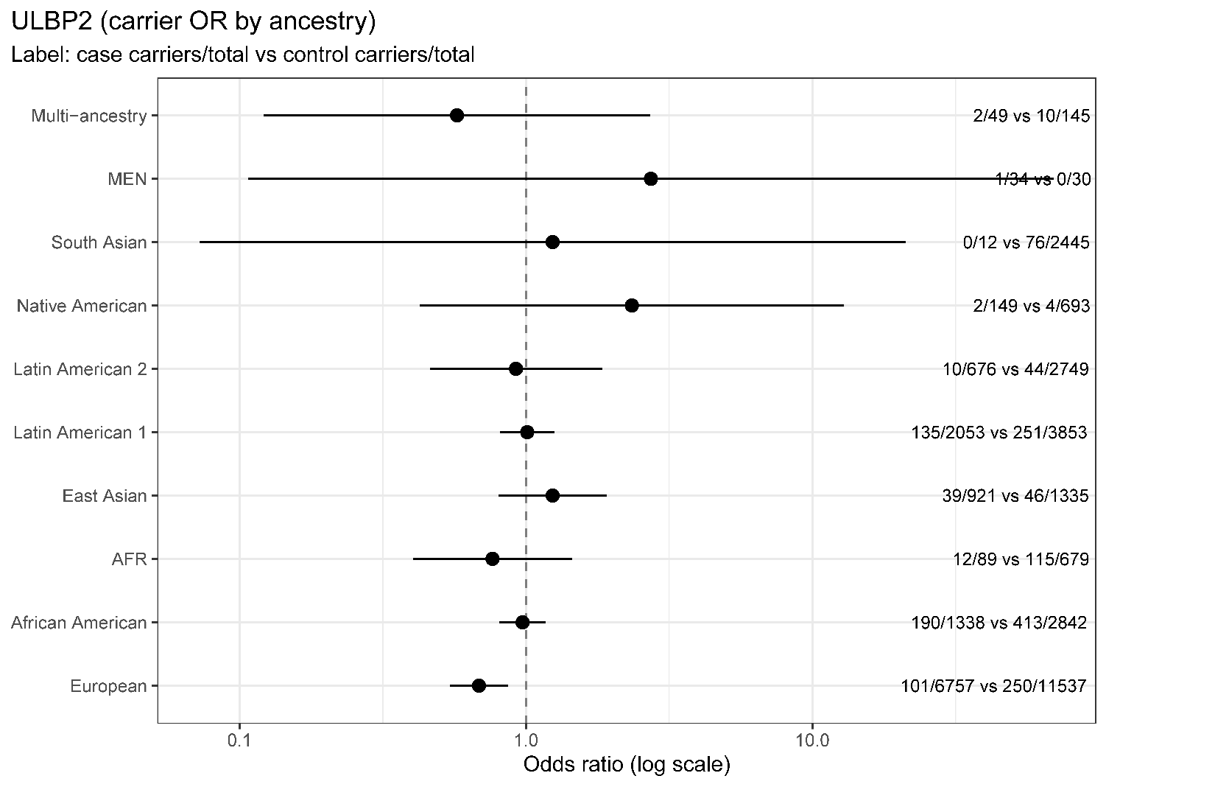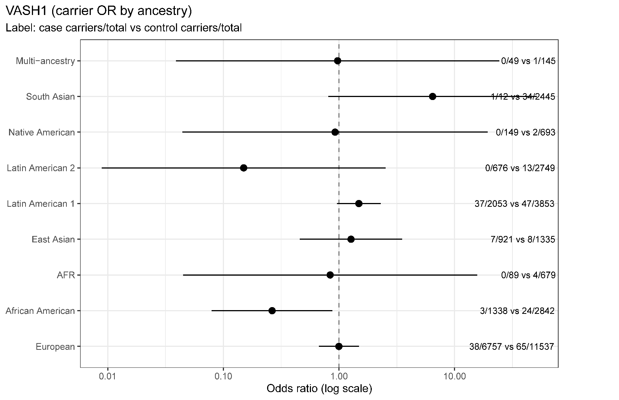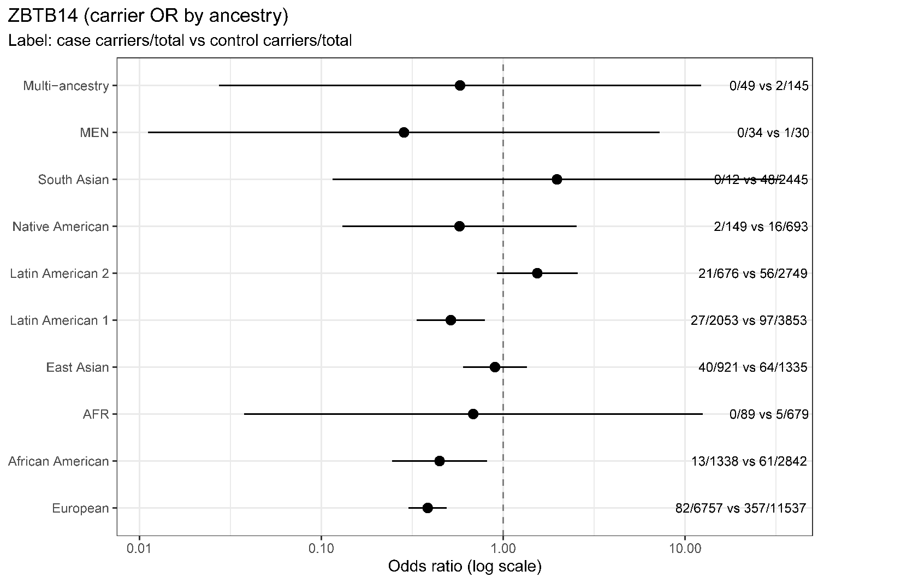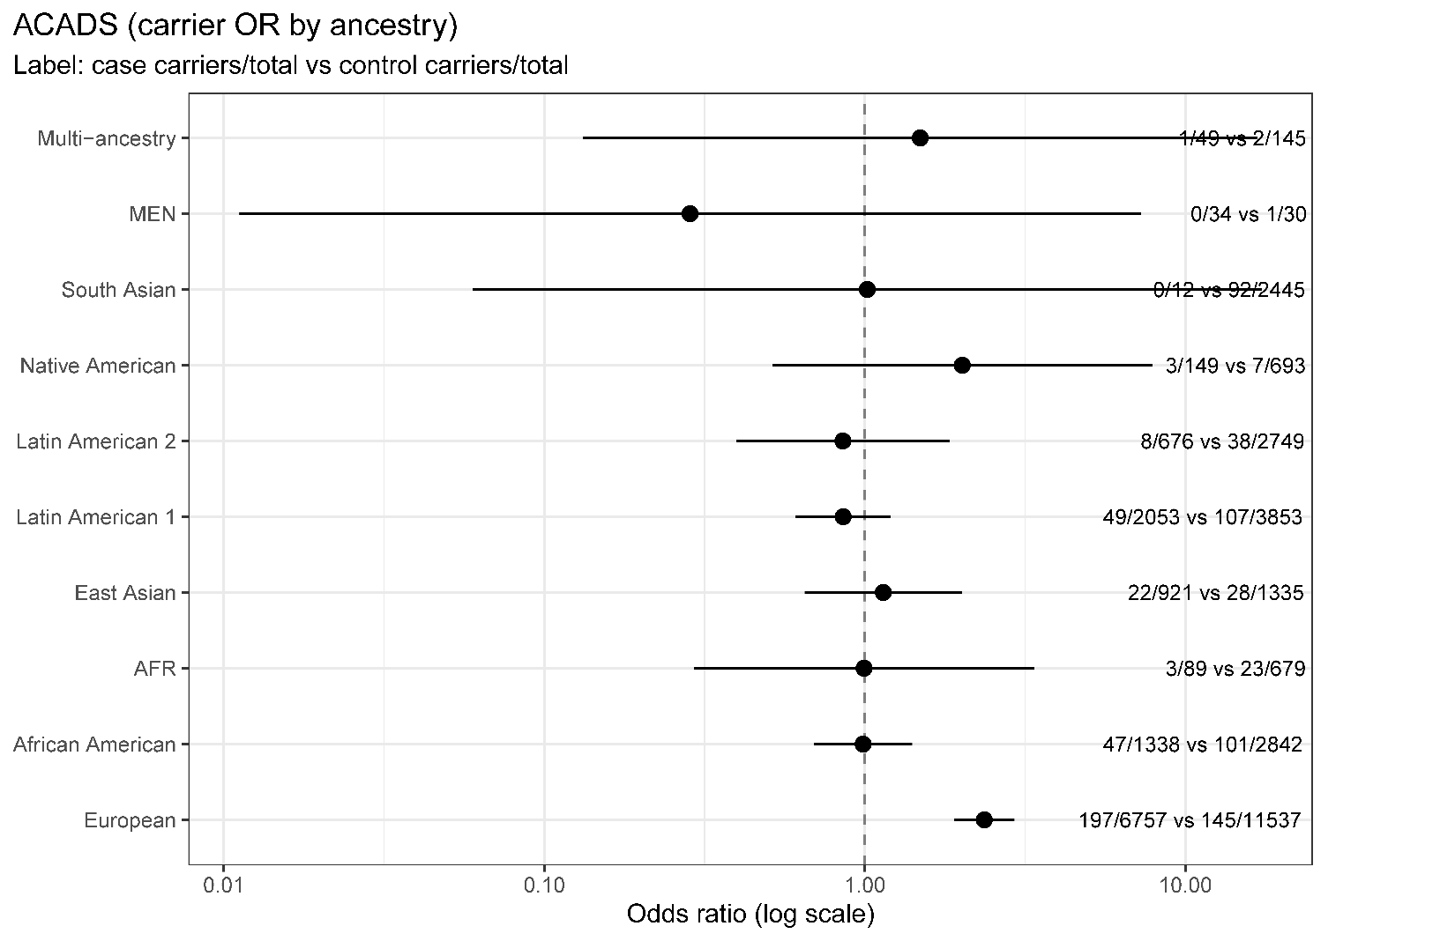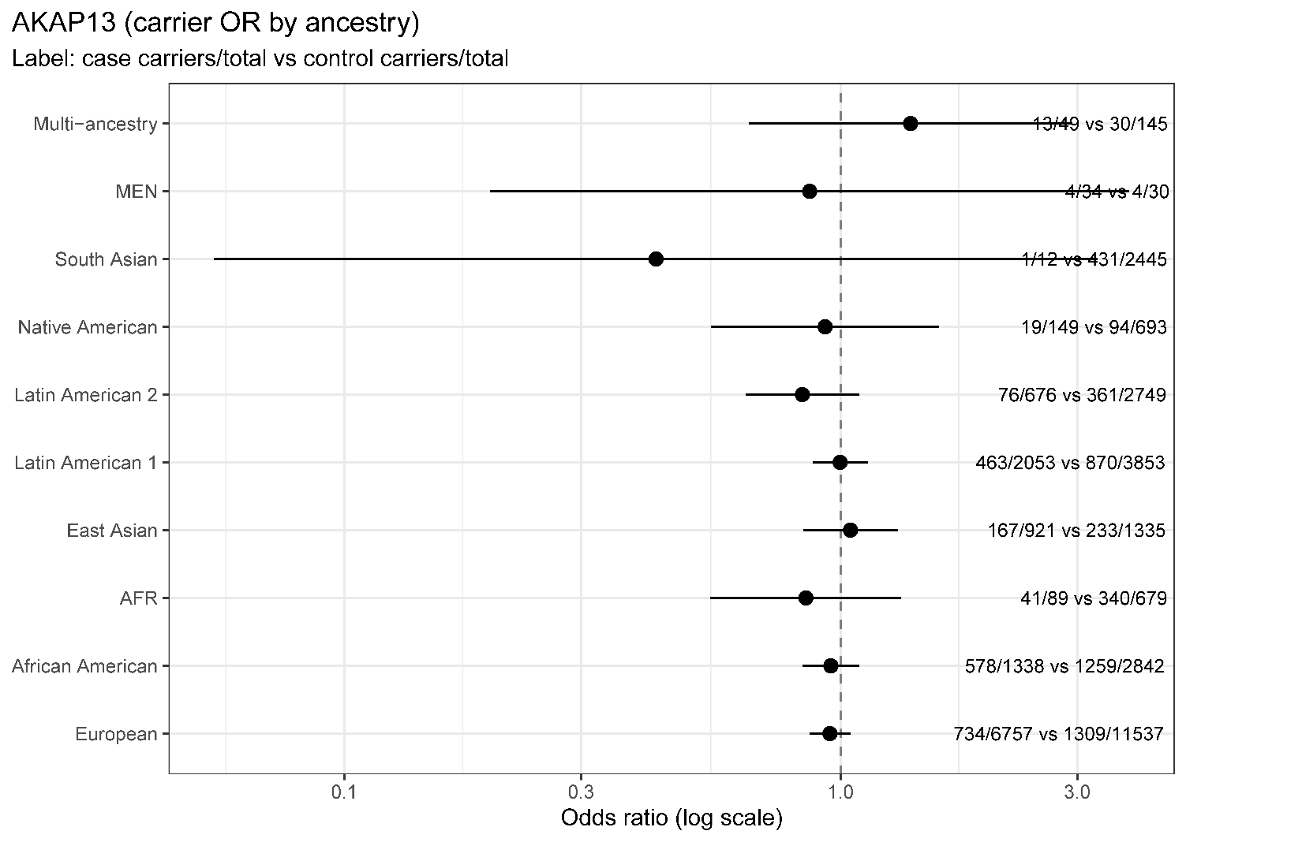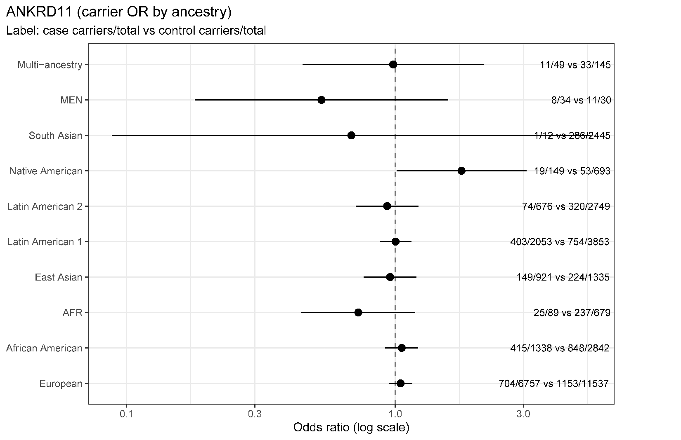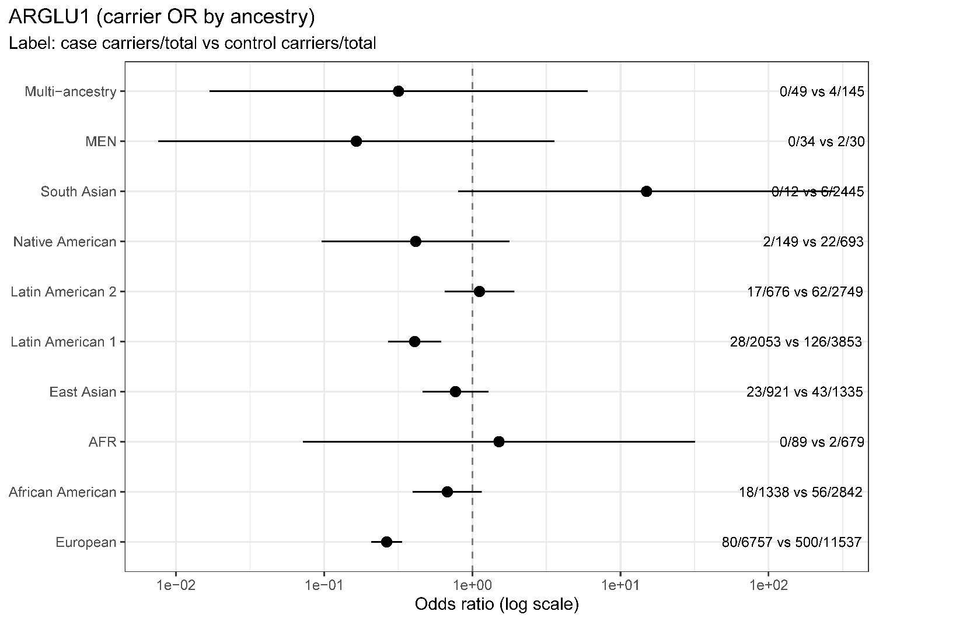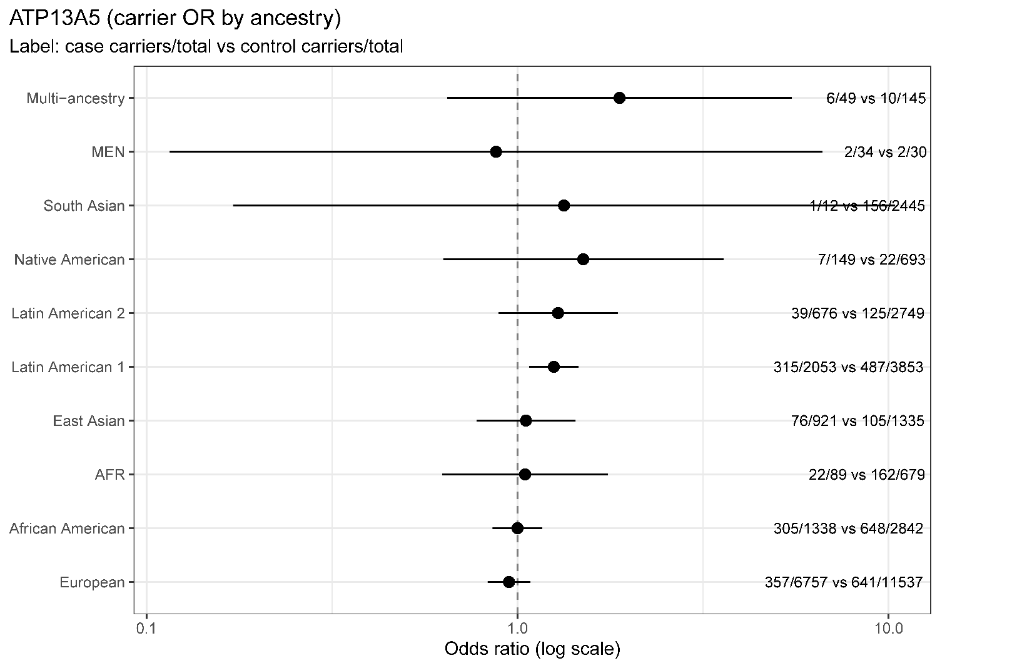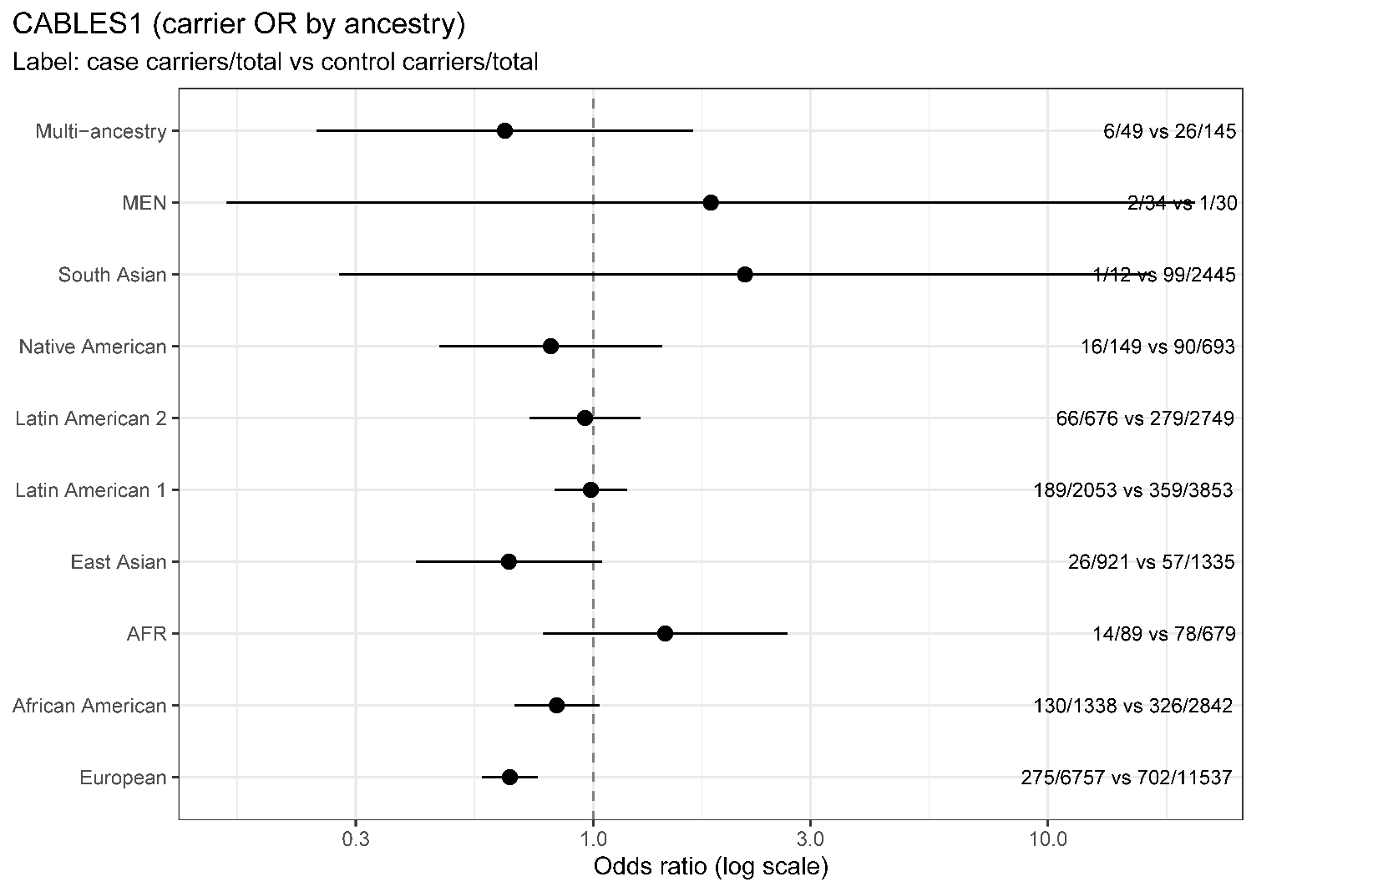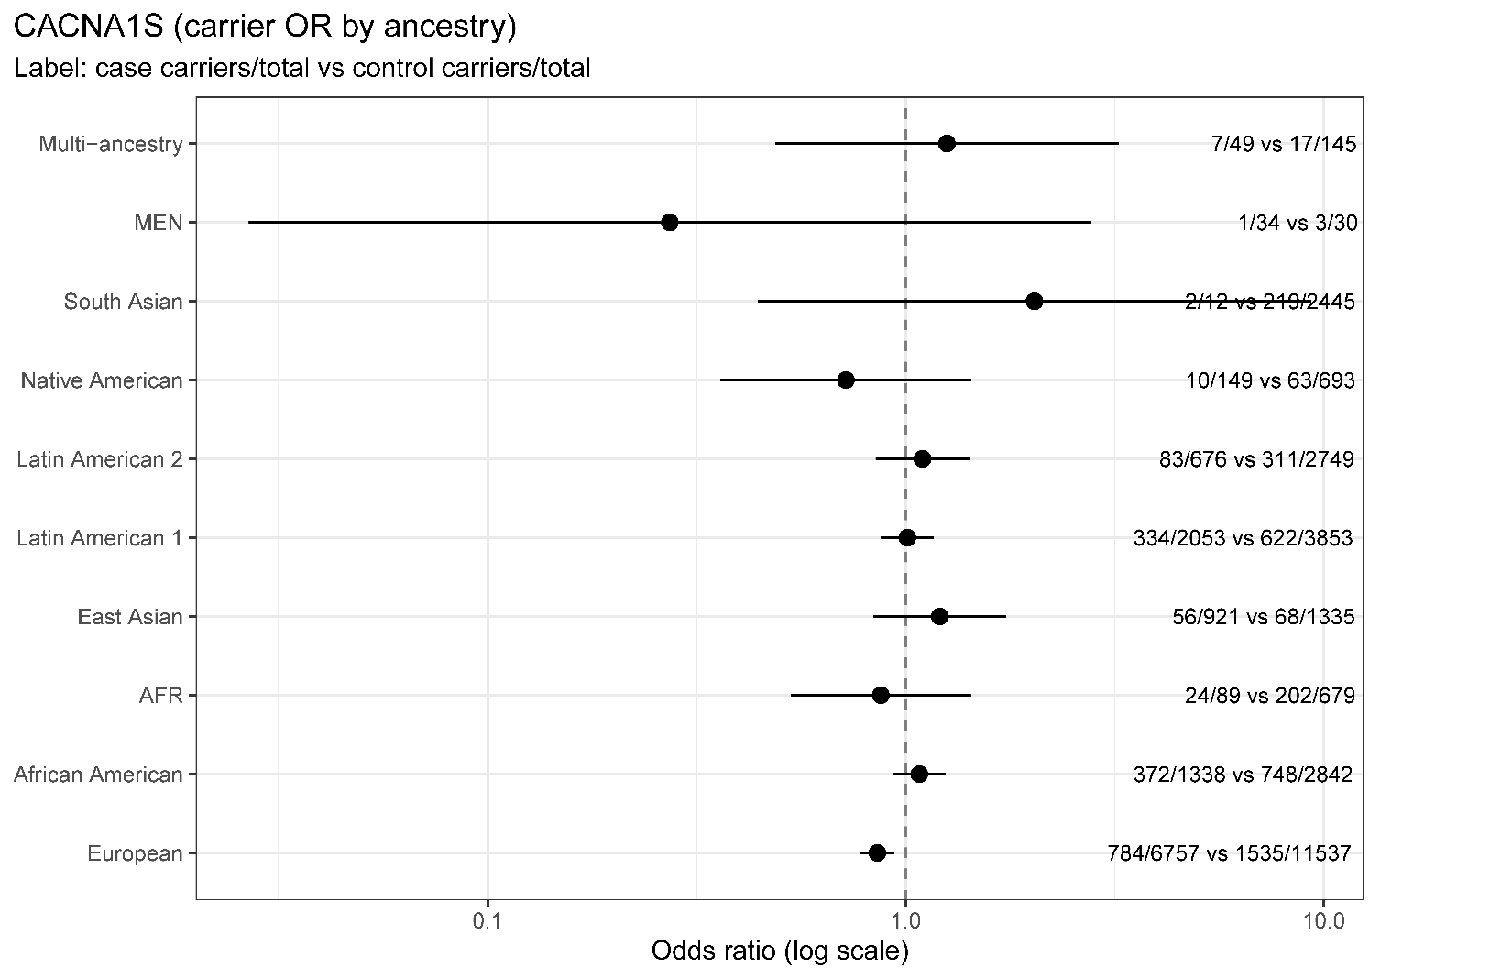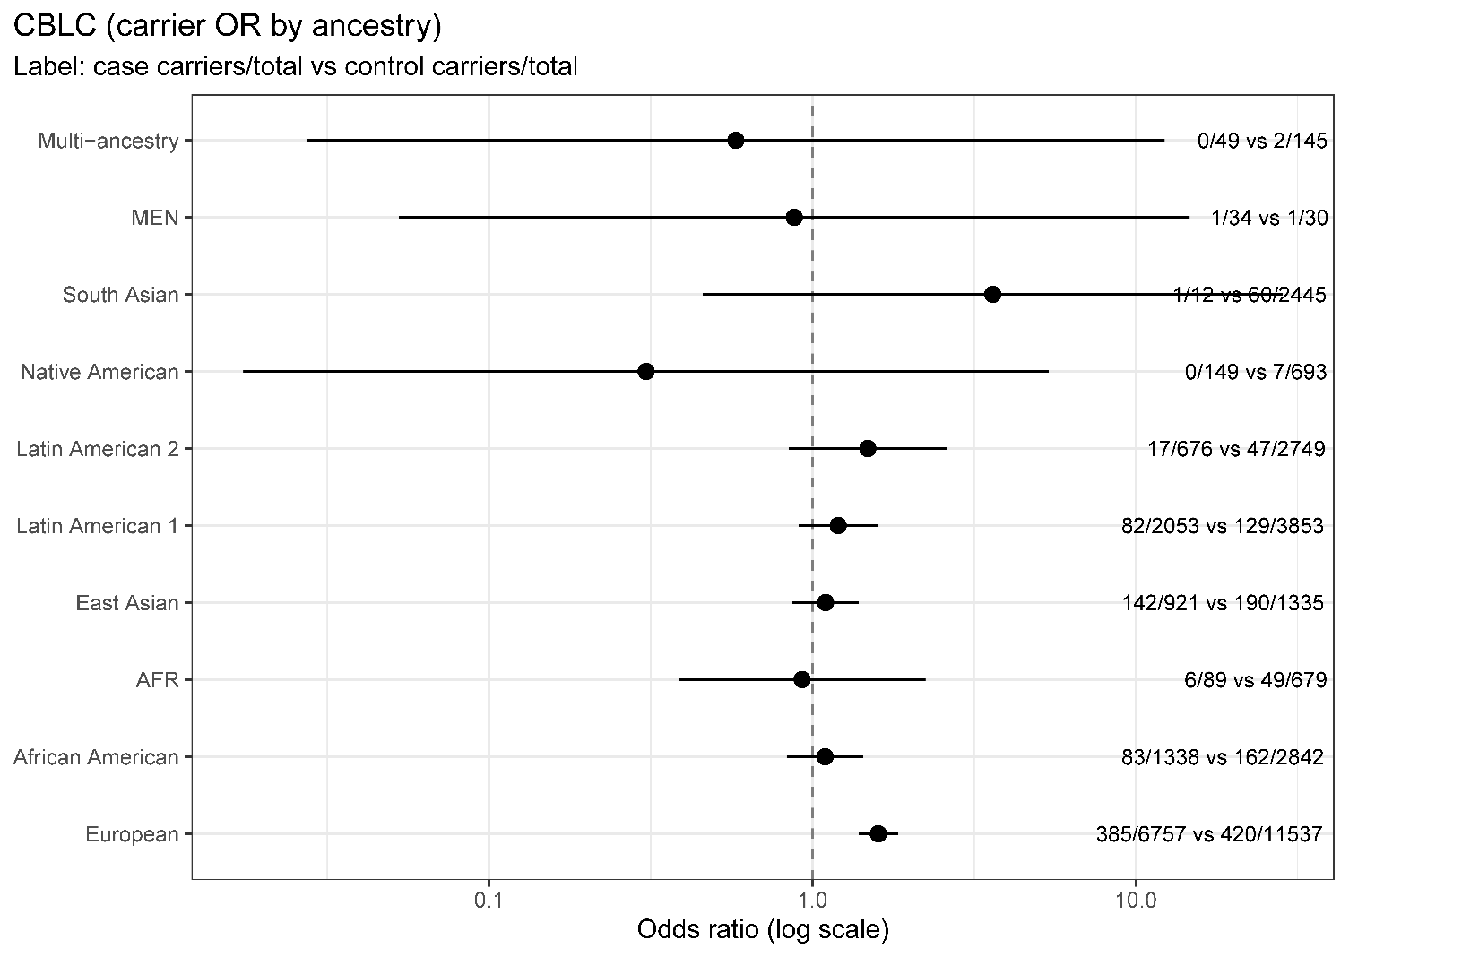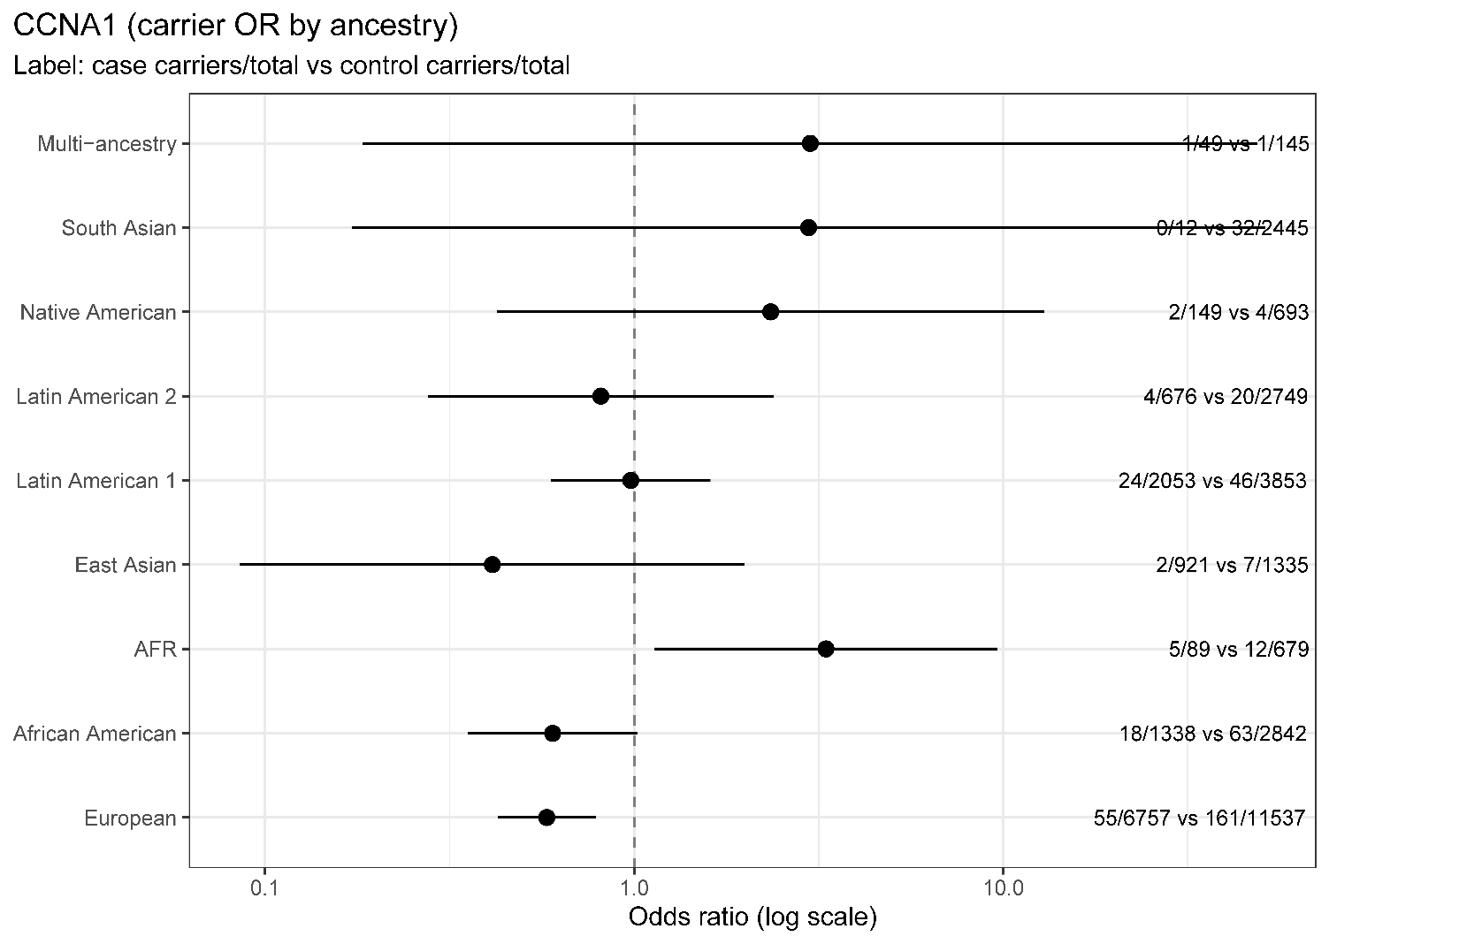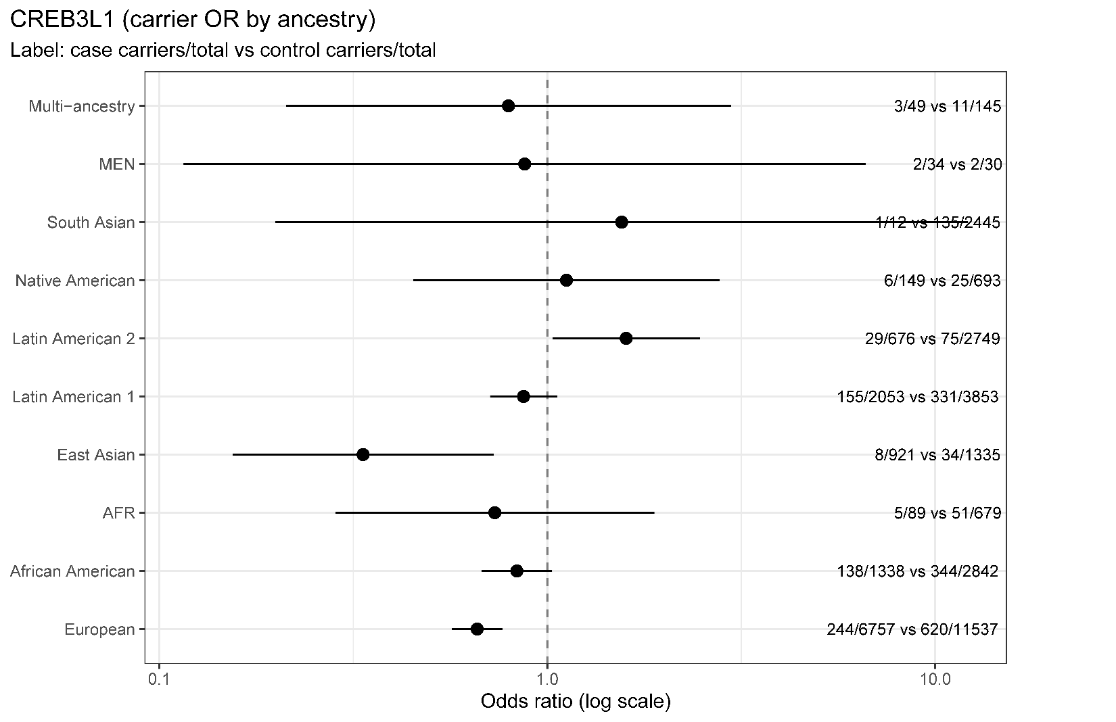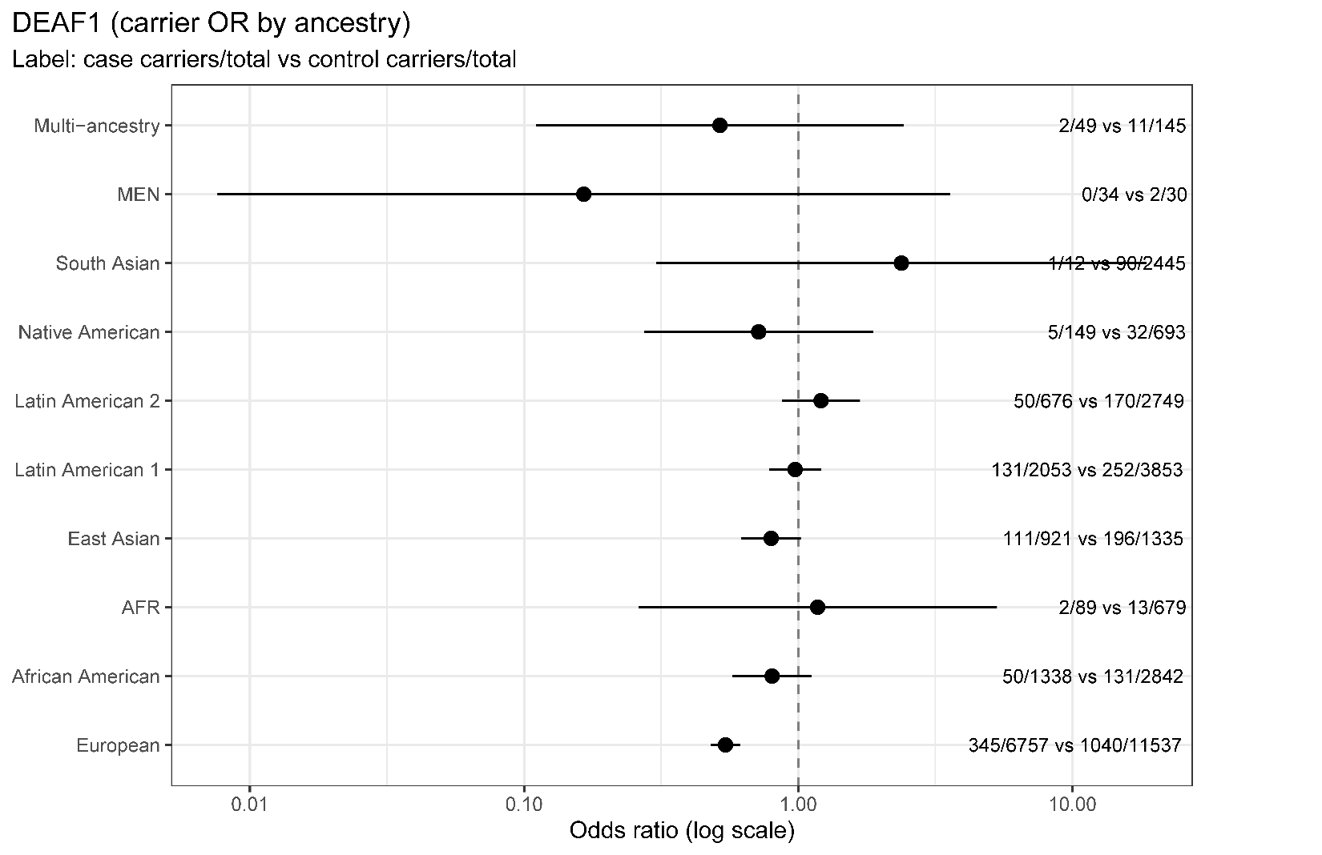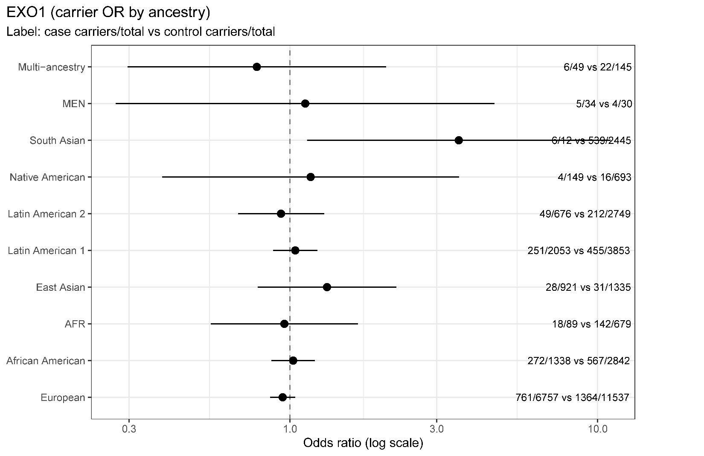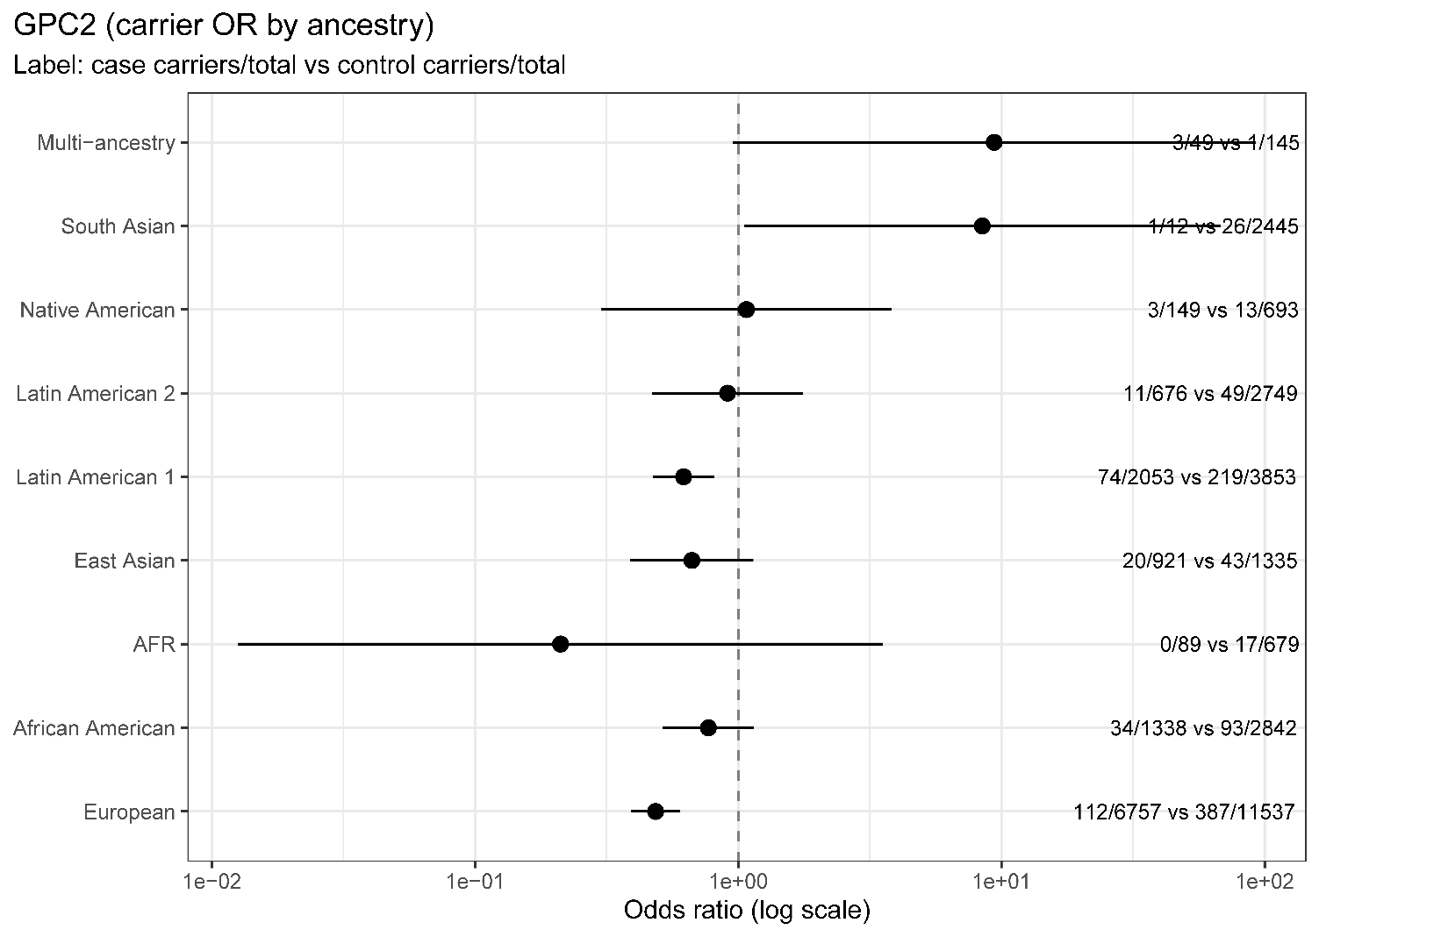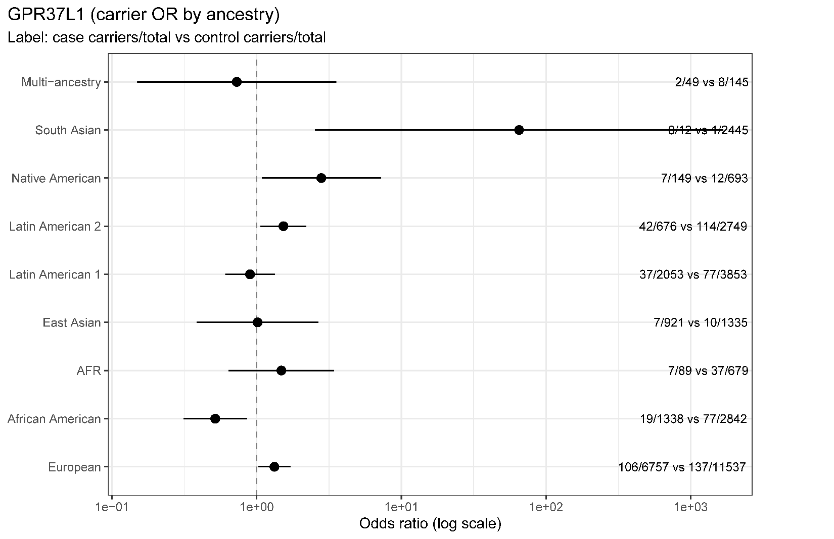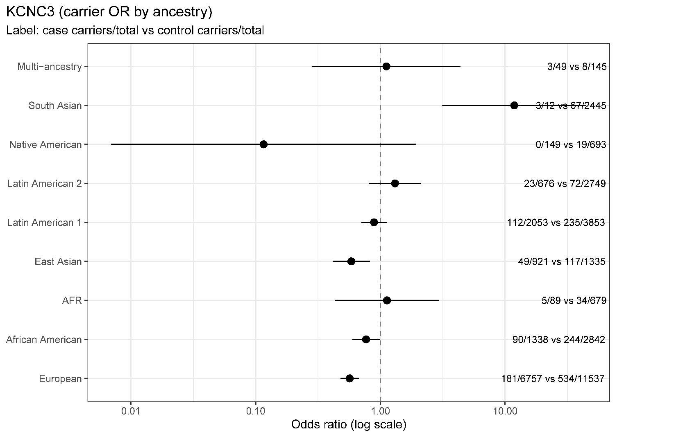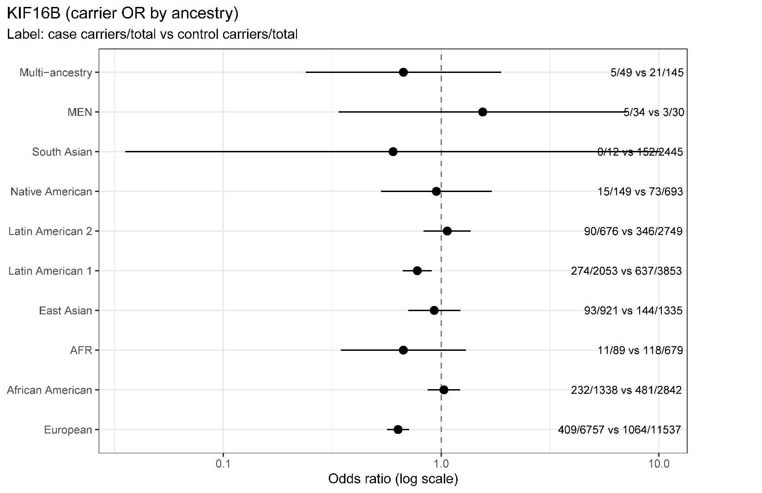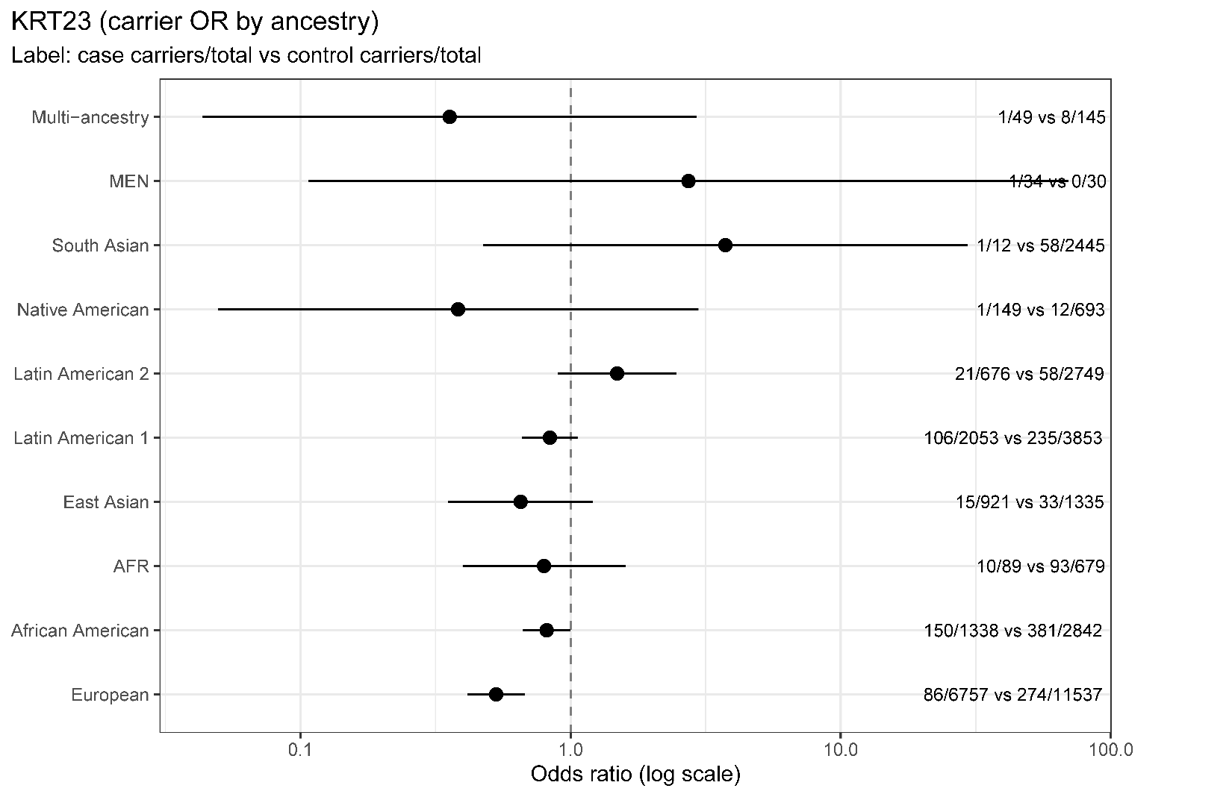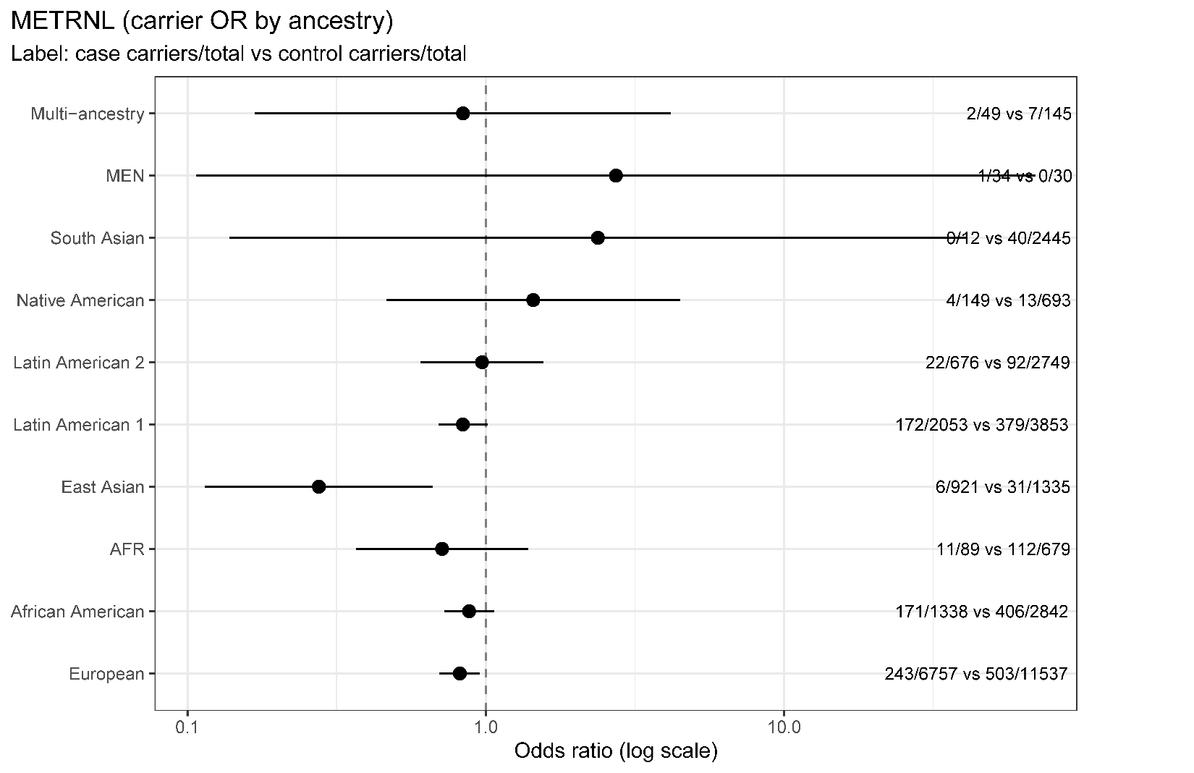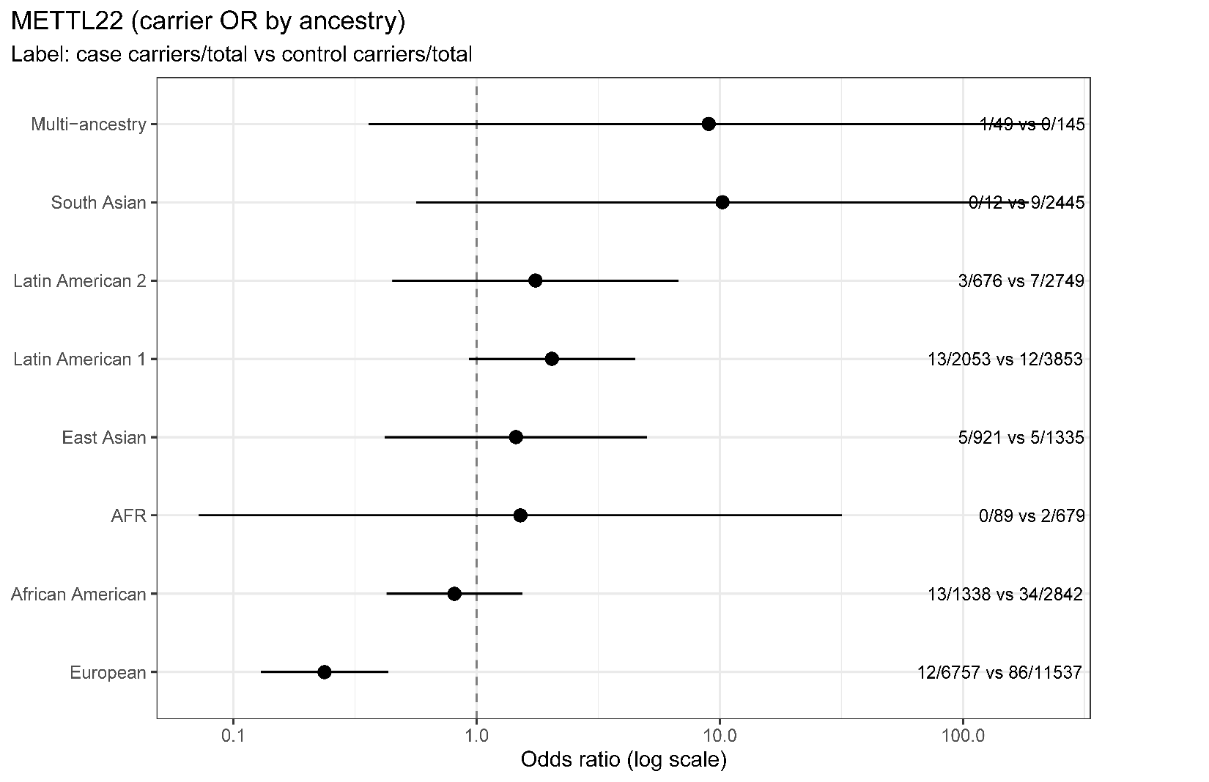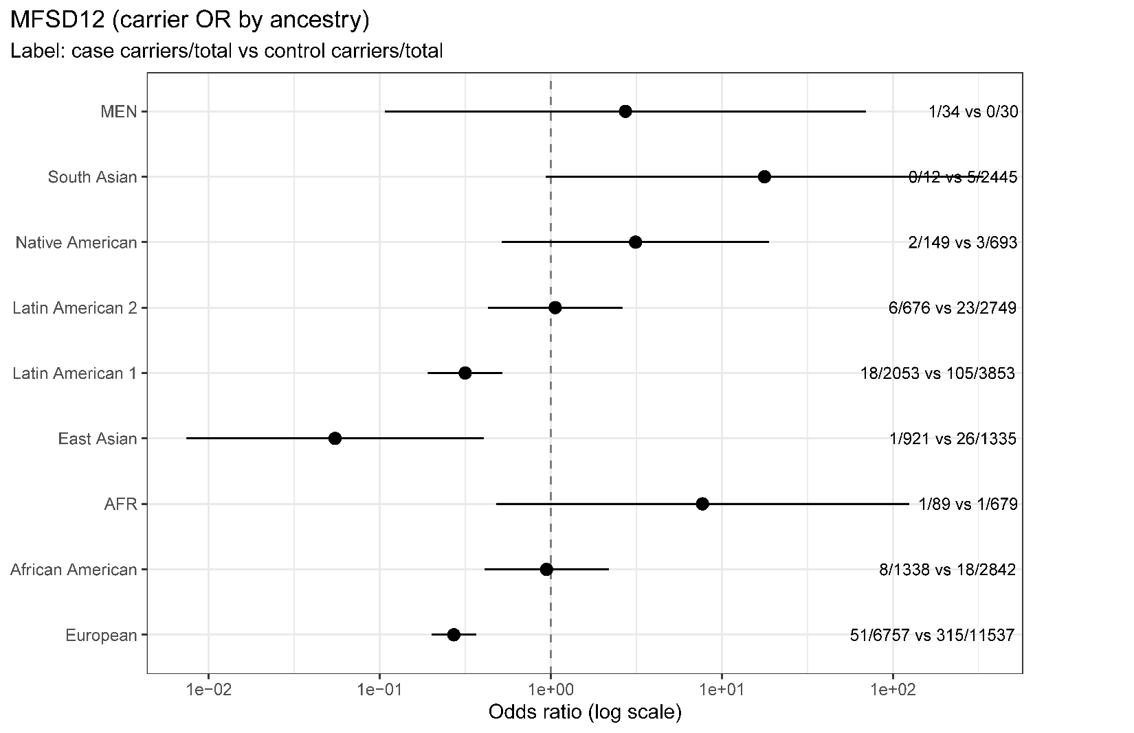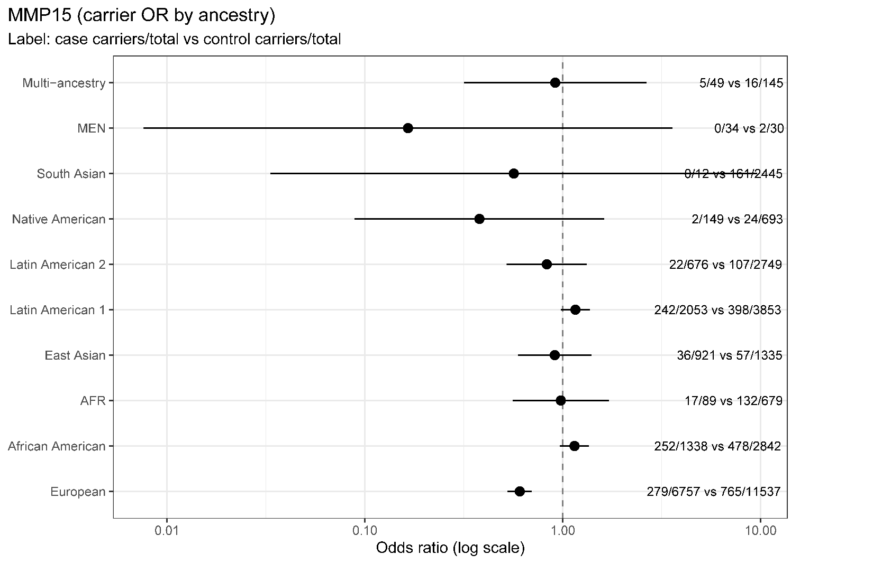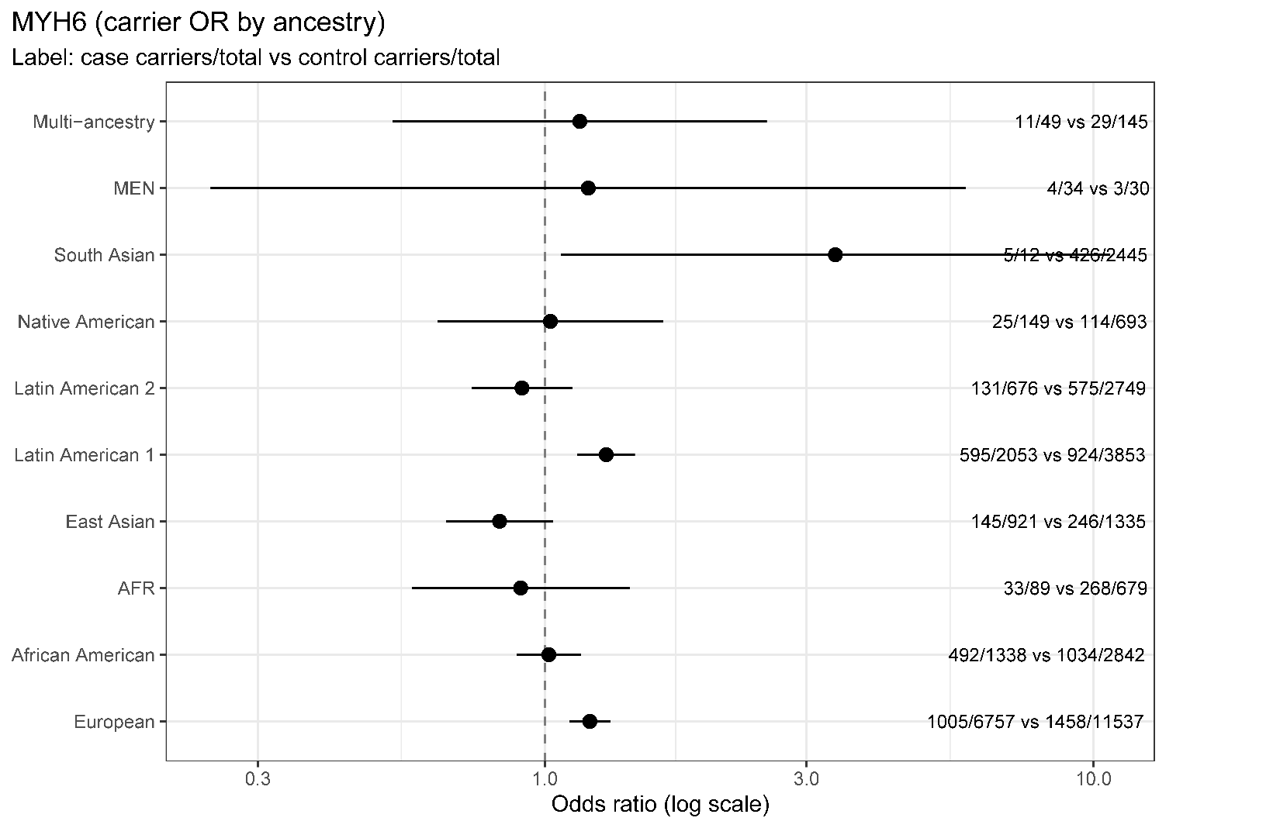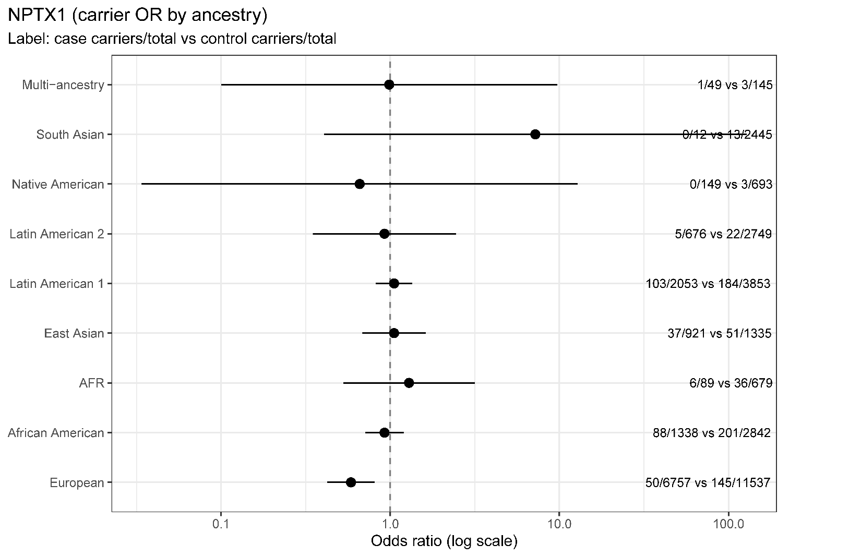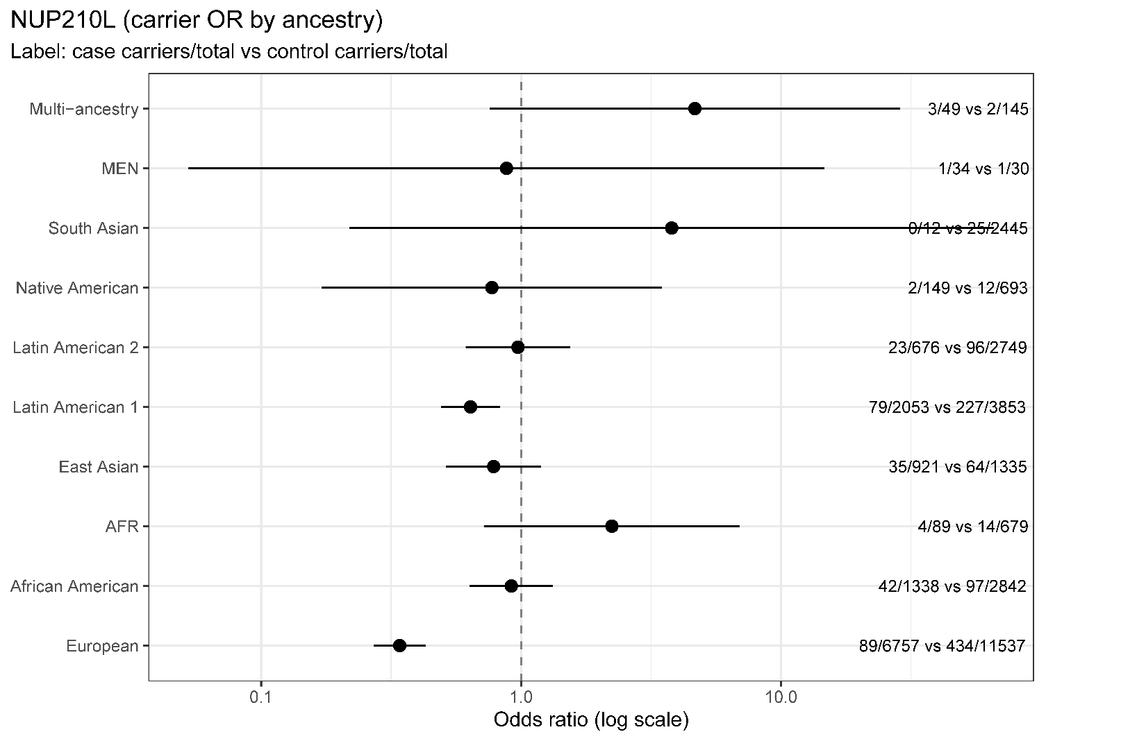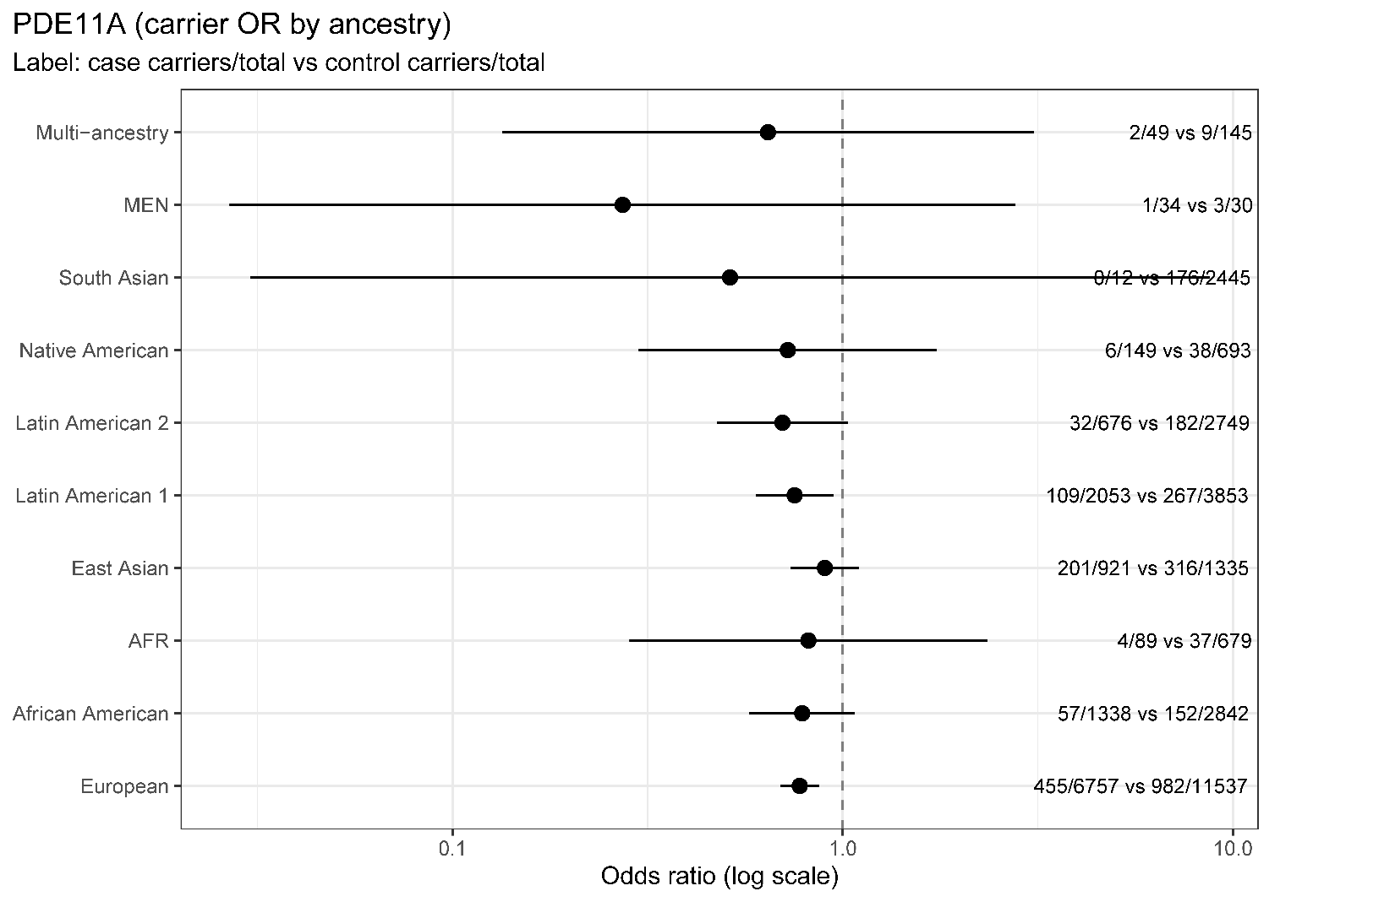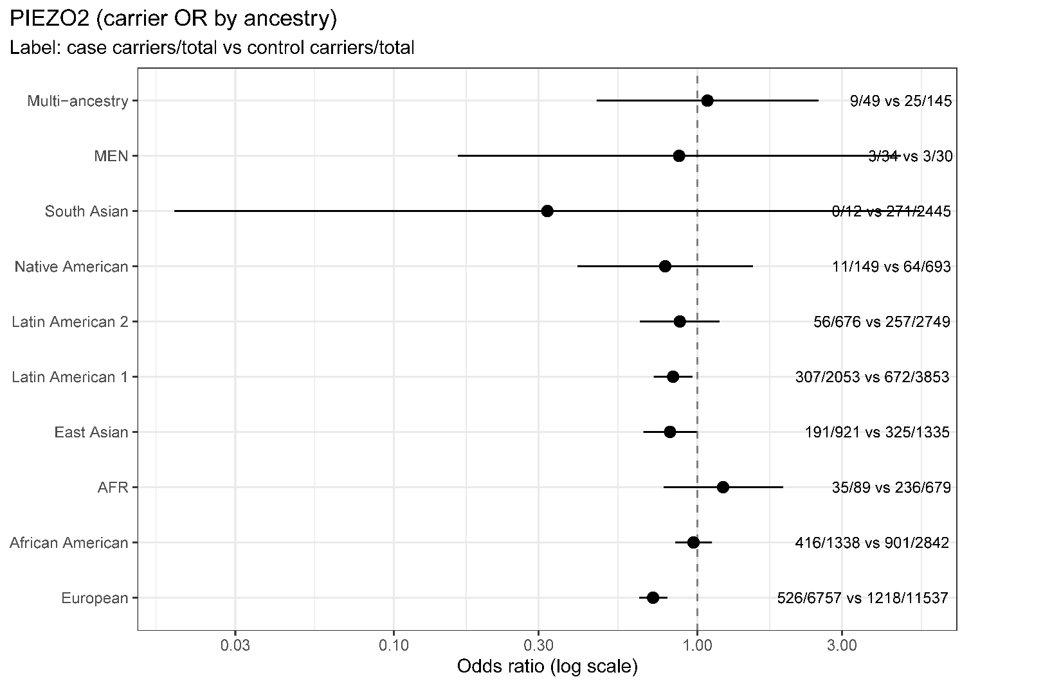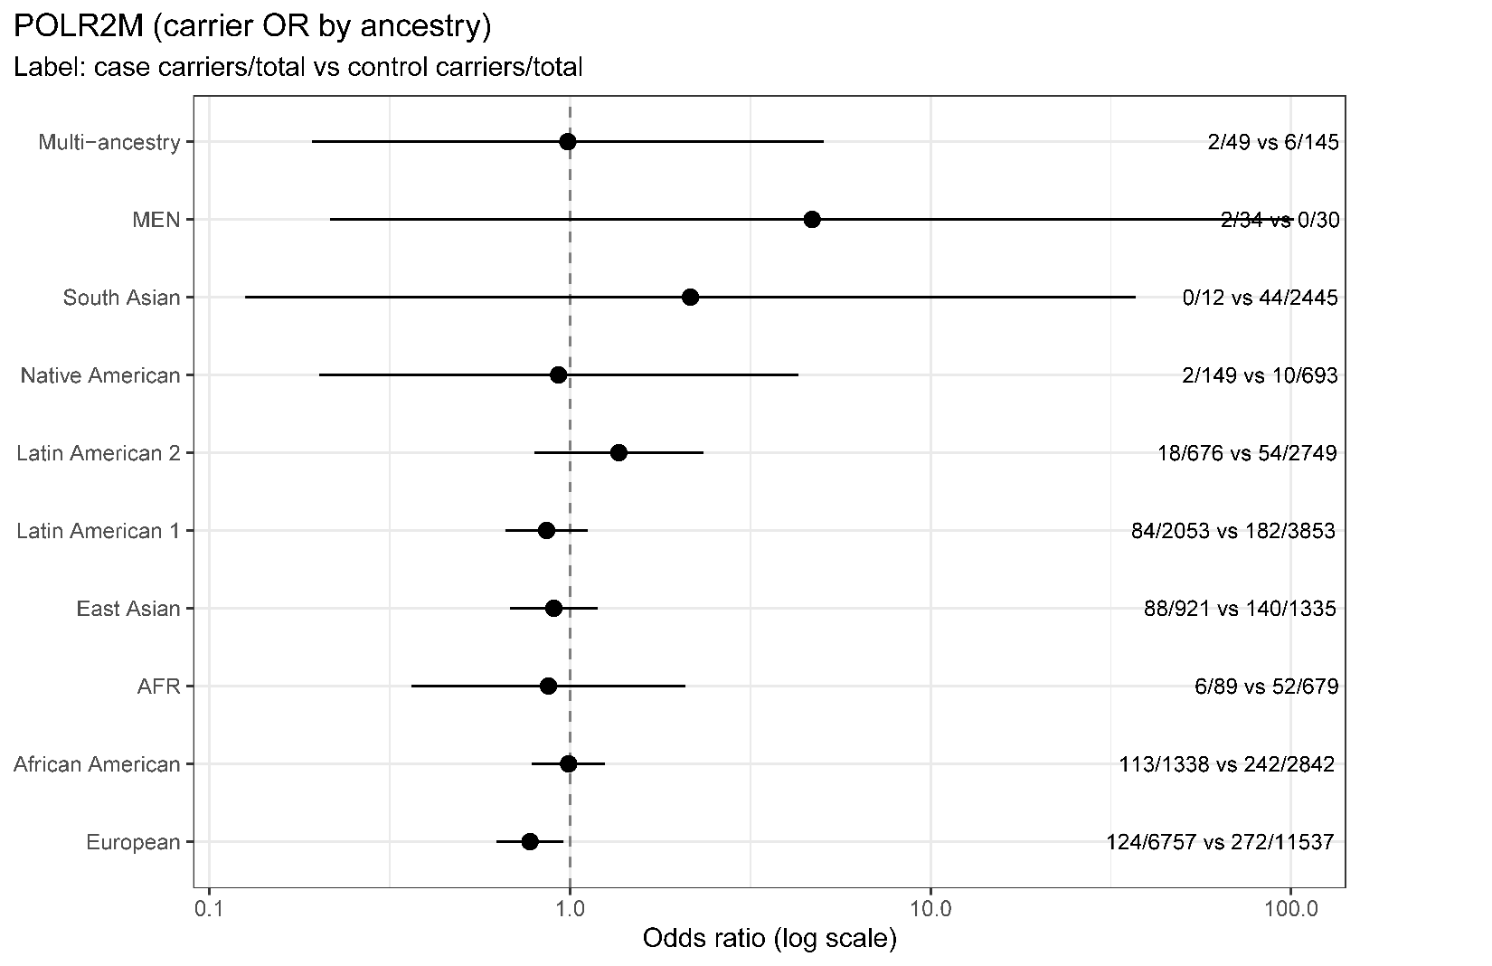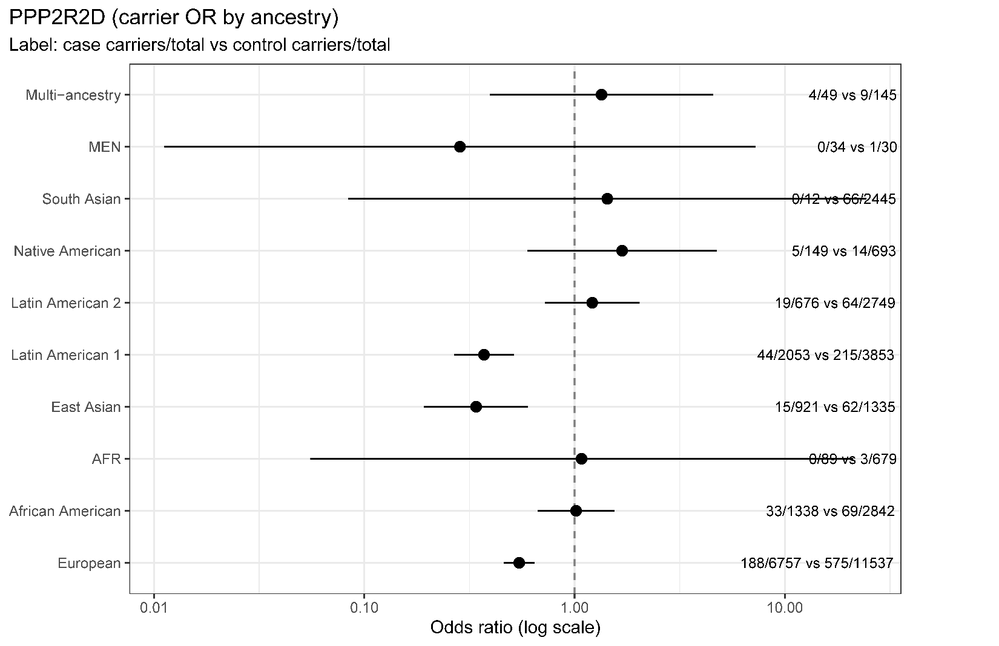

Figure S2: Carrier vs. non-carrier comparison for all endophenotypes
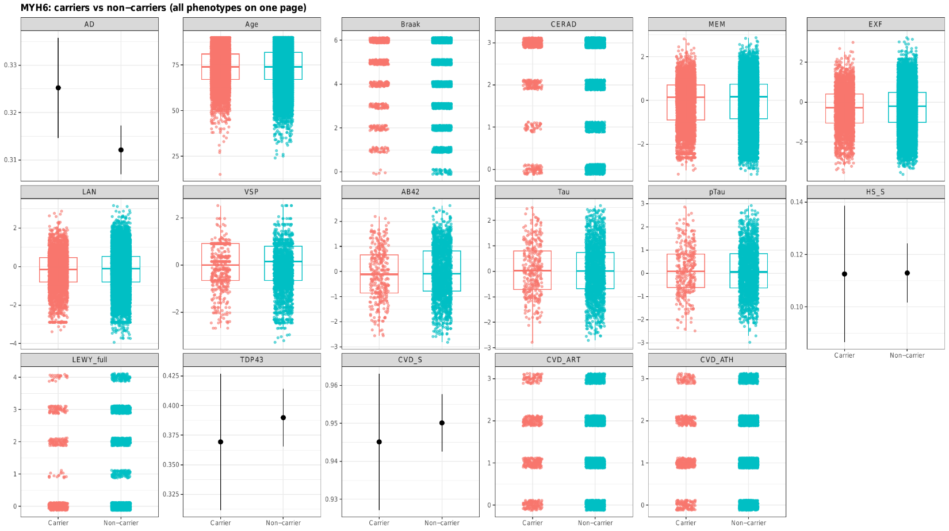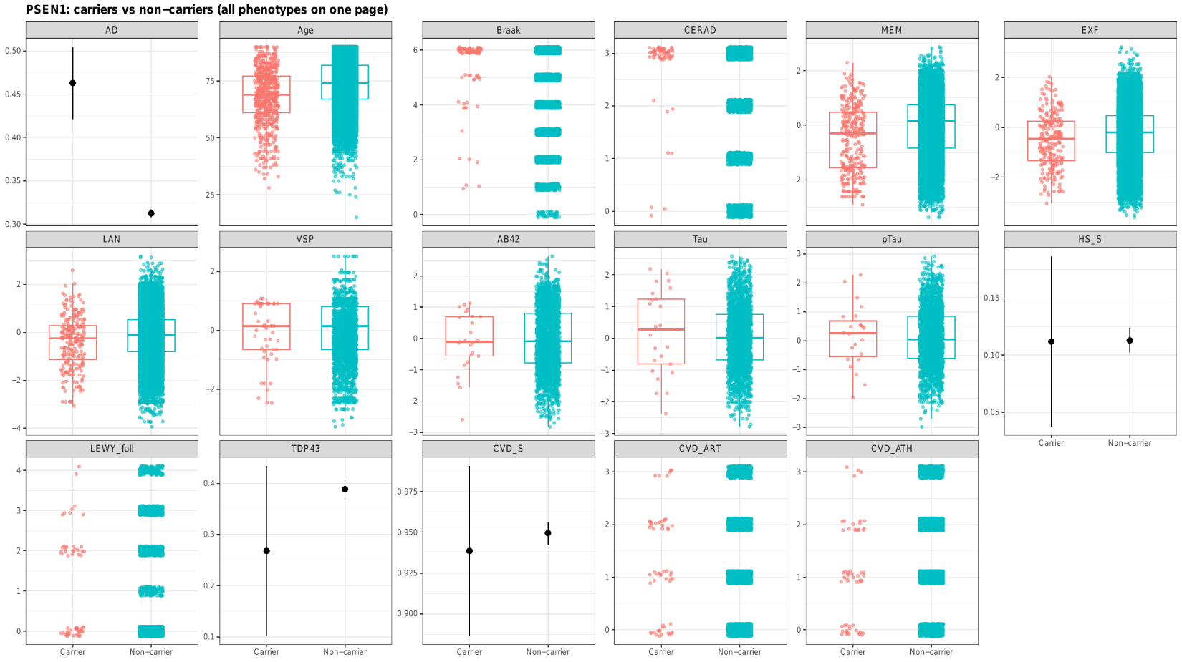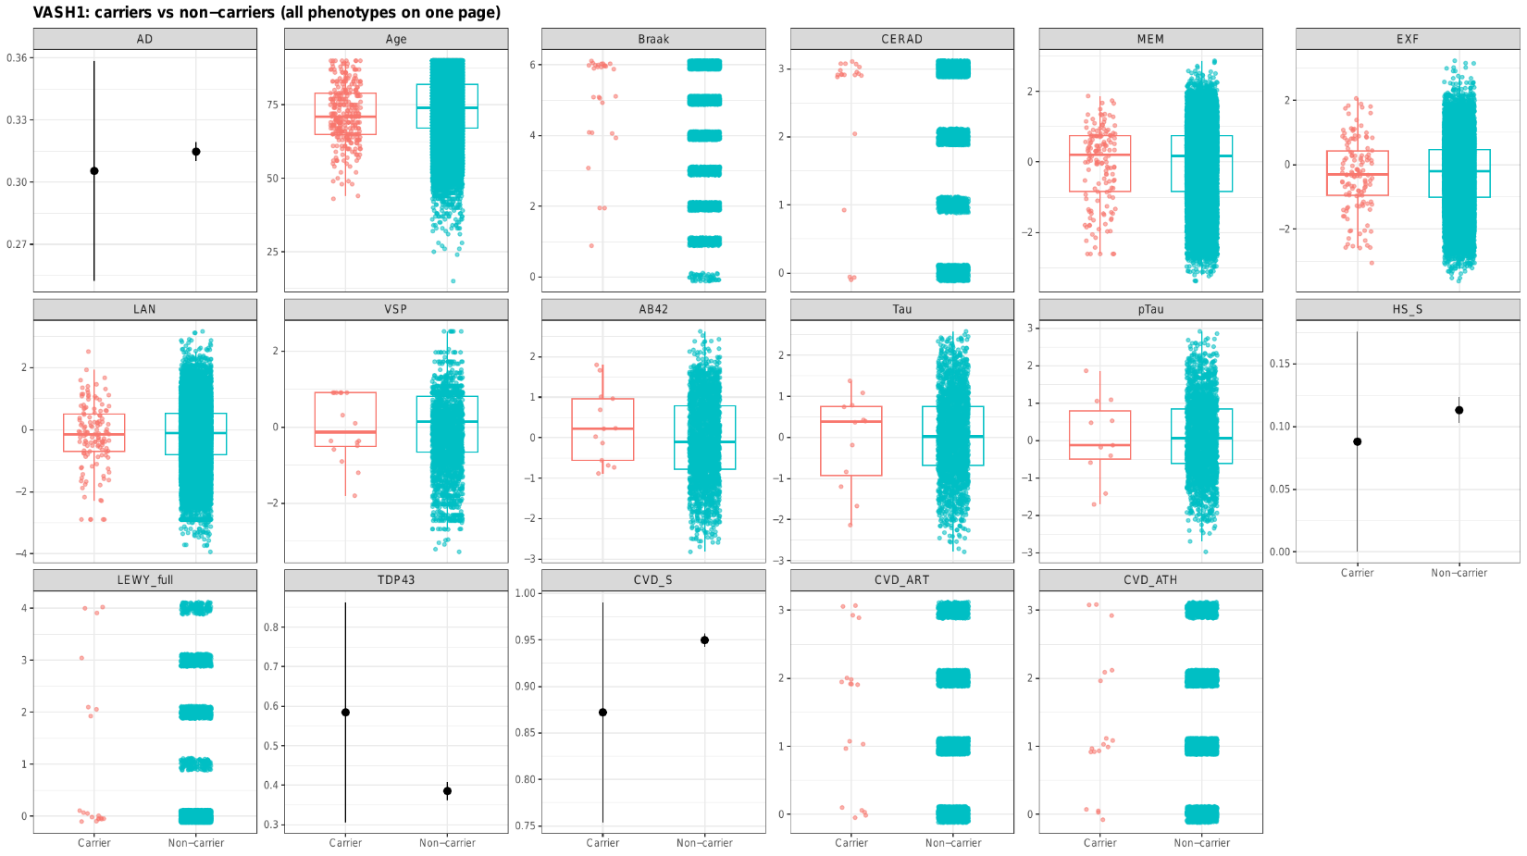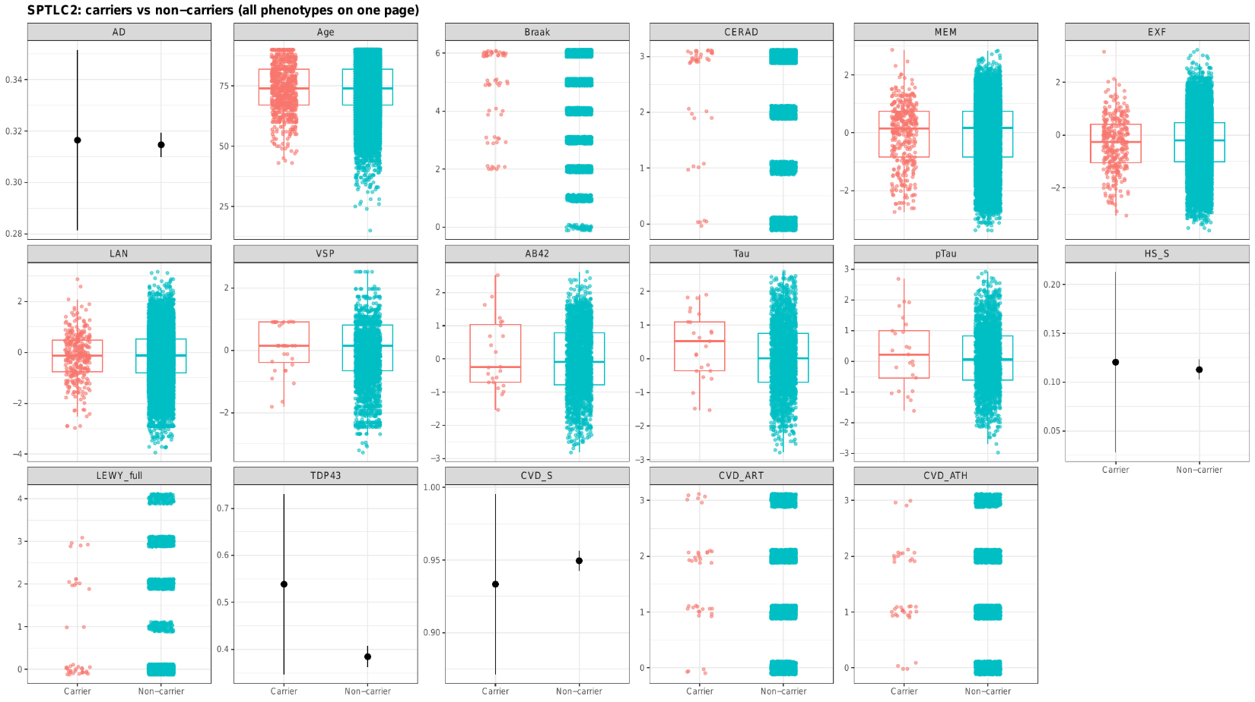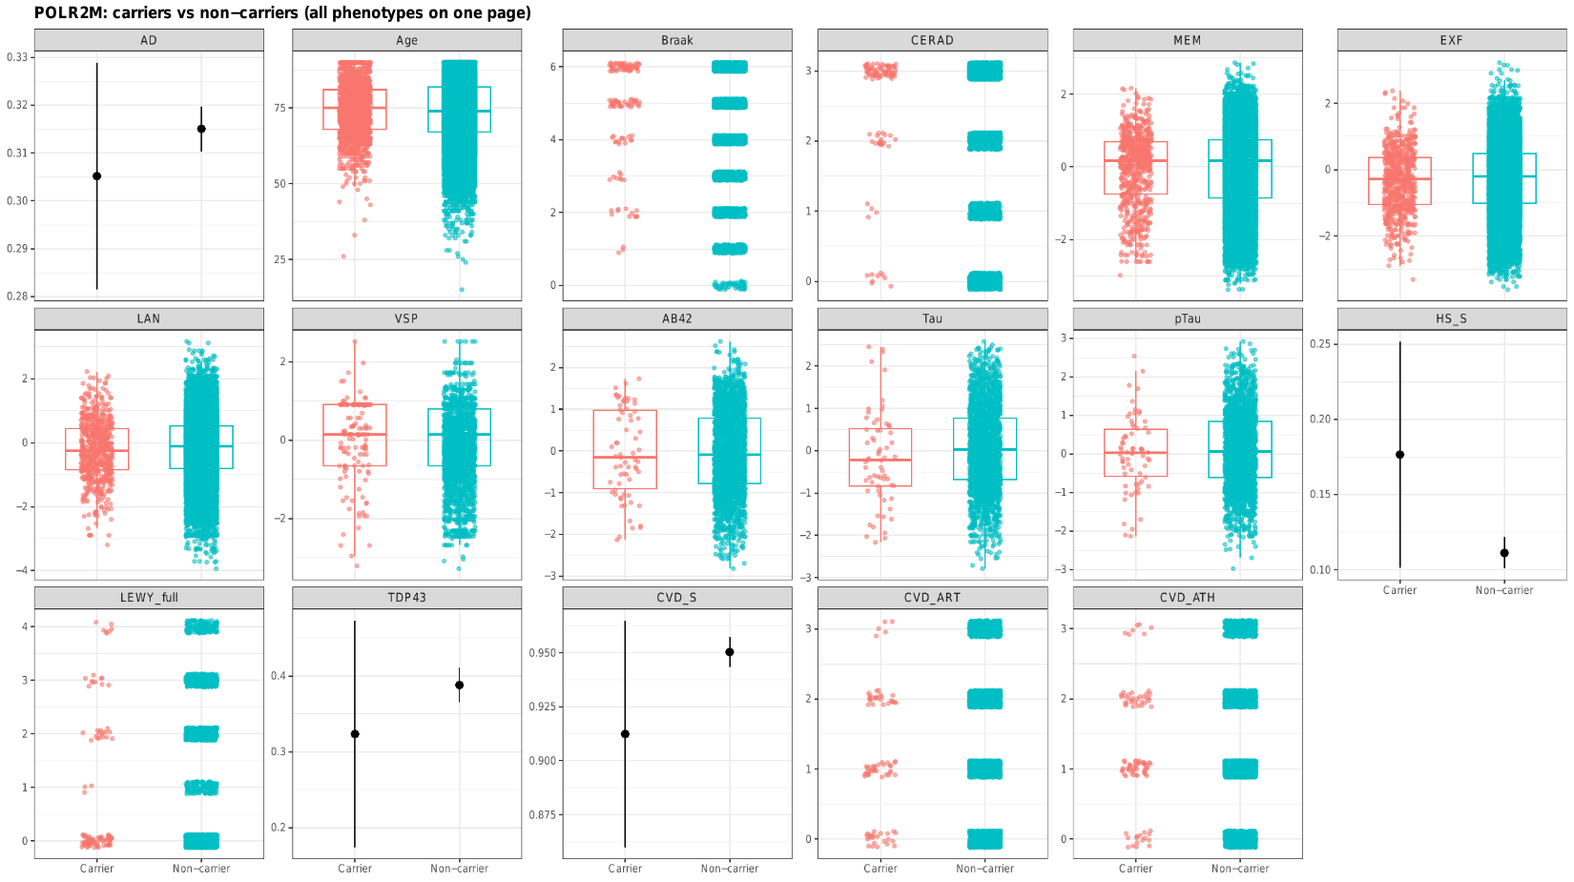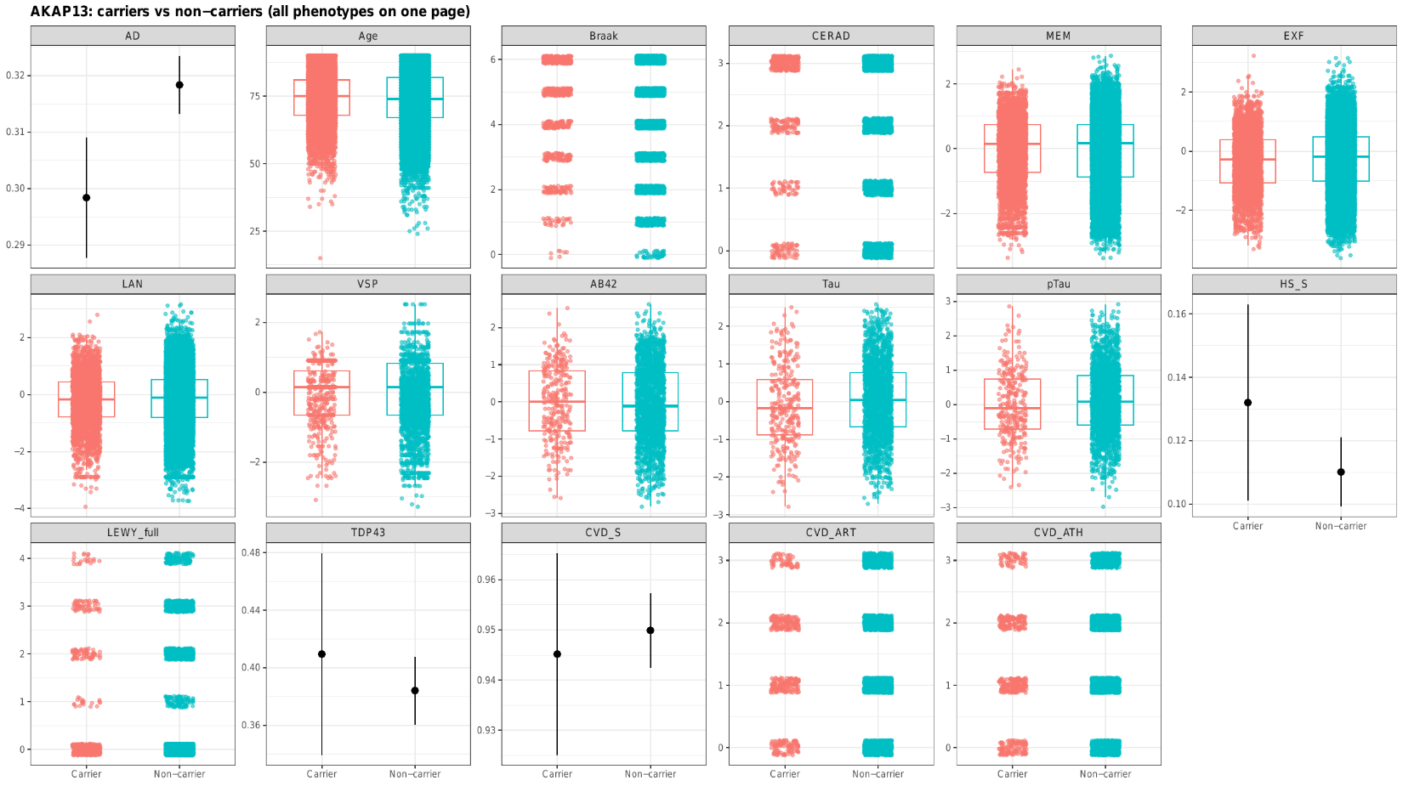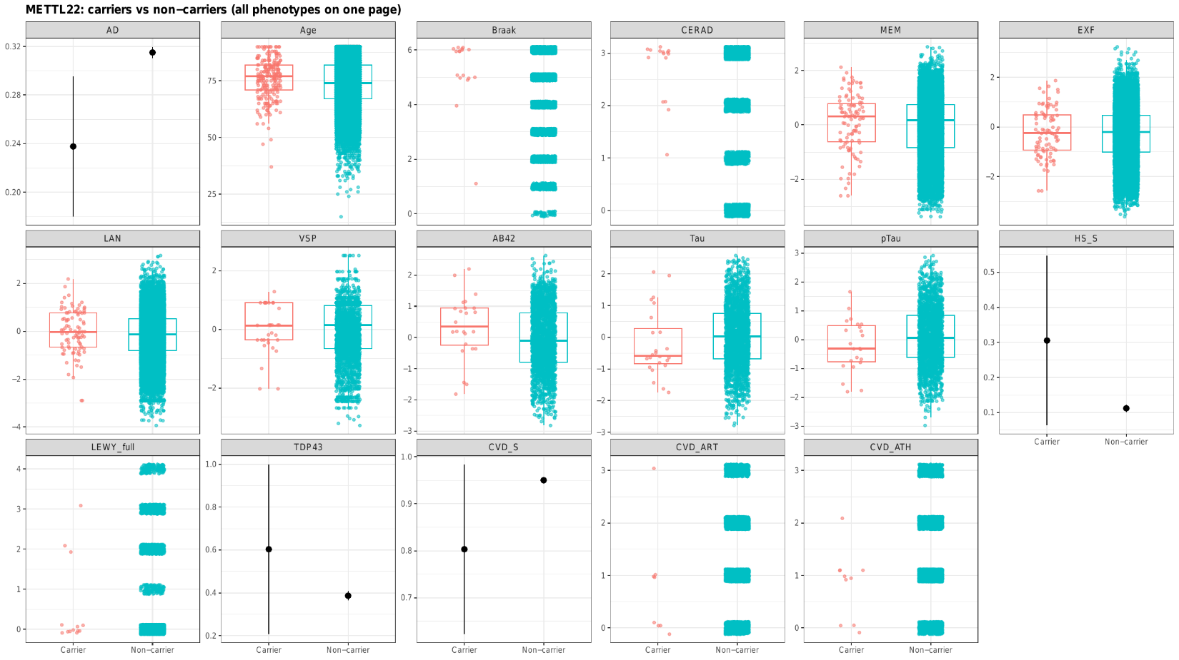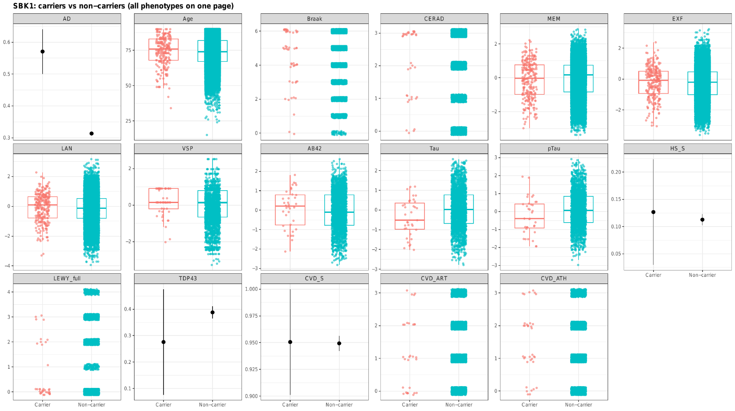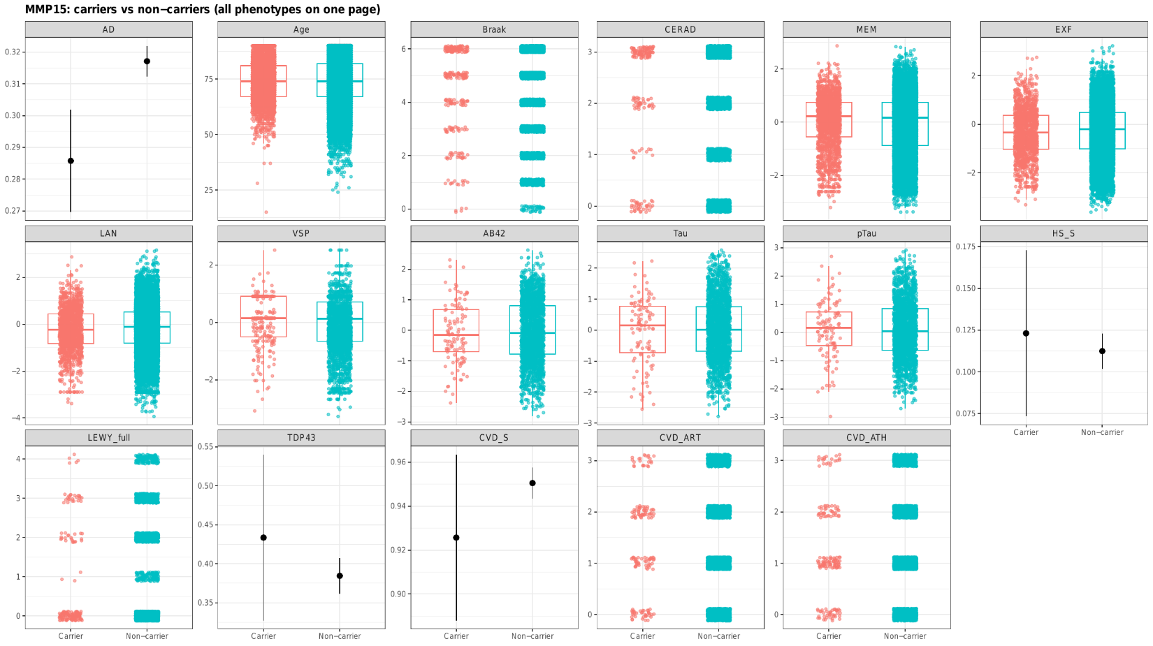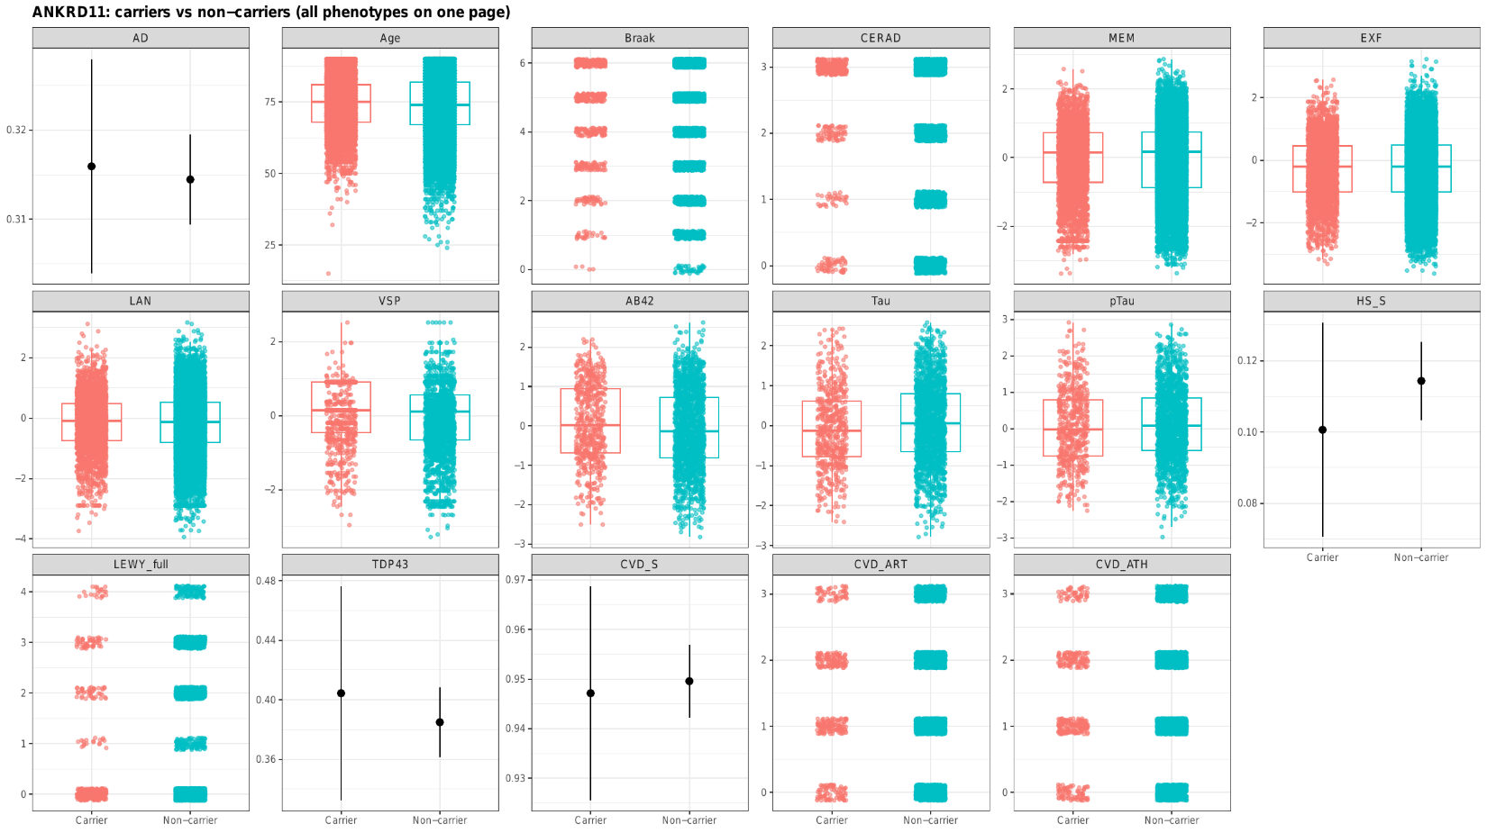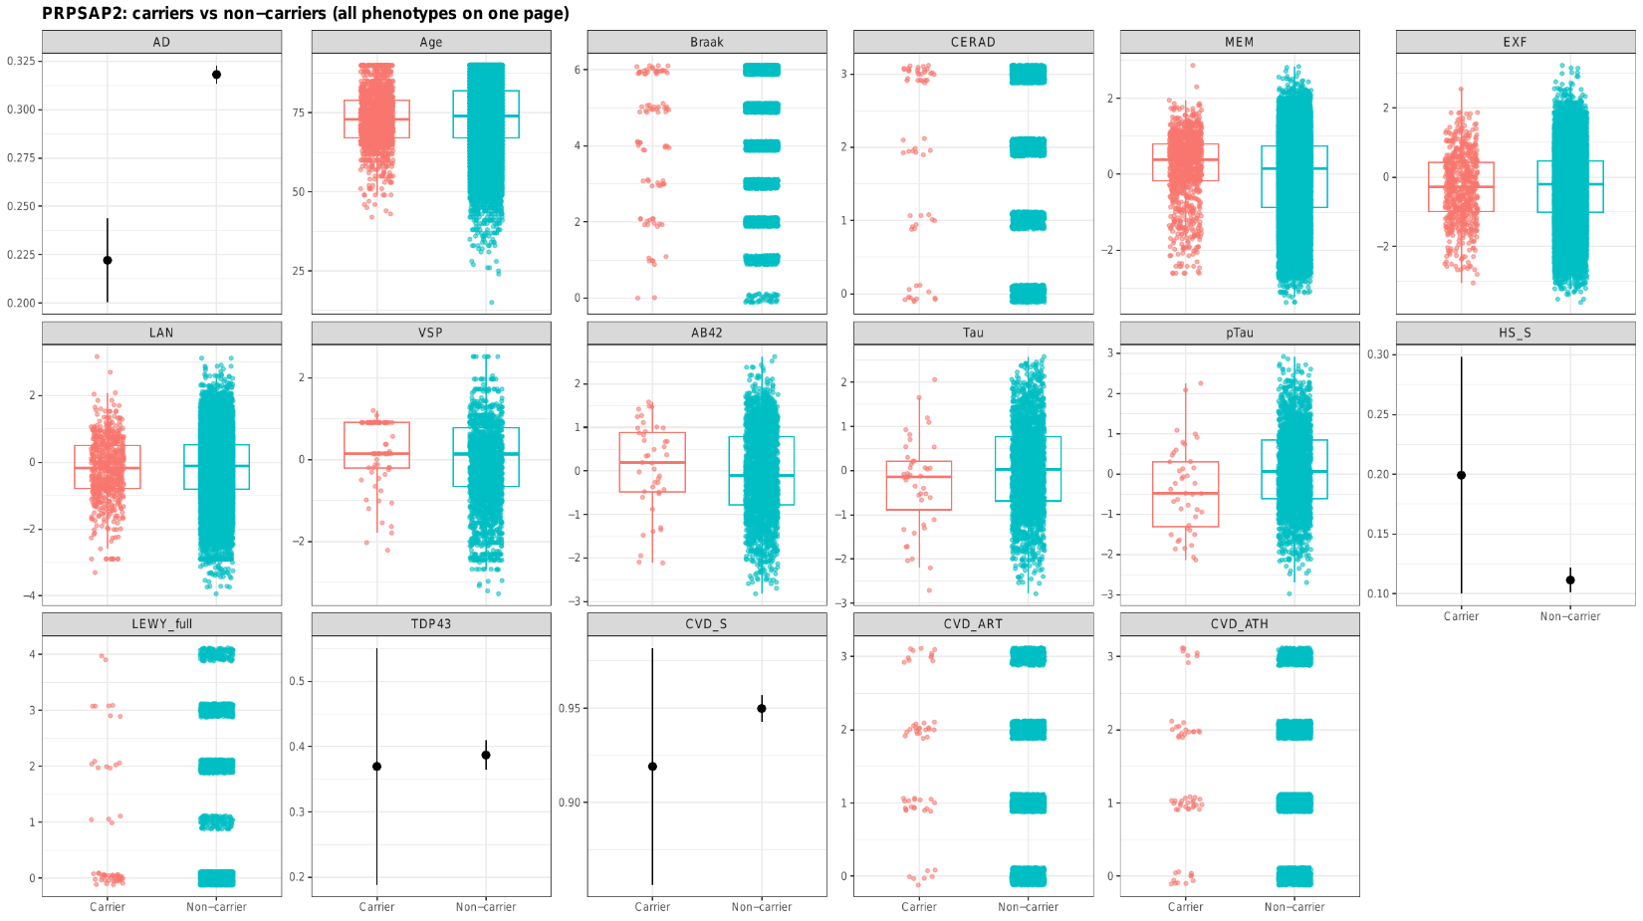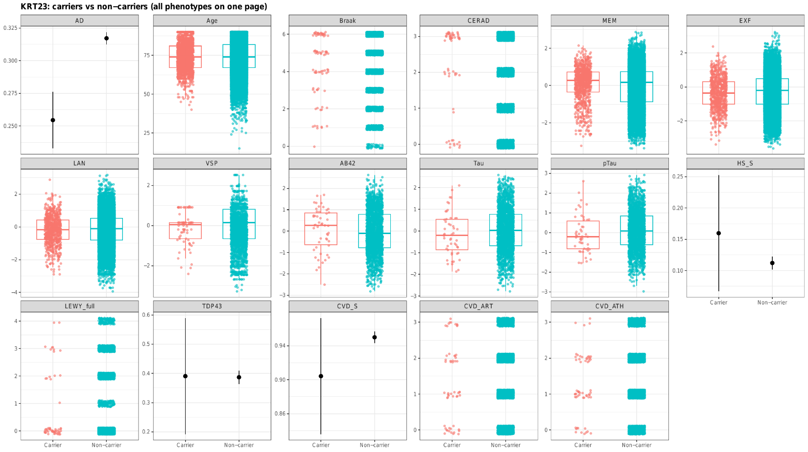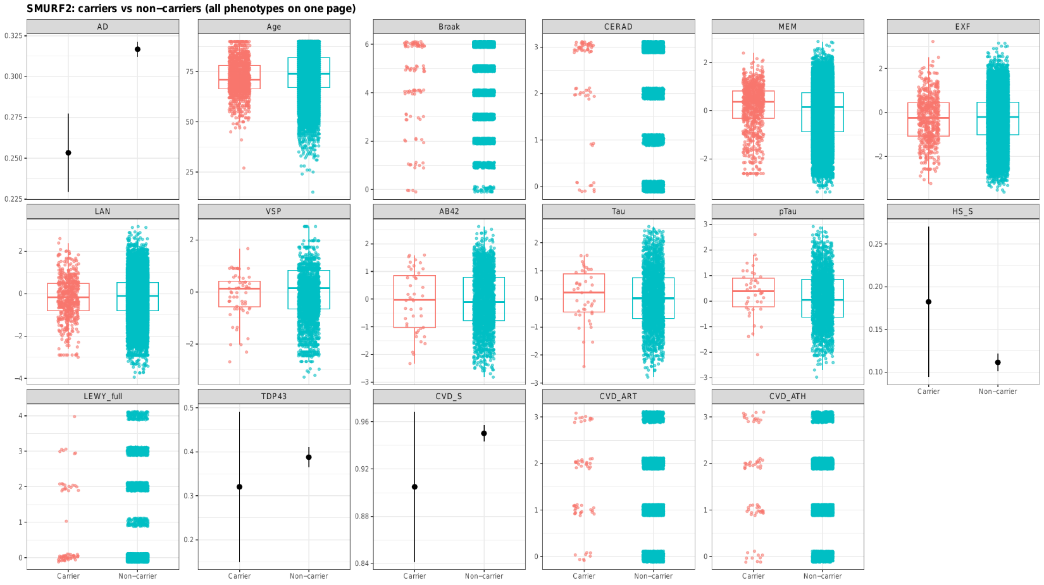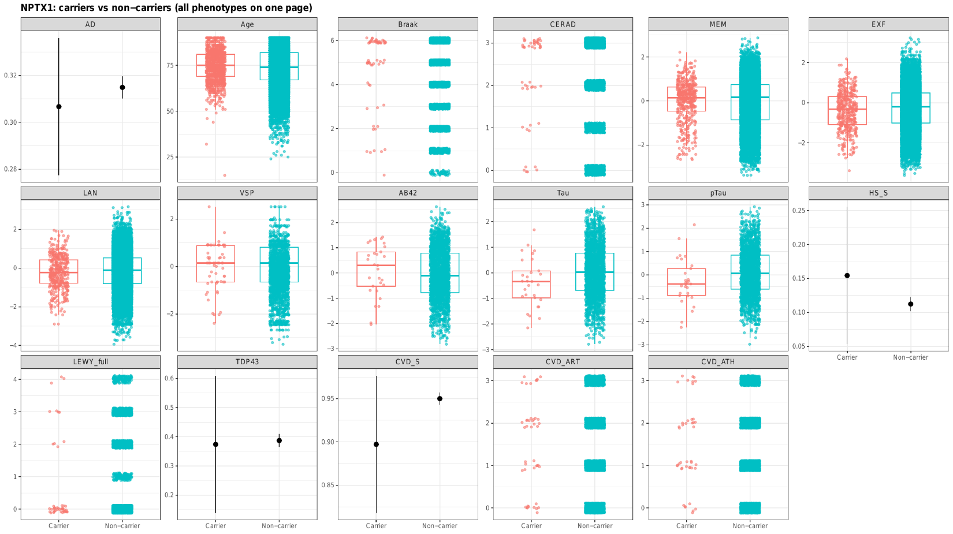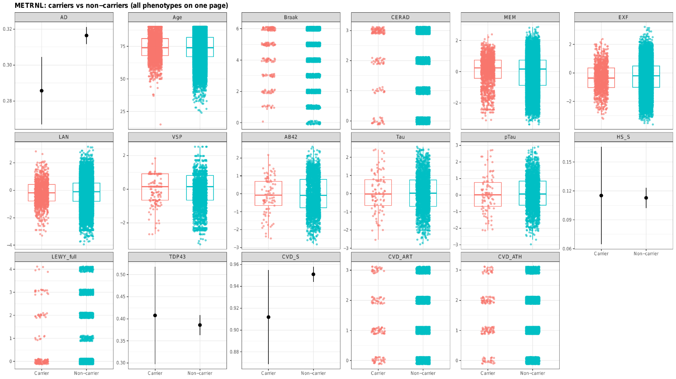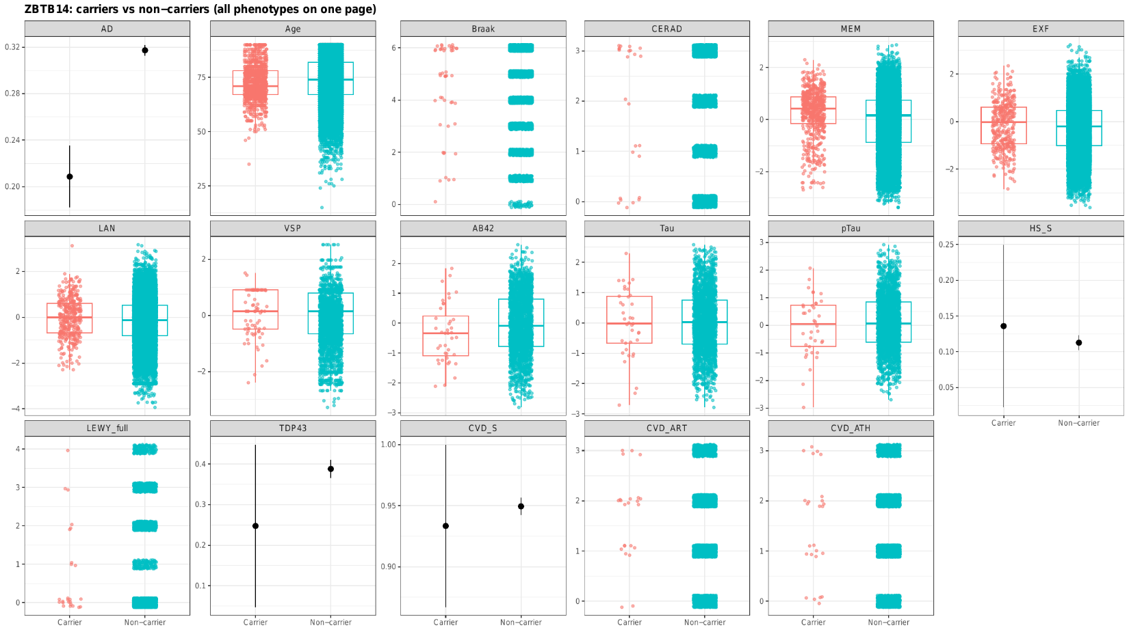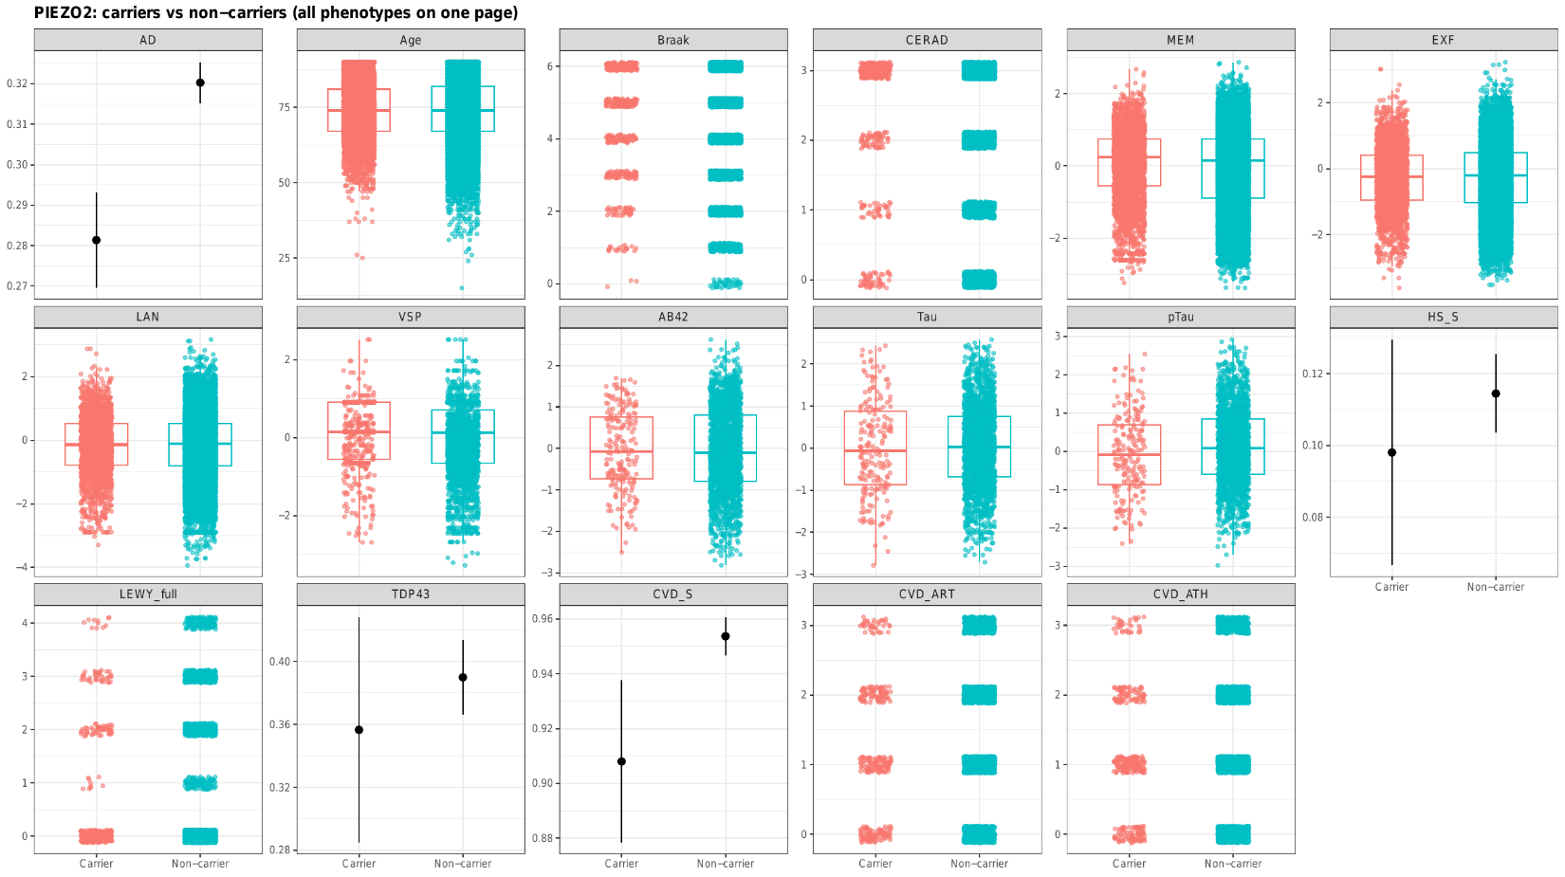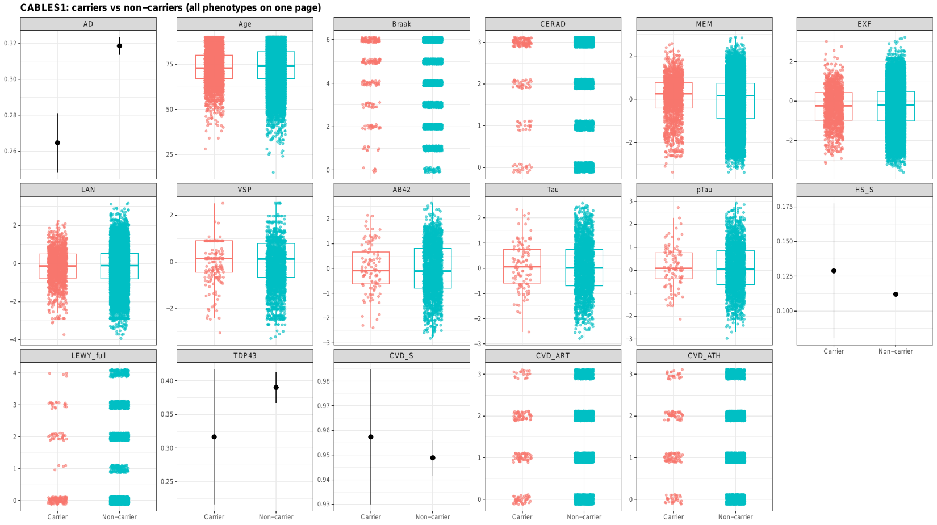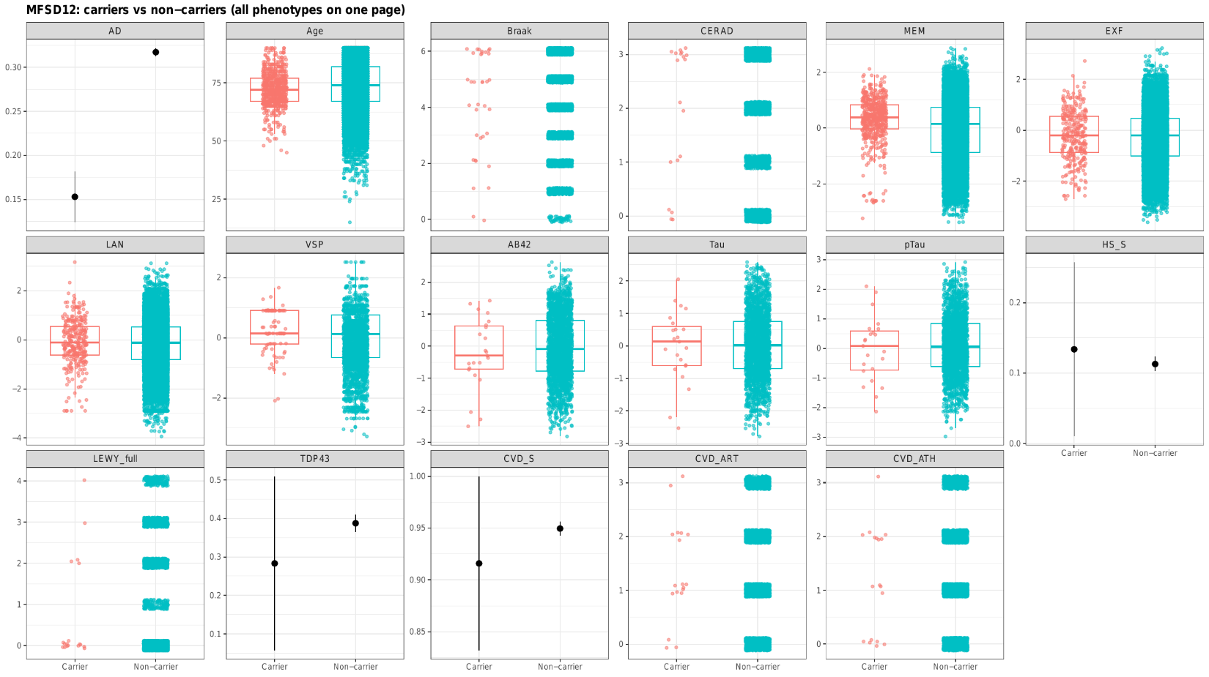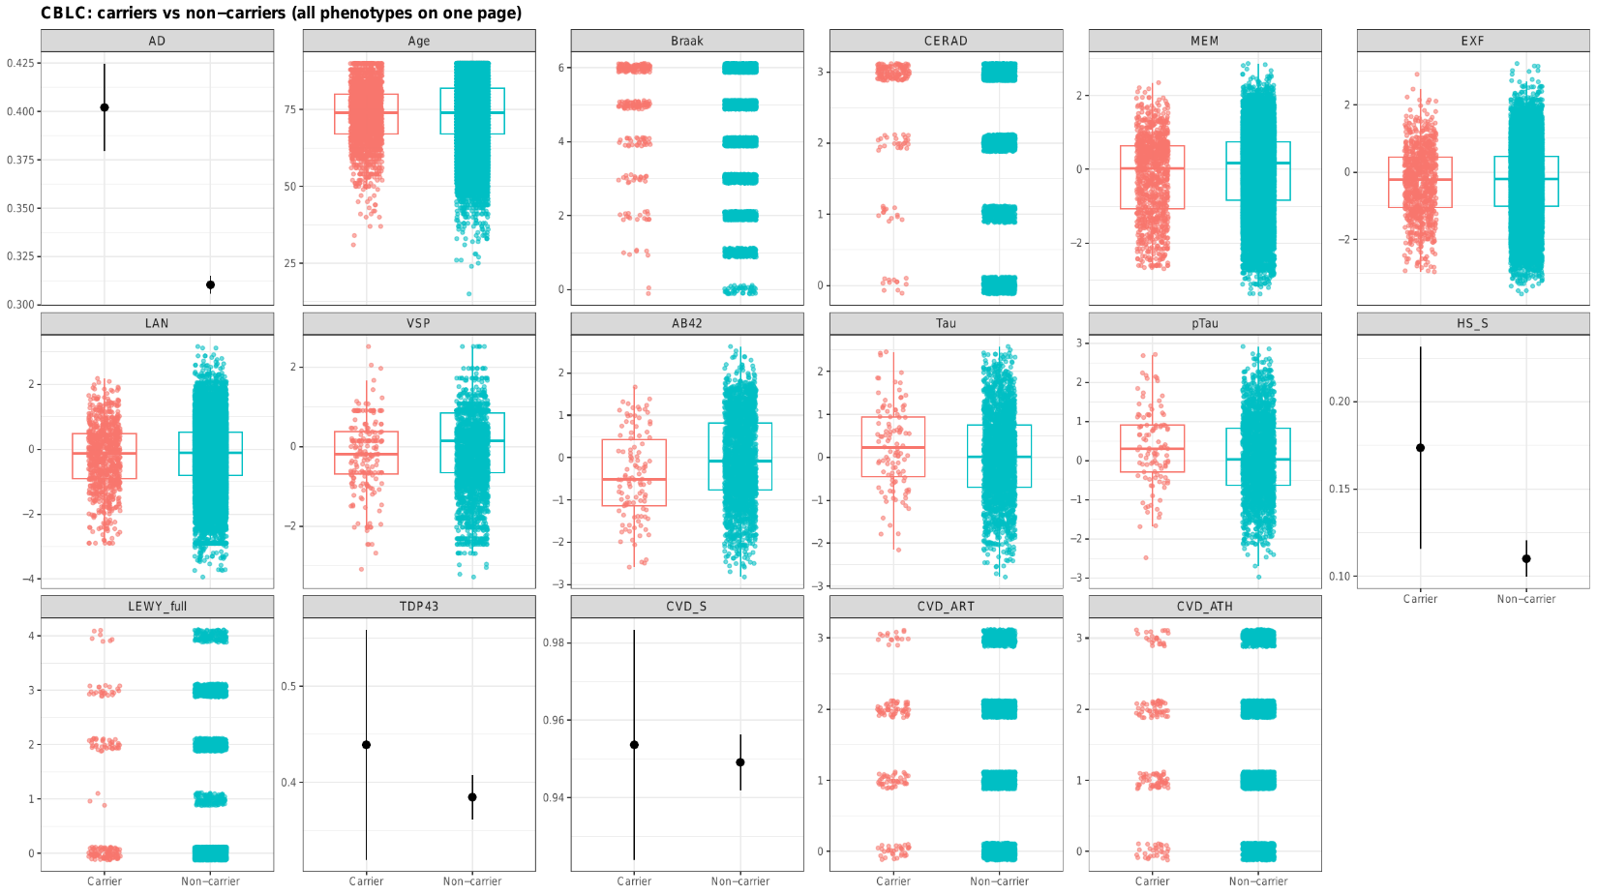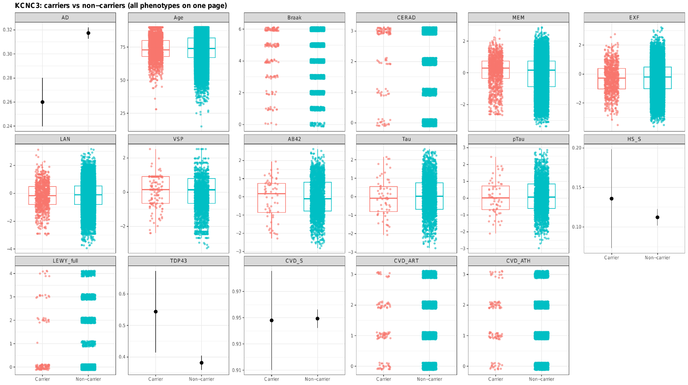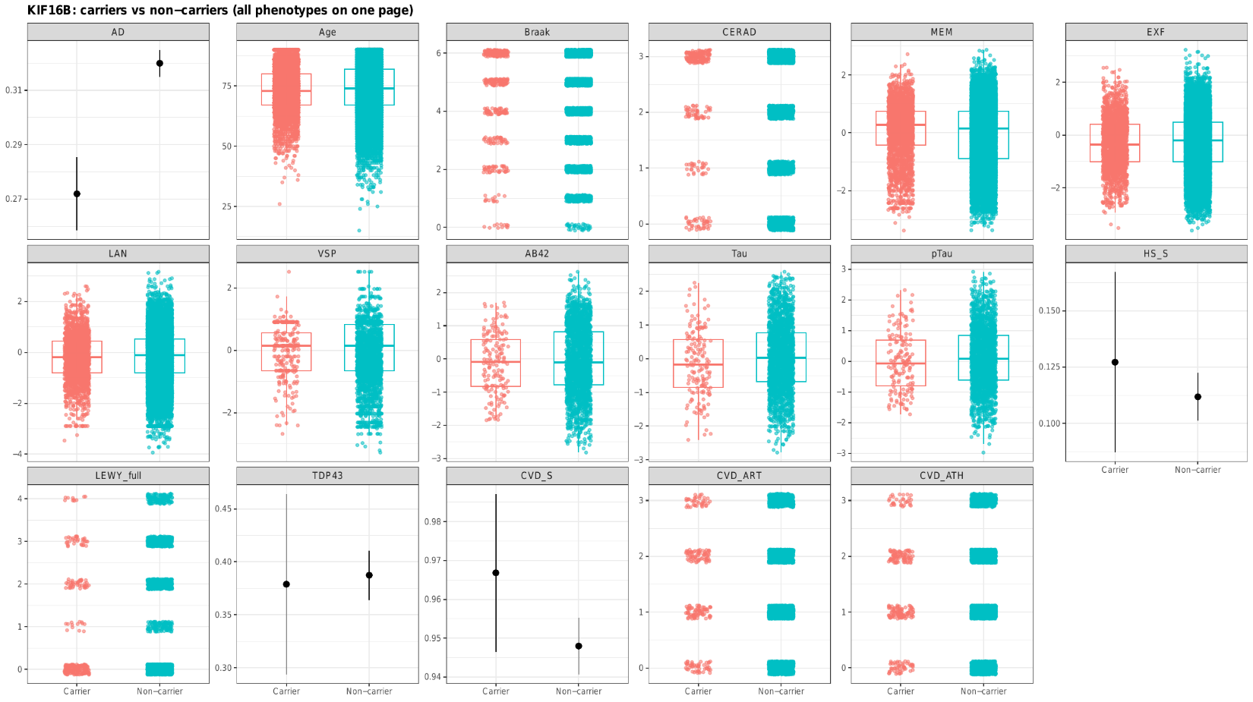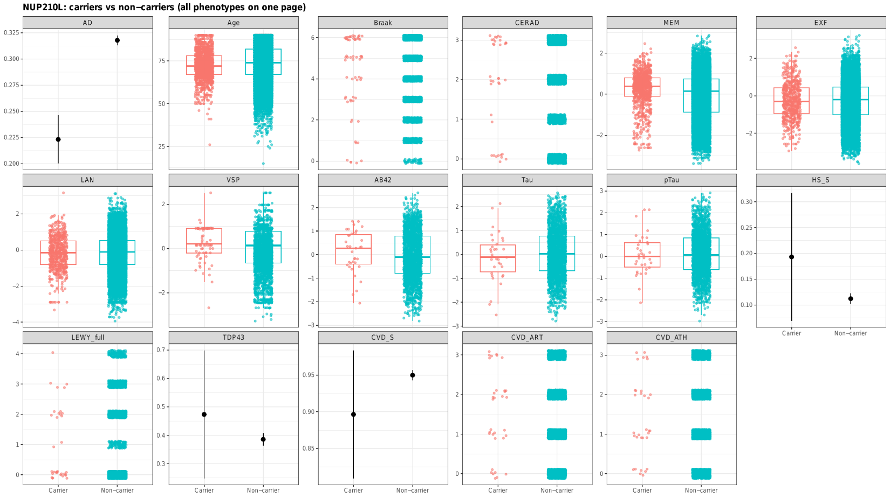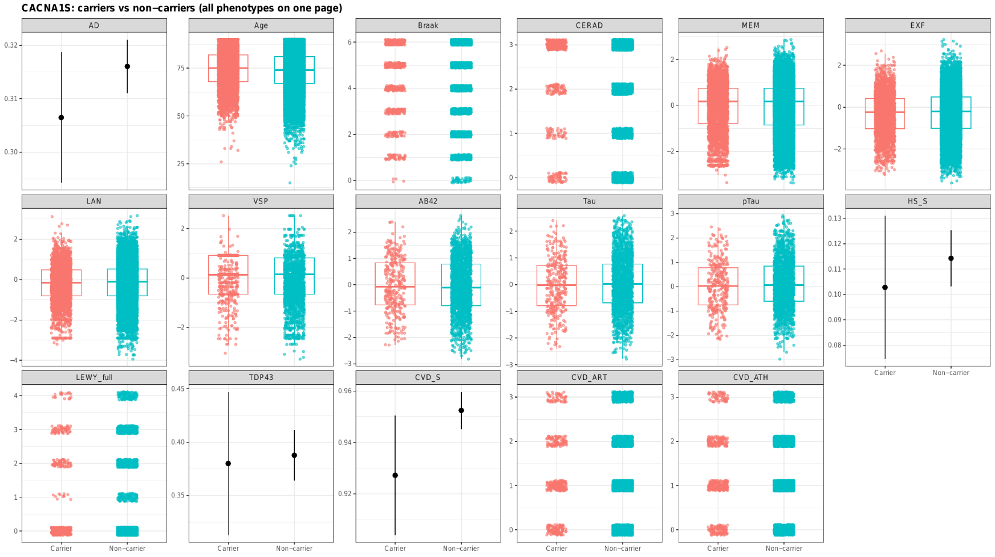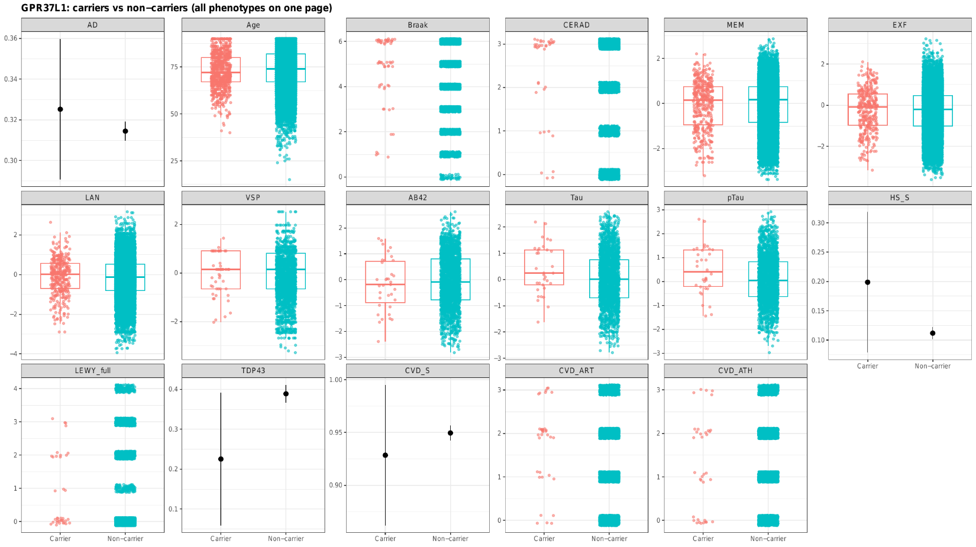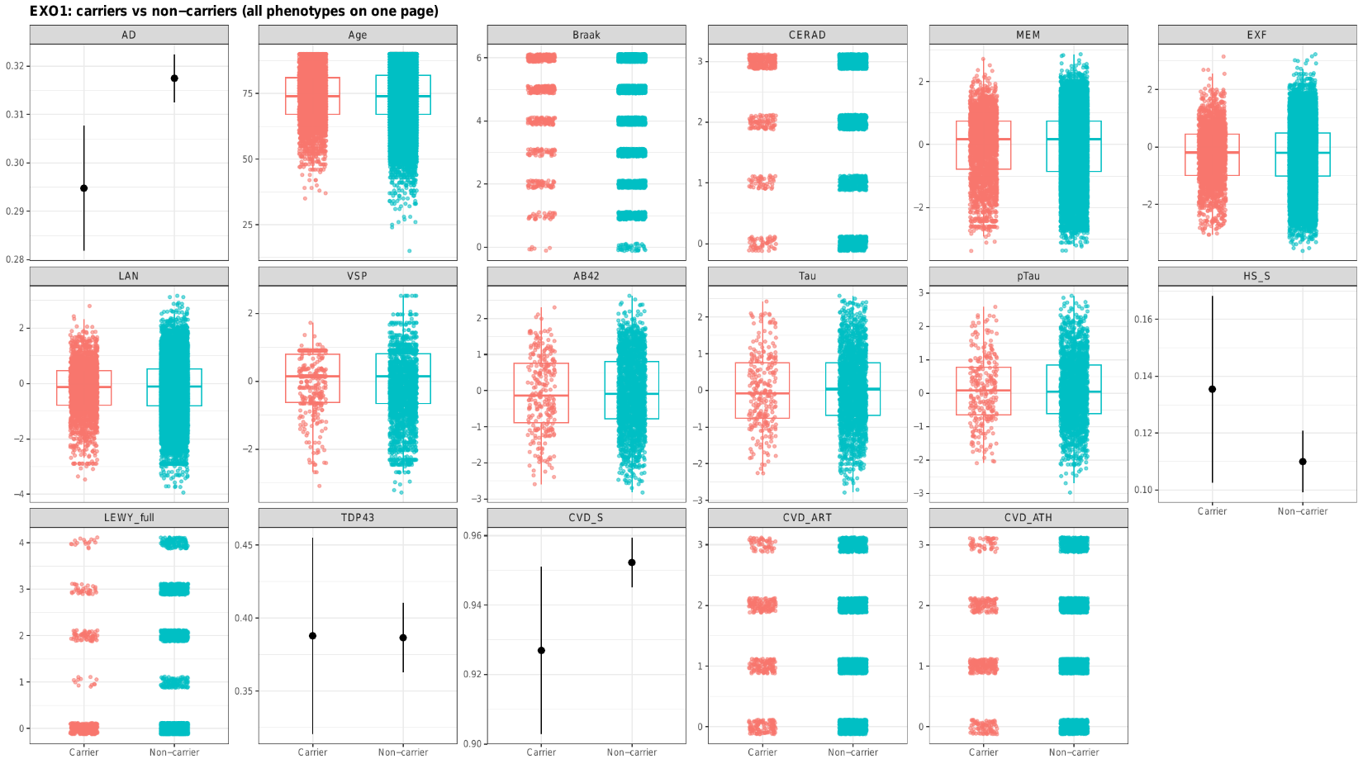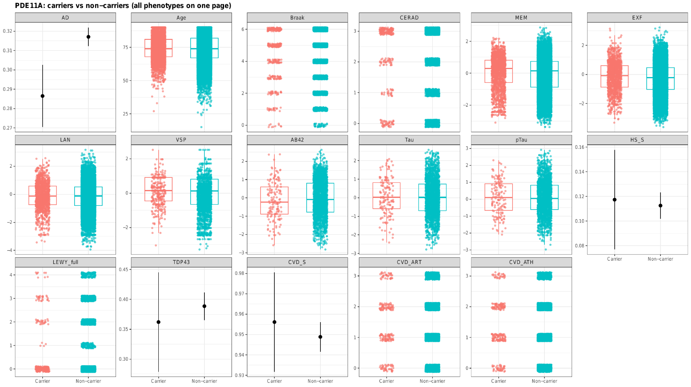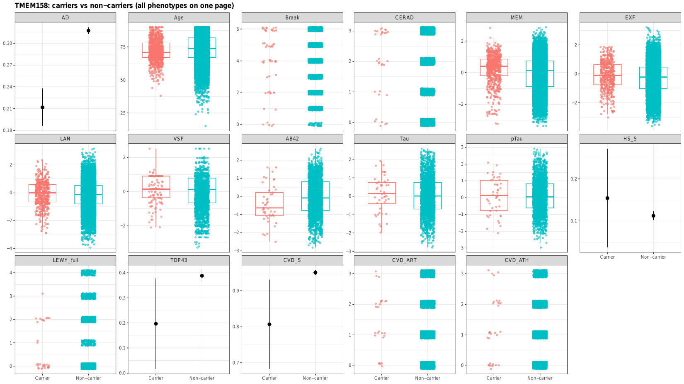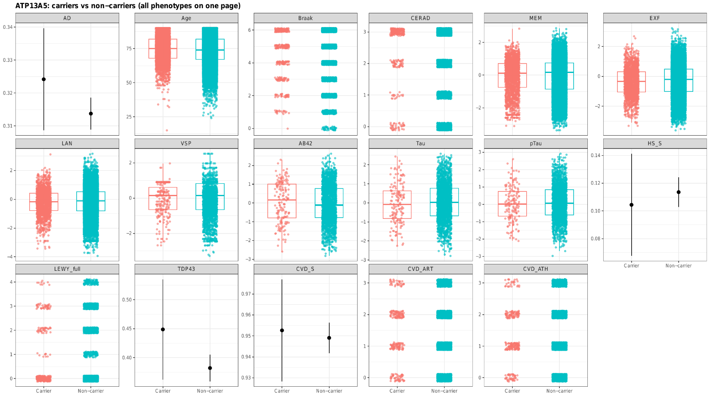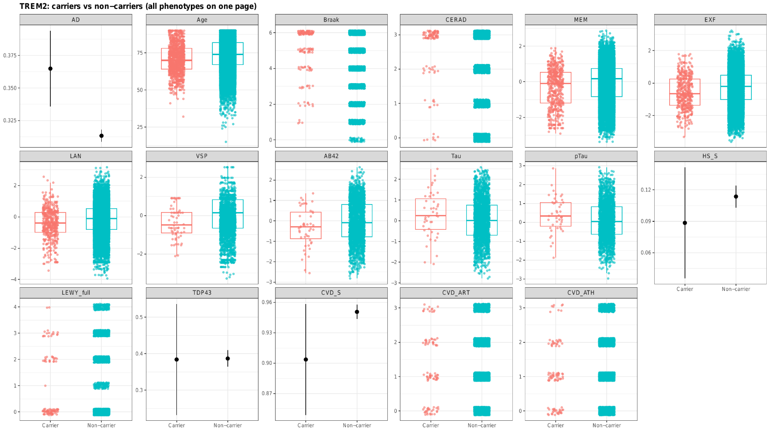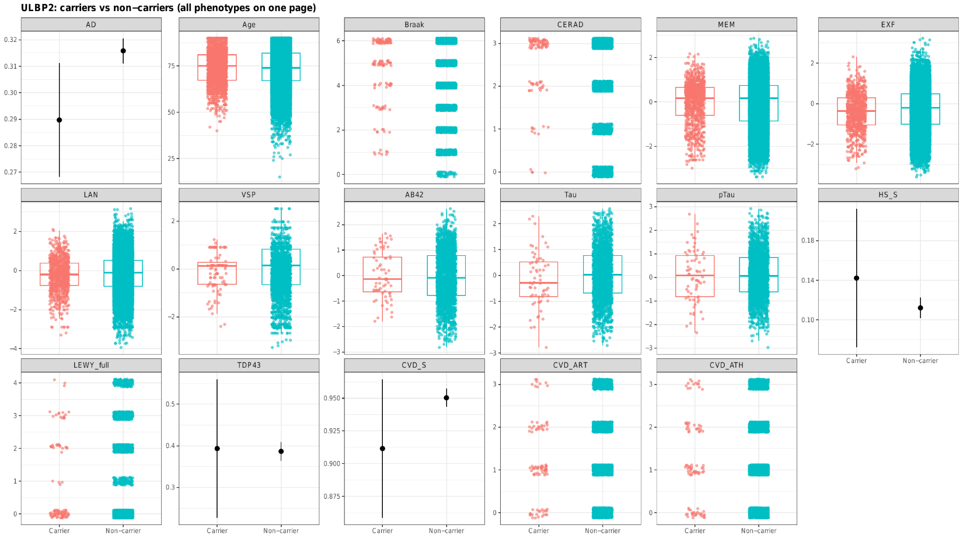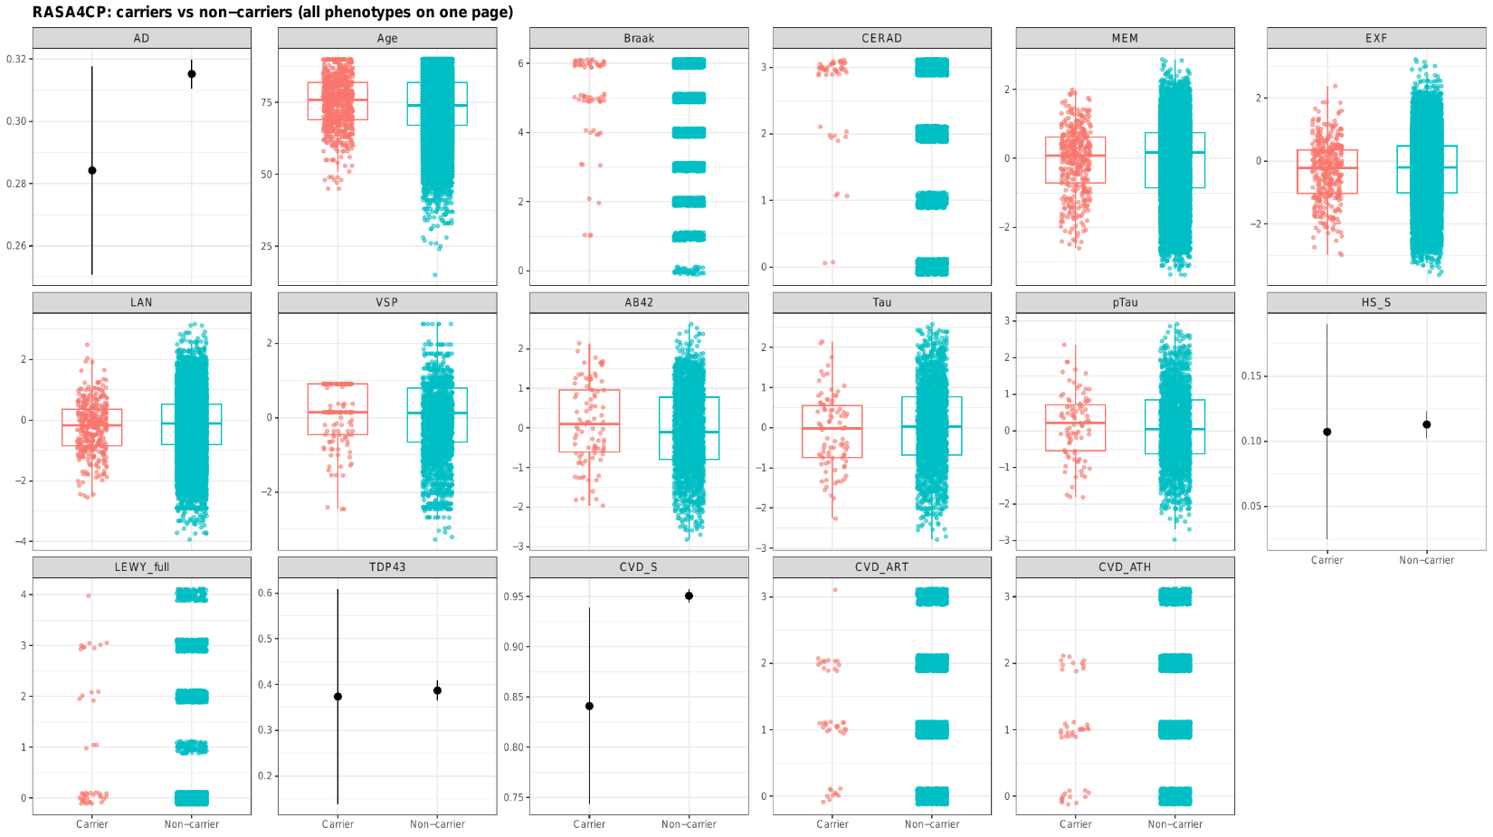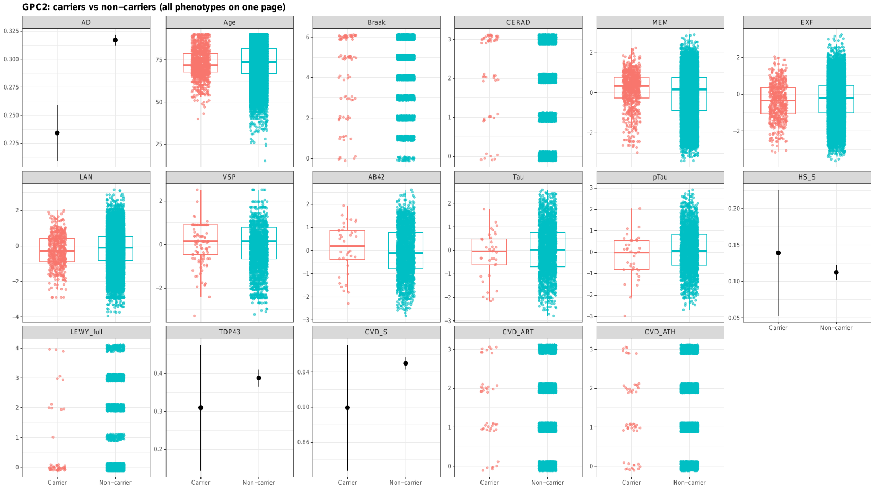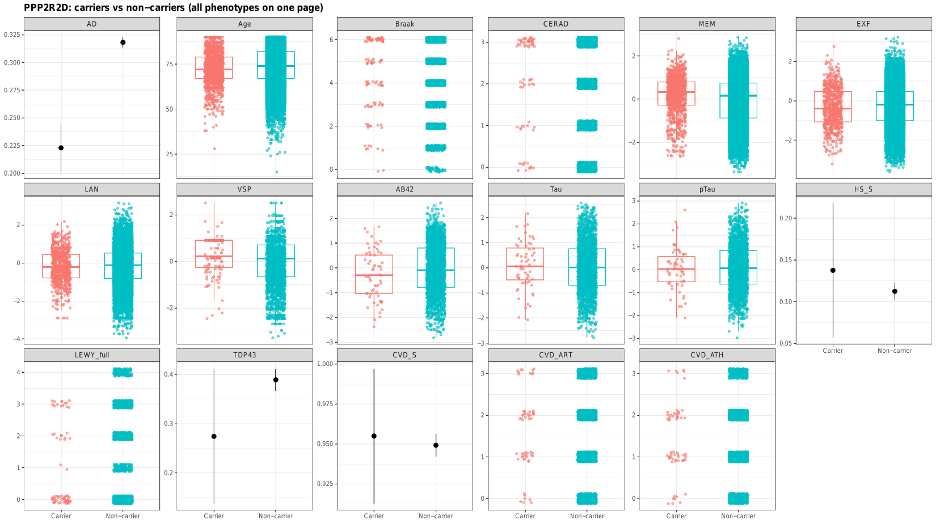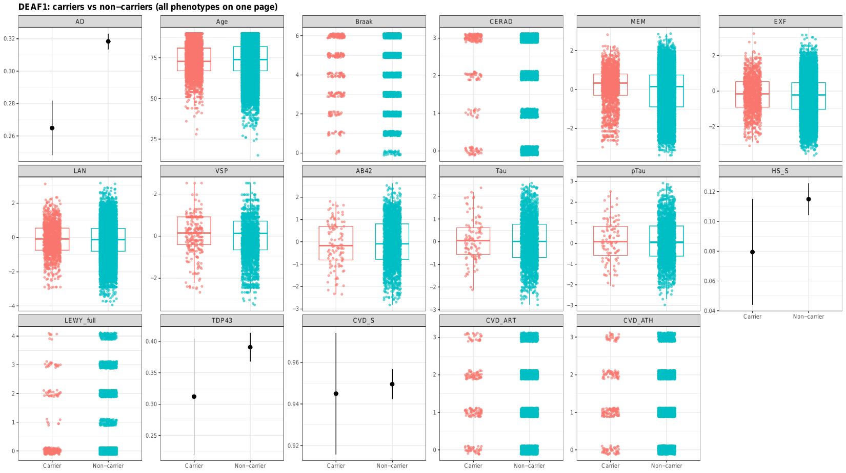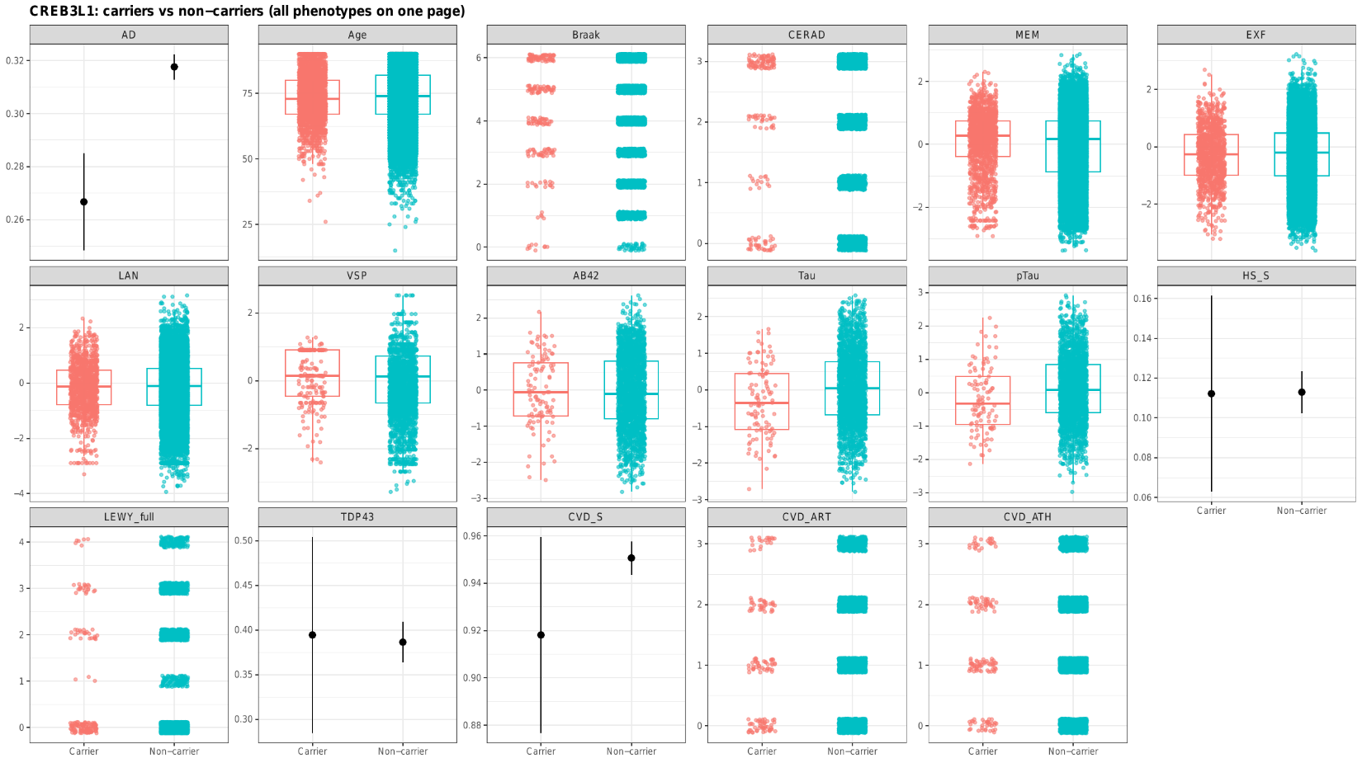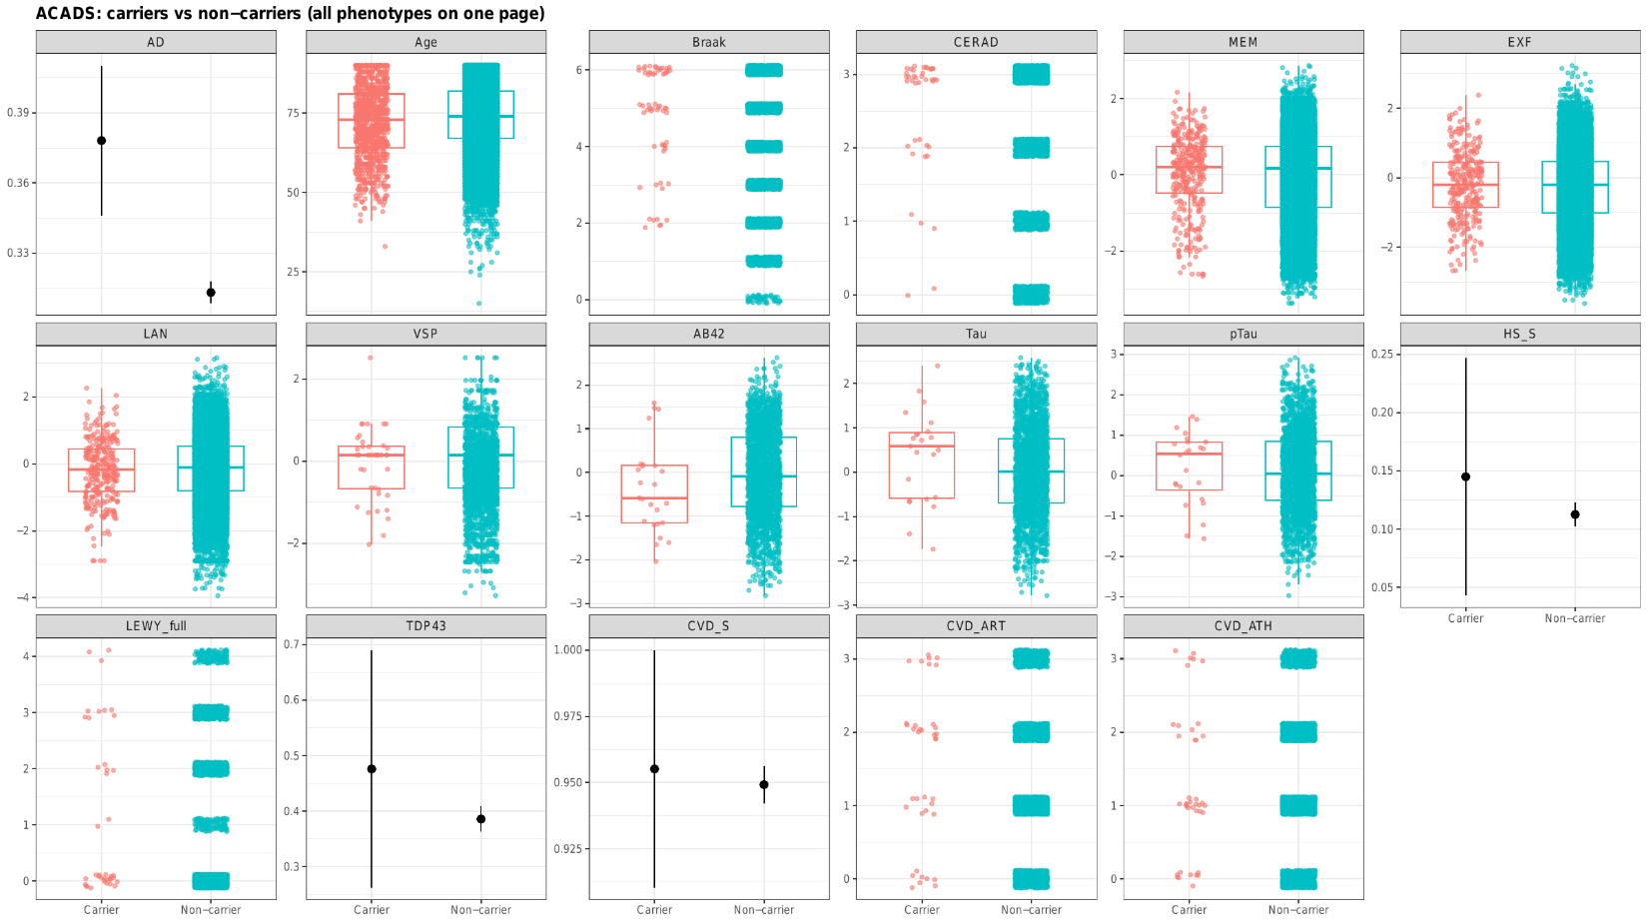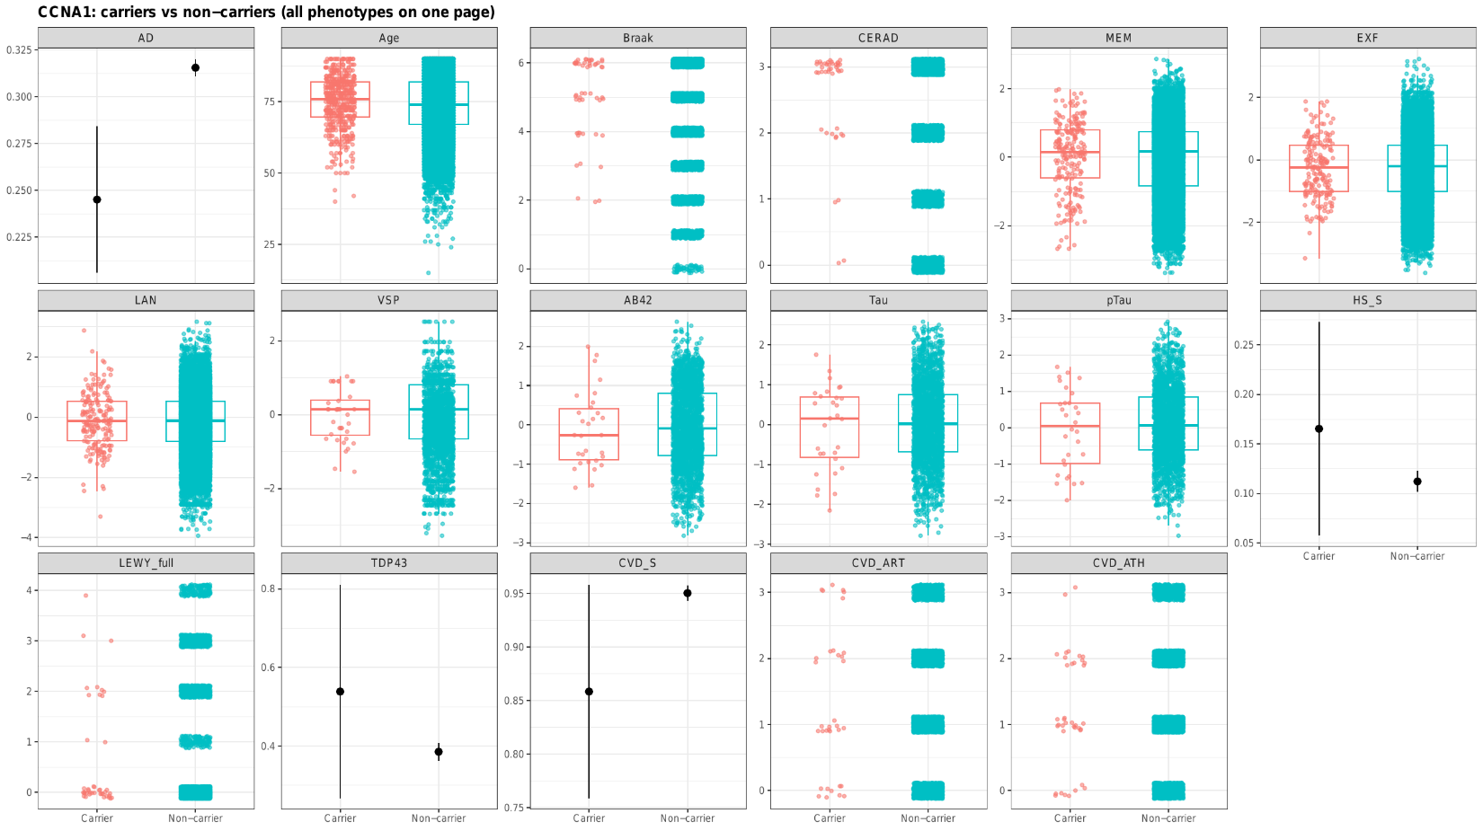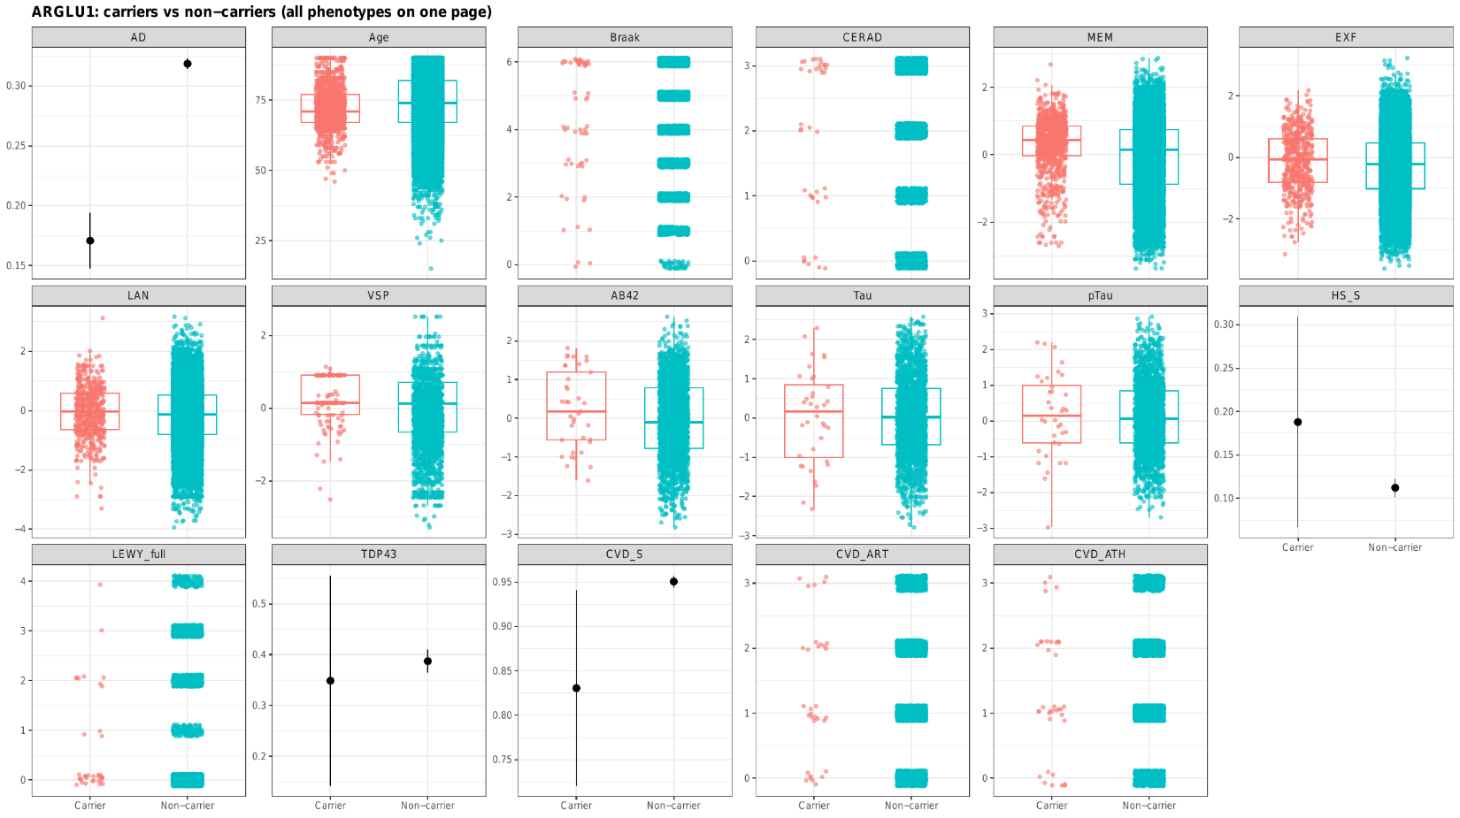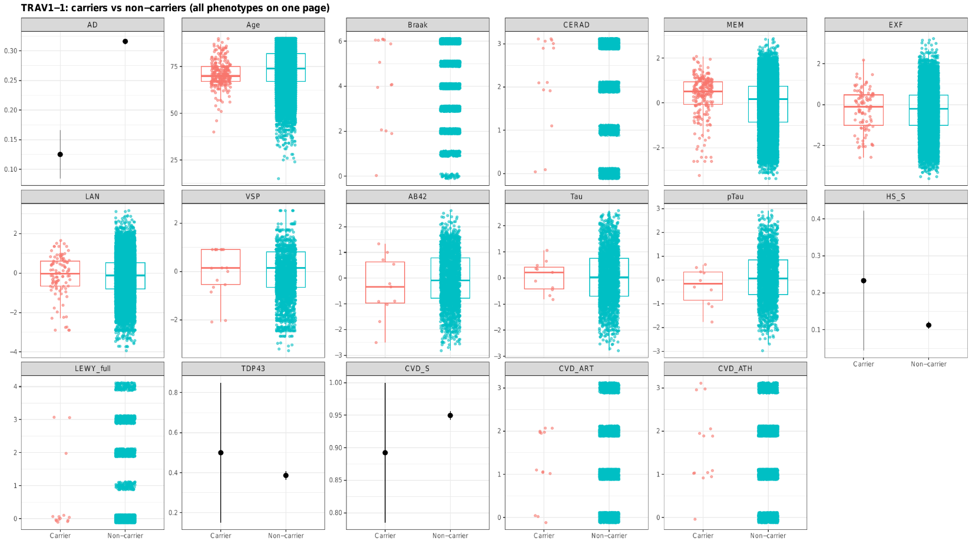

Figure S3: Allele Age of 40 Significant Genes
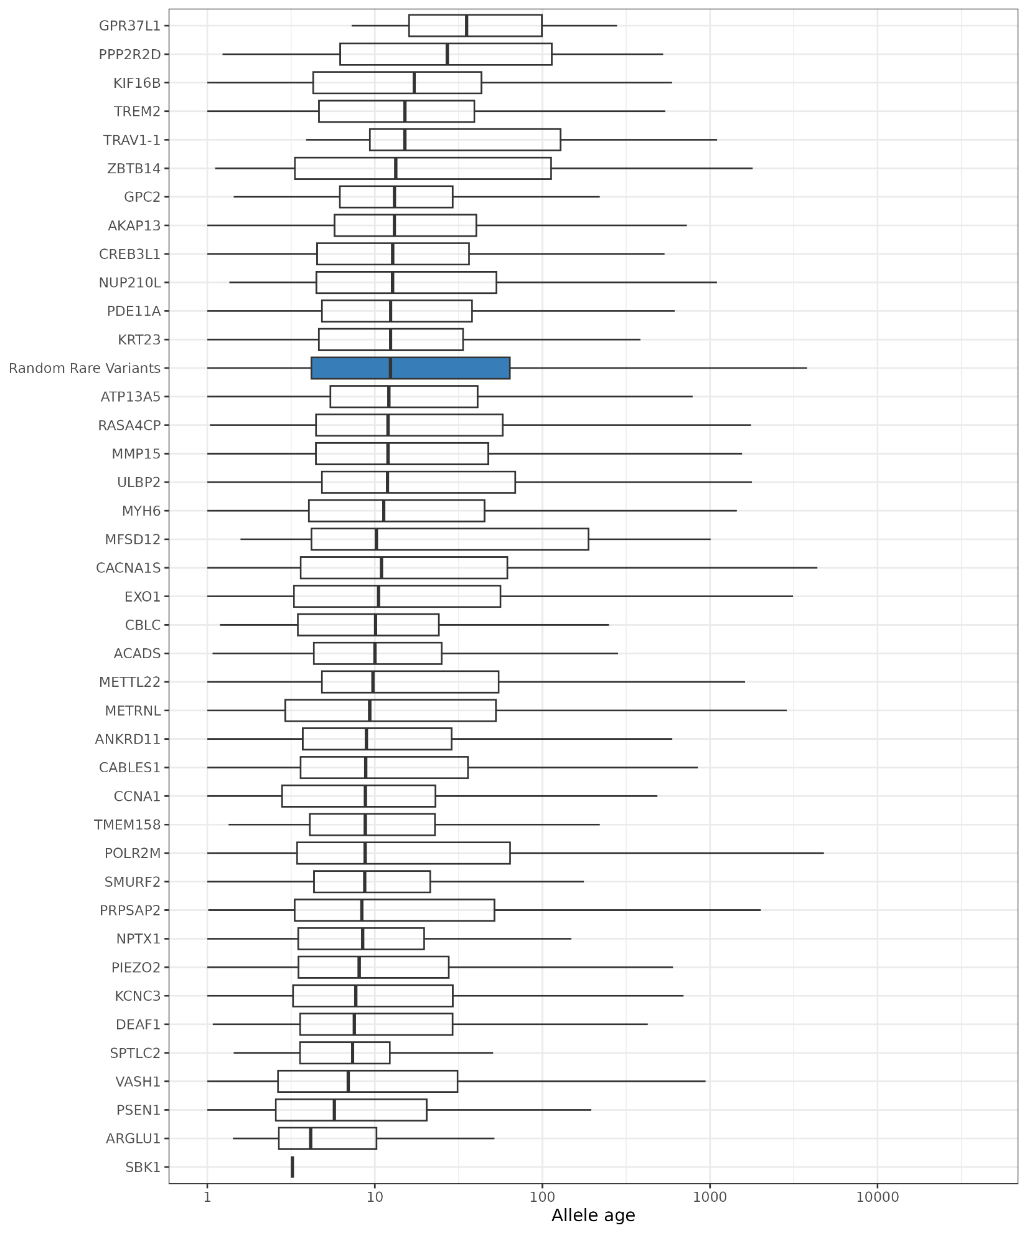
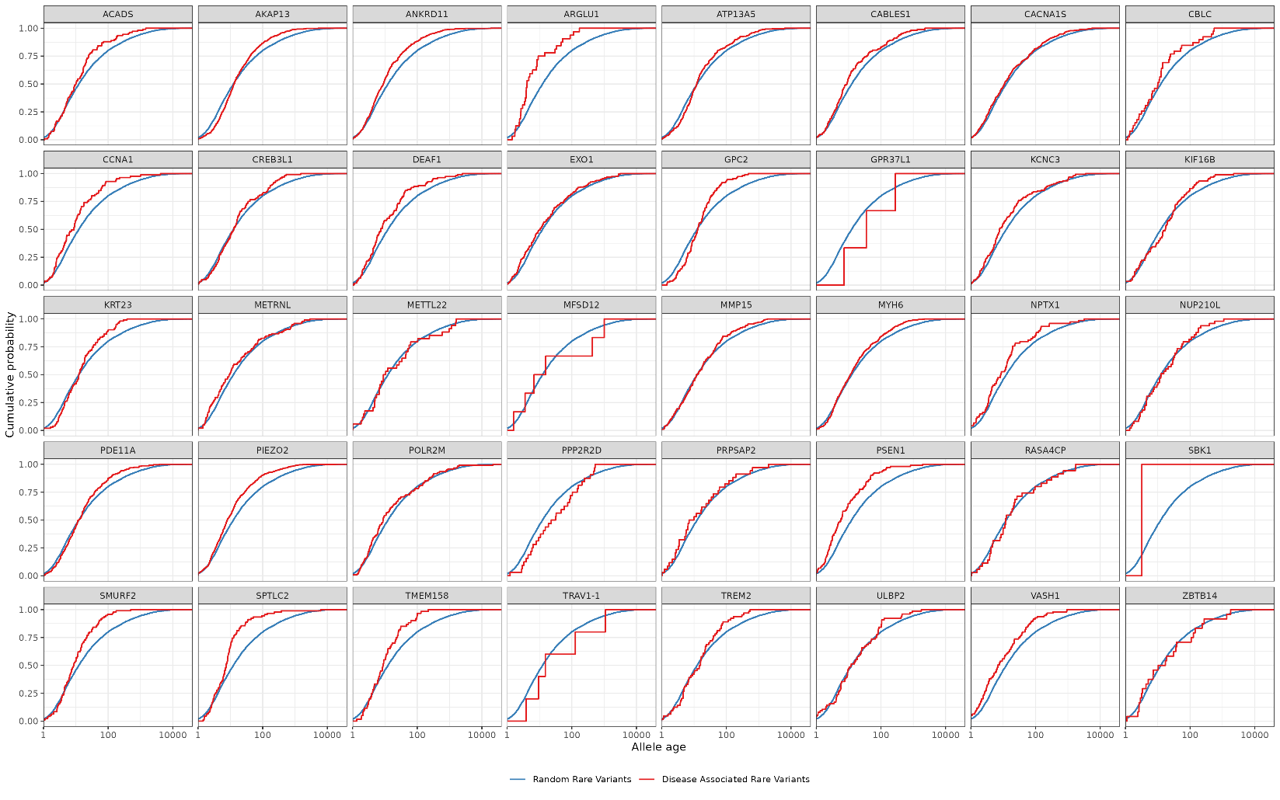

Figure S4: PC plots

Figure S5: Overview of the ADSP R5 callset.
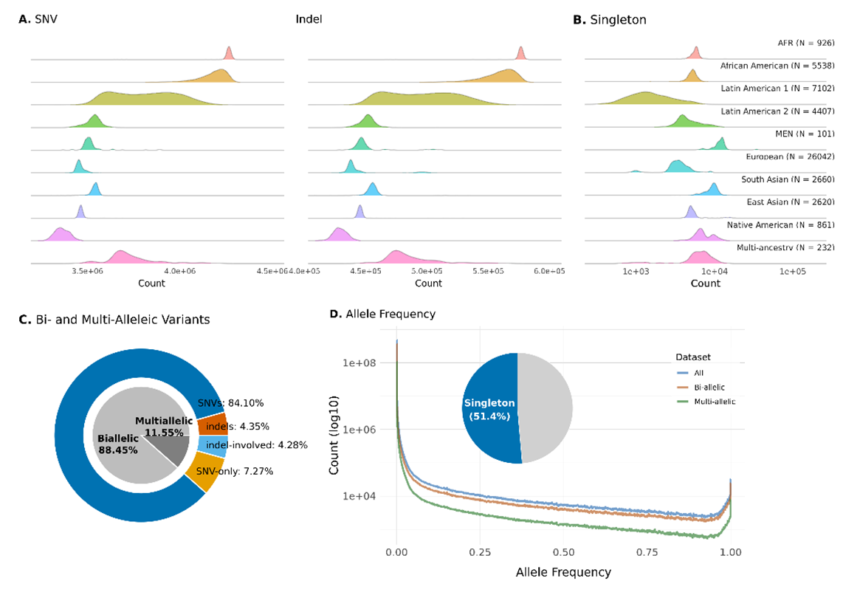
(A) Per-sample counts of SNVs and indels by ancestry. (B) Per-sample counts of singletons by ancestry. (C) Counts of bi-allelic and multi-allelic sites. (D) Allele-frequency spectrum.

Supplementary Material

Whole-Genome Sequencing Quality
Across samples, the mean depth of coverage was 40.5x (95% Confidence Interval [CI]: 40.5-40.6x), and the mean fraction of bases with Q≥30 was 90.5% (95% CI: 90.47-90.50%). Samples were processed using the VCPA pipeline6, aligned with BWA-MEM, called with GATK v4.1, and joint-genotyped with GLnexus7. The transition/transversion (Ti/Tv) ratio had a mean of 1.90 (95% CI: 1.9042-1.9046). The fraction of the genome covered at least 30x alignments averaged 92.0% (95% CI: 91.9-92.1%). To further assess WGS quality, we compared genotype concordance for 19,110 samples with array‑genotyped data available from the Alzheimer’s Disease Genetics Consortium (ADGC). The mean concordance was 99.43% (95% CI: 97.86-100.00%), indicating high agreement between array and WGS data.

Variant Quality Control
The raw callset comprised 509,854,643 autosomal variants distributed across 503 segment-level VCFs. Because sites at segment boundaries can appear in adjacent files, we merged all segments, normalized variant representations, and removed duplicates, yielding 498,393,437 unique variants (97.75% of the raw set). We then removed: (i) sites observed exclusively in individuals excluded during relatedness filtering (i.e., among the 8,018 samples removed when going from 58,507 to 50,489), (ii) sites with QUAL < 100, and (iii) sites with alternate allele count (AC) = 0 after per-sample genotype quality control (genotypes with GQ < 20 or DP < 10 set to missing). After these filters, 463,298,183 variants (90.87%) remained. Finally, variants failing Hardy-Weinberg equilibrium (HWE) tests or with genotype missingness > 5% were excluded, resulting in 449,265,450 variants overall (88.12% of the original set). All variants in the final callset are left-aligned.
Each sample harbored an average of 3,612,500 SNVs (95% CI: 3,098,605-4,126,394) and 468,145 indels (95% CI: 382,495-553,794; Figure S5A). AFR-ancestry samples had the highest average variant counts per individual (4,262,195 SNVs and 576,248 indels), followed by African American samples (4,176,011 SNVs and 558,238 indels). Native American samples had the fewest variants (3,361,949 SNVs and 428,920 indels), followed by European samples (3,459,868 SNVs and 445,289 indels). The mean transition/transversion (Ti/Tv) ratio after quality control was 2.11 (95% CI: 2.09–2.13), compared to 1.90 before filtering. AFR samples had the lowest mean Ti/Tv (mean = 2.097), followed by Native American samples (mean = 2.102). The highest ratios were observed in South Asian (mean = 2.116) and European (mean = 2.113) samples. Higher Ti/Tv ratios indicate improved call-set quality and fewer artifacts. Biologically, transitions tend to be synonymous, while transversions more frequently produce missense changes.
In the final callset, 397,380,877 variant sites (88.45%) are bi-allelic (i.e., one reference allele and one alternative allele), and 51,884,573 (11.55%) are multi-allelic (i.e., more than one alternative allele; Figure S5C). Of all sites, 84.10% are bi-allelic SNVs and 4.35% are bi-allelic indels; within the bi-allelic class, this corresponds to 95.08% SNVs and 4.92% indels. Among multi-allelic sites, 7.27% of all sites are SNV-only and 4.28% include at least one indel; within the multi-allelic class, these are 62.94% and 37.06%, respectively. Decomposing multi-allelic sites into per-allele representation yields 118,645,478 alternate alleles (mean 2.28 per multi-allelic site; maximum 463 at a single site).
WGS enables analysis of singletons, defined as variants observed exactly once (allele count [AC] = 1) in the callset. Across the callset, 51.39% of variants are singletons (53.47% of bi-allelic and 44.40% of multi-allelic variants). In aggregate, 96.58%, 97.42%, and 98.54% of variants have allele frequency (AF) smaller than 0.005, 0.01, and 0.05, respectively (Figure S5D). The mean per-sample singleton count is 4,208.49. By ancestry (Figure S5A), the highest per-sample singleton means are observed in Middle Eastern and North African (mean = 11,968.70) and South Asian (mean = 9,264.11) samples. Latin American1 (e.g., Puerto Rican and Dominican cohorts) shows the lowest mean (mean = 1,838.44), followed by European ancestry (mean = 3,614.22).

Comparisons with Existing Callsets
We compared the final callset with dbSNP v151, ADSP R4, and gnomAD v4.1. Overall, 54.52% of variants were present in dbSNP v151. Relative to ADSP R4 results, 75.44% of variants overlapped, highlighting that R5 builds upon and extends R4 by incorporating additional rare and unique variants. At the allele-frequency level, 4.06% of shared variants had AF > 0.005, while 1.37% of private variants fell into this category, consistent with the expectation that common variants are more likely to be observed across multiple callsets. Compared with the gnomAD v4.1 callset, 60.12% of variants overlapped. The proportion of variants with AF > 0.005 was 5.58% in the shared set versus 0.11% among variants unique to our callset. Together, these results underscore that our callset captures both well-established common variants and a substantial number of rare variants not represented in existing databases.

Acknowledgment statement for any data distributed by NIAGADS
Data for this study were prepared, archived, and distributed by the National Institute on Aging Alzheimer’s Disease Data Storage Site (NIAGADS) at the University of Pennsylvania (U24-AG041689), funded by the National Institute on Aging.
Use the study-specific acknowledgement statements below (as applicable):
For Investigators using any data from this dataset:
Please cite/reference the use of NIAGADS data by including the accession NG00067.
Alzheimer's Disease Sequencing Project (sa000001) data:
The Alzheimer’s Disease Sequencing Project (ADSP) is comprised of two Alzheimer’s Disease (AD) genetics consortia and three National Human Genome Research Institute (NHGRI) funded Large Scale Sequencing and Analysis Centers (LSAC). The two AD genetics consortia are the Alzheimer’s Disease Genetics Consortium (ADGC) funded by NIA (U01 AG032984), and the Cohorts for Heart and Aging Research in Genomic Epidemiology (CHARGE) funded by NIA (R01 AG033193), the National Heart, Lung, and Blood Institute (NHLBI), other National Institute of Health (NIH) institutes and other foreign governmental and non-governmental organizations. The Discovery Phase analysis of sequence data is supported through UF1AG047133 (to Drs. Schellenberg, Farrer, Pericak-Vance, Mayeux, and Haines); U01AG049505 to Dr. Seshadri; U01AG049506 to Dr. Boerwinkle; U01AG049507 to Dr. Wijsman; and U01AG049508 to Dr. Goate and the Discovery Extension Phase analysis is supported through U01AG052411 to Dr. Goate, U01AG052410 to Dr. Pericak-Vance and U01 AG052409 to Drs. Seshadri and Fornage.
Sequencing for the Follow Up Study (FUS) is supported through U01AG057659 (to Drs. PericakVance, Mayeux, and Vardarajan) and U01AG062943 (to Drs. Pericak-Vance and Mayeux). Data generation and harmonization in the Follow-up Phase is supported by U54AG052427 (to Drs. Schellenberg and Wang). The FUS Phase analysis of sequence data is supported through U01AG058589 (to Drs. Destefano, Boerwinkle, De Jager, Fornage, Seshadri, and Wijsman), U01AG058654 (to Drs. Haines, Bush, Farrer, Martin, and Pericak-Vance), U01AG058635 (to Dr. Goate), RF1AG058066 (to Drs. Haines, Pericak-Vance, and Scott), RF1AG057519 (to Drs. Farrer and Jun), R01AG048927 (to Dr. Farrer), and RF1AG054074 (to Drs. Pericak-Vance and Beecham).
The ADGC cohorts include: Adult Changes in Thought (ACT) (U01 AG006781, U19 AG066567), the Alzheimer’s Disease Research Centers (ADRC) (P30 AG062429, P30 AG066468, P30 AG062421, P30 AG066509, P30 AG066514, P30 AG066530, P30 AG066507, P30 AG066444, P30 AG066518, P30 AG066512, P30 AG066462, P30 AG072979, P30 AG072972, P30 AG072976, P30 AG072975, P30 AG072978, P30 AG072977, P30 AG066519, P30 AG062677, P30 AG079280, P30 AG062422, P30 AG066511, P30 AG072946, P30 AG062715, P30 AG072973, P30 AG066506, P30 AG066508, P30 AG066515, P30 AG072947, P30 AG072931, P30 AG066546, P20 AG068024, P20 AG068053, P20 AG068077, P20 AG068082, P30 AG072958, P30 AG072959), the Chicago Health and Aging Project (CHAP) (R01 AG11101, RC4 AG039085, K23 AG030944), Indiana Memory and Aging Study (IMAS) (R01 AG019771), Indianapolis Ibadan (R01 AG009956, P30 AG010133), the Memory and Aging Project (MAP) ( R01 AG17917), Mayo Clinic (MAYO) (R01 AG032990, U01 AG046139, R01 NS080820, RF1 AG051504, P50 AG016574), Mayo Parkinson’s Disease controls (NS039764, NS071674, 5RC2HG005605), University of Miami (R01 AG027944, R01 AG028786, R01 AG019085, IIRG09133827, A2011048), the Multi-Institutional Research in Alzheimer’s Genetic Epidemiology Study (MIRAGE) (R01 AG09029, R01 AG025259), the National Centralized Repository for Alzheimer’s Disease and Related Dementias (NCRAD) (U24 AG021886), the National Institute on Aging Late Onset Alzheimer’s Disease Family Study (NIA- LOAD) (U24 AG056270), the Religious Orders Study (ROS) (P30 AG10161, R01 AG15819), the Texas Alzheimer’s Research and Care Consortium (TARCC) (funded by the Darrell K Royal Texas Alzheimer’s Initiative), Vanderbilt University/Case Western Reserve University (VAN/CWRU) (R01 AG019757, R01 AG021547, R01 AG027944, R01 AG028786, P01 NS026630, and Alzheimer’s Association), the Washington Heights-Inwood Columbia Aging Project (WHICAP) (RF1 AG054023), the University of Washington Families (VA Research Merit Grant, NIA: P50AG005136, R01AG041797, NINDS: R01NS069719), the Columbia University Hispanic Estudio Familiar de Influencia Genetica de Alzheimer (EFIGA) (RF1 AG015473), the University of Toronto (UT) (funded by Wellcome Trust, Medical Research Council, Canadian Institutes of Health Research), and Genetic Differences (GD) (R01 AG007584). The CHARGE cohorts are supported in part by National Heart, Lung, and Blood Institute (NHLBI) infrastructure grant HL105756 (Psaty), RC2HL102419 (Boerwinkle) and the neurology working group is supported by the National Institute on Aging (NIA) R01 grant AG033193.
The CHARGE cohorts participating in the ADSP include the following: Austrian Stroke Prevention Study (ASPS), ASPS-Family study, and the Prospective Dementia Registry-Austria (ASPS/PRODEM-Aus), the Atherosclerosis Risk in Communities (ARIC) Study, the Cardiovascular Health Study (CHS), the Erasmus Rucphen Family Study (ERF), the Framingham Heart Study (FHS), and the Rotterdam Study (RS). ASPS is funded by the Austrian Science Fond (FWF) grant number P20545-P05 and P13180 and the Medical University of Graz. The ASPS-Fam is funded by the Austrian Science Fund (FWF) project I904), the EU Joint Programme – Neurodegenerative Disease Research (JPND) in frame of the BRIDGET project (Austria, Ministry of Science) and the Medical University of Graz and the Steiermärkische Krankenanstalten Gesellschaft. PRODEM-Austria is supported by the Austrian Research Promotion agency (FFG) (Project No. 827462) and by the Austrian National Bank (Anniversary Fund, project 15435. ARIC research is carried out as a collaborative study supported by NHLBI contracts (HHSN268201100005C, HHSN268201100006C, HHSN268201100007C, HHSN268201100008C, HHSN268201100009C, HHSN268201100010C, HHSN268201100011C, and HHSN268201100012C). Neurocognitive data in ARIC is collected by U01 2U01HL096812, 2U01HL096814, 2U01HL096899, 2U01HL096902, 2U01HL096917 from the NIH (NHLBI, NINDS, NIA and NIDCD), and with previous brain MRI examinations funded by R01-HL70825 from the NHLBI. CHS research was supported by contracts HHSN268201200036C, HHSN268200800007C, N01HC55222, N01HC85079, N01HC85080, N01HC85081, N01HC85082, N01HC85083, N01HC85086, and grants U01HL080295 and U01HL130114 from the NHLBI with additional contribution from the National Institute of Neurological Disorders and Stroke (NINDS). Additional support was provided by R01AG023629, R01AG15928, and R01AG20098 from the NIA. FHS research is supported by NHLBI contracts N01-HC-25195 and HHSN268201500001I. This study was also supported by additional grants from the NIA (R01s AG054076, AG049607 and AG033040 and NINDS (R01 NS017950). The ERF study as a part of EUROSPAN (European Special Populations Research Network) was supported by European Commission FP6 STRP grant number 018947 (LSHG-CT-2006-01947) and also received funding from the European Community’s Seventh Framework Programme (FP7/2007-2013)/grant agreement HEALTH-F4- 2007-201413 by the European Commission under the programme “Quality of Life and Management of the Living Resources” of 5th Framework Programme (no. QLG2-CT-2002- 01254). High-throughput analysis of the ERF data was supported by a joint grant from the Netherlands Organization for Scientific Research and the Russian Foundation for Basic Research (NWO-RFBR 047.017.043). The Rotterdam Study is funded by Erasmus Medical Center and Erasmus University, Rotterdam, the Netherlands Organization for Health Research and Development (ZonMw), the Research Institute for Diseases in the Elderly (RIDE), the Ministry of Education, Culture and Science, the Ministry for Health, Welfare and Sports, the European Commission (DG XII), and the municipality of Rotterdam. Genetic data sets are also supported by the Netherlands Organization of Scientific Research NWO Investments (175.010.2005.011, 911-03-012), the Genetic Laboratory of the Department of Internal Medicine, Erasmus MC, the Research Institute for Diseases in the Elderly (014-93-015; RIDE2), and the Netherlands Genomics Initiative (NGI)/Netherlands Organization for Scientific Research (NWO) Netherlands Consortium for Healthy Aging (NCHA), project 050-060-810. All studies are grateful to their participants, faculty and staff. The content of these manuscripts is solely the responsibility of the authors and does not necessarily represent the official views of the National Institutes of Health or the U.S. Department of Health and Human Services.
The FUS cohorts include: the Alzheimer’s Disease Research Centers (ADRC) (P30 AG062429, P30 AG066468, P30 AG062421, P30 AG066509, P30 AG066514, P30 AG066530, P30 AG066507, P30 AG066444, P30 AG066518, P30 AG066512, P30 AG066462, P30 AG072979, P30 AG072972, P30 AG072976, P30 AG072975, P30 AG072978, P30 AG072977, P30 AG066519, P30 AG062677, P30 AG079280, P30 AG062422, P30 AG066511, P30 AG072946, P30 AG062715, P30 AG072973, P30 AG066506, P30 AG066508, P30 AG066515, P30 AG072947, P30 AG072931, P30 AG066546, P20 AG068024, P20 AG068053, P20 AG068077, P20 AG068082, P30 AG072958, P30 AG072959), Alzheimer’s Disease Neuroimaging Initiative (ADNI) (U19AG024904), Amish Protective Variant Study (RF1AG058066), Cache County Study (R01AG11380, R01AG031272, R01AG21136, RF1AG054052), Case Western Reserve University Brain Bank (CWRUBB) (P50AG008012), Case Western Reserve University Rapid Decline (CWRURD) (RF1AG058267, NU38CK000480), CubanAmerican Alzheimer’s Disease Initiative (CuAADI) (3U01AG052410), Estudio Familiar de Influencia Genetica en Alzheimer (EFIGA) (5R37AG015473, RF1AG015473, R56AG051876), Genetic and Environmental Risk Factors for Alzheimer Disease Among African Americans Study (GenerAAtions) (2R01AG09029, R01AG025259, 2R01AG048927), Gwangju Alzheimer and Related Dementias Study (GARD) (U01AG062602), Hillblom Aging Network (2014-A-004-NET, R01AG032289, R01AG048234), Hussman Institute for Human Genomics Brain Bank (HIHGBB) (R01AG027944, Alzheimer’s Association “Identification of Rare Variants in Alzheimer Disease”), Ibadan Study of Aging (IBADAN) (5R01AG009956), Longevity Genes Project (LGP) and LonGenity (R01AG042188, R01AG044829, R01AG046949, R01AG057909, R01AG061155, P30AG038072), Mexican Health and Aging Study (MHAS) (R01AG018016), Multi-Institutional Research in Alzheimer’s Genetic Epidemiology (MIRAGE) (2R01AG09029, R01AG025259, 2R01AG048927), Northern Manhattan Study (NOMAS) (R01NS29993), Peru Alzheimer’s Disease Initiative (PeADI) (RF1AG054074), Puerto Rican 1066 (PR1066) (Wellcome Trust (GR066133/GR080002), European Research Council (340755)), Puerto Rican Alzheimer Disease Initiative (PRADI) (RF1AG054074), Reasons for Geographic and Racial Differences in Stroke (REGARDS) (U01NS041588), Research in African American Alzheimer Disease Initiative (REAAADI) (U01AG052410), the Religious Orders Study (ROS) (P30 AG10161, P30 AG72975, R01 AG15819, R01 AG42210), the RUSH Memory and Aging Project (MAP) (R01 AG017917, R01 AG42210Stanford Extreme Phenotypes in AD (R01AG060747), University of Miami Brain Endowment Bank (MBB), University of Miami/Case Western/North Carolina A&T African American (UM/CASE/NCAT) (U01AG052410, R01AG028786), Wisconsin Registry for Alzheimer’s Prevention (WRAP) (R01AG027161 and R01AG054047), Mexico-Southern California Autosomal Dominant Alzheimer's Disease Consortium (R01AG069013), Center for Cognitive Neuroscience and Aging (R01AG047649), and the A4 Study (R01AG063689, U19AG010483 and U24AG057437).
The four LSACs are: the Human Genome Sequencing Center at the Baylor College of Medicine (U54 HG003273), the Broad Institute Genome Center (U54HG003067), The American Genome Center at the Uniformed Services University of the Health Sciences (U01AG057659), and the Washington University Genome Institute (U54HG003079). Genotyping and sequencing for the ADSP FUS is also conducted at John P. Hussman Institute for Human Genomics (HIHG) Center for Genome Technology (CGT).
Biological samples and associated phenotypic data used in primary data analyses were stored at Study Investigators institutions, and at the National Centralized Repository for Alzheimer’s Disease and Related Dementias (NCRAD, U24AG021886) at Indiana University funded by NIA. Associated Phenotypic Data used in primary and secondary data analyses were provided by Study Investigators, the NIA funded Alzheimer’s Disease Centers (ADCs), and the National Alzheimer’s Coordinating Center (NACC, U24AG072122) and the National Institute on Aging Genetics of Alzheimer’s Disease Data Storage Site (NIAGADS, U24AG041689) at the University of Pennsylvania, funded by NIA. Harmonized phenotypes were provided by the ADSP Phenotype Harmonization Consortium (ADSP-PHC), funded by NIA (U24 AG074855, U01 AG068057 and R01 AG059716) and Ultrascale Machine Learning to Empower Discovery in Alzheimer’s Disease Biobanks (AI4AD, U01 AG068057). This research was supported in part by the Intramural Research Program of the National Institutes of health, National Library of Medicine. Contributors to the Genetic Analysis Data included Study Investigators on projects that were individually funded by NIA, and other NIH institutes, and by private U.S. organizations, or foreign governmental or nongovernmental organizations.
The ADSP Phenotype Harmonization Consortium (ADSP-PHC) is funded by NIA (U24 AG074855, U01 AG068057 and R01 AG059716). The harmonized cohorts within the ADSP-PHC include: the Anti-Amyloid Treatment in Asymptomatic Alzheimer’s study (A4 Study), a secondary prevention trial in preclinical Alzheimer's disease, aiming to slow cognitive decline associated with brain amyloid accumulation in clinically normal older individuals. The A4 Study is funded by a public-private-philanthropic partnership, including funding from the National Institutes of Health-National Institute on Aging, Eli Lilly and Company, Alzheimer's Association, Accelerating Medicines Partnership, GHR Foundation, an anonymous foundation and additional private donors, with in-kind support from Avid and Cogstate. The companion observational Longitudinal Evaluation of Amyloid Risk and Neurodegeneration (LEARN) Study is funded by the Alzheimer's Association and GHR Foundation. The A4 and LEARN Studies are led by Dr. Reisa Sperling at Brigham and Women's Hospital, Harvard Medical School and Dr. Paul Aisen at the Alzheimer's Therapeutic Research Institute (ATRI), University of Southern California. The A4 and LEARN Studies are coordinated by ATRI at the University of Southern California, and the data are made available through the Laboratory for Neuro Imaging at the University of Southern California. The participants screening for the A4 Study provided permission to share their de-identified data in order to advance the quest to find a successful treatment for Alzheimer's disease. We would like to acknowledge the dedication of all the participants, the site personnel, and all of the partnership team members who continue to make the A4 and LEARN Studies possible. The complete A4 Study Team list is available on: a4study.org/a4-study-team.; the Adult Changes in Thought study (ACT), U01 AG006781, U19 AG066567; Alzheimer’s Disease Neuroimaging Initiative (ADNI): Data collection and sharing for this project was funded by the Alzheimer's Disease Neuroimaging Initiative (ADNI) (National Institutes of Health Grant U01 AG024904) and DOD ADNI (Department of Defense award number W81XWH-12-2-0012). ADNI is funded by the National Institute on Aging, the National Institute of Biomedical Imaging and Bioengineering, and through generous contributions from the following: AbbVie, Alzheimer's Association; Alzheimer's Drug Discovery Foundation; Araclon Biotech; BioClinica, Inc.; Biogen; Bristol-Myers Squibb Company; CereSpir, Inc.; Cogstate; Eisai Inc.; Elan Pharmaceuticals, Inc.; Eli Lilly and Company; EuroImmun; F. Hoffmann-La Roche Ltd and its affiliated company Genentech, Inc.; Fujirebio; GE Healthcare; IXICO Ltd.;Janssen Alzheimer Immunotherapy Research & Development, LLC.; Johnson & Johnson Pharmaceutical Research & Development LLC.; Lumosity; Lundbeck; Merck & Co., Inc.;Meso Scale Diagnostics, LLC.; NeuroRx Research; Neurotrack Technologies; Novartis Pharmaceuticals Corporation; Pfizer Inc.; Piramal Imaging; Servier; Takeda Pharmaceutical Company; and Transition Therapeutics. The Canadian Institutes of Health Research is providing funds to support ADNI clinical sites in Canada. Private sector contributions are facilitated by the Foundation for the National Institutes of Health (www.fnih.org). The grantee organization is the Northern California Institute for Research and Education, and the study is coordinated by the Alzheimer's Therapeutic Research Institute at the University of Southern California. ADNI data are disseminated by the Laboratory for Neuro Imaging at the University of Southern California; Estudio Familiar de Influencia Genetica en Alzheimer (EFIGA): 5R37AG015473, RF1AG015473, R56AG051876; the Health & Aging Brain Study – Health Disparities (HABS-HD), supported by the National Institute on Aging of the National Institutes of Health under Award Numbers R01AG054073, R01AG058533, R01AG070862, P41EB015922, and U19AG078109; the Korean Brain Aging Study for the Early Diagnosis and Prediction of Alzheimer’s disease (KBASE), which was supported by a grant from Ministry of Science, ICT and Future Planning (Grant No: NRF-2014M3C7A1046042); Memory & Aging Project at Knight Alzheimer’s Disease Research Center (MAP at Knight ADRC): The Memory and Aging Project at the Knight-ADRC (Knight-ADRC). This work was supported by the National Institutes of Health (NIH) grants R01AG064614, R01AG044546, RF1AG053303, RF1AG058501, U01AG058922 and R01AG064877 to Carlos Cruchaga. The recruitment and clinical characterization of research participants at Washington University was supported by NIH grants P30AG066444, P01AG03991, and P01AG026276. Data collection and sharing for this project was supported by NIH grants RF1AG054080, P30AG066462, R01AG064614 and U01AG052410. We thank the contributors who collected samples used in this study, as well as patients and their families, whose help and participation made this work possible. This work was supported by access to equipment made possible by the Hope Center for Neurological Disorders, the Neurogenomics and Informatics Center (NGI: https://neurogenomics.wustl.edu/) and the Departments of Neurology and Psychiatry at Washington University School of Medicine; National Alzheimer’s Coordinating Center (NACC): The NACC database is funded by NIA/NIH Grant U24 AG072122. SCAN is a multi-institutional project that was funded as a U24 grant (AG067418) by the National Institute on Aging in May 2020. Data collected by SCAN and shared by NACC are contributed by the NIA-funded ADRCs as follows: P30 AG062429 (PI James Brewer, MD, PhD), P30 AG066468 (PI Oscar Lopez, MD), P30 AG062421 (PI Bradley Hyman, MD, PhD), P30 AG066509 (PI Thomas Grabowski, MD), P30 AG066514 (PI Mary Sano, PhD), P30 AG066530 (PI Helena Chui, MD), P30 AG066507 (PI Marilyn Albert, PhD), P30 AG066444 (PI John Morris, MD), P30 AG066518 (PI Jeffrey Kaye, MD), P30 AG066512 (PI Thomas Wisniewski, MD), P30 AG066462 (PI Scott Small, MD), P30 AG072979 (PI David Wolk, MD), P30 AG072972 (PI Charles DeCarli, MD), P30 AG072976 (PI Andrew Saykin, PsyD), P30 AG072975 (PI David Bennett, MD), P30 AG072978 (PI Neil Kowall, MD), P30 AG072977 (PI Robert Vassar, PhD), P30 AG066519 (PI Frank LaFerla, PhD), P30 AG062677 (PI Ronald Petersen, MD, PhD), P30 AG079280 (PI Eric Reiman, MD), P30 AG062422 (PI Gil Rabinovici, MD), P30 AG066511 (PI Allan Levey, MD, PhD), P30 AG072946 (PI Linda Van Eldik, PhD), P30 AG062715 (PI Sanjay Asthana, MD, FRCP), P30 AG072973 (PI Russell Swerdlow, MD), P30 AG066506 (PI Todd Golde, MD, PhD), P30 AG066508 (PI Stephen Strittmatter, MD, PhD), P30 AG066515 (PI Victor Henderson, MD, MS), P30 AG072947 (PI Suzanne Craft, PhD), P30 AG072931 (PI Henry Paulson, MD, PhD), P30 AG066546 (PI Sudha Seshadri, MD), P20 AG068024 (PI Erik Roberson, MD, PhD), P20 AG068053 (PI Justin Miller, PhD), P20 AG068077 (PI Gary Rosenberg, MD), P20 AG068082 (PI Angela Jefferson, PhD), P30 AG072958 (PI Heather Whitson, MD), P30 AG072959 (PI James Leverenz, MD); National Institute on Aging Alzheimer’s Disease Family Based Study (NIA-AD FBS): U24 AG056270; Religious Orders Study (ROS): P30AG10161,R01AG15819, R01AG42210; Memory and Aging Project (MAP - Rush): R01AG017917, R01AG42210; Minority Aging Research Study (MARS): R01AG22018, R01AG42210; the Texas Alzheimer’s Research and Care Consortium (TARCC), funded by the Darrell K Royal Texas Alzheimer’s Initiative, directed by the Texas Council on Alzheimer’s Disease and Related Disorders; Washington Heights/Inwood Columbia Aging Project (WHICAP): RF1 AG054023;and Wisconsin Registry for Alzheimer’s Prevention (WRAP): R01AG027161 and R01AG054047. Additional acknowledgments include the National Institute on Aging Genetics of Alzheimer’s Disease Data Storage Site (NIAGADS, U24AG041689) at the University of Pennsylvania, funded by NIA.
Alzheimer's Disease Neuroimaging Initiative (sa000002) data:
Data collection and sharing for this project was funded by the Alzheimer's Disease Neuroimaging Initiative (ADNI) (National Institutes of Health Grant U01 AG024904) and DOD ADNI (Department of Defense award number W81XWH-12-2-0012). ADNI is funded by the National Institute on Aging, the National Institute of Biomedical Imaging and Bioengineering, and through generous contributions from the following: AbbVie, Alzheimer’s Association; Alzheimer’s Drug Discovery Foundation; Araclon Biotech; BioClinica, Inc.; Biogen; Bristol-Myers Squibb Company; CereSpir, Inc.; Cogstate; Eisai Inc.; Elan Pharmaceuticals, Inc.; Eli Lilly and Company; EuroImmun; F. Hoffmann-La Roche Ltd and its affiliated company Genentech, Inc.; Fujirebio; GE Healthcare; IXICO Ltd.; Janssen Alzheimer Immunotherapy Research & Development, LLC.; Johnson & Johnson Pharmaceutical Research & Development LLC.; Lumosity; Lundbeck; Merck & Co., Inc.; Meso Scale Diagnostics, LLC.; NeuroRx Research; Neurotrack Technologies; Novartis Pharmaceuticals Corporation; Pfizer Inc.; Piramal Imaging; Servier; Takeda Pharmaceutical Company; and Transition Therapeutics. The Canadian Institutes of Health Research is providing funds to support ADNI clinical sites in Canada. Private sector contributions are facilitated by the Foundation for the National Institutes of Health (www.fnih.org). The grantee organization is the Northern California Institute for Research and Education, and the study is coordinated by the Alzheimer’s Therapeutic Research Institute at the University of Southern California. ADNI data are disseminated by the Laboratory for Neuro Imaging at the University of Southern California.
Additional information to include in an acknowledgment statement can be found on the LONI site: https://adni.loni.usc.edu/wp-content/uploads/how_to_apply/ADNI_Data_Use_Agreement.pdf.
Alzheimer’s Disease Genetics Consortium (sa000003) data:
Use the following for use of any ADGC generated data:
The Alzheimer’s Disease Genetics Consortium (ADGC) supported sample preparation, sequencing and data processing through NIA grant U01AG032984. Sequencing data generation and harmonization is supported by the Genome Center for Alzheimer’s Disease, U54AG052427, and data sharing is supported by NIAGADS, U24AG041689. Samples from the National Centralized Repository for Alzheimer’s Disease and Related Dementias (NCRAD), which receives government support under a cooperative agreement grant (U24 AG021886) awarded by the National Institute on Aging (NIA), were used in this study. We thank contributors who collected samples used in this study, as well as patients and their families, whose help and participation made this work possible.
This study was made possible by the Texas Alzheimer’s Research and Care Consortium (TARCC) funded by the state of Texas through the Texas Council on Alzheimer’s Disease and Related Disorders and the Darrell K Royal Texas Alzheimer’s Initiative.
The Familial Alzheimer Sequencing Project (sa000004) data:
This work was supported by grants from the National Institutes of Health (R01AG044546, P01AG003991, RF1AG053303, R01AG058501, U01AG058922, RF1AG058501 and R01AG057777). The recruitment and clinical characterization of research participants at Washington University were supported by NIH P50 AG05681, P01 AG03991, and P01 AG026276. This work was supported by access to equipment made possible by the Hope Center for Neurological Disorders, and the Departments of Neurology and Psychiatry at Washington University School of Medicine.
We thank the contributors who collected samples used in this study, as well as patients and their families, whose help and participation made this work possible. This work was supported by access to equipment made possible by the Hope Center for Neurological Disorders, and the Departments of Neurology and Psychiatry at Washington University School of Medicine
Washington Heights and Inwood Community Aging project (WHICAP) (sa000007) data:
Data collection and sharing for this project was supported by the Washington Heights-Inwood Columbia Aging Project (WHICAP R01AG072474, PO1AG07232, R01AG037212, RF1AG054023) funded by the National Institute on Aging (NIA). This manuscript has been reviewed by WHICAP investigators for scientific content and consistency of data interpretation with previous WHICAP Study publications. We acknowledge the WHICAP study participants and the WHICAP research and support staff for their contributions to this study.
Charles F. and Joanne Knight Alzheimer’s Disease Research Center (sa000008) data:
This work was supported by grants from the National Institutes of Health (R01AG044546, P01AG003991, RF1AG053303, R01AG058501, U01AG058922, RF1AG058501 and R01AG057777). The recruitment and clinical characterization of research participants at Washington University were supported by NIH P50 AG05681, P01 AG03991, and P01 AG026276. This work was supported by access to equipment made possible by the Hope Center for Neurological Disorders, and the Departments of Neurology and Psychiatry at Washington University School of Medicine.
We thank the contributors who collected samples used in this study, as well as patients and their families, whose help and participation made this work possible. This work was supported by access to equipment made possible by the Hope Center for Neurological Disorders, and the Departments of Neurology and Psychiatry at Washington University School of Medicine.
Progressive Supranuclear Palsy Study (sa000010) data:
This work was funded by the following NIH grants: P01 AG017586 (VM-YL, GDS, JQT), U54 NS100693 (OR, DD, GDS), UG3 NS104095 (GDS, L-SW, OR), U54 AG052427 (l-SW, GDS), P30 AG010133 (B.G.), R01 AG057516 (AC, AM, AW, JAP, SG), R01 HL143790 (AC, SG), R01 HG010067 (SG), RF1 AG055477 (CB), P01 AG017586 (VM-YL, GDS, JQT, VMV), UG3 NS104095 and CWOW grant U54 NS100693 (DD), AG025688 and NS055077 (MG), P30 AG012300 (CLW), P30 AG053760 (APL and RA), 1P50NS091856 (RA), 5 P50 AG005134 (MPF), AG005131 (DRG), Johns Hopkins University Morris K. Udall Parkinson’s Disease Research Center of Excellence grant P50 NS038377 and Alzheimer’s Disease Research Center grant P50 AG05146 (JCT), U24 NS072026 and P30 AG19610 (TGB). This work was also funded by Cure PSP (GDS), the Rainwater Foundation (GDS), the Daniel B. Burke Endowed Chair for Diabetes Research (SG), the CHOP Center for Spatial and Functional Genomics (AW, SFG), a CUREPSP research grant (Cure PSP Grant # 515-14; 2013-2015) to P.P., the Reta Lila Weston Trust for Medical Research, the PSP Association (RdS), and the Michael J. Fox Foundation for Parkinson’s Research (TGB). G. Höglinger was funded by the German Research Foundation (DFG) under Germany’s Excellence Strategy within the framework of the Munich Cluster for Systems Neurology (EXC 2145 SyNergy – ID 390857198), the German Federal Ministry of Education and Research (BMBF, 01KU1403A EpiPD; 01EK1605A HitTau), and the NOMIS foundation (FTLD project). J. Hardy was partly funded by UKDRI limited which receives its funding from the MRC, the Alzheimer’s Society and Alzheimer Research UK. The London Neurodegenerative Diseases Brain Bank receives funding from the UK Medical Research Council (MR/L016397/1) and as part of the Brains for Dementia Research programme, jointly funded by Alzheimer’s Research UK and the Alzheimer’s Society. Queen Square Brain Bank is supported by the Reta Lila Weston Institute for Neurological Studies and the Medical Research Council UK. Newcastle Brain Tissue Resource is funded in part by a grant from the UK Medical Research Council (MR/L016451/1) and by Brains for Dementia Research, a joint venture between Alzheimer’s Society and Alzheimer’s Research UK (CMM) and National Institute of Health Research Biomedical Research Centre at Newcastle upon Tyne Hospitals NHS Foundation Trust and Newcastle University (CMM). This work was partly funded by UKDRI limited which receives its funding from the MRC, the Alzheimer’s Society and Alzheimer Research UK (JH). The Mayo Clinic Florida had support from a Morris K. Udall Parkinson’s Disease Research Center of Excellence (NINDS P50 #NS072187), CurePSP and the Tau Consortium. OAR is supported by a NINDS Tau Center without Walls (U54-NS100693), NINDS R01-NS078086 and the Mayo Clinic Center for Individualized Medicine. Funding provided by CurePSP through the generous support of the Peebler PSP Research Foundation in memory of Charles D. Peebler Jr. and Drs. Jeffrey S. and Jennifer R. Friedman in memory of Morton L. Friedman.
Accelerating Medicines Partnership-Alzheimer’s Disease (AMP-AD) (sa000011) data:
Mayo RNAseq Study- Study data were provided by the following sources: The Mayo Clinic Alzheimer's Disease Genetic Studies, led by Dr. Nilufer Ertekin-Taner and Dr. Steven G. Younkin, Mayo Clinic, Jacksonville, FL using samples from the Mayo Clinic Study of Aging, the Mayo Clinic Alzheimer's Disease Research Center, and the Mayo Clinic Brain Bank. Data collection was supported through funding by NIA grants P50 AG016574, R01 AG032990, U01 AG046139, R01 AG018023, U01 AG006576, U01 AG006786, R01 AG025711, R01 AG017216, R01 AG003949, NINDS grant R01 NS080820, CurePSP Foundation, and support from Mayo Foundation. Study data includes samples collected through the Sun Health Research Institute Brain and Body Donation Program of Sun City, Arizona. The Brain and Body Donation Program is supported by the National Institute of Neurological Disorders and Stroke (U24 NS072026 National Brain and Tissue Resource for Parkinson's Disease and Related Disorders), the National Institute on Aging (P30 AG19610 Arizona Alzheimer's Disease Core Center), the Arizona Department of Health Services (contract 211002, Arizona Alzheimer's Research Center), the Arizona Biomedical Research Commission (contracts 4001, 0011, 05-901 and 1001 to the Arizona Parkinson's Disease Consortium) and the Michael J. Fox Foundation for Parkinson's Research
ROSMAP- We are grateful to the participants in the Religious Order Study, the Memory and Aging Project. This work is supported by the US National Institutes of Health [U01 AG046152, R01 AG043617, R01 AG042210, R01 AG036042, R01 AG036836, R01 AG032990, R01 AG18023, RC2 AG036547, P50 AG016574, U01 ES017155, KL2 RR024151, K25 AG041906-01, R01 AG30146, P30 AG10161, R01 AG17917, R01 AG15819, K08 AG034290, P30 AG10161 and R01 AG11101.
Mount Sinai Brain Bank (MSBB)- This work was supported by the grants R01AG046170, RF1AG054014, RF1AG057440 and R01AG057907 from the NIH/National Institute on Aging (NIA). R01AG046170 is a component of the AMP-AD Target Discovery and Preclinical Validation Project. Brain tissue collection and characterization was supported by NIH HHSN271201300031C.
University of Pittsburgh- Kamboh (sa000012) data:
This study was supported by the National Institute on Aging (NIA) grants AG030653, AG041718, AG064877 and P30-AG066468.
APOE Extremes WGS Study (sa000013) data:
We would like to thank study participants, their families, and the sample collectors for their invaluable contributions. This research was supported in part by the National Institute on Aging grant U01AG049508 (PI Alison M. Goate) and U01AG052411 (MPIs Alison Goate, Carlos Cruchaga, Bin Zhang). This research was supported in part by the National Institute on Aging Intramural Program (MPIs Sonja Scholz, Bryan Traynor, Andrew Singleton). This research was supported in part by Genentech, Inc. (PI Alison Goate, Robert Graham).
The NACC database is funded by NIA/NIH Grant U01 AG016976. NACC data are contributed by these NIA-funded ADCs: P30 AG013846 (PI Neil Kowall, MD), P50 AG008702 (PI Scott Small, MD), P50 AG025688 (PI Allan Levey, MD, PhD), P30 AG010133 (PI Andrew Saykin, PsyD), P50 AG005146 (PI Marilyn Albert, PhD), P50 AG005134 (PI Bradley Hyman, MD, PhD), P50 AG016574 (PI Ronald Petersen, MD, PhD), P30 AG013854 (PI M. Marsel Mesulam, MD), P30 AG008017 (PI Jeffrey Kaye, MD), P30 AG010161 (PI David Bennett, MD), P30 AG010129 (PI Charles DeCarli, MD), P50 AG016573 (PI Frank LaFerla, PhD), P50 AG005131 (PI Douglas Galasko, MD), P30 AG028383 (PI Linda Van Eldik, PhD), P30 AG010124 (PI John Trojanowski, MD, PhD), P50 AG005142 (PI Helena Chui, MD), P30 AG012300 (PI Roger Rosenberg, MD), P50 AG005136 (PI Thomas Grabowski, MD), P50 AG005681 (PI John Morris, MD), P30 AG028377 (Kathleen Welsh-Bohmer, PhD), and P50 AG008671 (PI Henry Paulson, MD, PhD).
Samples from the National Cell Repository for Alzheimer’s Disease (NCRAD), which receives government support under a cooperative agreement grant (U24 AG21886) awarded by the National Institute on Aging (NIA), were used in this study. We thank contributors who collected samples used in this study, as well as patients and their families, whose help and participation made this work possible.
The Alzheimer's Disease Genetics Consortium supported the collection of samples used in this study through National Institute on Aging (NIA) grants U01AG032984 and RC2AG036528.
Cache County Study (sa000014) data:
We acknowledge the generous contributions of the Cache County Memory Study participants. Sequencing for this study was funded by RF1AG054052 (PI: John S.K. Kauwe).
NIH, CurePSP and Tau Consortium PSP WGS (sa000015) data:
This project was funded by the NIH grant UG3NS104095 and supported by grants U54NS100693 and U54AG052427. Queen Square Brain Bank is supported by the Reta Lila Weston Institute for Neurological Studies and the Medical Research Council UK. The Mayo Clinic Florida had support from a Morris K. Udall Parkinson's Disease Research Center of Excellence (NINDS P50 #NS072187), CurePSP and the Tau Consortium. The samples from the University of Pennsylvania are supported by NIA grant P01AG017586.
CurePSP and Tau Consortium PSP WGS (sa000016) data:
This project was funded by the Tau Consortium, Rainwater Charitable Foundation, and CurePSP. It was also supported by NINDS grant U54NS100693 and NIA grants U54NS100693 and U54AG052427. Queen Square Brain Bank is supported by the Reta Lila Weston Institute for Neurological Studies and the Medical Research Council UK. The Mayo Clinic Florida had support from a Morris K. Udall Parkinson's Disease Research Center of Excellence (NINDS P50 #NS072187), CurePSP and the Tau Consortium. The samples from the University of Pennsylvania are supported by NIA grant P01AG017586. Tissues were received from the Victorian Brain Bank, supported by The Florey Institute of Neuroscience and Mental Health, The Alfred and the Victorian Forensic Institute of Medicine and funded in part by Parkinson’s Victoria and MND Victoria. We are grateful to the Sun Health Research Institute Brain and Body Donation Program of Sun City, Arizona for the provision of human biological materials (or specific description, e.g. brain tissue, cerebrospinal fluid). The Brain and Body Donation Program is supported by the National Institute of Neurological Disorders and Stroke (U24 NS072026 National Brain and Tissue Resource for Parkinson's Disease and Related Disorders), the National Institute on Aging (P30 AG19610 Arizona Alzheimer's Disease Core Center), the Arizona Department of Health Services ( contract 211002, Arizona Alzheimer's Research Center), the Arizona Biomedical Research Commission (contracts 4001, 0011, 05-901 and 1001 to the Arizona Parkinson's Disease Consortium) and the Michael J. Fox Foundation for Parkinson's Research. Biomaterial was provided by the Study Group DESCRIBE of theClinical Research of the German Center for Neurodegenerative Diseases (DZNE).
UCLA Progressive Supranuclear Palsy (sa000017) data:
If data are used for a publication, “on behalf of the AL-108-231 investigators” should be included in the authorship list.
The Diagnostic Assessment of Dementia for the Longitudinal Aging Study of India (LASI-DAD) (sa000019) data:
In text: "The Longitudinal Aging Study in India, Diagnostic Assessment of Dementia data is sponsored by the National Institute on Aging (grant numbers R01AG051125 and U01AG064948) and is conducted by the University of Southern California."
In references: "The Longitudinal Aging Study in India, Diagnostic Assessment of Dementia Study. Produced and distributed by the University of Southern California with funding from the National Institute on Aging (grant numbers R01AG051125 and U01AG064948), Los Angles, CA."
Dissecting the Genomic Etiology of non-Mendelian Early-Onset Alzheimer Disease (EOAD) and Related Phenotypes (sa000023) data:
This work was supported by the National Institutes of Health (NIH) grant R01AG064614. The ADSP-FUS is supported by U01AG057659.
The National Institutes of Health, National Institute on Aging (NIH-NIA) supported this work through the following grants: ADGC, U01 AG032984, RC2 AG036528; samples from the National Centralized Repository for Alzheimer’s Disease and Related Dementias (NCRAD), which receives government support under a cooperative agreement grant (U24 AG21886) awarded by the National Institute on Aging (NIA), were used in this study. Sequencing data generation and harmonization is supported by the Genome Center for Alzheimer’s Disease, U54AG052427, and data sharing is supported by NIAGADS, U24AG041689. We thank contributors who collected samples used in this study, as well as patients and their families, whose help and participation made this work possible.
NIH grants supported enrollment and data collection for the individual studies including the Alzheimer’s Disease Centers (ADC, P30 AG062429 (PI James Brewer, MD, PhD), P30 AG066468 (PI Oscar Lopez, MD), P30 AG062421 (PI Bradley Hyman, MD, PhD), P30 AG066509 (PI Thomas Grabowski, MD), P30 AG066514 (PI Mary Sano, PhD), P30 AG066530 (PI Helena Chui, MD), P30 AG066507 (PI Marilyn Albert, PhD), P30 AG066444 (PI John Morris, MD), P30 AG066518 (PI Jeffrey Kaye, MD), P30 AG066512 (PI Thomas Wisniewski, MD), P30 AG066462 (PI Scott Small, MD), P30 AG072979 (PI David Wolk, MD), P30 AG072972 (PI Charles DeCarli, MD), P30 AG072976 (PI Andrew Saykin, PsyD), P30 AG072975 (PI David Bennett, MD), P30 AG072978 (PI Neil Kowall, MD), P30 AG072977 (PI Robert Vassar, PhD), P30 AG066519 (PI Frank LaFerla, PhD), P30 AG062677 (PI Ronald Petersen, MD, PhD), P30 AG079280 (PI Eric Reiman, MD), P30 AG062422 (PI Gil Rabinovici, MD), P30 AG066511 (PI Allan Levey, MD, PhD), P30 AG072946 (PI Linda Van Eldik, PhD), P30 AG062715 (PI Sanjay Asthana, MD, FRCP), P30 AG072973 (PI Russell Swerdlow, MD), P30 AG066506 (PI Todd Golde, MD, PhD), P30 AG066508 (PI Stephen Strittmatter, MD, PhD), P30 AG066515 (PI Victor Henderson, MD, MS), P30 AG072947 (PI Suzanne Craft, PhD), P30 AG072931 (PI Henry Paulson, MD, PhD), P30 AG066546 (PI Sudha Seshadri, MD), P20 AG068024 (PI Erik Roberson, MD, PhD), P20 AG068053 (PI Justin Miller, PhD), P20 AG068077 (PI Gary Rosenberg, MD), P20 AG068082 (PI Angela Jefferson, PhD), P30 AG072958 (PI Heather Whitson, MD), P30 AG072959 (PI James Leverenz, MD). The Miami ascertainment and research were supported in part through: RF1AG054080, R01AG027944, R01AG019085, R01AG028786-02, RC2AG036528. The Columbia ascertainment and research were supported in part through: R37AG015473 and U24AG056270. The University of Washington ascertainment and research were supported in part through R01AG044546, RF1AG053303, RF1AG058501, U01AG058922 and R01AG064877.
University of Alabama at Birmingham Alzheimer’s Disease Research Center (sa000036) data:
Funding for genome sequencing was provided by the HudsonAlpha Memory and Mobility program. Funding for exome sequencing was provided by the Alzheimer’s Association. Funding for array genotyping was provided by NIA grant 5P20AG068024.
Genetic Studies of Alzheimer’s Disease in Korea (sa000056) data:
This research was supported by the Original Technology[HW1] [LF2] Research Program for Brain Science of the National Research Foundation (NRF) funded by the Korean government, MSIT (NRF-2014M3C7A1046041 and NRF-2014M3C7A1046042); by KBRI basic research program through Korea Brain Research Institute funded by the Ministry of Science and ICT (23-BR-03-05); by Healthcare AI Convergence Research & Development Program through the National IT Industry Promotion Agency of Korea (NIPA) funded by the Ministry of Science and ICT (No.1711120216); by National Institute on Aging grant U01-AG062602.
Wellderly – Healthy Elderly Active Longevity (HEAL) (sa000057) data:
Development of the Wellderly resource was supported by the National Center For Advancing Translational Sciences of the National Institutes of Health under Award Number UM1TR004407.
Arizona APOE Cohort Study (sa000058) data:
The Arizona APOE Cohort Study is conducted by Banner Alzheimer’s Institute located in Phoenix, AZ, USA in collaboration with Mayo Clinic Arizona in Scottsdale, AZ, USA. The Arizona APOE Cohort Study is supported by funding from the National Institute on Aging (NIA) of the National Institutes of Health (NIH) (R01AG069453). Research reported in this publication was also supported by the NIA under Award Number P30AG072980 to the Arizona Alzheimer’s Disease Research Center. We thank the staff and investigators of the studies as well as the participants whose help and participation made this work possible. The contents of this paper are solely the responsibility of the authors and do not necessarily represent the official views of the funders or study team.
Genetic Architecture of Alzheimer’s disease and Related Proteinopathies (sa000059) data:
This work was made possible by the support from the National Institutes of Health grants:
Pitt: AG064877, AG030653, AG041718, P30-AG066468, U01 AT000162, AG023651, AG052521, AG025516, UF1 AG051197, P01 AG025204, RF1 AG052525, AG052446.
WashU: R01AG044546, P01AG003991, RF1AG053303, R01AG058501, U01AG058922, RF1AG058501 and R01AG057777). The recruitment and clinical characterization of research participants at Washington University were supported by NIH P50 AG05681, P01 AG03991, and P01 AG026276. This work was supported by access to equipment made possible by the Hope Center for Neurological Disorders, and the Departments of Neurology and Psychiatry at Washington University School of Medicine.
We thank the contributors who collected samples used in this study, as well as patients and their families, whose help and participation made this work possible. This work was supported by access to equipment made possible by the Hope Center for Neurological Disorders, and the Departments of Neurology and Psychiatry at Washington University School of Medicine.
ASPirin in Reducing Events in the Elderly (sa000060) data:
ASPREE was supported by U01AG029824 from the National Institute on Aging (NIA) and the National Cancer Institute (NCI) at the National Institutes of Health (NIH), as well as grants 334047 and 1127060 from the National Health and Medical Research Council of Australia (NHMRC), and additional funding from Monash University and the Victorian Cancer Agency. ASPREE-XT is supported by U19AG062682 from NIA and NCI.
We thank the ASPREE/ASPREE-XT trial staff in Australia and the United States, the participants who volunteered for this trial, and the general practitioners and staff of the medical clinics who cared for the participants.
Health & Aging Brain Study – Health Disparities (HABS-HD) (sa000061) data:
Research reported in this publication was supported by the National Institute on Aging of the National Institutes of Health under Award Numbers R01AG054073 and R01AG058533, R01AG070862, P41EB015922 and U19AG078109. The content is solely the responsibility of the authors and does not necessarily represent the official views of the National Institutes of Health. We gratefully acknowledge the contributions of our study partners and their families, whose help and participation made this work possible.
Estudio Familiar de la Influencia Genetica en Alzheimer (EFIGA) (sa000062) data:
Data collection for this project was supported by the Genetic Studies of Alzheimer’s disease in Caribbean Hispanics (EFIGA) funded by the National Institute on Aging (NIA) and by the National Institutes of Health (NIH) (5R37AG015473, RF1AG015473, R56AG051876, R01AG067501). We acknowledge the EFIGA study participants and the EFIGA research and support staff for their contributions to this study.
National Institute of Aging Alzheimer’s Disease Family Based Study (NIA AD-FBS) (sa000063) data:
The NIA-AD FBS study supported the collection of samples used in this study through National Institute on Aging (NIA) grants U24AG056270,U24AG026395, R01AG041797 and U24AG056270. We thank contributors, including the Alzheimer’s disease Centers who collected samples used in this study, as well as patients and their families, whose help and participation made this work possible.

