Supplementary Material

A direct interaction of JAM-C with the tight junction scaffold protein ZO-2

Annika Schulte¹, Mariel F. Schwietzer¹, Frauke Brinkmann¹, Valentin Teuber¹, Sandra Citi², Mikio Furuse³, Michel Aurrand-Lions⁴, Klaus Ebnet^{1,5,*}

¹Institute-associated Research Group "Cell adhesion and cell polarity", Institute of Medical Biochemistry, ZMBE; University Münster, Münster, Germany;
²Department of Molecular and Cellular Biology, University of Geneva, 1205 Geneva, Switzerland;
³Division of Cell Structure, National Institute for Physiological Sciences, National Institute of Natural Sciences, Okazaki, Aichi, Japan;
⁴Institut Paoli-Calmettes, CRCM, Equipe Labellisée Ligue 2020, Team “Leuko/stromal interactions in normal and pathological haematopoiesis”, Aix Marseille University, CNRS, INSERM, Marseille, France;
⁵Cells-in-Motion Cluster of Excellence (EXC 1003 - CiM), University of Münster, Münster, Germany;

*Correspondence
Klaus Ebnet, PhD, Institute-associated Research Group "Cell adhesion and cell polarity”, Institute of Medical Biochemistry, ZMBE, University of Münster, Von-Esmarch-Str. 56, D-48149 Münster, Germany
Tel.: +49-(0)251-8352127
FAX: +49-(0)251-8356748
e-mail: ebnetk@uni-muenster.de

Running title: JAM-C binds ZO-2

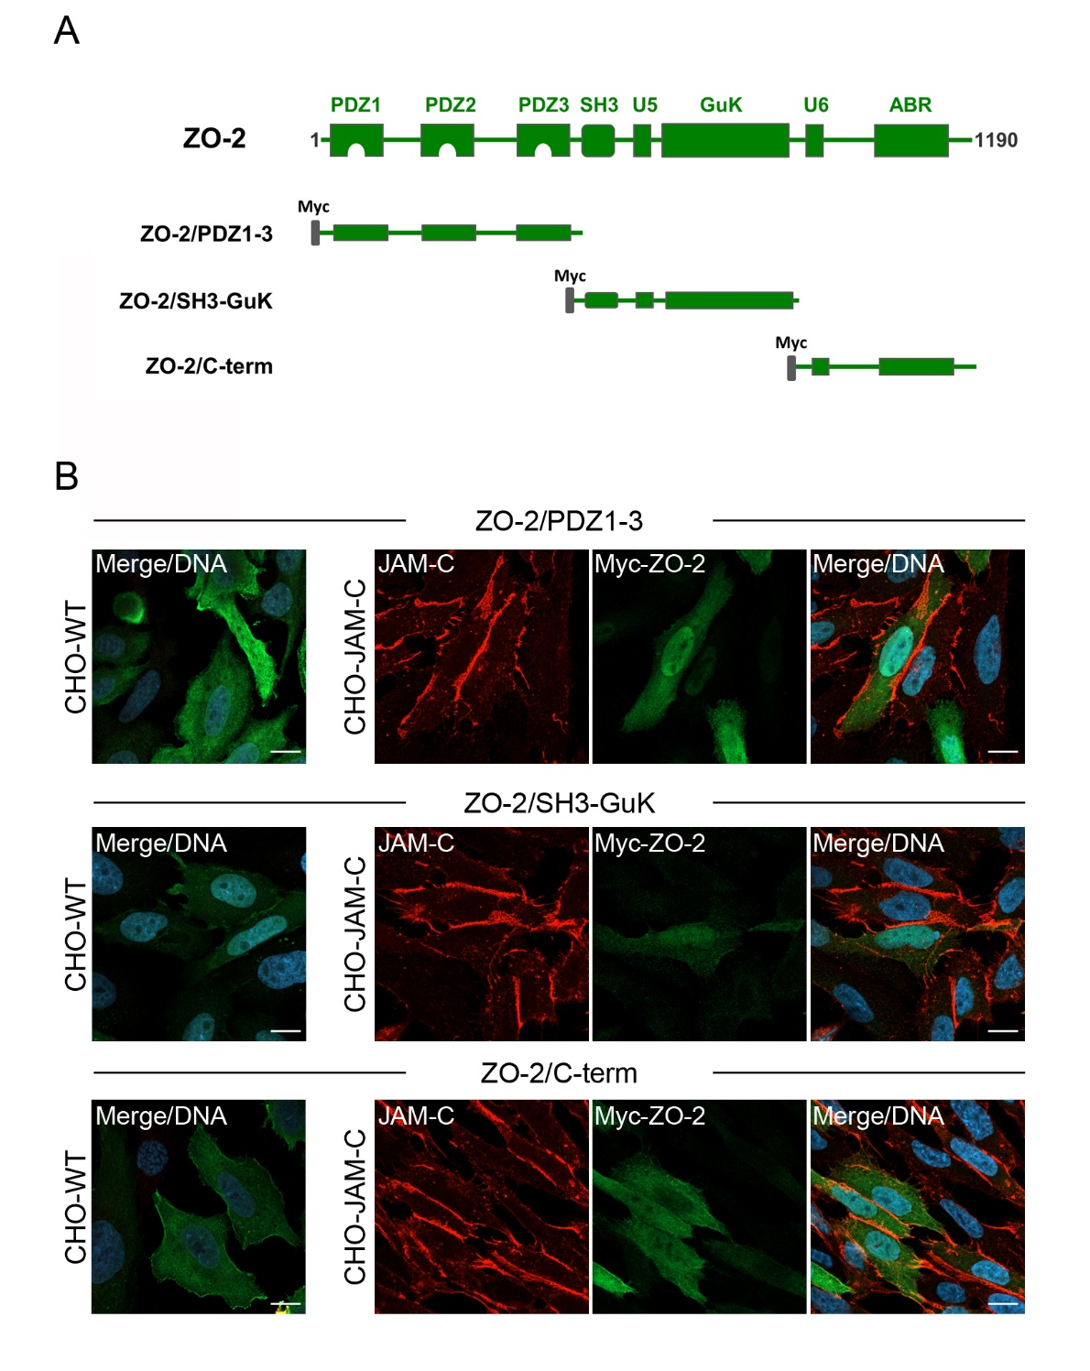

Suppl. Fig. S1: Recruitment of ZO-2 deletion constructs by JAM-C. (A) Cartoon of ZO-2 deletion constructs used in recruitment assays. (B) CHO-WT and CHO-JAM-C cells were transfected with Myc-tagged ZO-2 constructs shown in panel (A) and stained with antibodies against JAM-C (red) and against the Myc tag (green). Note that none of the three constructs is enriched at JAM-C-positive cell junctions. Data is representative of N = three independent experiments. Scale bars: 10 µm.

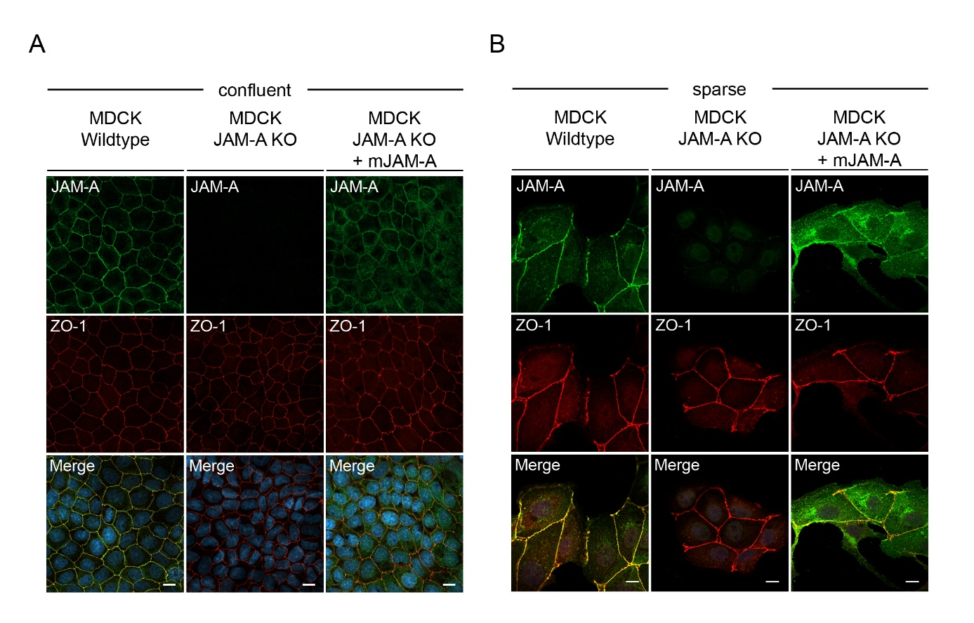
Suppl. Fig. S2: Expression of JAM-A in JAM-A KO MDCKII cells. (A) Wildtype MDCKII cells, JAM-A knockout MDCKII cells or JAM-A knockout MDCK cells ectopically expressing mJAM-A were grown to confluency and stained with antibodies against JAM-A and ZO-1. Scale bars: 10 µm. (B) Wildtype MDCKII cells, JAM-A knockout MDCKII cells or JAM-A knockout MDCK cells ectopically expressing mJAM-A were grown under sparse conditions and stained with antibodies against JAM-A and ZO-1. Scale bars: 10 µm.

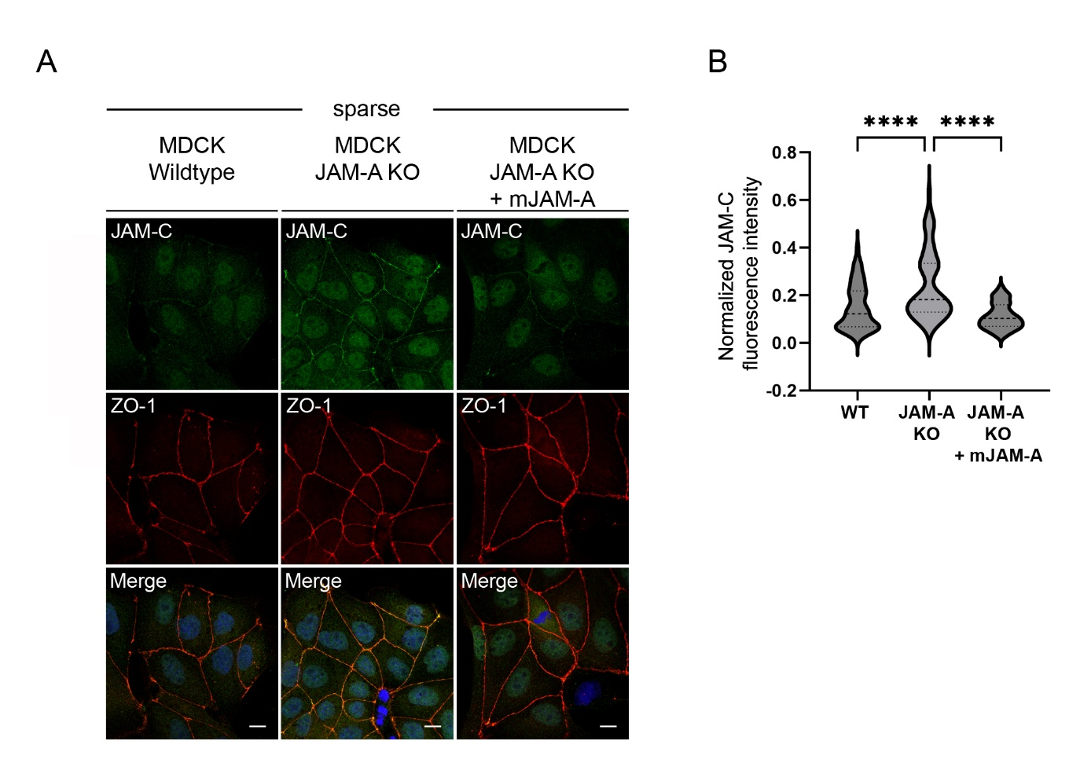
Suppl. Fig. S3: Localization of JAM-C in JAM-A KO MDCKII cells grown at sparse conditions. (A) Wildtype MDCKII cells, JAM-A knockout MDCKII cells or JAM-A knockout MDCK cells ectopically expressing mJAM-A were grown under sparse conditions and stained with antibodies against JAM-C and ZO-1. Scale bars: 10 µm. (B) Statistical analysis of JAM-C localization at cells-cell contacts in sparse cells. The data shows the ratios of JAM-C fluorescence cell-cell contacts to the ZO-1 fluorescence intensity and is depicted as normalized JAM-C fluorescence intensity. Statistical analysis was performed with Kruskal-Wallis Test for multiple comparisons. Data were obtained and data points were pooled from at least 11 randomly chosen fields of view (FOV) per experiment derived from three independent experiments (WT cells: 67 FOV; JAM-A KO cells: 70 FOV; JAM-A KO cells expressing mJAM-A: 71 FOV). Data is presented as Violin plot. Broken lines indicate mean values, dotted lines indicate first and third quartiles. ****p < 0.0001.

